



MCA -I Sem – I
Division - D Name:Snehal Suresh Shitole
Roll no. : MC2527229
Subject: [IT11L] Python Programming Lab

For Academic Year 2025 – 2026

Department of Master of Computer Application


INDEX

Sr.  No. | Practical Name | Date | Sign
1. | Write a python program to print the following string in a specific format?  Out put : Twinkle, twinkle, little star, How I wonder what you are! Up above the world so high, Like a diamond in the sky. Twinkle, twinkle, little star, How I wonder what you  are
2 | Write a program to perform arithmetic operations.
3 | Write a program using list to perform below operation: a. Slicing b. Concatenation c.  Repetition
4 | Write a program using tuple to perform below operation: a. Slicing b. Concatenation  c. Repetition
5 | Write a program using dictionary to access value using keys .
6. | Write a program using set: a. Create empty set b. Assign value to set c. Adding element d. Removing element

7. | . Write a program to get the largest number from the given list ?
8. | Write a program to find out Factorial of a given Number
9. | Write a program to find given number is prime or not



10. | Write a program to identify total number of digits present in given number
11. | Write a program to display Fibonacci series up to a given number by using range function
12. | Write a program using for loop with:  String, Integer, Enumerate, Nested, For List, Dictionary, Tuple, Zip()
13. | Write a program to perform Loop manipulation using pass, continue, break and else
14. | Write a program to perform Comprehensions on List Dictionaries.
15. | Write a program to Find all the numbers from 1-500 that have three in them.
16.. | Write a python program for numbers=range(20) produce a list containing the word "even" if the number is even or the word "odd" if the number is odd
17 | Find the common numbers in two list 1[1,3,4,5,6,7] 2[5,2,8,7,1,3]



ASSIGNMENT=2

1 | Implement a nested function that calculates compound interest using non-local variables
2 | Write a program using lambda to filter even numbers from a list
3. | Write a program using lambda to find area of triangle
4. | Create a generator function to yield Fibonacci numbers up to a certain limit
5. | Develop a custom Python module with functions for basic statistical operations (mean, median, mode)
6. | rite a program to handle file reading errors and log them to a separate file
7 | reate a custom exception class AgeException and use it to validate user input



ASSIGNMENT=3

1 | Write a simple Python class named Student and display its type. Also display the dict attribute keys and values of the module  attribute of the Student class.
2 | Write a Python class Student with attributes, student name and marks. Modify any attribute value of the class and show the original and modified values o attributes.
3 | Write a Python class to convert an integer to a Roman numeral.
4 | Write a Python class to convert a Roman numeral to an integer
5 | W ite a program to create a class Shape with methods called get_perimeter and get area. Create a subclass called Circle that overrides the get_perimeter and get area methods o calculate the area and erimeter of a circle.
6 | rite a program to create a Vehicle class hierarchy. The base class should be ehicle, with subclasses Truck, Car, and Motorcycle. Each subclass should ave properties such as make, model, year, and fuel_type. Implement methods for calculatin fuel efficienc ,  distance traveled, and maximum s eed.
7 | Implement a class BankAccount with methods for deposit, withdrawal, and dis la in the account balance.
8 | Develop a hierarchy of shapes (e.g., Shape, Circle, Rectangle) with area and perimeter methods.



9 | Overload the + operator for concatenating two custom string objects
10 | Create a static method to validate user credentials (e.g., email format, password len h
11 | Implement a class Library containing a list of Book objects
12 | Demonstrate method overriding in a superclass-subclass relationship for a payment
13 | Write a program to validate a password that meets certain criteria (length, uppercase, dioit s ecial character .
14 | Parse email addresses from a given text and classify them by domain
15 | Create threads to perform independent tasks such as downloading multiple files Simultaneousl
16 | Write a Python program to create two threads. The first thread will print even numbers, and the second thread will print odd numbers. Demonstrate the conce t of  multithreadin
17 | Use multithreading to compute factorials of multiple numbers and log the results into a file.



ASSIGNMENT=4

1. | Develop a Python program to create, read, update, and delete documents in MongoDB a collection.
2. | Write a program to insert valid data into MongoDB using exception handling for errors.
3. | Use MongoDB’s aggregation pipeline to find the average salary of employees in a collection.
4. | Develop a Python program to create a database name employee. With the collection name empinfo. Add 5 douments in the collection. Perform read, update, and delete operations on documents in a  MongoDB.

ASSIGNMENT=5

1 | Create a Django project with models for Product and Category, along with views to display them on a webpage.
2. | mplement user login, logout, and registration functionality in a Django application.
3. | Build a REST API for a task management system where users can create, update, and delete tasks



CERTIFICATE
This is to certify that, Ms.Snehal Shitole of MCA C (SEM- I) Class, Roll No. MC2527229, has completed all the Practical work of the subject “IT11L Python Programming Practical Assignments” satisfactorily in the MCA program as prescribed by Savitribai Phule Pune University in the academic year 2025 - 2026.

Date: -

Course Coordinator HOD, MCA Director

Examiner 1 Sign Examiner 2 Sign



Student Name: Sanyukta Balkrishna Sasane Roll No:MC2527208
Subject Code: PPR501MJ
Subject Name: Python Practical Lab Assignments

Assignment- 1
- Write a python program to print the following string in a specific format? Out put : Twinkle, twinkle, little star, How I wonder what you are! Up above the world so high,
Like a diamond in the sky. Twinkle, twinkle, little star, How I wonder what you are
Program:
print("twinkle twinkle little star") print("how i wonder what you are") print("up above the world so high") print("like a diamond in the
sky") print("twinkle twinkle little star") print("how i wonder what you are") Output:
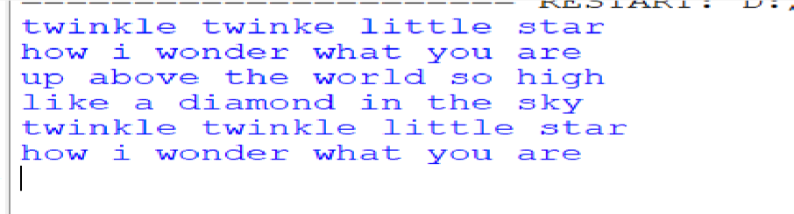
- Write a program to perform arithmetic operations. Program:

a = int(input("Enter first number: ")) b
= int(input("Enter second number: "))

print("Arithmetic operations:") print("Addition:", a + b) print("Subtraction:", a - b) print("Multiplication:", a * b) print("Division:", a / b) Output:
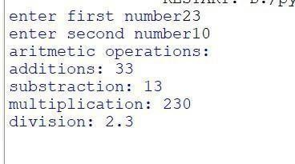

- Write a program using list to perform below operation: a. Slicing b. Concatenation
c. Repetition

Program:

a = [1, 2, 3, 4, 5] #
Slicing print(a[1:4])

# Concatenation print([1, 2] + [3, 4])

# Repetition print([7, 8] * 3)

output:
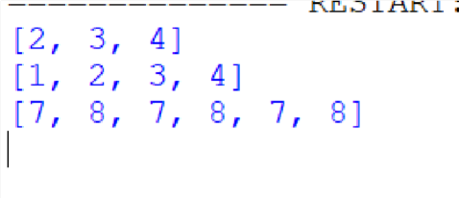

- Write a program using tuple to perform below operation: a. Slicing b. Concatenation
c. Repetition

Program:
t = (10, 20, 30, 40, 50)
# Slicing print(t[1:4])

#Concatenation print((1, 2)
+ (3, 4))
#Repetition print((7,8) * 3)
Output:
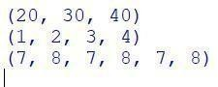

- Write a program using dictionary to access value using keys . Program:
# student = { "name": "Varsha", "age": 20,
"course": "MCA"

}

print(student["name"])

print(student["age"])

print(student["course"])

output:
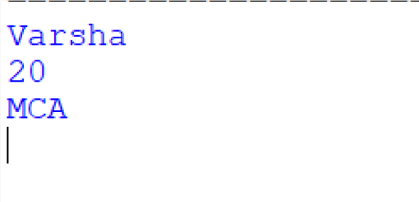

- Write a program using set: a. Create empty set b. Assign value to set c. Adding element d. Removing element
Program:
# a. Create empty set s= set()
print(s)

# b. Assign values to set s = {1, 2, 3}
print(s) # c. Adding element s.add(4)
print(s)

# d. Removing element

s.remove(2) print(s)
output:

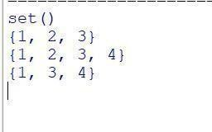

- Write a program to get the largest number from the given list ? Program:
numbers = [10, 25, 3, 89, 45] largest

= max(numbers) print("Largest number:", largest)
output:
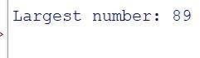

- Write a program to find out Factorial of a given Number Program:
num = int(input("Enter a number: ")) fact = 1 for i in range(1, num + 1):
fact *= i print("Factorial:", fact) output:

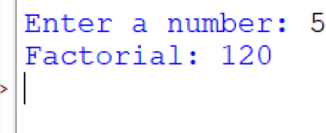
- Write a program to find given number is prime or not. Program:
n = int(input("Enter number: "))
for i in range(2, n): if n % i == 0:
print("Not Prime") break else:
print("Prime")
output:
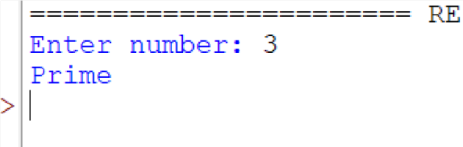

- Write a program to identify total number of digits present in given number. Program:
n = input("Enter a number: ") print("Total digits:", len(n)) output:
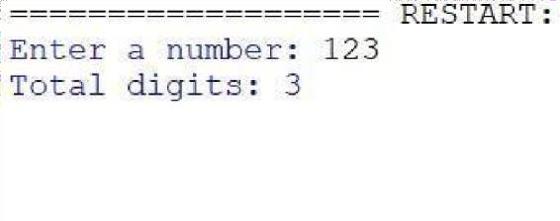
- Write a program to display Fibonacci series up to a given number by using range function.
Program:
n = int(input("Enter the limit: ")) a, b = 0, 1 for i in range(n):

print(a, end=" ") a, b = b, a + b
output:
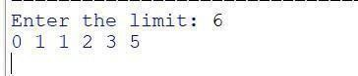

- Write a program using for loop with: String Integer Enumerate List Nested For Dictionary Tuple Zip() Program:
# 1. String for ch in "Hello":
print(ch) # 2. Integer (range) for i in range(5): print(i)
# 3. Enumerate for i, val in enumerate(["a",
"b", "c"]): print(i, val) # 4. List for x in [10, 20, 30]:
print(x)

# 5. Nested For Loop for i in range(2): for j in range(3):

print(i, j)

# 6. Dictionary
d = {"name": "Varsha", "age": 20} for key, value
in d.items(): print(key, value) # 7. Tuple for t in (1, 2, 3): print(t) # 8.
zip() names = ["A", "B",
"C"] marks = [90, 80, 70]
for n, m in zip(names, marks):
print(n, m)

output:
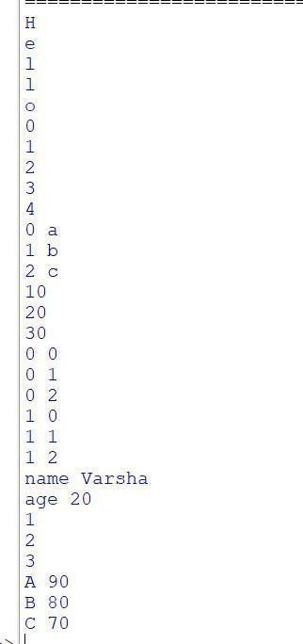

- Write a program to perform Loop manipulation using pass, continue, break and else

Program:
# Loop manipulation: pass, continue, break, else

for i in range(1, 8):

if i == 2:
pass # Does nothing, just a placeholder print("pass at", i

if i == 4:
continue # Skips the rest of loop for this value print("You won't see this")
if i == 6:

print("break at", i) break # Stops the loop print("Number:", i) else:
print("Loop completed without break") output:
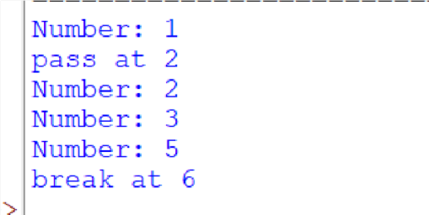
- Write a program to perform Comprehensions on List Dictionaries. Program:

# List Comprehension: create a list of squares
squares = [x*x for x in range(1, 6)] print("List Comprehension:", squares)

# Dictionary Comprehension: number as key, square as value square_dict = {x: x*x for x in range(1, 6)} print("Dictionary
Comprehension:", square_dict)

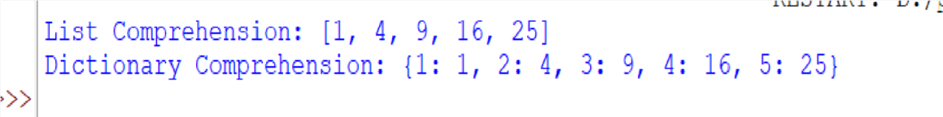
output:

- Write a program to Find all the numbers from 1-500 that have three in them.
Program: numbers_with_3 = [x for x in range(1, 501) if '3' in str(x)] print(numbers_with_3)
output:

Write a python program for numbers=range(20) produce a list containing the word "even" if the number is even or the word "odd" if the number is odd Program:
numbers = range(20) result = ["even" if x % 2 == 0 else "odd" for x in numbers]

print(result) output:

Find the common numbers in two list 1[1,3,4,5,6,7] 2[5,2,8,7,1,3] Program:
list1 = [1, 3, 4, 5, 6, 7] list2 = [5, 2, 8,
7, 1, 3] common = list(set(list1) &
set(list2)) print("Common numbers:", common)
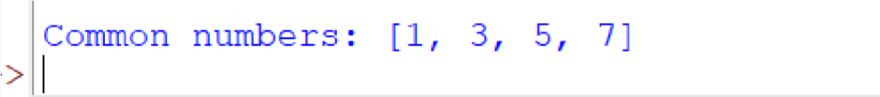
output:



Assignment- 2
Q1. Implement a nested function that calculates compound interest using non-local variables Program: def compound_interest(): principal = 1000 rate = 5 time = 2

def calculate():
nonlocal principal, rate, time return principal * (1 + rate / 100) ** time

print("Compound Interest:", calculate())

compound_interest()
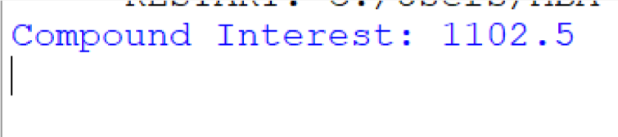
output:

Q2. Write a program using lambda to filter even numbers from a list Program: nums
= [1, 2, 3, 4, 5, 6]
evens = list(filter(lambda x: x % 2 == 0, nums)) print(evens)

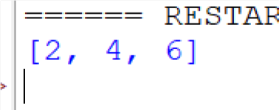
output:

- Write a program using lambda to find area of triangle Program: area = lambda b, h: 0.5 * b * h print("Area:", area(10, 5))

output:

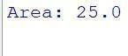
- Create a generator function to yield Fibonacci numbers up to a certain limit
Program:
def fib(limit): a, b = 0, 1 while a
<= limit: yield a
a, b = b, a + b

for n in fib(50): print(n)
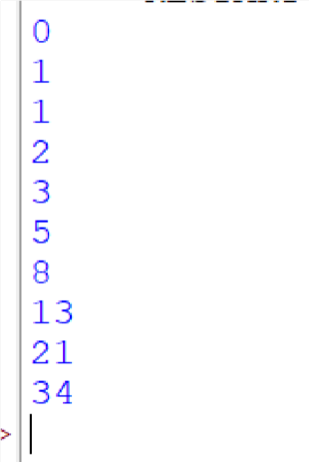
output:

Develop a custom Python module with functions for basic statistical operations (mean, median, mode)
# basic_stats.py

def mean(data):
"""Returns the mean (average) of a list of numbers.""" if not data:
raise ValueError("Data list is empty") return sum(data) / len(data)

def median(data):
"""Returns the median of a list of numbers.""" if not data:
raise ValueError("Data list is empty")

sorted_data = sorted(data) n = len(sorted_data) mid = n // 2

if n % 2 == 0:
return (sorted_data[mid - 1] + sorted_data[mid]) / 2 else:
return sorted_data[mid]

def mode(data):
"""Returns the mode (most frequent value) from a list of numbers.""" if not data:
raise ValueError("Data list is empty")

frequency = {} for value in data:
frequency[value] = frequency.get(value, 0) + 1

max_count = max(frequency.values()) modes = [k for k, v in frequency.items() if v == max_count]

# If all values appear equally, there is no mode if len(modes) == len(frequency):
return None return modes[0]
import basic_stats numbers = [1, 2, 2, 3, 4]

print("Mean:", basic_stats.mean(numbers)) print("Median:", basic_stats.median(numbers))
print("Mode:", basic_stats.mode(numbers)) output:
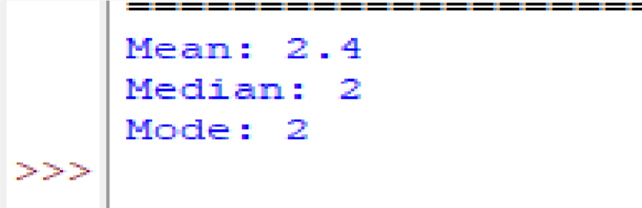

Write a program to handle file reading errors and log them to a separate file
def read_file(filename): try: with open(filename, 'r') as f: print(f.read())
except Exception as e:
# Log the error to error_log.txt with open("error_log.txt", "a") as log:
log.write(f"Error reading '{filename}': {e}\n") print("Error occurred. Check error_log.txt")

read_file("sample.txt")
output:
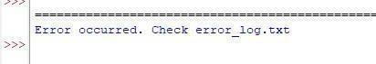

- Write a program to handle file reading errors and log them to a separate file Program; try: try:
f = open("data.txt", "r") print(f.read()) f.close() except

Exception as e: with open("error.log", "a") as log:
log.write(str(e) + "\n") print("Error logged.")
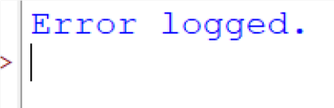
output:

- Create a custom exception class AgeException and use it to validate user input Program: class AgeException(Exception): pass

try:
age = int(input("Enter age: ")) if age < 18:
raise AgeException("Age must be 18 or above") print("Valid age")

except AgeException as e:
print("Error:", e) output:
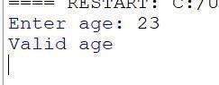



Assignment- 3

Write a simple Python class named Student and display its type. Also display the dict attribute keys and values of the module attribute of the Student class.

Program:
class Student: pass a = Student() print(type(a)) print(Student. dict .keys()
) print(Student. module )

Output:
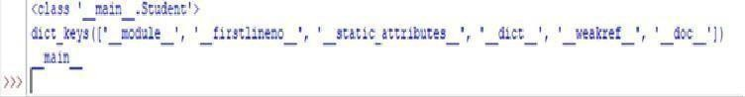

Write a Python class Student with attributes, student name and marks. Modify any attribute value of the class and show the original and modified values of attributes.
Program:
class Student:
def init (self, name, marks): self.name = name
self.marks = marks s =

Student("Rahul", 85) print("Original:", s.name, s.marks)
s.name = "Amit" s.marks = 92
print("Modified:", s.name, s.marks)
Output:

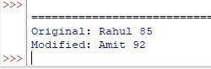

Write a Python class to convert an integer to a Roman numeral.
Program:
class RomanConverter: def int_to_roman(self, num):
vals = [1000, 900, 500, 400, 100, 90, 50, 40, 10, 9, 5, 4, 1] syms =
["M", "CM", "D", "CD", "C", "XC", "L", "XL", "X", "IX", "V", "IV", "I"] roman
= ""

for i in range(len(vals)): while num >= vals[i]:
roman += syms[i] num -= vals[i]

return roman

print(RomanConverter().int_to_roman(3549))

Output:
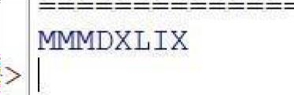

Write a Python class to convert a Roman numeral to an integer.
Program:
class RomanToInt: def roman_to_int(self, s):
roman = {"I": 1, "V": 5, "X": 10, "L": 50, "C": 100, "D": 500, "M": 1000}
total = 0 prev = 0

# Traverse the string from right to left for ch in s[::-1]: val = roman[ch]

else:
if val < prev:
total -= val # Subtract if smaller than previous total += val # Add otherwise
prev = val

return total

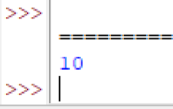
print(RomanToInt().roman_to_int("MMMDXLIX")) Output:

Write a program to create a class Shape with methods called get_perimeter and get area. Create a subclass called Circle that overrides the get_perimeter and get area methods to calculate the area and perimeter of a circle
Program: class Shape: def get_perimeter(self):
return 0

def get_area(self): return 0

class Circle(Shape): def init (self, r):
self.r = r

def get_perimeter(self): return 2 * 3.14 * self.r

def get_area(self):

return 3.14 * self.r * self.r c = Circle(5) print("Perimeter:", c.get_perimeter()) print("Area:", c.get_area()) Output:
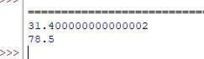

6 .Write a program to create a Vehicle class hierarchy. The base class should be vehicle, with subclasses Truck, Car, and Motorcycle. Each subclass should have properties such as make, model, year, and fuel_type. Implement methods for calculating fuel efficienct
, distance traveled, and maximum seed.
Program: class Vehicle: def
init (self, make, model, year,
fuel_type):
self.make = make
self.model = model self.year
= year self.fuel_type = fuel_type

def fuel_efficiency(self): return "Depends"

def distance_traveled(self, speed, time): return speed * time

def max_speed(self): return "Unknown"

class Car(Vehicle): def fuel_efficiency(self):
return 18

def max_speed(self): return 180

c = Car("Honda", "City", 2022, "Petrol") print("Make:", c.make) print("Fuel Efficiency:", c.fuel_efficiency())
print("Max Speed:", c.max_speed())
print("Distance traveled at 60 km/h for 2 hours:", c.distance_traveled(60, 2)) Output:
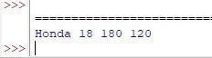

Implement a class BankAccount with methods for deposit, withdrawal, and dis la in the account balance.
Program:
class BankAccount: def
init (self, bal=0): self.bal = bal

def deposit(self, amt): self.bal += amt

def withdraw(self, amt): self.bal -= amt

def display(self):
print("Balance:", self.bal)

# Example usage b = BankAccount(500) b.deposit(200)
b.withdraw(100) b.display() Output:
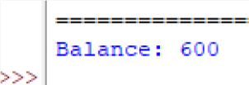

Develop a hierarchy of shapes (e.g., Shape, Circle, Rectangle) with area and perimeter methods.
Program:
class Shape:
def area(self): pass

def perimeter(self): pass

class Circle(Shape):
def init (self, r): self.r = r

def area(self):
return 3.14 * self.r * self.r

def perimeter(self): return 2 * 3.14 * self.r

class Rectangle(Shape): def init (self, l, b): self.l = l self.b = b

def area(self):

return self.l * self.b

def perimeter(self): return 2 * (self.l + self.b)

# Example usage r = Rectangle(4, 5) print("Rectangle Area:", r.area())
print("Rectangle Perimeter:", r.perimeter())
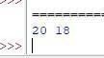
Output:

9 .Overload the + operator for concatenating two custom string objects
Program: class MyString:
def init (self, text): self.text = text

def add (self, other): return MyString(self.text + other.text)

def str (self): return self.text

# Example usage s1 = MyString("Hello ") s2 = MyString("World") print(s1 + s2) Output:
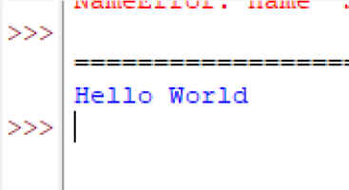

Create a static method to validate user credentials (e.g., email format, password length

Program: import re class Validator: @staticmethod def check(email, password):
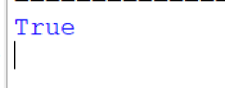
# Check if email is valid and password length is at least 6 return bool(re.match(r"[^@]+@[^@]+\.[^@]+", email)) and len(password) >= 6 print(Validator.check("abc@gmail.com", "secure123")) # True print(Validator.check("abc@gmail", "123")) # False Output:

Implement a class Library containing a list of Book objects
Program: class Book:
def init (self, title): self.title = title

class Library: def

init (self): self.books = []
def add_book(self, b): self.books.append(b)

def show(self): for b in self.books:
print(b.title) l = Library()
l.add_book(Book("Python")) l.add_book(Book("ML")) l.show() Output:
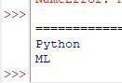

Demonstrate method overriding in a superclass-subclass relationship for a payment
Program: class Payment: def pay(self):
print("General payment") class CardPayment(Payment):
def pay(self):

print("Card payment processed")

CardPayment().pay()

Output:
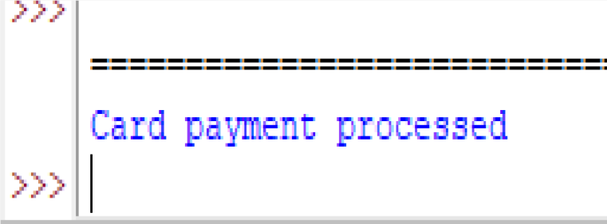

- Write a program to validate a password that meets certain criteria (length, uppercase, digit special character . Program: import re pwd = "Abc@12345"
valid = ( len(pwd) >= 8 and re.search(r"[A-Z]", pwd) # Uppercase letter and re.search(r"[a-z]", pwd) #
Lowercase letter and re.search(r"[0-9]", pwd) # Digit and re.search(r"[@#$%^&+=]", pwd) # Special character
)

print(bool(valid))
Output:
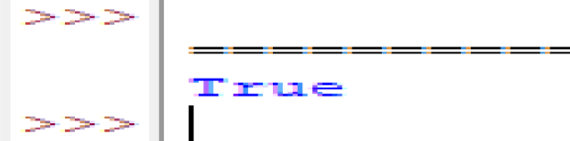

Parse email addresses from a given text and classify them by domain. Program:
import re
text = "Emails: abc@gmail.com, user@yahoo.com, test@zeal.com"
# Find all email addresses

found =
re.findall(r"[\w\.]+@[\w\
.-]+", text) domains = {} for email in found:
domain = email.split("@")[1]

domains.setdefault(doma in, []).append(email) print(domains)

Output:

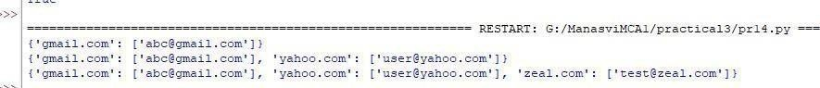

Create threads to perform independent tasks such as downloading multiple files Simultaneously
Program:
import threading import time def download(n):
print("Downloading", n) time.sleep(1)
print("Done", n) threads = [] for i in range(1, 4):
t=threading.Thread(ta r get=download,
args=(i,)) threads.append(t)
t.start() for t in threads:
t.join()

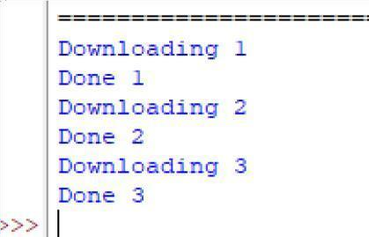
Output:

Write a Python program to create two threads. The first thread will print even numbers, and the second thread will print odd numbers. Demonstrate the concept t of multithreading
Program: import threading def even():
for i in range(0, 11, 2): print("Even:", i) def
odd(): for i in range(1, 11, 2):
print("Odd:", i)
t1 =

threading.Thread(target=even) t2

= threading.Thread(target=odd) t1.start() t2.start() t1.join() t2.join()

Output:

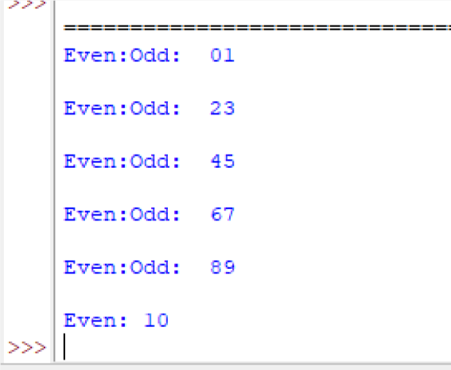
...

Use multithreading to compute factorials of multiple numbers and log the results into a file.
Program:
import threading import math
def fact(n):
print(f"Fact {n} =
{math.factorial(n)}") nums = [5, 6, 7] threads = [] for n in nums:
t = threading.Thread(target=fact, args=(n,)) threads.append(t)
t.start()
for t in threads: t.join()
output:
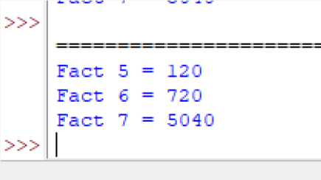



Assignment- 4

Develop a Python program to create, read, update, and delete documents in a MongoDB collection
->1) create-
db.products.insertOne({ "name": "Smartphone X", "price": 699.99, "manufacturer": "TechCo", "inStock": true
})
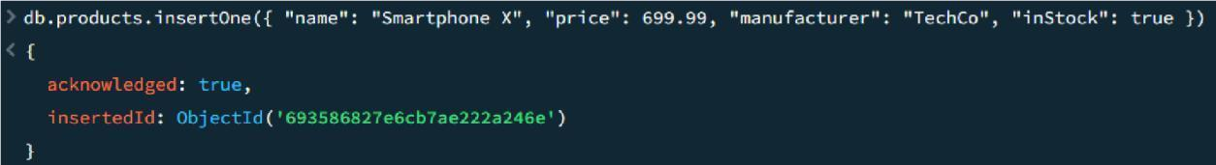
- read- Db.products.find({})

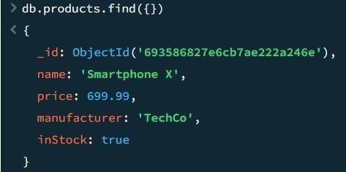
- update- db.products.updateOne({ "name": "Smartphone X" }, { $set: { "price": 649.99, "inStock": false } })
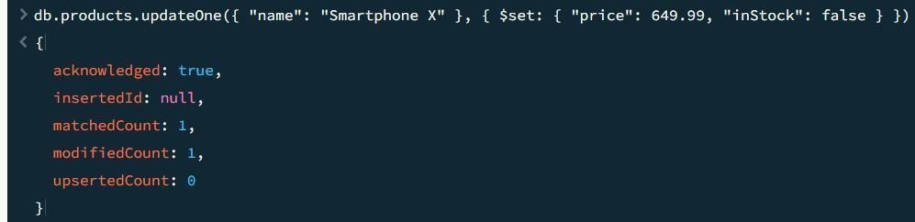
- delete- db.products.deleteOne({ "name": "Smartphone X" })

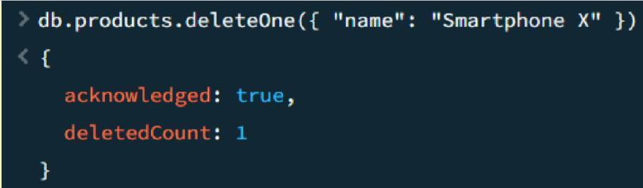

Write a program to insert valid data into MongoDB using exception handling for errors
try {
// Document to insert const doc = {
_id: 1,
name: "Aditya", age: 22,
department: "IT"
};

// Insert into current database (company) const result = db.employees.insertOne(doc);

print("Document inserted successfully!"); printjson(result);

} catch (err) {
// Duplicate key error if (err.code === 11000) { print("Error: Duplicate _id. Document already exists.");
} else { print("An error occurred:"); printjson(err);
}
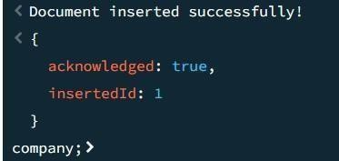
}OUTPUT-

Use MongoDB's aggregation pipeline to find the average salary of employees in a collection
// First need to add some records db.employees.insertMany([

]);
{ _id: 11, name: "Aditya", salary: 50000, department: "IT" },
{ _id: 12, name: "Rahul", salary: 60000, department: "HR" },
{ _id: 13, name: "Sneha", salary: 55000, department: "Finance" },
{ _id: 14, name: "Neha", salary: 65000, department: "IT" },
{ _id: 15, name: "Amit", salary: 48000, department: "Sales" }

// To find the average salary db.employees.aggregate([
{
$group: { _id: null, averageSalary: { $avg: "$salary" }
}
}
]);
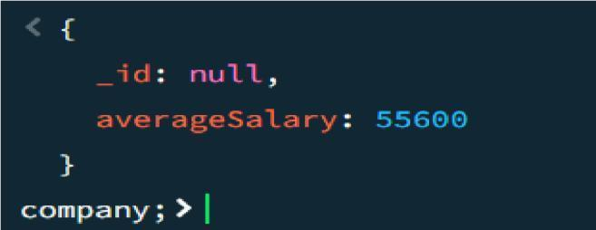
OUTPUT-

Develop a Python program to create a database name employee. With the collection name empinfo. Add 5 documents in the collection. Perform read, update, and delete operations on documents in a MongoDB
db.empinfo.insertMany([

{ _id: 1, name: "Aditya", age: 22, salary: 50000 },
{ _id: 2, name: "Rahul", age: 24, salary: 55000 },
{ _id: 3, name: "Sneha", age: 23, salary: 60000 },
{ _id: 4, name: "Amit", age: 25, salary: 52000 },
{ _id: 5, name: "Neha", age: 22, salary: 58000 } ])

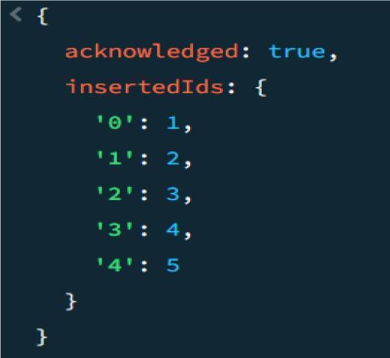
#READ THE DOCUMENTS-
db.empinfo.find()
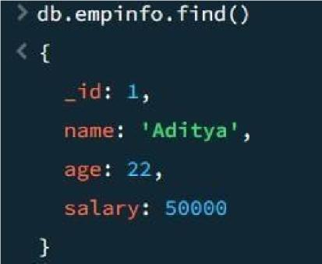
#UPDATE THE RECORDS-
db.empinfo.updateOne(
{ _id: 3 },

{ $set: { salary: 65000 } }
)
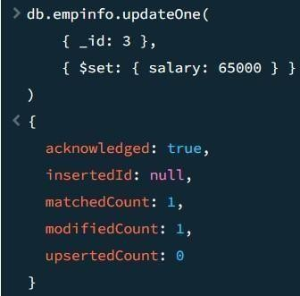

#DELETE THE REOCRDS- db.empinfo.deleteOne({
_id: 4 })
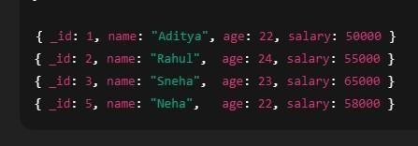

Assignment-5

Create a Django project with models for Product and Category, along with views to display them on a webpage.
Program:-
  - Create Django Project django-admin startproject shop cd shop python manage.py startapp store Add the app in shop/settings.py:
INSTALLED_APPS = [
'django.contrib.admin', 'django.contrib.auth', 'django.contrib.contenttypes', 'django.contrib.sessions', 'django.contrib.messages', 'django.contrib.staticfiles', 'store',
]
  - Models (Category & Product) from django.db import models

class Category(models.Model):
name = models.CharField(max_length=100)
def str (self): return self.name

class Product(models.Model): name = models.CharField(max_length=100) price = models.FloatField()
category = models.ForeignKey(Category, on_delete=models.CASCADE)
def str (self): return self.name
  - Register Models in Admin from django.contrib import admin from .models import Category, Product
admin.site.register(Category) admin.site.register(Product) Run migrations: python manage.py
makemigrations python manage.py migrate

  - Views to Display Categories & Products from django.shortcuts import render from
.models import Category, Product
def category_list(request):
categories = Category.objects.all()
return render(request, "category_list.html", {"categories": categories})
def product_list(request): products = Product.objects.all() return render(request, "product_list.html", {"products": products})
//Create Templates//
6.Add URL
Inside store/urls.py: from django.urls import path from .

import views
urlpatterns = [ path("categories/", views.category_list, name="categories"), path("products/", views.product_list,
name="products"),
]
Link the app URLs in shop/urls.py: from django.contrib import admin from
django.urls import path, include
urlpatterns = [ path('admin/', admin.site.urls), path('', include('store.urls')),
]

Now Run Django Server python manage.py runserver Visit:
- http://127.0.0.1:8000/categories/
- http://127.0.0.1:8000/products/ Output:-
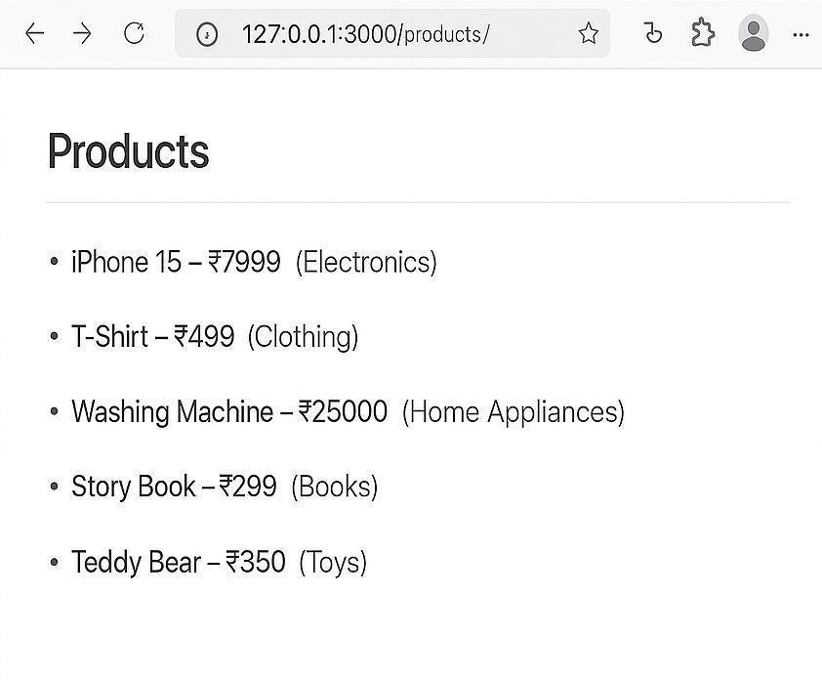

Implement user login, logout, and registration functionality in a Django application.
Step 1: Setup Django Project If you haven’t created a Django project yet: django-admin startproject myproject cd
myproject
python manage.py startapp accounts
Add accounts to INSTALLED_APPS in myproject/settings.py: INSTALLED_APPS = [
...
'accounts',
]
Step 2: Setup URLs In myproject/urls.py: from django.contrib import admin from django.urls import path, include
urlpatterns = [
path('admin/', admin.site.urls), path('accounts/', include('accounts.urls')),
]
Create accounts/urls.py:
from django.urls import path from . import views
urlpatterns = [ path('register/', views.register_view, name='register'), path('login/', views.login_view, name='login'), path('logout/', views.logout_view, name='logout'), path('', views.home_view, name='home'),
]

Step 3: Create Views from django.shortcuts import render, redirect from django.contrib.auth.models import User from django.contrib.auth import authenticate, login, logout from django.contrib import messages
return render(request, 'accounts/home.html')

# User registration def register_view(request): if request.method
== 'POST': username = request.POST['username'] email = request.POST['email'] password1 = request.POST['password1']
password2 = request.POST['password2']
if password1 != password2: messages.error(request, "Passwords do not match") return redirect('register')
if User.objects.filter(username=username).exists(): messages.error(request, "Username already taken") return redirect('register')
user = User.objects.create_user(username=username, email=email, password=password1)
user.save()
messages.success(request, "Registration successful") return redirect('login')
return render(request, 'accounts/register.html')

# User login def login_view(request): if request.method == 'POST':
username = request.POST['username'] password = request.POST['password']
user = authenticate(request, username=username, password=password) if user is not None:

login(request, user) return redirect('home') else:
messages.error(request, "Invalid username or password") return redirect('login')
return render(request, 'accounts/login.html')
# User logout def logout_view(request): logout(request) return redirect('login') Step 4: Create Templates(create using HTML CSS )
Step 5: Configure Messages
In myproject/settings.py make sure django.contrib.messages is included in INSTALLED_APPS (it usually is). Add this in your TEMPLATES context processors: 'context_processors': [
...
'django.contrib.messages.context_processors.messages',
]
Step 6: Run Migrations python manage.py migrate python manage.py runserver Output:-
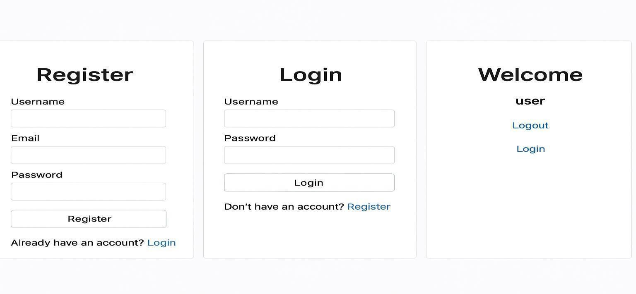

Build a REST API for a task management system where users can create, update, and delete tasks

# Task Management REST API (Django + DRF)
Below is the complete Python code needed to build a REST API for a task management system with CRUD operations.
---
## | project/settings.py | from pathlib import Path BASE_DIR =
Path( file ).resolve().parent.paren t
SECRET_KEY = 'your-secret-key' DEBUG = True ALLOWED_HOSTS = []
INSTALLED_APPS = [
'django.contrib.admin', 'django.contrib.auth', 'django.contrib.contenttypes', 'django.contrib.sessions', 'django.contrib.messages', 'django.contrib.staticfiles', 'rest_framework',
'tasks',
]
MIDDLEWARE = [
'django.middleware.security.SecurityMiddleware', 'django.contrib.sessions.middleware.SessionMiddleware', 'django.middleware.common.CommonMiddleware', 'django.middleware.csrf.CsrfViewMiddleware', 'django.contrib.auth.middleware.AuthenticationMiddleware', 'django.contrib.messages.middleware.MessageMiddleware', 'django.middleware.clickjacking.XFrameOptionsMiddleware',
]
ROOT_URLCONF = 'project.urls' TEMPLATES = [

{
'BACKEND': 'django.template.backends.django.DjangoTemplates', 'DIRS': [],
'APP_DIRS': True, 'OPTIONS': {
'context_processors': [ 'django.template.context_processors.debug', 'django.template.context_processors.request', 'django.contrib.auth.context_processors.auth', 'django.contrib.messages.context_processors.messages',
],
},
},
]
WSGI_APPLICATION = 'project.wsgi.application' DATABASES = {
'default': {
'ENGINE': 'django.db.backends.sqlite3', 'NAME': BASE_DIR / 'db.sqlite3',
}
}
LANGUAGE_CODE = 'en-us' TIME_ZONE = 'UTC'
USE_I18N = True USE_TZ = True STATIC_URL = 'static/'
DEFAULT_AUTO_FIELD = 'django.db.models.BigAutoField'
---
## | tasks/models.py | from django.db import models from django.contrib.auth.models import
User
class Task(models.Model): user = models.ForeignKey(User, on_delete=models.CASCADE) title = models.CharField(max_length=200) description =

models.TextField(blank=True) completed = models.BooleanField(default=False)
def str (self): return self.title
---
## | tasks/serializers.py | from rest_framework import serializers from .models import Task class TaskSerializer(serializers.ModelSerializer): class Meta: model = Task fields
= ' all ' ---
## | tasks/views.py | from rest_framework import viewsets from rest_framework.permissions import IsAuthenticated from .models import Task from .serializers import TaskSerializer
class TaskViewSet(viewsets.ModelViewSet): queryset = Task.objects.all()
serializer_class = TaskSerializer
permission_classes = [IsAuthenticated]
def get_queryset(self):
return Task.objects.filter(user=self.request.user)
def perform_create(self, serializer): serializer.save(user=self.request.user)
---
## | tasks/urls.py | from django.urls import path, include from rest_framework.routers import
DefaultRouter from .views import TaskViewSet
router = DefaultRouter() router.register('tasks',TaskViewSet, basename='tasks')
urlpatterns = [ path('', include(router.urls)),
]
---

## | project/urls.py | from django.contrib import admin from django.urls import path, include urlpatterns = [
path('admin/', admin.site.urls), path('api/', include('tasks.urls')),
]

---
## RUN MIGRATIONS
python manage.py makemigrations python manage.py migrate
## CREATE SUPERUSER
python manage.py createsuperuser ## START SERVER python manage.py runserver

