**LAB ASSIGNMENT - 01**

***Task_01:***

1. Creating 4 files and 2 directories: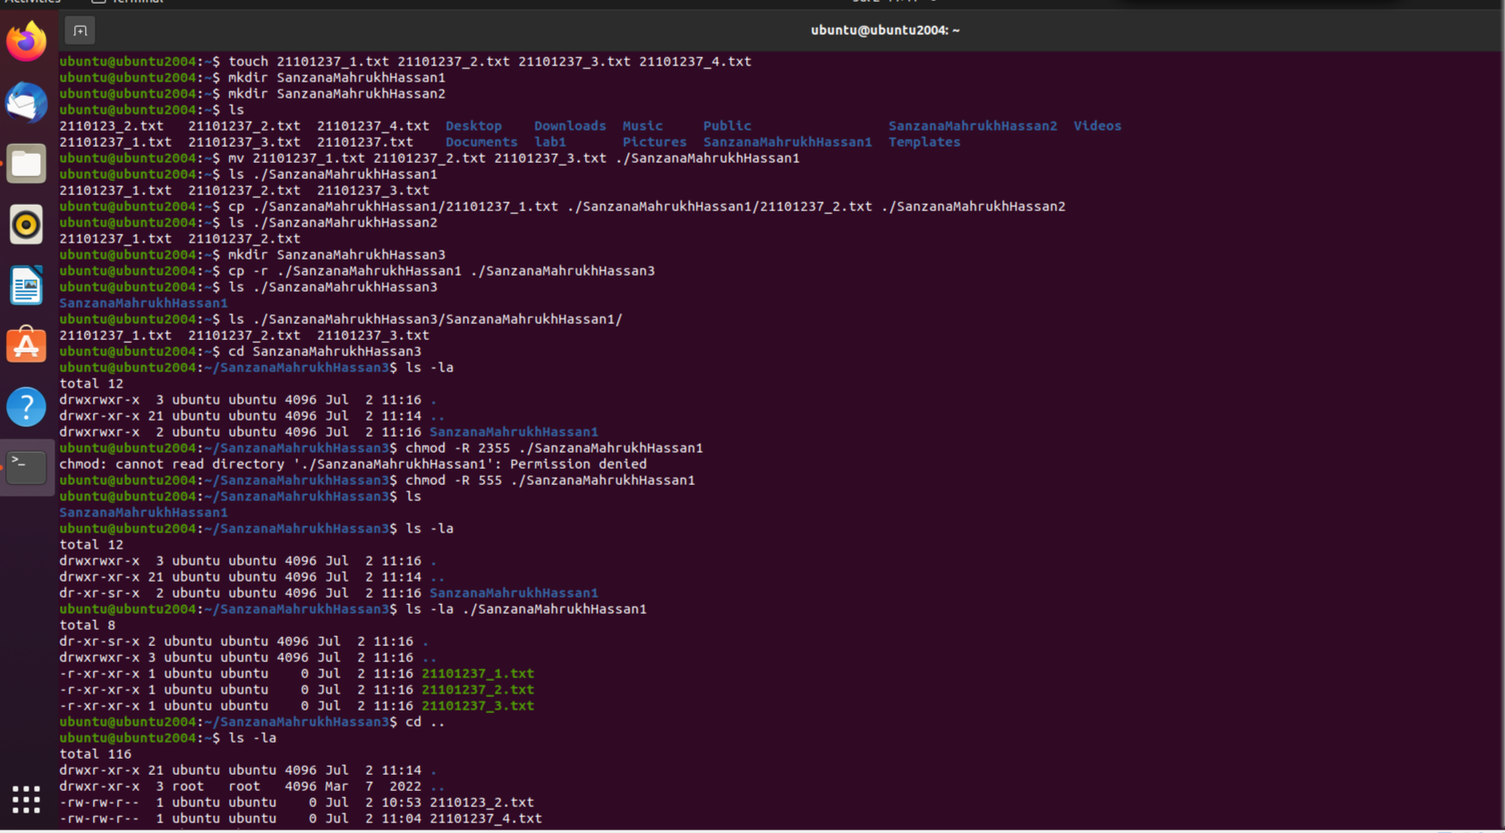

Moving the first three text files to SanzanaMahrukhHassan1:



Copying the first two text files to SanzanaMahrukhHassan2:



i) Making a new directory named SanzanaMahrukhHassan3.

ii) Now, copying the SanzanaMahrukhHassan1 directory along with its contents to the SanzanaMahrukhHassan3 directory.

iii) Now going into the SanzanaMahrukhHassan3 directory and check the permissions of the files/directory and change the permissions for both groups and others to only read-execute for all the files.

iv) Now going back to one directory and print all the directories and files in the current working directory.

v) Finally, move the SanzanaMahrukhHassan3 folder to the root directory and delete the rest of the files and folders in the current working directory.

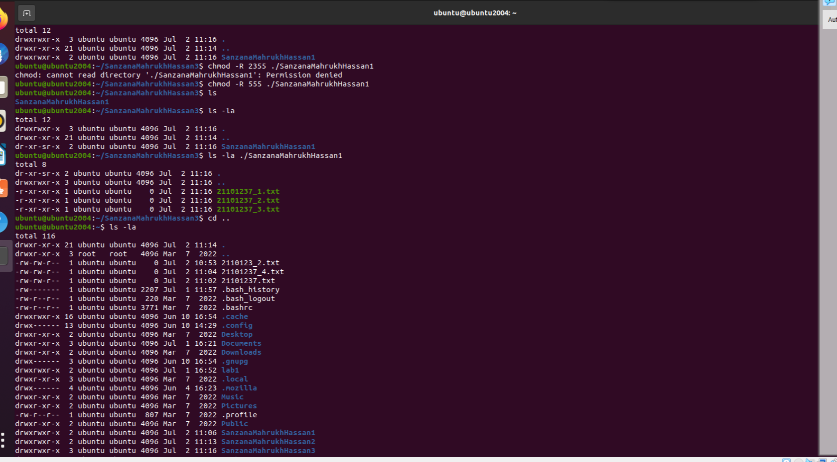

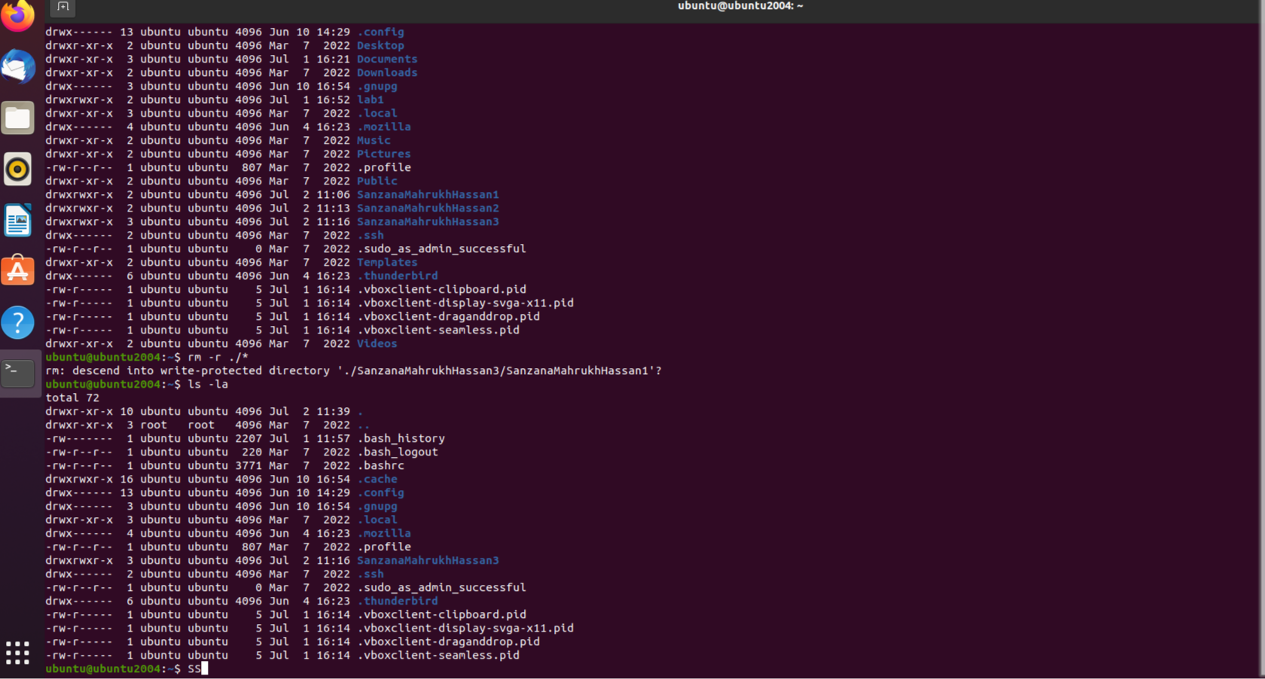

1. touch 21101237_1.txt 21101237_2.txt 21101237_3.txt 21101237_4.txt
2. mkdir SanzanaMahrukhHassan1
3. Mkdir SanzanaMahrukhHassan2
4. ls
5. mv 21101237_1.txt 21101237_2.txt 21101237_3.txt ./SanzanaMahrukhHassan1
6. ls ./SanzanaMahrukhHassan1
7. cp ./SanzanaMahrukhHassan1/ 21101237_1.txt ./SanzanaMahrukhHassan1/ 21101237_2.txt ./SanzanaMahrukhHassan2
8. ls ./SanzanaMahrukhHassan2
9. mkdir SanzanaMahrukhHassan3
10. cp -r ./SanzanaMahrukhHassan1 ./SanzanaMahrukhHassan3
11. ls ./SanzanaMahrukhHassan3
12. ls ./SanzanaMahrukhHassan3/SanzanaMahrukhHassan1
13. cd SanzanaMahrukhHassan3
14. ls -la
15. chmod -R 555 ./SanzanaMahrukhHassan1
16. ls
17. ls -la
18. ls -la ./SanzanaMahrukhHassan1
19. cd ..
20. ls -la
21. Rm -r ./*
22. ls -la
23. i)Creating a file containing my running semester’s course information (course IDs, Course names, Sections, etc.) :

ubuntu@ubuntu2004:~$ touch courses.txt

ubuntu@ubuntu2004:~$ gedit courses.txt

ubuntu@ubuntu2004:~$ cat courses.txt

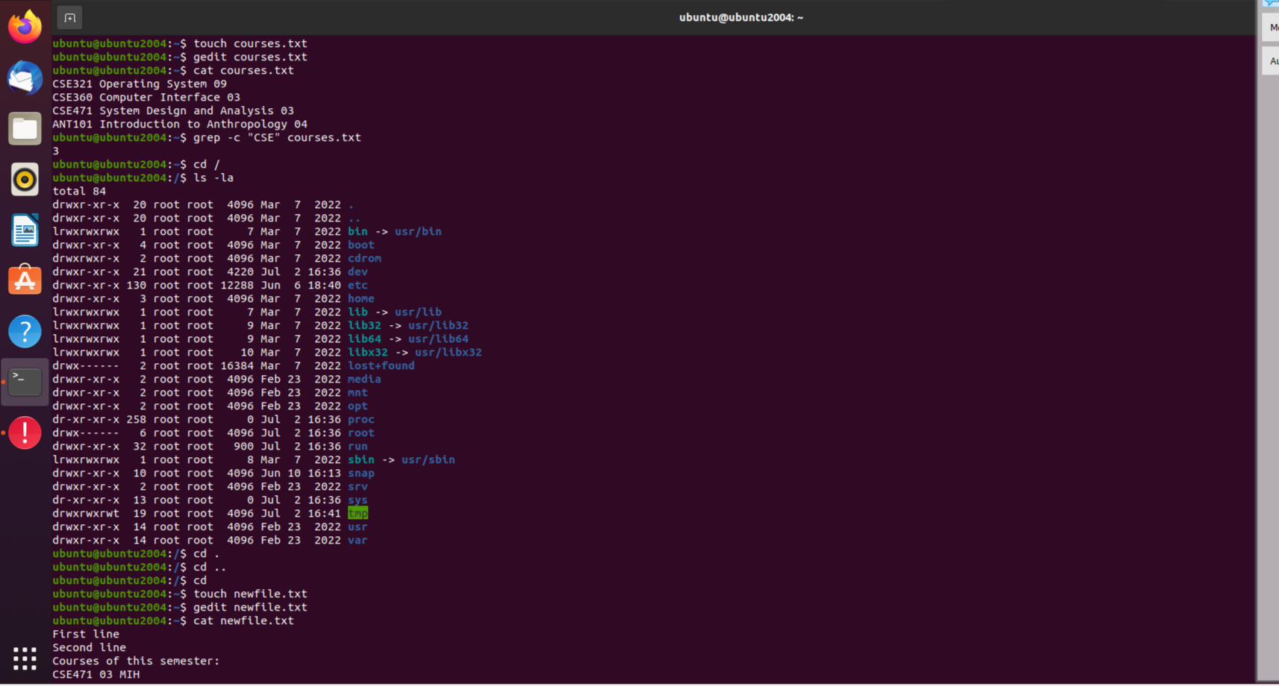

ii) Counting the lines containing the word “CSE” in that file named course.txt :

ubuntu@ubuntu2004:~$ grep -c "CSE" courses.txt



1. Showing all the hidden files in your root directory :

ubuntu@ubuntu2004:~$ cd /

ubuntu@ubuntu2004:/$ ls -la



1. Showing only lines 5-17 of a .txt file(you have to create a file containing more than 17 line) :

ubuntu@ubuntu2004:/$ cd

ubuntu@ubuntu2004:~$ touch newfile.txt

ubuntu@ubuntu2004:~$ gedit newfile.txt

ubuntu@ubuntu2004:~$ cat newfile.txt

ubuntu@ubuntu2004:~$ head -17 ./newfile.txt | tail +5

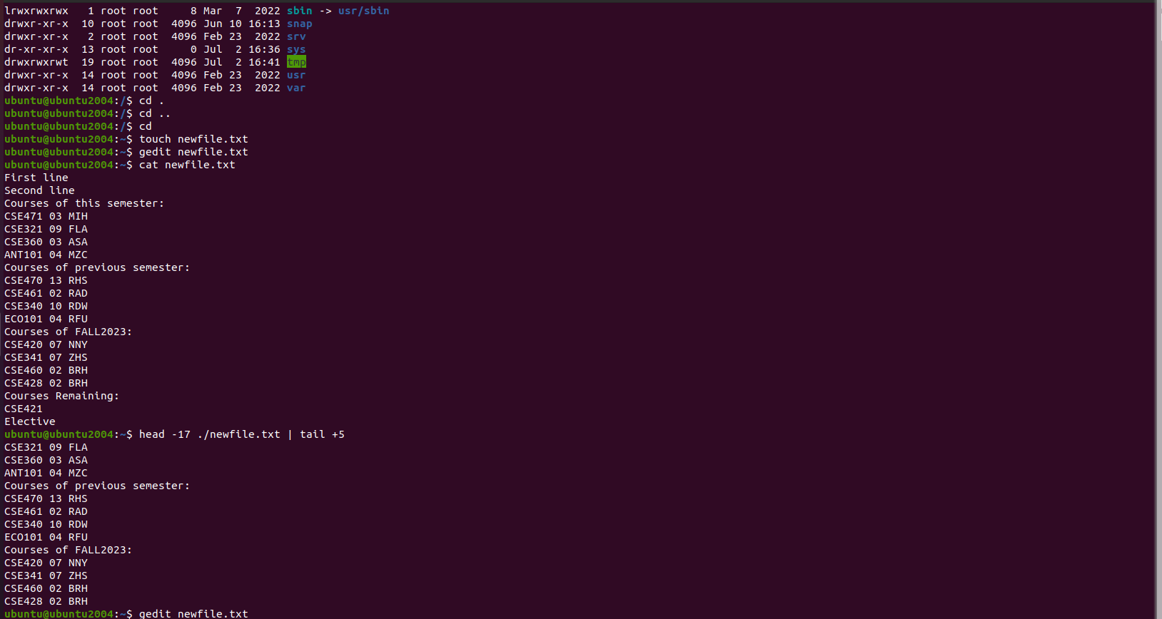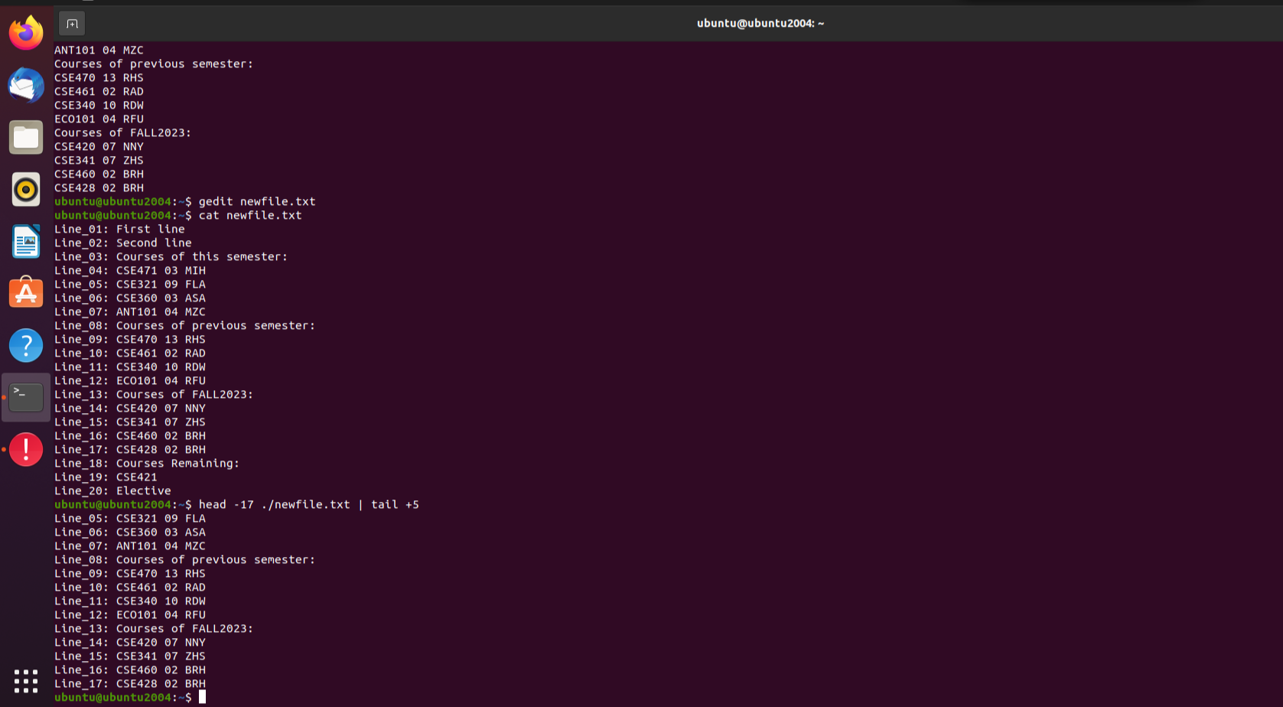

**Task_02**

1. ubuntu@ubuntu2004:~$ mkdir lab_01

ubuntu@ubuntu2004:~$ cd lab_01

ubuntu@ubuntu2004:~/lab_01$ touch task_a.c

ubuntu@ubuntu2004:~/lab_01$ gedit task_a.c

ubuntu@ubuntu2004:~/lab_01$ gcc -o a task_a.c

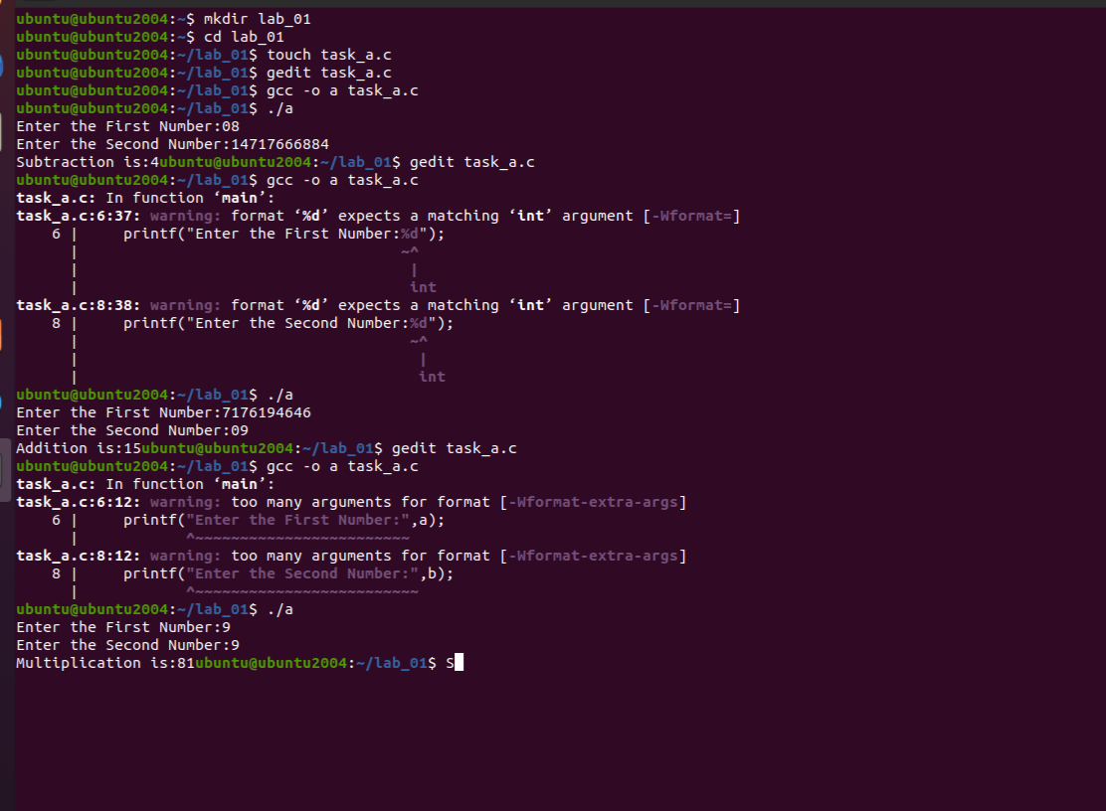ubuntu@ubuntu2004:~/lab_01$ ./a



***b.***

I love Python Programming.

I love Python Programming. ubuntu@ubuntu2004:~/lab_01$ touch task_b.c

ubuntu@ubuntu2004:~/lab_01$ gedit task_b.c

ubuntu@ubuntu2004:~/lab_01$ touch input_b.txt

ubuntu@ubuntu2004:~/lab_01$ gedit input_b.txt

ubuntu@ubuntu2004:~/lab_01$ cat input_b.txt

ubuntu@ubuntu2004:~/lab_01$ gedit task_b.c

ubuntu@ubuntu2004:~/lab_01$ gcc -o b task_b.c

ubuntu@ubuntu2004:~/lab_01$ ./b

ubuntu@ubuntu2004:~/lab_01$ cat output_b.txt

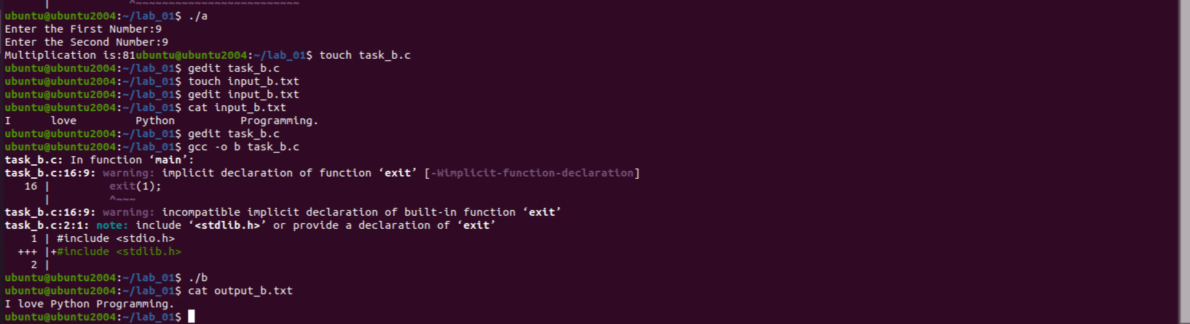



***c.***

ubuntu@ubuntu2004:~/lab_01$ touch task_c.c

ubuntu@ubuntu2004:~/lab_01$ gedit task_c.c

ubuntu@ubuntu2004:~/lab_01$ gcc -o c task_c.c

ubuntu@ubuntu2004:~/lab_01$ ./c

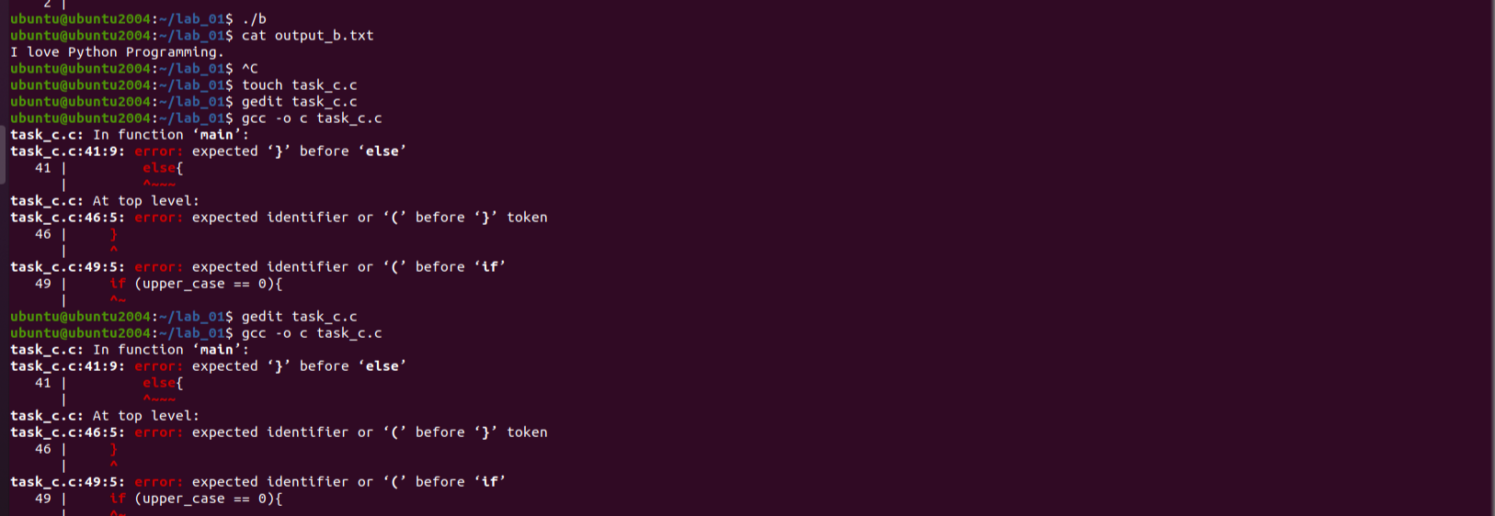

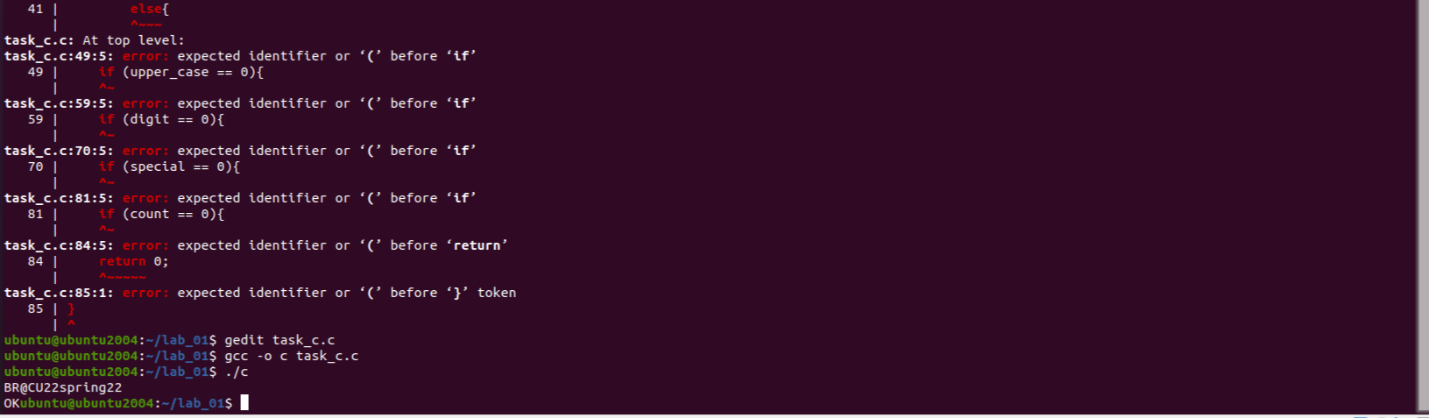

***d.*** ubuntu@ubuntu2004:~/lab_01$ touch task_d.c

ubuntu@ubuntu2004:~/lab_01$ gedit task_d.c

ubuntu@ubuntu2004:~/lab_01$ gcc -o d task_d.c

ubuntu@ubuntu2004:~/lab_01$ ./

