Sanzhar Abayev SE-2538
Project Report: Advanced File System Using the Visitor Pattern
1. Purpose and Design Choices
- Purpose: The primary objective is to implement an in-memory hierarchical file system that completely decouples operations from the underlying element nodes (FileNode and DirectoryNode) by leveraging the Visitor behavioral pattern.
- Design Choices:
  - Double Dispatch (R2): Concrete elements implement accept(Visitor visitor), which directly calls visitor.visit(this). This design completely avoids runtime type discrimination or instanceof checks.
  - Deterministic Traversal (R4, R7): DirectoryNode maintains its children using a TreeMap<String, FileSystemElement>, ensuring strict lexicographical ordering and predictable root-relative path generation (/ separator).
  - Tree Integrity Guardrails (R6): Defensive checks are enforced in addChild() to proactively reject negative file sizes, duplicate sibling names, multi-parent ownership, and cyclic directory references.
2. UML Diagram
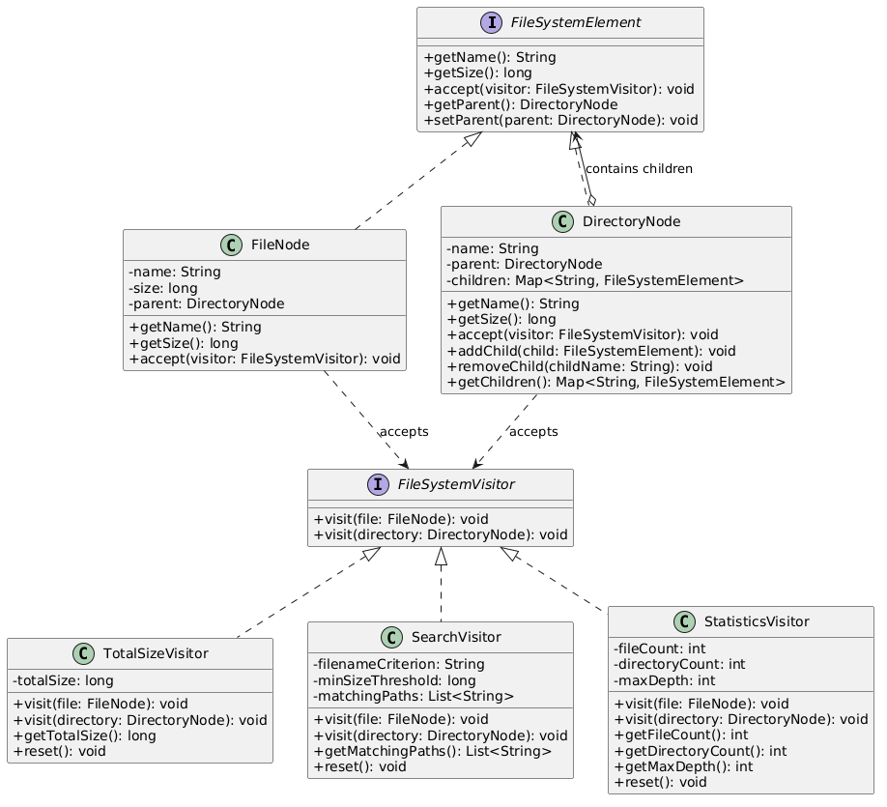
3. Five Clean Code Justifications
- Meaningful Naming (TotalSizeVisitor): Classes and methods are explicitly named after their domain responsibilities (e.g., getTotalSize(), getMatchingPaths()), removing the need for redundant comments.

- Single Responsibility Principle (SRP): Each visitor encapsulates precisely one algorithm (size summation, file searching, structural metric collection), whereas element classes handle structural state exclusively.

- Small Methods: All visitor visit methods and integrity check routines are kept concise and focused (<15 lines), keeping cyclomatic complexity low.
- Encapsulation (DirectoryNode): Internal child maps are exposed exclusively via read-only wrappers (Collections.unmodifiableMap) to protect internal directory invariants.
- Elimination of Type-Checking Chains: Branching logic based on concrete types is entirely replaced by polymorphic double dispatch across the visitor contract.
4. Sample Program Outputs
Executing the demonstration application yields the following deterministic output:
=== Advanced File System Visitor Pattern Demonstration ===
File system structure initialized successfully.

[Visitor 1 - TotalSizeVisitor]
-> Total storage size across subtree: 4864 bytes

[Visitor 2 - SearchVisitor]
-> Matching files (*.java with size >= 500 bytes):
* /source/Main.java

[Visitor 3 - StatisticsVisitor]
-> Total File Count: 5
-> Total Directory Count (including root): 3
-> Maximum Tree Depth (root = 0): 1

=== Demonstration Completed Successfully ===

5. Test Summary
- Test Class Name: com.filesystem.FileSystemTest
- Test Results: All tests executed successfully via mvn clean test ($8/8$ verification targets passed).
  - t1_bothElementTypesReachCorrectVisitMethods (Passed)
  - t2_sizeAccumulationAcrossMultipleNestingLevels (Passed)
  - t3_searchCombinesFilterConditions (Passed)
  - t4_searchProducesDeterministicRootRelativePaths (Passed)
  - t5_statisticsAreCorrectForNestingCountingAndDepth (Passed)
  - t6_emptyStructuresAndNoMatchSearchHandled (Passed)
  - t7_repeatExecutionsDoNotLeakOrMultiplyState (Passed)
  - t8_invalidTreeMutationsRejectedWhileValidNestingSupported (Passed)
6. Traversal and Extension Trade-offs
- Traversal Trade-off (R7): Delegating traversal execution between DirectoryNode and visitors balances structural encapsulation with visitor control, ensuring each reachable node is visited exactly once.
- Extension Boundary & Trade-off (R8): Adding the third visitor (StatisticsVisitor) required zero modifications to FileNode, DirectoryNode, or their accept methods, fulfilling the open-closed principle. However, the classical trade-off of the Visitor pattern is the Expression Problem: adding a new element type (e.g., SymlinkNode) would require modifying every existing visitor interface and implementation.
7. GitHub Repository Link
Repository URL: https://github.com/Sanzh-123/assignment-6-visitor-pattern

