> You have not accepted the license agreements of the following SDK components:

[ConstraintLayout for Android 1.0.2, Solver for ConstraintLayout 1.0.2].

<https://blog.csdn.net/qasimcyrus/article/details/55188740?utm_source=itdadao&utm_medium=referral>

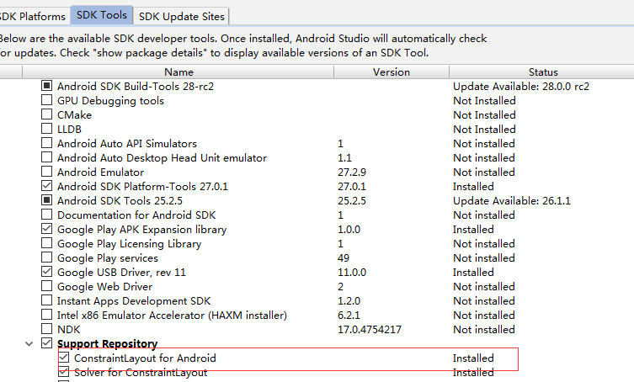

You have not accepted the license agreements of the following SDK components: [SDK Patch Applier v4, Google Repository].

<https://stackoverflow.com/questions/41417503/ionic-error-with-license-for-sdk-patch-applier-v4>

2.Execution failed for task ':qrcode:lint'.

> Lint found errors in the project; aborting build.

这个是因为代码不符合规范，lint检查时报错，因此中断了整个编译过程。

只要在当前app的app/build.gradle文件内增加如下代码，

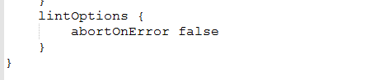

Android-sdk-linux安装