Jenkins配置

# Jenkins搭建

## 1 安装JDK

  本文采用jdk-8u111-windows-x64.exe；

## 2 配置tomcat

  本文采用tomcat8，无需安装，配置JAVA_HOME及JRE_HOME环境变量即可；

## 3 安装maven，ant

  本文采用maven3.3.9，无需安装；

## 4 安装Jenkins

下载地址https://jenkins.io/download/，仅下载war包，如下图：

## 5 相关配置

详见：<https://blog.csdn.net/hc_ttxs/article/details/79384535>

推荐的方法是先安装tomcat，然后再加jenkins.war放在tomcat的webapp路径下来启动jenkins会比较好，这样不存在权限的问题，否则会出现root和jenkins用户权限的相关问题

# 二、Linux节点slave环境配置

## 1 配置slave

主页面-系统管理-节点管理-新建节点

注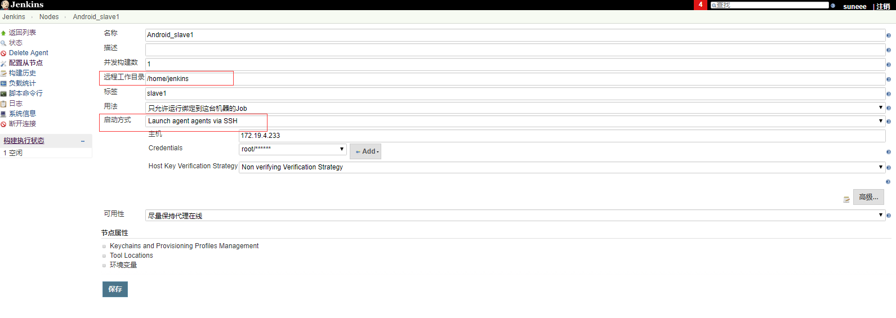

#启动方式 Launch agent agents via ssh

## 2 环境配置SDK，android ，gradle

vim /etc/profile #增加环境变量

Source /etc/profile

yum install -y unzip zip

安装所有包

android update sdk --no-ui

设置环境变量

方法一：

export PATH=$PATH:/opt/gradle/gradle-4.7/bin

方法二：

vim /etc/profile

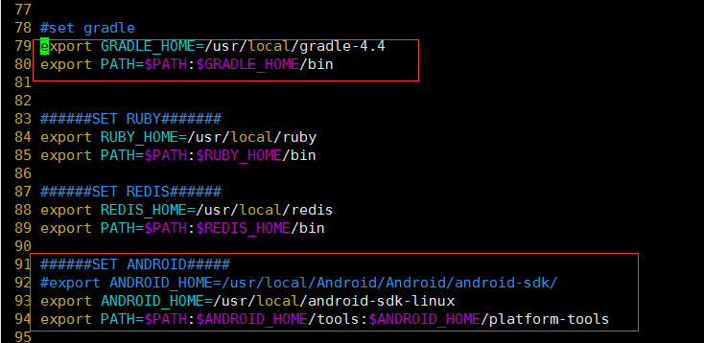

source /etc/profile #环境变量生效

# 三、Mac节点slave环境配置

# ifconfig

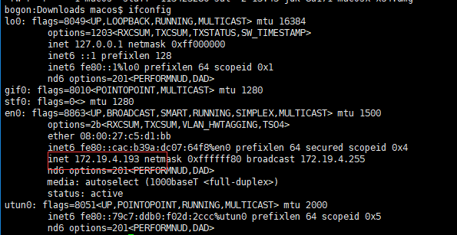

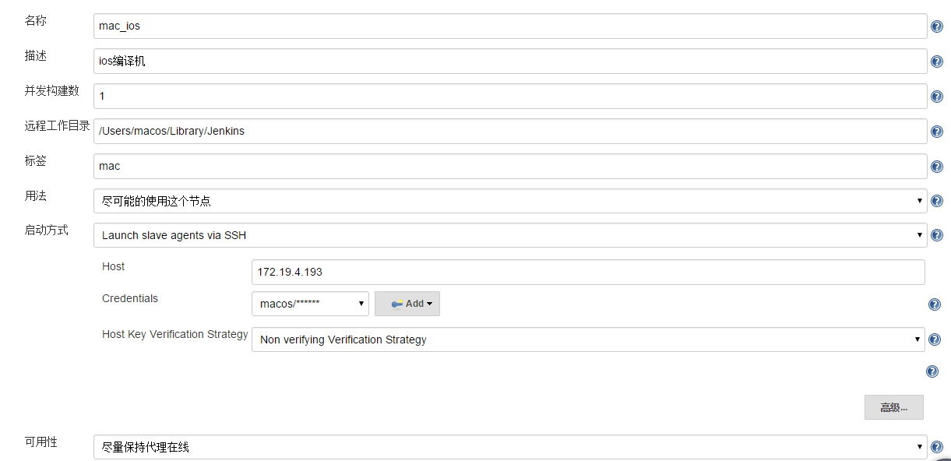

Ipconfig

环境变量查看

Mac :echo $PATH

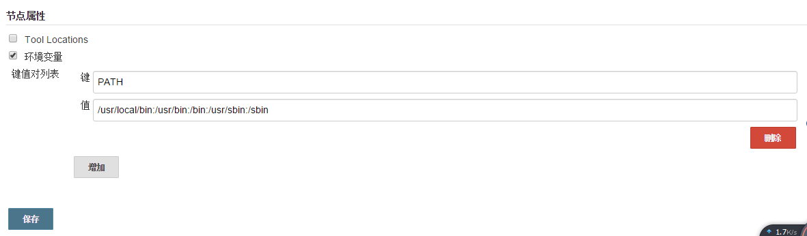

# 四、流水线配置

1.安卓打包

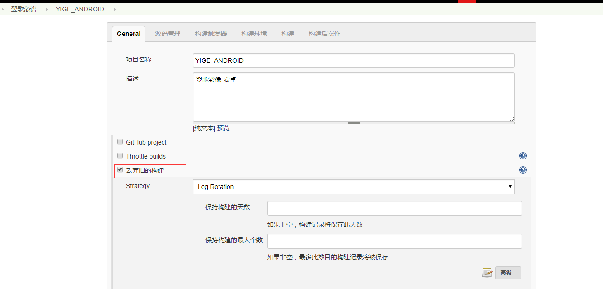

丢弃旧的构建 可设置也可不设置

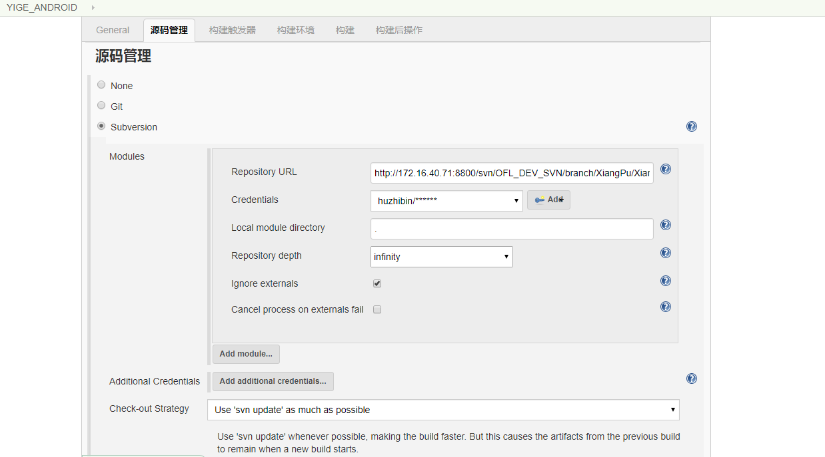

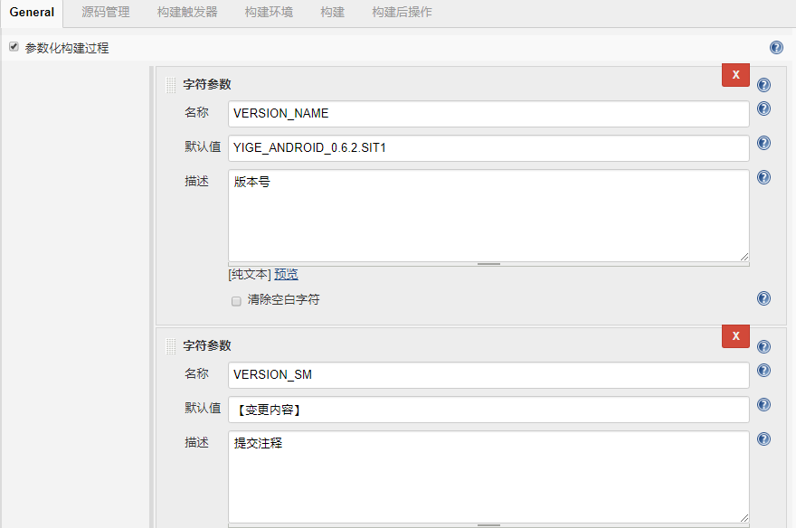

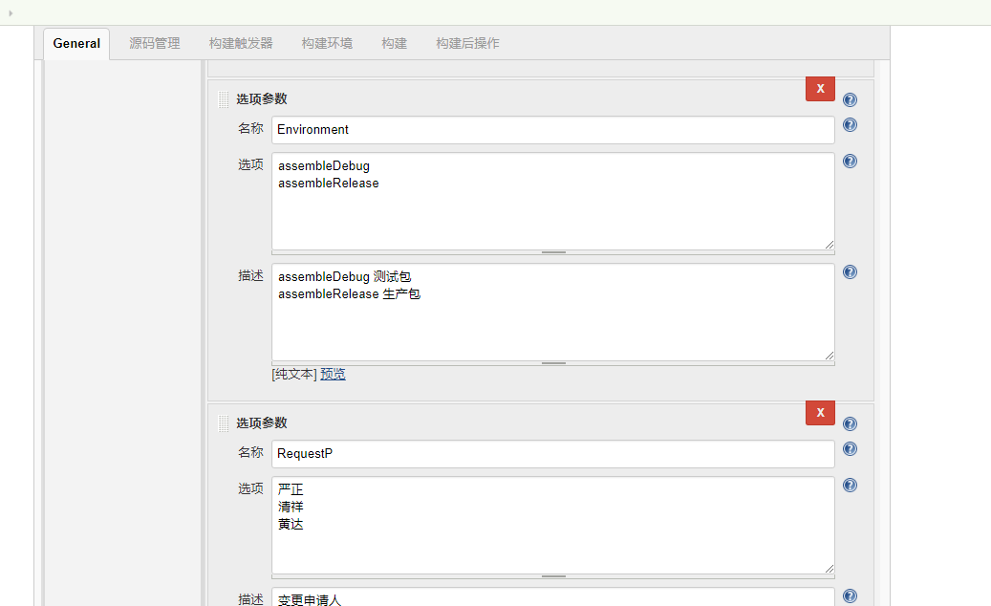

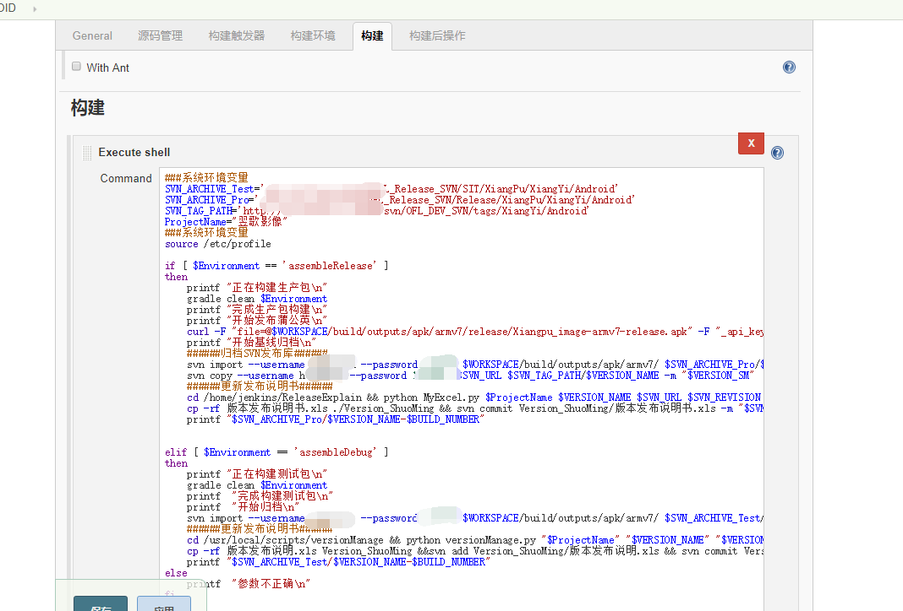

构建后

自动发布蒲公英

curl -F "file=@D:\jenkins\workspace\Andriod_XiangYi_Merge_Pro\Andriod_XiangYi_Merge_Pro-armv7-release.apk" -F "uKey=蒲公英key" -F "_api_key=蒲公英key " https://qiniu-storage.pgyer.com/apiv1/app/upload

gradle自动签名配置gradle.xml

buildTypes

{release

{signingConfig signingConfigs.release}  
}

2 Java工程Ant打包

if [ $Environmental == 'TestEnvironmental' ]

then

echo $Environmental,'开始构建测试包'

cd $WORKSPACE/ && ant clean war -f build-test.xml

###备份###

ssh -p 12222 root@10.0.0.144 "cd /opt/apache-tomcat-command/; mkdir -p backup; cp -rf webapps/NVRCT.war backup/NVRCT-`date +%m%d%H%M`.war"

ssh -p 12222 root@10.0.0.144 "pwd"

###更新包###

rsync -aP -e "ssh -p 12222" $WORKSPACE/target/NVRCT.war root@10.0.0.144:/tmp

###重启###

ssh root@10.0.0.144 "source /etc/profile;cd /opt/apache-tomcat-command/; ./bin/shutdown.sh; sleep 3; ./bin/startup.sh"

elif [ $Environmental == 'PreleaseEnvironmental' ]

then

echo $Environmental,'开始构建预发布包'

cd $WORKSPACE/ && ant clean war -f build-demo.xml

###备份###

ssh root@10.0.253.184 "cd /opt/apache-tomcat-command/; mkdir -p backup; cp -rf webapps/NVRCT.war backup/NVRCT-`date +%Y%m%d%H%M`.war"

###更新包###

rsync -aP -e "ssh" $WORKSPACE/target/NVRCT.war root@10.0.253.184:/opt/apache-tomcat-command/webapps

###重启###

ssh root@10.0.253.184 "source /etc/profile;cd /opt/apache-tomcat-command/; ./bin/shutdown.sh; sleep 3; ./bin/startup.sh"

else

echo 'error'

fi

gradle基本命令

gradlew clean

//打包所有渠道的debug apk

gradlew assembleDebug

//打包所有渠道的release apk

gradlew assembleRelease

//仅打包GooglePlay渠道的release apk

gradlew assembleGooglePlayRelease

//仅打包GooglePlay渠道的debug apk

gradlew assembleGooglePlayDebug

//打包GooglePlay渠道的debug/release apk

gradlew assembleGooglePlay

3 Java 工程Maven 打包

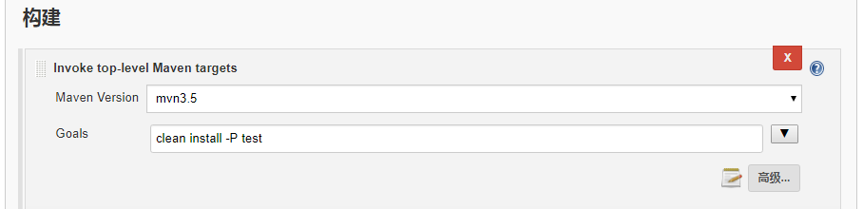

##只清理打包

mvn clean package

# 五、构建问题

1.gradle构建环境问题

* You have not accepted the license agreements of the following SDK components

原因：没有同意SDK

android list sdk --all

android update sdk -u -a -t 3

* Error:Unable to find method ‘com.android.build.gradle.tasks.factory.AndroidJavaCompile.setDependencyCacheDir(Ljava/io/File;)V’.

原因：gradle版本太高；distributionUrl是指定gradle的版本, Android Studio里会指定gradle插件的版本com.android.tools.build:gradle:2.2.3,

而gradle插件的版本又会影响你的build脚本(方法的有无和废弃). 所以这三者要对应起来才能正常运行.

解决版本1：修改项目build.gradle dependencies {classpath 'com.android.tools.build:gradle:2.3.0'}

解决办法2：将本地gradle版本修改到 gradle-3.3

* Could not resolve com.twitter.sdk.android:twitter:1.4.0.

原因：不能翻墙

解决办法1：注释该段依赖

解决办法2：修改版本号 3.1.1,；

* maven.aliyun.com: 未知的名称或服务 下载gradle 3.1.4报错

原因：镜像站关闭了或者地址更新了

解决版本1：修改 ~/.m2/setting.xml 文件 mirror 的 url

* Could not find method google() for arguments [] on repository container.

gradle 版本问题

gradle-4.1

解决办法1：升级gradle版本

解决办法2：注释google()

=== SDK Patch Applier v4, Google Repository

204

202

=== 动态权限

../../src/main/java/com/suneee/demo/scan/ScanQRActivity.java:415: Missing permissions required by Vibrator.vibrate: android.permission.VIBRATE

412 }

413 if (vibrate) {

414 Vibrator vibrator = (Vibrator) getSystemService(VIBRATOR_SERVICE);

415 vibrator.vibrate(VIBRATE_DURATION);

416 }

417 }

=== gradlew 一个gradle的封装体，即使电脑上没有安装gradle也能构建

=== “your project path contains non-ascii characters”问题（android studio不支持中文路径问题）

根目录不能为中文

=== 象翌象谱

生产环境文件修改

src/com/xiangpu/utils/UrlInterfaceUtils.java UrlInterfaceUtils

// 应用环境(false:正式环境，true:测试环境)

private static final boolean is_debug = true;

res/values/string.xml api_env

<!--1、生产环境 2、测试环境 3、本地环境-->

<string name="api_env">Android2</string>

=== 宁家鲜生.

src/com/xiangpu/common/Constants.java

=== java.lang.NullPointerException (no error message)

https://stackoverflow.com/questions/40108471/java-lang-nullpointerexception-no-error-message-apk-building

=== com.android.ide.common.process.ProcessException: Failed to execute aapt

原因：在build.gradle文件中，

出现这种错误原因是因为buildToolsVersion、buildToolsVersion、compileSdkVersion、targetSdkVersion、compile 'com.android.support:appcompat-v7:xxx'不一致。

compileSdkVersion 25

buildToolsVersion 26.0.3不匹配

targetSdkVersion 23

解决：

将 compileSdkVersion 和buildToolsVersion targetSdkVersion

compile 'com.android.support:appcompat-v7:xxx'改成一致

=== java.io.IOException: Please correct the above warnings first.

问题描述：

1、如果不使用混淆，那么可以正常打包，并且运行也正常

2、如果使用混淆，则打包报错

3、在proguard中忽略所有的警告，则打包成功，但运行即报错（至于报什么错没看，因为这样根本不是解决之道）

// 在gradle使用minifyEnabled进行Proguard混淆的配置，可大大减小APP大小

minifyEnabled true

// 开启shrinkResources去除无用资源

//shrinkResources true

adb install

=== Could not find com.android.support:appcompat-v7:26.1.0.

问题描述：

build.gradle maven 中心库地址问题

解决办法：

1.尝试google Maven存储库添加到应用的build.gradle文件中：

repositories {

maven { url "https://maven.google.com" }

}

2. 修改com.android.support:appcompat-v7:26.1.0 版本 26.0.0

=== Android studio 混淆打包时，出现Error:Execution failed for task ':app:proguardRelease'.

问题描述：> java.io.IOException: Please correct the above warnings first.

解决办法：

打开proguard-rules.txt，加入-dontwarn org.apache.http.**即可。

=== You have not accepted the license agreements of the following SDK components:

[ConstraintLayout for Android 1.0.2, Solver for ConstraintLayout 1.0.2].

解决办法：

sdk管理工具sdkmanager.位于$ANDROID_HOME/tools/bin/sdkmanager

sdkmanager --list

sdkmanager "extras;m2repository;com;android;support;constraint;constraint-layout;1.0.2"

21：

Error:Could not create service of type FileCollectionSnapshotterRegistry using TaskExecutionServices.createFileCollectionSnapshotterRegistry().

> Could not create service of type CachingFileHasher using TaskExecutionServices.createFileSnapshotter().

解决方法：删除项目根目录下的.gradle文件夹即可

Failed to resolve: com.twitter.sdk.android:twitter:1.4.0

=== Minimum supported Gradle version is 4.1. Current version is 3.3

=== Could not find method implementation() for arguments

把build.gradle中的dependencies中的

implementation改为compile即可

=== Could not find runtime.jar (android.arch.lifecycle:runtime:1.0.0)

./gradle删掉重新编译，一切正常。

描述 下载文件不存在，gradle 版本问题

解决方法： gradle -version 升级到4.4以上

=== Failed to apply plugin [id 'com.android.application']

=== Deprecated Gradle features were used in this build, making it incompatible with Gradle 5.0.

=== Could not resolve com.facebook.android:facebook-android-sdk:4. .

compile 'com.facebook.android:audience-network-sdk:4.13.0'

2.buildscript {

repositories {

maven { url "https://download.01.org/crosswalk/releases/crosswalk/android/maven2/" }

=== Could not find method api() for arguments [com.facebook.fresco:fresco:1.4.0]

=== Could not resolve com.facebook.android:facebook-android-sdk:4.+.

1.maven { url "http://maven.aliyun.com/nexus/content/repositories/central/" }

2.修改cordova-plugin-crosswalk-webview/chat-xwalk.gradle

=== Could not create service of type ScriptPluginFactory

1.删除 .gradle 文件

=== abortOnError false

//代码不符合规范，lint检查时报错，因此中断了整个编译过程；取消lint报错中断

加入此行代码

android {

lintOptions {

abortOnError false

}

}

=== All flavors must now belong to a named flavor dimension

=== 告警Warning:The `android.dexOptions.incremental` property is deprecated and it has；

dexOptions { incremental true }

=== Could not resolve com.sina.weibo.sdk:core:4.2.7

maven { url "https://dl.bintray.com/thelasterstar/maven" }

=== Could not resolve com.amap.api:3dmap:latest.integration..

引入最新版本的SDK

compile 'com.amap.api:3dmap:5.0.0'

compile 'com.amap.api:location:3.3.0'

compile 'com.amap.api:search:5.0.0'

=== Could not resolve com.umeng.analytics:analytics:latest.integration.

compile 'com.umeng.analytics:analytics:5.4.1'

=== version `GLIBC_2.14' not found

查看GLIBC支持版本 strings /lib64/libc.so.6 |grep GLIBC_

wget http://mirrors.ustc.edu.cn/gnu/libc/glibc-2.14.1.tar.xz

安装1 https://www.linuxidc.com/Linux/2017-01/139806.htm

或者升级1 https://www.linuxidc.com/Linux/2015-04/116472.htm

=== Could not resolve com.tencent.bugly:crashreport:latest.release.

repositories:

maven { url "http://maven.aliyun.com/nexus/content/repositories/central/" }

maven { url "http://maven.aliyun.com/nexus/content/repositories/releases" }

=== Gradle build daemon disappeared unexpectedly (it may have been killed or may have crashed)

Gradle 守护进程

#禁用gradle守护进程

org.gradle.daemon=false

=== Could not find com.android.tools.build:gradle:3.0.1

=== Could not find org.jetbrains.trove4j:trove4j:20160824.

buildscript {

repositories {

google() //加入此行

jcenter() //加入此行

=== Could not get unknown property 'cdvBuildToolsVersio' for object of type com.android.build.gradle.LibraryExtension.

=== Could not resolve com.github.FacePlusPlus:MegviiLicMgr-Android-SDK:0.3.0.

注释该段依赖

=== Could not resolve com.tencent.mm.opensdk:wechat-sdk-android-without-mta:+.

buildscript {

maven { url "http://maven.aliyun.com/nexus/content/repositories/jcenter/"}

=== Your project path contains non-ASCII characters.

--- Could not find method google() for arguments [] on object of type org.gradle.api.internal.initialization.DefaultScriptHandler.

=== Could not resolve com.aliyun.ams:alicloud-android-push:3.0.11

maven { http://maven.aliyun.com/nexus/content/repositories/releases/ }

=== mvn deploy:deploy-file -DgroupId=com.suneee -DartifactId=module_mc_link-release -Dversion=1.0.0-SNAPSHOT -Dpackaging=aar -Dfile=G:\11\BoX.A_Component_Android\module_mc_link-release.aar -Durl=http://172.16.43.134:8081/content/repositories/snapshots/ -DrepositoryId=snapshots