项目发布至nexus私库

相关规范建议

groupid:com.suneee.product.project

artifactid:projectname

# 1.gradle 发布私库

cd project/

vim build.gradle

加入此任务

uploadArchives {

repositories {

mavenDeployer {

repository(url:MAVEN_LOCAL_PATH ){

authentication(userName:ACCOUNT,password:PASSWORD)

}

pom.project {

groupId GROUP_ID

artifactId ARTIFACT_ID

version VERSION_NAME

packaging 'aar'

}

}

}

}

运行cmd：gradle buid uploadArchives

# 2.maven 发布私库

mvn deploy:deploy-file -DgroupId=groupld -DartifactId=artifactId -Dversion=1.0.0 -Dpackaging=aar -Dfile=project.aar -Durl=http://172.16.43.134:8081/content/repositories/releases/ -DrepositoryId=central

修改setting.xml 免密上传

D:\program files\MAVEN\apache-maven-3.5.3\conf

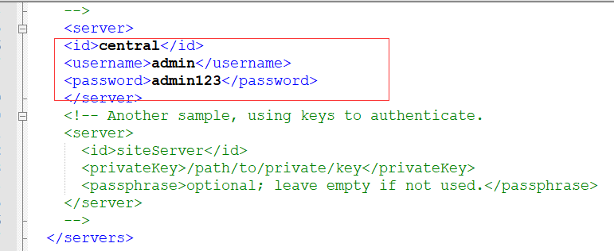

举个栗子：

mvn deploy:deploy-file -DgroupId=com.suneee.android.communication -DartifactId=BoX.A_SDK_Android -Dversion=20180726 -Dpackaging=aar -Dfile=BoX.A_SDK_Android.aar -Durl=http://172.16.43.134:8081/content/repositories/releases -DrepositoryId=central