Dynamic occupancy models for applied ecology: a review and framework for implementation

Target Journal: Ecography

# Abstract

Dynamic occupancy models are a key tool for ecologists seeking to understand patterns of occupancy across space and time while accounting for imperfect detection. Thanks to their relative ease of implementation, realistic data requirements, and capacity to generate useful estimates of occupancy parameters, these models have become popular in modelling natural systems for conservation and wildlife management objectives. We conducted a systematic review of studies incorporating these models to assess what they are used for and how they are implemented in applied studies. Our findings indicate these models experience significant use in assessing occupancy trends and in evaluating specific relationships for a great diversity of taxa, with far more limited use in generating either spatial or future predictions. However, their implementation has not always been consistent – decisions in the model-building process such as covariate inclusion, model selection, and model evaluation are highly variable between authors, with potential implications for upholding model assumptions and the robustness of outputs. In light of this, we provide some simple guidelines for future authors seeking to implement dynamic occupancy models to ensure that key considerations are accounted for in the model building process.

**Ecography author guidelines:**

**Review and synthesis papers** provide a critical assessment of the literature with emphasis on current topics in which rapid and significant advances are occurring. Items in this category should be more focused than the broad, topical reviews typically published elsewhere, developing a synthesis that inspires new hypotheses or new methods. Contributions in this category will be solicited by the editors. However, unsolicited submissions will also be considered and sent for pre-submission assessment by Review & Synthesis editors. Review articles should be maximum 7500 words in length (main text) and maximum 10 figures, tables or boxes.

# Introduction

## Overview

Capturing patterns of species occupancy over space and time is a common goal for ecologists, particularly those focused on conservation and wildlife management. Advances in recent decades have provided numerous options for methods and statistical models, with sub-fields such as species distribution modelling and metapopulation modelling contributing increasingly sophisticated tools to support on-ground practitioners. No matter the method, ecologists must balance data input requirements and analyst skillsets against inferential power and suitability to purpose when determining how best to analyse data from natural systems.

MacKenzie et al.’s 2002 paper, ‘Estimating site occupancy rates when detection probabilities are less than one,’ first defined what is now termed the ‘Dynamic occupancy’ model[1] (henceforth DOMs - see ‘Box 1’ for details on the basic model structure). The model sits in the sweet spot for many applied ecologists: it requires relatively common presence/absence records; albeit with revisits during each primary sampling occasion; yet provides valuable estimates of initial occupancy, colonisation, extinction, and detection probabilities.

Box 1: What are dynamic occupancy models?

**Model definition**

The basic structure of the model is simple, consisting of an occupancy module and an observation module. In the occupancy module, independent sites may exist in either occupied or unoccupied states; transitions between the two between time steps are termed colonisation and extinction. In the observation module, we account for imperfect detection by conducting multiple surveys within a single timestep.

**[GRAPHICAL REPRESENTATION HERE]**

**[Key formulas to go here]**

**Assumptions**

1. Sites are considered ‘closed’ between time-steps, with occupancy state presumed to be un-changed.
2. There are no false positive detections.
3. No unmodelled heterogeneity exists.

**Model extensions**

Beyond the basic form of the model, authors have contributed several other extensions to DOMs. Most popular are the multi-species extensions, valued for modelling interspecific relationships, and multi-state options with use for incorporating demography among other variations in what constitutes occupancy. Also available are variants accounting for false positive error.

Researchers in governmental agencies, academic institutions, and non-governmental organisations (NGOs) have implemented DOMs for a wide range of species and purposes, from estimating occupancy patterns of threatened species to monitoring the range expansion of invasive species. Since its publication, MacKenzie et al.’s 2002 model defining paper has been cited 4962[2] times increasing year-over year – a testament to their continued popularity within the applied modelling community.

DOMs do have their pitfalls, however. Their assumptions (see Box 1), while relatively straightforward, are also unlikely to be entirely fulfilled in natural systems. While a reasonable amount of work has been conducted on the importance of the closure assumption, comparatively little has been done with respect to the heterogeneity assumption. Heterogenous landscapes and patterns of occupancy are the norm in ecological systems and fully satisfying this assumption is not realistic in natural systems. The main option for users to mitigate this concern is via the inclusion of covariates to estimate parameters to describe how environmental variation may affect probabilities of occupancy or detection; however, in internal discussions the authors noted that implementation may be inconsistent across papers.

The matter in which models are implemented, including the data inputs, covariates considered, manner of final model selection, and evaluation of model fit are all important contributors to the reliability of model outputs. When conservation and management decisions are made based on model outputs, it is critical to ensure that all steps are fully considered to develop the best possible model.

This paper has two principal objectives:

1. To review the use of DOMs in applied ecological research, including for what practitioners used these models and how they have implemented them.
2. To provide practical recommendations for how to use DOMs to ensure outputs and predictions are as robust as possible, with a practical workflow for development to incorporate key considerations.

# Review methods

## Paper elicitation

This review was focused only on papers which model occupancy across space and time using real data. To quality for inclusion, papers were required to fulfil each of these criteria:

* Multiple sites capable of exhibiting two or more occupancy states; including an occupied and unoccupied state.
* Multiple time-steps between which occupancy states can change, with transitions between states modelled as a Markovian process.
* Data must be collected from a natural system, not theorical or simulated. The data need not have been explicitly collected for the given paper.

Following internal discussions, four search terms[3] were used to generate the initial pool of papers:

* Dynamic occupancy model
* Occupancy dynamics model
* Multi-season occupancy model
* Stochastic patch occupancy model

Each term was searched on Google Scholar (Appendix I). The first 100 results (if available) for each term were considered for inclusions, although non-English papers, those clearly outside the field of ecology, or those not accessible via Google Scholar or the University of Melbourne library were immediately discarded. 287 papers remained for consideration at this stage.

## Preliminary and formal reviews

The pool of papers was stratified by search term and publication period[4] and randomly ranked within their strata. Papers in the lowest 25% or lowest 5 (whichever was larger) were marked for inclusion in review. In cases where papers did not meet qualification criteria, they were replaced by the next lowest paper in their strata if available.

Authors developed a structured spreadsheet with categories for study metadata, objectives, taxa, location, survey methods, detection, covariates, modelling, and outputs. Findings were systematically noted as each paper was read; 75 papers were included at this stage.

Study questions were further refined after the preliminary review, and a revised spreadsheet with better articulated parameters was generated (Appendix II). The authors also determined that ‘Stochastic patch occupancy models’ represented a distinct model form from the other three search queries, with a unique history and distinct qualities. Therefore, we decided to exclude these papers (n = 21) from the formal review.

For the formal review, all remaining papers were re-read and their results logged in the spreadsheet. The final count of qualified papers was n = 54. All analyses were conducted in R.

# Results

## Authorship

Two thirds of included papers (36/54) had first authors affiliated with institutions based in the United States reflecting broader trends in ecological publication. The types of authors were more variable – affiliations were divided into four general categories. 81.5% had at least one author affiliated with an academic institution, 42.6 percent had at least one affiliation with a governmental agency, 29.6 with a non-governmental organisation, and 7.4 in the private sector.

## Taxa and location

DOMs in the review sample were fit to a diversity of taxa spanning mammals, birds, herptiles, invertebrates, and fish. 16/54 involved threatened species, and another 8 included invasives.

Study sites were globally distributed with studies from each of six biogeographic realms, although over half (30/54) were from the Nearctic. Study size, defined as the area of inference in which authors were assessing occupancy, were more diverse ranging from less than a square kilometre to over 1 million km2.

## Survey methods

Datasets used for DOMs were considerably diverse in scale, duration, and survey method. The average study length was 7 years, with a median or 5 primary occasions and 4 secondary occasions. The average number of sites was 377, with a range of 7 to 9394.

Data used to generate detection history included standardised surveys (22/54), exhaustive searches (13/54), trapping (12/54), camera trapping (8/54), and one case employing bioacoustics monitors. An additional 7/54 used citizen-science data in some form.

## Research objectives and outputs

Five categories of objectives and goals were assessed for each paper; these were not mutually exclusive, and many papers had multiple objectives.

* 72.2% were assessing trends: interested in the trajectory of estimated or derived parameters.
* 55.6% were testing hypotheses: evaluating attributes of a **specific** covariate on parameters.
* 18.5% were methods oriented: introducing, testing, or demonstrating a new extension to DOMs.
* 9.3% conducted spatial mapping: Extrapolating estimates of parameter values beyond surveyed sites.
* 7.4% made future projections: Making predictions of parameters into the future.

## Parameters and covariate inclusion

The vast majority of papers used the four core parameters of the standard DOM: Initial occupancy, colonisation, extinction, and detection (although 12 used the reciprocal of Extinction, Persistence). 9 papers included at least one multi-species parameter (conditional on the occupancy/detection state of another species) and 8 included parameters beyond the four core parameters.

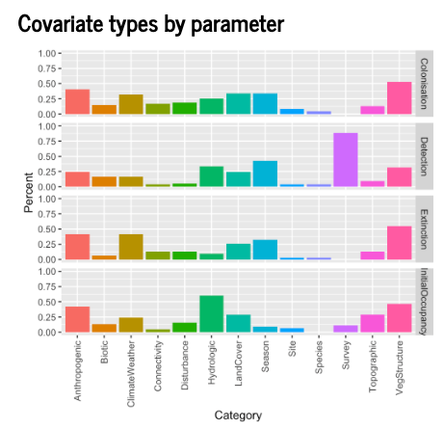

## Model selection

The majority of papers selected models **a priori** (either single or multiple).

| **Selection category** | **Percent** |
| --- | --- |
| Apriori | 0.65 |
| PbyP | 0.17 |
| Step | 0.15 |
| Simple | 0.07 |
| Exhaustive | 0.04 |
| None | 0.04 |
| Other | 0.04 |

# Discussion

* DOMs are widely used, for many species, with many different types of data, in studies of all sizes.
* Good diversity of covariates are used reflecting different system; but number considered varies dependent on study objective

* Concerning that higher order and interactive covariates are rare, considering their importance in ecological relationships.
* Model selection methods also vary by the reason which authors used them for, this is of concern because of the heterogeneity assumption – variation unrelated to the main hypothesis still must be accounted for.

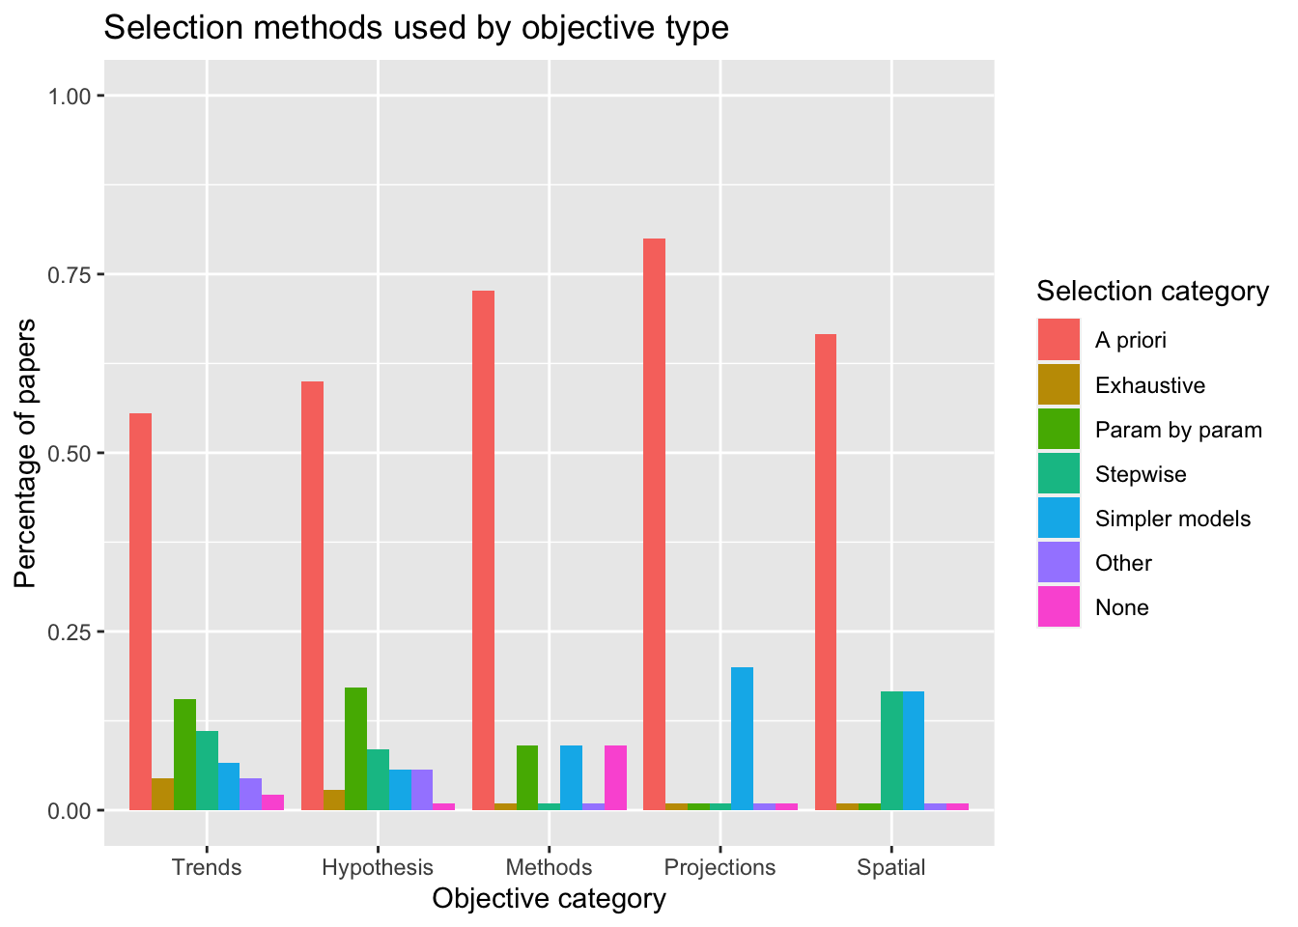

* There is quite a disparity between model selection in Bayesian vs Frequentist models, cause is unclear but possibly related to computing requirements.

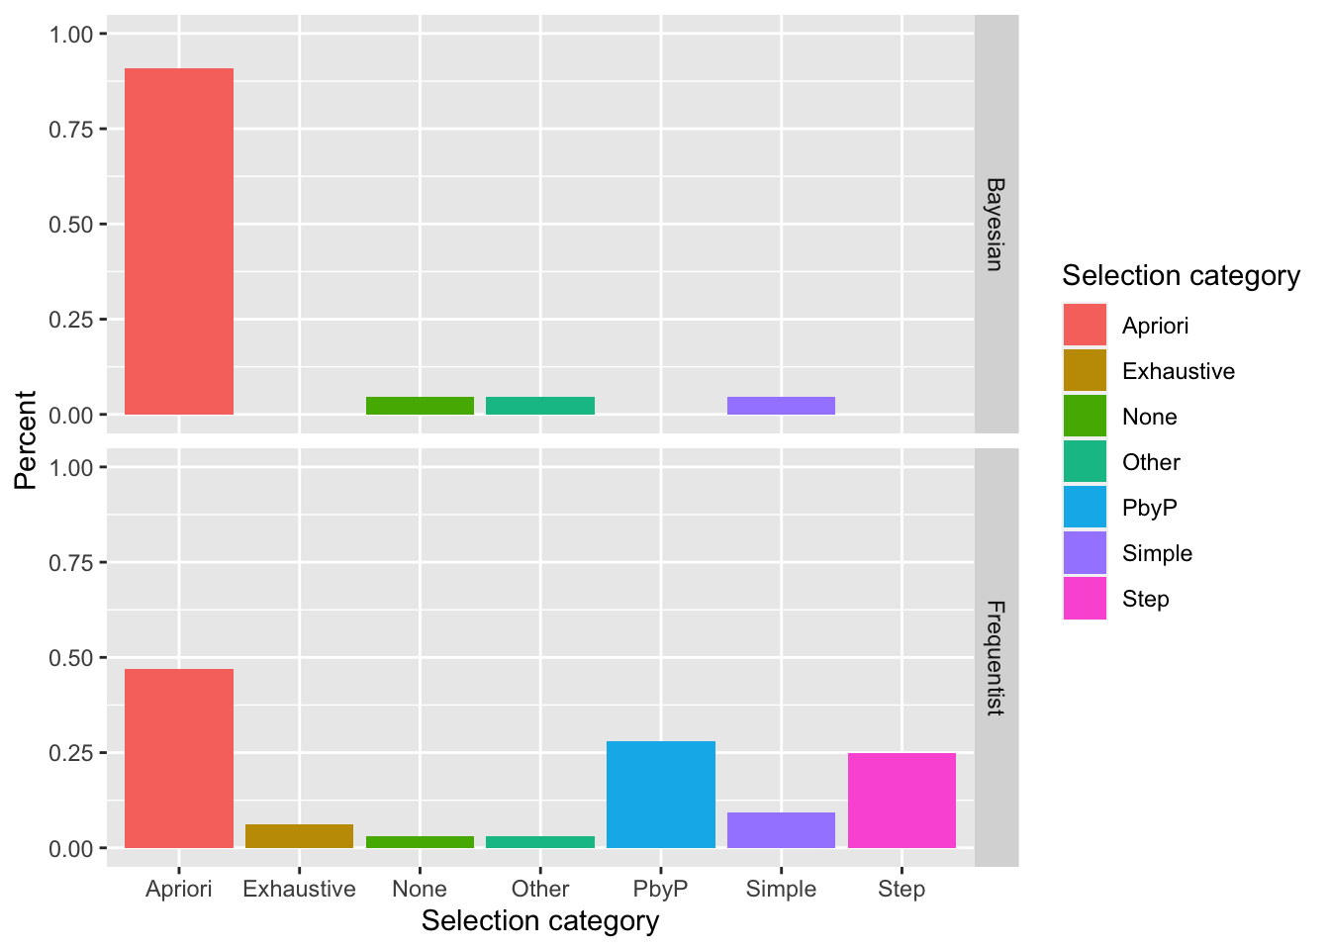

* Model evaluation is particularly uncommon, very few studies go beyond AIC in assessing fit.

# Recommendations for developing dynamic occupancy models for applied ecology

* Considering the ‘candidate covariates,’ including those which pertain to specific hypothesis as well as background drivers of heterogeneity?
* Does the covariate type (i.e., static vs dynamic) appropriately fit the hypothesised relationship to the parameter?
* Considering the form statistical relationships between occupancy/detection and covariates take – are higher order terms or interaction terms necessary?
* What is an appropriate method for model selection given the system, data, and computing resources?
* Is there sufficient data available for more extensive evaluation of model fit, for example, out of sample validation?

# Conclusions

* Key points from review: DOMs are heavily used for important questions, but implementations are highly variable and some aspects are cause for concern – specifically in the model selection process.
* Lots of research has been done on closure but comparatively little on the heterogeneity assumption and what happens to estimates when they are violated.
* Rarity of meaningful model evaluation means that decisions are potentially being made without confirmation that models are appropriate fit.
* Guidelines are provided for best-practice considerations in the model building process to reduce risk of inappropriate model selection

1. Also variously termed ‘occupancy dynamics models’ and ‘multi-season occupancy models
2. Google scholar citation figure
3. Plus grammatic variation
4. 2000-2005, 2006-2010, 2010-2015, 2015-2021