# Discussion

The existing literature of DOMs in applied research indicate that these models have been widely used for many species, with different types of data, in studies of all spatial scales. Their increase in popularity since their inception, with a tenfold increase in the number of publications per year, are testament to their importance within applied ecology and conservation.

However, the inconsistency in implementation does raise some concerns about the untested robustness of DOMs when assumptions are not fully fulfilled. Model evaluation beyond basic AIC metrics is rare; only a handful of reviewed papers employed more reliable methods such as out-of-sample validation. This may be because of limitations in data quantity and a reluctance to further reduce the amount of training data by reserving some for testing. Additionally, the focus on assessing trends during a study period over predicting into the future or across landscapes may also contribute to this pattern.

Patterns in covariate inclusion and model selection are largely driven by the study’s objective: Those which were assessing trends in population were more likely to use more and more diverse covariates than those which were assessing specific hypotheses. While it is reasonable for authors to focus on their covariate of interest, ignoring background variation caused by other factors may result in violations of the heterogeneity assumption. Violations of this assumption have been less studied than those of the closure assumption, and to extent to which they introduce bias into results are not fully known.

An exceptionally wide variety of covariates have been used to model parameters in DOMs; however, one area where concersn

* Concerning that higher order and interactive covariates are rare, considering their importance in ecological relationships.
* Model selection methods also vary by the reason which authors used them for, this is of concern because of the heterogeneity assumption – variation unrelated to the main hypothesis still must be accounted for.

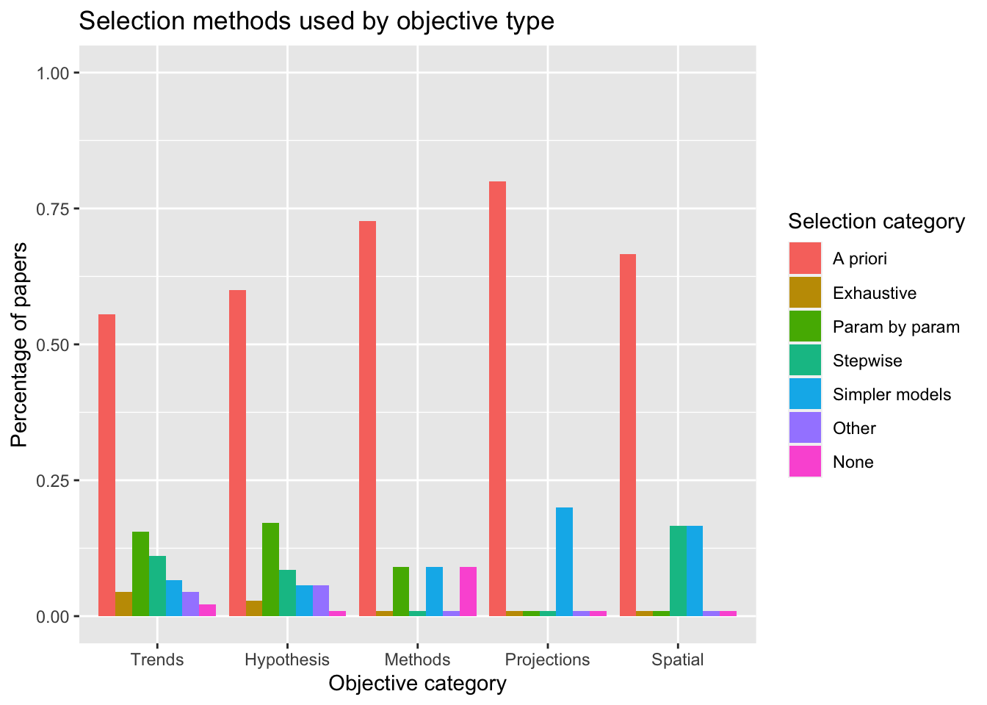

* There is quite a disparity between model selection in Bayesian vs Frequentist models, cause is unclear but possibly related to computing requirements.

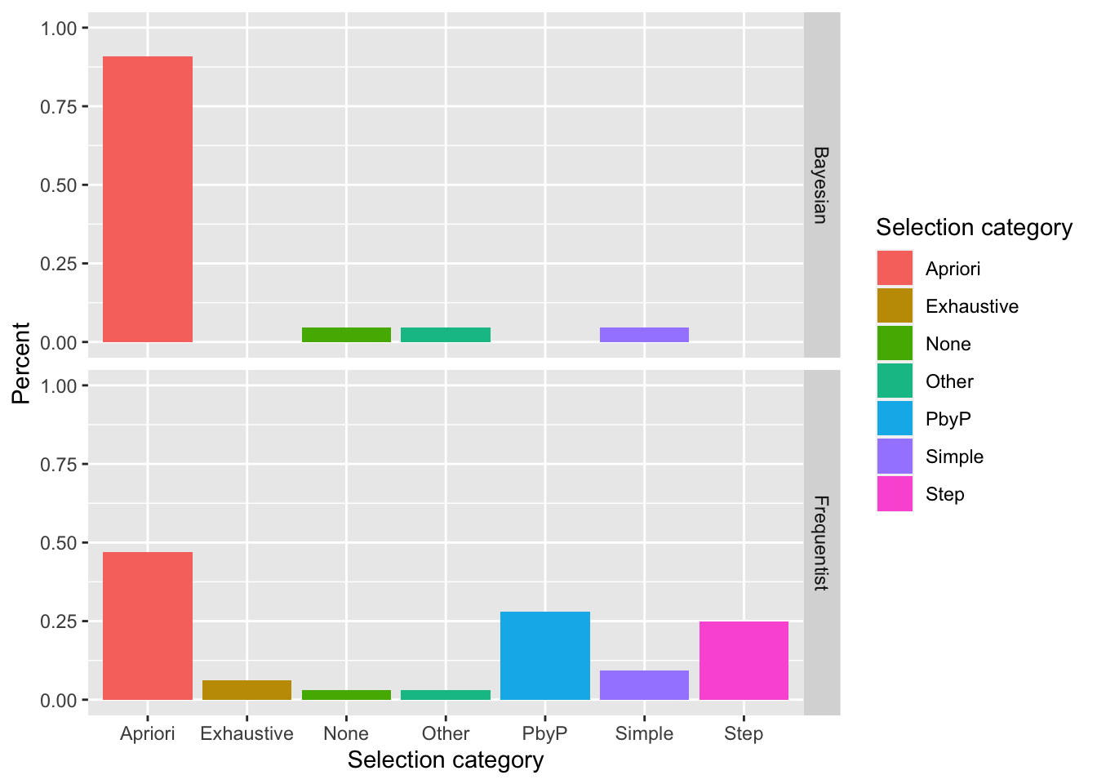

* Model evaluation is particularly uncommon, very few studies go beyond AIC in assessing fit.

# Recommendations for developing dynamic occupancy models for applied ecology

* Considering the ‘candidate covariates,’ including those which pertain to specific hypothesis as well as background drivers of heterogeneity?
* Does the covariate type (i.e., static vs dynamic) appropriately fit the hypothesised relationship to the parameter?
* Considering the form statistical relationships between occupancy/detection and covariates take – are higher order terms or interaction terms necessary?
* What is an appropriate method for model selection given the system, data, and computing resources?
* Is there sufficient data available for more extensive evaluation of model fit, for example, out of sample validation?

# Conclusions

* Key points from review: DOMs are heavily used for important questions, but implementations are highly variable and some aspects are cause for concern – specifically in the model selection process.
* Lots of research has been done on closure but comparatively little on the heterogeneity assumption and what happens to estimates when they are violated.
* Rarity of meaningful model evaluation means that decisions are potentially being made without confirmation that models are appropriate fit.
* Guidelines are provided for best-practice considerations in the model building process to reduce risk of inappropriate model selection