# Results

## Authorship

Two thirds of included papers (36/54) had first authors affiliated with institutions based in the United States reflecting broader trends in ecological publication. The types of authors were more variable – affiliations were divided into four general categories. 81.5% had at least one author affiliated with an academic institution, 42.6 percent had at least one affiliation with a governmental agency, 29.6 with a non-governmental organisation, and 7.4 in the private sector.

## Taxa and location

DOMs in the review sample were fit to a diversity of taxa spanning mammals, birds, herptiles, invertebrates, and fish. 16/54 involved threatened species, and another 8 included invasives.

Study sites were globally distributed with studies from each of six biogeographic realms, although over half (30/54) were from the Nearctic. Study size, defined as the area of inference in which authors were assessing occupancy, were more diverse ranging from less than a square kilometre to over 1 million km2.

## Survey methods

Datasets used for DOMs were considerably diverse in scale, duration, and survey method. The average study length was 7 years, with a median or 5 primary occasions and 4 secondary occasions. The average number of sites was 377, with a range of 7 to 9394.

Data used to generate detection history included standardised surveys (22/54), exhaustive searches (13/54), trapping (12/54), camera trapping (8/54), and one case employing bioacoustics monitors. An additional 7/54 used citizen-science data in some form.

## Research objectives and outputs

Five categories of objectives and goals were assessed for each paper; these were not mutually exclusive, and many papers had multiple objectives.

* 72.2% were assessing trends: interested in the trajectory of estimated or derived parameters.
* 55.6% were testing hypotheses: evaluating attributes of a **specific** covariate on parameters.
* 18.5% were methods oriented: introducing, testing, or demonstrating a new extension to DOMs.
* 9.3% conducted spatial mapping: Extrapolating estimates of parameter values beyond surveyed sites.
* 7.4% made future projections: Making predictions of parameters into the future.

## Parameters and covariate inclusion

The vast majority of papers used the four core parameters of the standard DOM: Initial occupancy, colonisation, extinction, and detection (although 12 used the reciprocal of Extinction, Persistence). 9 papers included at least one multi-species parameter (conditional on the occupancy/detection state of another species) and 8 included parameters beyond the four core parameters.

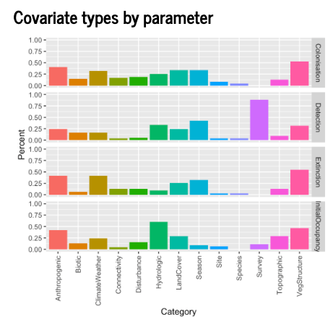

## Model selection

The majority of papers selected models **a priori** (either single or multiple).

| **Selection category** | **Percent** |
| --- | --- |
| Apriori | 0.65 |
| PbyP | 0.17 |
| Step | 0.15 |
| Simple | 0.07 |
| Exhaustive | 0.04 |
| None | 0.04 |
| Other | 0.04 |