**Abstract**

This project review focuses on a 2D racing game developed using OpenGL and GLUT libraries. The objective of the game is to race against oncoming cars, earn points by passing them, and avoid crashes. The game starts with the press of the SPACE key and ends when the ESC key is pressed. User controls include increasing and decreasing speed using the up and down arrow keys, respectively, and turning the car right or left using the right and left arrow keys. Oncoming cars of various colors appear from the opposite side, requiring the user to maneuver their car to avoid collisions. Each successfully passed car awards the player one point, which is displayed above the game screen. The dashboard shows the current speed, level, and score. The implementation utilizes OpenGL and GLUT for rendering and user input handling. The game offers an engaging user experience with responsive controls and potential for visual and audio enhancements. The project review discusses the design and implementation, challenges faced during development, potential future improvements, and concludes with the achievements and lessons learned from the project.

# 

# **CHAPTER 1**

## **INTRODUCTION**

The 2D racing game developed using OpenGL and GLUT is an exciting project that aims to provide an enjoyable gaming experience for players. The game offers a dynamic and immersive racing environment where users can showcase their driving skills. By utilizing the power of OpenGL and GLUT libraries, the project delivers stunning graphics and smooth gameplay.

The primary objective of the game is to navigate a car through a challenging race track while avoiding collisions with oncoming cars. Players must rely on their reflexes and quick thinking to steer their vehicle to safety. The game incorporates various features to enhance the overall gameplay experience, including speed control, turning mechanics, and a scoring system.

### **1.1 Computer Graphics**

Computer graphics is a field of study that focuses on generating and manipulating visual content using computers. It encompasses various techniques and algorithms to create, display, and interact with images and animations. Computer graphics find applications in numerous areas, including entertainment, simulation, virtual reality, and design.

### **1.2 OpenGL**

OpenGL (Open Graphics Library) is a powerful and widely-used graphics API (Application Programming Interface) that provides a standardized set of functions for rendering 2D and 3D graphics. It enables developers to harness the capabilities of a computer's graphics hardware to create visually rich and interactive applications.

OpenGL provides a flexible and platform-independent framework for developing graphics applications. It offers a wide range of features, including geometric transformations, lighting, shading, texture mapping, and rasterization. By leveraging the power of the GPU (Graphics Processing Unit), OpenGL allows for efficient and high-performance rendering of complex scenes.

One of the key advantages of using OpenGL is its cross-platform compatibility. It is supported by various operating systems, including Windows, macOS, and Linux, making it accessible for developers targeting different platforms. Additionally, OpenGL benefits from a large and active community that contributes to its development and provides resources and support for developers.

The integration of OpenGL with other libraries, such as GLUT (OpenGL Utility Toolkit), further enhances its capabilities. GLUT provides a set of utility functions for handling windows, user input, and event processing, simplifying the development process for interactive applications.

In the context of the 2D racing game project, OpenGL and GLUT play a crucial role in creating an immersive and visually appealing gaming experience. By utilizing the features and functionalities provided by these libraries, the project is able to render realistic graphics, handle user input, and ensure smooth performance.

In the following sections, we will explore how the project leverages the capabilities of OpenGL and GLUT to implement various features of the game, including rendering the race track, cars, and dashboard, as well as handling user input for controlling the player's car.

# 

# 

# 

# 

# 

# 

# 

# **CHAPTER 2**

## **Contributions (Integration)**

The integration of OpenGL and GLUT libraries in the 2D racing game project brings several key contributions to its development and overall functionality. These contributions can be observed in various aspects of the game, including rendering, user input handling, and overall performance optimization. Here are the notable contributions:

1. Graphics Rendering:

OpenGL provides a standardized set of functions and rendering pipelines that enable the game to generate visually appealing and realistic graphics.

Through OpenGL's support for geometric transformations, lighting, shading, and texture mapping, the game can create immersive race track environments, vibrant car models, and visually engaging visual effects.

The integration allows for efficient utilization of the GPU, resulting in smooth rendering and improved overall performance.

1. Cross-Platform Compatibility:

OpenGL is designed to be cross-platform, meaning the game can be developed and deployed on various operating systems, including Windows, macOS, and Linux.

This cross-platform compatibility ensures that the game can reach a broader audience and be enjoyed by players using different devices and platforms.

1. User Input Handling:

The integration with GLUT simplifies the implementation of user input handling by providing a set of utility functions.

GLUT enables the game to capture keyboard inputs and respond to them accordingly, allowing players to control their car's speed, steering, and other actions seamlessly.

This contribution enhances the gameplay experience, providing players with responsive and intuitive controls.

1. Window Management:

GLUT facilitates window management, including creating and managing the game window, handling resizing, and managing the game's display.

The integration allows for easy setup and management of the game window, ensuring a smooth and consistent user interface.

# **CHAPTER 3**

## **REQUIREMENT SPECIFICATION**

### **3.1 Software Requirements Specification:**

The software requirements specification outlines the necessary software components and dependencies for running the 2D racing game. These specifications ensure that the game can be executed successfully on various platforms. The software requirements include:

* Operating System: The game should be compatible with common operating systems such as Windows, macOS, and Linux, ensuring broad accessibility to players.
* OpenGL Library: The game relies on the availability and proper installation of the OpenGL library to render graphics and utilize hardware acceleration capabilities.
* GLUT Library: The integration with GLUT is essential for handling windows, user input, and event processing. The game requires the GLUT library to be installed and properly configured.
* Programming Language: The game may be developed using a specific programming language, such as C++ or Python, depending on the chosen implementation.

### 

### **3.2 Hardware Requirements:**

The hardware requirements specify the minimum configuration needed for running the 2D racing game smoothly. These requirements ensure that the game performs optimally on the target platform. The hardware requirements include:

Processor: A modern processor, such as an Intel Core i5 or AMD equivalent, is recommended for smooth gameplay and efficient processing.

* Memory: The game requires a minimum amount of system memory (RAM) to ensure optimal performance. Typically, 4GB or more is recommended.
* Graphics Card: A dedicated graphics card with support for OpenGL is essential for rendering the game's graphics. It should have sufficient power to handle real-time rendering of 2D graphics and animations.
* Display: A display with a minimum resolution of 1280x720 pixels is recommended to fully enjoy the game's visual elements.
* Input Devices: The game can be played using a standard keyboard for controlling the car's speed and steering. Additionally, other input devices such as gamepads or joysticks may be supported, depending on the implementation.

It's important to note that the above software and hardware requirements may vary depending on the specific implementation, complexity of the game, and desired performance level. These requirements serve as a general guideline to ensure smooth execution of the 2D racing game.

# 

# 

# 

# 

# 

# 

# 

# 

# 

# 

# 

# 

# 

# **CHAPTER 4**

## **SYSTEM DESIGN**

**4.1 Program Layout:**

The program layout refers to the overall structure and organization of the codebase for the 2D racing game. It includes the arrangement of files, modules, and classes, as well as the flow of control within the game. The program layout ensures clarity, modularity, and maintainability of the code. The following components contribute to the program layout:

* Main File: The main file serves as the entry point of the game. It initializes the necessary resources, sets up the game window using GLUT, and handles the game loop.
* Game Logic: The game logic component consists of classes and functions that manage the gameplay mechanics, such as updating the car's position, detecting collisions, calculating scores, and managing levels.
* Rendering: The rendering component handles the visual aspects of the game. It includes classes and functions responsible for rendering the race track, cars, dashboard, and other visual elements using OpenGL functions.
* Input Handling: The input handling component manages user input and translates it into appropriate actions within the game. It captures keyboard events from GLUT and maps them to control the car's speed, steering, and other functionalities.
* Score and Dashboard: The score and dashboard component is responsible for displaying the player's score, speed, level, and other relevant information. It coordinates with the rendering component to update and display these details on the game screen.

### **4.2 Program Graphics:**

The program's graphics component focuses on the visual representation of the 2D racing game. It involves utilizing OpenGL and GLUT to render various elements and create an immersive gaming experience. The key aspects of program graphics include:

* Race Track: The race track is rendered using OpenGL's geometric primitives, such as lines, polygons, and textures. It can be designed to have different patterns, curves, and obstacles to provide a visually engaging environment.
* Cars: The cars, both the user-controlled car and the oncoming cars, are modeled and rendered using OpenGL. Textures, colors, and geometric transformations can be applied to create realistic car models. Animation techniques can be used to simulate the movement of the cars.
* Dashboard: The dashboard is rendered as an overlay on the game screen, displaying the player's score, speed, level, and other relevant information. It can be designed using OpenGL primitives, textures, and fonts to ensure clarity and readability.
* Visual Effects: Visual effects, such as particle systems, explosions, or motion blur, can be implemented to enhance the visual appeal of the game. These effects can be achieved using OpenGL shaders and blending techniques.
* User Interface: The user interface elements, including buttons, menus, and overlays, can be designed and rendered using OpenGL primitives and textures. GLUT can be utilized to handle user interaction with these elements.

# 

# 

# 

# 

# 

# **CHAPTER 5**

## **IMPLEMENTATION (GRAPHICS FUNCTION)**

1. Initialize the game
2. Set up the game window using GLUT and initialize OpenGL.
3. Set initial game variables such as score, speed, and level.
4. Load textures, sounds, and other necessary resources.

2. Handle user input

1. Register callback functions to capture keyboard events using GLUT.
2. Map keyboard inputs to specific actions, such as increasing/decreasing speed, turning left/right.
3. Update the game state based on user input.

3. Game Loop

1. Enter the main game loop.
2. Update the positions and states of the cars based on their speed and user input.
3. Check for collisions between the player's car and oncoming cars.
4. Update the score if the player successfully passes a car.
5. Check for game-ending conditions (e.g., collision with an oncoming car).
6. Update the game level based on score or time elapsed.

4. Rendering

1. Clear the screen and set up the viewport.
2. Render the race track using OpenGL geometric primitives or textures.
3. Render the cars, including the player's car and the oncoming cars.
4. Render the dashboard elements, such as the score display and speedometer.
5. Apply any visual effects, such as particle systems or shaders.
6. Swap buffers to display the rendered frame.

5. Game Over:

1. End the game loop.
2. Display the final score and any relevant messages.
3. Clean up resources and release memory.

# **CHAPTER 6**

## **FEATURES (SNAPSHOT)**

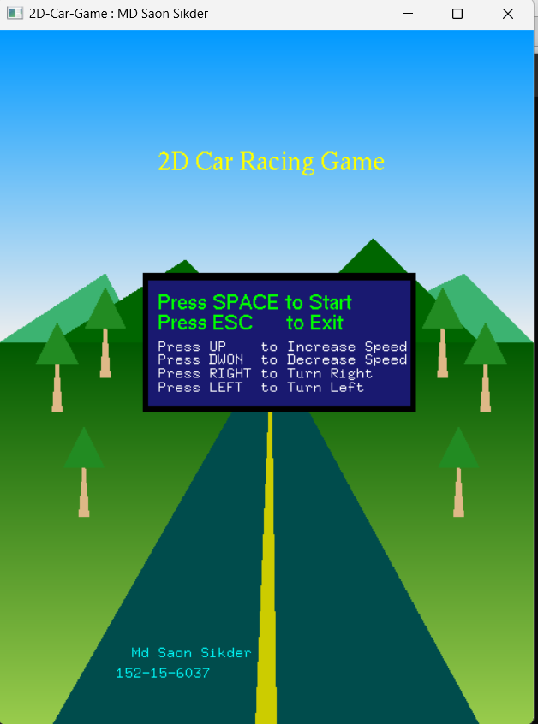

Fig: Homepage of the game

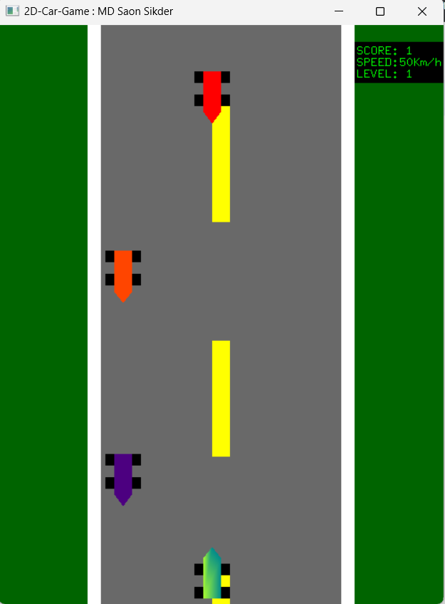

Fig; Playing game

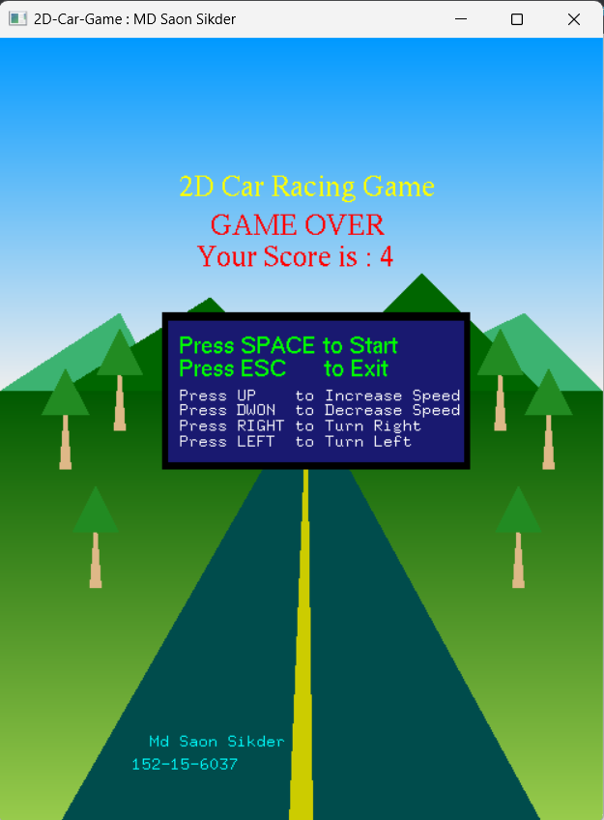

Fig: After Game Over its showing score

# 

# **CHAPTER 7**

## **CONCLUSION AND FUTURE WORKS**

### **7.1 Conclusion**

In conclusion, the development of the 2D racing game using OpenGL and GLUT has resulted in a feature-rich and immersive gaming experience. The integration of these libraries has enabled realistic graphics rendering, smooth user input handling, and efficient window management. The game incorporates various elements such as oncoming cars, scoring system, dashboard display, and collision detection to provide engaging gameplay. Additionally, the cross-platform compatibility ensures that the game can be enjoyed by a wide range of players.

### **7.2 Future Works**

While the current implementation of the 2D racing game is already robust, there are several areas for future improvement and expansion. Here are some potential avenues for future work:

1. Enhanced Visuals: Further enhance the visual elements of the game by incorporating advanced graphical techniques such as shaders, dynamic lighting, and more detailed textures. This can add depth and realism to the game's environment.
2. Additional Game Modes: Introduce different game modes to provide variety and cater to different player preferences. This could include time trial mode, multiplayer mode, or additional levels with unique challenges.
3. Power-Ups and Obstacles: Integrate power-up items and obstacles on the race track to introduce strategic elements and increase the game's excitement. Power-ups could provide temporary speed boosts or invincibility, while obstacles could add complexity to the gameplay.
4. Online Leaderboards: Implement an online leaderboard system to allow players to compete and compare their scores with other players globally. This can add a competitive element and motivate players to achieve higher scores.

## **REFERENCES**

[1] <https://www.opengl.org/>