Full, Differential and Transactional Backup

1. Full backup: Tuesday at 12:00 PM
2. Differential backup: every 4 hours from wednesday and thursday
3. Transactional backup: every 1 hours on friday

=> System crash on sunday at 11:00 AM

**Full Backup:**

Step 1: Firstly, open SQL Server, and then navigate to Management => Maintenance Plans and then right-click to choose new maintenance plan.

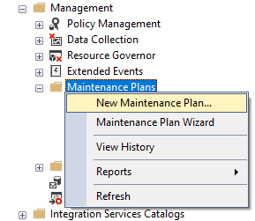

Step 2:

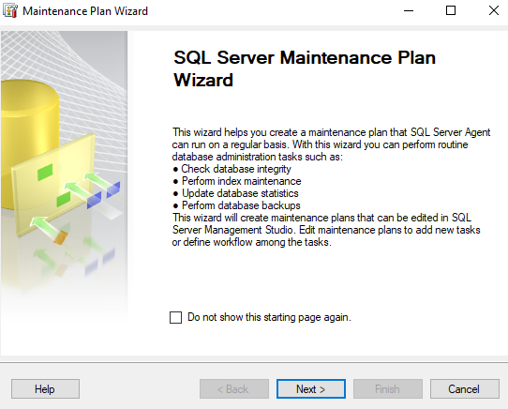

Name: Full_Backup and click on Change button

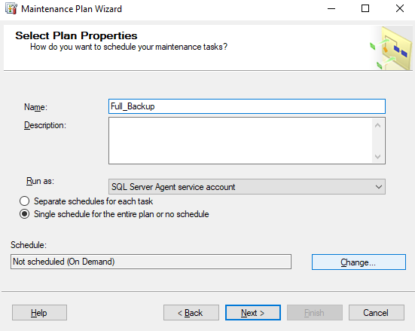

Every week on Tuesday at 12:00 PM, set full backup. The schedule will be followed beginning on May 30, 2023.

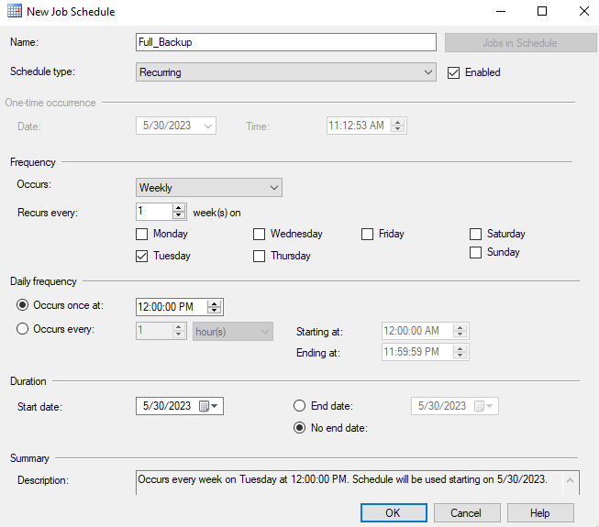

Click ok to continue.

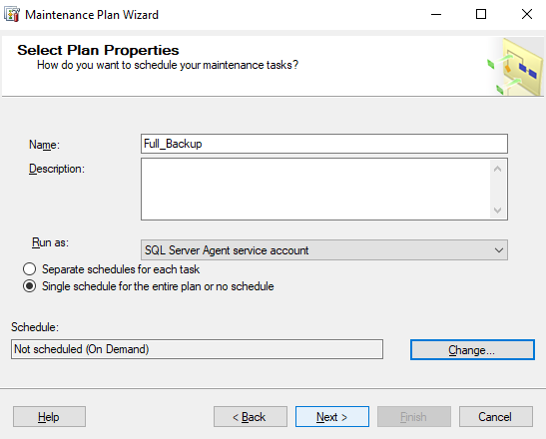

Click next

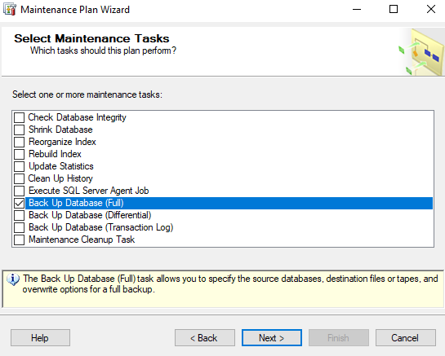

Select Back Up Database (Full) and click next to continue.

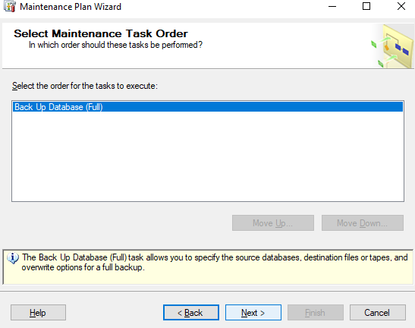

Click Next to continue

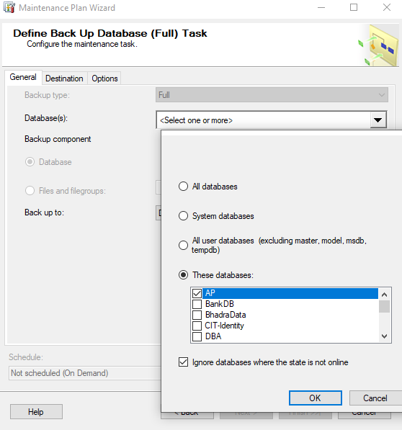

Go to General then choose database AP from dropdown box then click ok.

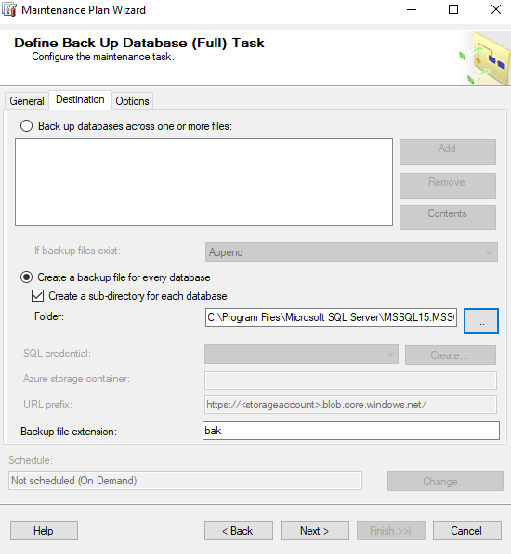

Go to Destination then check create a sub-directory for each database and choose folder ‘E:\Full’.

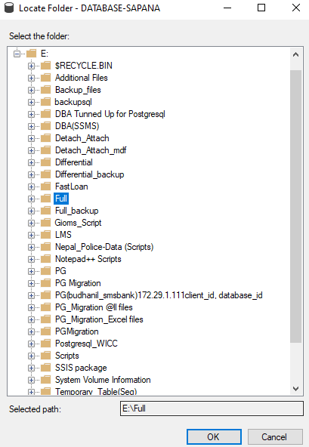

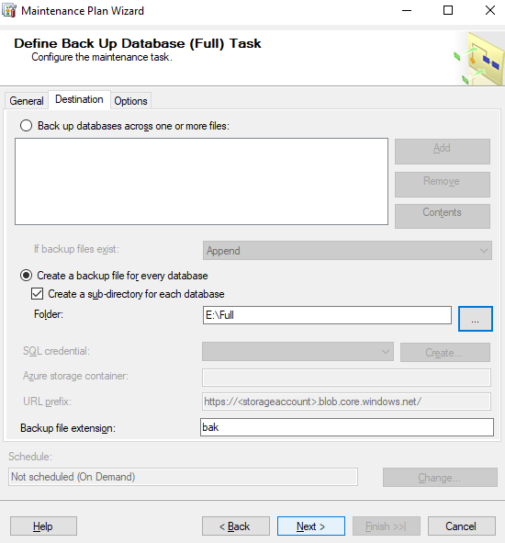

To proceed, leave the options tab unfilled and click next.

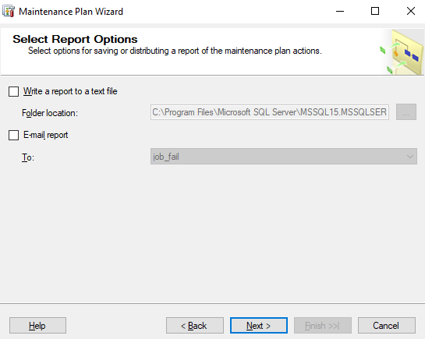

Uncheck the report to a text file box and next to continue. Finally, press the Finish button.

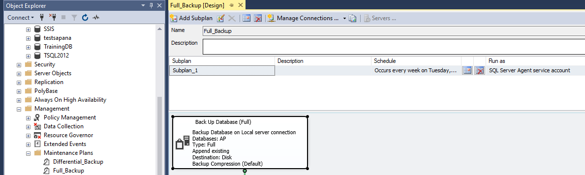

**Differential Backup:**

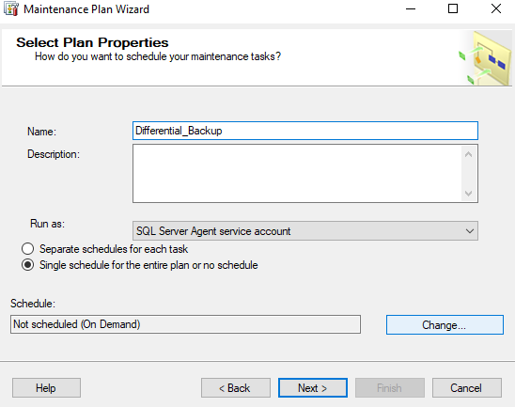

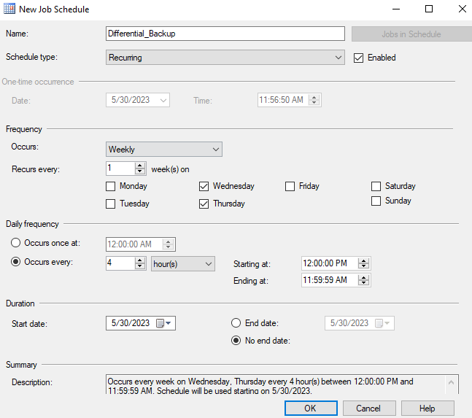

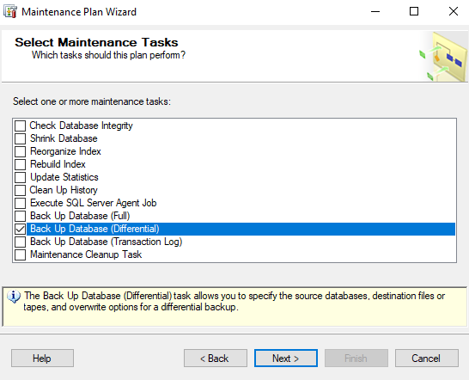

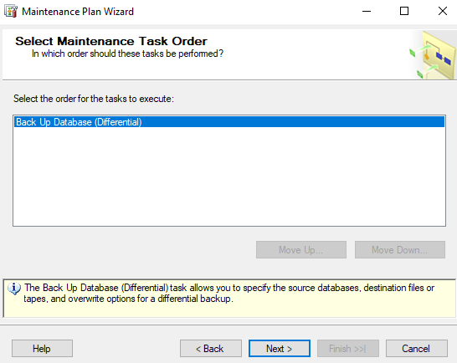

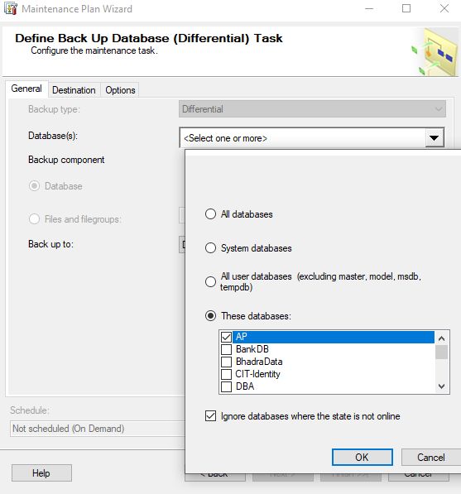

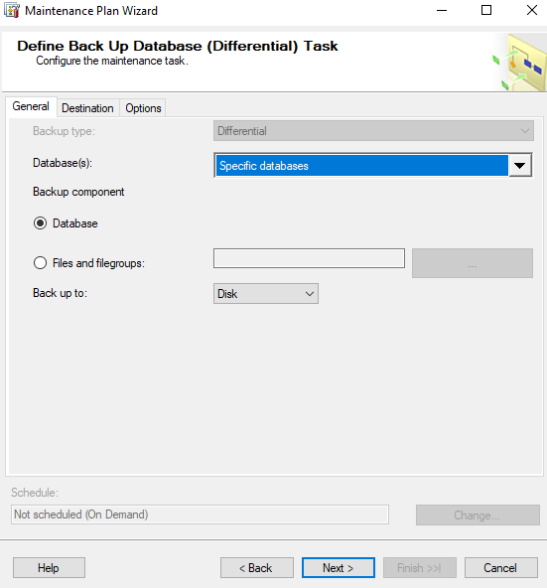

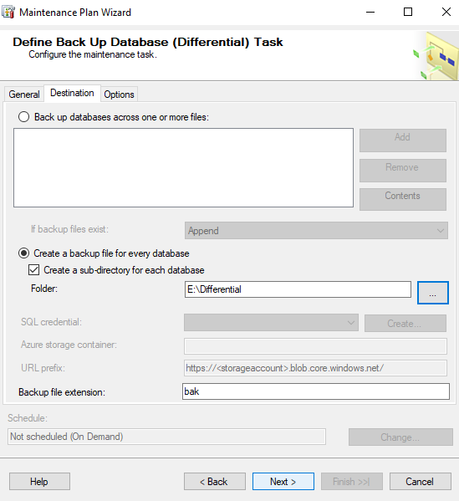

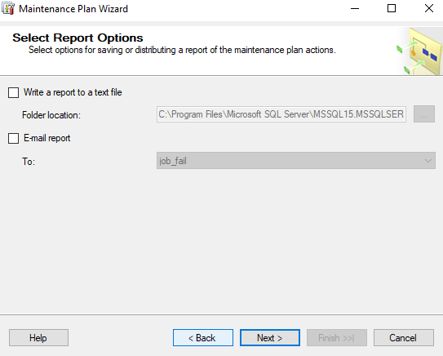

Uncheck the report to a text file box and next to continue. Finally, press the Finish button.

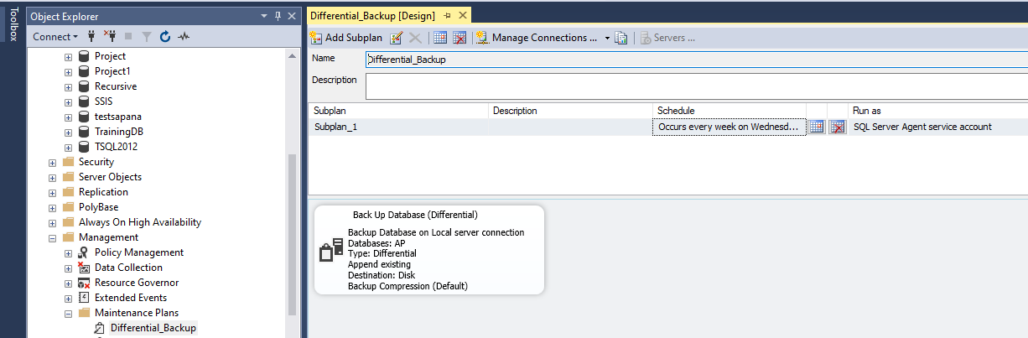

**Transactional Backup:**

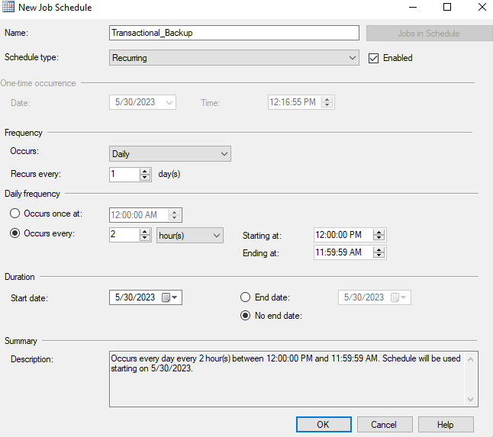

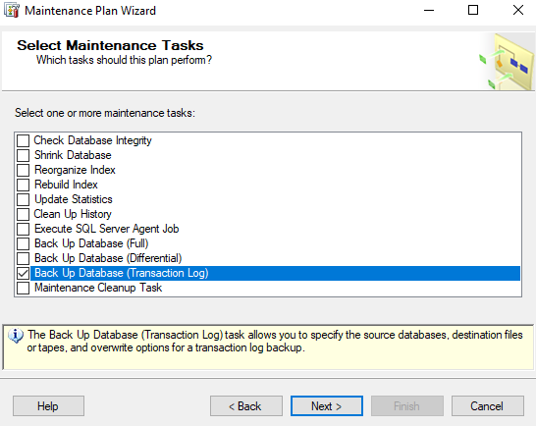

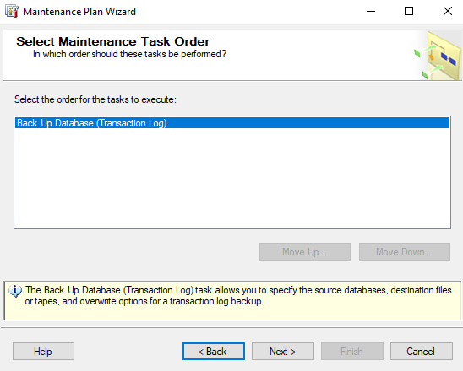

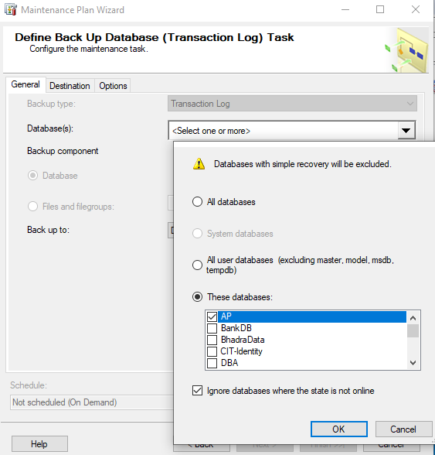

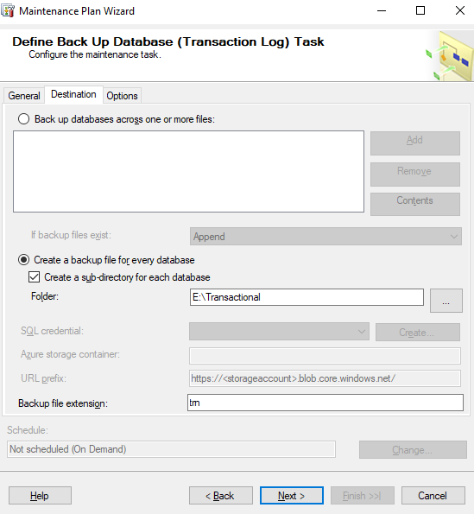



Uncheck the report to a text file box and next to continue. Finally, press the Finish button.

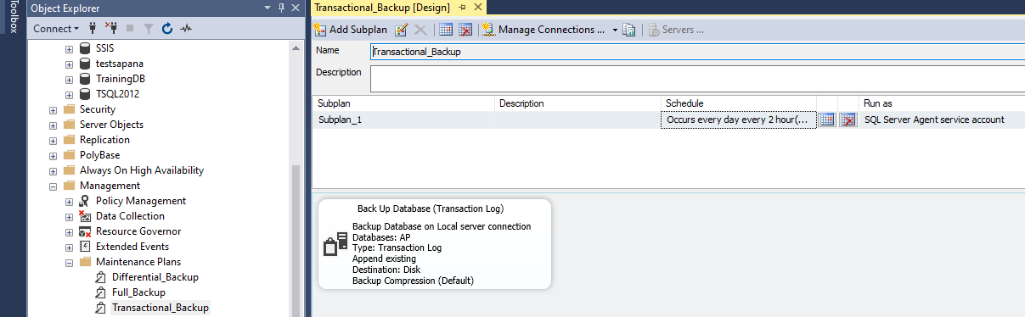

**System crash on Sunday at 11:00 AM**

After a system crash, a backup is not feasible. Backup will not continue from 11:00 AM. Therefore, until the system is restored, there won't be a full, differential, or transactional backup. Once the system has been restored, a backup will be made on the scheduled day and time.