**How to configure Database mail setup in SQL Server.**

Step 1: Connect SQL Server

Step 2: Once Management is expanded, database mail may be obtained from SQL Server logs

Step 3: Right Click Database Mail then configure database mail

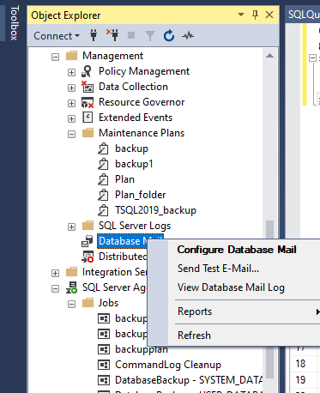

Step 4: From Database Mail Configuration Wizard, Click next to continue then check set up database mail by performing the following tasks.

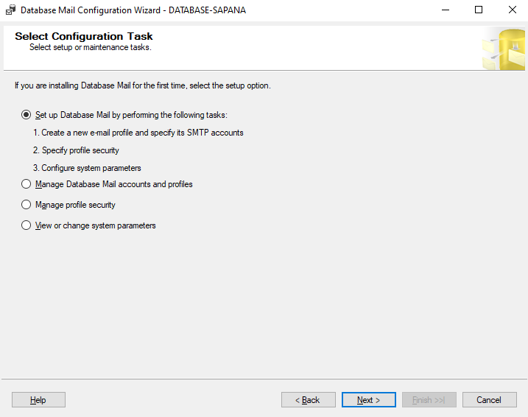

Step 5: The Add Account to Profile 'test_mail' window will open up when you click Next to Continue. Type in your profile name there and then click Add.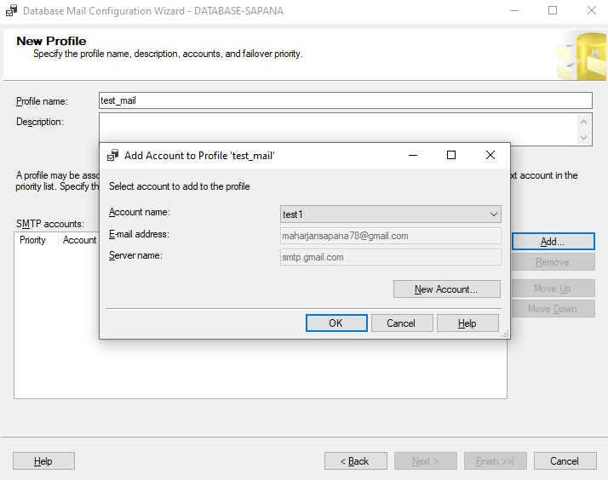

Step 6: Click on New Account button which will open new database mail account

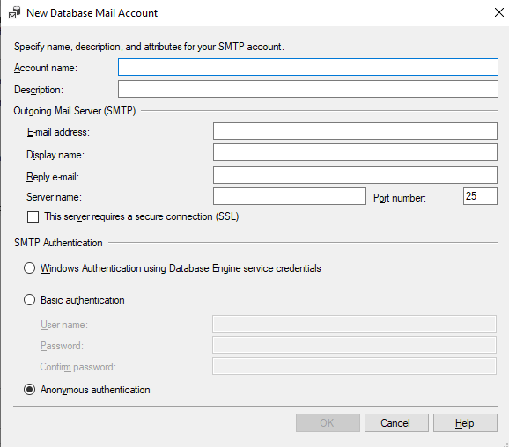

Step 7: Then fill up all the information required:

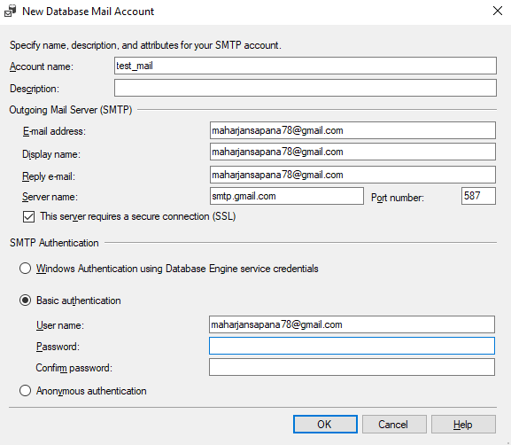

Step 8: In accordance with the screenshot above, the server name: smtp.gmail.com port number is 587, SSL must be verified, and for basic authentication, we must create a password using the email address we previously gave.

Step 9: Access your Gmail account, click Manage Your Google Account, then choose Security, 2-Step Verification, and App Passwords.

Step 10: The pop-up message containing the password will be created after logging into your email address, selecting Mail from the Select App drop-down menu and Windows Computer from the Select Device drop-down menu.

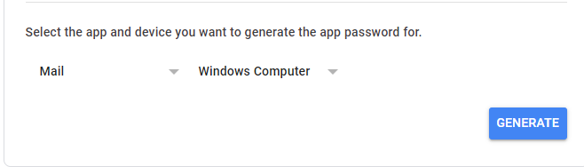

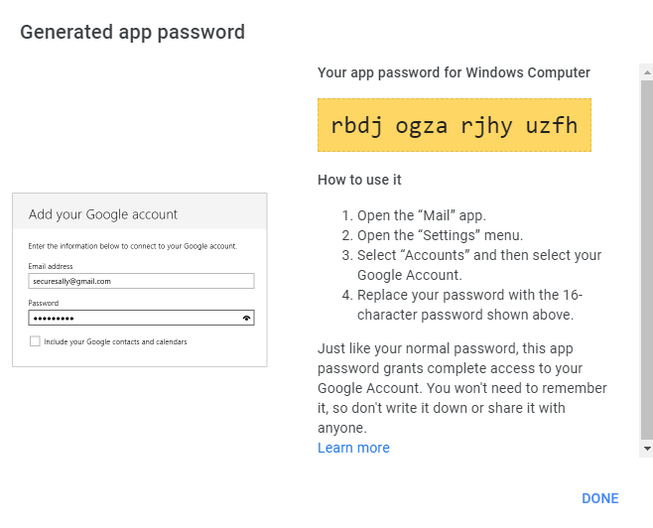

Step 11: After that, copy the password and put it in the basic authentication password field.

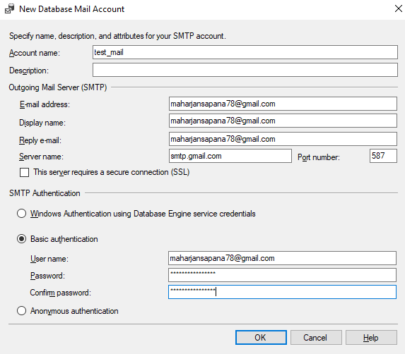

Step 12: Then click ok and again click next to continue

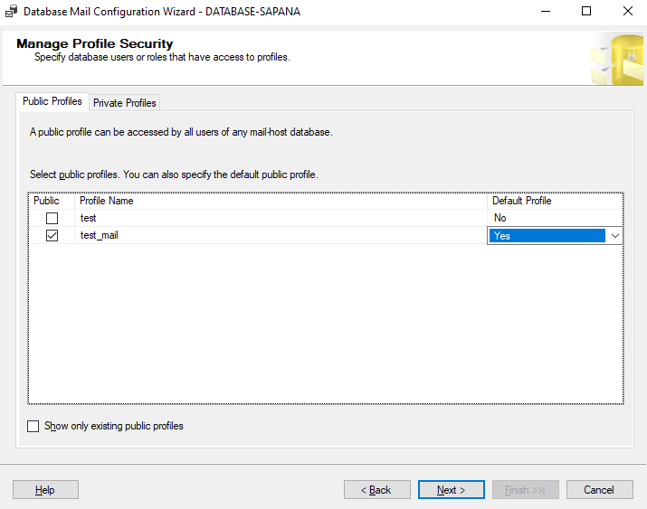

Step 13: Click next -> next -> Finish after selecting Yes from the Default Profile selection box and checking the Public box for test_mail. Then, success will be evident.

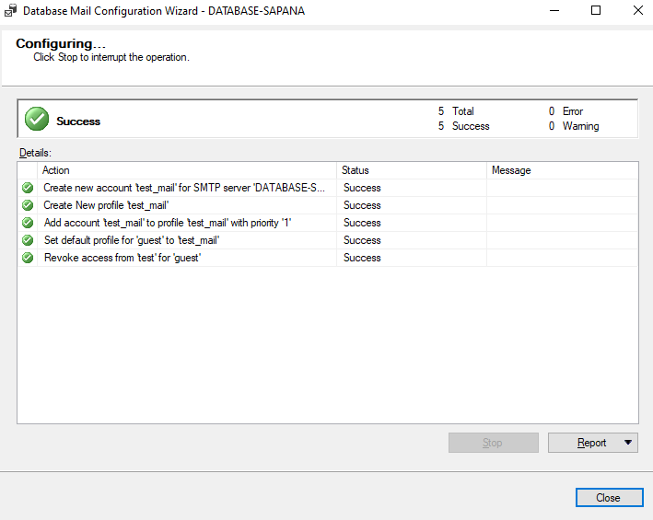

Step 14: Click to Send test E-Mail

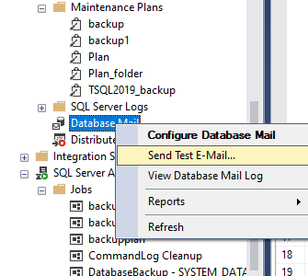

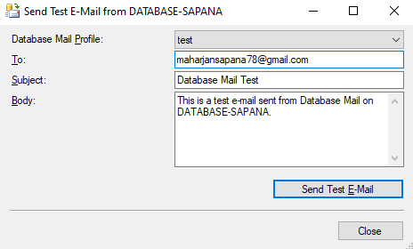

Step 15: Click Send Test E-Mail, then click ok to continue. Then check mail

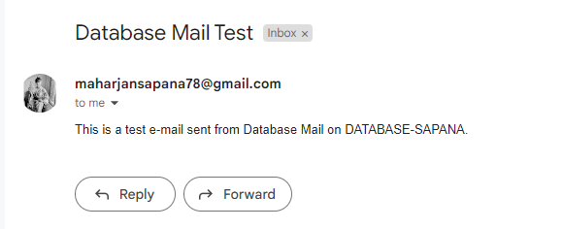

Only one Database Mail could be there, more than one database mail is configured then following issues can be shown as:

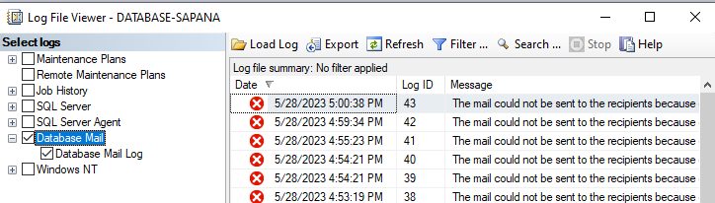

**Taking Success_backup and Failed_backup from SQL Server Agent (Jobs)**

**Success_backup**

Step 1: Select Jobs and create new Job

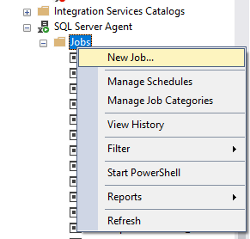

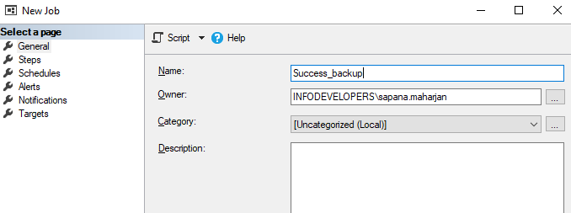

Step 2: Steps => new

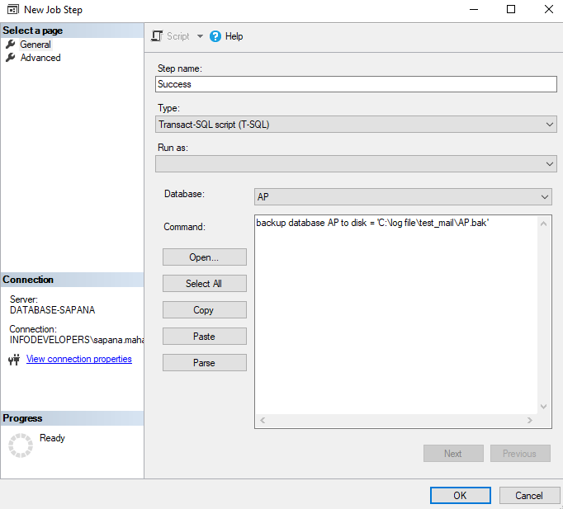

Click ok to confirm.

Step 3: Schedules => New

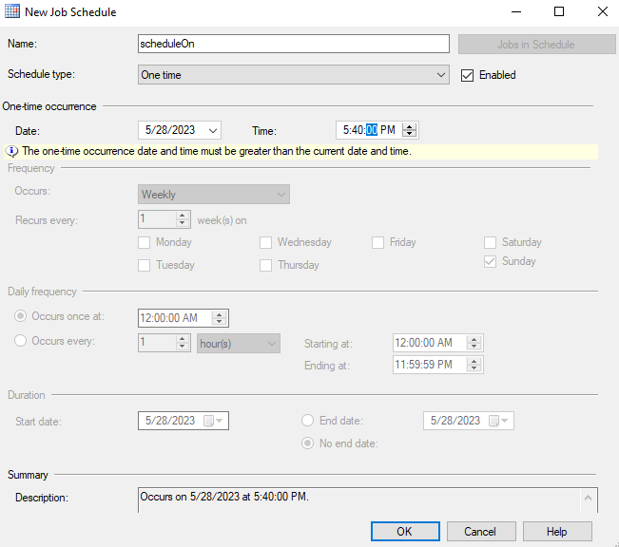

Click ok to confirm.

Step 4: Then in Notifications

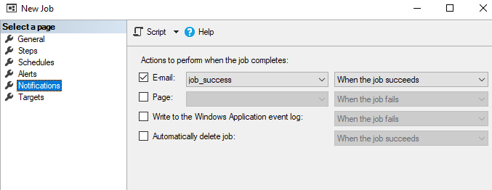

For E-mail (job_success must be created in operators by selecting new operator)

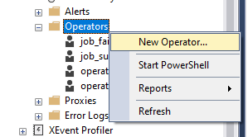

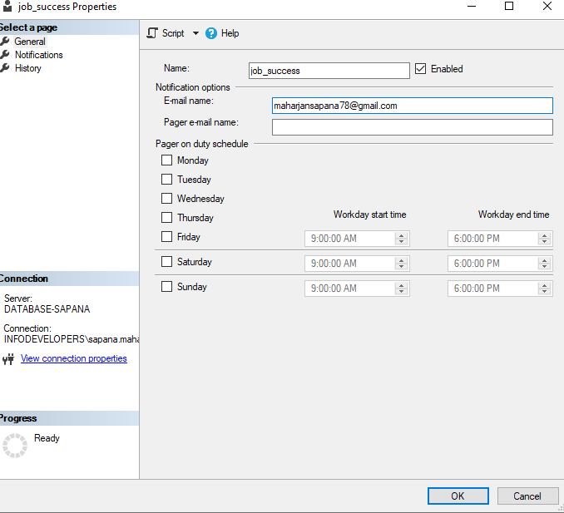

Then click ok to continue. It will create job_success as a new operator.

Step 5: For alert system:

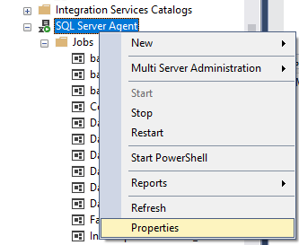

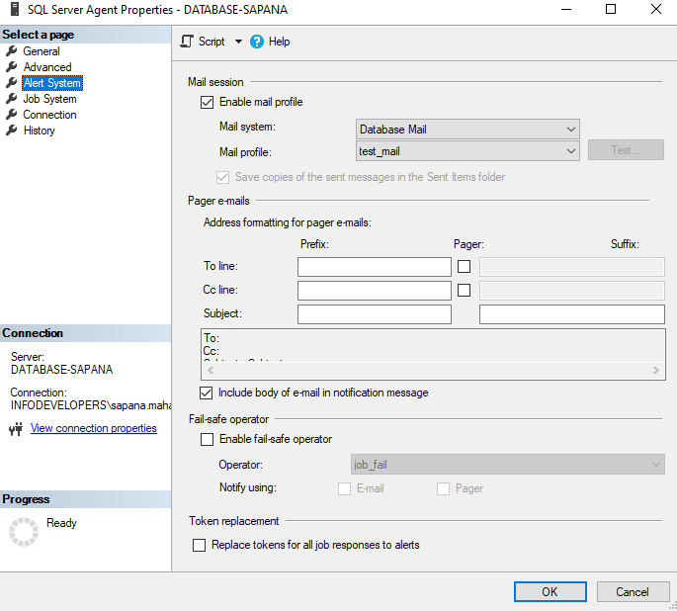

Enable mail profile then we select mail system as Database Mail and mail profile as test_mail which was recently made above under SQL Server Logs => Database Mail.

For viewing test_mail, double click on Database Mail.

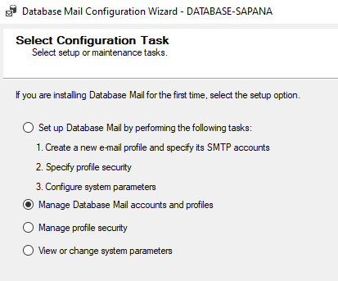

Next

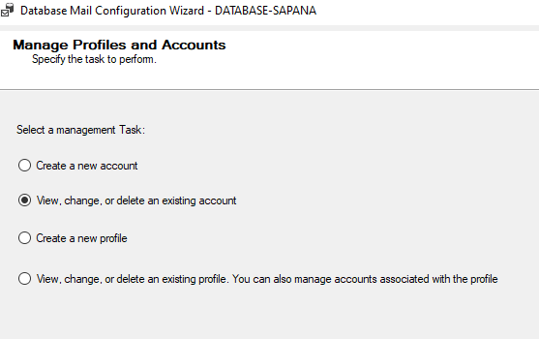

Next

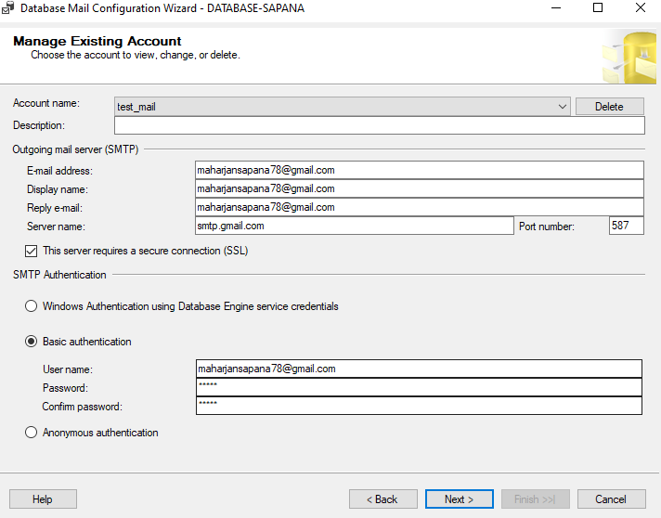

According to step 2, the backup file is saved to path 'C:\log file\test_mail\AP.bak'.

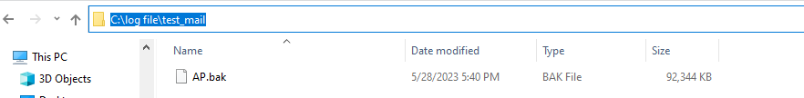

According to step 3, the schedule time was on 5:40:00 PM and the job succeeded on same time which shows the success_backup of AP database.

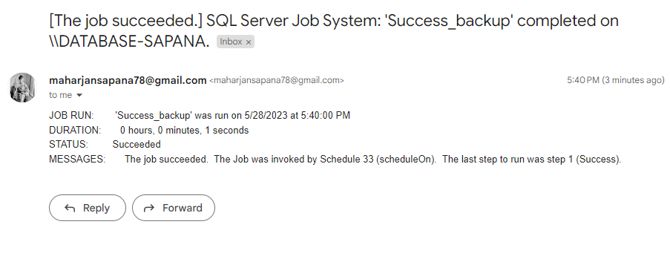

**Failed_backup**

Same process repeats as in Success_backup

Step 1:

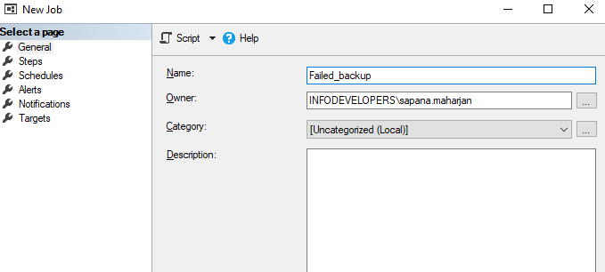

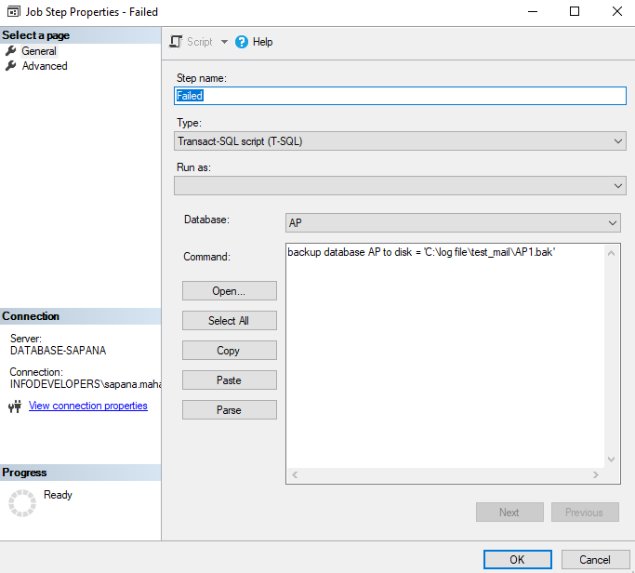

Click ok to continue

Before scheduling time, under 'C:\log file\test_mail’ right click test_mail then under security => Users edit do not allow full control and modify. Also deny read and write permission. Then click ok to continue.

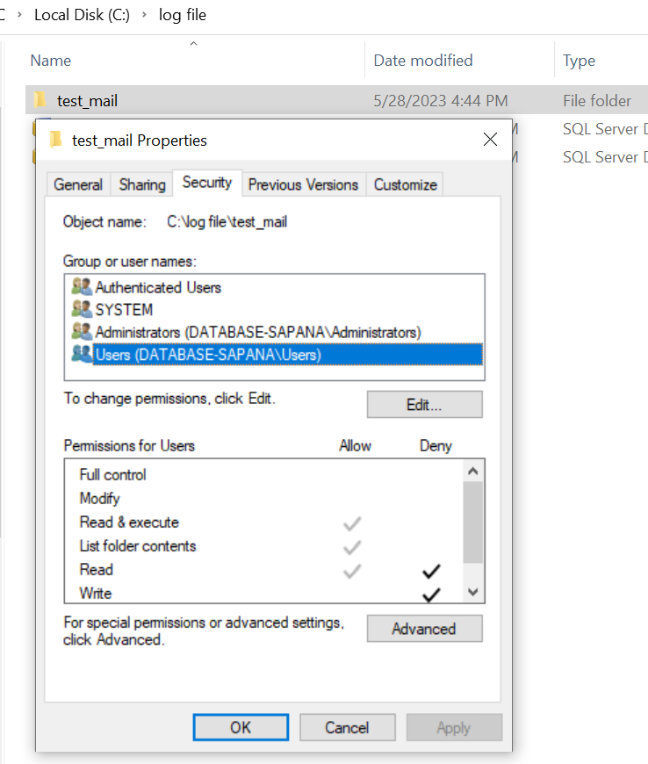

After deny read and write access to test_mail, it cannot be open

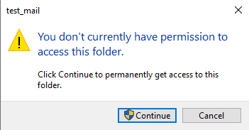

Step 2: Schedule on 10:35:00 AM

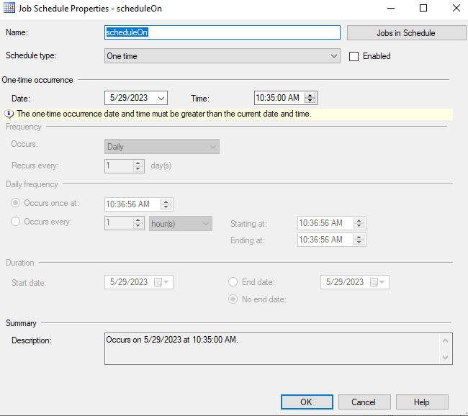

Click ok to continue

Step 3: In notification Email => job_fail . For this set next operator as job_fails.

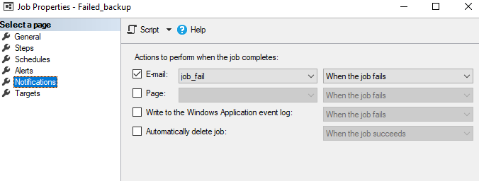

For E-mail (job_fail must be created in operators by selecting new operator)



Create job_fail operators and double click on job_fail, it will open job_fail properties.

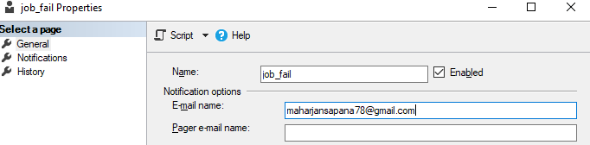

Step 4: For alert system:





Enable mail profile then we select mail system as Database Mail and mail profile as test_mail which was recently made above under SQL Server Logs => Database Mail.

For viewing test_mail, double click on Database Mail.



Next



Next



According to step 1, the backup file is saved to path 'C:\log file\test_mail\AP1.bak'.

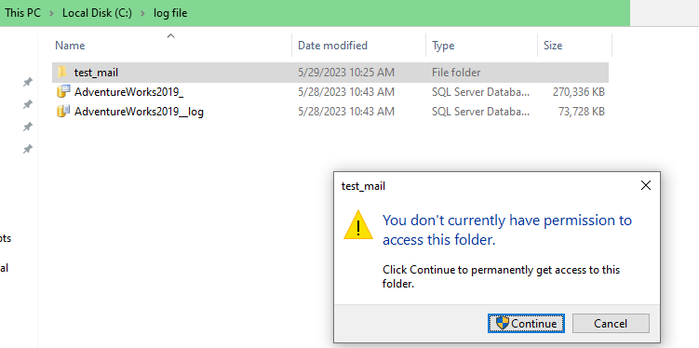

According to step 2, the schedule time was on 10:35:00 AM, and the job failed on same time which shows the failure_backup of AP database.

