**CREATE USER MAPPING**

CREATE USER MAPPING

CREATE USER MAPPING — define a new mapping of a user to a foreign server

## Synopsis:

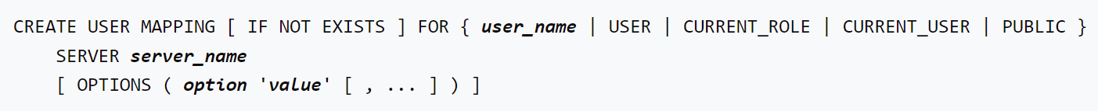

Examples:

Create a user mapping for user sapana, server foo:

CREATE USER MAPPING FOR sapana SERVER foo OPTIONS (user 'sapana', password 'postgre123');

Alter User Mapping:

ALTER USER MAPPING — change the definition of a user mapping

## Synopsis:

## 

Examples:

Change the password for user mapping sapana, server foo:

ALTER USER MAPPING FOR sapana SERVER foo OPTIONS (SET password 'password');

Drop User Mapping:

DROP USER MAPPING — remove a user mapping for a foreign server

## Synopsis:

## 

## DROP USER MAPPING removes an existing user mapping from foreign server.

Examples:

Drop a user mapping sapana, server foo if it exists:

