**Oracle Data Pump (Expdp and Impdp)/Backup and Restore in Oracle Database 10g, 11g, 12c, 18c, 19c**

**Oracle Data Pump** enables high-speed movement of data and metadata from one database to another. This technology is the basis for the following Oracle Database data movement utilities:

* **Data Pump Export (Export):** Export is a utility for unloading data and metadata into a set of operating system files called a **dump file set**. The dump file set is made up of one or more binary files that contain table data, database object metadata, and control information.
* **Data Pump Import (Import):** Import is a utility for loading an export dump file set into a database. You can also use Import to load a destination database directly from a source database with no intervening files, which allows export and import operations to run concurrently, minimizing total elapsed time.

## **Getting Started**

For the examples to work we must first unlock the SCOTT account and create a directory object it can access. The directory object is only a pointer to a physical directory, creating it does not actually create the physical directory on the file system of the database server.

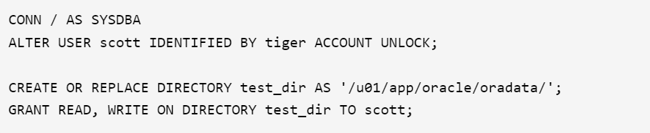

Below is the attached example from command line:

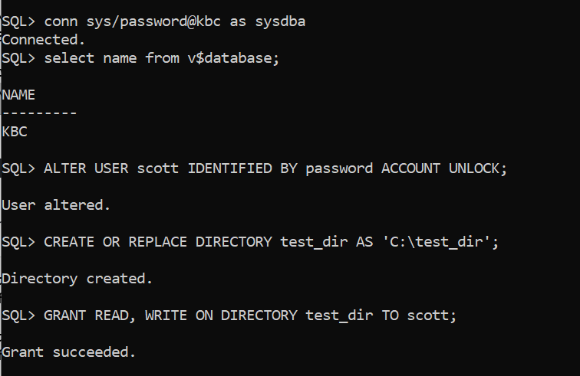

## **Table Exports/Imports**

The TABLES parameter is used to specify the tables that are to be exported. The following is an example of the table export and import syntax.

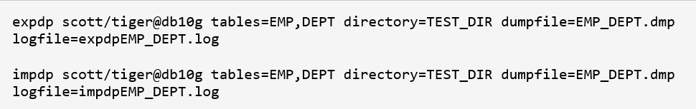

Here is the attached example in command line:

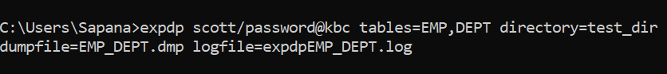

So to restore (import) table EMP, DEPT in ORCL database, create user scott in ORCL database and grant dba to scott.

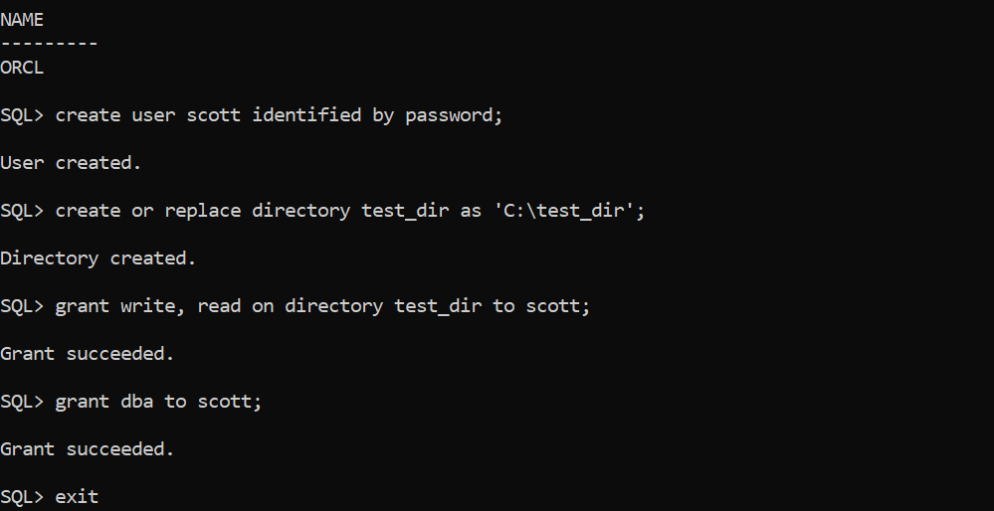

Then, finally import table EMP_DEPT to scott schema.



For example output files see [expdpEMP_DEPT.log](https://oracle-base.com/articles/10g/expdpEMP_DEPT.log) and [impdpEMP_DEPT.log](https://oracle-base.com/articles/10g/impdpEMP_DEPT.log).

The TABLE_EXISTS_ACTION=APPEND parameter allows data to be imported into existing tables.

## **Schema Exports/Imports**

The OWNER parameter of exp has been replaced by the SCHEMAS parameter which is used to specify the schemas to be exported. The following is an example of the schema export and import syntax.

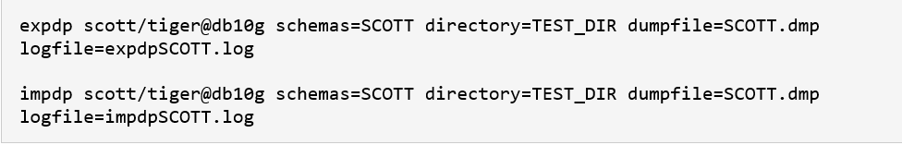

For example output files see [expdpSCOTT.log](https://oracle-base.com/articles/10g/expdpSCOTT.log) and [impdpSCOTT.log](https://oracle-base.com/articles/10g/impdpSCOTT.log).

## **Database Exports/Imports**

The FULL parameter indicates that a complete database export is required. The following is an example of the full database export and import syntax.

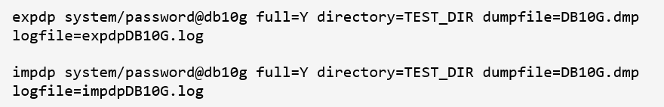

For an example output file see [expdpDB10G.log](https://oracle-base.com/articles/10g/expdpDB10G.log).

That database user performing the export will need DATAPUMP_EXP_FULL_DATABASE role, and the user performing the import will need the DATAPUMP_IMP_FULL_DATABASE role.