Project Steps: -

1. Requirement Gathering.(BRD/FRD)
2. Data Gathering (blob/adls/onprem etc)
3. Architecture of project.
4. Azure Services.
5. Data Cleaning /Data pre- Pre-processing/Data Transformation.
6. Building ETL/Pipeline using ADF.
7. Schedule the pipeline.
8. Get data in PBI from Azure SQL ---import/direct query mode.
9. UI Design. (report/charts/custom charts)
10. Additional information (Dax functions (Measures/Calculated Column)
11. RLS.
12. Workspace (collaboration with teams)
13. Publish the report.
14. Dashboard.
15. Gateways.
16. Schedule refresh.
17. Add roles/ subscribe/ Alerts
18. Share the reports(team/outlook/link)
19. Pipeline Deployment
20. App

**Datasets stored in below format:-**

1. Sales (folder by year)
2. Categories (Excel)
3. Geography (Excel)
4. Product (MySQL Database)
5. SalesRep (Excel)
6. SubCategories (Excel)

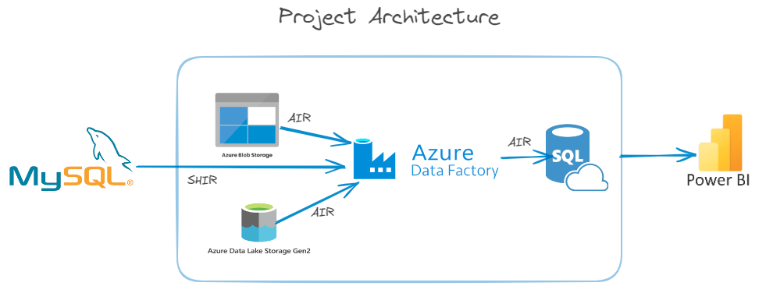

Environment Setup:-

1. MySQL
2. Azure Blob Storage
3. Azure Data Lake Storage Gen2
4. Azure Data Factory
5. Azure SQL Database
6. Power BI

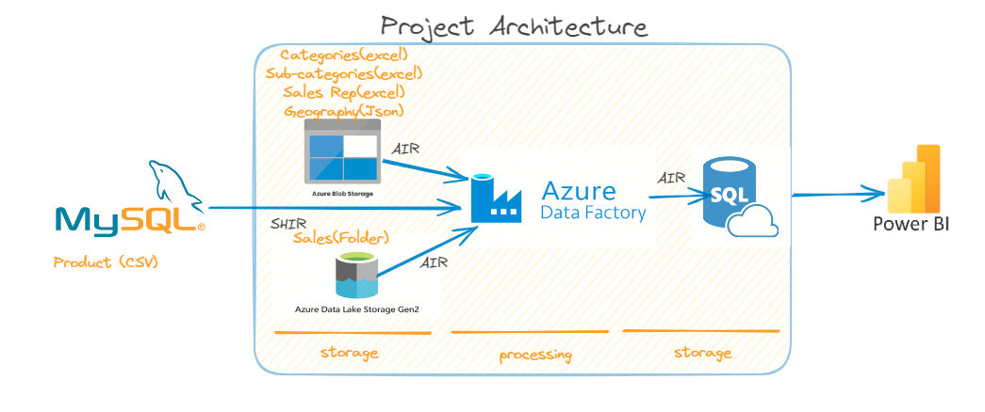

**Dimension Data (Category,Subcategory, Geography, Salesrep, Product table) is stored in Blob Storage in the Denisdimdata folder and the product table is pulled from on-prem to the Denisdimdata folder by running onpremtoclodepipeline**

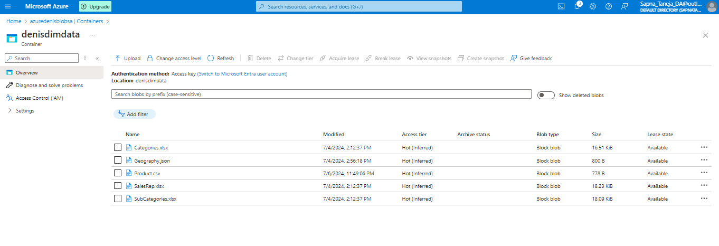**Fact Table -Sales tables stored in ADLS in the Denisfactdata folder**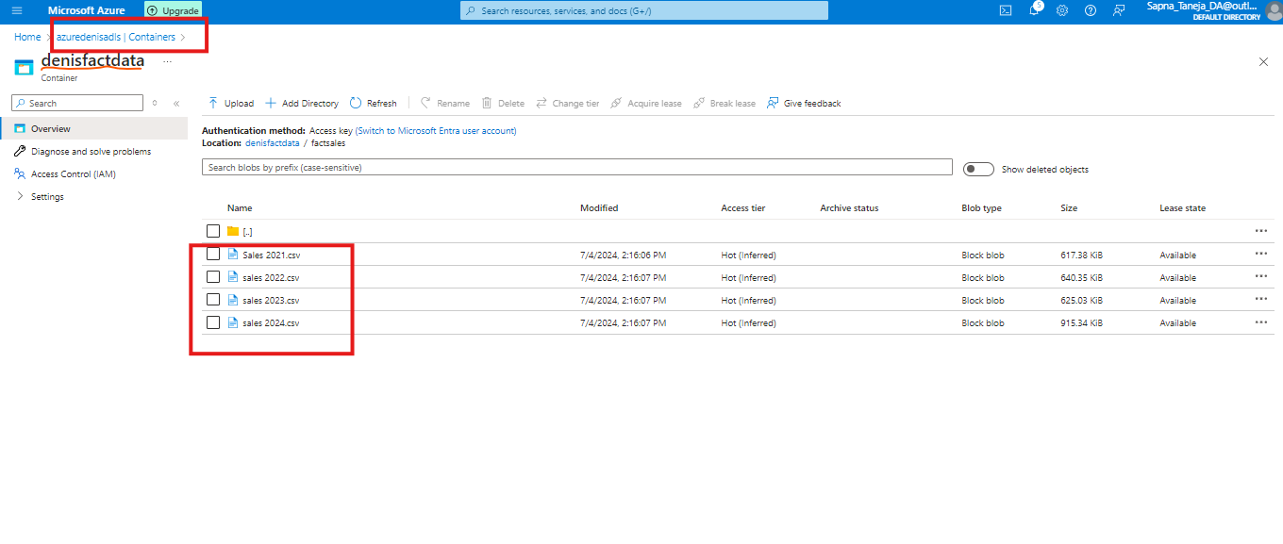

Before, performing the final transformation on the data we will perform some basic transformations and keep all the data in the staging area from where any team can access cleaned data.

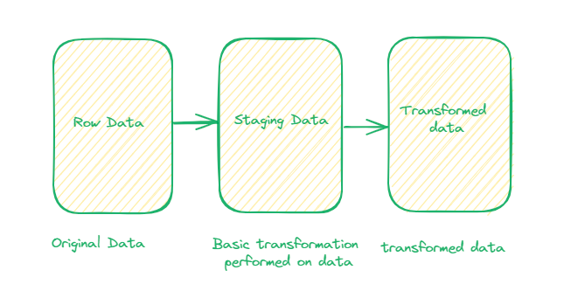

For storing the data in the staging area we created dataflows and stored the dimension data in the Blob Storage staging folder and Fact data in the ADLS staging folder.

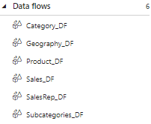

Blob Staging data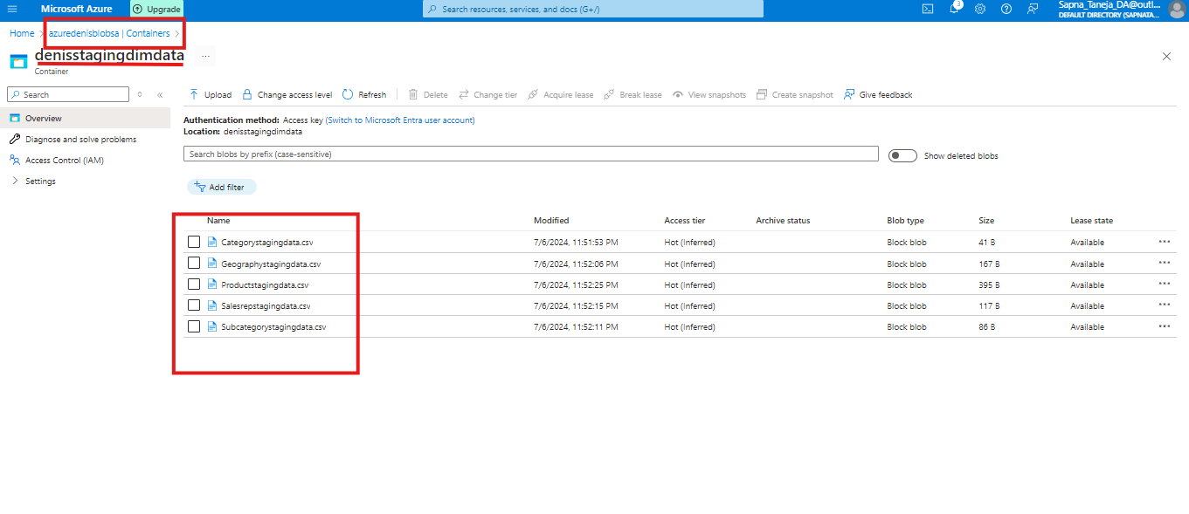

ADLS staging data

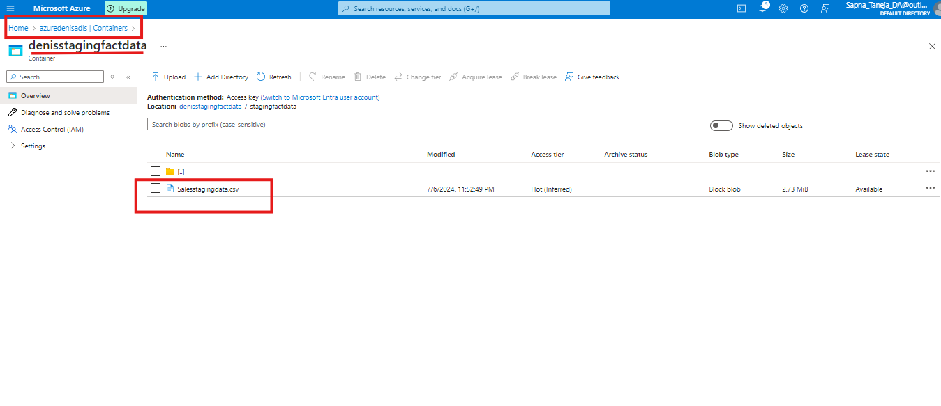

Keep in mind while saving the file in staging always give the correct name to the file and select a single partition in the optimize tab.

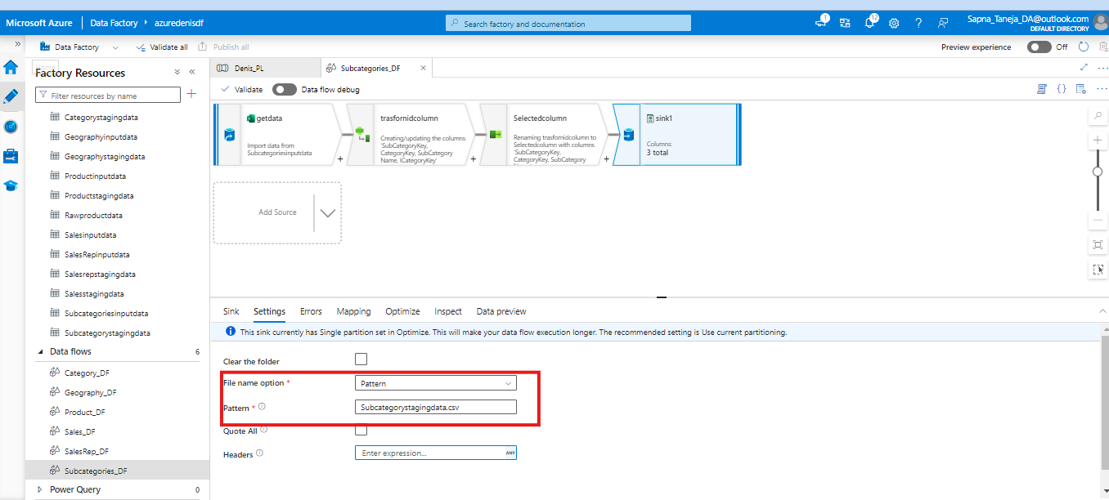

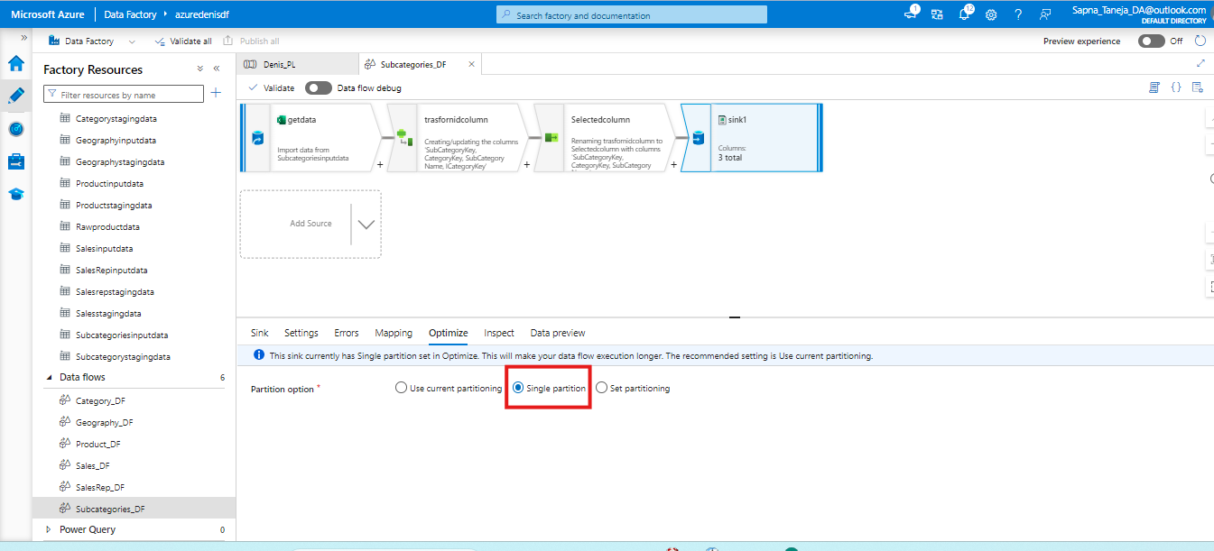

Finally after creating Final DF we will Create Pipeline to Pull the data from Blob ,Adls to SQL Server .

Lastly load the data in Power BI.