PROJECT 6 DOCUMENTATION
PIC24 Processor Design in VHDL
Student: Sapca Stefan | Group: CEN3.2A | Project: #6
―――――――――――――――――――――――――――――――――――――――――――――――――――――――
Specific Instructions Implemented
Non-jump Instructions | Flags | Jump Instructions
FF1L Ws, Wnd | OV | BRA OV, Expr
ADD #lit10, Wn | C | BRA C, Expr
INC2 Ws, Wd | N | BRA N, Expr
SETM Wd | Z | BRA Z, Expr

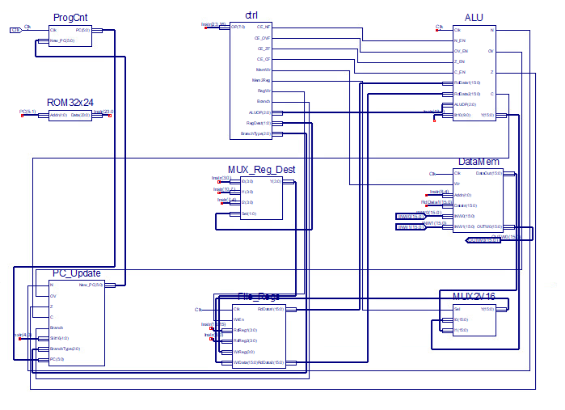
1. PC (Program Counter)
The Program Counter (PC) is a fundamental 6-bit register responsible for storing the address of the currently executing instruction. Its output directly drives the address input of the ROM32x24 program memory. It is updated synchronously on the rising edge of the clock signal (Clk) with the value computed by New_PC.
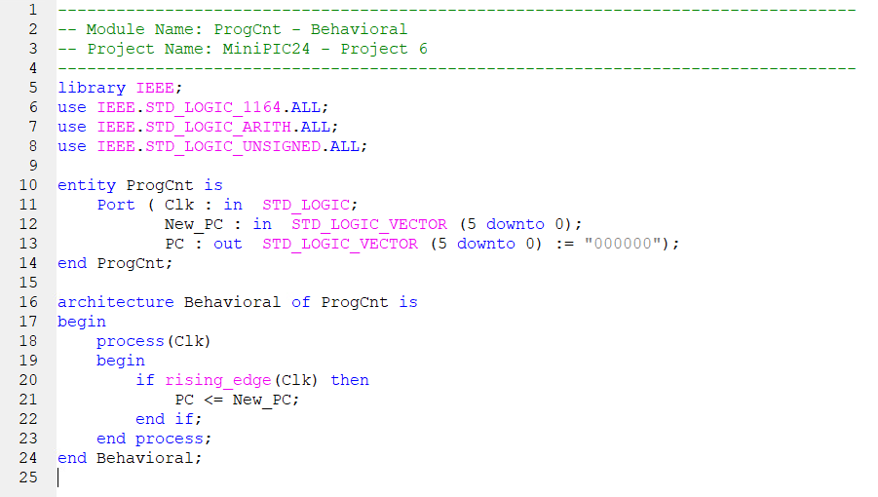
2. PC_UPDATE
The PC_Update module implements combinational logic determining the next PC value (New_PC). It handles sequential execution by incrementing PC by 2, or branch operations by calculating relative offset (Slit16) based on status flags (N, OV, Z, C).
PC_UPDATE TABLE (Opcode Encoding Table)
Instruction | Bits 23..20 | Bits 19..16 | Bits 15..12 | Bits 11..8 | Bits 7..4 | Bits 3..0 | Flags Affected
ADD Wb, Ws, Wd | 0100 | 0www | wBqq | qddd | dppp | SSSS | N, OV, Z, C
SUB Wb, Ws, Wd | 0101 | 0www | wBqq | qddd | dppp | SSSS | N, OV, Z, C
AND Wb, Ws, Wd | 0110 | 0www | wBqq | qddd | dppp | SSSS | N, Z
IOR Wb, Ws, Wd | 0111 | 0www | wBqq | qddd | dppp | SSSS | N, Z
MOV Wns, f | 1000 | 1fff | ffff | ffff | ffff | SSSS | None
MOV f, Wnd | 1000 | 0fff | ffff | ffff | ffff | dddd | None
BRA Expr | 0011 | 0111 | nnnn | nnnn | nnnn | nnnn | None
FF1L Ws, Wnd | 1110 | 0111 | 0000 | 0ddd | 0000 | SSSS | C
ADD #lit10, Wn | 0100 | 0110 | 0kkk | kkkk | kkk0 | dddd | N, OV, Z, C
INC2 Ws, Wd | 1110 | 0001 | 0000 | 0ddd | 0000 | SSSS | N, OV, Z, C
SETM Wd | 1110 | 1011 | 1000 | 0ddd | 0000 | 0000 | None
BRA OV, Expr | 0011 | 0000 | nnnn | nnnn | nnnn | nnnn | None
BRA C, Expr | 0011 | 0001 | nnnn | nnnn | nnnn | nnnn | None
BRA N, Expr | 0011 | 0011 | nnnn | nnnn | nnnn | nnnn | None
BRA Z, Expr | 0011 | 0010 | nnnn | nnnn | nnnn | nnnn | None

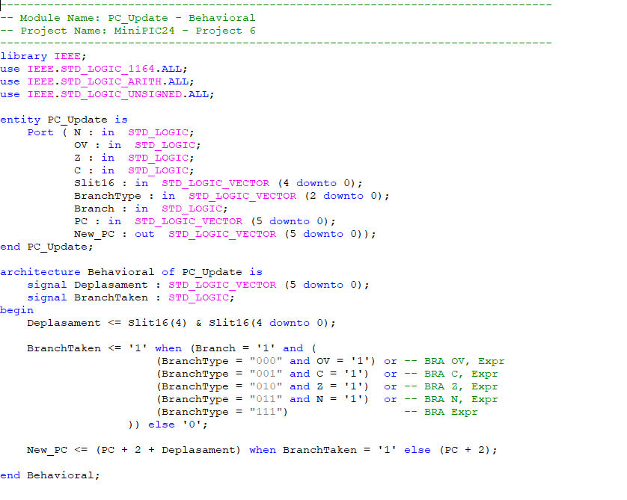
3. ROM32x24 (Program Memory)
Implements the 32x24-bit Program Memory ROM, storing 24-bit instruction words addressed by PC(5:1). It operates combinationally to supply instructions during the fetch stage.
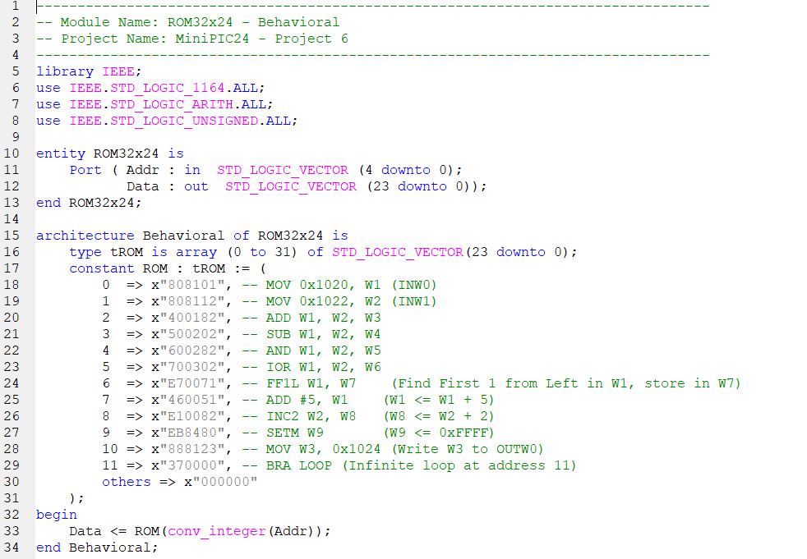
4. MUX REG DEST (Destination Register MUX)
Selects destination register index Wd from bits [3:0], [10:7], or [7:4] depending on instruction encoding format controlled by RegDest signal. 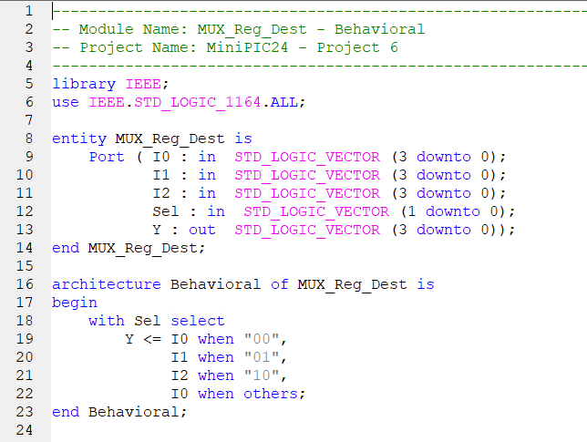

5. CTRL (Control Unit)
Combinational decoder evaluating opcode bits [23:16] and generating control signals for datapath execution.
CTRL TABLE (Control Signals Truth Table)
Instruction | Opcode | CE_NF | CE_OVF | CE_ZF | CE_CF | ALUOP | MemWr | Mem2Reg | RegWr | RegDest | Branch
ADD | 01000 | 1 | 1 | 1 | 1 | 000 | 0 | 0 | 1 | 01 | 0
SUB | 01010 | 1 | 1 | 1 | 1 | 001 | 0 | 0 | 1 | 01 | 0
AND | 01100 | 1 | 0 | 1 | 0 | 010 | 0 | 0 | 1 | 01 | 0
IOR | 01110 | 1 | 0 | 1 | 0 | 011 | 0 | 0 | 1 | 01 | 0
MOV f, Wnd | 10000 | 0 | 0 | 0 | 0 | - | 0 | 1 | 1 | 00 | 0
MOV Wns, f | 10001 | 0 | 0 | 0 | 0 | - | 1 | 0 | 0 | 00 | 0
BRA Expr | 00110 | 0 | 0 | 0 | 0 | - | 0 | 0 | 0 | - | 1
FF1L Ws, Wnd | 11100 | 0 | 0 | 0 | 1 | 100 | 0 | 0 | 1 | 10 | 0
ADD #lit10, Wn | 01000 | 1 | 1 | 1 | 1 | 101 | 0 | 0 | 1 | 00 | 0
INC2 Ws, Wd | 11100 | 1 | 1 | 1 | 1 | 110 | 0 | 0 | 1 | 10 | 0
SETM Wd | 11101 | 0 | 0 | 0 | 0 | 111 | 0 | 0 | 1 | 01 | 0
BRA OV, Expr | 00110 | 0 | 0 | 0 | 0 | - | 0 | 0 | 0 | - | 1
BRA C, Expr | 00110 | 0 | 0 | 0 | 0 | - | 0 | 0 | 0 | - | 1
BRA N, Expr | 00110 | 0 | 0 | 0 | 0 | - | 0 | 0 | 0 | - | 1
BRA Z, Expr | 00110 | 0 | 0 | 0 | 0 | - | 0 | 0 | 0 | - | 1

6. FILE REGS (Register File)
Implements 16 general-purpose 16-bit registers (W0 to W15) with dual combinational read ports and single synchronous write port. 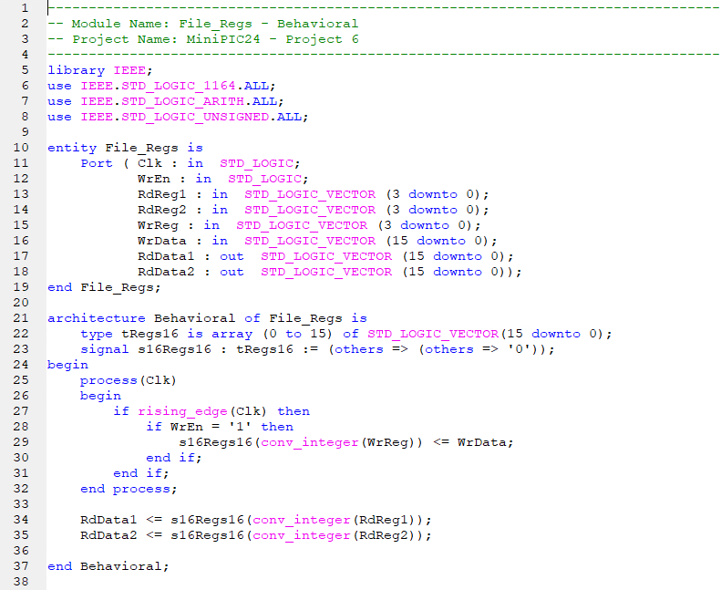

7. ALU (Arithmetic Logic Unit)
Executes 16-bit arithmetic/logic operations on 17-bit extended hardware and maintains internal status flag registers (N, OV, Z, C) gated by clock enables.
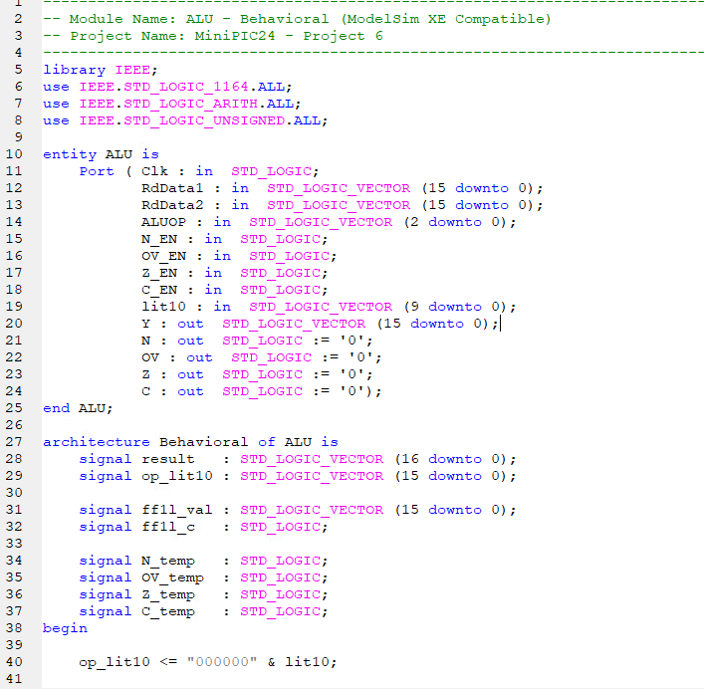
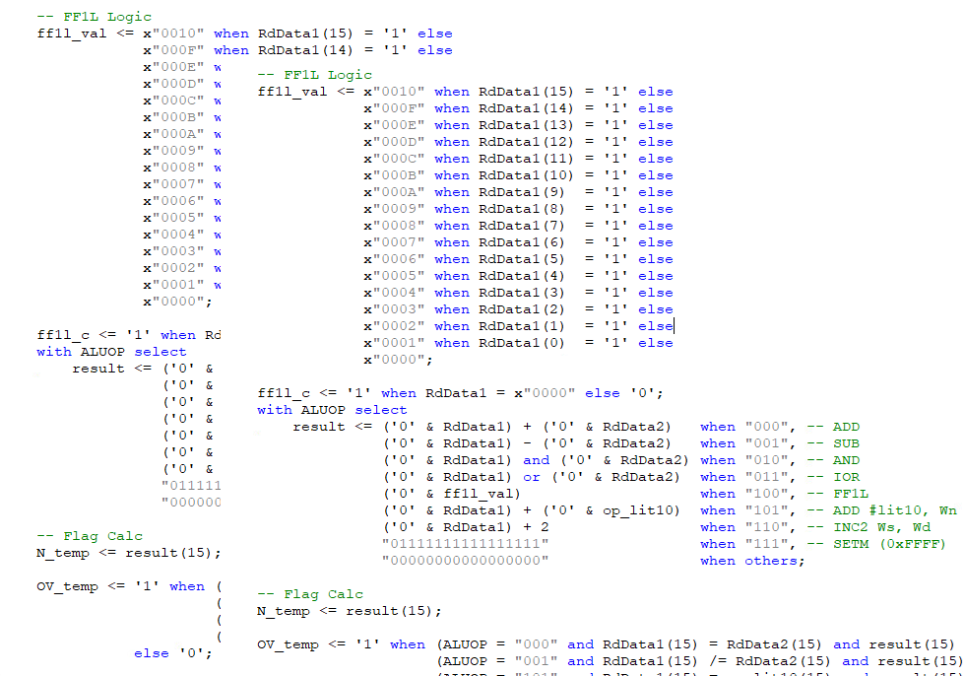
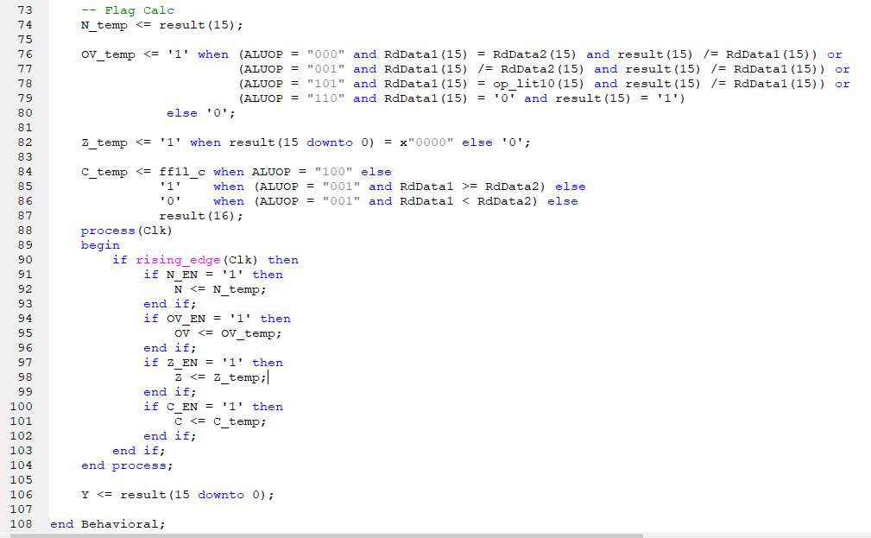
8. DATAMEM (Data Memory)
Provides 16x16 internal RAM plus memory-mapped I/O registers: INW0 @ 0x1020, INW1 @ 0x1022, OUTW0 @ 0x1024.
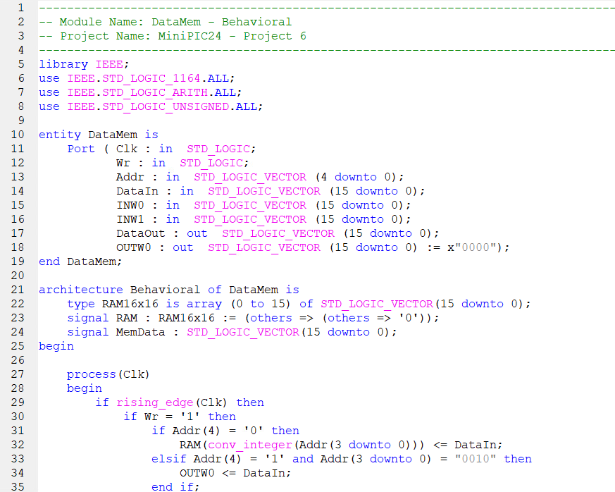
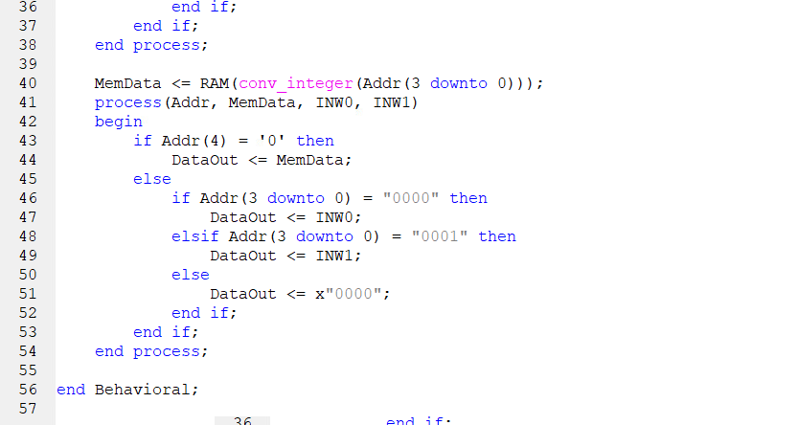
9. MUX2V16 (Write-Back MUX)
2-to-1 16-bit multiplexer selecting register write-back source from ALU result or DataMem output.
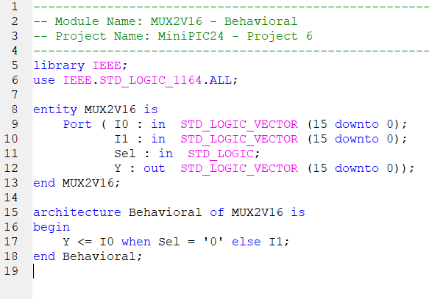

BEHAVIORAL SIMULATION
Execution verification waveform screenshot from ModelSim :

