Title: Dracula

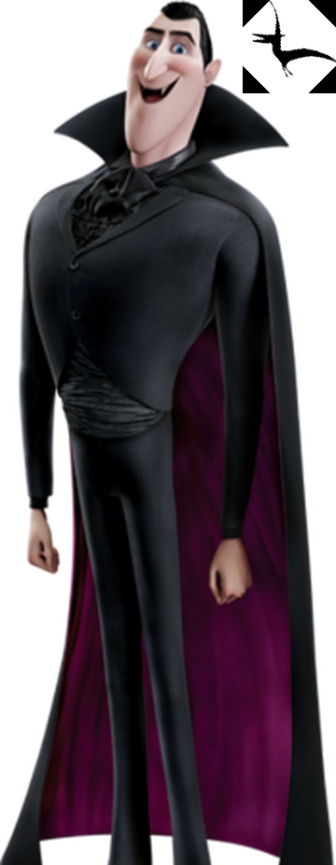

# Author

Author: Bram Stoker

# Report author

Eryk Sapijaszko

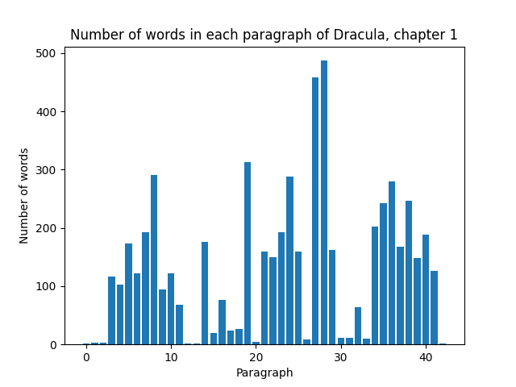

# Description

Here we can see the number of words in each paragraph of chapter 1

# Statistics

1. **Min***: 1*
2. **Max***: 487*
3. **Average***: 132.6*
4. **Total***: 5702*