Outline
The name of my application is: Booker. It is a web app intended to be used by clinics to provide patients and staff with a simple and easy-to-use interface where they can manage appointments.
Patients will be able to use Booker to book their appointments. This is much more efficient compared to the traditional over-the-phone method. When booking appointments, patients can also add the reason for their appointment. Additionally, patients will be able to view their upcoming appointments, previous appointments and change or cancel appointments.
On the other hand, staff will be able to view all patient appointments (upcoming and past appointments) and view the reason for the appointment. They will also be able to cancel and make changes to appointments, and view patient details, such as their name and contact details.
For security and privacy reasons, Booker does not store any more sensitive patient information than necessary. For example, Booker does not store height, weight and other metrics regarding the patient, as these should only be available within internal systems.
Architecture
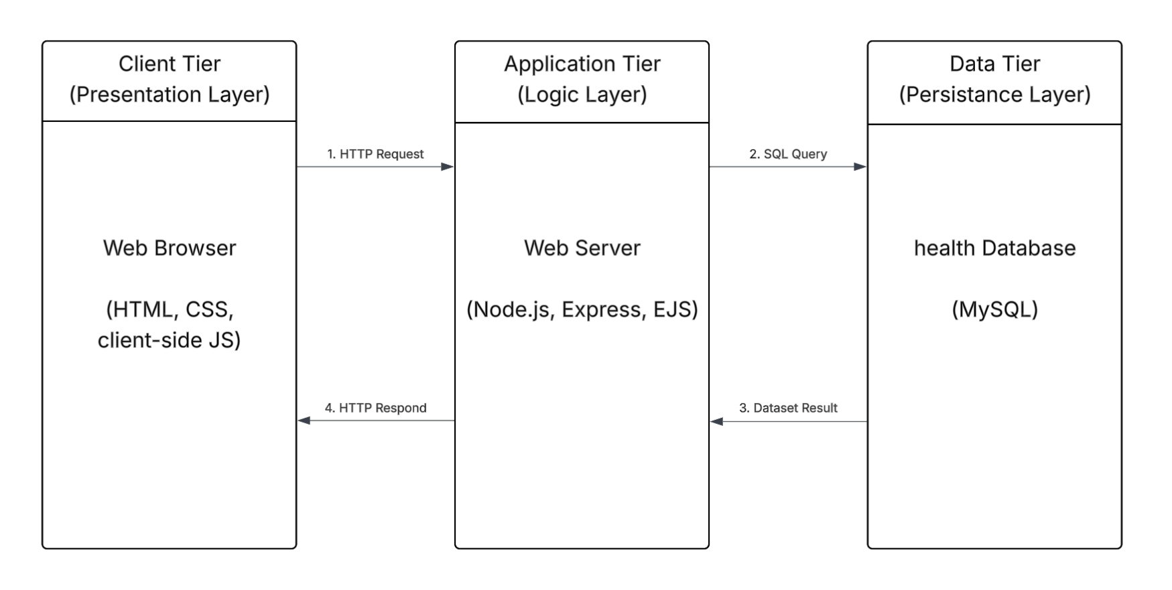
Booker follows a very standard 3-tier architectural approach. The Client Tier uses HTML, CSS and client-side JavaScript to provide a user-friendly and intuitive interface for users to interact with. This tier also handles client-side validation for a more seamless experience.
The Data Tier uses a MySQL relational database to store patient and staff credentials, and appointment records.
The Application Tier, which lies in the middle of the Client Tier and Data Tier, is built on the Node.js environment using the Express framework. It handles routing, authentication and access control, session management, server-side validation and server-side rendering via the EJS templating engine. This tier also communicates with the database through SQL queries, processes the results and serves dynamic HTML pages to the client.
Data Model
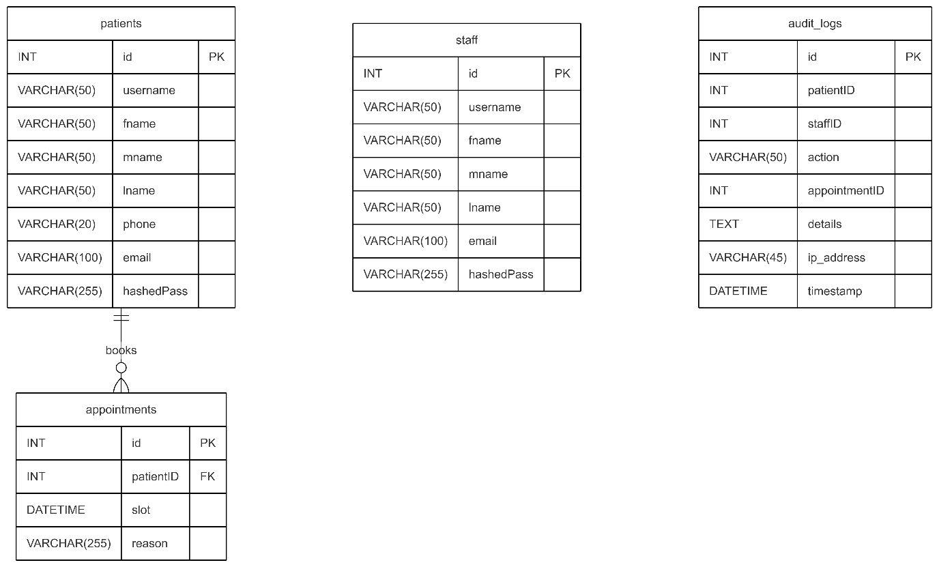
The health database contains 4 tables: patients, staff, appointments and audit_logs.
- The patients table holds patient credentials, such as username, email and hashed password.
- The staff table holds staff credentials such as username, hashed password and email.
- The appointments table holds appointment details, such as the time and reason. It is also related to the patients table via the patientID column.
- The audit_logs table is where a log of user interactions is kept for security purposes.

User Functionality
User functionality was considered at every step of this app’s building’s process. This app is aimed to be used by patients and staff alike, therefore the app has 2 sides.
The landing page of the app immediately greets the user with a title to assure them that they are at the right place. It also provides the user with basic information that they may be interested in or need.
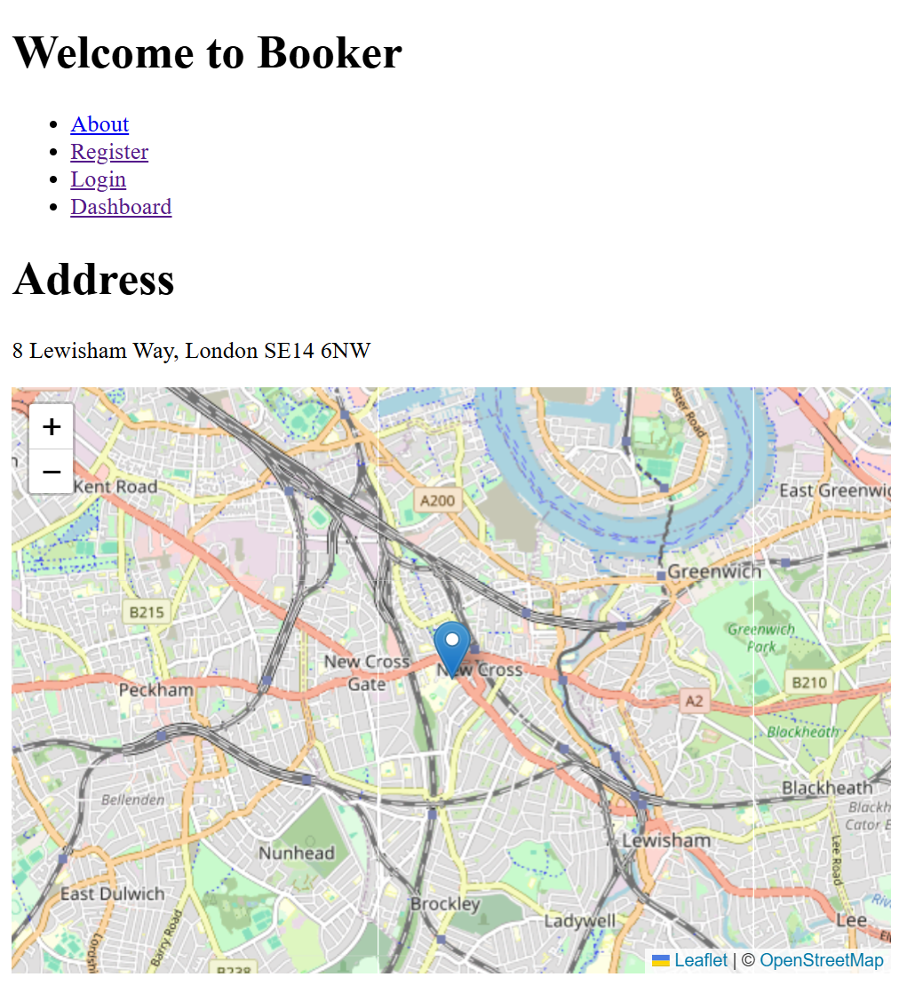
Patients can use the registration page to register. The page has client-side validation and alerts, to guide patients. If patients are unable to register, the page tells them why.
Staff cannot register themselves as they are initialised by the organisation.
Also note that, username field was only added to satisfy the compliance criteria as set out by the ‘final lab assignment instructions’ document. As Booker is not a social app, the use of usernames wholly unnecessary, which is why the initial iteration of Booker does not accept usernames. Usernames are only used for registration and login and nowhere else.
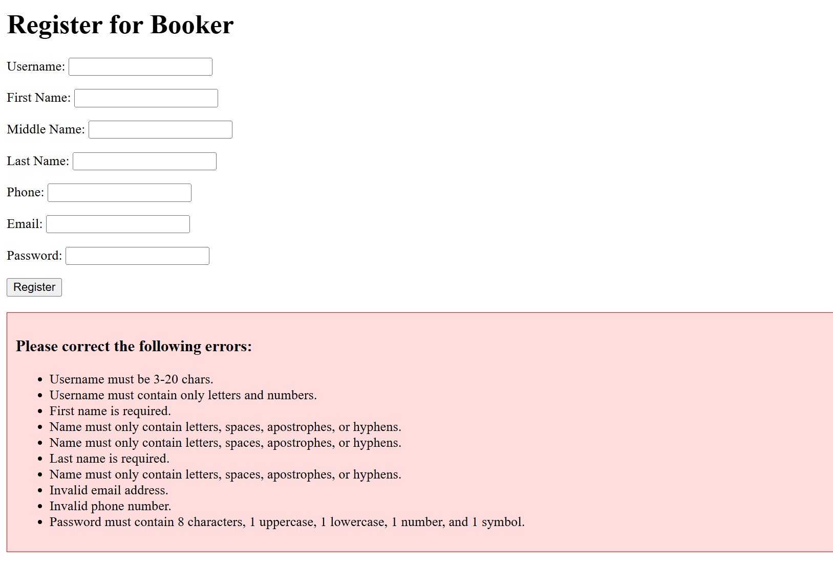
Similarly, the login page also gives feedback to the user to guide them.
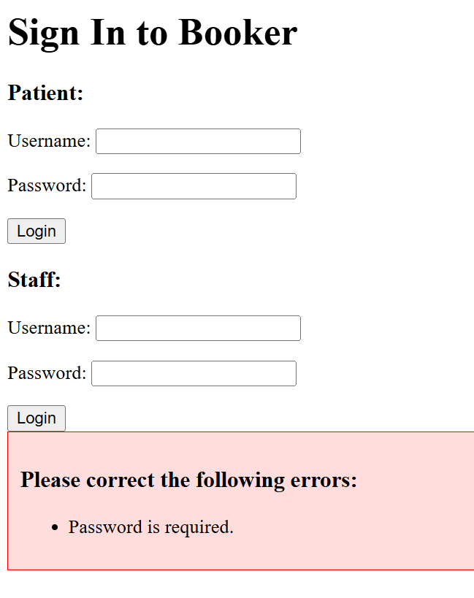
Once logged in, the patient will be able see all their appointments separated into upcoming appointments and past appointments. The appointments are also ordered chronologically to ensure the user can easily find them. Staff will also be able to see the name of the patient that has booked that specific appointment.
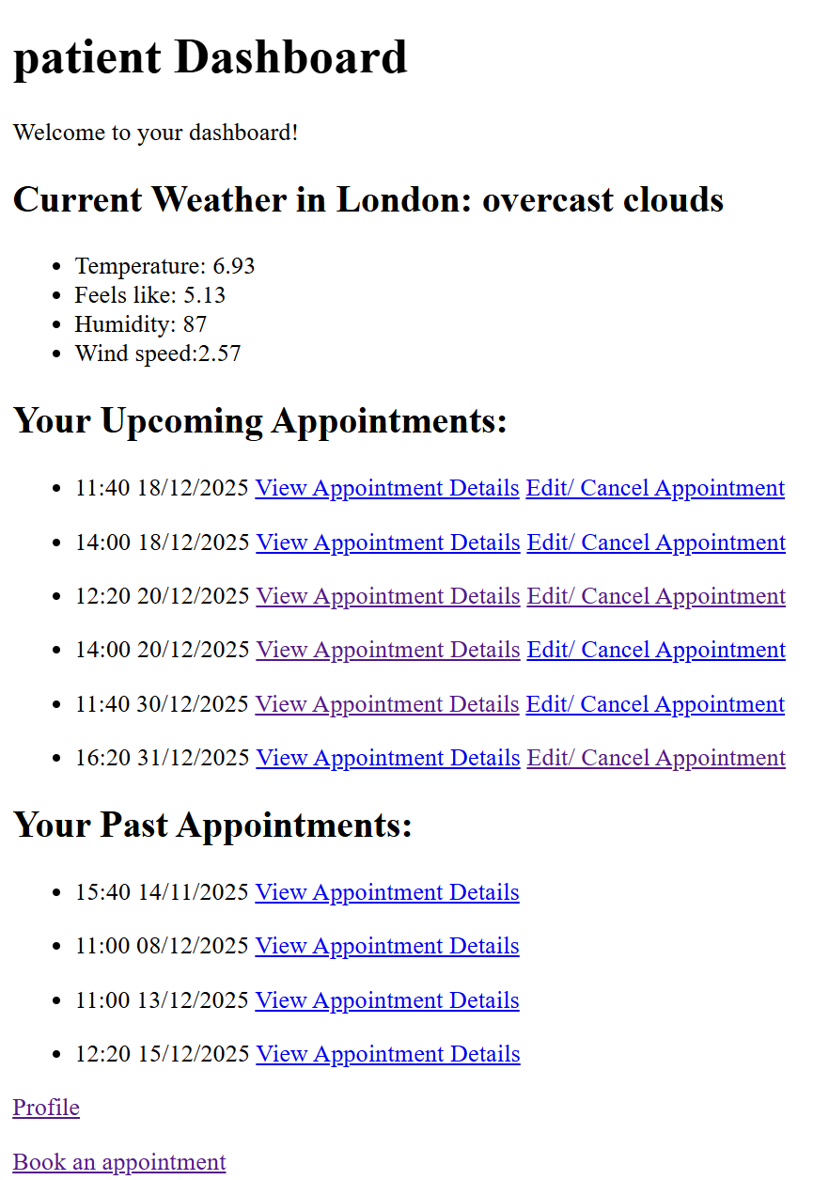
The dashboard presents the user with links to seamlessly book, view and edit appointments.
Patients can also view their profile and change their profile details (staff are unable to change their details themselves).
Staff have a link to be able to search for patients.
When booking appointments, the date has to be anywhere from tomorrow to 6 months at the very latest. This is the same for patients and staff. To ensure this, there is both client-side and server-side validation. Below shows client-side validation.
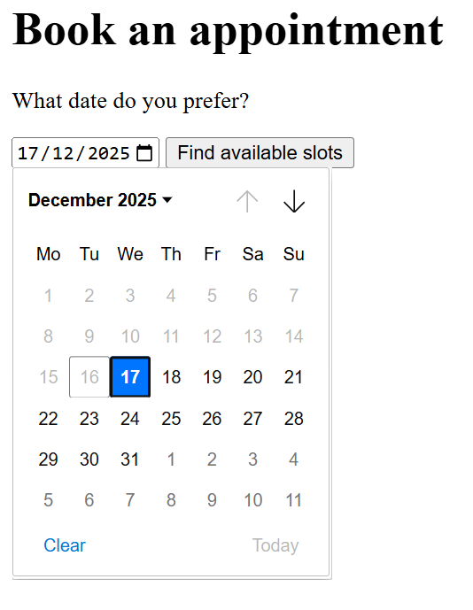
In addition to this, the form provides a predefined list of times to ensure that the patient can only pick times from 9 AM (clinic opening time) to 5 PM (clinic closing time). The time slots presented to the user are dynamically adjusted on the server to ensure only available slots are presented.
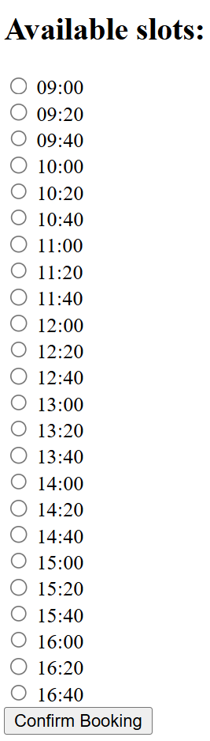
The patient can also include the reason for their appointment, which can be viewed by staff. The patient can also edit or cancel the time of their appointments from the link on the dashboard. The UI for the editing is consistent with the booking to maintain ease-of-use.
As previously mentioned, patients can change their details from the profile page. The profile page runs server-side validation to verify current password before allowing the patient to change it. This is all accompanied by alerts and messages to guide the patient.
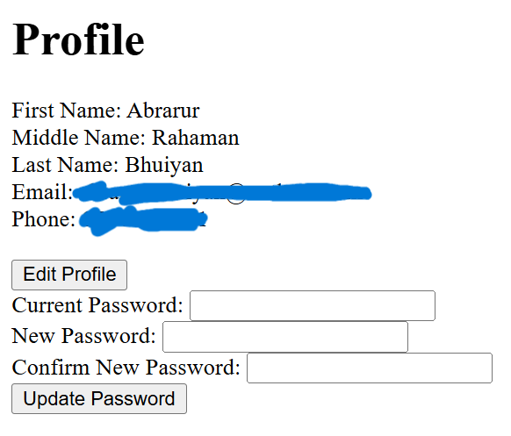
Staff can view and search for patients. Below is the search page.
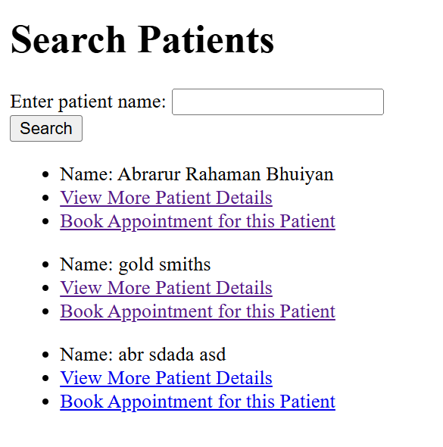
From here, staff can choose to view more details about the patient if they needed their contact information. The patient details page also contains the patient’s appointments.
Staff could also choose to book an appointment for a patient. This feature was added as a safety net for patients, who may get stuck online, and call the clinic to book an appointment over the phone.
Booker is plain and looks incredibly basic. Very little CSS was used in Booker’s creation. While on one hand, this could be seen as taking away from user experience, on the other hand, this means that Booker is a blank canvas for organisations that choose to use it.
Advanced Techniques
Booker handles patient’s data, as such, security is imperative. To achieve maximum security, Booker was built on the principle of least privilege.
Firstly, Booker only holds data that is absolutely necessary. I considered adding weight and height tracking, in addition to other metrics, but quickly dismissed the idea. This is because in the event of a breach, as little as possible should be leaked. Booker holds contact information as it may be needed by the clinic to get in touch with the patient. Additionally, certain information is only made available when the user needs it. For example, a staff member can view all the patient names on the ‘patient search’ page, but they can only view the contact details of a patient by pressing on the ‘view more’ button, by which point this activity will be logged.
Secondly, Booker uses salt and pepper to hash passwords. This makes it incredibly difficult for a hacker to decrypt passwords even if the database was somehow stolen. The pepper is stored separate to the database on the .env file. Passwords are also validated to ensure that they are strong.
Thirdly, validation and sanitisation is done to prevent hackers from performing XSS. This validation and sanitisation is present for every input field in the app. Below shows the validation done upon registration.
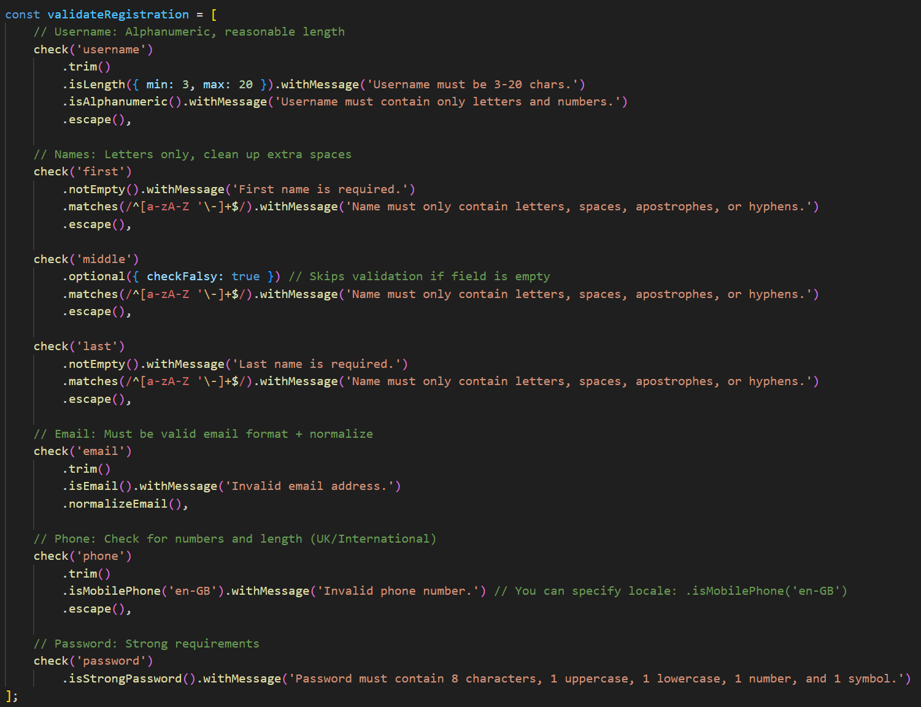
Below is the validation done when bookings are made.
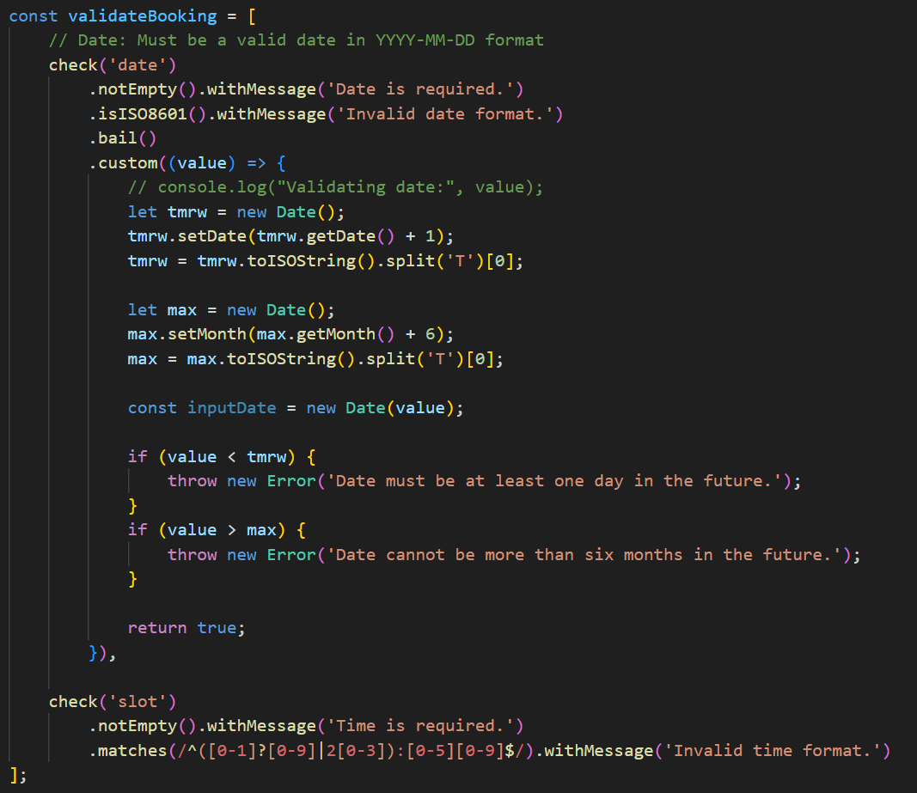
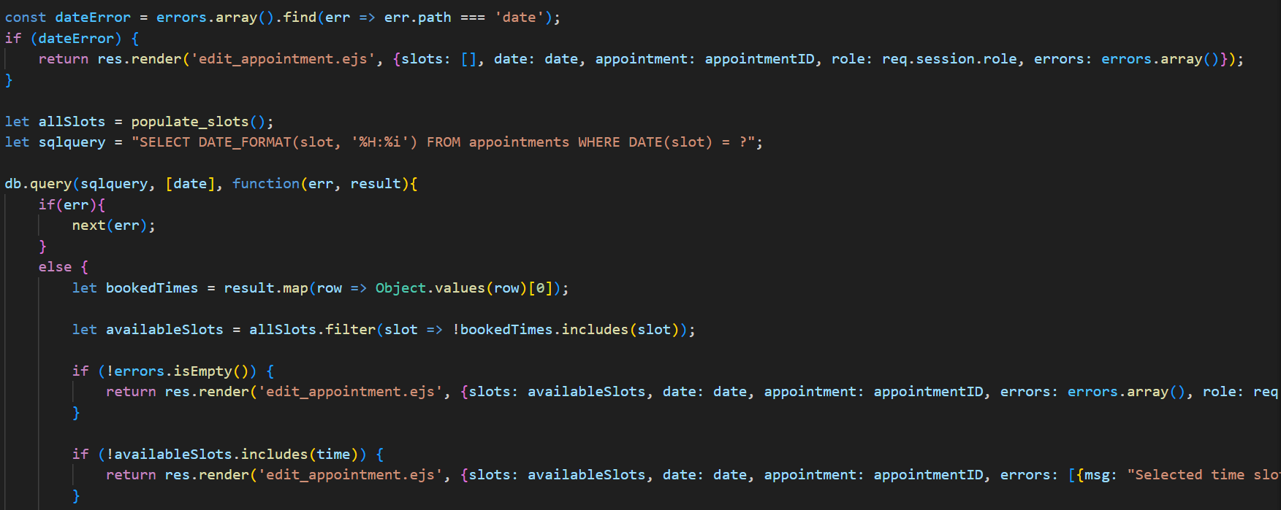
Finally, user activity is logged. Activity that is logged includes:
- Login attempts
- Appointment bookings
- Appointment cancellations
- Appointment time changes
- Patient detail views
Details that are logged for these activities include:
- The identity of the user responsible.
- The details of the change made, for example, the time that the appointment was changed to.
- IP address.
Logging activities is especially important for the staff side of the app. This is because unlike patients, staff have much less restrictions and validations that they must clear, which makes the app vulnerable to insider attacks. In the case of an insider attack (or external attack), we can use the logs to trace back and identify the culprit.
Imagine a scenario where patient details were leaked. The log could be used to identify that a particular staff viewed the details of a certain patient last week Monday. This information could be used in addition to other information to discover the staff that was the culprit.
Below shows the logging of an unsuccessful login attempt.
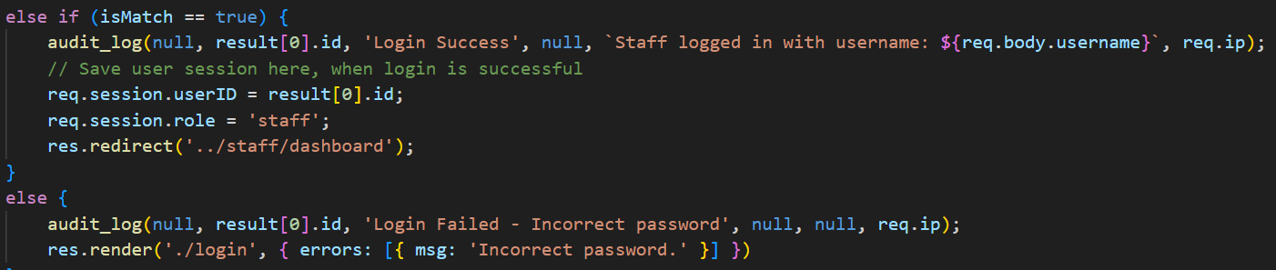
Below shows the cancellation of a booking done by a staff member.
AI Declaration
AI was used sparingly in the creation of Booker. When AI was used, it was used in supplement to other resources, mainly as a way to quickly refer to documentation.

