Sprint 3: Backend Setup & Authentication - Feature Work Evidence
Sprint Duration: 12/09/25 - 12/20/25 (12 days)
Sprint Goal: Set up backend infrastructure and authentication system
Commit : Auth Section Completed
Note: Backend authentication was completed on 12/07/25 (during Sprint 2), ahead of schedule.

Evidence Summary
Sprint 3 established the server-side foundation with Express.js, PostgreSQL, and JWT authentication.
1. Express.js Backend Server
Files Created: backend/src/app.ts (70 lines), backend/src/server.ts (71 lines)
Date: 12/07/25
Status: Complete
Implementation:
- Express.js application with TypeScript
- Security middleware (Helmet, CORS)
- Rate limiting and error handling
- Environment configuration
- Request logging with Winston
Code Snippet - backend/src/app.ts:
import express, { Application } from 'express';
import cors from 'cors';
import helmet from 'helmet';
import authRoutes from './routes/authRoutes';
import { errorHandler } from './middleware/errorHandler';
import { rateLimiter } from './middleware/rateLimiter';

const app: Application = express();

app.use(helmet());
app.use(cors({
origin: process.env.FRONTEND_URL || 'http://localhost:3000',
credentials: true
}));
app.use(express.json());
app.use('/api/', rateLimiter);
app.use('/api/auth', authRoutes);
app.use(errorHandler);

export default app;
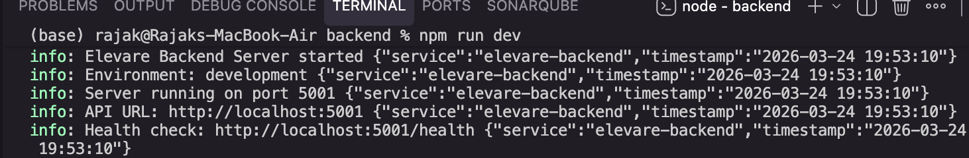
Figure 1: Backend Running
Git Evidence:
Commit: 45e2a725eef545ce18ec8996bd0be086de28c127
Date: 2025-12-07 17:17:24 +0545
Message: "Completed auth section"
Files: app.ts, server.ts, package.json, tsconfig.json

2. PostgreSQL Database Configuration
Files Created: backend/src/db/connection.ts (87 lines)
Date: 12/07/25
Status: Complete
Implementation:
- Connection pool configuration (max 20 clients)
- Query execution utilities
- Transaction support
- Connection health checks
- Error handling and logging
Code Snippet - backend/src/db/connection.ts:
import { Pool, QueryResult } from 'pg';
import config from '../config';
import logger from '../utils/logger';

const pool = new Pool({
connectionString: config.databaseUrl,
max: 20,
idleTimeoutMillis: 30000,
connectionTimeoutMillis: 2000,
});

export async function query(text: string, params?: any[]): Promise<QueryResult> {
const start = Date.now();
try {
const result = await pool.query(text, params);
const duration = Date.now() - start;
logger.debug('Executed query', { text, duration, rows: result.rowCount });
return result;
} catch (error) {
logger.error('Query error:', { text, error });
throw error;
}
}
Database Migrations:
- Users Table (20241126000001_create_users_table.sql - 29 lines)
  - UUID primary key, email (unique), password_hash, name, email_verified flag
  - Timestamps with auto-update trigger
- OTP Verification (add_otp_verification.sql - 9 lines)
  - OTP code storage with expiration
- Password Reset Tokens (20241126000002_create_password_reset_tokens_table.sql - 15 lines)
  - Token storage with expiration and used flag

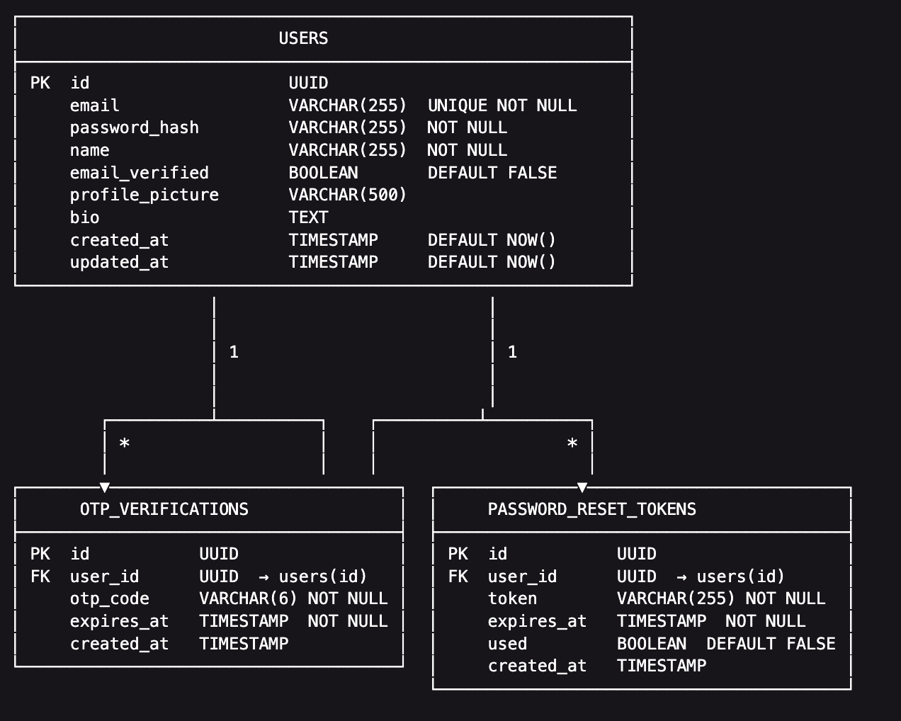
Figure 2: Schema Relationship

3. JWT Authentication System
Files Created: backend/src/services/authService.ts (414 lines), backend/src/middleware/auth.ts (82 lines)
Date: 12/07/25
Status: Complete
Implementation:
- JWT token generation and verification
- Password hashing with bcrypt (10 salt rounds)
- User registration with OTP generation
- Login with password verification
- Authentication middleware for protected routes
Code Snippet - JWT Token Generation:
import jwt from 'jsonwebtoken';
import bcrypt from 'bcrypt';
import config from '../config';

export function generateToken(payload: { userId: string; email: string }): string {
return jwt.sign(payload, config.jwtSecret, {
expiresIn: config.jwtExpiresIn,
});
}

export async function hashPassword(password: string): Promise<string> {
return await bcrypt.hash(password, 10);
}

export async function comparePassword(password: string, hash: string): Promise<boolean> {
return await bcrypt.compare(password, hash);
}
4. User Registration & Email Verification
Files Created: backend/src/controllers/authController.ts (515 lines), backend/src/services/emailService.ts (138 lines)
Date: 12/07/25
Status: Complete
Implementation:
- Registration endpoint with input validation
- OTP generation (6-digit code, 10-minute expiration)
- Email service with Nodemailer
- OTP verification endpoint
- Resend OTP functionality
Code Snippet - Registration Controller:
export async function register(req: Request, res: Response): Promise<void> {
const { email, password, name } = req.body;

const { user, otp } = await authService.register({ email, password, name });

await emailService.sendOTPEmail(email, name, otp);

res.status(201).json({
message: 'User registered successfully. Please check your email for the OTP code.',
user,
requiresVerification: true,
});
}
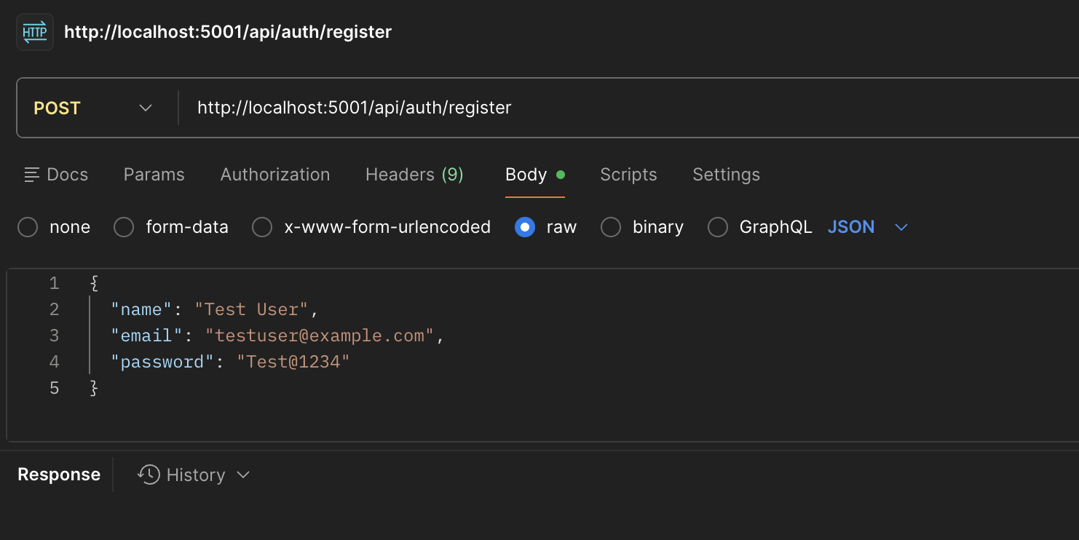
Figure 3: Entering Valid Registration Details
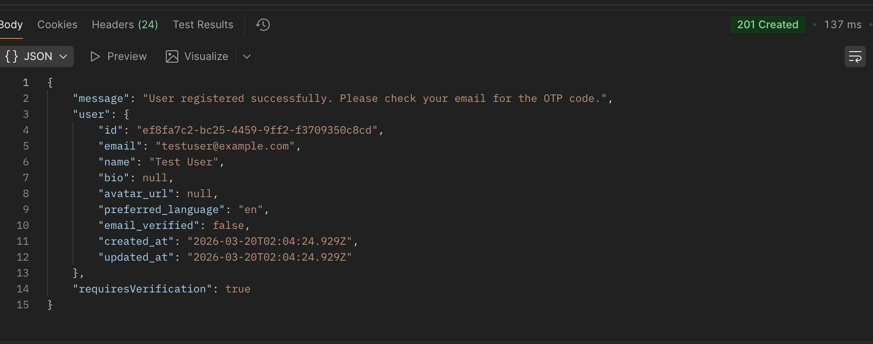
Figure 4: User registered successfully message
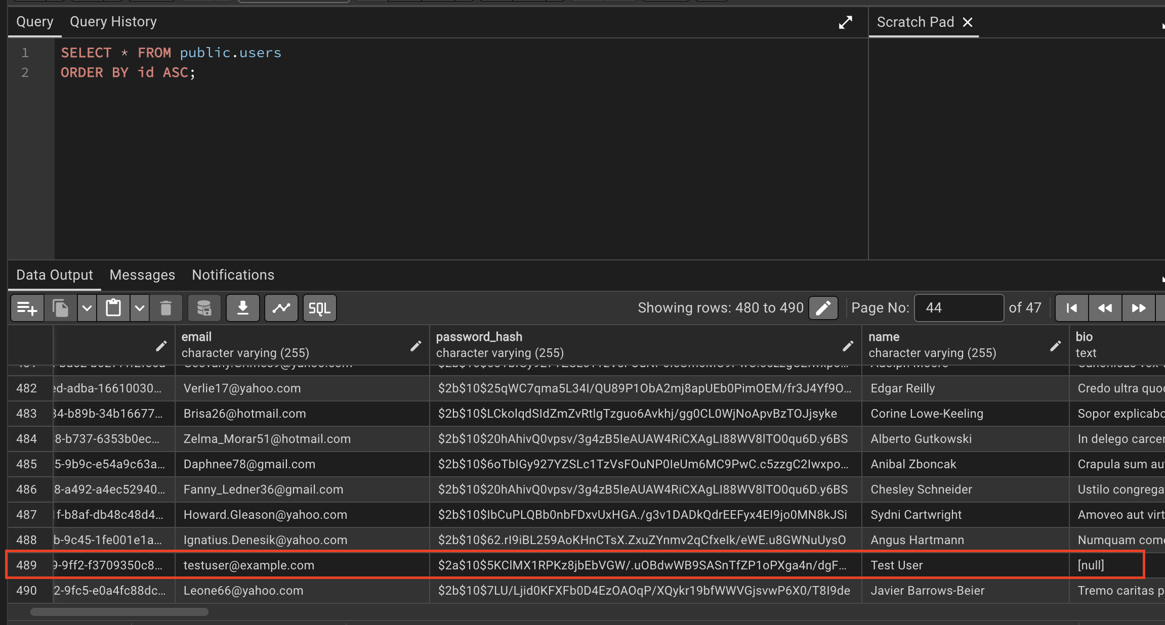
Figure 5: User added in Database
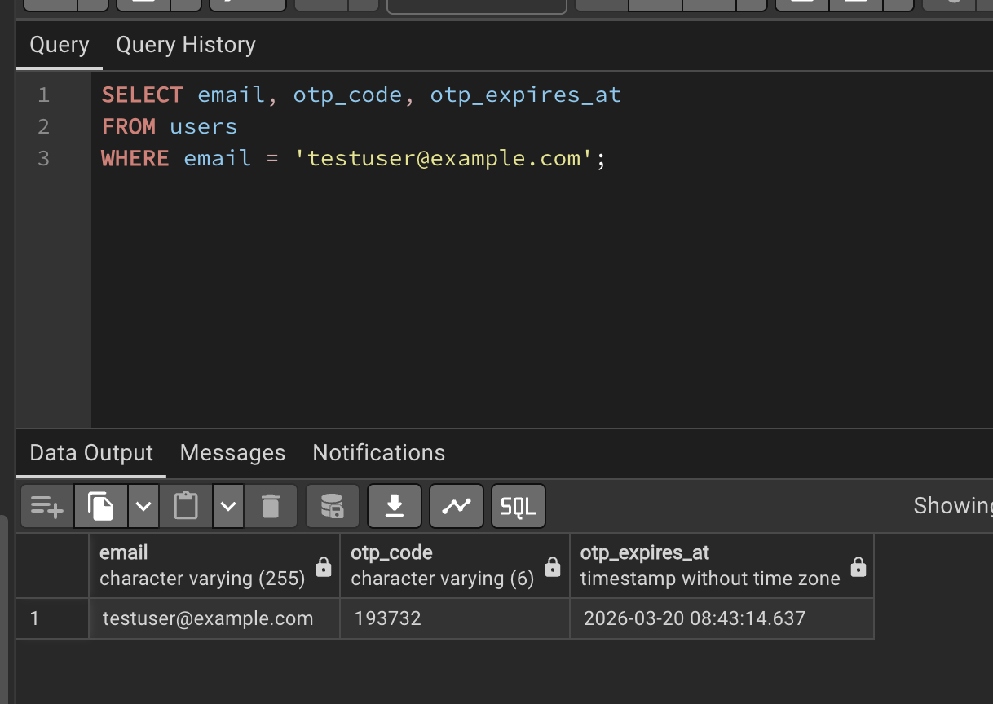
Figure 6: Getting OTP for the user
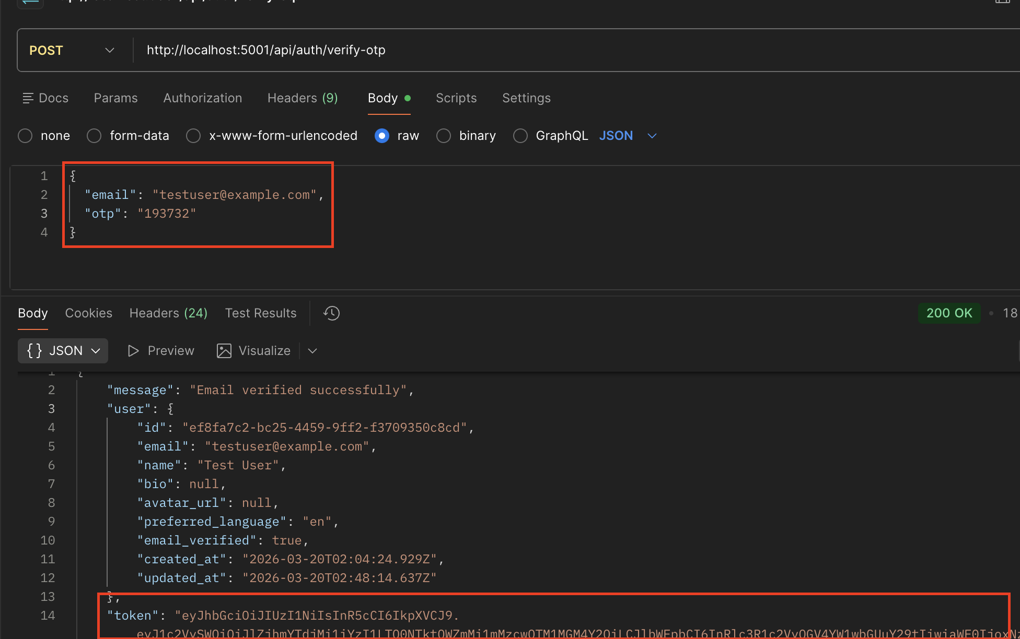
Figure 7: OTP verified successfully

5. Secure Login & Session Management
Implementation:
- Login endpoint with email/password validation
- Email verification check before login
- Password comparison with bcrypt
- JWT token generation on successful login
- Rate limiting (5 attempts per 15 minutes)
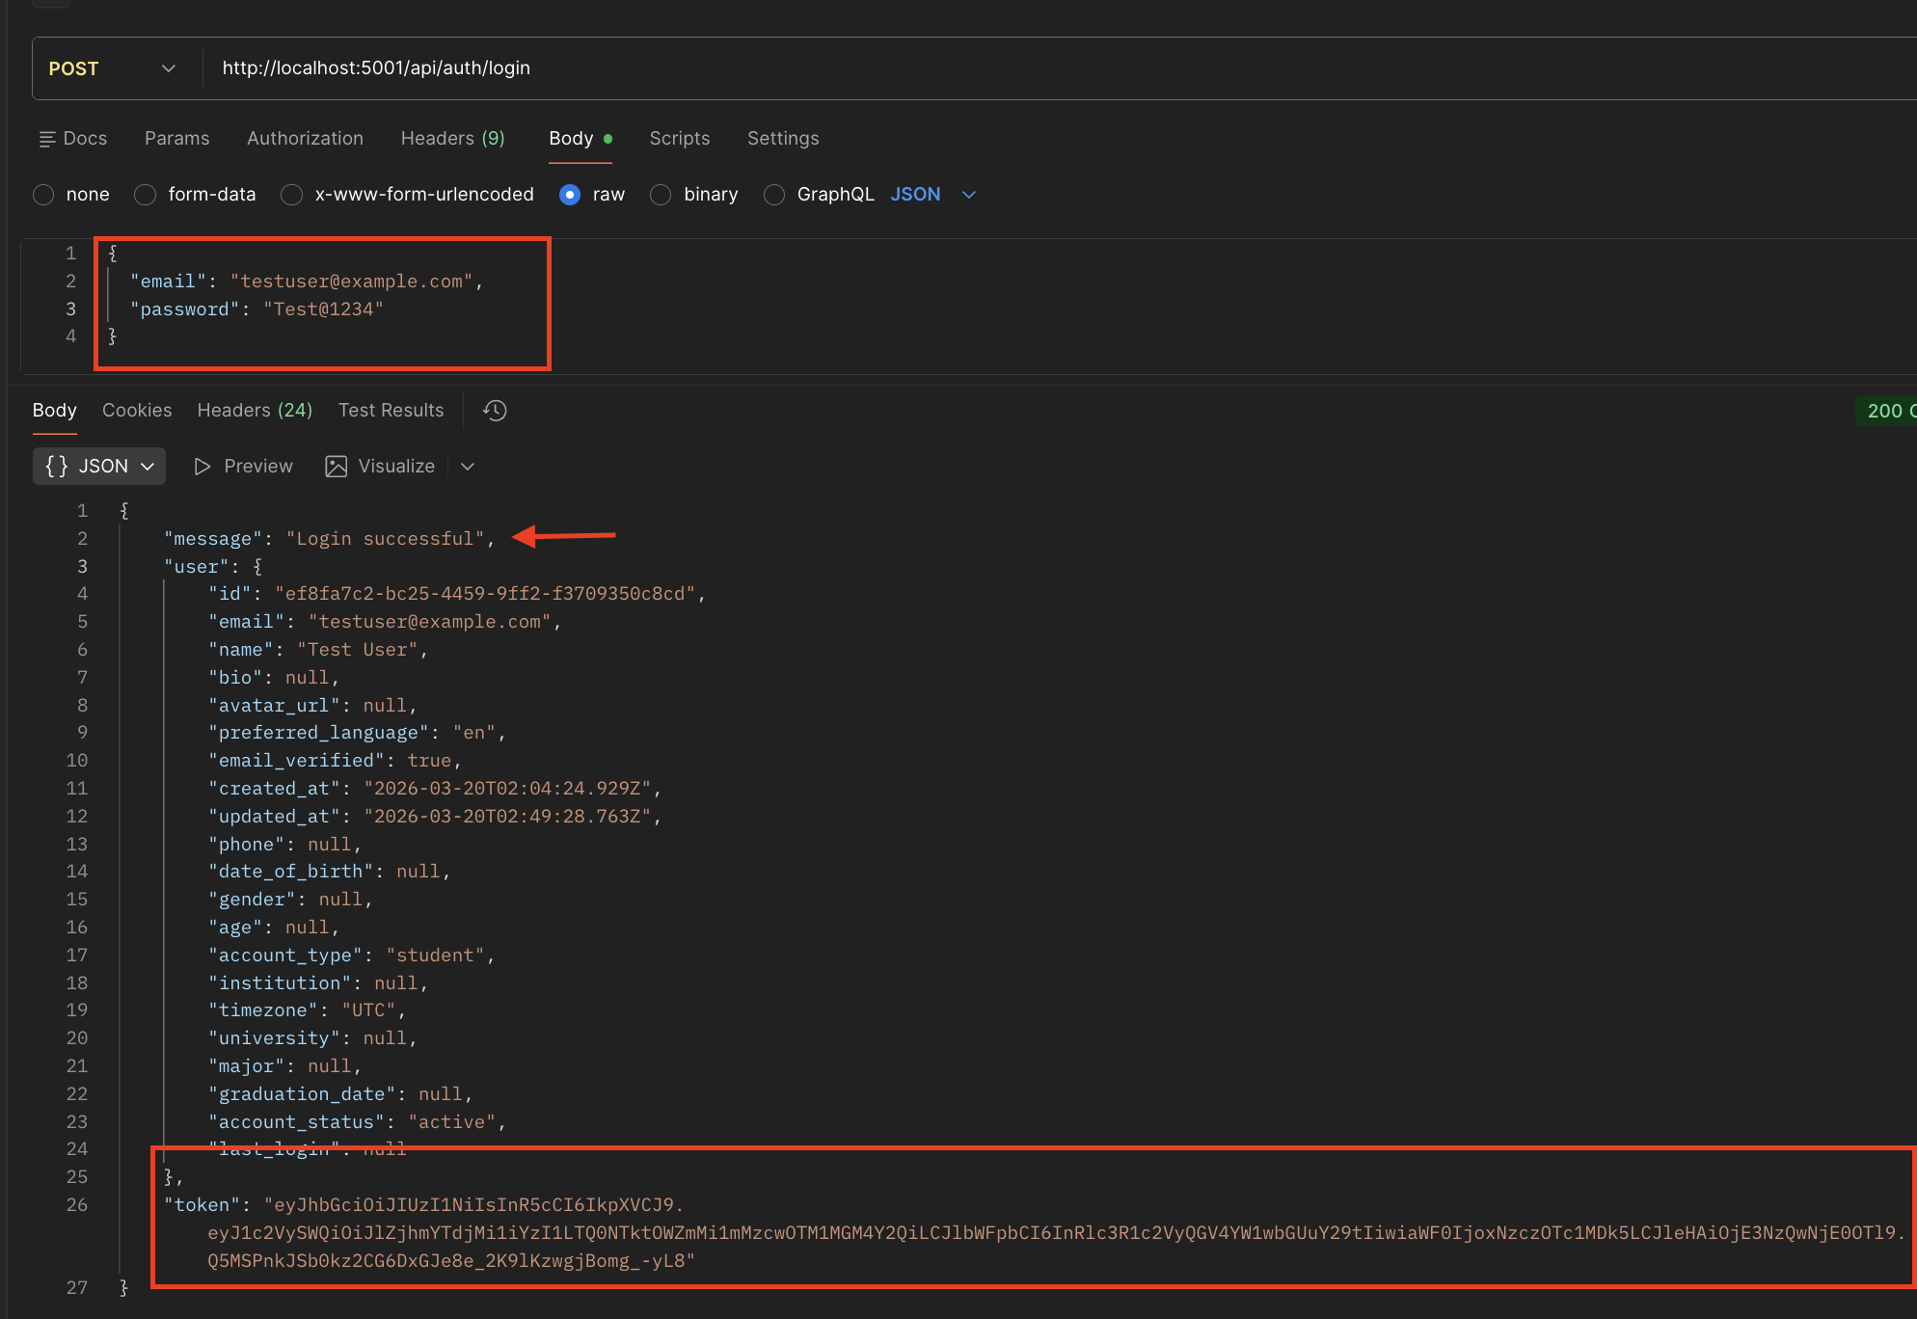
Figure 8: Login Successful

6. Password Reset Functionality
Implementation:
- Forgot password endpoint (generates reset token)
- Password reset email with token link
- Reset password endpoint (validates token, updates password)
- Token expiration (1 hour)
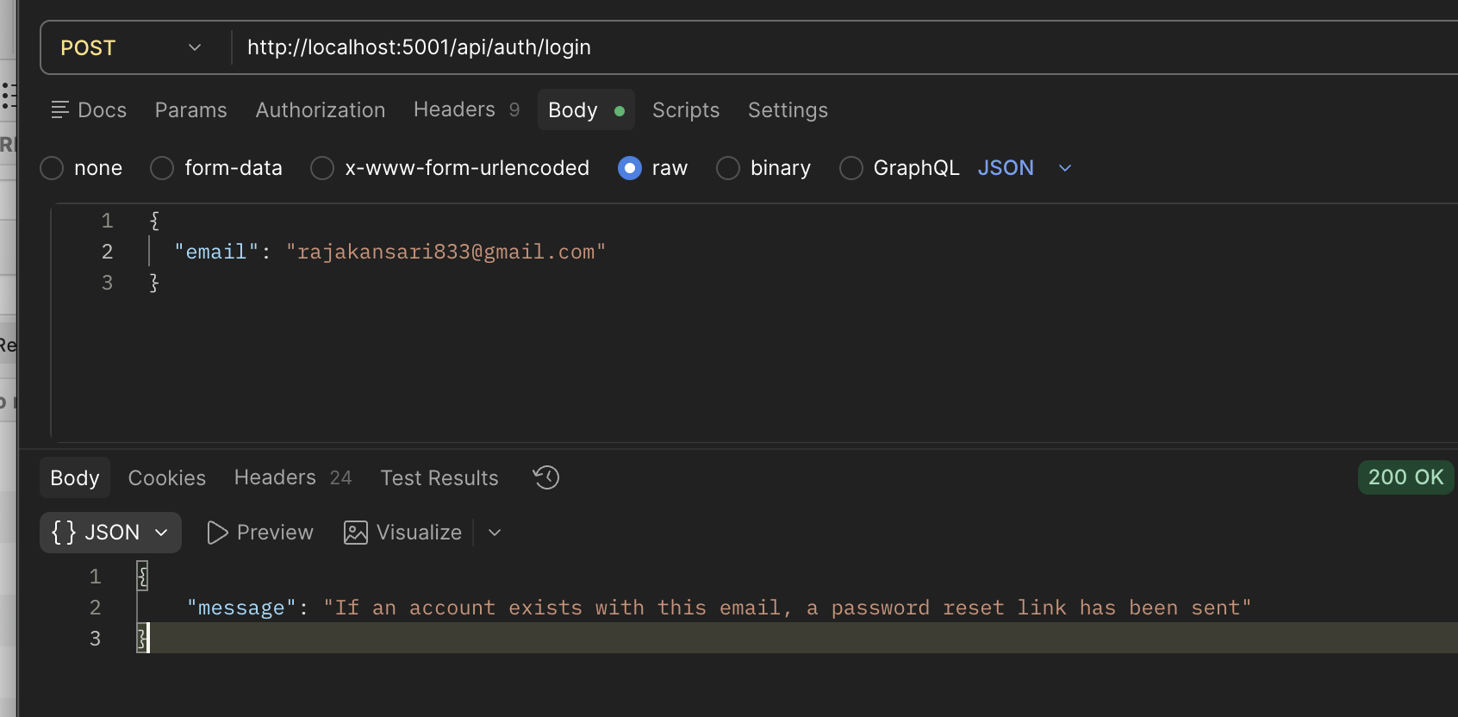
Figure 9: Sending request
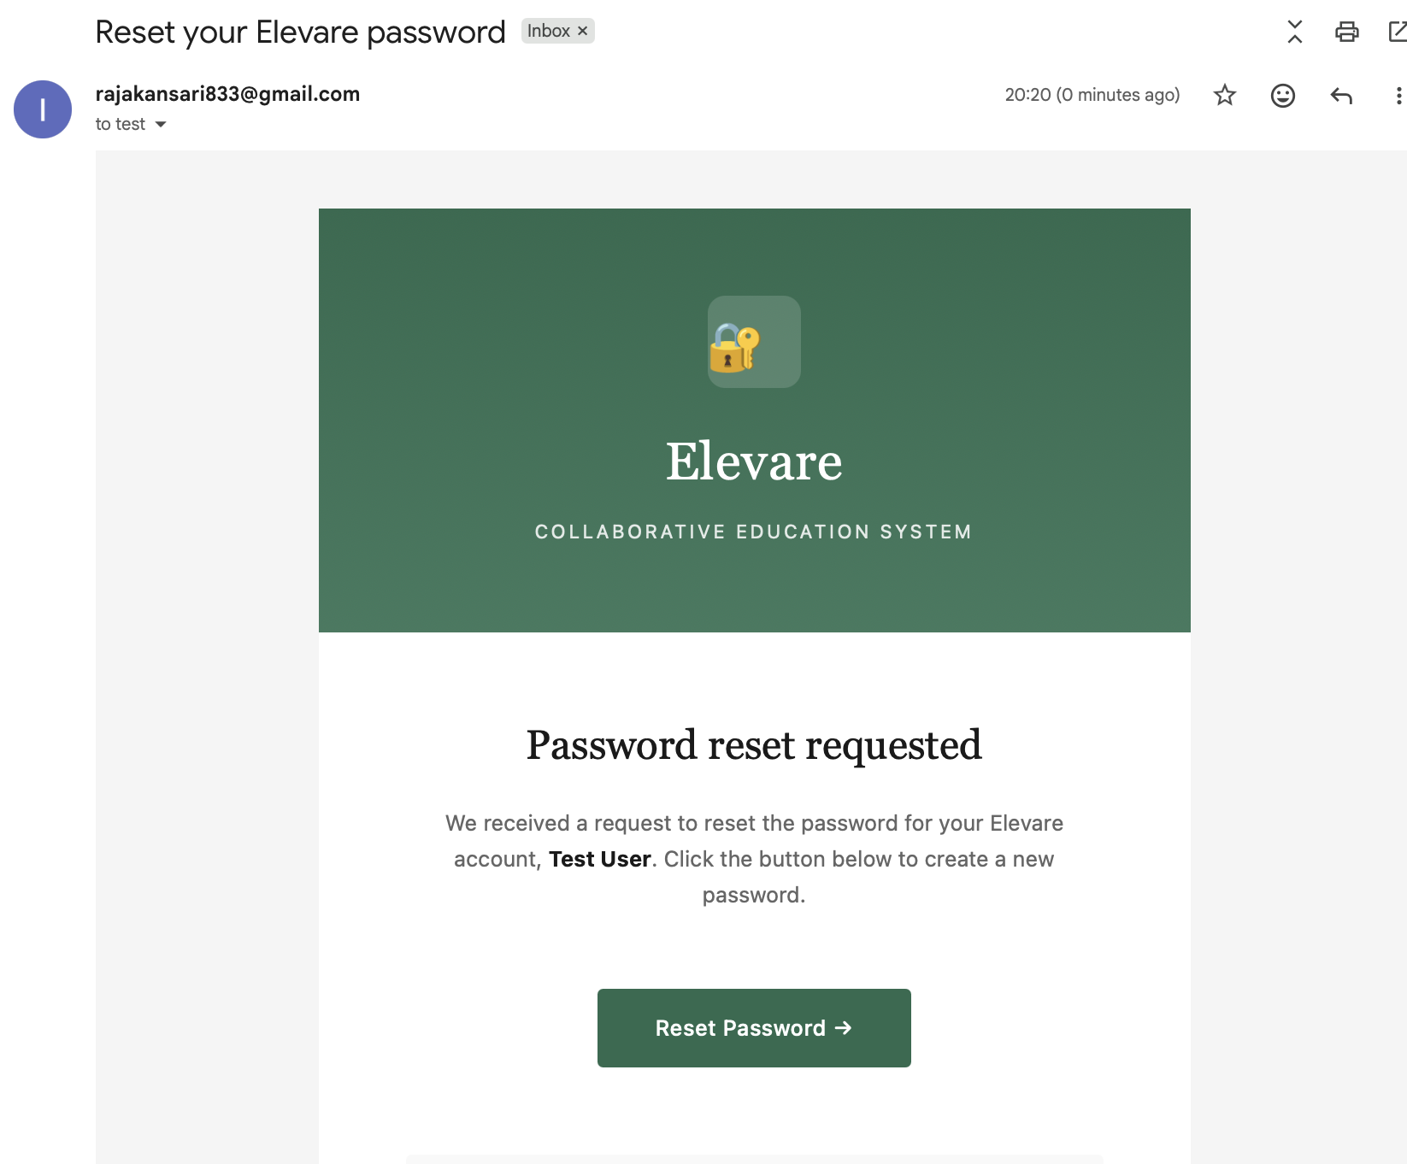
Figure 10: Mail Received

7. Middleware & Security
Files Created:
- errorHandler.ts (63 lines) - Centralized error handling
- rateLimiter.ts (66 lines) - API rate limiting
- auth.ts (82 lines) - JWT authentication middleware
- validation.ts (102 lines) - Input validation with express-validator
Security Features:
- Helmet security headers
- CORS configuration
- Rate limiting (100 requests/15 min general, 5 requests/15 min auth)
- Input validation and sanitization
- SQL injection prevention (parameterized queries)
- Password strength requirements (8+ chars, uppercase, lowercase, number)
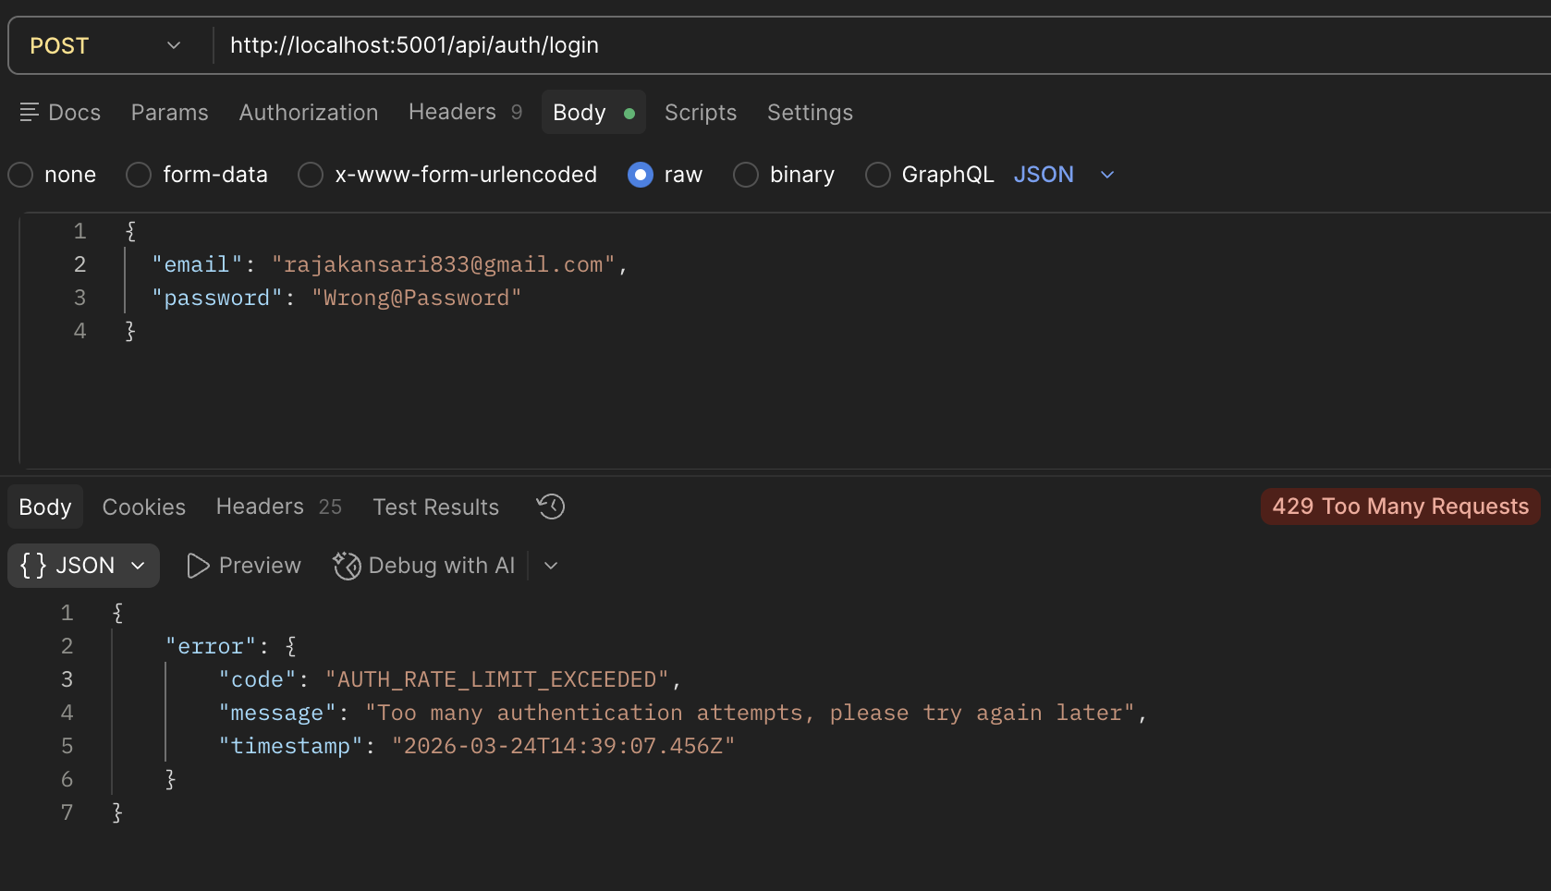
Figure 11: Rate Limiting Applied

8. API Routes
File Created: backend/src/routes/authRoutes.ts (65 lines)
Date: 12/07/25
Status: Complete
Endpoints Implemented:
- POST /api/auth/register - User registration
- POST /api/auth/login - User login
- POST /api/auth/verify-otp - Email verification
- POST /api/auth/resend-otp - Resend OTP
- POST /api/auth/forgot-password - Request password reset
All these endpoints evidence have been shown in the diagrams above.
Quantitative Metrics
- Total Files Created: 34 files
- Total Lines Added: 3,768+ lines
- Controllers: 1 file (515 lines)
- Services: 2 files (552 lines)
- Middleware: 4 files (313 lines)
- Routes: 1 file (65 lines)
- Database Migrations: 3 files (53 lines)
Dependencies Installed
- express (4.18.2), pg (8.11.3), bcrypt (5.1.1), jsonwebtoken (9.0.2)
- express-validator (7.0.1), express-rate-limit (7.1.5), nodemailer (6.9.7)
- cors (2.8.5), helmet (7.1.0), morgan (1.10.0), winston (3.11.0)

Feature Completion
- Express.js server setup
- PostgreSQL database configuration
- JWT authentication
- User registration with OTP
- Email verification
- Secure login
- Password hashing (bcrypt)
- Password reset
- Rate limiting
- Input validation
- Error handling
Sprint Timeline
12/07: Initialize Express.js backend with TypeScript
12/07: Configure PostgreSQL database connection
12/07: Implement JWT authentication system
12/07: Create user registration with OTP verification
12/07: Implement secure login with bcrypt
12/07: Add password reset functionality
12/07: Configure authentication routes and middleware
12/07: Git commit - "Completed auth section" (3,768+ lines)
12/10: Add database migrations to repository

