Next to
Contract Name: FREE TEXT
INS Contracting Party: Dropdown List - Image Nation Studios FZ LLC / Image Nation Cayman / Image Nation Cayman Feeder Ltd / Image Nation US Feeder / Hyde Park Image Nation / Hyde Park Image Nation Singapore / Parkes MacDonald Image Nation / PM/Fund / IN Splitter / Third Party Entity
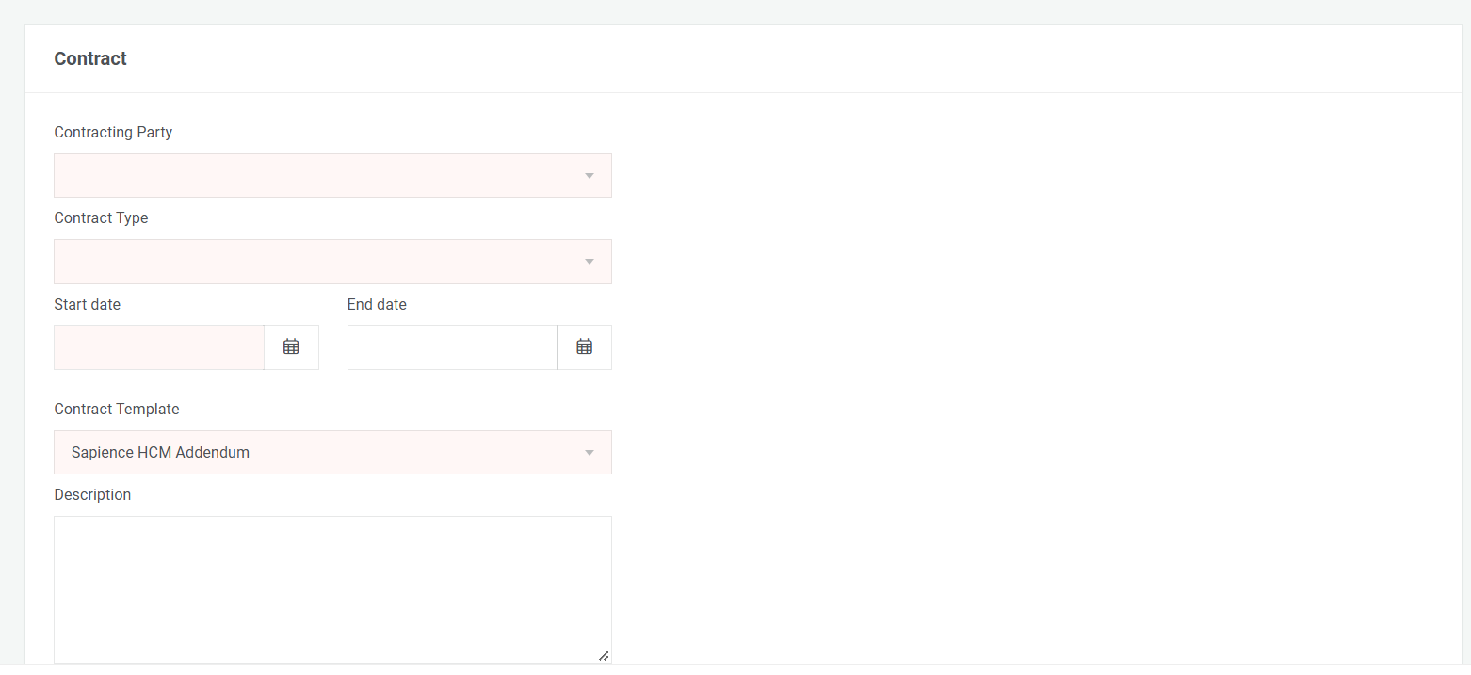
Department: TO BE AUTOMATICALLY DETECTED BASED ON THE LOGIN OF THE CONTRACT INITIATOR
Contract Value (Exclusive of VAT) : NUMERIC FIELD WITH A CURRENCY SELECTION DROPDOWN
VAT Amount (5% of Contract Value): AUTOMATICALLY CALCULATED AS 5% OF THE CONTRACT VALUE WITH A CURRENCY SELECTION DROPDOWN
Total Contract Value (Contract Value + 5% VAT): AUTOMATICALLY CALCULATED AS CONTRACT VALUE + VAT AMOUNT WITH A CURRENCY SELECTION DROPDOWN
Payment Terms: FREE TEXT
Payer Invoicing Entity: FREE TEXT
Payee Invoicing Entity: FREE TEXT

Dropdown List: New / Renew / Amendment / Extension / Variation / Additional Services

Project Owner: FREE TEXT
Project Related: FREE TEXT
Contract Status: Dropdown list – In Process / Fully Executed and Complete / Closed/Not Proceeding

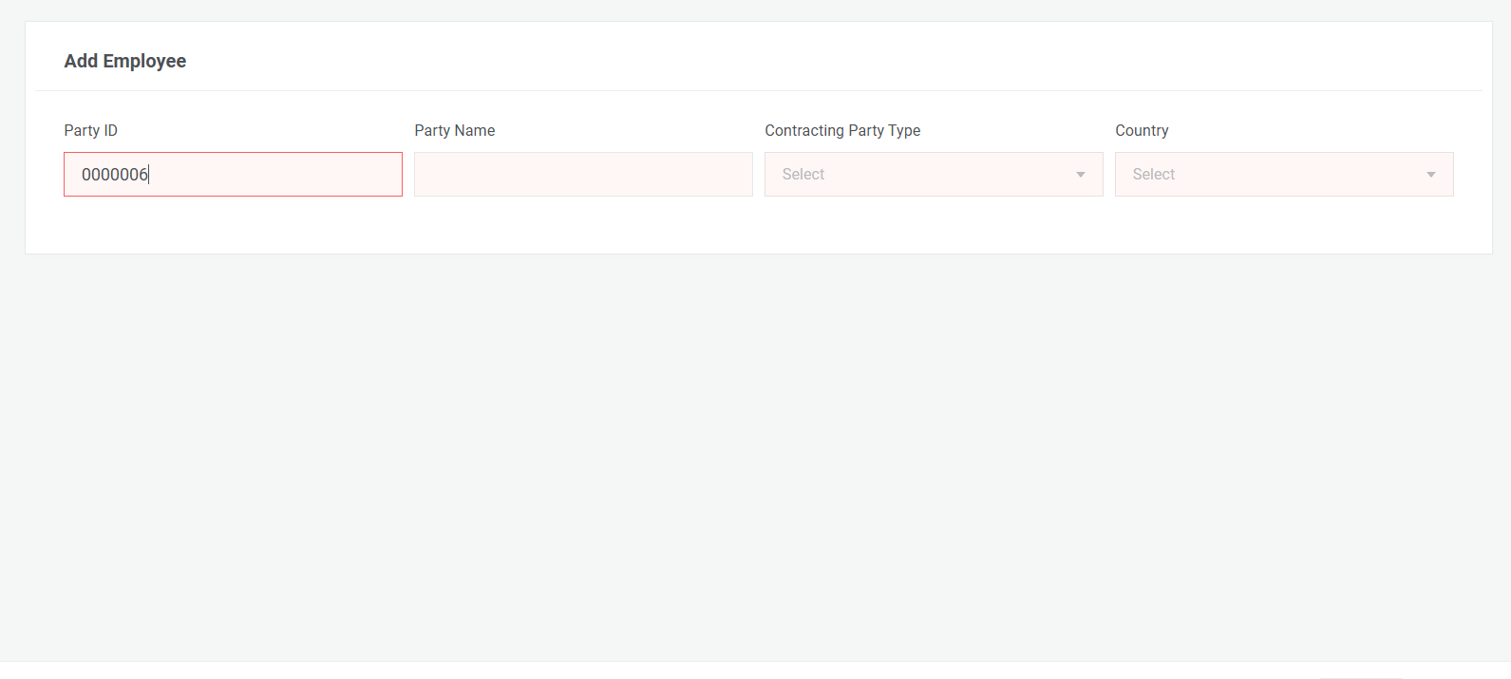
Please add a dropdown list for the “Non-Supplier” category
Address: FREE TEXT
Is other Contract Party's place of residence/establishment within a) UAE, b) GCC (except UAE), c) Outside GCC?: FREE TEXT
Other Contract Party's specific place of residence/establishment: FREE TEXT
If Other Contracting Party is (i) a Company - upload valid Trade Licence, (ii) an Indiviual - upload valid passport ID: FREE TEXT

Contracting Party

