BUSINESS REQUIREMENTS DOCUMENT
Contract Lifecycle Management
Image Nation Abu Dhabi
Purpose
Define the business, functional, data, workflow, security and integration requirements for a centralized legal and contract lifecycle management platform supporting Image Nation's internal Legal department and wider business users.

Document status | Draft for Validation
Version | 1.1
Date | 24 September 2026
Prepared by | Business Analysis Team

Document Control
Field | Detail
Document title | Business Requirements Document - Contract Lifecycle Management
Organization | Image Nation Abu Dhabi
Document owner | Business / Legal stakeholder - to be nominated
Status | Draft for Validation
Version | 1.1
Prepared date | 24 September 2026
Intended use | Business validation, solution design, vendor evaluation and implementation planning

Review and Approval Record
Role | Name | Review / Approval | Date
Executive Sponsor | TBC | Approval | TBC
Head of Legal / Legal Representative | TBC | Approval | TBC
Finance Representative | TBC | Review | TBC
Production / Project Representative | TBC | Review | TBC
IT / Information Security | TBC | Review | TBC

Document status
This version is intentionally marked Draft for Validation. It converts the known discovery requirements into an implementation-ready structure and identifies policy, data and operating-model points that should be confirmed in business workshops.

Table of Contents
1. Executive Summary | 4
2. Business Context and Drivers | 5
3. Purpose, Objectives and Scope | 6
4. Stakeholders and User Groups | 7
5. Future-State Contract Lifecycle | 8
6. Business and Functional Requirements | 9
7. Contract Lifecycle Journeys and Swim-Lane Process Maps | 14
8. Business Rules | 21
9. Information and Data Requirements | 22
10. Delegation of Authority and Approval Model | 23
11. Rights, Milestones, Options and Contractual Obligations | 24
12. Reporting, Dashboards and Management Information | 24
13. Security, Access and Compliance Requirements | 25
14. Integration Requirements | 25
15. Localization, Capacity and Scalability | 26
16. Non-Functional Requirements | 27
17. Migration and Repository Onboarding | 27
18. Business Acceptance Criteria | 28
19. Assumptions and Dependencies | 29
20. Open Questions for Business Validation | 29
21. Implementation Priorities and Suggested Phasing | 30
Appendix A - Requirements Traceability Matrix | 32
Appendix B - Glossary | 37
Appendix C - Diagram Inventory | 37

1. Executive Summary
Image Nation manages contracts that are closely tied to media projects, intellectual property, production commitments, distribution rights and commercial obligations. The contract record therefore needs to do more than store a signed PDF: it must preserve the history of the deal, route approvals correctly, support global execution and continue to manage rights, milestones, options and renewal dates after signature.
The required future-state capability is a centralized Contract Lifecycle Management (CLM) environment that serves as the authoritative record for each agreement and supports the day-to-day operation of Image Nation's internal Legal department. Legal users and authorized business users across departments should be able to initiate agreement requests, Legal should be able to allocate work through individual lawyer queues, and every agreement should remain governed through a controlled lifecycle from request and drafting through approval, signature, active obligation monitoring, renewal and closure.
The highest-priority controls are flexible agreement initiation, complete draft version history, configurable Corporate DOA and Projects DOA routing, individual lawyer assignment and reassignment, document locking during formal approval and signature, repeatable reminders for critical dates, rights and licensing visibility, e-signature or controlled manual execution, enterprise-grade security, and integration with Microsoft Dynamics 365 Business Central. The platform must also support the practical reality of media contracting: multiple stakeholders, high-frequency redlining, project-specific approvals, exceptional international co-production routes, and time-sensitive production deliverables.
What success looks like
Legal, production, finance and management can answer three questions from one place: What is the current contractual position? Who approved and signed it? What obligations, rights, milestones or dates require action next?

1.1 Business Outcomes
- A single, searchable repository organized around projects and titles rather than disconnected files or inboxes.
- An audit trail covering draft history, approvals, signatures, changes and post-execution actions.
- Fewer missed option dates, renewals, distribution windows and contractual milestones through repeatable alerts and dashboards.
- Faster, more consistent approvals through configurable DOA rules and clear ownership at each stage.
- Reduced risk of working from the wrong draft by archiving every iteration and locking documents when submitted for approval or signature.
- Secure collaboration with internal and external stakeholders using SSO, 2FA, role-based access and controlled e-signature.
- A scalable foundation that can operate standalone or integrate with the broader enterprise architecture through APIs.

1.2 Requirement Baseline
Theme | Baseline requirement
Repository | Project/title-centric organization; contract-type classification; linked appendices, NDAs and privacy documents.
Drafting | Complete and immutable version history for high-frequency drafting cycles; no overwrite of historical versions.
Approvals | Layered DOA routing across project, corporate, exceptional and ad-hoc scenarios.
Execution | DocuSign and Adobe Sign interoperability, controlled signature positioning and final executed-copy capture.
Post-execution | Milestones, rights windows, option dates, expiries, auto-renewals and repeating reminders.
Security | Group and user-level access, Microsoft 365 SSO, 2FA.
Localization | English, Arabic interface / metadata support, subject to final localization scope.
Capacity | Initial planning baseline of approximately X active contracts and at least X users, with headroom for growth.

2. Business Context and Drivers
Contracts sit at the center of Image Nation’s operating model because they define ownership, services, talent commitments, financial terms, distribution rights and exploitation windows. A contract may begin as a project-specific commercial arrangement but can remain operationally relevant for years through options, renewals, rights windows, amendments, deliverables and payment obligations.
The discovery requirements point to a move away from manual document handling toward a governed CLM model. The business concern is not simply document storage; it is control over the chronology and status of the agreement. Where a negotiation can run through many redline cycles, or where approval authority changes according to value, entity or risk, the system must make the applicable version and decision path unambiguous.

2.1 Key Business Drivers
Driver | Business implication
Version control | A complete chronological archive is needed because contracts may pass through 13 or more drafts before execution.
IP and rights protection | Distribution windows, territorial rights and option dates require structured tracking, not only narrative text in a document.
Approval governance | Project-level and corporate approvals must be enforced through configurable DOA logic with an audit trail.
Production timing | Contractual milestones such as Locked Cut or Final Sound Mix need action-oriented tracking and escalation.
Global execution | Parties may operate across time zones; e-signature and standardized signature positioning are required.
Information security | Sensitive commercial and talent information must be restricted to authorized groups and individuals.
Enterprise interoperability | The CLM should be usable as a standalone platform and be capable of API integration with the enterprise environment.

2.2 Current-State Pain Points to Address
- Risk of version ambiguity when multiple redlines and draft copies circulate between stakeholders.
- Potential for signed or supporting documentation to remain isolated in email or disconnected storage locations.
- Manual effort in determining the correct approval path for project, corporate or exceptional deals.
- Limited portfolio-level visibility of renewals, option dates, rights expirations and contractual milestones.
- Dependence on individual knowledge to remember critical dates and follow up obligations.
- Difficulty demonstrating a complete history of who changed, approved, rejected, signed or acted on a contract.

3. Purpose, Objectives and Scope

3.1 Purpose of this BRD
This BRD defines the business requirements for selecting, configuring and implementing a Contract Lifecycle Management solution for Image Nation. It is written as a business-facing specification: requirements are stated in terms of the control, information or outcome required, while detailed technical design choices remain for solution design.

3.2 Objectives
- Establish one governed agreement record from request through closure, regardless of whether the request is initiated by Legal or an authorized business user.
- Create consistent and auditable workflows for drafting, lawyer assignment, approval and execution, while allowing approved templates, third-party drafts and agreements created from scratch.
- Protect IP and commercial rights through structured tracking of territories, windows, options and expiry dates.
- Give contract owners clear accountability for post-execution obligations and milestones.
- Enable secure role-based access and collaboration across Legal, Finance, Procurement, Production / Project teams, Management and other authorized departments.
- Integrate with enterprise authentication, e-signature, document-intake channels and Microsoft Dynamics 365 Business Central without creating unnecessary vendor lock-in.

3.3 In Scope
- Agreement request and intake by Legal and authorized end users across departments, including email-based intake where required.
- Project/title-based contract repository and a configurable agreement taxonomy that allows administrators to add and maintain agreement types.
- Drafting from predefined templates, upload of existing or third-party agreements, creation from scratch, version history, redlining chronology and controlled document locking.
- Configurable approval routing based on Image Nation's Corporate DOA and Projects DOA, including rejection, resubmission, exceptional and ad-hoc approval paths.
- E-signature integration, manual-signature support and controlled capture of the final executed document.
- Contract metadata, related documentation and searchable audit history.
- Obligation, milestone, option, renewal, expiry, territory and rights-window monitoring.
- Alerts, recurring reminders, escalations and portfolio dashboards.
- Role-based access, Microsoft 365 SSO, 2FA and enterprise compliance expectations.
- Legal work queues with named lawyer assignment, reassignment and workload visibility.
- API-based integration capability, Microsoft Dynamics 365 Business Central integration, and synchronized document intake / backup where approved.
- Localization requirements for English, Arabic and Spanish.
- Migration and onboarding of active / relevant historical contracts, once migration scope is confirmed.

3.4 Out of Scope for this BRD
- Negotiation of vendor pricing or commercial procurement conditions.
- Detailed redesign of ERP, finance, production or document-management processes outside the contract lifecycle.
- Legal drafting of clause language or standard agreement templates themselves; the CLM must manage approved templates where provided.
- Data cleansing of legacy contracts beyond the migration rules that will be agreed for implementation.

4. Stakeholders and User Groups
The lifecycle crosses several functions. A user may participate only at specific stages, so the solution should support role-based work queues and notifications rather than assuming that every user needs broad repository access.
Stakeholder / Role | Primary responsibilities in the CLM
Project / Business Requestor | Initiates contract needs, provides commercial context and supporting documents, responds to clarification requests.
Contract Owner | Accountable for the business relationship, key dates, renewals and completion of post-execution obligations.
Legal / Contract Administration | Triages requests, manages drafts and legal review, assigns / reassigns agreements to lawyers, manages version history, approval readiness, signature and legal metadata.
Production / Project Lead | Confirms project-specific terms, deliverables and production milestones.
Finance | Reviews value / financial terms where required and supports DOA or payment-related obligations.
Project-Level Approver | Approves within delegated authority for the relevant production / film entity.
Corporate Approver | Approves higher-value or corporate-level commitments according to DOA.
Executive / Board Approver | Participates in exceptional, high-risk or designated international co-production routes.
IT / Information Security | Owns authentication, integration, security review and technical governance.
System Administrator | Configures roles, contract types, reminders, approval matrices, metadata and system settings.
External Counterparty / Signatory | Reviews negotiated documents and signs through the approved e-signature channel.
Assigned Lawyer / Legal Counsel | Owns the legal review queue for assigned agreements, manages drafting / negotiation, progresses matters to approval and keeps legal status current.

4.1 Proposed RACI for Core Lifecycle Activities
Validation point
The following RACI is a proposed operating model to accelerate workshops. Final accountability and segregation-of-duties rules should be confirmed with Legal, Finance and Management.

Activity | Business / Legal Requestor | Legal | Finance | Approver | IT / Admin
Contract request | R/A | C | I | I | I
Draft / redline management | C | R/A | C | I | I
DOA rule definition | C | R | R | A | C
Approval decision | I | C | C | R/A | I
E-signature dispatch | I | R/A | I | C | C
Milestone / obligation update | R/A | C | C | I | I
Rights / expiry review | C | R/A | I | C | I
Access / configuration | I | C | I | I | R/A

5. Future-State Contract Lifecycle
The future-state process is built around a single contract record. The record begins before a document is signed and remains active after execution. Drafts, approvals, signatures, obligations and renewal actions should therefore be part of the same lifecycle history rather than separate activities that are reconstructed later.
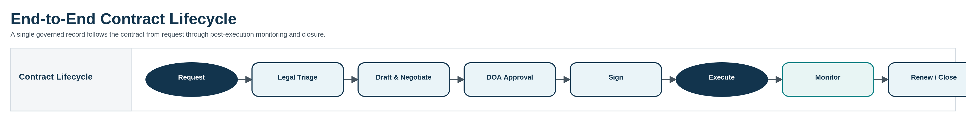
Figure 1. End-to-End Contract Lifecycle Overview

5.1 Proposed Status Model
Status | Purpose / entry condition
Requested | Business request has been submitted but has not yet been triaged.
Legal Review | Legal / contract administration is validating the request and required information.
Drafting | An initial draft is being prepared or uploaded.
Negotiation | Drafts are being exchanged and terms remain open.
Awaiting Approval | Terms are sufficiently agreed and the document is locked for formal approval.
Returned / Rejected | Approval was not granted; the agreement returns to controlled drafting / negotiation.
Approved | Required internal approvals are complete.
Awaiting Signature | The approved document has been sent for signature.
Partially Signed | One or more required signatures remain outstanding.
Executed / Active | The final document is signed and post-execution monitoring is active.
Renewal Review | An option, renewal or expiry decision is in progress.
Expired / Terminated | The agreement is no longer active under its original term.
Closed | All required close-out actions are complete; record remains retained and auditable.
Superseded | A renewal, amendment or replacement agreement has become the operative record.

6. Business and Functional Requirements
Requirements in this section are grouped by lifecycle capability. “Confirmed” indicates a requirement stated directly in discovery. “Validate” identifies a supporting control or configuration point that should be agreed in workshops before build.

Agreement Initiation & Legal Work Allocation
ID | Requirement | Priority | Basis
FR-INT-001 | The system shall allow both authorized Legal users and authorized business users across departments to initiate an agreement request and associate it with a project / media title where applicable. | Must | Confirmed
FR-INT-002 | The request shall capture the contract type, parties, contract owner, business entity and supporting documentation required for legal triage. | Must | Validate
FR-INT-003 | The system shall support contract intake through email so that documents received in a shared or approved mailbox can be brought into the controlled repository. | Must | Confirmed
FR-INT-004 | Mandatory intake fields shall be configurable by contract type. | Should | Validate
FR-INT-005 | The system shall assign a unique contract identifier and maintain a lifecycle status from intake onward. | Must | Validate
FR-INT-006 | Legal shall be able to return an incomplete request for clarification without creating a duplicate record. | Should | Validate
FR-INT-007 | All configured agreement types shall be available during initiation, and authorized administrators shall be able to add, deactivate and configure agreement types without source-code changes. | Must | Confirmed
FR-INT-008 | Each agreement shall support assignment to a named lawyer, with a personal lawyer queue showing assigned matters, current status, age and next required action. | Must | Confirmed
FR-INT-009 | Authorized Legal users shall be able to assign and reassign agreements between lawyers while preserving the assignment history and notifying affected users. | Must | Confirmed
FR-INT-010 | The request shall capture the originating department so that Legal can prioritize, filter, report and route matters by department. | Must | Confirmed

Repository
ID | Requirement | Priority | Basis
FR-REP-001 | All agreements shall be organized under the relevant media project / title so users can view the contractual position for that asset in one place. | Must | Confirmed
FR-REP-002 | The repository shall support a configurable taxonomy including talent / crew, consultancy, service-level and other agreement types used by Image Nation. Authorized administrators shall be able to add and configure new agreement types. | Must | Confirmed
FR-REP-003 | Rights and licensing information shall be available through dedicated structured views, including distribution windows and territorial exploitation rights. | Must | Confirmed
FR-REP-004 | Appendices, NDAs, privacy documents and other related records shall be linked to the parent contract. | Must | Confirmed
FR-REP-005 | Users shall be able to search and filter contracts by project/title, agreement type, party, originating department, assigned lawyer, owner, status, key dates, rights / territory and other configured metadata. | Must | Confirmed
FR-REP-006 | The system shall preserve relationships between an original contract and its renewals, amendments, addenda or replacement agreements. | Should | Validate
FR-REP-007 | Executed contracts shall be clearly distinguished from working drafts and other supporting documents. | Must | Validate
FR-REP-008 | The system shall provide a complete audit history for material record and document actions. | Must | Confirmed

Drafting, Templates & Versioning
ID | Requirement | Priority | Basis
FR-DRF-001 | The system shall preserve a complete, chronological and auditable history of every contract draft; previous versions shall not be overwritten. | Must | Confirmed
FR-DRF-002 | The versioning design shall support negotiations that may exceed 13 draft iterations without loss of earlier copies. | Must | Confirmed
FR-DRF-003 | Each uploaded or generated draft shall be date/time stamped and attributable to the user or intake channel that created it. | Must | Validate
FR-DRF-004 | The operative / current working draft shall be clearly identified while historical versions remain read-only. | Must | Validate
FR-DRF-005 | When a contract is submitted for formal approval or signature, the document shall be locked against unauthorized editing. | Must | Confirmed
FR-DRF-006 | Editing shall be re-enabled only through a controlled return, rejection or withdrawal action with audit logging. | Must | Confirmed
FR-DRF-007 | The solution should support comparison or easy identification of changes between material draft versions. | Should | Validate
FR-DRF-008 | Approved predefined contract templates shall be available by agreement type for standardized authoring. | Must | Confirmed
FR-DRF-009 | Users shall be able to upload an existing agreement, including a third-party draft, and establish it as the first controlled version for legal review. | Must | Confirmed
FR-DRF-010 | Authorized users shall be able to create an agreement from scratch where no approved template or third-party draft is used. | Must | Confirmed
FR-DRF-011 | The drafting initiation method (template, uploaded draft or from-scratch authoring) shall be recorded on the agreement for audit and reporting. | Should | Validate

Approvals / DOA
ID | Requirement | Priority | Basis
FR-APR-001 | The system shall support configurable multi-level approval workflows aligned to Image Nation's Corporate DOA and Projects DOA, including project-level, corporate-level, exceptional and ad-hoc approval paths. | Must | Confirmed
FR-APR-002 | Approval routing rules shall be configurable without source-code changes for permitted administrators. | Must | Validate
FR-APR-003 | The approval engine shall support threshold-based routing by contract value and business entity. | Must | Confirmed
FR-APR-004 | The design shall support risk-based triggers for exceptional international co-production or other designated deal structures. | Must | Confirmed
FR-APR-005 | Authorized users shall be able to add an ad-hoc approver where a special deal requires additional review. | Must | Confirmed
FR-APR-006 | The platform shall record each approval, rejection, return, date/time, approver and any decision comment. | Must | Validate
FR-APR-007 | A rejection shall return the contract to a controlled editable stage and preserve the rejected version and approval history. | Must | Confirmed
FR-APR-008 | The system should support sequential and, where permitted, parallel approval steps. | Should | Validate
FR-APR-009 | Approval delegation / substitute approver rules, if used, shall be auditable and time-bound. | Should | Validate

Signature & Execution
ID | Requirement | Priority | Basis
FR-SIG-001 | The solution shall support integration with DocuSign and/or another Image Nation-approved e-signature platform, subject to final enterprise platform selection. | Must | Confirmed
FR-SIG-002 | Authorized users shall be able to position standardized signature / initial fields at defined locations in the document. | Must | Confirmed
FR-SIG-003 | The solution shall support multiple signatories and a configurable signing order. | Must | Validate
FR-SIG-004 | Signature status shall be visible from the contract record, including outstanding signers. | Must | Validate
FR-SIG-005 | The completed signed document and available signature evidence shall be automatically captured against the contract record. | Must | Confirmed
FR-SIG-006 | Once fully executed, the final contract version shall be locked and identified as the executed copy. | Must | Confirmed
FR-SIG-007 | Where an agreement is signed manually outside the e-signature platform, authorized users shall be able to upload the fully executed copy and mark the agreement as executed through a controlled action. | Must | Confirmed
FR-SIG-008 | For manually executed agreements, the system shall capture execution metadata including execution date, uploader and available signatory details, while preserving the prior approved version and audit history. | Must | Confirmed

Post-Execution
ID | Requirement | Priority | Basis
FR-POST-001 | The system shall track contractual milestones as structured obligations rather than only calendar notes. | Must | Confirmed
FR-POST-002 | The solution shall support multiple reminder intervals for critical dates, including configurable examples such as 90, 60 and 30 days. | Must | Confirmed
FR-POST-003 | Reminders shall be repeatable for auto-renewing contracts across subsequent renewal cycles. | Must | Confirmed
FR-POST-004 | The contract record shall support option dates, renewal dates, expiry dates and notice deadlines. | Must | Confirmed
FR-POST-005 | The solution shall support tracking of production deliverables such as Locked Cut and Final Sound Mix where they are contractual milestones. | Must | Confirmed
FR-POST-006 | Each obligation / milestone shall have an owner, due date, status and evidence / note capability. | Must | Validate
FR-POST-007 | Overdue or high-risk obligations should support escalation to defined stakeholders. | Should | Validate
FR-POST-008 | Rights records shall support territory, exploitation / distribution window, effective period and related counterparty / agreement. | Must | Confirmed
FR-POST-009 | The platform shall allow renewal, option exercise, amendment or closure actions to create a traceable link to the original contract. | Should | Validate

Reporting
ID | Requirement | Priority | Basis
FR-RPT-001 | A contract dashboard shall show upcoming renewals, expiries, option dates and other critical milestones. | Must | Confirmed
FR-RPT-002 | Portfolio views shall allow Legal and Management to identify expiring rights and time-sensitive contractual exposure across projects. | Must | Confirmed
FR-RPT-003 | Users shall be able to filter and report on agreements by status, department, assigned lawyer, agreement type, project/title, owner, approval stage and key date. | Must | Confirmed
FR-RPT-004 | Authorized users should be able to export filtered reporting data for offline review where permitted by security policy. | Should | Validate
FR-RPT-005 | The platform should provide cycle-time metrics for intake-to-approval and approval-to-execution so process performance can be monitored. | Could | Validate
FR-RPT-006 | Legal management shall have workload views showing agreement counts and aging by assigned lawyer, with filters for department, agreement type and status. | Must | Confirmed

Security & Access
ID | Requirement | Priority | Basis
FR-SEC-001 | The platform shall enforce role-based access control (RBAC) for agreements, data and actions, combining role/group permissions with contract-specific user access where required so each user can only view and perform what their assigned role permits. | Must | Confirmed
FR-SEC-002 | The platform shall support Microsoft 365 Single Sign-On. | Must | Confirmed
FR-SEC-003 | The platform shall support Two-Factor Authentication in accordance with enterprise security policy. | Must | Confirmed
FR-SEC-004 | Sensitive contracts shall be restrictable to directly authorized participants even where users belong to a broader functional group. | Must | Confirmed
FR-SEC-005 | Administrative and user actions shall be auditable with user, date/time and action details. | Must | Confirmed
FR-SEC-006 | The selected platform / hosting service shall meet the required ISO 27001 and SOC 2 Type II assurance expectations. | Must | Confirmed
FR-SEC-007 | The solution shall support the organization’s GDPR compliance obligations for applicable personal data. | Must | Confirmed

Integration
ID | Requirement | Priority | Basis
FR-INTG-001 | The CLM shall be capable of operating standalone and of integrating with the broader enterprise architecture through documented APIs. | Must | Confirmed
FR-INTG-002 | The platform shall support synchronized document backup / connectivity with Microsoft 365 and, if retained in the target architecture, Google Drive and Dropbox. | Must | Confirmed
FR-INTG-003 | Integration shall not compromise the CLM audit trail or allow uncontrolled changes to an executed contract. | Must | Validate
FR-INTG-004 | API authentication, authorization and integration logging shall follow enterprise security standards. | Must | Validate
FR-INTG-005 | The CLM shall integrate with Microsoft Dynamics 365 Business Central so relevant agreement information and status can be reflected in the ERP and made visible to Finance and Procurement. | Must | Confirmed
FR-INTG-006 | The Business Central integration shall use an agreed data mapping and synchronization model covering the agreement identifier, counterparty, department / project, value and currency, effective / expiry dates, status and other fields approved during solution design. | Must | Validate
FR-INTG-007 | The integration shall define system-of-record ownership, create/update triggers, error handling and reconciliation so ERP visibility does not compromise CLM version control, approvals or auditability. | Must | Validate

Localization
ID | Requirement | Priority | Basis
FR-LOC-001 | The user experience shall support English, Arabic and Spanish to the level confirmed during design. | Must | Confirmed
FR-LOC-002 | Contract metadata shall support multilingual text where required. | Should | Confirmed
FR-LOC-003 | Right-to-left rendering and Arabic usability shall be tested if Arabic interface support is included in the selected product. | Should | Validate

Capacity
ID | Requirement | Priority | Basis
FR-CAP-001 | The solution shall support an initial planning baseline of approximately 600 active contracts without functional degradation. | Must | Confirmed
FR-CAP-002 | The licensing / user model shall support at least 30 users at launch planning stage, subject to final role mapping. | Must | Confirmed
FR-CAP-003 | The platform shall scale beyond the initial baseline as the project slate and contract volume increase. | Must | Confirmed

AI - Optional
ID | Requirement | Priority | Basis
FR-AI-001 | AI-assisted contract extraction / analysis may be evaluated as a desirable capability; it is not mandatory until business scope is confirmed. | Could | Validate

7. Contract Lifecycle Journeys and Swim-Lane Process Maps
The following journeys translate the requirements into day-to-day operating flows. Each map shows the hand-off between business users, Legal, approvers, external parties and the CLM platform. The swim lanes are intended to be the starting point for configuration workshops and user acceptance test scenarios.

7.1 Journey 1 - Contract Request and Legal Triage
- A request is raised against a specific project or title with enough information for Legal to understand the business need.
- The CLM validates mandatory metadata, creates a unique contract record and routes it to Legal / contract administration.
- Legal either accepts the request into drafting or returns it for clarification while preserving the same contract record.
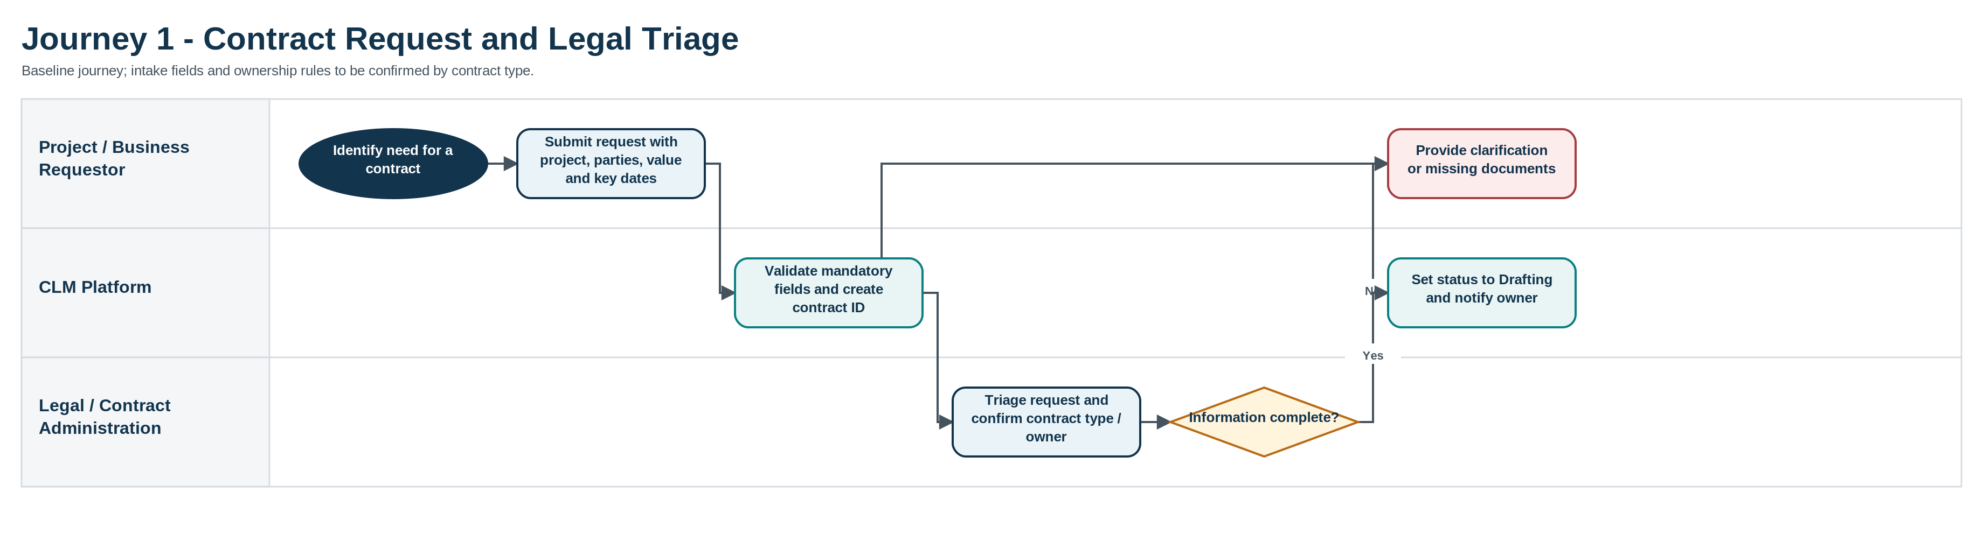
Figure 2. Contract Request and Legal Triage - Swim-Lane Process Map

7.2 Journey 2 - Drafting, Redlining and External Negotiation
- Legal creates or uploads the initial draft and the system establishes the first controlled version.
- Commercial / production stakeholders and the counterparty review terms as required. Every returned redline becomes a new archived version.
- The negotiation loop continues until terms are sufficiently agreed for internal approval; historical drafts remain read-only and chronologically traceable.
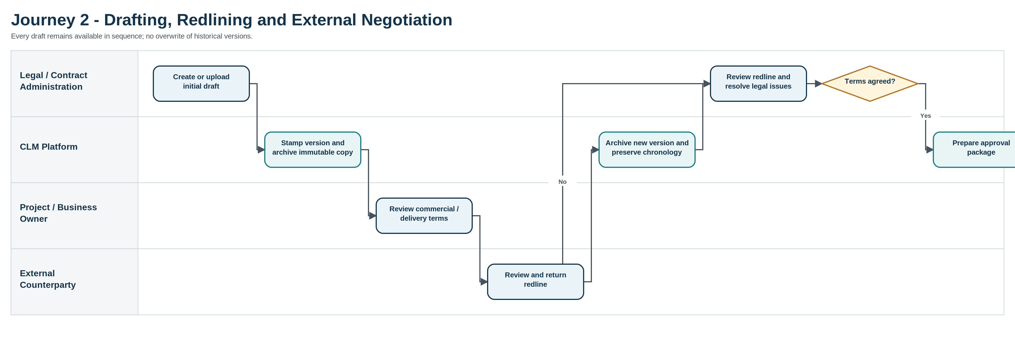
Figure 3. Drafting, Redlining and External Negotiation - Swim-Lane Process Map

7.3 Journey 3 - Delegation of Authority Approval
- The agreed draft is submitted for approval and immediately locked against unauthorized editing.
- The platform evaluates the applicable DOA route. Discovery identified project-level, corporate-level, exceptional and ad-hoc routing scenarios.
- A rejection returns the agreement to controlled drafting without deleting the rejected approval package. Approval releases the document to signature.
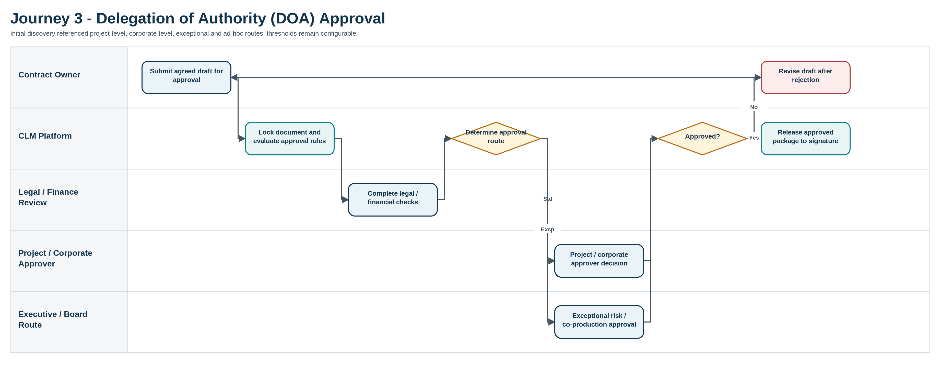
Figure 4. Delegation of Authority Approval - Swim-Lane Process Map

7.4 Journey 4 - E-Signature and Execution
- Legal prepares the approved signature package, signatory order and standardized signature positions.
- The e-signature service manages signer authentication and execution. Signature progress is visible from the contract record.
- When all signatures are complete, the executed copy is automatically stored, locked and transitioned to post-execution management.
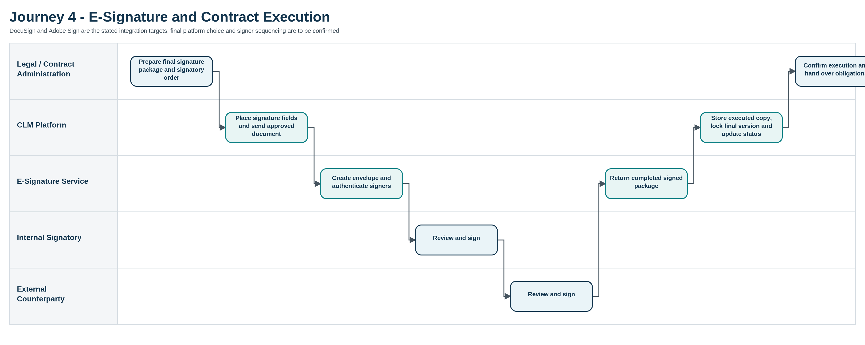
Figure 5. E-Signature and Execution - Swim-Lane Process Map

7.5 Journey 5 - Post-Execution Obligations, Milestones and Rights
- The contract owner, Legal and relevant operational teams establish the obligations, milestones, rights windows, options and key dates that require active monitoring.
- The CLM generates repeatable reminders, while owners record completion evidence and status updates.
- Critical or overdue events are escalated and remain visible on portfolio dashboards so action can be taken before rights or contractual positions are affected.
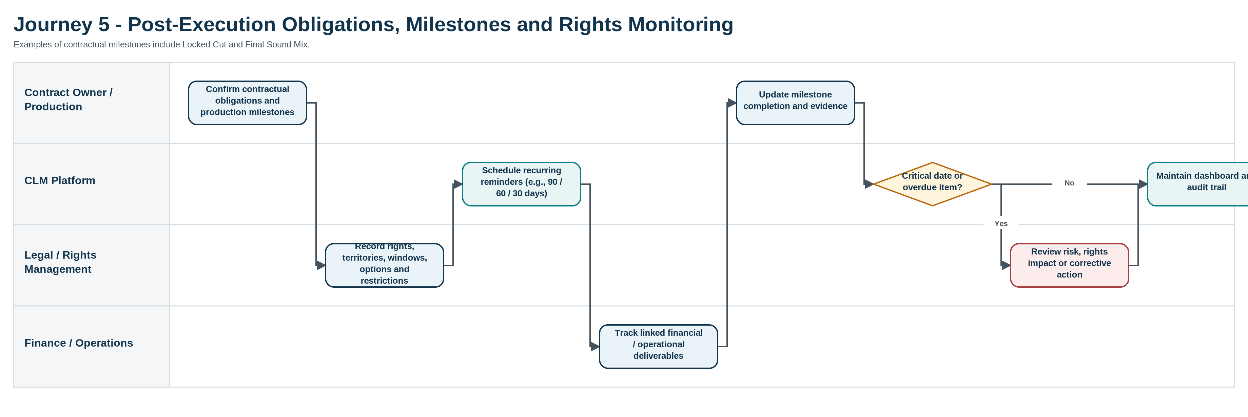
Figure 6. Post-Execution Obligations, Milestones and Rights - Swim-Lane Process Map

7.6 Journey 6 - Renewal, Option Exercise, Expiry and Closure
- The process begins before the renewal / option / notice date through configured reminders rather than at the point of expiry.
- The owner and Legal review the commercial need, rights position and notice terms, and obtain approval where required.
- A renewal or amendment is linked back to the original record; if no extension is pursued, the contract is expired / closed while the complete history is retained.
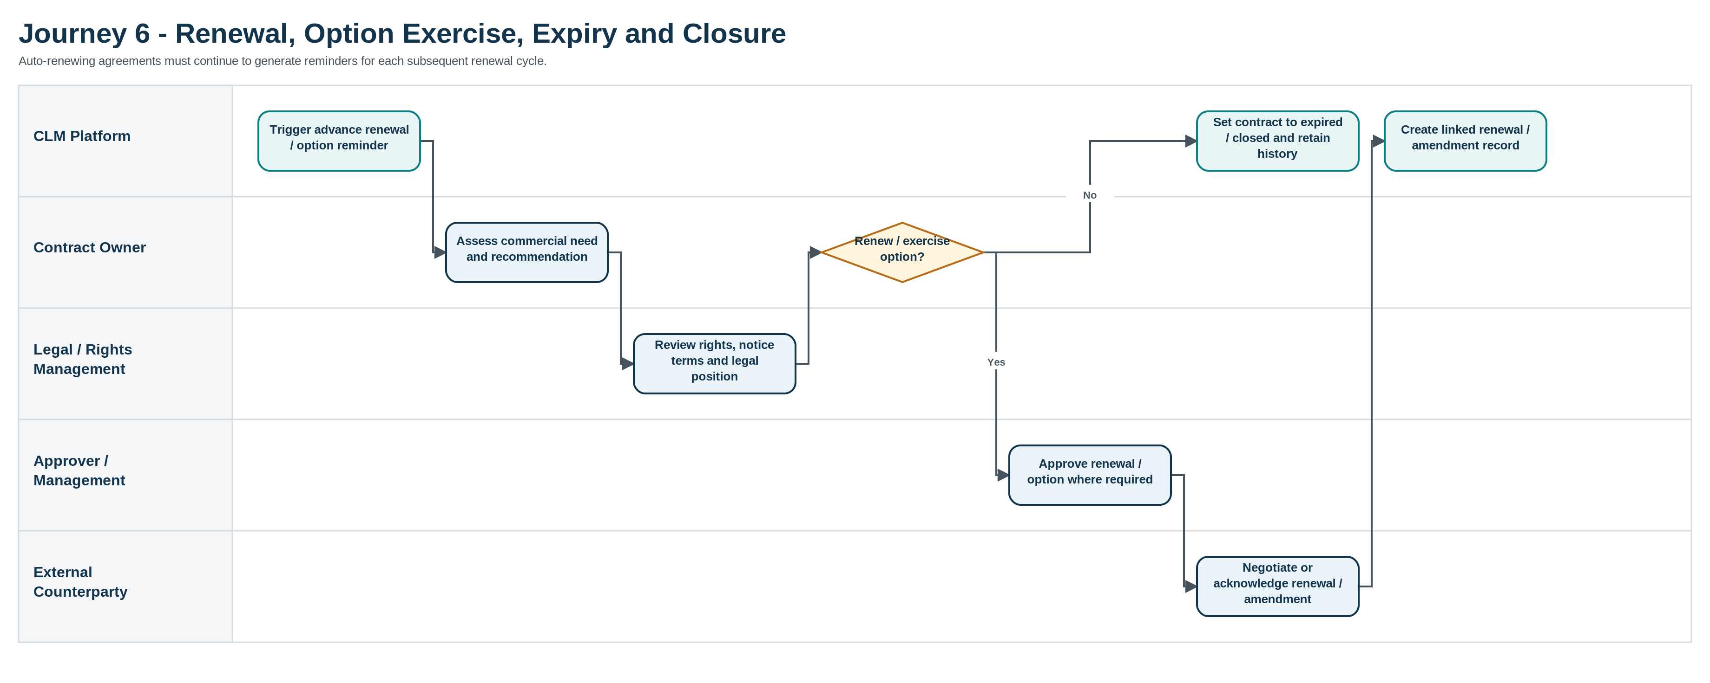
Figure 7. Renewal, Option Exercise, Expiry and Closure - Swim-Lane Process Map

8. Business Rules
Business rules should be configuration-driven wherever possible so that policy changes do not require code changes. The values below reflect the current discovery baseline and identify where policy confirmation is still required.
Rule ID | Rule | Status
BR-001 | Every managed contract must be associated with a project / title unless an approved non-project contract category is defined. | Confirmed
BR-002 | Historical contract drafts must never be overwritten; a new material draft creates a new version. | Confirmed
BR-003 | Submitting a contract for formal approval or signature locks the document from editing. | Confirmed
BR-004 | Only a controlled rejection / return / withdrawal may move a locked contract back to an editable stage. | Confirmed
BR-005 | DOA routing must support project-level approval, corporate-level approval, exceptional risk / co-production approval and ad-hoc additions. | Confirmed
BR-006 | Discovery referenced a USD 50,000 dividing line between project and corporate routes; the final threshold, currency conversion logic and effective dates must be configurable and formally confirmed. | Validate
BR-007 | The approval path may also depend on entity and risk triggers, not only contract value. | Confirmed
BR-008 | Every approval decision must record the approver, outcome and timestamp; comments should be captured where provided. | Validate
BR-009 | A fully executed contract becomes the authoritative final copy and is protected from direct editing. | Confirmed
BR-010 | Auto-renewing contracts continue to create reminders for each renewal cycle until closed or superseded. | Confirmed
BR-011 | Critical date reminders must support multiple configurable lead times; 90 / 60 / 30 days are the discovery examples, not hard-coded values. | Confirmed
BR-012 | Rights / licensing data must support visibility of territorial and distribution-window constraints. | Confirmed
BR-013 | Related appendices, NDAs and privacy documents remain linked to the parent agreement and inherit appropriate access controls. | Confirmed
BR-014 | Access is determined through both role/group permissions and contract-specific user assignment where stricter restriction is needed. | Confirmed
BR-015 | An amendment, renewal or replacement agreement must remain traceably linked to the original contract. | Validate
BR-016 | A contract cannot be marked closed while mandatory unresolved obligations remain, unless an authorized override reason is recorded. | Validate
BR-017 | The platform must preserve audit history when a contract changes owner, project, status or approval route. | Validate
BR-018 | E-signature dispatch may occur only from an approved contract version. | Validate
BR-019 | The system should prevent duplicate executed copies from being treated as separate active contracts where they represent the same agreement. | Validate
BR-020 | Retention, legal-hold and destruction rules will be configured once the corporate records-management policy is confirmed. | Validate
BR-021 | Both Legal and authorized end users across departments may initiate agreement requests; the same governed lifecycle and audit controls apply regardless of initiator. | Confirmed
BR-022 | Every active legal matter must have an assigned lawyer before substantive legal review begins; reassignment must preserve assignment history. | Confirmed
BR-023 | Approval workflows must be driven by the current Corporate DOA and Projects DOA configuration and must not hard-code policy values in application logic. | Confirmed
BR-024 | A manually signed agreement may become the authoritative executed copy only through an authorized upload / execution action that records the uploader and execution date. | Confirmed
BR-025 | Agreement data synchronized to Microsoft Dynamics 365 Business Central must not permit uncontrolled alteration of the authoritative CLM document, version history or approval record. | Confirmed

9. Information and Data Requirements
The contract record must contain enough structured data to route, search, report and monitor the agreement. The exact mandatory fields will vary by contract type. The following baseline data model is proposed for configuration workshops.

9.1 Core Data Entities
Entity | Purpose | Indicative key fields
Contract | Master record for the agreement lifecycle. | Contract ID, title, agreement type, project/title, originating department, business entity, contract owner, assigned lawyer, status, value/currency, initiation method, effective / expiry dates, renewal type.
Project / Media Title | Groups agreements around the underlying creative asset or production. | Project/title name, internal ID, production entity, status, business owner.
Party / Counterparty | Identifies external and internal contracting parties. | Legal name, party type, country, contact / signatory relationship.
Document Version | Preserves the chronology of drafts and executed documents. | Version number, file, created by, created date/time, version status, source channel.
Approval | Stores each DOA decision and route. | Approval level, approver, outcome, date/time, comments, delegated / ad-hoc flag.
Signatory / Signature | Tracks execution progress. | Signer, organization, signing order, signature status, sent / signed timestamps.
Obligation / Milestone | Tracks post-execution commitments. | Description, owner, due date, status, evidence, escalation rule.
Rights / Licence | Captures exploitable rights and restrictions. | Right type, territory, window start/end, exclusivity / restriction, related party.
Option / Renewal | Tracks decisions that must occur before a contractual deadline. | Option / renewal type, decision date, notice deadline, outcome, linked renewal record.
Related Document | Links supporting legal documentation. | Document type, parent contract, file, access classification.
Audit Event | Provides defensible lifecycle history. | User / system actor, action, timestamp, old/new value where applicable.
Legal Assignment | Tracks lawyer ownership and transfer of legal matters. | Assigned lawyer, assigned by, assignment date/time, reassignment reason, previous lawyer, active / historical flag.

9.2 Baseline Search and Filter Fields
- Project / title
- Contract ID and contract name
- Agreement type
- Counterparty
- Contract owner / assigned lawyer
- Originating department / business entity
- Lifecycle status
- Approval stage / approver
- Contract value and currency
- Effective, expiry, notice, renewal and option dates
- Territory / rights window
- Milestone / obligation status

10. Delegation of Authority and Approval Model
Approval routing is one of the most important controls in the future-state design. The system should determine the required path from configured rules reflecting Image Nation's Corporate DOA and Projects DOA, and show users why a particular route was selected. The routing model must also handle exceptions without creating an ungoverned manual workaround.

10.1 Discovery Baseline for Approval Routing
Route | Entity context | Discovery threshold / trigger | Typical signatory
Project Level | Production / Film Entity | Below USD 50,000 (to validate) | Line Producer / Head of Production
Corporate Level | Studio Operations | Above USD 50,000 (to validate) | CFO / Head of Legal
Exceptional Route | International Co-Production | Risk-based trigger | CEO / Board Member
Ad-Hoc | Special Deal Structure | Added as required | Variable / on-demand

Design principle
The USD 50,000 values should be treated as configurable policy data until formally confirmed. The system should not embed approval limits in code.

10.2 Approval Capabilities
- Route by value, entity, contract type, risk flag and other approved attributes.
- Support serial and permitted parallel approvals.
- Allow an authorized ad-hoc approver to be inserted with reason and audit trace.
- Provide reminders for pending approvals and escalation where an approval remains outstanding beyond agreed service levels.
- Prevent final signature dispatch until all mandatory approvals are complete.
- Preserve rejected approval packages and comments when the document returns for revision.
- Support time-bound delegation / substitute approver arrangements if approved by policy.

11. Rights, Milestones, Options and Contractual Obligations
Post-execution management is a core part of the required solution. A contract may be legally complete at signature but still carry production deliverables, financial commitments, options, notice periods and rights windows that need active ownership. These items should be represented as structured records so they can be filtered, alerted and reported.

11.1 Critical Date Types
Date / event | How it should be managed
Contract effective / commencement date | Structured date; drives active status and reporting.
Contract expiry date | Structured date with advance reminder and renewal / closure decision.
Notice deadline | Tracked separately from expiry where notice must be served earlier.
Option exercise date | Advance alerts with decision owner and recorded outcome.
Distribution / exploitation window | Start/end dates linked to territory and rights type.
Auto-renewal date | Repeating reminder cycle for each renewal period.
Production milestone | Structured contractual deliverable such as Locked Cut or Final Sound Mix.
Payment / operational obligation | Tracked where the contract requires a time-bound action or evidence.

11.2 Reminder and Escalation Behaviour
- Multiple reminders can be configured against the same critical date.
- Lead times are configuration values; 90, 60 and 30 days are the discovery examples.
- Recipients can include the contract owner, Legal and other nominated stakeholders.
- Reminder sequences continue for recurring auto-renewal cycles.
- Overdue obligations and unmade renewal / option decisions should be visible in exception dashboards.
- Completion evidence and decision outcomes should remain part of the contract record.

12. Reporting, Dashboards and Management Information
Dashboards should be action-oriented rather than purely descriptive. The priority is to identify what needs attention: agreements awaiting approval, signatures still outstanding, rights that are approaching expiry, options that require a decision, and obligations that are overdue.
Dashboard / Report | Primary audience | Key information
My Agreements / Lawyer Work Queue | Assigned lawyers, contract owners, Legal | Assigned agreements, originating department, status, age, next action, pending clarification, approval, signature and milestones.
Approval Queue | Approvers, Legal | Contracts awaiting decision, approval level, age, value, owner, exception / ad-hoc flag.
Renewals & Expiries | Legal, Management | 90/60/30-day horizon, option dates, auto-renewals, expiries, notice deadlines.
Rights & Licensing Portfolio | Legal / Rights, Management | Territories, distribution windows, expiring rights, overlapping or restricted periods for review.
Obligations & Milestones | Production, Legal, Finance | Due / overdue deliverables, owners, status, escalation.
Contract Portfolio | Management | Agreements by project/title, department, assigned lawyer, agreement type, owner, entity and lifecycle status.
Audit / Compliance | Legal, Audit, Security | Version history, approvals, access-sensitive actions, signature and status history.
Legal Workload & Allocation | Head of Legal / Legal Management | Matter count and aging by assigned lawyer, department, agreement type and status; supports reassignment and workload balancing.

13. Security, Access and Compliance Requirements
The solution will contain commercially sensitive agreements, personal information and IP-related rights. Access therefore needs to be intentionally restrictive, with a clear separation between broad functional permissions and contract-specific access.

13.1 Access Model
- Role-based access control (RBAC) defines the agreements, data and functions a user can view or perform according to their assigned role / group.
- Contract-specific assignments can further restrict which records a user can view or act on.
- Sensitive contracts can be limited to named participants even within a broader Legal, Finance or Management group.
- Administrative privileges are separated from normal contract ownership and approval roles.
- Access changes and privileged actions are captured in the audit log.

13.2 Enterprise Security and Compliance Baseline
Requirement | Baseline
Authentication | Microsoft 365 SSO and 2FA.
Authorization | Group-level plus user-specific access control.
Auditability | User and system activity history for material actions.
Information security assurance | ISO 27001 and SOC 2 Type II expectations for the selected platform / hosting service.
Privacy | Support for applicable GDPR obligations and organization-approved data handling.
Data retention / legal hold | Detailed policy and configuration to be confirmed before production.

14. Integration Requirements
Integration should reduce re-keying and document silos without weakening contract controls. Microsoft Dynamics 365 Business Central is a required enterprise integration so relevant agreements are reflected in the ERP and Finance and Procurement have visibility. The CLM remains responsible for lifecycle status, version history and the authoritative executed copy unless a future-state architecture explicitly assigns a specific data element elsewhere.
Integration / Channel | Business requirement | Direction / notes
Microsoft 365 | SSO; document connectivity / synchronized backup as approved. | Authentication and document services.
DocuSign | Prepare and send approved contracts for e-signature; return status and completed signed package. | Bi-directional.
Adobe Sign | Equivalent e-signature interoperability where selected. | Bi-directional.
Email intake | Bring contract requests / documents from approved mailboxes into the managed lifecycle. | Inbound with controlled mapping.
Microsoft Dynamics 365 Business Central | Synchronize agreed agreement metadata and lifecycle status so Finance and Procurement have ERP visibility of relevant contractual commitments. | Bi-directional or CLM-to-ERP direction to be confirmed during design; CLM remains authoritative for contract document, version and approval history.

14.1 Integration Control Requirements
- Integration events must be logged and diagnosable.
- Inbound documents must not silently overwrite an existing controlled version.
- Executed copies returned from e-signature must be matched to the correct contract record.
- API and service credentials must follow enterprise authentication and secret-management standards.
- Integration failures affecting signature or critical document capture should generate an operational alert.
- Business Central synchronization failures should be logged, alerted and reconcilable without blocking access to the authoritative CLM record.

15. Localization, Capacity and Scalability

15.1 Language Requirements
The target platform is expected to support English, Arabic and Spanish. The final design should distinguish between user-interface localization, metadata entry, notifications, search behavior and contract-document language. Arabic usability should be explicitly tested if right-to-left interface support forms part of the selected solution.

15.2 Capacity Baseline
Dimension | Planning baseline | Requirement
Active contracts | Approximately 600 | The platform must operate comfortably at the initial baseline and allow material growth without redesign.
Users | At least 30 | Final licensing depends on role mapping; collaboration must span Legal, Finance, Management and project teams.
Draft versions | 13+ may occur on an agreement | Version history must not be limited to a small fixed number of retained drafts.

16. Non-Functional Requirements
The discovery material establishes several enterprise requirements but does not yet define measurable service levels for availability, performance and recovery. These should be completed during solution design and vendor due diligence.
NFR ID | Area | Requirement / target
NFR-001 | Security | Microsoft 365 SSO and 2FA must be supported.
NFR-002 | Assurance | ISO 27001 and SOC 2 Type II assurance expectations must be satisfied by the selected service.
NFR-003 | Privacy | The solution must support applicable GDPR obligations and approved data-handling controls.
NFR-004 | Auditability | Material contract, document, approval, access and configuration actions must be traceable.
NFR-005 | Interoperability | Documented APIs must be available so the CLM can operate standalone or as part of the enterprise architecture.
NFR-006 | Usability | The interface should support users who participate occasionally, particularly approvers and project stakeholders, without specialist training.
NFR-007 | Localization | English, Arabic and Spanish support must be validated in the selected solution.
NFR-008 | Scalability | The platform must exceed the initial baseline of approximately 600 active contracts and 30 users.
NFR-009 | Performance | Interactive search, record open and workflow actions - measurable target TBC during design.
NFR-010 | Availability | Business-hour / service availability target TBC with IT and vendor.
NFR-011 | Resilience | Backup, recovery-point and recovery-time objectives TBC with IT and vendor.
NFR-012 | Accessibility | Accessibility standard and testing scope TBC with IT / corporate policy.

17. Migration and Repository Onboarding
The source requirements establish the need for a centralized repository but do not yet define the volume or quality of historical data to migrate. Migration should therefore be planned as a controlled onboarding exercise with clear criteria for which contracts become active managed records.

17.1 Proposed Migration Approach
- Inventory existing active and legally relevant historical contracts and their current storage locations.
- Define inclusion criteria: active contracts, open options / renewals, live rights windows, unresolved obligations and other records Legal determines are necessary.
- Map contract types, projects/titles, parties, owners and key dates to the new metadata model.
- Identify the authoritative executed copy and, where available, material historical drafts / approval evidence.
- Load related appendices, NDAs and privacy documents with the parent relationship preserved.
- Validate migrated rights, option dates, expiry dates and reminders before go-live.
- Reconcile migrated counts and exceptions; obtain business sign-off on the initial repository baseline.

17.2 Migration Decisions to Confirm
- Historical period to migrate and whether closed / expired contracts are included.
- Whether all historic drafts are migrated or only executed copy plus selected material versions.
- Source locations and ownership of document cleanup.
- Treatment of duplicates, unsigned copies and incomplete metadata.
- Retention and legal-hold requirements for files that remain outside the CLM.

18. Business Acceptance Criteria
The implementation should not be accepted solely because screens and workflows have been configured. Acceptance should demonstrate that the key business controls work end to end using representative media-contract scenarios.
Capability | Acceptance criterion
Repository & Search | A user can find all authorized agreements for a selected project/title, distinguish working drafts from executed copies, and open linked appendices / NDAs.
Version History | A test contract can progress through at least 13 draft versions with every version preserved, date/time stamped and accessible in sequence.
Document Locking | A contract submitted for approval or signature cannot be edited by unauthorized users; a controlled rejection / withdrawal re-enables drafting.
DOA Routing | Test cases route correctly through project, corporate, exceptional and ad-hoc approval scenarios using agreed configuration.
Approval Audit | The system records approver, decision, date/time and comments for approval and rejection steps.
E-Signature | An approved contract can be sent through the selected e-signature service, signed by required parties and automatically returned to the correct record.
Executed Copy | The final signed version is identified as authoritative and protected from direct editing.
Critical Dates | 90/60/30-day sample reminders can be configured, delivered and repeated for an auto-renewing agreement.
Milestones | A contractual production milestone can be assigned to an owner, completed with evidence and reported on the dashboard.
Rights | A rights / licensing record can show territory and distribution window and appear in an expiring-rights view.
Security | Microsoft 365 SSO, 2FA and role / record-specific access restrictions work for agreed test personas.
Audit | A reviewer can reconstruct the material lifecycle of the test contract from request through approval, signature and post-execution actions.
Localization | Agreed English, Arabic and Spanish scenarios render and behave correctly for the selected scope.
Capacity | Performance is validated against an implementation test volume that represents at least the initial planning baseline.
Agreement Initiation | An authorized Legal user and an authorized business user from another department can each initiate an agreement request, select from configured agreement types and route the request into the same governed legal intake process.
Lawyer Queue & Assignment | Each lawyer can view their assigned agreement queue, and an authorized Legal user can reassign a matter to another lawyer with the assignment history retained.
Drafting Options | A test agreement can be initiated from an approved template, from an uploaded third-party draft and from a blank / from-scratch authoring path, with each method entering controlled versioning.
Manual Execution | A manually signed agreement can be uploaded as the executed copy through an authorized action with execution metadata and audit history retained.
Business Central Integration | A representative executed or active agreement synchronizes the agreed metadata and status to Microsoft Dynamics 365 Business Central and is visible to the intended Finance / Procurement users; a failed synchronization can be identified and reconciled.

19. Assumptions and Dependencies
ID | Assumption / dependency
AD-01 | Image Nation will nominate business owners for Legal, Finance, Production / Projects, Management, IT and system administration during design.
AD-02 | The current DOA policy and signatory rules will be provided and approved before workflow configuration is finalized.
AD-03 | The project/title master data source and ownership model will be confirmed before migration and integration design.
AD-04 | The enterprise e-signature platform decision will confirm whether DocuSign, Adobe Sign or both must be production-supported.
AD-05 | Microsoft 365 identity configuration and required application registrations / security approvals will be available to the implementation team.
AD-06 | The organization will define which historical contracts are in migration scope and identify the authoritative executed document where duplicates exist.
AD-07 | Retention, legal-hold and data-deletion policies will be supplied before production configuration.
AD-08 | Final localization scope will clarify whether English, Arabic and Spanish are required for full UI, metadata, notifications, templates or combinations of these.
AD-09 | Image Nation will provide the current Corporate DOA and Projects DOA, including approval thresholds, approver roles, exceptions and effective-date rules, before workflow configuration is finalized.
AD-10 | Image Nation will provide Microsoft Dynamics 365 Business Central integration access, API / extension prerequisites, target company / environment details and Finance / Procurement data owners for mapping and testing.
AD-11 | Legal will confirm the lawyer assignment model, queue ownership rules, reassignment permissions and any service-level or workload-balancing rules.

20. Open Questions for Business Validation
ID | Area | Question
Q-01 | DOA | how should foreign-currency contracts be evaluated against it?
Q-02 | DOA | Which attributes beyond value and entity can change the route - contract type, risk category, territory, partner type, budget owner or project status?
Q-03 | DOA | Who may add an ad-hoc approver, and can a mandatory approver ever be bypassed?
Q-04 | Repository | What is the authoritative source for project/title and production-entity master data?
Q-05 | Metadata | Which fields are mandatory for each major agreement type, particularly talent/crew, consultancy, SLA, distribution/licensing and co-production?
Q-06 | Versioning | Does the business require redline comparison inside the CLM, or is complete version retention sufficient?
Q-07 | Signature | Will Image Nation standardize on DocuSign, Adobe Sign or maintain both?
Q-08 | Signature | What signatory sequencing, witness / countersignature and delegation scenarios need to be supported?
Q-09 | Milestones | Which production / financial milestones should be standardized by contract type and which remain contract-specific?
Q-10 | Reminders | Who receives each class of reminder and what escalation applies when no action is taken?
Q-11 | Email Intake | Which mailbox(es) will be used, and should inbound email create new requests automatically or require user confirmation?
Q-12 | Reporting | Which dashboards are required for executive reporting versus operational work queues?
Q-13 | Initiation | Which departments may initiate agreements directly, and are any agreement types restricted to Legal-only initiation?
Q-14 | Legal Assignment | Should new requests route to a shared Legal triage queue before lawyer assignment, or can certain agreement types be auto-assigned based on department, project or agreement type?
Q-15 | Legal Assignment | Who may reassign agreements between lawyers, and should workload, leave / absence or service-level rules influence assignment?
Q-16 | Drafting | Which agreement types require mandatory use of an approved template, and which may begin from a third-party draft or from scratch?
Q-17 | Integration | Which agreement fields and lifecycle events must be synchronized with Microsoft Dynamics 365 Business Central, and which system is authoritative for each shared field?
Q-18 | Integration | Should Business Central receive agreement records at approval, signature / execution, or another lifecycle stage, and is one-way or bi-directional synchronization required?

21. Implementation Priorities and Suggested Phasing
A phased implementation can reduce delivery risk while ensuring that the core legal controls are in place before advanced automation is introduced. The following phasing is a recommended sequencing for planning, not a commitment to a specific delivery timeline.
Phase | Primary scope | Exit condition
Phase 1 - Foundation | Repository, agreement taxonomy, configurable agreement types, department / project structure, legal assignment queues, metadata, RBAC, SSO, version history, core search and audit. | Users can initiate, assign, secure, find and version agreements reliably.
Phase 2 - Governed Workflow | Template / upload / from-scratch drafting, Corporate DOA and Projects DOA routing, document locking, approval audit, e-signature, manual execution and executed-copy capture. | A representative contract completes approval and signature end to end with full auditability.
Phase 3 - Post-Execution Control | Milestones, obligations, rights, options, renewals, repeating reminders and dashboards. | Critical dates and obligations are actively managed from the CLM.
Phase 4 - Integration & Optimization | Microsoft Dynamics 365 Business Central integration, approved storage integrations, advanced analytics, optional AI-assisted capabilities and process tuning. | ERP visibility and automation reduce manual effort without compromising CLM governance.

Appendix A - Requirements Traceability Matrix
This matrix provides a compact implementation and testing reference for the functional requirements defined in Section 6.
ID | Area | Requirement | Priority | Basis | Verification
FR-INT-001 | Intake | The system shall allow both authorized Legal users and authorized business users across departments to initiate an agreement request and associate it with a project / media title where applicable. | Must | Confirmed | Design / UAT
FR-INT-002 | Intake | The request shall capture the contract type, parties, contract owner, business entity and supporting documentation required for legal triage. | Must | Validate | Design / UAT
FR-INT-003 | Intake | The system shall support contract intake through email so that documents received in a shared or approved mailbox can be brought into the controlled repository. | Must | Confirmed | Design / UAT
FR-INT-004 | Intake | Mandatory intake fields shall be configurable by contract type. | Should | Validate | Design / UAT
FR-INT-005 | Intake | The system shall assign a unique contract identifier and maintain a lifecycle status from intake onward. | Must | Validate | Design / UAT
FR-INT-006 | Intake | Legal shall be able to return an incomplete request for clarification without creating a duplicate record. | Should | Validate | Design / UAT
FR-REP-001 | Repository | All agreements shall be organized under the relevant media project / title so users can view the contractual position for that asset in one place. | Must | Confirmed | Design / UAT
FR-REP-002 | Repository | The repository shall support a configurable taxonomy including talent / crew, consultancy, service-level and other agreement types used by Image Nation. Authorized administrators shall be able to add and configure new agreement types. | Must | Confirmed | Design / UAT
FR-REP-003 | Repository | Rights and licensing information shall be available through dedicated structured views, including distribution windows and territorial exploitation rights. | Must | Confirmed | Design / UAT
FR-REP-004 | Repository | Appendices, NDAs, privacy documents and other related records shall be linked to the parent contract. | Must | Confirmed | Design / UAT
FR-REP-005 | Repository | Users shall be able to search and filter contracts by project/title, agreement type, party, originating department, assigned lawyer, owner, status, key dates, rights / territory and other configured metadata. | Must | Confirmed | Design / UAT
FR-REP-006 | Repository | The system shall preserve relationships between an original contract and its renewals, amendments, addenda or replacement agreements. | Should | Validate | Design / UAT
FR-REP-007 | Repository | Executed contracts shall be clearly distinguished from working drafts and other supporting documents. | Must | Validate | Design / UAT
FR-REP-008 | Repository | The system shall provide a complete audit history for material record and document actions. | Must | Confirmed | Design / UAT
FR-DRF-001 | Drafting & Versioning | The system shall preserve a complete, chronological and auditable history of every contract draft; previous versions shall not be overwritten. | Must | Confirmed | Design / UAT
FR-DRF-002 | Drafting & Versioning | The versioning design shall support negotiations that may exceed 13 draft iterations without loss of earlier copies. | Must | Confirmed | Design / UAT
FR-DRF-003 | Drafting & Versioning | Each uploaded or generated draft shall be date/time stamped and attributable to the user or intake channel that created it. | Must | Validate | Design / UAT
FR-DRF-004 | Drafting & Versioning | The operative / current working draft shall be clearly identified while historical versions remain read-only. | Must | Validate | Design / UAT
FR-DRF-005 | Drafting & Versioning | When a contract is submitted for formal approval or signature, the document shall be locked against unauthorized editing. | Must | Confirmed | Design / UAT
FR-DRF-006 | Drafting & Versioning | Editing shall be re-enabled only through a controlled return, rejection or withdrawal action with audit logging. | Must | Confirmed | Design / UAT
FR-DRF-007 | Drafting & Versioning | The solution should support comparison or easy identification of changes between material draft versions. | Should | Validate | Design / UAT
FR-DRF-008 | Drafting & Versioning | Approved predefined contract templates shall be available by agreement type for standardized authoring. | Must | Confirmed | Design / UAT
FR-APR-001 | Approvals / DOA | The system shall support configurable multi-level approval workflows aligned to Image Nation's Corporate DOA and Projects DOA, including project-level, corporate-level, exceptional and ad-hoc approval paths. | Must | Confirmed | Design / UAT
FR-APR-002 | Approvals / DOA | Approval routing rules shall be configurable without source-code changes for permitted administrators. | Must | Validate | Design / UAT
FR-APR-003 | Approvals / DOA | The approval engine shall support threshold-based routing by contract value and business entity. | Must | Confirmed | Design / UAT
FR-APR-004 | Approvals / DOA | The design shall support risk-based triggers for exceptional international co-production or other designated deal structures. | Must | Confirmed | Design / UAT
FR-APR-005 | Approvals / DOA | Authorized users shall be able to add an ad-hoc approver where a special deal requires additional review. | Must | Confirmed | Design / UAT
FR-APR-006 | Approvals / DOA | The platform shall record each approval, rejection, return, date/time, approver and any decision comment. | Must | Validate | Design / UAT
FR-APR-007 | Approvals / DOA | A rejection shall return the contract to a controlled editable stage and preserve the rejected version and approval history. | Must | Confirmed | Design / UAT
FR-APR-008 | Approvals / DOA | The system should support sequential and, where permitted, parallel approval steps. | Should | Validate | Design / UAT
FR-APR-009 | Approvals / DOA | Approval delegation / substitute approver rules, if used, shall be auditable and time-bound. | Should | Validate | Design / UAT
FR-SIG-001 | Signature & Execution | The solution shall support integration with DocuSign and/or another Image Nation-approved e-signature platform, subject to final enterprise platform selection. | Must | Confirmed | Design / UAT
FR-SIG-002 | Signature & Execution | Authorized users shall be able to position standardized signature / initial fields at defined locations in the document. | Must | Confirmed | Design / UAT
FR-SIG-003 | Signature & Execution | The solution shall support multiple signatories and a configurable signing order. | Must | Validate | Design / UAT
FR-SIG-004 | Signature & Execution | Signature status shall be visible from the contract record, including outstanding signers. | Must | Validate | Design / UAT
FR-SIG-005 | Signature & Execution | The completed signed document and available signature evidence shall be automatically captured against the contract record. | Must | Confirmed | Design / UAT
FR-SIG-006 | Signature & Execution | Once fully executed, the final contract version shall be locked and identified as the executed copy. | Must | Confirmed | Design / UAT
FR-POST-001 | Post-Execution | The system shall track contractual milestones as structured obligations rather than only calendar notes. | Must | Confirmed | Design / UAT
FR-POST-002 | Post-Execution | The solution shall support multiple reminder intervals for critical dates, including configurable examples such as 90, 60 and 30 days. | Must | Confirmed | Design / UAT
FR-POST-003 | Post-Execution | Reminders shall be repeatable for auto-renewing contracts across subsequent renewal cycles. | Must | Confirmed | Design / UAT
FR-POST-004 | Post-Execution | The contract record shall support option dates, renewal dates, expiry dates and notice deadlines. | Must | Confirmed | Design / UAT
FR-POST-005 | Post-Execution | The solution shall support tracking of production deliverables such as Locked Cut and Final Sound Mix where they are contractual milestones. | Must | Confirmed | Design / UAT
FR-POST-006 | Post-Execution | Each obligation / milestone shall have an owner, due date, status and evidence / note capability. | Must | Validate | Design / UAT
FR-POST-007 | Post-Execution | Overdue or high-risk obligations should support escalation to defined stakeholders. | Should | Validate | Design / UAT
FR-POST-008 | Post-Execution | Rights records shall support territory, exploitation / distribution window, effective period and related counterparty / agreement. | Must | Confirmed | Design / UAT
FR-POST-009 | Post-Execution | The platform shall allow renewal, option exercise, amendment or closure actions to create a traceable link to the original contract. | Should | Validate | Design / UAT
FR-RPT-001 | Reporting | A contract dashboard shall show upcoming renewals, expiries, option dates and other critical milestones. | Must | Confirmed | Design / UAT
FR-RPT-002 | Reporting | Portfolio views shall allow Legal and Management to identify expiring rights and time-sensitive contractual exposure across projects. | Must | Confirmed | Design / UAT
FR-RPT-003 | Reporting | Users shall be able to filter and report on agreements by status, department, assigned lawyer, agreement type, project/title, owner, approval stage and key date. | Must | Confirmed | Design / UAT
FR-RPT-004 | Reporting | Authorized users should be able to export filtered reporting data for offline review where permitted by security policy. | Should | Validate | Design / UAT
FR-RPT-005 | Reporting | The platform should provide cycle-time metrics for intake-to-approval and approval-to-execution so process performance can be monitored. | Could | Validate | Design / UAT
FR-SEC-001 | Security & Access | The platform shall enforce role-based access control (RBAC) for agreements, data and actions, combining role/group permissions with contract-specific user access where required so each user can only view and perform what their assigned role permits. | Must | Confirmed | Design / UAT
FR-SEC-002 | Security & Access | The platform shall support Microsoft 365 Single Sign-On. | Must | Confirmed | Design / UAT
FR-SEC-003 | Security & Access | The platform shall support Two-Factor Authentication in accordance with enterprise security policy. | Must | Confirmed | Design / UAT
FR-SEC-004 | Security & Access | Sensitive contracts shall be restrictable to directly authorized participants even where users belong to a broader functional group. | Must | Confirmed | Design / UAT
FR-SEC-005 | Security & Access | Administrative and user actions shall be auditable with user, date/time and action details. | Must | Confirmed | Design / UAT
FR-SEC-006 | Security & Access | The selected platform / hosting service shall meet the required ISO 27001 and SOC 2 Type II assurance expectations. | Must | Confirmed | Design / UAT
FR-SEC-007 | Security & Access | The solution shall support the organization’s GDPR compliance obligations for applicable personal data. | Must | Confirmed | Design / UAT
FR-INTG-001 | Integration | The CLM shall be capable of operating standalone and of integrating with the broader enterprise architecture through documented APIs. | Must | Confirmed | Design / UAT
FR-INTG-002 | Integration | The platform shall support synchronized document backup / connectivity with Microsoft 365 and, if retained in the target architecture, Google Drive and Dropbox. | Must | Confirmed | Design / UAT
FR-INTG-003 | Integration | Integration shall not compromise the CLM audit trail or allow uncontrolled changes to an executed contract. | Must | Validate | Design / UAT
FR-INTG-004 | Integration | API authentication, authorization and integration logging shall follow enterprise security standards. | Must | Validate | Design / UAT
FR-LOC-001 | Localization | The user experience shall support English, Arabic and Spanish to the level confirmed during design. | Must | Confirmed | Design / UAT
FR-LOC-002 | Localization | Contract metadata shall support multilingual text where required. | Should | Confirmed | Design / UAT
FR-LOC-003 | Localization | Right-to-left rendering and Arabic usability shall be tested if Arabic interface support is included in the selected product. | Should | Validate | Design / UAT
FR-CAP-001 | Capacity | The solution shall support an initial planning baseline of approximately 600 active contracts without functional degradation. | Must | Confirmed | Design / UAT
FR-CAP-002 | Capacity | The licensing / user model shall support at least 30 users at launch planning stage, subject to final role mapping. | Must | Confirmed | Design / UAT
FR-CAP-003 | Capacity | The platform shall scale beyond the initial baseline as the project slate and contract volume increase. | Must | Confirmed | Design / UAT
FR-AI-001 | AI - Optional | AI-assisted contract extraction / analysis may be evaluated as a desirable capability; it is not mandatory until business scope is confirmed. | Could | Validate | Design / UAT
FR-INT-007 | Intake | All configured agreement types shall be available during initiation, and authorized administrators shall be able to add, deactivate and configure agreement types without source-code changes. | Must | Confirmed | Design / UAT
FR-INT-008 | Intake | Each agreement shall support assignment to a named lawyer, with a personal lawyer queue showing assigned matters, current status, age and next required action. | Must | Confirmed | Design / UAT
FR-INT-009 | Intake | Authorized Legal users shall be able to assign and reassign agreements between lawyers while preserving the assignment history and notifying affected users. | Must | Confirmed | Design / UAT
FR-INT-010 | Intake | The request shall capture the originating department so that Legal can prioritize, filter, report and route matters by department. | Must | Confirmed | Design / UAT
FR-DRF-009 | Drafting & Versioning | Users shall be able to upload an existing agreement, including a third-party draft, and establish it as the first controlled version for legal review. | Must | Confirmed | Design / UAT
FR-DRF-010 | Drafting & Versioning | Authorized users shall be able to create an agreement from scratch where no approved template or third-party draft is used. | Must | Confirmed | Design / UAT
FR-DRF-011 | Drafting & Versioning | The drafting initiation method (template, uploaded draft or from-scratch authoring) shall be recorded on the agreement for audit and reporting. | Should | Validate | Design / UAT
FR-SIG-007 | Signature & Execution | Where an agreement is signed manually outside the e-signature platform, authorized users shall be able to upload the fully executed copy and mark the agreement as executed through a controlled action. | Must | Confirmed | Design / UAT
FR-SIG-008 | Signature & Execution | For manually executed agreements, the system shall capture execution metadata including execution date, uploader and available signatory details, while preserving the prior approved version and audit history. | Must | Confirmed | Design / UAT
FR-RPT-006 | Reporting | Legal management shall have workload views showing agreement counts and aging by assigned lawyer, with filters for department, agreement type and status. | Must | Confirmed | Design / UAT
FR-INTG-005 | Integration | The CLM shall integrate with Microsoft Dynamics 365 Business Central so relevant agreement information and status can be reflected in the ERP and made visible to Finance and Procurement. | Must | Confirmed | Design / UAT
FR-INTG-006 | Integration | The Business Central integration shall use an agreed data mapping and synchronization model covering the agreement identifier, counterparty, department / project, value and currency, effective / expiry dates, status and other fields approved during solution design. | Must | Validate | Design / UAT
FR-INTG-007 | Integration | The integration shall define system-of-record ownership, create/update triggers, error handling and reconciliation so ERP visibility does not compromise CLM version control, approvals or auditability. | Must | Validate | Design / UAT

Appendix B - Glossary
Term | Meaning
CLM | Contract Lifecycle Management.
DOA | Delegation of Authority - rules determining who must review / approve a contractual commitment.
IP | Intellectual Property.
NDA | Non-Disclosure Agreement.
SLA | Service Level Agreement.
SSO | Single Sign-On.
2FA | Two-Factor Authentication.
ERP | Enterprise Resource Planning.
Contract Owner | Business person accountable for the commercial relationship and ongoing contract actions.
Executed Copy | Final version signed by all required parties and treated as the authoritative contract document.
Rights Window | The period in which a defined right may be exercised or exploited, often combined with territory or channel restrictions.
Option Date | Deadline by which an option must be exercised or a related decision made.
Superseded | A contract record that has been replaced by a later amendment, renewal or replacement agreement while remaining part of the audit history.
RBAC | Role-Based Access Control - permissions governing which agreements, data and actions a user may access based on assigned role / group and, where required, agreement-specific assignment.
Lawyer Queue | A personal work queue showing agreements currently assigned to a lawyer and the next legal action required.
Microsoft Dynamics 365 Business Central | Image Nation ERP platform that will receive agreed contract metadata / status so Finance and Procurement have visibility of relevant agreements.

Appendix C - Diagram Inventory
The process maps embedded in this BRD are maintained as draw.io-compatible swim-lane diagrams and cover the principal journeys used for workflow design and UAT planning.
Diagram | Journey
Figure 2 | Journey 1 - Contract Request and Legal Triage
Figure 3 | Journey 2 - Drafting, Redlining and External Negotiation
Figure 4 | Journey 3 - Delegation of Authority (DOA) Approval
Figure 5 | Journey 4 - E-Signature and Contract Execution
Figure 6 | Journey 5 - Post-Execution Obligations, Milestones and Rights Monitoring
Figure 7 | Journey 6 - Renewal, Option Exercise, Expiry and Closure

