FACTORY SIMULATION — PROGRESS REPORT
OOP with C++ GIST EECS

1. Team Information
Team name
Factory domain | e.g. bakery, car plant, electronics
GitHub repository

Member | Student ID | Primary responsibility
이승준 | 20225124 | UI

2. Class Inventory
List every class you have defined or plan to define. Mark its layer and whether it is abstract or concrete.

Class name | Layer (Model/View/Controller) | Abstract / Concrete | Inherits from | Status (Planned/In progress / Done)
MachineCardView | View | Concrete | None | In progress
MachineCmd | Controller | Concrete | None | In progress
SimulationControlView | View | Concrete | None | Done
FactoryFloorView | View | Concrete | None | In progress
EventlogView | View | Concrete | None | Planned
StasticsView | View | Concrete | None | Done
UIManger | View | Concrete | None | In progress
InspectorView | View | Concrete | None | Planned

Layer: Model/View/Controller Status: Planned / In progress / Done

3. Class Diagram (first version)
Attach or paste your current UML class diagram below. Hand-drawn is fine at this stage. Must show: class names, inheritance arrows, and key methods.

[ Paste or attach UML diagram here ]
Minimum required: class names, inheritance arrows, key methods on each class

4. UI Screenshots
Paste 1–3 screenshots of your current UI. Add a one-line caption below each one explaining what it shows.

Screenshot 1
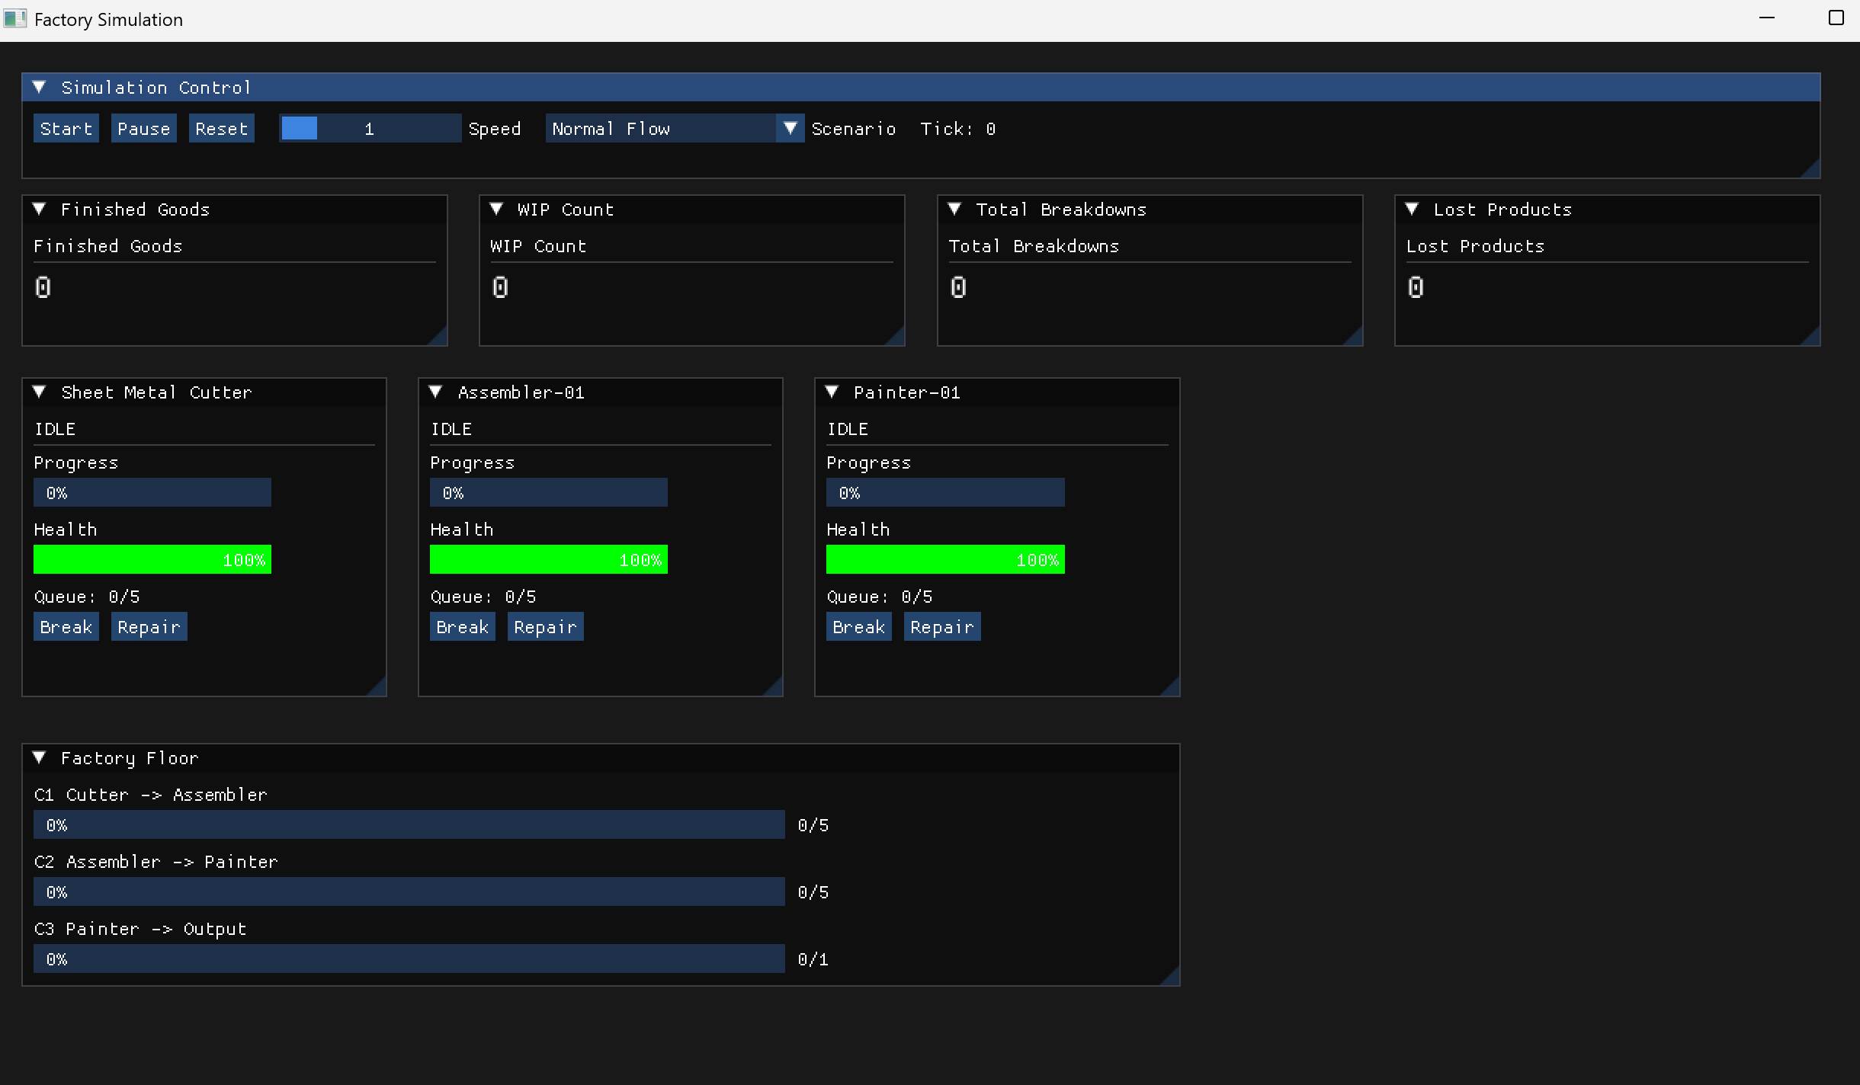
Caption: UI dashboard in its initial/reset state where the simulation tick counter, all machine statuses, conveyor load progress bars, and cumulative statistics are completely cleared to zero or set to default IDLE values.

Screenshot 2
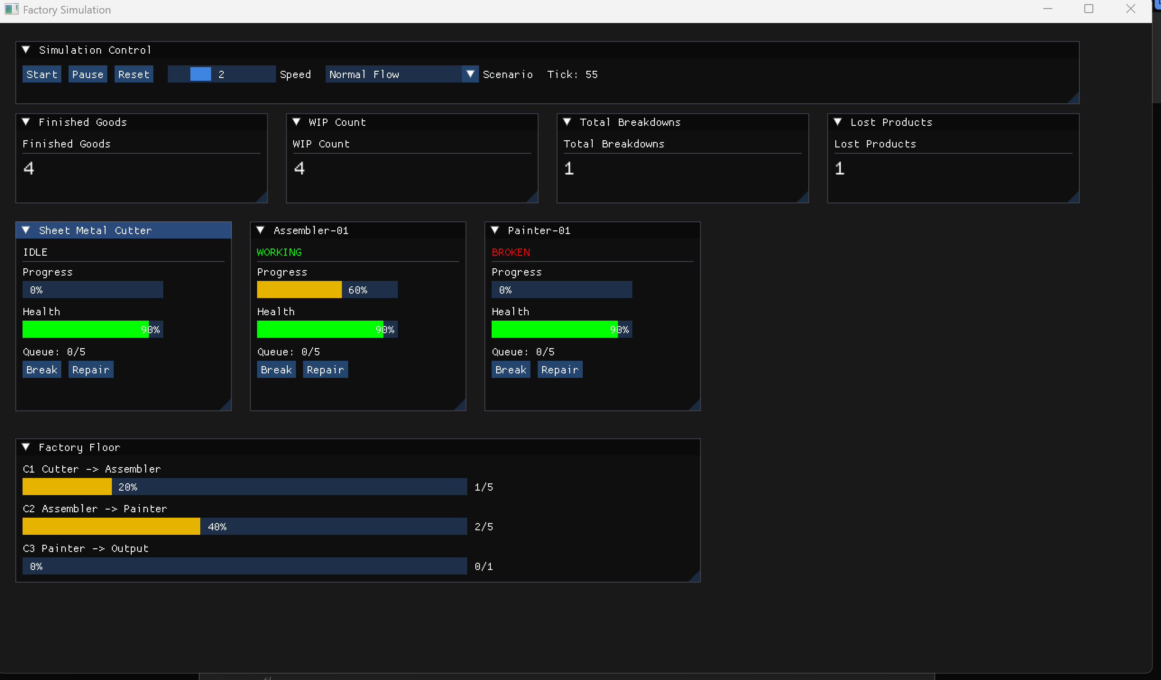
Caption: UI dashboard during an active simulation run demonstrating real-time data binding, dynamic color-coded machine statuses, working conveyor progress bars, and updated running totals for cumulative statistics.

5. Project Completion Roadmap
List your remaining tasks with target dates. Be specific — one task per row.

# | Task | Owner | Target date | Done?
1 | Complete FactoryFloorView with conveyor progress bars and machine state color map | 이승준 | 5/24 | □
2 | Refactor MachineCardView into MachineListView and InspectorView | 이승준 | 5/26 | □
3 | Move Break / Repair controls from MachineCardView to InspectorView | 이승준 | 5/26 | □
4 | Implement EventLogView with scrollable log and Clear button | 이승준 | 5/29 | □
5 | Add final UI screenshots and verify all required ImGui widgets are visible | 이승준 | 5/31 | □
6 | Final UI cleanup: labels, spacing, window sizes | 이승준 | 6/2 | □
7 |  |  |  | □
8 |  |  |  | □

6. Instructor Feedback
(This section is for instructor use only.)
Progress rating | □ On track □ Minor delays □ At risk □ Needs discussion
Architecture check | □ Frontend / backend correctly separated □ Needs revision
UML quality | □ Satisfactory □ Incomplete □ Incorrect — resubmit
Comments
Date reviewed

