Project Title: Lidar Point Cloud Analysis

Author: Sapir Carlo Lastimoza-Dooley

1. Introduction
   1. In this project, we are interested in a LIDAR DEM dataset of Hut Point Peninsula, Ross Island, Antarctica. This dataset contains two files: a LIDAR survey taken by NASA’s Airborne Topographic Mapper (ATM) laser altimetry system in December of 2001, and an image taken by DigitalGlobe’s QuickBird Earth observation satellite on January 1st, 2003.
2. Motivation
   1. In this project, we are interested in analyzing these datasets for elevation inconsistencies, correcting those errors and producing 3D Perspective View Models to depict elevation distribution in an easy-to-understand manner. We will be performing all analysis in ENVI and creating models using the 3D Surface View function.
3. Methods
   1. To correct the LIDAR DEMs we first manually inspect the raw data using the Cursor Location/Value Tool and inspect the full dataset using the Compute Statistics Function. Several inconsistencies were found where data points were missing elevation values, possibly relating to lack of backscattered signals. Using the Replace Bad Values function we are able to remove those data entries from our dataset. After, we use the Band Math tool to correct the elevation values from Geoid to Orthometric Heights for more intuitive analysis. After all correction is complete, we use the secondary images to create a 3D perspective view of the LIDAR data.
4. Completed Project Data

Original DEM

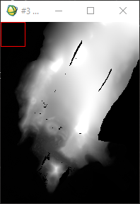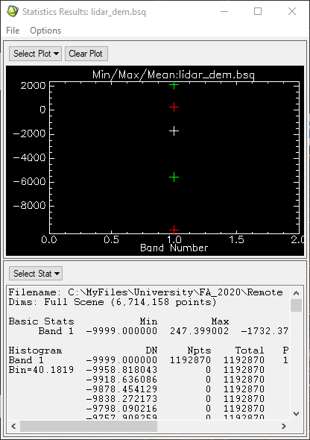

Corrected Elevation

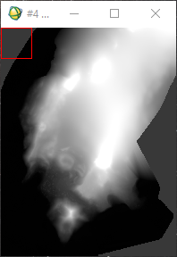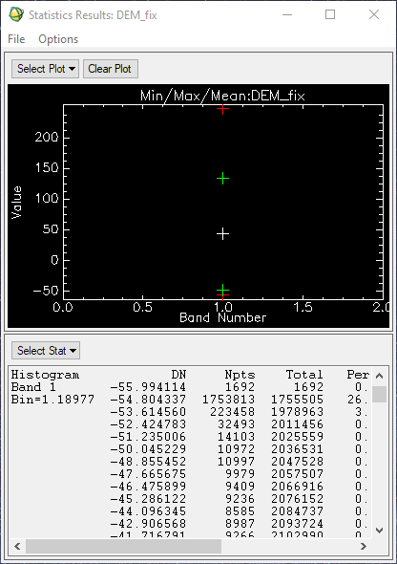

Orthorectified

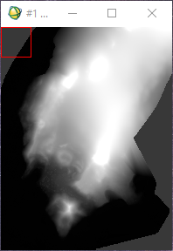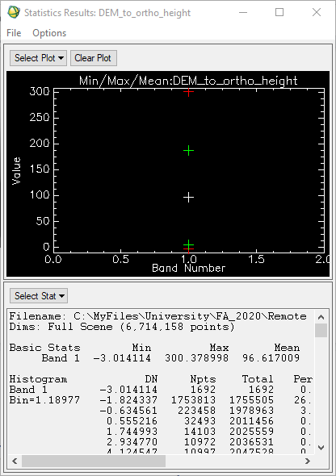

Image to 3D Perspective View

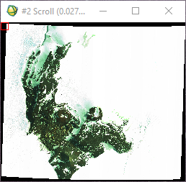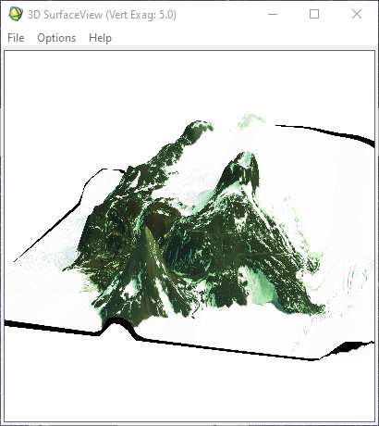

1. Conclusion
   1. The purpose of this project is to clean and process LIDAR point cloud data so that a 3D model can be made. Using that 3D model, more accurate assumptions can be made relating to elevation and conclusions can be drawn about glacier movement, landslide prediction and snowfall accumulation.