
INTEGRATED TOMATO DROUGHT PHENOTYPING
From Canopy Heat
to Stomatal Form
A combined SeedThermal and StomatalPhenotypingPipeline research report
16 tomato varieties | 32 plants | 2 water treatments
Prepared for Sapkota Lab
29 July 2026
SCOPE An integrated, quality-aware interpretation of thermal canopy traits, projected plant area, and manually measured stomatal-complex area from the same tomato cohort.

DECISION BRIEF

Executive summary
32  PLANT UNITS | 16  VARIETIES | 85  MANUAL MASKS | 14  THERMAL QC PAIRS

PRIMARY INTERPRETATION The current batch does not show a clear overall treatment effect on canopy temperature or stomatal-complex area. The strongest signal is a provisional increase in projected plant area under drought among thermal-mask-QC-valid pairs.

What the data show
Canopy temperature. Across all 16 pairs, drought-stressed plants averaged 25.69 °C versus 25.84 °C for watered plants (difference -0.15 °C; p = 0.448). Two plant masks failed QC, so this full-set estimate is descriptive.
Projected plant area. After restricting to 14 complete QC-valid pairs, drought-stressed plants had 39.3% larger projected area on average (difference 2,374 pixels²; 95% CI 968 to 3,779; p = 0.003). This remains provisional pending camera-geometry review and physical calibration.
Stomatal-complex area. Drought-stressed plants averaged 10,211.5 pixels² versus 10,968.5 pixels² for watered plants. The paired difference was -757.1 pixels² (-6.9%; 95% CI -2,766.3 to 1,252.2; p = 0.434).
Cross-scale relationship. Plant-level stomatal area was essentially unrelated to canopy temperature or projected plant area in this batch. The two pipelines are complementary rather than interchangeable.

Recommended use
Use now | Descriptive treatment and variety profiles; candidate prioritization; protocol refinement.
Do not claim yet | Generalized drought-response mechanisms, calibrated physical area, stomatal density, or variety ranking with inferential certainty.
Next milestone | Correct two thermal masks, acquire physical scale references, and repeat with biological replication.

ONE COHORT, TWO SCALES

Study design and evidence chain
SeedThermal and StomatalPhenotypingPipeline are treated as a single experiment. Every row resolves to a stable plant unit, a variety, and one of two biological treatment labels.
Watered | Source code Regular; 100 mL.
Drought-stressed | Source code Control; 0 mL.
Experimental unit | One plant. Individual stomata are within-plant subsamples, not independent replicates.
Pairing | One watered and one drought-stressed plant for each of 16 varieties.

Evidence collected
Scale | Input | Primary traits | Usable scope
Canopy | 64 radiometric FLIR captures across 13-15 July | Mean, median, range, dispersion, ΔT-air | July 15 isolates 32 plants; earlier paired frames show combined canopies.
Plant silhouette | 32 July 15 binary masks | Projected area and frame fraction | 30 masks pass QC; 14 complete variety pairs.
Leaf epidermis | 32 micrographs | Candidate confidence and per-object evidence | 5,633 candidates retained across decision tiers.
Stomatal complex | 85 manual polygons | Area, length, width, perimeter, shape, orientation | 2-3 quality-selected objects per plant; pixel units.
Source: combined plant manifest, thermal run table, calibrated candidate ledger, and manual mask manifest.

Thermal acquisition context
Date | Captures | Mean °C | Range °C | Interpretation
2026-07-13 | 16 | 24.32 | 23.86-24.56 | Paired full-frame: both treatments in one image
2026-07-14 | 16 | 23.57 | 23.23-24.08 | Paired full-frame: both treatments in one image
2026-07-15 | 32 | 25.76 | 23.45-26.77 | Individual auto-masked plants; treatment comparison

CANOPY PHENOTYPE

Thermal findings
BOTTOM LINE No clear overall treatment-temperature difference was detected. Across all 16 pairs, the mean drought-minus-watered difference was -0.15 °C (95% CI -0.58 to +0.27; p = 0.448).

Figure 1. Paired canopy temperatures by variety. Red QC labels mark the two pairs affected by failed automatic masks.
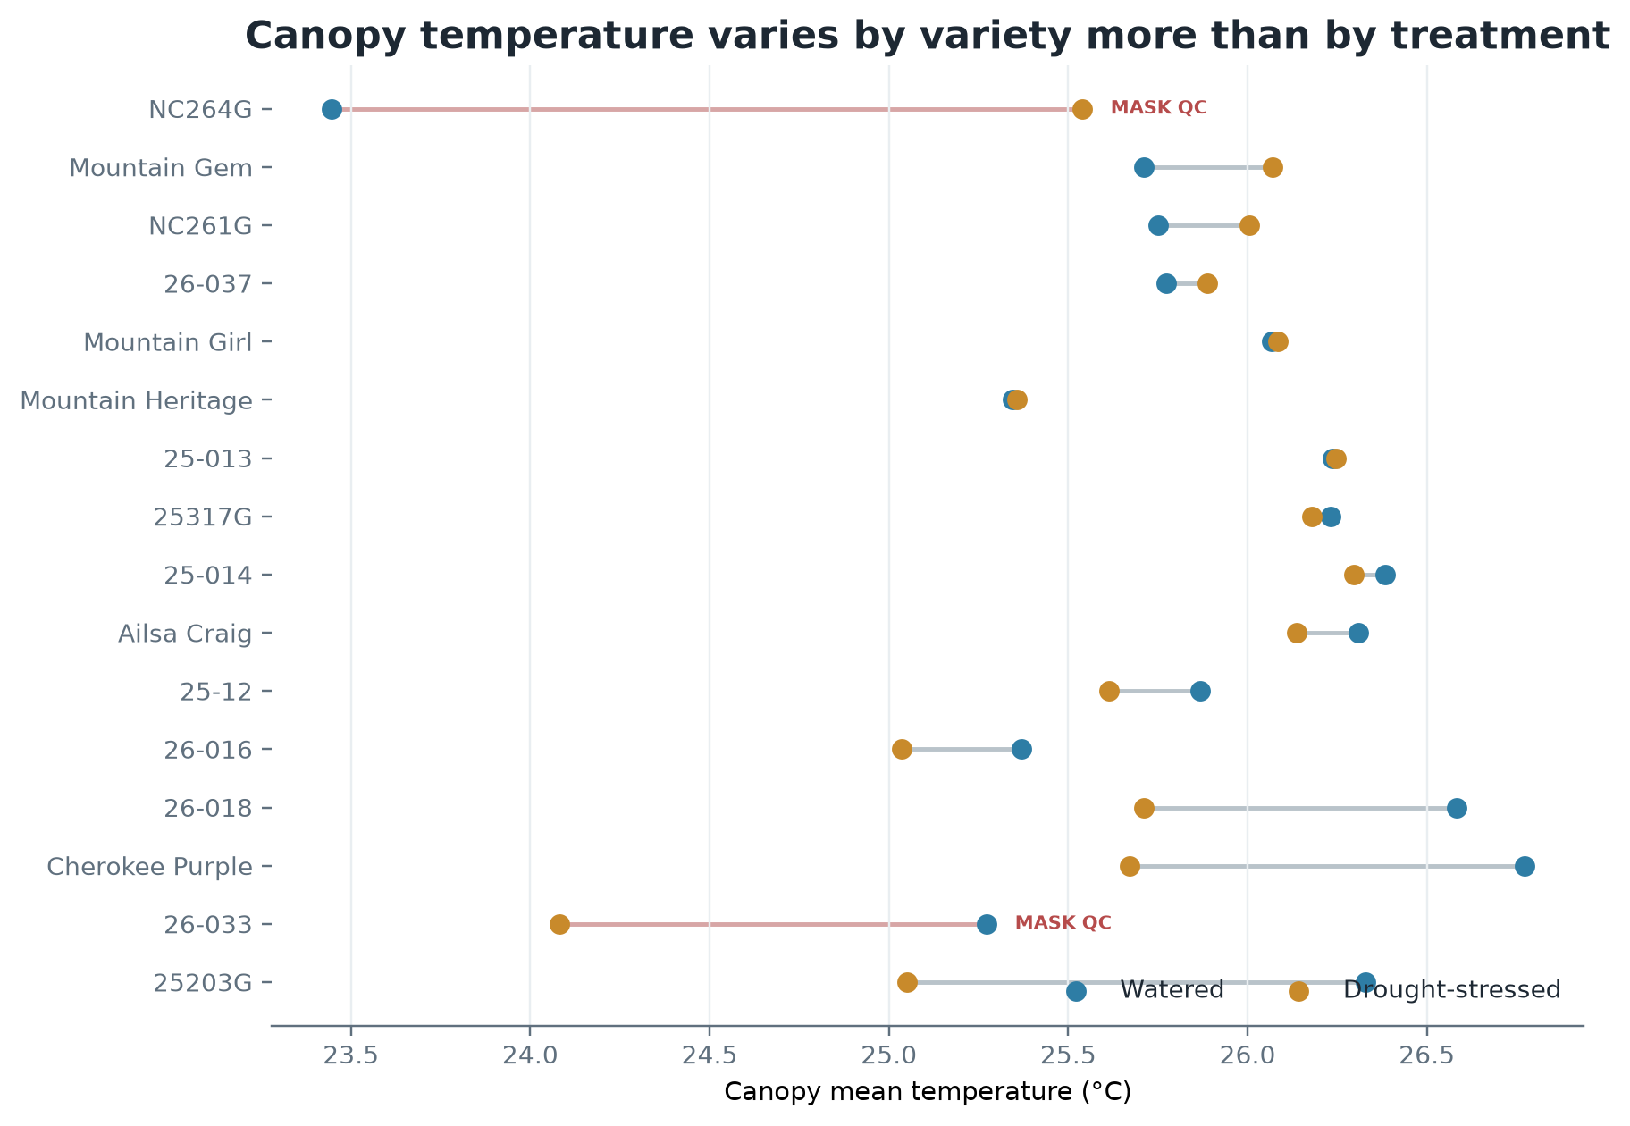
Source: July 15 plant-level FLIR extraction. Watered = Regular; drought-stressed = Control.

QC-restricted sensitivity result
After excluding NC264G and 26-033 to retain 14 complete QC-valid pairs, drought-stressed plants averaged 25.81 °C and watered plants 26.05 °C. The paired difference was -0.24 °C (95% CI -0.53 to +0.05; paired t-test p = 0.093; Wilcoxon p = 0.217). This near-zero-to-modest cooling estimate should be treated as inconclusive rather than as evidence of equivalence.

PLANT SILHOUETTE PHENOTYPE

Projected plant area
6,035  WATERED MEAN PX² | 8,409  DROUGHT MEAN PX² | +39.3%  PAIRED DIFFERENCE | 0.003  PAIRED T-TEST P

Figure 2. Within-variety difference in projected plant-mask area among the 14 complete thermal-QC pairs.
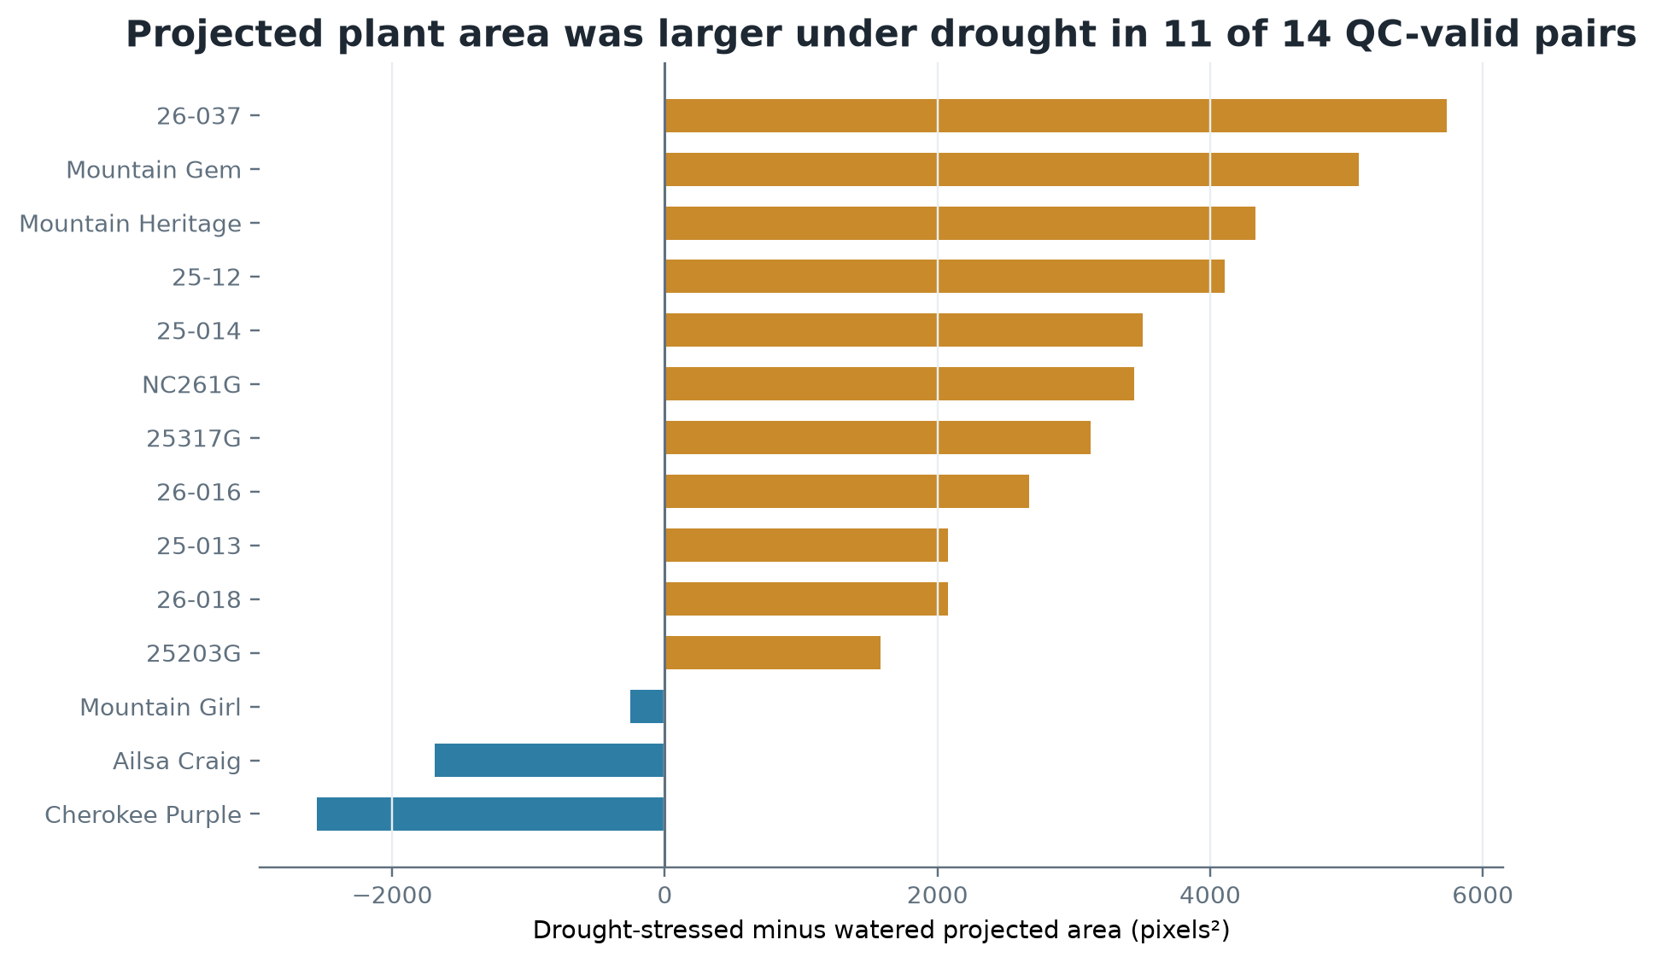
Blue bars favor watered; ochre bars favor drought-stressed. Area is in image pixels, not physical units.
Drought-stressed plants were larger in 11 of 14 QC-valid pairs. The mean paired difference was 2,374 pixels² (95% CI 968 to 3,779); paired t-test p = 0.003, Wilcoxon p = 0.005.
WHY THIS REMAINS PROVISIONAL The signal is statistically coherent within this batch, but projected pixel area depends on mask quality, camera distance, angle, and plant pose. It is not yet calibrated leaf area.

OBJECT-LEVEL EVIDENCE

Stomatal detection and measurement
5,633  CANDIDATES | 325  ACCEPTED TIER | 1,495  REVIEW TIER | 3,813  REJECTED TIER

The automated system is structured as an analysis engine: it preserves every candidate, its model evidence, confidence-related fields, decision tier, image position, and measurement context. Candidate counts are a derived summary, not the primary scientific output.
Figure 3. Example of a quality-selected stomatal complex with the manually traced outer contour.
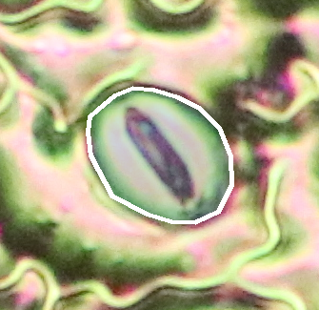
White boundary = reviewer polygon; translucent teal = measured stomatal-complex region.

Manual measurement subset
Coverage | 85 accepted manual polygons across 32 plants and all 16 varieties; 2-3 objects per plant.
Selection | Highest local focus and contrast with low clipping and good edge containment among completed masks.
Not used for selection | Treatment, variety, object area, mask area, or apparent stomatal shape.
Available traits | Complex area, length, width, perimeter, aspect ratio, eccentricity, solidity, circularity, orientation, centroid.
Current unit | Pixels and pixels². Physical dimensions require a stage-micrometer calibration.

MICROSCOPIC PHENOTYPE

Stomatal-complex area by treatment
10,968.5  WATERED PX² | 10,211.5  DROUGHT PX² | -6.9%  RELATIVE DIFFERENCE | 0.434  PAIRED T-TEST P

Figure 4. Plant-level mean stomatal-complex area for each of 16 matched variety pairs.
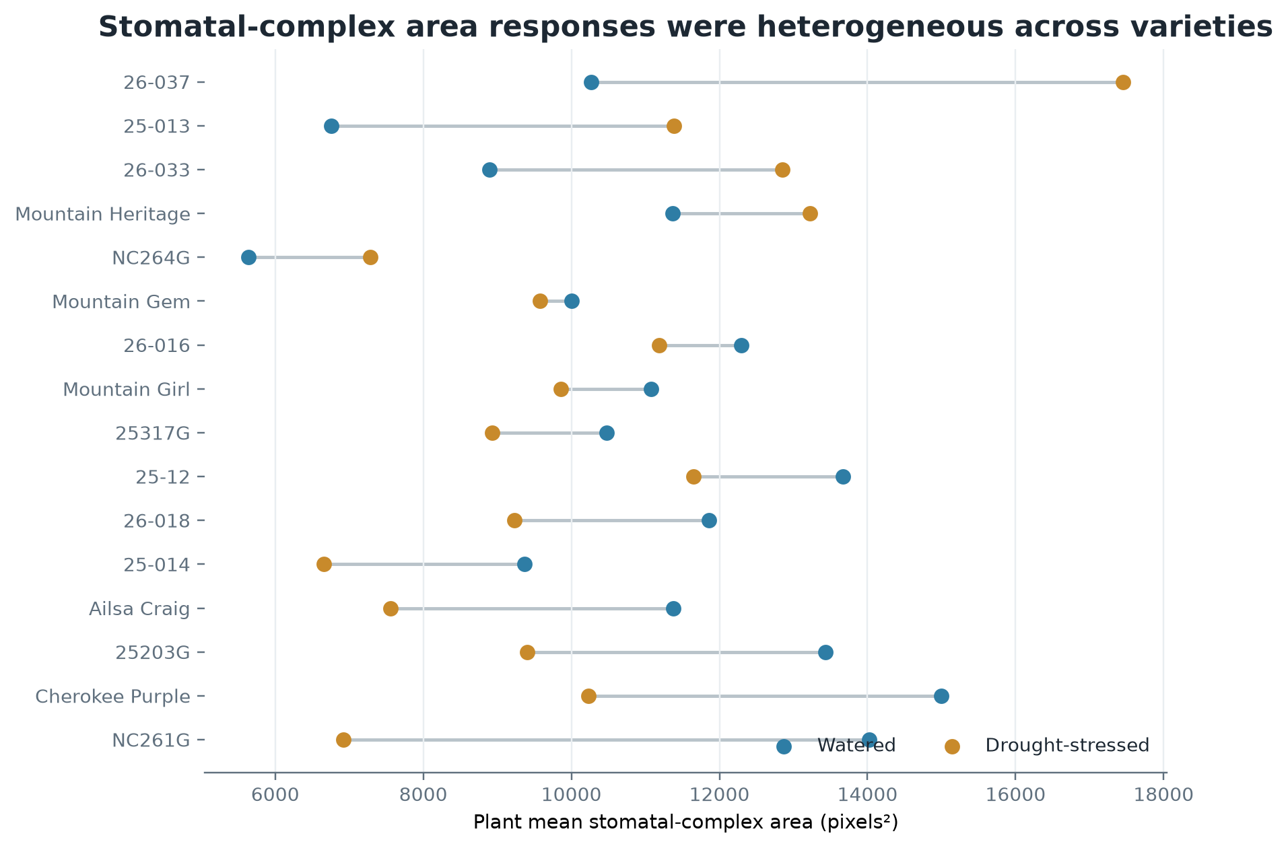
Each plant mean is based on 2-3 quality-selected manual masks; inferential tests use plants, not individual stomata.
The mean paired difference, defined as drought-stressed minus watered, was -757.1 pixels². Its 95% confidence interval ranged from -2,766.3 to 1,252.2 pixels². The paired t-test gave p = 0.434; the Wilcoxon signed-rank test gave p = 0.404; Cohen's dz = -0.20. The estimate is compatible with both modest drought-associated reduction and modest increase.
INTERPRETATION There is no clear batch-level treatment effect on stomatal-complex area. The variety-specific directions are heterogeneous and should guide replication, not selection decisions.

GENOTYPE PROFILES

Descriptive comparison among 16 varieties
The highest two-treatment descriptive mean was observed for 26-037; the lowest for NC264G. Because each variety-treatment cell contains one plant, these are profiles of this cohort, not population estimates.
Variety | Watered px² | Drought px² | Two-treatment mean | Drought - watered
26-037 | 10,269 | 17,451 | 13,860 | +7,183
25-12 | 13,670 | 11,652 | 12,661 | -2,018
Cherokee Purple | 14,993 | 10,230 | 12,611 | -4,762
Mountain Heritage | 11,369 | 13,223 | 12,296 | +1,854
26-016 | 12,299 | 11,188 | 11,744 | -1,111
25203G | 13,436 | 9,401 | 11,418 | -4,035
26-033 | 8,892 | 12,849 | 10,870 | +3,957
26-018 | 11,857 | 9,230 | 10,543 | -2,627
NC261G | 14,028 | 6,918 | 10,473 | -7,110
Mountain Girl | 11,072 | 9,860 | 10,466 | -1,212
Mountain Gem | 10,005 | 9,574 | 9,789 | -431
25317G | 10,477 | 8,928 | 9,702 | -1,550
Ailsa Craig | 11,374 | 7,561 | 9,467 | -3,812
25-013 | 6,753 | 11,383 | 9,068 | +4,630
25-014 | 9,363 | 6,656 | 8,010 | -2,708
NC264G | 5,641 | 7,280 | 6,461 | +1,639
Ranking is based on the descriptive average of the watered and drought-stressed plant means.
RESPONSE RANGE The largest positive response was 26-037 (+7,183 pixels²); the largest negative response was NC261G (-7,110 pixels²). These extremes are especially sensitive to low replication.

CROSS-SCALE SYNTHESIS

Do canopy and stomatal traits move together?
Figure 5. Plant-level stomatal-complex area versus thermal and projected-area traits for the 30 thermal-QC-valid plants.
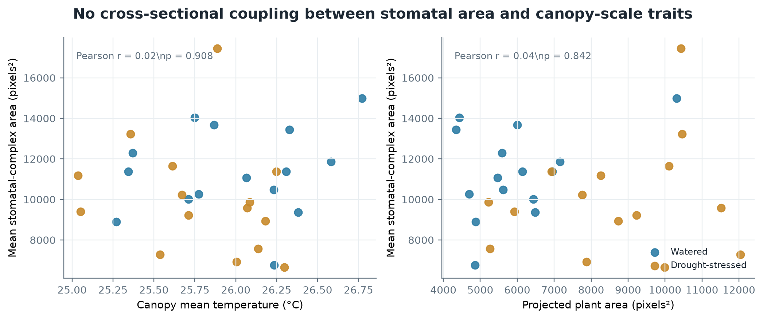
Correlations are exploratory; points are plants and colors indicate treatment.
Stomatal area vs canopy temperature | Pearson r = 0.022; p = 0.908; n = 30 plants.
Stomatal area vs projected plant area | Pearson r = 0.038; p = 0.842; n = 30 plants.
Paired stomatal response vs thermal response | Pearson r = 0.379; p = 0.181; n = 14 varieties.
Paired stomatal response vs projected-area response | Pearson r = 0.471; p = 0.089; n = 14 varieties.

The cross-sectional relationships are essentially null. The response-level associations are moderate in direction but imprecise, especially for projected area (r = 0.47, p = 0.089). They are useful hypotheses for a replicated experiment, not evidence of mechanistic coupling.
SCIENTIFIC READING A plant can show canopy-scale size or temperature differences without a matching change in the area of its clearest stomatal complexes. Response is multiscale; one trait cannot substitute for another.

INTERPRETATION GUARDRAILS

Limitations and recommended next steps
Constraint | Why it matters | Recommended action
One plant per variety-treatment cell | Variety effects and interactions cannot be estimated reliably. | Repeat with independent biological replicates.
2-3 selected stomata per plant | Within-leaf variation is only sparsely represented. | Expand objects per plant using the validated analysis engine.
Quality-selected objects | Results describe clearest measurable stomata, not a random within-image population. | Predefine random/systematic fields and selection rules.
Pixel-only geometry | Areas cannot be compared in µm² or across changed magnification. | Acquire a stage-micrometer image at every optical configuration.
Two failed thermal masks | NC264G watered and 26-033 drought distort area and temperature extraction. | Correct masks and rerun the joined analysis.
Projected area is view-dependent | Camera pose and plant architecture affect silhouette size. | Fix camera geometry and add a scale reference.
No stomatal density or pore aperture | Current masks support complex morphology, not density or conductance. | Define analyzed leaf area; validate pore segmentation separately.
These constraints define the boundary between current evidence and future claims.

Prioritized next experiment
1 Repair | Correct the two thermal masks and regenerate all joined outputs.
2 Calibrate | Capture stage-micrometer and plant-view scale references.
3 Replicate | Target at least 3-5 plants per variety-treatment cell; preserve within-variety pairing.
4 Sample | Use predefined fields and a consistent number of stomata per plant.
5 Validate | Reserve held-out tomato images for detection calibration and mask-error assessment.
6 Extend | Only after validation, add pore aperture, density, and spatial-pattern traits.

GO/NO-GO RECOMMENDATION Proceed with the combined platform as a research workflow. Do not yet use this single batch to rank varieties for drought tolerance or claim a stomatal mechanism.

REPRODUCIBILITY

Methods and data provenance

Thermal pipeline
Radiometric FLIR JPGs were converted to per-pixel Celsius arrays. July 15 plant masks defined the canopy pixels used for mean, median, minimum, maximum, standard deviation, P10, P90, and temperature relative to the 25 °C ambient reference. Projected plant area is the number and fraction of selected pixels.

Stomatal pipeline
Native-resolution micrographs were processed with a high-recall, tiled candidate detector. The object ledger retains decision tiers and confidence evidence. For this report, manual outer stomatal-complex polygons were ranked within each image by local focus, contrast, clipping, and edge containment; at most three objects per plant were retained. Polygon geometry produced direct pixel-space morphology.

Statistical analysis
Treatment contrasts were paired by variety. Plant means, not individual stomata, were the inferential units. Paired t-tests were accompanied by 95% confidence intervals and Wilcoxon signed-rank sensitivity tests. Variety results are descriptive because each variety-treatment cell contains one plant. Cross-modal Pearson correlations were exploratory and restricted to thermal-mask-QC-valid plants or pairs.

Primary source files
Combined plant table | results/combined_quality_mask_analysis_v1/plant_phenotypes.csv
Variety-level paired table | results/combined_quality_mask_analysis_v1/variety_phenotypes.csv
Per-stoma measurements | results/quality_mask_analysis_v1/stomatal_complex_measurements.csv
Stomatal statistical record | results/quality_mask_analysis_v1/area_comparisons/stomatal_area_analysis.json
Thermal run table | ../SeedThermal/processed/thermal_data_all_sessions.csv
Study definitions | docs/COMBINED_STUDY.md and docs/ANALYSIS_ENGINE.md

Reporting language
PREFERRED CONCLUSION In this quality-selected pilot cohort, drought stress was not associated with a clear overall change in canopy temperature or stomatal-complex area. A larger projected plant silhouette was observed in the QC-valid drought group, but this finding remains provisional pending mask correction, calibration, and biological replication.

