How to Use Terminal App

1. Open Terminal app
2. Select port and baudrate, click connect button

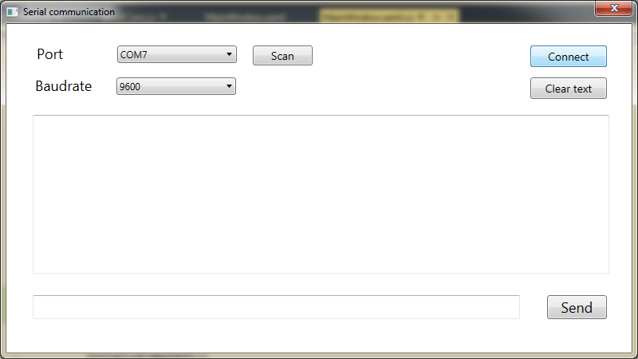

1. Write data and click on send button

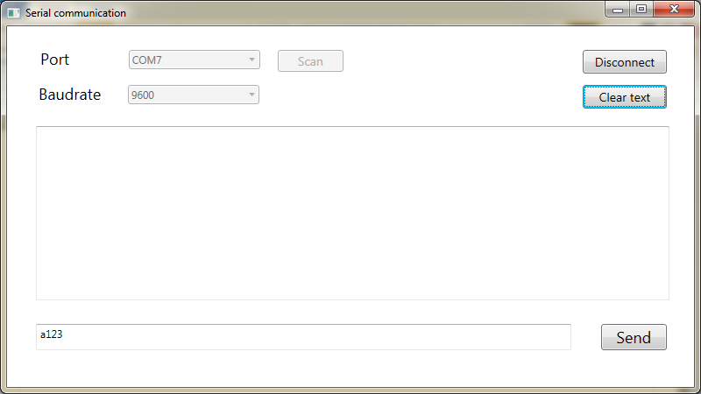

1. Data received is visible in Receive pad in hex format.

*(Note : Cable sending and receiving point is short, thats why is visible on same terminal)*

You can connect two ports and open 2 terminals to communicate.

Here Receiving pad will display only received bytes

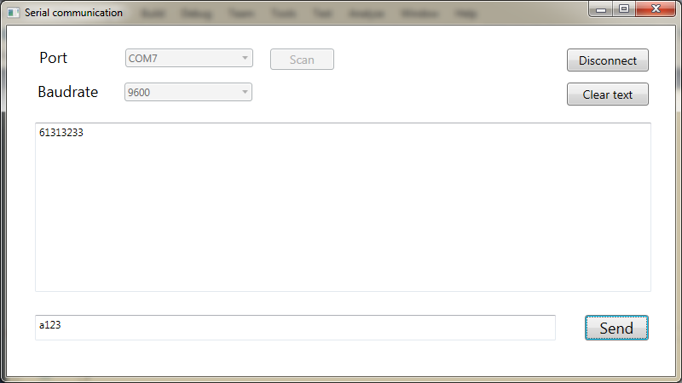

1. To clear text of Receiving pad, click on clear button

