Chapter # 01

1. Write a script to greet your website visitor using JS alert box.

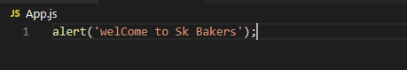

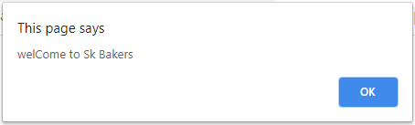

1. Write a script to display following message on your web page:



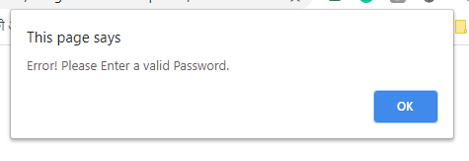

1. Write a script to display following message on your web page: (Hint : Use line break)



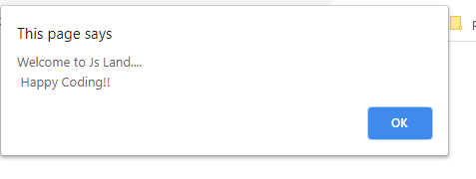

1. Write a script to display following messages in sequence:

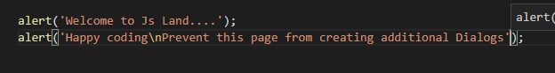

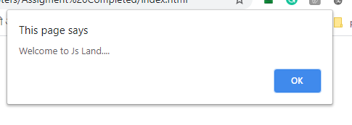

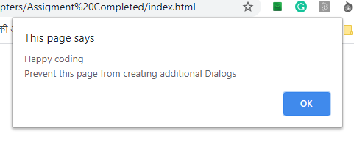

1. Generate the following message through browser’s developer console:

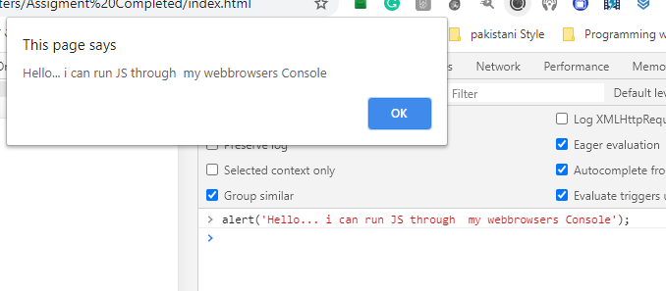

1. Make use of alerts in your new/existing HTML & CSS project.



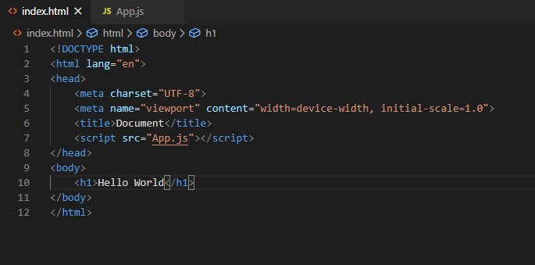

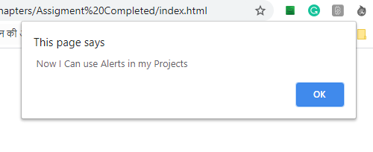

1. Practice placement of element in following sections of your project in exercise 6:
2. Head

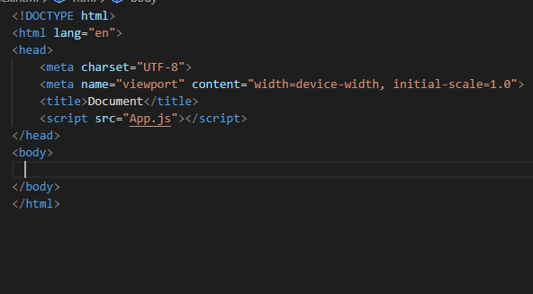

1. Body (before your page’s HTML)

ALERTS | JAVASCRIPT Page 3 of 3

1. Body (inside your page’s HTML)

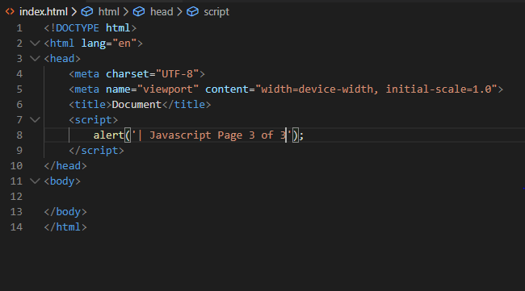

1. Body (after your page’s HTM
2. 