**Chapter #03 Variables of Numbers**

1. Declare a variable called age & assign to it your age. Show your age in an alert box.

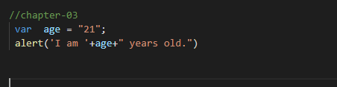

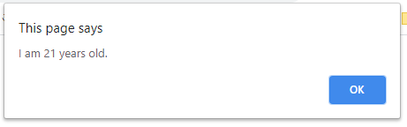

1. Declare & initialize a variable to keep track of how many times a visitor has visited a web page. Show his/her number of visits on your web page. For example: “You have visited this site N times”.
2. Declare a variable called birth Year & assign to it your birth year. Show the following message in your browser:

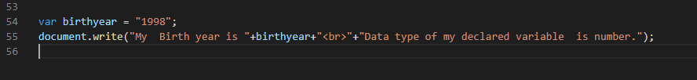

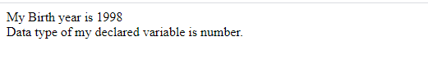

1. A visitor visits an online clothing store www.xyzClothing.com . Write a script to store in variables the following information:
   1. Visitor’s name
   2. Product title
   3. Quantity i.e. how many products a visitor wants to order

Show the following message in your browser: “John Doe ordered 5 T-shirt(s) on XYZ Clothing store”.

