**Chapter -4 Legal & Illegal**

1. Declare 3 variables in one statement.

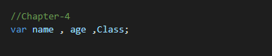

1. Declare 5 legal & 5 illegal variable names.

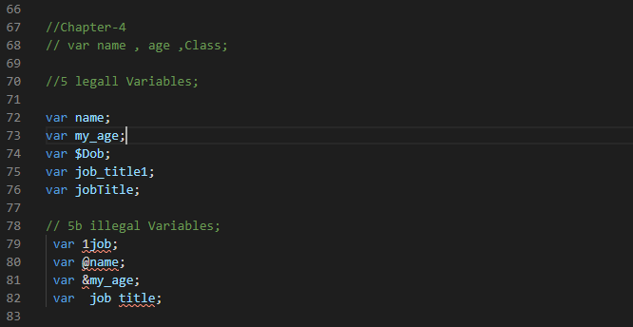

3. Display this in your browser

a) A heading stating “Rules for naming JS variables”

b) Variable names can only contain ______, ______, ______ and ______. For example $my_1stVariable c) Variables must begin with a ______, ______ or _____. For example $name, _name or name

d) Variable names are case _________ e) Variable names should not be JS _________

