**Chapter 5: Math Expression**

1. a program that take two numbers & add them in a new variable. Show the result in your browser.

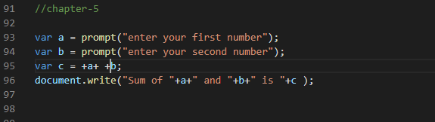

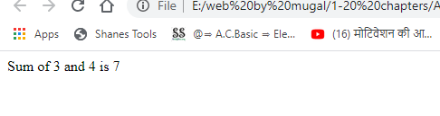

1. Repeat task1 for subtraction, multiplication, division & modulus.

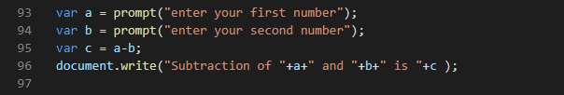

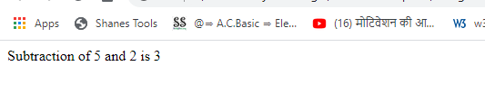

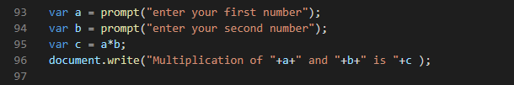

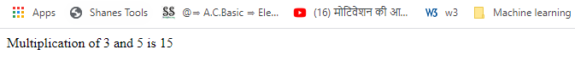

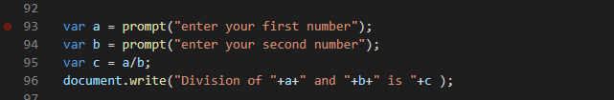

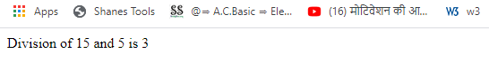

1. Do the following using JS Mathematic Expressions

a. Declare a variable.

b. Show the value of variable in your browser like “Value after variable declaration is: ??”

c. Initialize the variable with some number.

d. Show the value of variable in your browser like “Initial value: 5”.

e. Increment the variable.

f. Show the value of variable in your browser like “Value after increment is: 6”.

g. Add 7 to the variable.

h. Show the value of variable in your browser like “Value after addition is: 13”.

i. Decrement the variable.

j. Show the value of variable in your browser like “Value after decrement is: 12”.

k. Show the remainder after dividing the variable’s value by 3.

l. Output : “The remainder is : 0”.

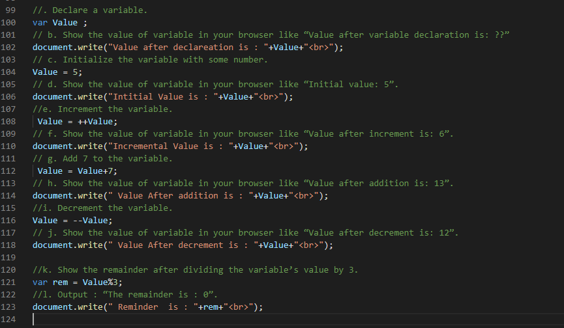

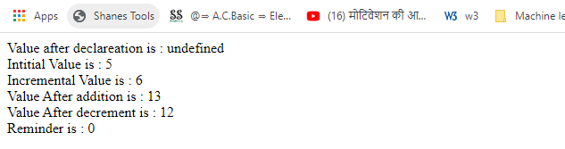

1. Cost of one movie ticket is 600 PKR. Write a script to store ticket price in a variable & calculate the cost of buying 5 tickets to a movie. Example output:

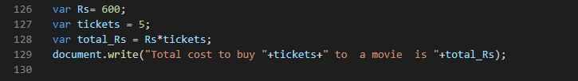

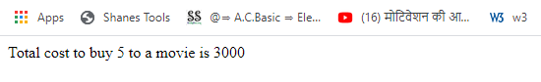

1. Write a script to display multiplication table of any number in your browser. E.g

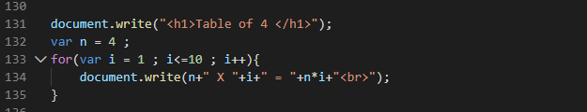

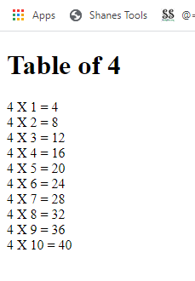

1. The Temperature Converter: It’s hot out! Let’s make a converter based on the steps here.

a. Store a Celsius temperature into a variable.

b. Convert it to Fahrenheit & output “NNoC is NNoF”.

c. Now store a Fahrenheit temperature into a variable.

d. Convert it to Celsius & output “NNoF is NNoC”.

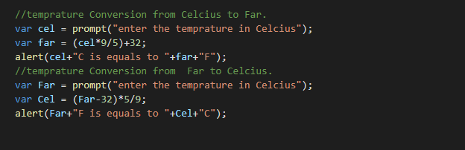

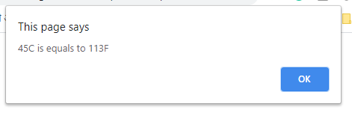

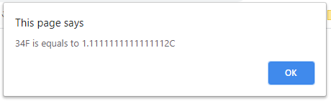

1. Write a program to implement checkout process of a shopping cart system for an e-commerce website. Store the following in variables.

a. Price of item1

b. Price of item 2

c. Ordered quantity of item 1

d. Ordered Quantity of item 2

e. Shipping charges Compute the total cost & show the receipt in your browser.

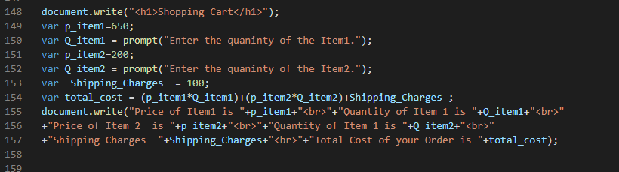

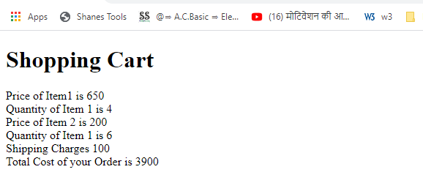

1. Store total marks & marks obtained by a student in 2 variables. Compute the percentage & show the result in your browser…

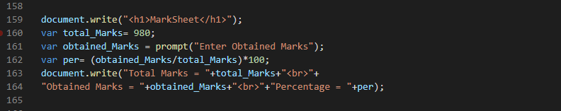

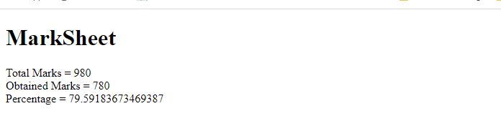

1. Assume we have 10 US dollars & 25 Saudi Riyals. Write a script to convert the total currency to Pakistani Rupees. Perform all calculations in a single expression. (Exchange rates : 1 US Dollar = 104.80 Pakistani Rupee and 1 Saudi Riyal = 28 Pakistani Rupee).

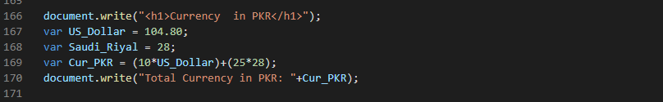

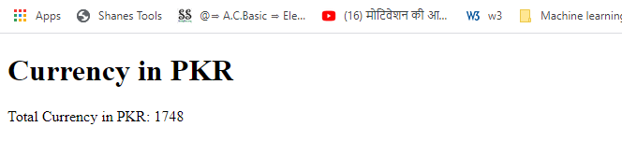

1. Write a program to initialize a variable with some number and do arithmetic in following sequence:

a. Add 5

b. Multiply by 10

c. Divide the result by 2 Perform all calculations in a single expression

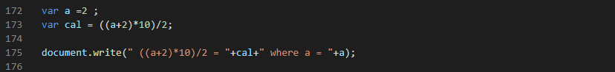

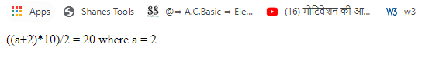

1. The Age Calculator: Forgot how old someone is? Calculate it!

a. Store the current year in a variable.

b. Store their birth year in a variable.

c. Calculate their 2 possible ages based on the stored values.

Output them to the screen like so: “They are either NN or NN years old”.

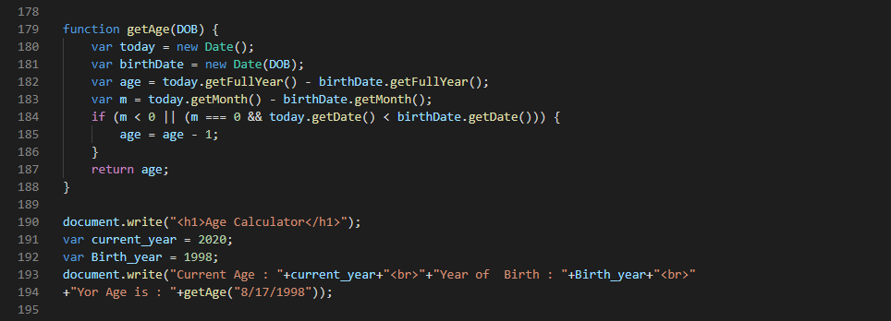

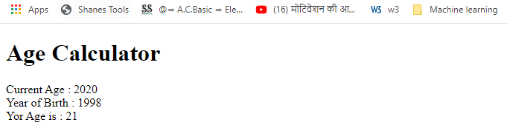

1. The Geometrizer: Calculate properties of a circle.

a. Store a radius into a variable.

b. Calculate the circumference based on the radius, and output “The circumference is NN”. (Hint : Circumference of a circle = 2 π r , π = 3.142) Calculate the area based on the radius, and output “The area is NN”. (Hint : Area of a circle = π r2, π = 3.142)

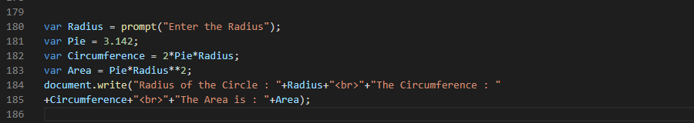

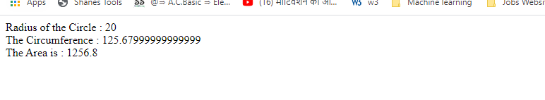

1. The Lifetime Supply Calculator: Ever wonder how much a “lifetime supply” of your favorite snack is? Wonder no more.

a. Store your favorite snack into a variable

b. Store your current age into a variable.

c. Store a maximum age into a variable.

d. Store an estimated amount per day (as a number).

e. Calculate how many would you eat total for the rest of your life.

Output the result to the screen like so: “You will need NNNN to last you until the ripe old age of NN

