**Chapter -2 Variable For String**

1. Declare a variable called username.

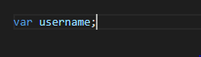

1. Declare a variable called myName & assign to it a string that represents your Full Name.

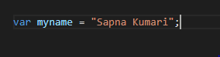

1. Write script to
   1. Declare a JS variable, titled message.
   2. Assign “Hello World” to variable message
   3. Display the message in alert box.

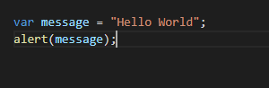

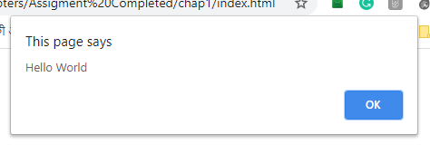

1. Write a script to save student’s bio data in JS variables and show the data in alert boxes.

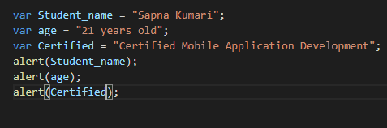

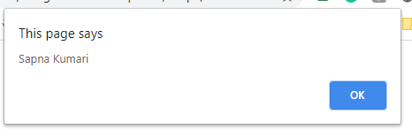

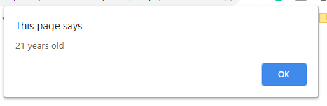

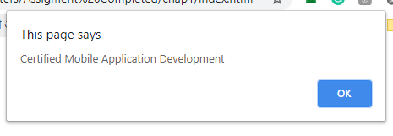

1. Write a script to display the following alert using one JS variable:

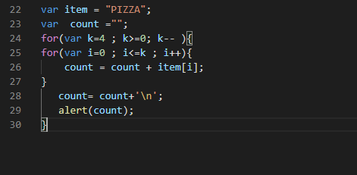

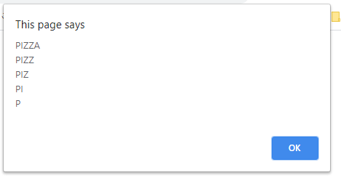

1. Declare a variable called email and assign to it a string that represents your Email Address(e.g. example@example.com). Show the blow mentioned message in an alert box.(Hint: use string concatenation)

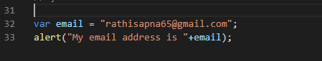

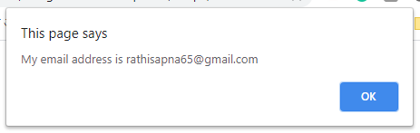

1. Declare a variable called book & give it the value “A smarter way to learn JavaScript”. Display the following message in an alert box:



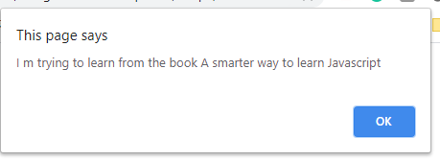

1. Write a script to display this in browser through JS.

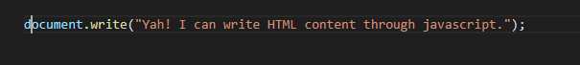

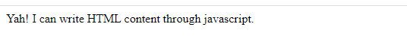

1. Store following string in a variable and show in alert and browser through JS “▬▬▬▬▬▬▬▬▬ஜ۩۞۩ஜ▬▬▬▬▬▬▬▬▬”

