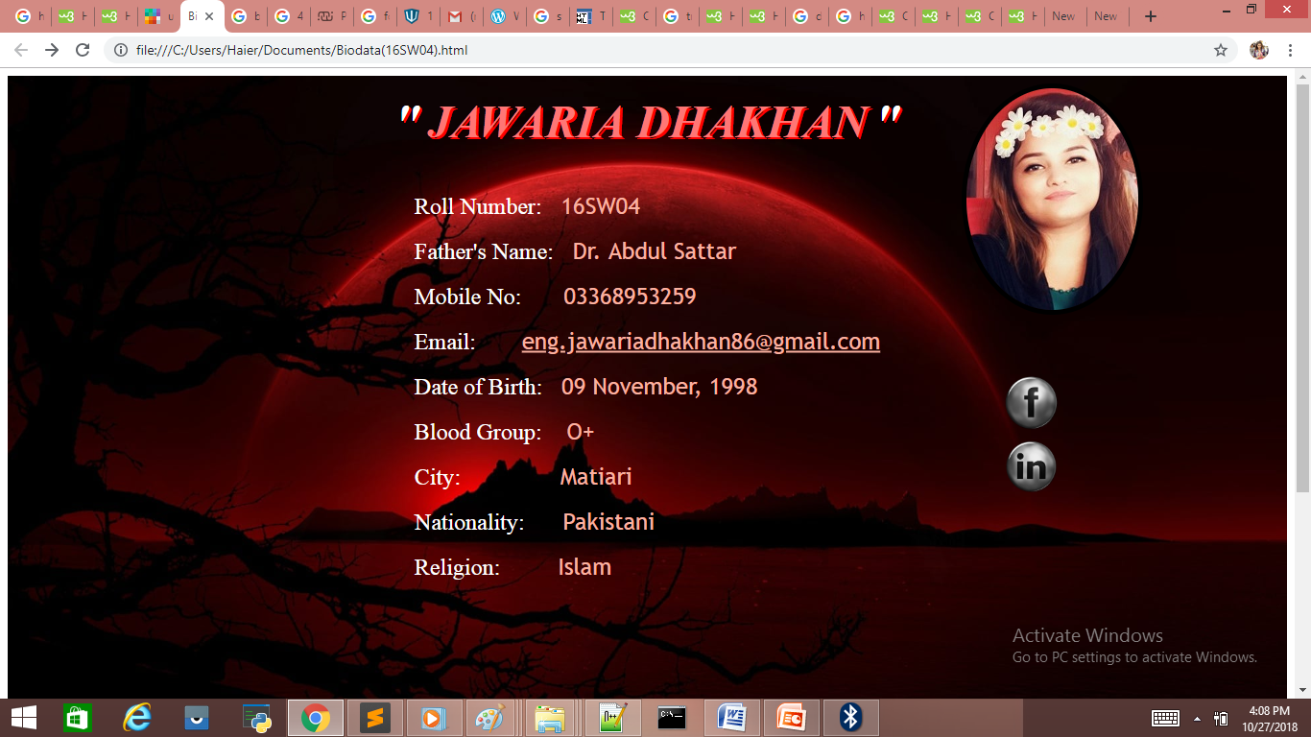**TASK NO 02:***Create a simple webpage displaying your entire bio data including an image and an anchor tag for your email.*