MINDSPRINT - PROJECT DOCUMENTATION
1. Introduction
1.1 Existing System
The existing system for student placement preparation and technical skill learning primarily relies on physical textbooks, static offline notes, and scattered web platforms. Students currently use separate applications or websites for practicing quantitative aptitude, watching video lectures, reading technical documentation, and tracking their study habits.
Key drawbacks of the existing system include:
- Disjointed platforms for exam preparation, skill learning, and progress tracking.
- Lack of real-time performance evaluation and weak spot identification.
- Inability to practice company-specific interview patterns in a single mobile interface.
- Manual tracking of daily study consistency without automated retention tools like flashcards or streak counters.
1.2 Need for the New System
With the rapid increase in competitive campus placement drives (TCS, Infosys, Wipro, Accenture, Amazon, Google), students require a unified, mobile-first learning management system.
The new system, MindSprint, addresses this need by combining:
- Practice questions categorized by Quantitative Aptitude, Logical Reasoning, and IT Technical topics.
- Company-specific question filters.
- Real-time exam simulation with live timers and scratchpad tools.
- Intelligent analytics to identify weak topics based on past test attempts.
- Integrated video learning modules and interactive flashcards.
1.3 Objective of the New System
The primary objectives of MindSprint are:
- 1. To provide a consolidated mobile platform for aptitude practice, technical courses, and academic revision.
- 2. To enable company-wise filter options for focused campus drive preparation.
- 3. To deliver real-time exam evaluation with automated score calculation and topic-level weak spot detection.
- 4. To improve daily student engagement through streak tracking and swipeable flashcards.
- 5. To offer a robust full-stack architecture with backend database persistence and offline dataset fallback.
1.4 Problem Definition
Students preparing for IT job placements face difficulty in identifying their specific technical and quantitative weak areas due to a lack of detailed test analysis. Furthermore, switching between multiple apps for learning, practicing, and reviewing formulas leads to reduced focus and study fragmentation.
MindSprint solves this problem by integrating test execution, video learning, weak topic analysis, and formula flashcards into a single application supported by a Node.js/MongoDB REST API backend.
1.5 Core Components
MindSprint consists of four primary software components:
- 1. Mobile Client App: React Native frontend built with Expo v54, TypeScript, and Expo Router.
- 2. REST API Backend: Node.js and Express server delivering authentication, question banks, course data, and exam result processing.
- 3. Database Layer: MongoDB database storing User accounts, Question banks, Courses, and Exam Results.
- 4. Offline Resilience Layer: Fallback service layer (ApiService) ensuring continuous app functionality using local datasets when network connectivity is lost.
1.6 Project Profile
- Project Title: MindSprint - Placement Preparation & Skill Learning App
- Front-End Technology: React Native, Expo v54, TypeScript, Expo Router
- Back-End Technology: Node.js, Express.js REST API
- Database: MongoDB / Mongoose ODM
- Target OS: Android, iOS, Web
- IDE / Environment: VS Code, Node.js v20+, Expo CLI
1.7 Assumptions and Constraints
Assumptions:
- Users possess an active Android/iOS mobile device or modern web browser.
- Network connectivity is available for user registration, live backend sync, and course video streaming.
Constraints:
- Offline mode relies on static local datasets for practice questions.
- Video playback requires active internet bandwidth.
- Backend API authentication uses JWT/hashed passwords for secure user access.
1.8 Advantages and Limitations of the Proposed System
Advantages:
- Single unified platform for aptitude practice, course videos, and flashcards.
- Real-time weak spot detection helping students target problem areas.
- Automated score calculation and test analytics.
- Cross-platform compatibility (Android, iOS, Web).
- Graceful offline fallback mechanism.
Limitations:
- Initial database setup requires internet connectivity for syncing recent exam results.
- Advanced AI recommendations depend on the volume of test data recorded over time.
2. Requirement Determination & Analysis
2.1 Requirement Determination
Functional Requirements:
- 1. User Authentication: User registration and login using email/password.
- 2. Track Selection: Ability to switch between Placement Prep, IT Skills, and School tracks.
- 3. Company Filter: Filter exam questions by company tag (TCS, Infosys, Amazon, etc.).
- 4. Exam Engine: Conduct timed mock tests, navigate via Question Palette, record user answers, calculate score percentages, and identify weak categories.
- 5. Course Learning: View IT skill course catalog and play instructional video lessons.
- 6. Revision & Engagement: Interactive flashcard flip deck and daily streak counter.
Non-Functional Requirements:
- 1. Performance: Screen load times under 2 seconds; instant local exam evaluation.
- 2. Reliability: Seamless offline fallback using local static data when backend API is unreachable.
- 3. Usability: Clean, accessible Material Design 3 interface with dark/light mode support.
- 4. Security: Encrypted user passwords and protected REST API endpoints.
2.2 Targeted Users
- 1. College / Placement Aspirant (Engineering Student): Focuses on aptitude tests, company filters, weak spot analysis, and exam timers.
- 2. Job Seeker / IT Skill Learner: Focuses on technical course catalog, streaming video lessons, DSA, and flashcard revision.
- 3. School & Academic Student: Focuses on foundational science and mathematics chapters.
3. System Design
3.1 Use Case Diagram
The following UML Use Case Diagram illustrates the interaction between each User Role and the MindSprint System:
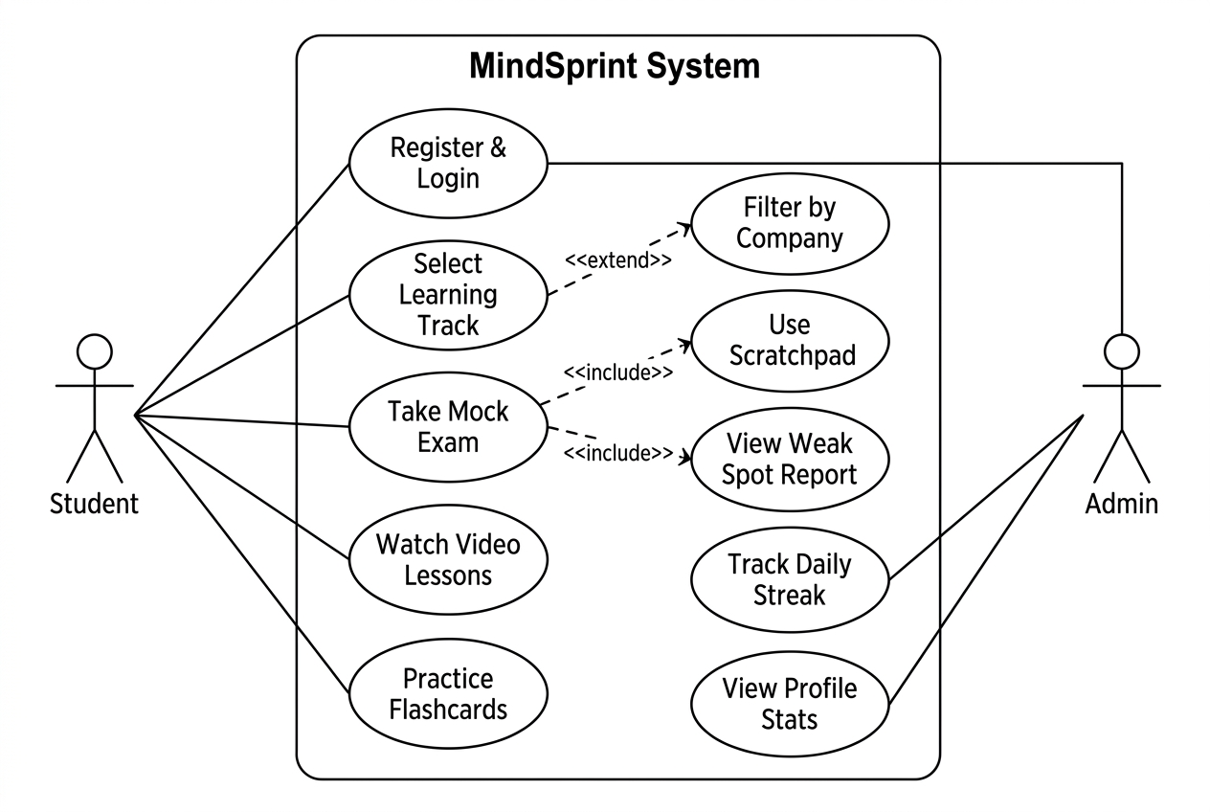

Figure 3.1: Use Case Diagram - MindSprint System
3.2 Class Diagram
The following UML Class Diagram shows the component architecture and relationships between the data models and service layer:
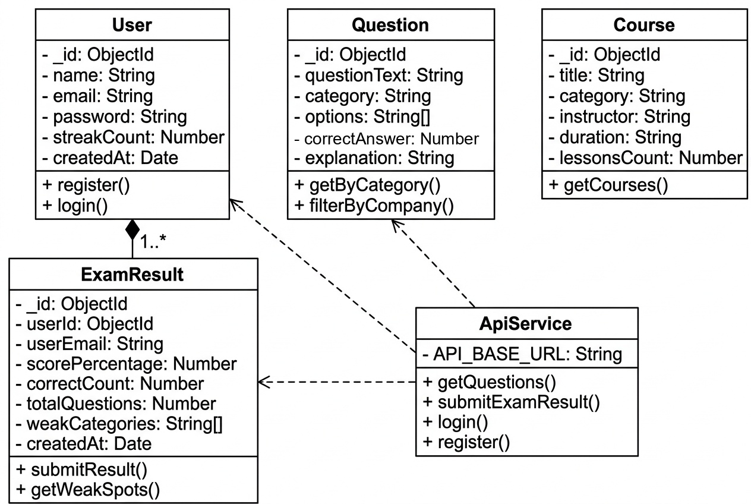

Figure 3.2: Class Diagram - MindSprint Data Models & ApiService
3.3 Interaction Diagram (Sequence Diagram)
The following UML Sequence Diagram shows the complete interaction flow for the Mock Exam feature, from the Student initiating the test through to the final score display:
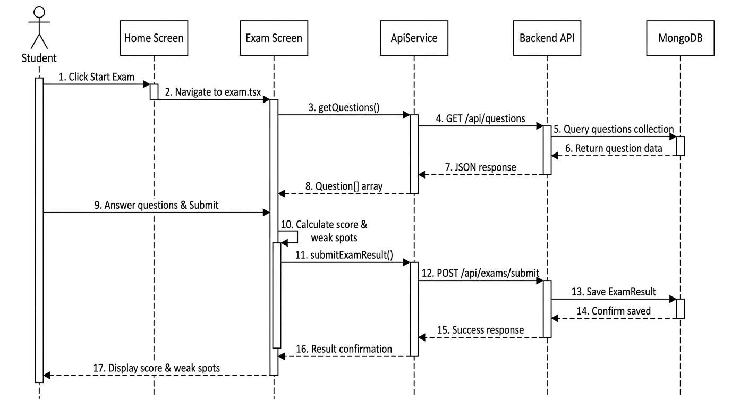

Figure 3.3: Interaction Diagram - Mock Exam Flow (Student -> Home Screen -> Exam Screen -> ApiService -> Backend API -> MongoDB)
3.4 Activity Diagram
The following UML Activity Diagram illustrates the step-by-step process flow for the Mock Exam use case, including decision points, parallel activities, and the offline fallback path:
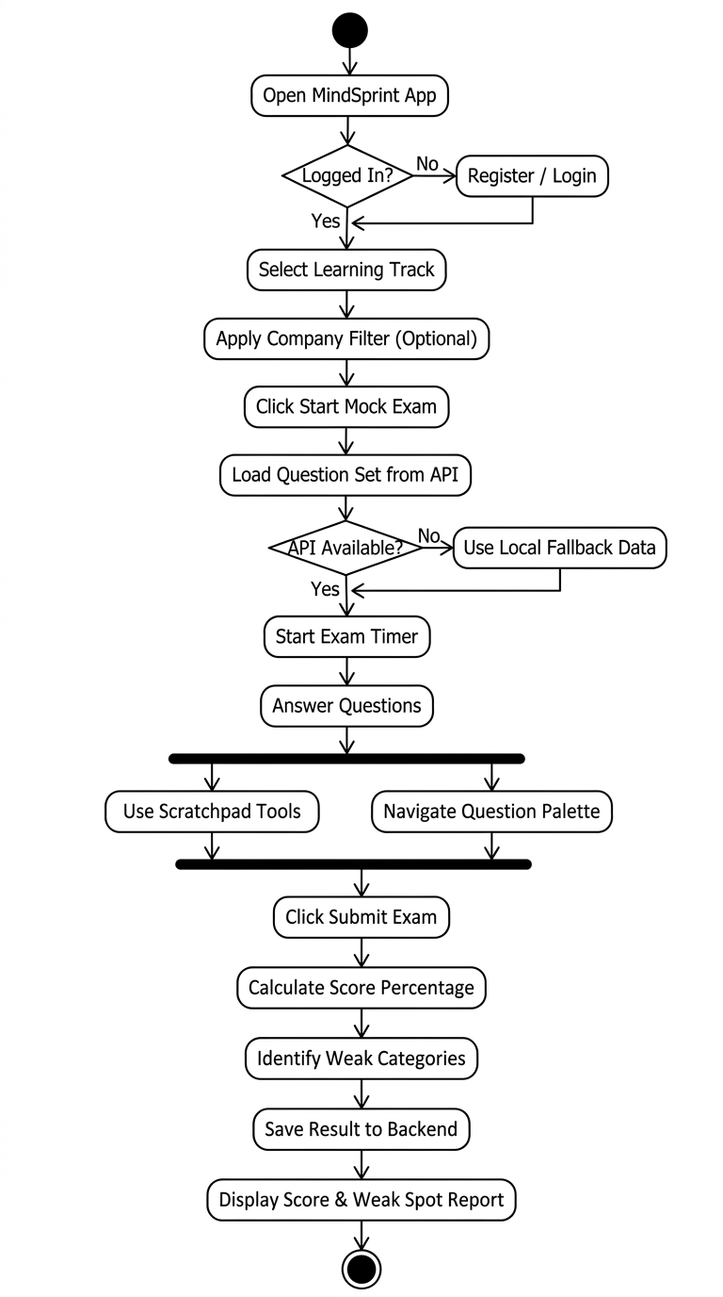

Figure 3.4: Activity Diagram - Mock Exam Process Flow

3.5 Data Dictionary
Table 1: User Schema (users)
Field Name | Data Type | Constraint | Description
_id | ObjectId | Primary Key | Unique user identifier
name | String | Required | Full name of user
email | String | Unique, Required | User email address
password | String | Required | Encrypted password
streakCount | Number | Default: 1 | Consecutive study days
createdAt | Date | Default: Now | Account creation timestamp

Table 2: Question Schema (questions)
Field Name | Data Type | Constraint | Description
_id | ObjectId | Primary Key | Unique question identifier
questionText | String | Required | The question statement
category | String | Required | Topic (Aptitude/DSA/React)
options | Array[String] | Required | 4 multiple choice options
correctAnswer | Number | Required | 0-based index of correct option
explanation | String | Optional | Detailed solution text

Table 3: Course Schema (courses)
Field Name | Data Type | Constraint | Description
_id | ObjectId | Primary Key | Unique course identifier
title | String | Required | Title of the IT course
category | String | Required | Course domain
instructor | String | Required | Instructor name
duration | String | Required | Total course hours
lessonsCount | Number | Required | Number of video lessons

Table 4: ExamResult Schema (examresults)
Field Name | Data Type | Constraint | Description
_id | ObjectId | Primary Key | Unique result identifier
userId | ObjectId | Foreign Key (User) | Reference to user account
userEmail | String | Default: Guest | User email
scorePercentage | Number | Required | Calculated score %
correctCount | Number | Required | Number of correct answers
totalQuestions | Number | Required | Total test questions count
userAnswers | Object | Required | Key-value pairs of answers
weakCategories | Array[String] | Optional | Topics where errors occurred
createdAt | Date | Default: Now | Exam submission timestamp

4. Development
4.1 Coding Standards
To ensure codebase maintainability, scalability, and seamless cross-platform execution across Android, iOS, and Web, MindSprint adheres to a strict set of industry-standard coding conventions, static type checking rules, and architectural guidelines.
4.1.1 Architectural & Structural Principles
- Component-Driven Development (CDD): The frontend is decomposed into self-contained, modular UI components located in /components/mindsprint/ (e.g., StreakWidget, StatsCard, VideoPlayerView, WeakSpotAnalyzer, SkeletonLoader).
- File-Based Routing: Route definitions follow Expo Router conventions in /app, creating a clear mapping between folder hierarchy and application navigation.
- Service Layer Abstraction: All REST API communication is centralized in /services/api.ts. Presentation components never execute direct fetch() requests, ensuring decoupled business logic.
- Backend MVC Architecture: The Node.js server maintains strict separation between Mongoose data models (/backend/models), business controllers, and Express route declarations (/backend/routes).
4.1.2 Naming Conventions
- Component Files & Interfaces: PascalCase is strictly enforced for React components, Context providers, and TypeScript interfaces (e.g., StreakWidget.tsx, AuthContext.tsx, UserProfile, GradeCurriculum).
- Functions, Methods & Hooks: camelCase is used for functions, event handlers, and custom React hooks (e.g., useAuth, getQuestions, toggleDarkMode, submitExamResult).
- Constants & Environment Keys: UPPER_SNAKE_CASE is reserved for compile-time constants and environment keys (e.g., EXPO_PUBLIC_API_URL, MONGODB_URI, APTITUDE_QUESTIONS).
- Route Files: kebab-case is utilized for Expo Router screen paths (e.g., doubt-solver.tsx, mastery-analytics.tsx, exam-review.tsx).
4.1.3 Static Typing & TypeScript Standards
- Strict Mode Enforcement: TypeScript configuration (tsconfig.json) enforces strict: true with no implicit 'any' declarations.
- Explicit Interfaces: All API payloads, component props, and state models are backed by dedicated interfaces (e.g., Question, ExamResult, VideoLecture).
- Path Aliasing: Imports utilize root alias syntax (@/*) to eliminate brittle relative paths (../../../).
4.1.4 Code Formatting & Static Analysis
- ESLint Configuration: Code style and linting are validated via ESLint Flat Config (eslint.config.js) extending eslint-config-expo/flat.
- Formatting Standards: 2-space indentation, single quotes for strings, trailing commas in multi-line objects, and strict avoidance of magic numbers by referencing theme tokens from constants/mindsprintTheme.ts.
4.1.5 State Management & Offline Resilience
- Global State via Context API: ThemeContext manages dark/light mode toggling, while AuthContext persists sessions and academic profile data in AsyncStorage.
- Transparent Offline Fallback: ApiService catches network connectivity failures and immediately returns static verified datasets (constants/mindsprintData.ts, verified_questions.json), guaranteeing continuous test practice without application crashes.
4.1.6 Error Handling & Security Standards
- Boundary Protection: React Error Boundary components encapsulate the root layout to intercept and gracefully recover from runtime UI render exceptions.
- Backend Security: Passwords are encrypted using bcryptjs (salt rounds: 10), and REST APIs validate bearer JWT tokens. Sensitive database credentials are kept out of source control using .env files.
4.2 Screen Shots
The following screenshots demonstrate the functional screens and user interface implementation of the MindSprint mobile application across the primary student workflows:
4.2.1 Welcome and Onboarding Screen
The Onboarding Screen introduces new students to the multi-stage academic platform, highlighting coverage across Gujarat State Board (GSEB), CBSE (English & Gujarati Medium), and competitive college placement drives with intuitive pagination indicators and a quick 'Continue' action.

Figure 4.1: Welcome & Onboarding Screen - MindSprint Academic & Career Companion
4.2.2 User Authentication and Sign-in Screen
The Authentication Screen enables secure email and password login, tabbed switching to user registration, Google OAuth single sign-on integration, and an instant 'Continue as Guest Student' option for immediate access.
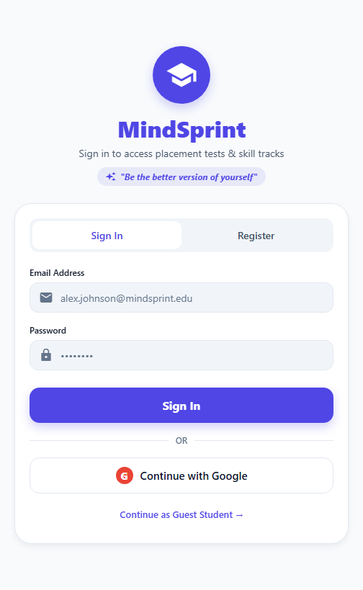
Figure 4.2: User Authentication & Sign-In Interface
4.2.3 Student Dashboard & Learning Hub
The central Dashboard features an active syllabus indicator with dynamic stage switching (GTU College / School stages), daily study streak tracking (1 Day Streak), quick action grid (1v1 Speed Duel, Mastery Radar, Leaderboard, Important Questions), Smart Study Accelerators (Error Vault, Scan Doubt, 2-Min Sprint), and the interactive Question of the Day widget.
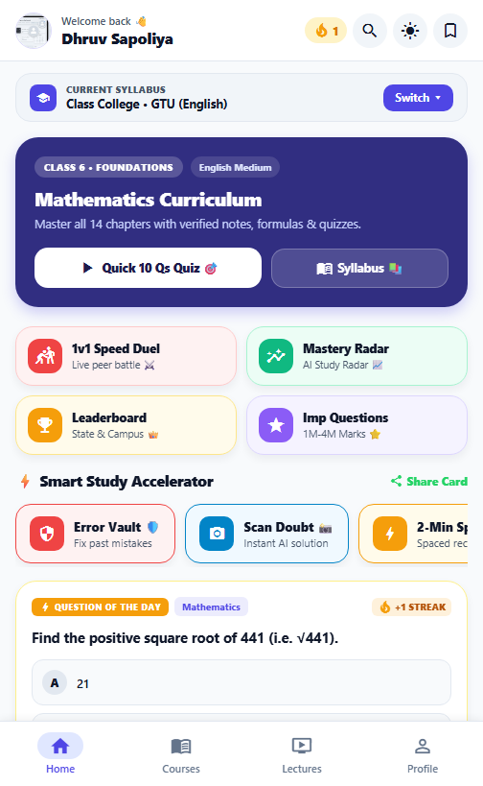
Figure 4.3: Main Dashboard, Syllabus Selector & Gamified Study Hub
4.2.4 Course Catalog & Chapter Navigator
The Course Catalog displays subject tabs (Mathematics, Science, Social Science), direct links to official NCERT / GSEB e-textbook PDFs, chapter progress indicators, key formula summaries, and direct triggers for reading notes, watching video lectures, or launching practice quizzes.
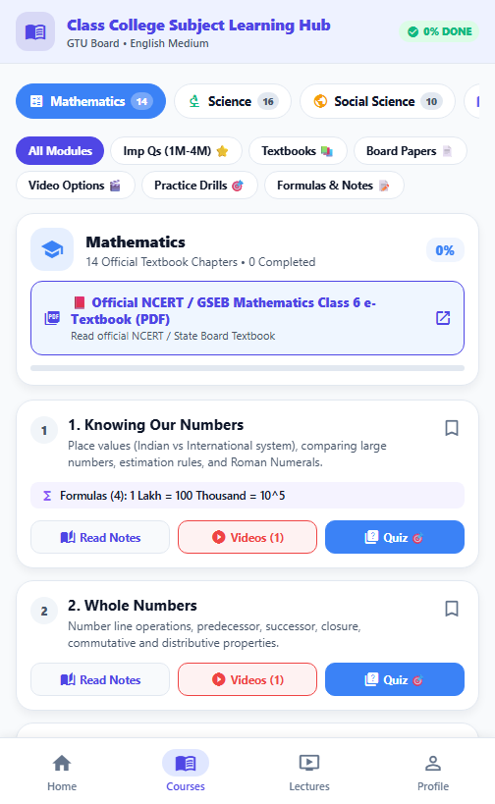
Figure 4.4: Course Catalog, Chapter Navigator & Official e-Textbook Reader
4.2.5 Interactive Video Lecture Player
The Video Learning screen features embedded YouTube masterclasses with lesson topic details, instructor credentials, multi-tab layout (Overview, Notes, Discussion), and automated lesson completion tracking.
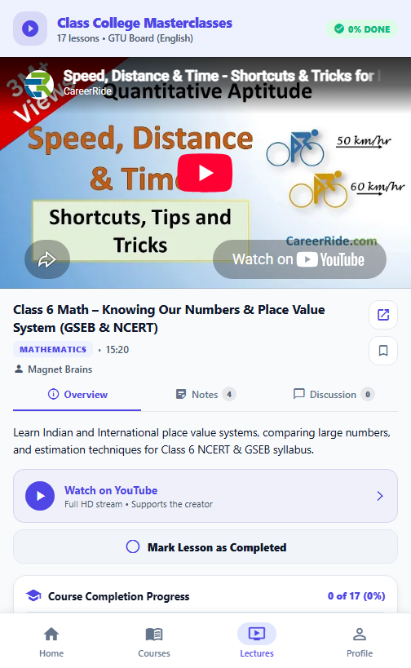
Figure 4.5: High-Definition Video Masterclasses & Lecture Player
4.2.6 Real-Time Timed Mock Exam Engine
The Mock Exam screen simulates real-world campus recruitment tests with a live countdown timer, category tags (Quantitative Aptitude, Logical Reasoning, IT Technical), single-tap radio answer options, Question Palette navigation, and a 'Mark for Review' tool.
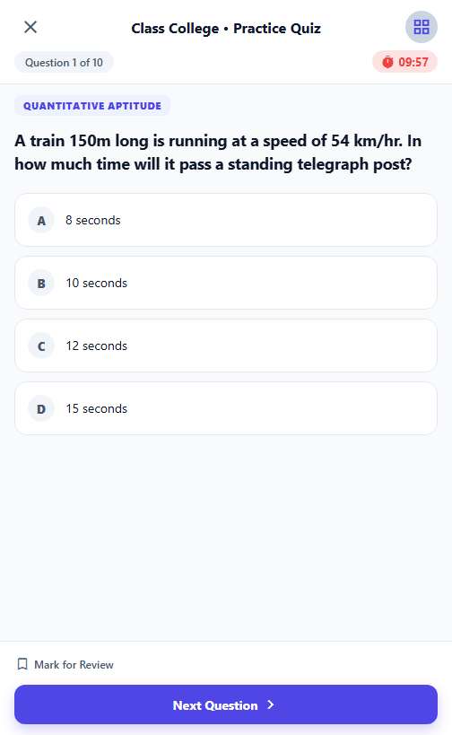
Figure 4.6: Real-Time Mock Exam Simulation & Question Palette
4.2.7 AI Doubt Solver & Camera Scanner
The AI Doubt Solver screen provides multi-modal question clearing through text queries, voice search, camera-based OCR scanning, and pre-indexed common board examination questions for instant solution retrieval.
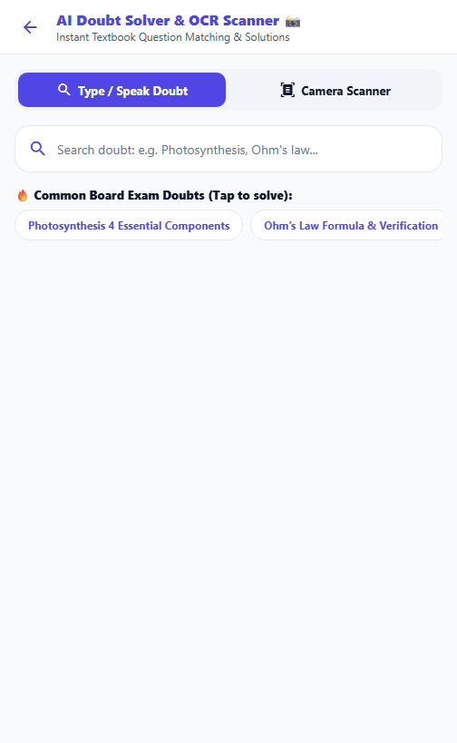
Figure 4.7: AI-Powered Doubt Solver & OCR Question Matching
4.2.8 Student Profile, Badges & Theme Configuration
The Profile screen showcases student verification credentials, active syllabus stage configuration, unlocked milestone badges ('First Step', 'Bullseye', 'Math Master'), user profile editing, and dynamic Dark/Light theme switching.
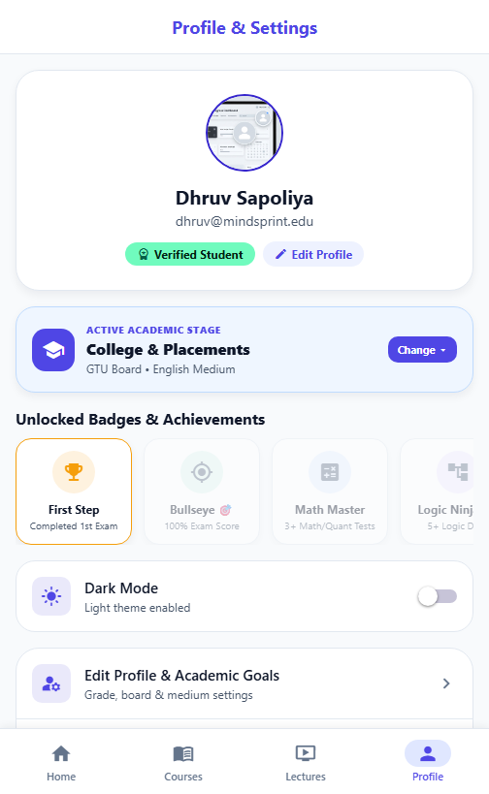
Figure 4.8: Student Profile, Gamification Badges & Theme Configuration

