#include<iostream>

using namespace std;

/*

1. 設電力公司的電費計算方式分成三類:

(1) 家庭用電: 100度以下,2.5元/度 101~300度,3.3元/度 301度以上,4.2元/度

(2) 工業用電: 基本費為100度,150元 超過部分每度1.9元

(3) 營業用電: 0~300度,6元/度 301度以上,6.8元/度

Q. 輸入用電類別及使用度數後,計算其應繳納費用如何?

PS. 以上三種用電類別必須以函式方式撰寫

*/

double family();

double industry();

double open();

main(){

int type;

double spend;

while(1){

cout << "輸入用電類別: ((1)家庭用電,(2)工業用電,(3)營業用電)) ";

cin >> type;

if(type==1)

spend=family();

if(type==2)

spend=industry();

if(type==3)

spend=open();

if(type>3 || type<1){

cout << "Error." << endl;

break;

}

cout << "Cost: NT$ " << spend << endl << endl;

}

}

double family(){

double e,cost=0;

cout << "輸入使用電量(單位: 度) : " ;

cin >> e;

if(e<=100)

cost=e*2.5;

if(e>100 && e<301)

cost=e*3.3;

if(e>300)

cost=e*4.2;

return cost;

}

double industry(){

double e,cost=0;

cout << "輸入使用電量(單位: 度) : " ;

cin >> e;

if(e<=100)

cost=150;

else

cost=(e-100)*1.9+150;

return cost;

}

double open(){

double e,cost=0;

cout << "輸入使用電量(單位: 度) : " ;

cin >> e;

if(e<=300)

cost=e*6;

else

cost=e*6.8;

return cost;

}

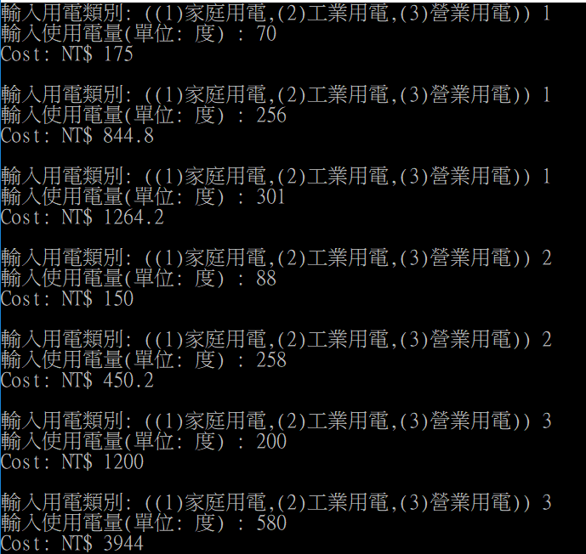

#include<iostream>

using namespace std;

/*

2. 課本p6-44 第10題 一樣必須以函式方式撰寫

*/

int change_money(int);

int Output(int,int,int);

main(){

int change;

int acceptable[4]={100,200,500,1000};

cout << "換幾元的紙鈔(100,200,500,1000) : " ;

cin >> change;

for(int i=0;i<4;i++){

if(change==acceptable[i]){

change_money(change);

break;

}

else{

if(i==3 && acceptable[i]!=change){

cout << "Error: 紙鈔面額錯誤 "

<< endl;

}

}

}

}

int change_money(int change){

int choose;

int acceptable[4]={1,5,10,50};

int number;

cout << "換幾元的零錢(1,5,10,50) :";

cin >> choose;

cout << "換幾個: ";

cin >> number;

for(int j=0;j<4;j++){

if(choose==acceptable[j]){

Output(change,choose,number);

break;

}

else{

if(j==3 && acceptable[j]!=choose){

cout << "Error: 零錢面額錯誤 "

<< endl;

}

}

}

}

int Output(int input,int money,int quantity){

int equal=0;

int fifty=0,ten=0,five=0,one=0;

equal = input-money*quantity;

if(equal<0){

cout << "Error: 換超過紙鈔的面額 "

<< endl;

}

while(equal>0){

if(equal>=50){

equal-=50;

fifty+=1;

}

if(equal>=10 && equal<50){

equal-=10;

ten+=1;

}

if(equal>=5 && equal<10){

equal-=5;

five+=1;

}

if(equal>=1 && equal<5){

equal-=1;

one+=1;

}

}

if(money==50)

fifty+=quantity;

if(money==10)

ten+=quantity;

if(money==5)

five+=quantity;

if(money==1)

one+=quantity;

cout << "NT " << input << " 可換成: "

<< "$50: " << fifty << "個"

<< " $10: " << ten << "個"

<< " $ 5: " << five << "個"

<< " $ 1: " << one << "個"

<< endl;

return 0;

}

