Guideline

# About

This walkthrough is designed for individuals already familiar with Microsoft SQL Server and who have administrative access to the database used for this program. As such, a high level overview of the steps used is provided for reference of the process, but some of the steps refer to outside installation guides, as well as assume administrative access is available to the user to view and access the work this document details.

# Installation of Microsoft SQL Server

This project utilizes a database that is constructed in MS SQL server and is created using MySQL. Please refer to the Lecture 6: BUDT 758Y Database Management Systems SQL Server Management Studio as a reference for installing MS SQL Server either on a local machine or through the University of Maryland’s Virtual Desktop.

The space allocated to this database is 15MB. The database can be found under BUDT758_DB_0503_09 in MS SQL Server Management Studio. A visual is shown in Figure 1 below.

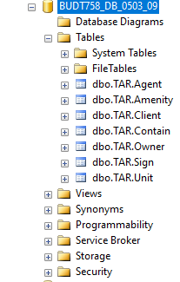

*Figure 1: Visual of database location*

# Installation of Tableau

An overall guide to gaining access to Tableau can be found in Lecture 10: BUDT 758Y Database Management Systems Tableau.

Access from Tableau can be received through downloading the software on tableau.com/academic, or it can be accessed through the University of Maryland’s Virtual Desktop.

# Creation of Database and Records in MS SQL Server

In order to create our database, the user should download the SQL script files as needed for the actions listed below (Create tables, Drop tables, Insert data into tables, Count rows in tables, and Select statements).

1. **Create Tables:** Download file *Project0503-09_DataDefinitionLanguage_CREATE_TAR_TABLES.sql*. Select the entire code in the file and execute it. If you need to drop tables, please see the next point.
2. **Drop Tables:** Download file *Project0503-09_DataDefinitionLanguage_DROP_TAR_TABLES.sql*. Select the entire code in the file and execute it. Please note that if you run this file before creating any tables, you will get an error message.
3. **Insert Data into Tables:** Download file *Project0503-09_DataDefinitionLanguage_INSERT_INTO_TAR_TABLES.sql*. Select the entire code in the file and execute it. This will populate the tables with data.
4. **Count rows in tables:** Download file *Project0503-09_DataDefinitionLanguage_COUNT_ROWS_TAR_TABLES.sql*. Select the entire code in the file and execute it. The SQL output will now show the number of records in each table. Please note that if you run this file before inserting any data, the code will return 0 as the number of rows.
5. **Select Statements:** Download file *Project0503-09_DataManipulationLanguage.sql*. This document has 13 business questions that can be answered using the database. If you would like to know the answer to any of the questions then please select the code directly under the question (until the next question). Please execute the code now. The SQL output will show the answer to the question. Some of these questions and their respective answers have been visualized in Tableau. More details on this in the following sections.

# Connecting to the database in Tableau

Once the database has been created, the user can connect this as a data source to Tableau. After launching Tableau, on the loading screen select Microsoft SQL Server under the Connect and To a Server Headers. See Figure 2 as a reference.

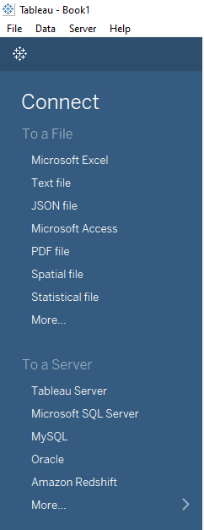

*Figure 2: Connecting tableau to MS SQL Server*

After clicking on the link you will be prompted to add your credentials. Figure 3 provides sample log-in information. Note that the reader of this document should use his/her appropriate log-in credentials.

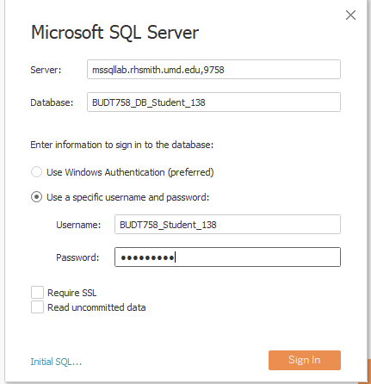

*Figure 3: Connecting Tableau to MS SQL Server*

Upon connecting to the server, the user can configure the data source as follows:

* Database: From the dropdown menu select BUDT758_DB_0503_09
* Drag and drop the tables into the window, connecting the appropriate tables. Figure 4 shows the fully connected database (all tables connected as well as full joins specified). The user may opt to limit the tables used based on the queries he/she chooses to run.

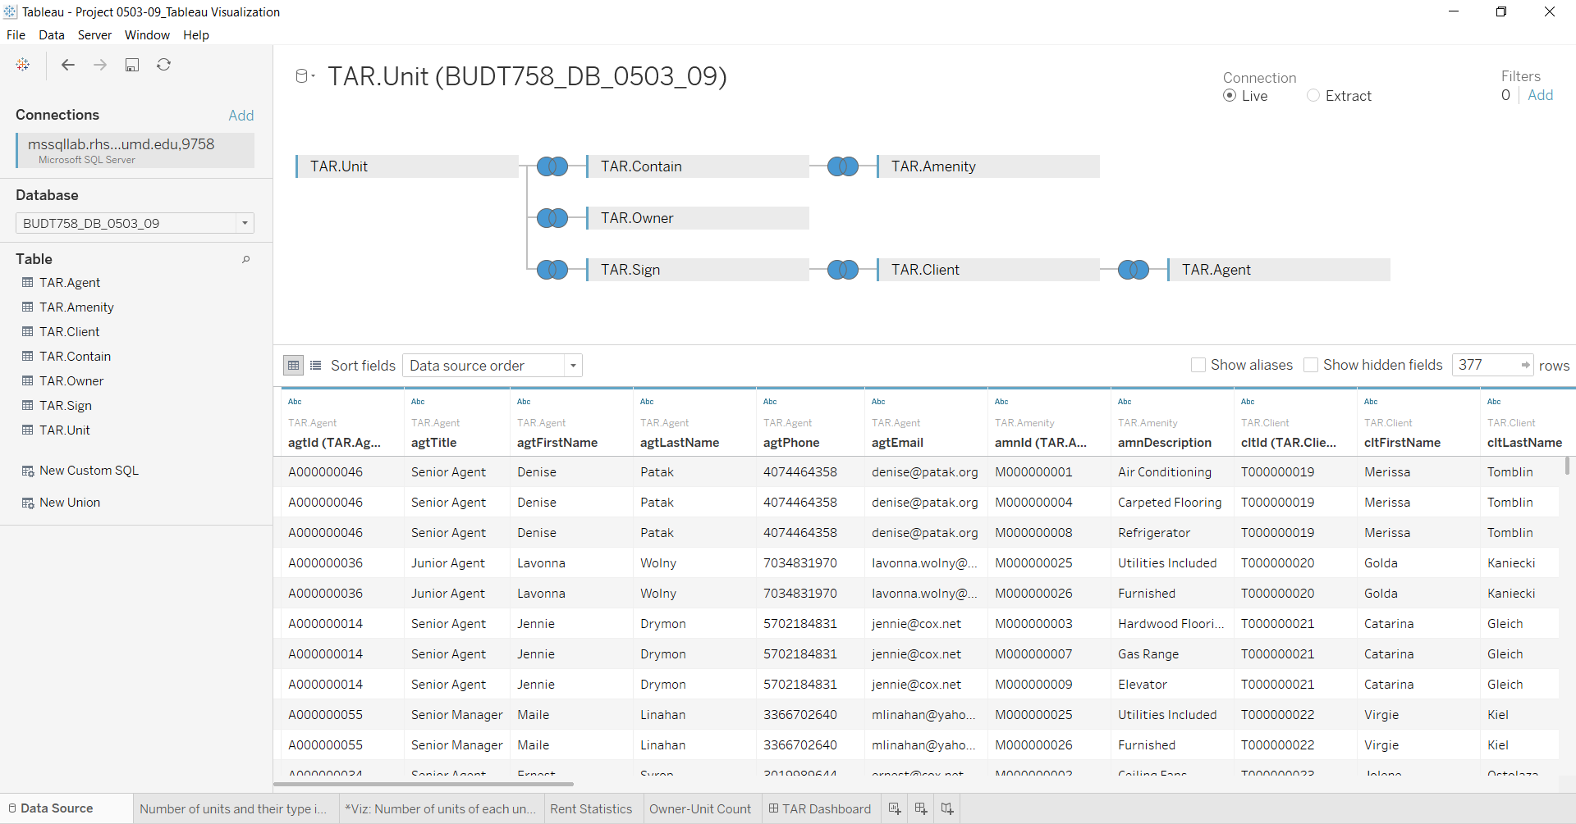

*Figure 4: Configured Data Source*

# SQL Queries and Tableau Visualization

The file name *Project0503-09_DataManipulationLanguage.sql* provides 13 sample business questions as well as the corresponding SQL queries that can be run on MS SQL Server Management Studio using the database that was built for TAR.

Questions 11, 12, and 13 from this SQL script file have been visualized in Tableau in individual sheets and in a dashboard can be viewed in the Tableau file *Project0503-09_TAR_Visualization.twb* such as the Figure 5 below.

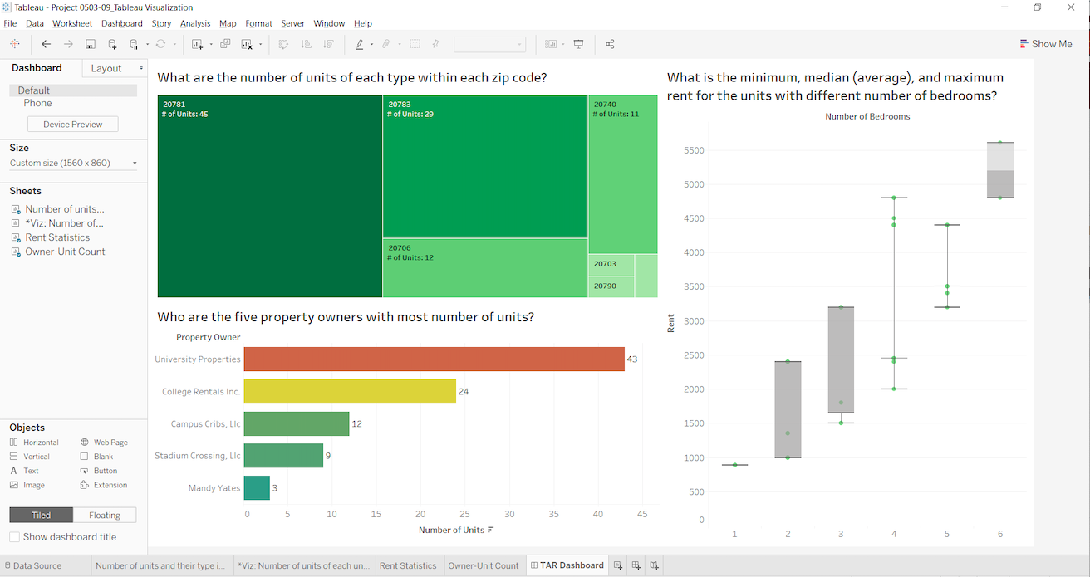

*Figure 5: Visualization in Tableau*

If you would like to simply view the screenshots for these questions, they can be viewed in the slides in the file *Project0503-09_Presentation.pptx.*

# Contact Us

Should you need any assistance, please feel free to reach any of one the team members through an email.

Sahitya Angara [sai.angaravenkatalaxmisridevi@rhsmith.umd.edu](mailto:sai.angaravenkatalaxmisridevi@rhsmith.umd.edu)

Jonathan Howarth [jonathan.howarth@rhsmith.umd.edu](mailto:jonathan.howarth@rhsmith.umd.edu)

Snigdha Sinha [snigdha.sinha@rhsmith.umd.edu](mailto:snigdha.sinha@rhsmith.umd.edu)

Apoorva Talwar [apoorva.talwar@rhsmith.umd.edu](mailto:apoorva.talwar@rhsmith.umd.edu)