
School of Computer Science Engineering and Information Systems
VIT, Vellore

DATABASE SYSTEMS (BCSE302L)
PROJECT REPORT

“MediTrack: Diagnostic Clinic Management System”

Submitted by
[STUDENT NAME(S)]
[REGISTER NUMBER(S)]

Academic Year: 2026–2027
Full code Link: [GitHub / Drive link to the MediTrack repository]

CERTIFICATE
This is to certify that the project report entitled “MediTrack: Diagnostic Clinic Management System” submitted by [STUDENT NAME(S)] ([REGISTER NUMBER(S)]) to the School of Computer Science Engineering and Information Systems, VIT, Vellore, in partial fulfilment of the requirements of the course BCSE302L Database Systems, is a record of bona fide work carried out under my supervision during the Fall Semester 2026–27.

Faculty: Thanga Marriapan Signature: ____________________
Date: ____________________

DECLARATION
I/We hereby declare that this project report, “MediTrack: Diagnostic Clinic Management System”, submitted for BCSE302L Database Systems at VIT, Vellore, is the result of my/our own work. The database design, SQL and PL/SQL code, Python application and this report were produced for this course and have not been submitted for any other course or degree.

Place: Vellore Date: ____________________
Name(s) and signature(s): [STUDENT NAME(S)]

ACKNOWLEDGEMENT
I/We thank our faculty, Thanga Marriapan, for guidance through the three reviews of this project, and the School of Computer Science Engineering and Information Systems, VIT, for the laboratory facilities and the Oracle environment. We also thank our classmates for testing the application and for their feedback on the user interface.

ABSTRACT
Small diagnostic clinics often record the same patient three times: at the front desk, in the laboratory and at the billing counter. This causes double-booked doctor slots, untracked samples, abnormal results that depend on someone noticing them, and hand-added bills with untraced dues. MediTrack is an Oracle database application that keeps one consistent record of each visit, from appointment through samples and results to the final bill.
The design has seven relations (PATIENT, DOCTOR, TEST_CATALOG, APPOINTMENT, SAMPLE, TEST_RESULT, BILL) with 7 primary keys, 7 foreign keys and 85 named constraints, normalised to BCNF with one documented price snapshot in BILL. The clinic's rules are enforced inside the database: three triggers block double booking, flag results LOW / NORMAL / HIGH and maintain payment status; four stored procedures (one with an explicit cursor) book appointments, raise bills, record payments and run end-of-day billing; two functions compute a doctor's daily load and a patient's dues. Fifteen SQL queries and one view answer operational questions such as overdue samples and revenue share.
A Python application using the python-oracledb driver exposes seven transactions (T1–T7) through a menu-driven CLI and a Streamlit website with Patient, Doctor and Administration portals. After every action the interface shows the user operation, the SQL/PL-SQL executed, the tables touched and the rows affected; refused actions show the ORA code with a plain-language reason. On a clean build, all 16 database objects compile VALID, all 15 queries return non-empty results, and all 10 deliberate constraint violations are refused and rolled back.
Keywords: Database Management System, ER Model, SQL, Normalization, Transactions, PL/SQL, Triggers, Healthcare / Diagnostic Clinic

TABLE OF CONTENTS
CERTIFICATE
DECLARATION
ACKNOWLEDGEMENT
ABSTRACT
LIST OF ABBREVIATIONS
CHAPTER 1: INTRODUCTION
1.1 Background
1.2 Problem Statement
1.3 Objectives
1.4 Scope
1.5 Existing System
1.6 Proposed System
1.7 Organization of the Report
CHAPTER 2: REQUIREMENTS ANALYSIS
2.1 Stakeholders and User Roles
2.2 Functional Requirements
2.3 Non-Functional Requirements
2.4 Hardware and Software Requirements
2.5 Feasibility Study
2.6 Use-Case Diagram and Descriptions
CHAPTER 3: DBMS CONCEPTS AND ARCHITECTURE
3.1 Introduction to DBMS
3.2 File System versus DBMS
3.3 Three-Schema Architecture
3.4 Data Independence
3.5 Data Models
3.6 Database Languages
3.7 Users and Database Administrator
CHAPTER 4: CONCEPTUAL DATABASE DESIGN
4.1 Entity Identification
4.2 Attributes and Attribute Types
4.3 Relationships and Cardinality
4.4 Participation Constraints
4.5 Weak and Strong Entities
4.6 ER Diagram
4.7 Design Assumptions
CHAPTER 5: RELATIONAL DATABASE DESIGN
5.1 Relational Schema
5.2 Table Definitions
5.3 Keys
5.4 Integrity Constraints
5.5 Schema Diagram
5.6 Data Dictionary
CHAPTER 6: FUNCTIONAL DEPENDENCIES AND NORMALIZATION
6.1 Functional Dependencies
6.2 Attribute Closure and Candidate Keys
6.3 First Normal Form (1NF)
6.4 Second Normal Form (2NF)
6.5 Third Normal Form (3NF)
6.6 Boyce–Codd Normal Form (BCNF)
6.7 Lossless Join and Dependency Preservation
6.8 Before-and-After Example
CHAPTER 7: SQL IMPLEMENTATION
7.1 Database and Table Creation (DDL)
7.2 Data Manipulation (DML)
7.3 Data Retrieval (DQL)
7.4 Built-In and Aggregate Functions
7.5 GROUP BY and HAVING
7.6 Joins
7.7 Subqueries
7.8 Set Operations
7.9 Views
7.10 Constraints
7.11 Data Control Language
7.12 SQL Output Evidence
CHAPTER 8: ADVANCED DATABASE OPERATIONS
8.1 Stored Procedures
8.2 User-Defined Functions
8.3 Triggers
8.4 Cursors
8.5 Sequences and Auto-Generated Keys
8.6 Transactions and ACID Properties
8.7 COMMIT, ROLLBACK, and SAVEPOINT
8.8 Concurrency Control
8.9 Deadlocks
CHAPTER 9: QUERY PROCESSING AND OPTIMIZATION
9.1 Query Processing Overview
9.2 Indexes
9.3 Query Execution Plan
9.4 Query Optimization
9.5 Performance Observations
CHAPTER 10: DATABASE SECURITY, TRANSACTIONS AND RECOVERY
10.1 Authentication and Authorization
10.2 SQL Injection Prevention
10.3 Backup Strategy
10.4 Recovery
10.5 Integrity and Audit
10.6 Security Demonstration
CHAPTER 11: APPLICATION DEVELOPMENT AND CONNECTIVITY
11.1 System Architecture
11.2 Technology Stack
11.3 Database Connectivity
11.4 CRUD Operations
11.5 Input Validation and Error Handling
11.6 Application Screenshots
11.7 Relational/NoSQL Note
CHAPTER 12: TESTING AND RESULTS
12.1 Testing Strategy
12.2 Test Cases
12.3 SQL Query Validation
12.4 Constraint and Transaction Tests
12.5 Results and Discussion
12.6 Limitations
CHAPTER 13: CONCLUSION AND FUTURE ENHANCEMENTS
13.1 Conclusion
13.2 Learning Outcomes
13.3 Future Enhancements
REFERENCES
APPENDIX A: SQL SCRIPTS
APPENDIX B: SAMPLE DATA AND SCREENSHOTS
APPENDIX C: SAMPLE TEST CASE TABLE

LIST OF FIGURES
Figure 1: Use-case diagram of MediTrack
Figure 2: ER diagram of MediTrack (7 entities, 7 relationships)
Figure 3: Relational schema diagram with PK/FK links
Figure 4: System architecture: front ends, service layer, driver, database
Figure 5: Error panel: a double booking refused by trg_no_double_booking (ORA-20003)
Figure 6: Home page with the three portals and the T1–T7 visit flow
Figure 7: Patient portal: Book a visit (live free/taken slots, doctor's load from doctor_daily_load)
Figure 8: Doctor portal: Complete a visit with the bill preview (T4)
Figure 9: “Behind the scenes” trace after T4: operation → SQL/PL-SQL → tables → rows affected
Figure 10: Administration: clinic dashboard built from Q1, Q2 and Q10
Figure 11: Administration: Lab desk (T2b, T3, T7b)
Figure 12: Administration: Reports page running the 15 queries from 03_queries.sql
Figure 13: Administration: Database explorer reading Oracle's data dictionary
Figure 14: Patient portal: My health
Figure 15: Patient portal: Lab reports with trigger-set flags
Figure 16: Patient portal: Bills and payments (T5)
Figure 17: Patient portal: New patient registration (T1a)
Figure 18: Doctor portal: My day
Figure 19: Administration: Billing (T5, T6)

LIST OF TABLES
Table 1: Stakeholders and user roles
Table 2: Functional requirements and where each is implemented
Table 3: Hardware and software requirements
Table 4: Key use cases
Table 5: File system versus DBMS for the clinic
Table 6: Database languages used
Table 7: Entities
Table 8: Relationships, cardinality and participation
Table 9: PATIENT table definition (read from USER_TAB_COLUMNS)
Table 10: DOCTOR table definition (read from USER_TAB_COLUMNS)
Table 11: TEST_CATALOG table definition (read from USER_TAB_COLUMNS)
Table 12: APPOINTMENT table definition (read from USER_TAB_COLUMNS)
Table 13: SAMPLE table definition (read from USER_TAB_COLUMNS)
Table 14: TEST_RESULT table definition (read from USER_TAB_COLUMNS)
Table 15: BILL table definition (read from USER_TAB_COLUMNS)
Table 16: Data dictionary: attributes that carry business rules
Table 17: BCNF check of every table
Table 18: Un-normalized visit rows (redundant patient, doctor and test data)
Table 19: Constraint lab results (each attempt rolled back)
Table 20: GRANT / REVOKE test with a least-privilege account
Table 21: Stored procedures
Table 22: Triggers
Table 23: SAVEPOINT demonstration on bill 900005
Table 24: Technology stack
Table 25: CRUD operations in the application
Table 26: Test cases and results
Table 27: DOCTOR rows
Table 28: TEST_CATALOG rows
Table 29: PATIENT rows (first 8)
Table 30: Sample test cases

LIST OF ABBREVIATIONS
- DBMS – Database Management System
- RDBMS – Relational Database Management System
- SQL – Structured Query Language
- PL/SQL – Procedural Language extension to SQL (Oracle)
- DDL – Data Definition Language
- DML – Data Manipulation Language
- DQL – Data Query Language
- DCL – Data Control Language
- TCL – Transaction Control Language
- ER – Entity–Relationship
- ACID – Atomicity, Consistency, Isolation, Durability
- CRUD – Create, Read, Update, Delete
- FD – Functional Dependency
- BCNF – Boyce–Codd Normal Form
- PK / FK / UQ – Primary key / Foreign key / Unique key
- FR – Functional Requirement
- T1–T7 – The seven clinic transactions demonstrated by the application
- ORA-nnnnn – Oracle error code
- UI / CLI – User Interface / Command-Line Interface
- INR (₹) – Indian Rupee

CHAPTER 1: INTRODUCTION

1.1 Background
A diagnostic clinic combines three activities: doctor consultations, laboratory testing and billing. A single visit touches all three. The patient books a slot with a doctor; the doctor orders tests; the laboratory collects samples and enters results; the billing desk charges the consultation fee plus the tests and collects payment. Each step depends on the previous one, so the data must stay consistent across departments. This makes the domain a natural fit for a relational database: one appointment row links the patient, the doctor, the samples, the results and the bill.

1.2 Problem Statement
Small and mid-sized clinics in India still run on paper registers, spreadsheets and separate billing software. The same patient is written down at the front desk, in the lab and at the billing counter. This leads to four recurring problems:
- Double booking: two patients get the same doctor slot because the front desk cannot see the live schedule.
- Lost or delayed results: samples are tracked on paper, so nobody can tell which tests are still pending.
- Missed abnormal values: results outside the normal range depend on a technician noticing them by eye.
- Billing errors: consultation and test charges are added by hand, and unpaid dues are hard to trace.
Problem statement: design a relational database, with SQL and PL/SQL business logic, that keeps one consistent record of each patient visit from appointment through samples and results to the final bill, and that enforces the clinic's rules (no double booking, automatic result flagging, correct bill totals) inside the database rather than relying on staff to remember them.

1.3 Objectives
1. Keep a single, consistent record of patients, doctors, appointments, tests, results and bills in 7 related tables.
2. Enforce clinic rules inside the database with named constraints and triggers (no double booking, automatic abnormal-result flags, valid bill totals).
3. Implement the core operations (booking, billing, payment, end-of-day billing) as PL/SQL procedures and functions.
4. Provide at least 15 operational queries: doctor workload, pending samples, abnormal results, revenue and outstanding dues.
5. Connect a Python application so that each user action runs the matching SQL or PL/SQL and shows the result, with at least 5 demonstrable transactions.

1.4 Scope
In scope: patient registration; doctor records with consultation fees and daily limits; appointment booking, completion and cancellation; a test catalogue with prices and normal ranges; sample collection and status tracking; result entry with automatic LOW / NORMAL / HIGH flags; bill generation with discounts, full and partial payments, outstanding dues; administrative reports. Users: receptionist, doctor, lab technician, billing staff and administrator (and the patient viewing their own data in the demo portal).
Out of scope: multi-branch clinics, reagent and equipment inventory, insurance claim processing, a public online portal with a payment gateway, and pharmacy / prescription management. The application is a single-clinic system run on a local Oracle instance; the Streamlit portals use a demo “Signed in as” picker instead of real authentication.

1.5 Existing System
In the existing manual process the receptionist keeps an appointment book per doctor, the laboratory keeps a sample register, and billing is done in a spreadsheet or a stand-alone billing program. There is no shared key between the three records. Consequences: clashes are found only when two patients arrive for the same slot; a sample's status is known only by asking the lab; abnormal values are not highlighted; and a patient's total dues must be added up by hand across receipts. None of the rules is enforced, so data quality depends entirely on staff discipline.

1.6 Proposed System
MediTrack replaces the three registers with one Oracle schema. Every sample, result and bill hangs off an APPOINTMENT row. Rules move into the database: a trigger refuses a clashing booking, a trigger computes the result flag from the test's normal range, a procedure computes the bill from the doctor's fee and the visit's tests, and CHECK constraints keep bill totals and payments consistent. A Python service layer exposes seven transactions (T1–T7) to two front ends, a CLI and a Streamlit website. Benefits: no double booking, live sample tracking, automatic flagging, correct bills, and one-query answers to questions such as “who owes more than average?”.

1.7 Organization of the Report
Chapter 2 analyses requirements. Chapter 3 reviews the DBMS concepts used. Chapters 4–6 present the conceptual design, the relational schema and normalization. Chapter 7 covers the SQL implementation and Chapter 8 the PL/SQL and transaction features. Chapter 9 discusses query processing, Chapter 10 security and recovery, and Chapter 11 the application. Chapter 12 reports testing and results, and Chapter 13 concludes. Appendices contain the full SQL scripts, sample data, screenshots and the test-case table.

CHAPTER 2: REQUIREMENTS ANALYSIS

2.1 Stakeholders and User Roles
Table 1: Stakeholders and user roles
Role | What they do in MediTrack | Portal / transactions
Receptionist | Registers patients, books and cancels appointments | Patient portal: T1, T7a
Patient (demo) | Books visits, sees own reports and bills, pays | Patient portal: T1, T5, T7a
Doctor | Views the daily schedule, orders tests, reviews results, completes visits | Doctor portal: T2a, T4
Lab technician | Records sample status, enters results, removes rejected samples | Administration › Lab desk: T2b, T3, T7b
Billing staff | Records payments, checks dues, runs end-of-day billing | Administration › Billing: T5, T6
Administrator | Views dashboard and reports, inspects the schema, rebuilds the demo database | Administration: Reports, Database

2.2 Functional Requirements
Table 2: Functional requirements and where each is implemented
ID | Requirement | Implemented by
FR1 | Register patients with a unique phone number and e-mail | T1, uq_patient_phone, uq_patient_email
FR2 | Maintain doctors; deactivate instead of delete | DOCTOR.status, book_appointment (-20001)
FR3 | Book appointments and view each doctor's daily schedule | T1, Q1, Q9
FR4 | Prevent double booking and enforce each doctor's daily capacity | trg_no_double_booking, doctor_daily_load
FR5 | Maintain a test catalogue with prices and normal ranges | TEST_CATALOG, Q7
FR6 | Order tests per visit and track sample collection | T2, SAMPLE
FR7 | Record results with automatic LOW / NORMAL / HIGH flagging | T3, trg_flag_result, Q3, Q11, Q13
FR8 | Track pending samples against turnaround time | Q2
FR9 | Generate a bill for each completed visit | T4, generate_bill, Q10, Q15
FR10 | Record full or partial payments and report patient dues | T5, record_payment, patient_total_due, Q6
FR11 | Bill all of a day's completed visits in one batch | T6, end_of_day_billing
FR12 | Management reports on revenue, workload and test usage | Q4, Q5, Q8, Q12, Q14

2.3 Non-Functional Requirements
- Integrity: every rule is enforced by a PK, FK, UNIQUE, NOT NULL, CHECK or DEFAULT constraint or a trigger, so it holds even if the application is bypassed.
- Reliability / consistency: each transaction commits once; on any error the whole unit of work is rolled back. Procedures never commit, except the batch job.
- Security: credentials come only from environment variables; every user value is passed as a bind variable (no SQL string concatenation).
- Usability: staff never type SQL. Errors are explained in plain language (what went wrong, why the rule exists, what enforced it, what to do).
- Traceability: every result records who verified it and when; the UI shows the SQL and rows affected for every action.
- Maintainability: one service layer shared by both front ends; every SQL file is re-runnable; constraints follow a naming convention.
- Performance: interactive operations complete well under a second on the lab machine; primary-key and unique indexes support the frequent look-ups.

2.4 Hardware and Software Requirements
Table 3: Hardware and software requirements
Item | Used in this project | Minimum
Operating system | macOS 15 (development); any OS that runs Docker or Oracle XE | Windows 10 / Linux / macOS
DBMS | Oracle Database Free 23ai (gvenzl/oracle-free:23-slim-faststart in Docker); also targets Oracle XE 21c | Oracle XE 18c+
Language | SQL, PL/SQL; Python 3.13 | Python 3.9+
Python libraries | oracledb ≥ 2.0 (thin mode), streamlit ≥ 1.35, pandas ≥ 2.0, tabulate ≥ 0.9 | same
Tools | SQL*Plus / SQL Developer (optional), VS Code, Docker Desktop | any SQL client
Hardware | Apple-silicon laptop, 16 GB RAM | 4 GB free RAM, ~4 GB free disk for the Oracle image

2.5 Feasibility Study
Technical: the course provides Oracle and PL/SQL; Oracle Free runs in Docker on a laptop, and python-oracledb's thin mode needs no Instant Client, so the stack installs in minutes. Operational: the screens follow the clinic's existing roles (front desk, doctor, lab, billing), and errors are explained in plain language, so staff need little training. Economic: every component is free (Oracle Free/XE, Python, Streamlit), and a single PC is enough for one clinic; the main saving is staff time spent reconciling three registers and chasing missed dues.

2.6 Use-Case Diagram and Descriptions
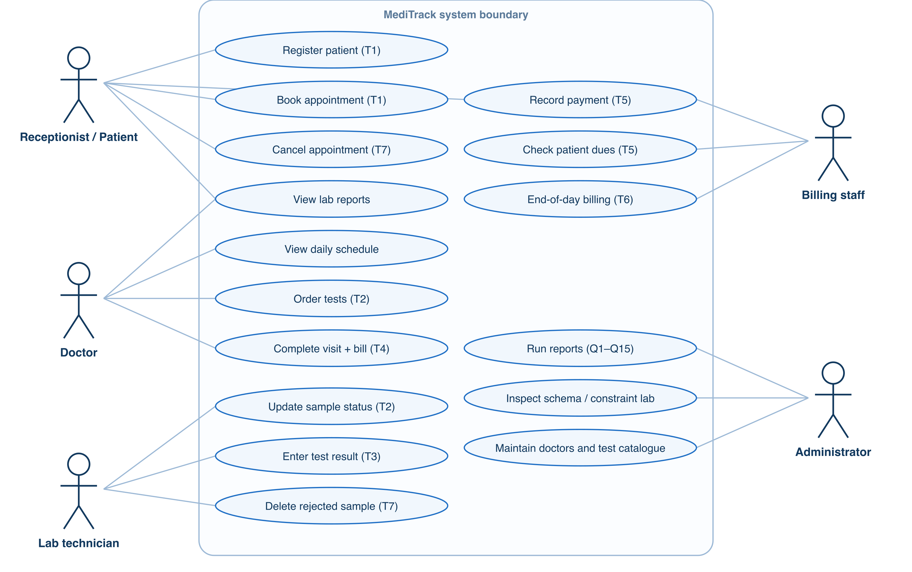
Figure 1: Use-case diagram of MediTrack
Table 4: Key use cases
Use case | Actor | Main flow | Alternate / failure
Book appointment (T1) | Receptionist / Patient | Choose doctor, date, free slot → book_appointment inserts the row | Inactive doctor (-20001), day full (-20002), slot clash (-20003), past date (-20004)
Order tests (T2) | Doctor | Select visit and tests → one SAMPLE row per test | Same test twice → uq_sample_appt_test
Enter result (T3) | Lab technician | Enter value → trigger sets flag and marks sample COMPLETED | Rejected sample (-20030)
Complete visit + bill (T4) | Doctor | UPDATE status + generate_bill in one COMMIT | Already billed (-20011); discount > 50 % → CHECK
Record payment (T5) | Billing staff / Patient | record_payment → trigger sets PARTIAL / PAID; dues recomputed | Overpayment or amount ≤ 0 (-20020)
End-of-day billing (T6) | Billing staff | Cursor bills every completed, unbilled visit of the day | Any failure rolls back the whole batch
Cancel / clean up (T7) | Receptionist, Lab | Cancel frees the slot; deleting a rejected sample cascades to its result | Only BOOKED visits / REJECTED samples qualify

CHAPTER 3: DBMS CONCEPTS AND ARCHITECTURE

3.1 Introduction to DBMS
A database is an organised collection of related data. A DBMS is the software that defines, stores, retrieves and protects that data and lets many users share it safely. An RDBMS stores data in relations (tables) linked by keys and is queried with SQL. Advantages: controlled redundancy, integrity constraints, concurrent access, security, and backup and recovery. Limitations: licence or hardware cost at scale, administration effort, and overhead that a tiny single-user file would not need. Oracle Database, used here, is an RDBMS with a procedural extension, PL/SQL.

3.2 File System versus DBMS
Table 5: File system versus DBMS for the clinic
Aspect | Separate files / spreadsheets (old clinic) | MediTrack on Oracle
Redundancy | Patient written in three registers | Stored once in PATIENT; others reference patient_id
Consistency | Registers drift apart | FKs and constraints keep all rows consistent
Sharing | One person edits a file at a time | Many sessions; row locks (record_payment uses FOR UPDATE)
Integrity | Nothing stops a double booking | trg_no_double_booking, CHECK constraints
Security | Whoever has the file sees everything | Accounts, roles, GRANT / REVOKE
Recovery | Lost if the file is overwritten | Redo logs, rollback, Data Pump backups

3.3 Three-Schema Architecture
External level: the views each user sees, e.g. the patient portal's “My bills” or the view v_bill_summary, which hides the four-table join. Conceptual level: the seven tables, their keys and constraints (Chapter 5). Internal level: how Oracle stores them: heap tables in a tablespace, B-tree indexes created automatically for every PK and UNIQUE constraint, and sequences cached in memory. Mappings between levels let each level change without breaking the others.

3.4 Data Independence
Logical data independence: the application reads bills through v_bill_summary; columns could be added to BILL or PATIENT without changing the screens that use the view. Physical data independence: in Chapter 9 an index on APPOINTMENT(doctor_id, appt_date) is added and removed; the query text, the function doctor_daily_load and the application are unchanged, only the execution plan differs.

3.5 Data Models
The hierarchical model stores data as a tree (one parent per child) and the network model as a graph of records with pointers; both make many-to-many links awkward. The relational model, used here, stores relations and links them by values (keys), which suits the clinic's M:N link between visits and tests. Object-oriented models attach behaviour to data; PL/SQL procedures play a similar role here. Document stores (e.g. MongoDB) keep nested JSON; a visit document could embed its samples, but the strict integrity rules of billing favour the relational model.

3.6 Database Languages
Table 6: Database languages used
Language | Purpose | Examples in MediTrack
DDL | Define structure | CREATE TABLE / SEQUENCE / VIEW / TRIGGER, DROP (99_drop_all.sql)
DML | Change data | INSERT PATIENT, UPDATE APPOINTMENT status, DELETE SAMPLE (07_dml_demo.sql)
DQL | Query data | the 15 SELECT queries in 03_queries.sql
DCL | Control access | GRANT SELECT ON v_bill_summary / REVOKE (Section 7.11)
TCL | Control transactions | COMMIT once per transaction, ROLLBACK on error, SAVEPOINT (Section 8.7)

3.7 Users and Database Administrator
End users are the clinic staff and patients using the portals. Application developers wrote services.py and the front ends. Database designers produced the ER model and schema. The DBA creates the schema owner (meditrack), grants privileges, sizes storage, schedules backups (Data Pump export), monitors performance and applies patches. In this project the team played all roles; the Administration › Database page exposes the DBA view of the schema.

CHAPTER 4: CONCEPTUAL DATABASE DESIGN

4.1 Entity Identification
Table 7: Entities
Entity | Role in the clinic
PATIENT | A person registered with the clinic
DOCTOR | A consultant with a fee, a daily limit and a status (ACTIVE / INACTIVE)
TEST_CATALOG | The master list of lab tests, with price, unit, normal range and turnaround time
APPOINTMENT | One visit of a patient to a doctor in a slot; the central entity of the design
SAMPLE | One test ordered in a visit and the specimen collected for it (associative entity)
TEST_RESULT | The measured value for one sample, with its flag and verifying doctor
BILL | The single bill raised for a visit

4.2 Attributes and Attribute Types
- Simple / atomic: gender, phone, slot_time, price, result_value, discount_pct.
- Composite (decomposed): the patient's name is stored as first_name + last_name; the normal range as normal_min + normal_max.
- Single-valued: every stored attribute; a patient has one phone in this design.
- Multivalued (resolved): the tests of a visit are multivalued for APPOINTMENT, so they become rows of SAMPLE instead of a list column.
- Derived: a patient's age (from dob), a doctor's daily load (doctor_daily_load), a patient's dues (patient_total_due), a bill's balance (total_amt − amount_paid, in the view) and result_flag (derived by trigger, stored for reporting).
- Key attributes: patient_id, doctor_id, test_code (natural key), appointment_id, sample_id, result_id, bill_id.

4.3 Relationships and Cardinality
Table 8: Relationships, cardinality and participation
Relationship | Entities | Cardinality | Participation
books | PATIENT – APPOINTMENT | 1 : N | Total for APPOINTMENT, partial for PATIENT
attends | DOCTOR – APPOINTMENT | 1 : N | Total for APPOINTMENT, partial for DOCTOR
orders | APPOINTMENT – SAMPLE | 1 : N | Total for SAMPLE, partial for APPOINTMENT
is ordered as | TEST_CATALOG – SAMPLE | 1 : N | Total for SAMPLE, partial for TEST_CATALOG
produces | SAMPLE – TEST_RESULT | 1 : 0..1 | Total for TEST_RESULT, partial for SAMPLE
verifies | DOCTOR – TEST_RESULT | 0..1 : N | Partial on both sides (verified_by may be NULL)
billed by | APPOINTMENT – BILL | 1 : 0..1 | Total for BILL, partial for APPOINTMENT

APPOINTMENT and TEST_CATALOG are in an M:N relationship (a visit orders many tests; a test is ordered in many visits). SAMPLE resolves it and carries its own attributes (sample type, collector, status, remarks).

4.4 Participation Constraints
Total participation means every entity on that side must take part: an appointment cannot exist without a patient and a doctor (NOT NULL foreign keys), a sample needs a visit and a test, a result needs a sample, a bill needs a visit. Partial participation: a patient may be registered with no appointments, a test may never be ordered (Q7 lists these), a visit may not yet be billed (Q10), and a result may not yet be verified (verified_by is nullable).

4.5 Weak and Strong Entities
All seven entities are strong: each has its own identifier generated by a sequence (or the natural test_code). SAMPLE and TEST_RESULT are existence-dependent on their parents, which is expressed with NOT NULL foreign keys and, for TEST_RESULT, ON DELETE CASCADE. A surrogate sample_id was chosen over the composite (appointment_id, test_code) so that TEST_RESULT can reference a sample with one column; the composite remains a candidate key via uq_sample_appt_test.

4.6 ER Diagram
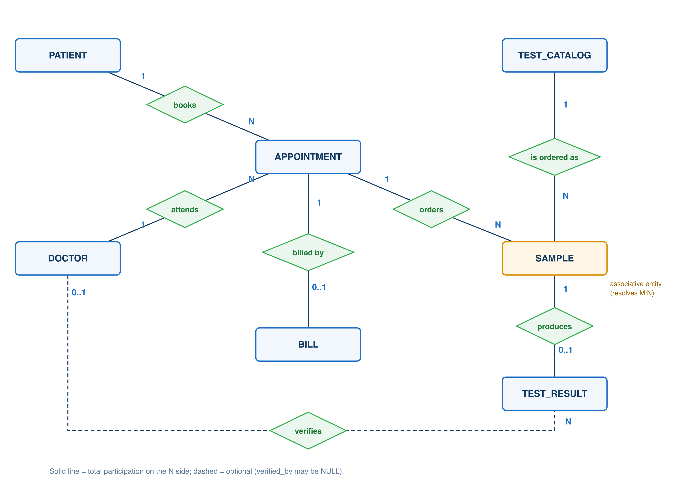
Figure 2: ER diagram of MediTrack (7 entities, 7 relationships)

4.7 Design Assumptions
- One clinic, one branch; all doctors share the same slot grid (HH:MI, 24-hour).
- A doctor has a fixed consultation fee and a maximum number of appointments per day (1–50, default 20).
- A test is ordered at most once per visit; each sample yields at most one result.
- A visit is billed once, only after it is COMPLETED; the bill is a snapshot of prices on that day.
- Discounts are 0–50 %; a bill may be paid in several instalments but never overpaid.
- Cancelled appointments are kept for history and do not block the slot; doctors are deactivated, never deleted.
- A rejected sample is not billed and cannot receive a result.

CHAPTER 5: RELATIONAL DATABASE DESIGN

5.1 Relational Schema
Primary keys are in bold; foreign keys are marked (FK).
- PATIENT (patient_id, first_name, last_name, dob, gender, phone, email, address, registered_on)
- DOCTOR (doctor_id, full_name, specialization, phone, consultation_fee, max_daily_appts, status)
- TEST_CATALOG (test_code, test_name, category, price, unit, normal_min, normal_max, turnaround_hrs)
- APPOINTMENT (appointment_id, patient_id (FK), doctor_id (FK), appt_date, slot_time, reason, status, booked_on)
- SAMPLE (sample_id, appointment_id (FK), test_code (FK), sample_type, collected_on, collected_by, status, remarks)
- TEST_RESULT (result_id, sample_id (FK), result_value, result_flag, result_date, verified_by (FK), remarks)
- BILL (bill_id, appointment_id (FK), bill_date, consultation_amt, test_amt, discount_pct, total_amt, amount_paid, payment_status, payment_mode)
ER-to-relational mapping: each strong entity became a table; each 1:N relationship placed the parent's key as a foreign key on the N side; the two 1:0..1 relationships (produces, billed by) placed the FK on the dependent side with a UNIQUE constraint; the M:N relationship became the SAMPLE table.

5.2 Table Definitions
Table 9: PATIENT table definition (read from USER_TAB_COLUMNS)
Column | Data type | Null? | Default
patient_id | NUMBER(6) | No
first_name | VARCHAR2(30) | No
last_name | VARCHAR2(30) | No
dob | DATE | No
gender | CHAR(1) | No
phone | VARCHAR2(10) | No
email | VARCHAR2(60) | Yes
address | VARCHAR2(150) | Yes
registered_on | DATE | No | SYSDATE

Table 10: DOCTOR table definition (read from USER_TAB_COLUMNS)
Column | Data type | Null? | Default
doctor_id | NUMBER(4) | No
full_name | VARCHAR2(60) | No
specialization | VARCHAR2(40) | No
phone | VARCHAR2(10) | Yes
consultation_fee | NUMBER(8,2) | No
max_daily_appts | NUMBER(2) | No | 20
status | VARCHAR2(8) | No | 'ACTIVE'

Table 11: TEST_CATALOG table definition (read from USER_TAB_COLUMNS)
Column | Data type | Null? | Default
test_code | VARCHAR2(10) | No
test_name | VARCHAR2(60) | No
category | VARCHAR2(30) | No
price | NUMBER(8,2) | No
unit | VARCHAR2(15) | No
normal_min | NUMBER(10,2) | No
normal_max | NUMBER(10,2) | No
turnaround_hrs | NUMBER(3) | No | 24

Table 12: APPOINTMENT table definition (read from USER_TAB_COLUMNS)
Column | Data type | Null? | Default
appointment_id | NUMBER(8) | No
patient_id | NUMBER(6) | No
doctor_id | NUMBER(4) | No
appt_date | DATE | No
slot_time | VARCHAR2(5) | No
reason | VARCHAR2(200) | Yes
status | VARCHAR2(10) | No | 'BOOKED'
booked_on | DATE | No | SYSDATE

Table 13: SAMPLE table definition (read from USER_TAB_COLUMNS)
Column | Data type | Null? | Default
sample_id | NUMBER(8) | No
appointment_id | NUMBER(8) | No
test_code | VARCHAR2(10) | No
sample_type | VARCHAR2(6) | No
collected_on | DATE | No | SYSDATE
collected_by | VARCHAR2(40) | Yes
status | VARCHAR2(10) | No | 'COLLECTED'
remarks | VARCHAR2(100) | Yes

Table 14: TEST_RESULT table definition (read from USER_TAB_COLUMNS)
Column | Data type | Null? | Default
result_id | NUMBER(8) | No
sample_id | NUMBER(8) | No
result_value | NUMBER(10,2) | No
result_flag | VARCHAR2(6) | No | 'NORMAL'
result_date | DATE | No | SYSDATE
verified_by | NUMBER(4) | Yes
remarks | VARCHAR2(200) | Yes

Table 15: BILL table definition (read from USER_TAB_COLUMNS)
Column | Data type | Null? | Default
bill_id | NUMBER(8) | No
appointment_id | NUMBER(8) | No
bill_date | DATE | No | SYSDATE
consultation_amt | NUMBER(10,2) | No
test_amt | NUMBER(10,2) | No | 0
discount_pct | NUMBER(5,2) | No | 0
total_amt | NUMBER(10,2) | No
amount_paid | NUMBER(10,2) | No | 0
payment_status | VARCHAR2(7) | No | 'UNPAID'
payment_mode | VARCHAR2(10) | Yes

5.3 Keys
- Superkeys: any attribute set containing a candidate key, e.g. {patient_id, phone} in PATIENT.
- Candidate keys: PATIENT {patient_id}, {phone}, {email} (email nullable); DOCTOR {doctor_id}, {phone}; TEST_CATALOG {test_code}, {test_name}; SAMPLE {sample_id}, {appointment_id, test_code}; TEST_RESULT {result_id}, {sample_id}; BILL {bill_id}, {appointment_id}.
- Primary keys: the surrogate ids from sequences seq_patient (100001…), seq_doctor (1001…), seq_appointment (500001…), seq_sample (700001…), seq_test_result (800001…), seq_bill (900001…); TEST_CATALOG uses the natural code (e.g. FBS).
- Alternate keys: the remaining candidate keys, enforced with UNIQUE constraints (uq_patient_phone, uq_patient_email, uq_doctor_phone, uq_test_catalog_test_name, uq_sample_appt_test, uq_test_result_sample_id, uq_bill_appointment_id).
- Composite key: (appointment_id, test_code) in SAMPLE.
- Foreign keys (7): fk_appointment_patient_id, fk_appointment_doctor_id, fk_sample_appointment_id, fk_sample_test_code, fk_test_result_sample_id (ON DELETE CASCADE), fk_test_result_verified_by (ON DELETE SET NULL), fk_bill_appointment_id.

5.4 Integrity Constraints
The schema has 85 named constraints: 7 primary keys, 7 foreign keys, 7 unique keys and 64 CHECK / NOT NULL constraints. Naming: pk_<table>, fk_<table>_<col>, uq_<table>_<col>, ck_<table>_<col>, nn_<table>_<col>.
- Domain: data types and sizes; CHECK lists such as gender IN ('M','F','O'), sample_type IN ('BLOOD','URINE','SALIVA','SWAB','OTHER'); ck_appointment_slot_time REGEXP_LIKE '^([01][0-9]|2[0-3]):[0-5][0-9]$'; ck_patient_phone / ck_doctor_phone 10 digits.
- Entity integrity: every table has a NOT NULL, unique primary key.
- Referential integrity: the 7 foreign keys; deleting a doctor with appointments fails with ORA-02292; deleting a sample cascades to its result.
- UNIQUE / NOT NULL: alternate keys above; NOT NULLs are named nn_<table>_<col>.
- CHECK (row-level business rules): ck_bill_total_amt total = ROUND((consultation_amt + test_amt) × (1 − discount_pct/100), 2); ck_bill_paid_le_total amount_paid ≤ total_amt; ck_bill_discount_pct 0–50; ck_test_catalog_range normal_min ≤ normal_max; ck_test_catalog_turnaround > 0; ck_doctor_max_daily_appts 1–50; ck_appointment_appt_date appt_date = TRUNC(appt_date).
- Rules a CHECK cannot express (they need other rows or SYSDATE) are triggers or procedure checks: double booking, booking in the past, result flags, payment status.

5.5 Schema Diagram
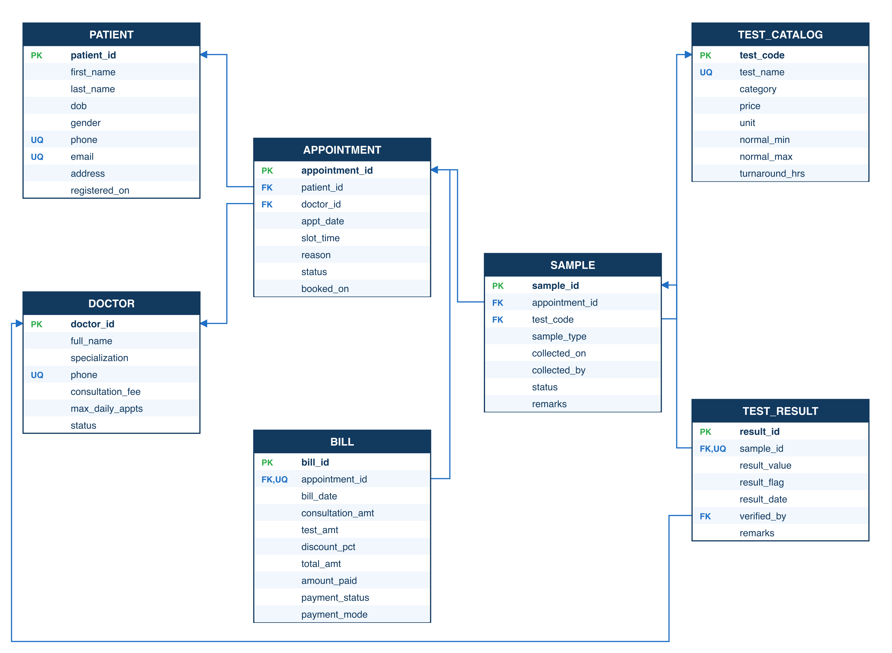
Figure 3: Relational schema diagram with PK/FK links

5.6 Data Dictionary
Section 5.2 lists every column with its type, nullability and default, read directly from Oracle's data dictionary. The table below explains the meaning and constraints of the attributes that carry business rules.
Table 16: Data dictionary: attributes that carry business rules
Table.column | Meaning | Constraint / rule
patient.phone | 10-digit mobile number | NOT NULL, UNIQUE, ck_patient_phone
patient.registered_on | Registration date | DEFAULT SYSDATE
doctor.consultation_fee | Fee per visit (₹) | > 0
doctor.max_daily_appts | Daily booking limit | DEFAULT 20, 1–50
doctor.status | ACTIVE or INACTIVE | DEFAULT 'ACTIVE'; INACTIVE blocks booking (-20001)
test_catalog.normal_min / normal_max | Reference range | normal_min ≤ normal_max; used by trg_flag_result
test_catalog.turnaround_hrs | Promised hours to result | DEFAULT 24, > 0; used by Q2
appointment.appt_date | Visit day (no time part) | = TRUNC(appt_date)
appointment.slot_time | 'HH:MI', 24-hour | REGEXP_LIKE CHECK
appointment.status | BOOKED / COMPLETED / CANCELLED / NO_SHOW | DEFAULT 'BOOKED'
sample.status | COLLECTED / PROCESSING / COMPLETED / REJECTED | DEFAULT 'COLLECTED'; COMPLETED set by trigger
test_result.result_flag | LOW / NORMAL / HIGH | set by trg_flag_result
test_result.verified_by | Doctor who verified | nullable FK, ON DELETE SET NULL
bill.consultation_amt, test_amt | Snapshot of charges | ≥ 0; copied by generate_bill
bill.total_amt | Amount payable | ck_bill_total_amt
bill.amount_paid | Paid so far | DEFAULT 0, ≤ total_amt
bill.payment_status | UNPAID / PARTIAL / PAID | set by trg_payment_status
bill.payment_mode | CASH / CARD / UPI / INSURANCE | CHECK list

CHAPTER 6: FUNCTIONAL DEPENDENCIES AND NORMALIZATION

6.1 Functional Dependencies
Normalization starts from a single un-normalized relation that mirrors the paper visit slip used at the clinic:
VISIT_SLIP(appointment_id, appt_date, slot_time, patient_id, patient_name, phone, doctor_id, doctor_name,
consultation_fee, {test_code, test_name, price, normal_min, normal_max, result_value, flag},
total_amt, amount_paid)
Functional dependencies identified (A = appointment_id, P = patient_id, D = doctor_id, T = test_code):
- A → appt_date, slot_time, P, D, total_amt, amount_paid
- P → patient_name, phone and phone → P
- D → doctor_name, consultation_fee
- T → test_name, price, normal_min, normal_max
- {A, T} → result_value, flag
- {result_value, normal_min, normal_max} → flag
- {D, appt_date, slot_time} → A for non-cancelled rows (the double-booking rule; enforced by trigger, see 6.6)

6.2 Attribute Closure and Candidate Keys
Compute {A, T}⁺: start with {A, T}. From A → appt_date, slot_time, P, D, total_amt, amount_paid; from P → patient_name, phone; from D → doctor_name, consultation_fee; from T → test_name, price, normal_min, normal_max; from {A, T} → result_value, flag. Every attribute is reached, so {A, T}⁺ = all attributes and {A, T} is a superkey. Neither A⁺ (lacks the test attributes) nor T⁺ (lacks the visit attributes) covers everything, so {appointment_id, test_code} is a candidate key of the flattened relation. In the final schema the closures are trivial: patient_id⁺ = all PATIENT attributes, phone⁺ = phone, patient_id, … (so phone is also a candidate key), and likewise for the alternate keys in Section 5.3.

6.3 First Normal Form (1NF)
VISIT_SLIP is not in 1NF: the braces mark a repeating group of tests. Flattening gives one row per (visit, test), with atomic values only. Names are split into first_name / last_name, each patient has one phone column, and the normal range is two numeric columns, not a text like '70-100'. The 1NF relation has key {appointment_id, test_code}.

6.4 Second Normal Form (2NF)
In the 1NF relation many attributes depend on only part of the key: appointment attributes depend on A alone, and test_name, price, normal_min, normal_max depend on T alone. These partial dependencies cause anomalies (a price change must be updated in every row that ordered the test). Decompose: VISIT(A, appt_date, slot_time, P, patient_name, phone, D, doctor_name, consultation_fee, total_amt, amount_paid), TEST(T, test_name, price, normal_min, normal_max) and ORDERED_TEST(A, T, result_value, flag). Now every non-key attribute depends on the whole key.

6.5 Third Normal Form (3NF)
VISIT still has transitive dependencies: A → P → patient_name, phone and A → D → doctor_name, consultation_fee. Remove them into PATIENT(P, …) and DOCTOR(D, …), leaving APPOINTMENT(A, P, D, appt_date, slot_time, …). The billing attributes describe the visit's bill and are 1:0..1 with A, so they move to BILL(bill_id, A, …). ORDERED_TEST is split into the specimen (SAMPLE) and its measurement (TEST_RESULT), because a sample exists for hours before a result does; keeping them apart avoids rows full of NULLs and lets the trigger fire exactly when a result is entered.

6.6 Boyce–Codd Normal Form (BCNF)
Table 17: BCNF check of every table
Table | Determinants | Candidate keys | BCNF?
PATIENT | patient_id, phone, email | patient_id, phone, email | Yes
DOCTOR | doctor_id, phone | doctor_id, phone | Yes
TEST_CATALOG | test_code, test_name | test_code, test_name | Yes
APPOINTMENT | appointment_id | appointment_id | Yes
SAMPLE | sample_id, (appointment_id, test_code) | both | Yes
TEST_RESULT | result_id, sample_id | both | Yes
BILL | bill_id, appointment_id; (consultation_amt, test_amt, discount_pct) → total_amt | bill_id, appointment_id | Deliberate exception (snapshot)

Every determinant is a candidate key, except in BILL, where total_amt is computable from the other amounts. This is a deliberate snapshot: a bill is a record of what was charged on that day, so consultation_amt and test_amt are copied from DOCTOR and TEST_CATALOG instead of recomputed, and old bills do not change when prices change. The redundancy is guarded by ck_bill_total_amt, so it can never become inconsistent. The rule {D, appt_date, slot_time} → A holds only for non-cancelled rows, so it is not a true FD of the table; enforcing it with UNIQUE would wrongly block rebooking a cancelled slot, which is why it is a trigger.

6.7 Lossless Join and Dependency Preservation
Each decomposition step splits R into R1 and R2 whose common attributes are a key of one side, so the join is lossless: VISIT ∩ ORDERED_TEST = {A}, the key of VISIT; TEST ∩ ORDERED_TEST = {T}, the key of TEST; APPOINTMENT ∩ PATIENT = {P}, the key of PATIENT; APPOINTMENT ∩ DOCTOR = {D}; SAMPLE ∩ TEST_RESULT = {sample_id}, the key of SAMPLE. Every FD in 6.1 lies within one final table (A → … in APPOINTMENT, P → … in PATIENT, D → … in DOCTOR, T → … in TEST_CATALOG, {A, T} → result via SAMPLE + TEST_RESULT), so the decomposition is dependency preserving; the flag dependency is enforced by trg_flag_result.

6.8 Before-and-After Example
Before (1NF, one row per visit × test):
Table 18: Un-normalized visit rows (redundant patient, doctor and test data)
appt_id | patient | doctor | fee | test_code | test_name | price | value | flag
500003 | Aarav Sharma | Dr. Rajesh Kumar | 500 | FBS | Fasting Blood Sugar | 150 | 128 | HIGH
500003 | Aarav Sharma | Dr. Rajesh Kumar | 500 | HB | Haemoglobin | 250 | 13.5 | NORMAL

Patient, doctor and fee repeat in every test row (update anomaly); a new test cannot be added to the catalogue until someone orders it (insertion anomaly); deleting a visit's only test deletes the visit (deletion anomaly).
After: APPOINTMENT(500003, 100001, 1001, …), PATIENT(100001, Aarav, Sharma, …), DOCTOR(1001, Dr. Rajesh Kumar, …, 500), TEST_CATALOG(FBS, Fasting Blood Sugar, …, 150, 70, 100), SAMPLE(sample_id, 500003, FBS, BLOOD, …), TEST_RESULT(result_id, sample_id, 128, HIGH, …) and BILL(…, 500003, 500, 400, 10, 810, …). Each fact is stored once.

CHAPTER 7: SQL IMPLEMENTATION

7.1 Database and Table Creation (DDL)
01_ddl.sql creates six sequences and the seven tables in dependency order with every constraint named. Excerpt:
CREATE SEQUENCE seq_appointment START WITH 500001 INCREMENT BY 1 NOCACHE;

CREATE TABLE appointment (
appointment_id NUMBER(8) CONSTRAINT pk_appointment PRIMARY KEY,
patient_id NUMBER(6) CONSTRAINT nn_appointment_patient_id NOT NULL,
doctor_id NUMBER(4) CONSTRAINT nn_appointment_doctor_id NOT NULL,
appt_date DATE CONSTRAINT nn_appointment_appt_date NOT NULL,
slot_time VARCHAR2(5) CONSTRAINT nn_appointment_slot_time NOT NULL,
reason VARCHAR2(200),
status VARCHAR2(10) DEFAULT 'BOOKED' CONSTRAINT nn_appointment_status NOT NULL,
booked_on DATE DEFAULT SYSDATE CONSTRAINT nn_appointment_booked_on NOT NULL,
CONSTRAINT fk_appointment_patient_id FOREIGN KEY (patient_id) REFERENCES patient (patient_id),
CONSTRAINT fk_appointment_doctor_id FOREIGN KEY (doctor_id) REFERENCES doctor (doctor_id),
CONSTRAINT ck_appointment_slot_time
CHECK (REGEXP_LIKE(slot_time, '^([01][0-9]|2[0-3]):[0-5][0-9]$')),
CONSTRAINT ck_appointment_appt_date CHECK (appt_date = TRUNC(appt_date)),
CONSTRAINT ck_appointment_status
CHECK (status IN ('BOOKED', 'COMPLETED', 'CANCELLED', 'NO_SHOW'))
);
DROP: 99_drop_all.sql drops triggers, procedures, functions, the view, tables (child first, with CASCADE CONSTRAINTS) and sequences, ignoring “does not exist” errors, so every build is re-runnable. ALTER changes a live schema without rebuilding it; for example, the doctor e-mail column from the Review I design would be added with ALTER TABLE doctor ADD (email VARCHAR2(60) CONSTRAINT uq_doctor_email UNIQUE), and Chapter 9 adds and drops an index the same way (CREATE INDEX / DROP INDEX). TRUNCATE is not used on clinic tables because it cannot be rolled back and ignores the FK-based delete rules; the rebuild uses DROP + CREATE instead.

7.2 Data Manipulation (DML)
02_seed_data.sql loads realistic data (PATIENT 12, DOCTOR 10, TEST_CATALOG 12, APPOINTMENT 24, SAMPLE 18, TEST_RESULT 16, BILL 11 rows). 07_dml_demo.sql walks through T1–T7 with INSERT, UPDATE and DELETE, including failure cases:
-- INSERT (T1)
INSERT INTO patient (patient_id, first_name, last_name, dob, gender, phone, email, address)
VALUES (seq_patient.NEXTVAL, 'Neha', 'Kapoor', DATE '1997-06-21', 'F', '9345678901',
'neha.kapoor@gmail.com', '15 Sainathapuram, Vellore');
-- UPDATE (T2b, T4, T7a)
UPDATE sample SET status = 'PROCESSING' WHERE sample_id = :sample_id;
UPDATE appointment SET status = 'COMPLETED' WHERE appointment_id = :appt_id AND status = 'BOOKED';
-- DELETE (T7b): the result row is removed by ON DELETE CASCADE
DELETE FROM sample WHERE sample_id = 700013 AND status = 'REJECTED';

7.3 Data Retrieval (DQL)
Simple retrieval with WHERE, DISTINCT and ORDER BY, e.g. active specialities and today's non-cancelled visits:
SELECT DISTINCT specialization FROM doctor WHERE status = 'ACTIVE' ORDER BY specialization;

SELECT appointment_id, slot_time, status
FROM appointment
WHERE appt_date = TRUNC(SYSDATE) AND status <> 'CANCELLED'
ORDER BY slot_time;
specialization
Cardiologist
Dermatologist
ENT Specialist
Endocrinologist
General Physician
Gynaecologist
Nephrologist
Orthopaedic Surgeon
Pathologist

7.4 Built-In and Aggregate Functions
String: ||, RTRIM, LISTAGG, REGEXP_LIKE (in CHECKs); numeric: ROUND, NVL; date: TRUNC(SYSDATE), TO_CHAR, MONTHS_BETWEEN (patient age); aggregates: COUNT, SUM, AVG, MIN, MAX. Example (per-category price statistics):
SELECT category, COUNT(*) AS tests, MIN(price) AS cheapest, MAX(price) AS dearest,
ROUND(AVG(price), 2) AS avg_price, SUM(price) AS catalogue_value
FROM test_catalog GROUP BY category ORDER BY category;
category | tests | cheapest | dearest | avg_price | catalogue_value
Biochemistry | 4 | 150 | 550 | 350 | 1400
Endocrinology | 3 | 450 | 1200 | 850 | 2550
Haematology | 3 | 200 | 250 | 216.67 | 650
Immunology | 1 | 500 | 500 | 500 | 500
Urinalysis | 1 | 180 | 180 | 180 | 180

7.5 GROUP BY and HAVING
Q5 groups the last 30 days' non-cancelled appointments by doctor and keeps groups with more than two (HAVING); Q4 groups bills by day and payment mode. Outputs are in Section 7.12.

7.6 Joins
- INNER JOIN: Q1 (APPOINTMENT ⋈ PATIENT ⋈ DOCTOR), Q3 (five tables).
- LEFT OUTER JOIN: Q3 (LEFT JOIN doctor for an unverified result), Q8 (tests with zero orders), Q10 (anti-join: LEFT JOIN bill … WHERE b.bill_id IS NULL).
- RIGHT JOIN: equivalent to a LEFT JOIN with the tables swapped; shown below for completeness.
- CROSS JOIN: every active doctor × a slot list builds the day's slot grid.
- SELF JOIN: patients who share an address (family members).
SELECT tc.test_code, COUNT(s.sample_id) AS times_ordered
FROM sample s RIGHT JOIN test_catalog tc ON tc.test_code = s.test_code
GROUP BY tc.test_code ORDER BY times_ordered, tc.test_code;
test_code | times_ordered
B12 | 0
LDL | 1
PLT | 1
UPROT | 1
VITD | 1
WBC | 1

(12 rows in total; first 6 shown.)
SELECT d.full_name, s.slot
FROM doctor d
CROSS JOIN (SELECT '09:00' AS slot FROM dual UNION ALL SELECT '09:30' FROM dual) s
WHERE d.doctor_id IN (1001, 1002) ORDER BY d.full_name, s.slot;
full_name | slot
Dr. Priya Sharma | 09:00
Dr. Priya Sharma | 09:30
Dr. Rajesh Kumar | 09:00
Dr. Rajesh Kumar | 09:30

Self join: pairs of patients who registered in the same month (PATIENT joined to itself):
SELECT p1.first_name || ' ' || p1.last_name AS patient,
p2.first_name || ' ' || p2.last_name AS registered_same_month,
TO_CHAR(p1.registered_on, 'YYYY-MM') AS month
FROM patient p1
JOIN patient p2 ON p1.patient_id < p2.patient_id
AND TO_CHAR(p1.registered_on, 'YYYY-MM') = TO_CHAR(p2.registered_on, 'YYYY-MM')
ORDER BY month, patient;
patient | registered_same_month | month
Aarav Sharma | Ananya Iyer | 2026-05
Diya Reddy | Vihaan Gupta | 2026-07
Ishita Nair | Kabir Singh | 2026-08
Arjun Das | Saanvi Joshi | 2026-09
Arjun Das | Aditya Menon | 2026-09
Meera Pillai | Aditya Menon | 2026-09
Meera Pillai | Arjun Das | 2026-09
Meera Pillai | Saanvi Joshi | 2026-09

(9 rows in total; first 8 shown.)

7.7 Subqueries
- Single-row: Q12's scalar subquery (SELECT SUM(total_amt) FROM bill) for the percentage share.
- Multiple-row / nested: Q6 compares each patient's dues with AVG over a derived table of per-patient dues; the service layer also uses IN (SELECT appointment_id FROM appointment WHERE doctor_id = :doctor_id).
- Correlated: Q7's NOT EXISTS (SELECT 1 FROM sample s WHERE s.test_code = tc.test_code); the cursor in end_of_day_billing uses NOT EXISTS on BILL.
- EXISTS: doctors who have at least one abnormal result to review:
SELECT d.full_name FROM doctor d
WHERE EXISTS (SELECT 1 FROM appointment a JOIN sample s ON s.appointment_id = a.appointment_id
JOIN test_result r ON r.sample_id = s.sample_id
WHERE a.doctor_id = d.doctor_id AND r.result_flag <> 'NORMAL')
ORDER BY d.full_name;
full_name
Dr. Anil Mehta
Dr. Kavita Iyer
Dr. Priya Sharma
Dr. Rajesh Kumar
Dr. Sunita Rao
Dr. Vikram Singh

7.8 Set Operations
Q13 uses INTERSECT (patients with both a HIGH and a LOW result). UNION and MINUS examples:
-- patients with a completed visit but no bill at all
SELECT patient_id FROM appointment WHERE status = 'COMPLETED'
MINUS
SELECT a.patient_id FROM bill b JOIN appointment a ON a.appointment_id = b.appointment_id;
patient_id
100010

-- one contact list across doctors and patients (UNION removes duplicates)
SELECT 'doctor' AS kind, phone FROM doctor WHERE phone LIKE '98400110%'
UNION
SELECT 'patient', phone FROM patient WHERE phone LIKE '98%' ORDER BY 1, 2;
kind | phone
doctor | 9840011001
doctor | 9840011002
doctor | 9840011003
doctor | 9840011004
doctor | 9840011005
doctor | 9840011006
doctor | 9840011007
doctor | 9840011008

(14 rows in total; first 8 shown.)

7.9 Views
Q15 creates v_bill_summary, a join of BILL, APPOINTMENT, PATIENT and DOCTOR with a computed balance column. The billing pages and list_bills() read only this view. Update limitation: because it joins four tables and contains an expression (balance), Oracle allows updates only to columns of the key-preserved table (BILL) and never to balance or the patient name; the application therefore updates BILL through record_payment, never through the view.

7.10 Constraints
PK, FK, UNIQUE, NOT NULL, CHECK and DEFAULT are all used (Section 5.4). The Administration › Database › Constraint lab page runs ten statements that each break one rule; Oracle refuses all ten and the page explains why:
Table 19: Constraint lab results (each attempt rolled back)
Violation attempted | Enforced by | Error | Outcome
Double booking (same doctor, same slot) | trg_no_double_booking → ORA-20003 | ORA-20003 | Refused
Invalid gender code | ck_patient_gender (CHECK) | ORA-02290 | Refused
Duplicate phone number | uq_patient_phone (UNIQUE) | ORA-00001 | Refused
Appointment for a patient who does not exist | fk_appointment_patient_id (FOREIGN KEY) | ORA-02291 | Refused
Slot time in the wrong format | ck_appointment_slot_time (REGEXP_LIKE CHECK) | ORA-02290 | Refused
Same test ordered twice in one visit | uq_sample_appt_test (composite UNIQUE) | ORA-00001 | Refused
Paying more than the bill total | ck_bill_paid_le_total (CHECK) | ORA-02290 | Refused
Discount above 50% | ck_bill_discount_pct (CHECK) | ORA-02290 | Refused
Deleting a doctor who has appointments | fk_appointment_doctor_id (no ON DELETE → ORA-02292) | ORA-02292 | Refused
Result for a sample that does not exist | trg_flag_result → ORA-20031 | ORA-20031 | Refused

7.11 Data Control Language
Least-privilege access was demonstrated with a temporary account and role (created by SYSTEM, dropped afterwards). The billing role may read the bill view and call record_payment, but cannot see or change base tables:
-- as SYSTEM
CREATE USER mt_frontdesk IDENTIFIED BY ********;
GRANT CREATE SESSION TO mt_frontdesk;
CREATE ROLE mt_billing_role;
-- as MEDITRACK (the schema owner)
GRANT SELECT ON v_bill_summary TO mt_billing_role;
GRANT EXECUTE ON record_payment TO mt_billing_role;
-- as SYSTEM
GRANT mt_billing_role TO mt_frontdesk;
-- later, as MEDITRACK
REVOKE SELECT ON v_bill_summary FROM mt_billing_role;
Table 20: GRANT / REVOKE test with a least-privilege account
Statement run as mt_frontdesk | Result
SELECT COUNT(*) FROM meditrack.v_bill_summary | 11 (permitted through the role)
SELECT COUNT(*) FROM meditrack.patient | ORA-00942: table or view does not exist (no privilege)
DELETE FROM meditrack.bill WHERE bill_id = 900005 | ORA-00942 (no privilege)
SELECT … FROM meditrack.v_bill_summary after REVOKE | ORA-00942 (privilege removed)

7.12 SQL Output Evidence
All 15 queries in 03_queries.sql, with purpose, functional requirement and SQL concept, run on the seed data on 28 October 2026. Seed dates are relative to SYSDATE, so the outputs have the same shape on any day.

Q1. Today's schedule per doctor
Purpose: Front desk prints each doctor's list of patients for today FR: FR3 Concept: INNER JOIN across 3 tables, WHERE filter, ORDER BY
SELECT d.full_name AS doctor,
a.slot_time AS slot,
p.first_name || ' ' || p.last_name AS patient,
p.phone,
a.reason,
a.status
FROM appointment a
JOIN patient p ON p.patient_id = a.patient_id
JOIN doctor d ON d.doctor_id = a.doctor_id
WHERE a.appt_date = TRUNC(SYSDATE)
ORDER BY d.full_name, a.slot_time;
doctor | slot | patient | phone | reason | status
Dr. Arjun Nair | 09:00 | Ishita Nair | 9988776655 | Lower back pain | BOOKED
Dr. Arjun Nair | 09:00 | Diya Reddy | 9900112233 | Knee pain | CANCELLED
Dr. Priya Sharma | 11:00 | Rohan Verma | 9810023456 | Cholesterol follow-up | BOOKED
Dr. Rajesh Kumar | 10:00 | Aditya Menon | 9778899001 | Blood sugar check | BOOKED
Dr. Rajesh Kumar | 10:30 | Priyanka Rao | 9889900112 | Headache and dizziness | BOOKED
Dr. Sanjay Gupta | 14:00 | Vihaan Gupta | 9123456780 | Sore throat | BOOKED
Dr. Sanjay Gupta | 14:30 | Meera Pillai | 9445566778 | Sinus congestion | BOOKED

Interpretation: Seven slots today; the cancelled 09:00 slot with Dr. Nair was rebooked by another patient, which the trigger allows.

Q2. Pending samples older than their test's turnaround time
Purpose: Lab supervisor chases samples that are overdue FR: FR8 Concept: JOIN, date arithmetic (hours -> days), multi-condition WHERE
SELECT s.sample_id,
tc.test_name,
p.first_name || ' ' || p.last_name AS patient,
TO_CHAR(s.collected_on, 'DD-MON HH24:MI') AS collected_on,
TO_CHAR(s.collected_on + tc.turnaround_hrs / 24, 'DD-MON HH24:MI') AS due_by,
ROUND((SYSDATE - (s.collected_on + tc.turnaround_hrs / 24)) * 24, 1) AS hours_overdue,
s.status
FROM sample s
JOIN test_catalog tc ON tc.test_code = s.test_code
JOIN appointment a ON a.appointment_id = s.appointment_id
JOIN patient p ON p.patient_id = a.patient_id
WHERE s.status IN ('COLLECTED', 'PROCESSING')
AND s.collected_on + tc.turnaround_hrs / 24 < SYSDATE
ORDER BY hours_overdue DESC;
sample_id | test_name | patient | collected_on | due_by | hours_overdue | status
700017 | Fasting Blood Sugar | Saanvi Joshi | 27-OCT 10:30 | 27-OCT 14:30 | 25.7 | PROCESSING
700018 | C-Reactive Protein | Saanvi Joshi | 27-OCT 10:30 | 27-OCT 22:30 | 17.7 | COLLECTED

Interpretation: Two samples of visit 500014 are past their turnaround time and still pending.

Q3. All abnormal (LOW / HIGH) results with patient and test names
Purpose: Doctors review results that need attention FR: FR7 Concept: 5-table INNER JOIN, IN list filter
SELECT p.first_name || ' ' || p.last_name AS patient,
tc.test_name,
r.result_value,
tc.unit,
RTRIM(TO_CHAR(tc.normal_min, 'FM99990.99'), '.') || ' - ' ||
RTRIM(TO_CHAR(tc.normal_max, 'FM99990.99'), '.') AS normal_range,
r.result_flag,
d.full_name AS verified_by
FROM test_result r
JOIN sample s ON s.sample_id = r.sample_id
JOIN test_catalog tc ON tc.test_code = s.test_code
JOIN appointment a ON a.appointment_id = s.appointment_id
JOIN patient p ON p.patient_id = a.patient_id
LEFT JOIN doctor d ON d.doctor_id = r.verified_by
WHERE r.result_flag IN ('LOW', 'HIGH')
AND s.status <> 'REJECTED'
ORDER BY p.last_name, tc.test_name;
patient | test_name | result_value | unit | normal_range | result_flag | verified_by
Arjun Das | Haemoglobin | 10.2 | g/dL | 12 - 17 | LOW | Dr. Sunita Rao
Ananya Iyer | Fasting Blood Sugar | 142 | mg/dL | 70 - 100 | HIGH | Dr. Sunita Rao
Ananya Iyer | Glycated Haemoglobin HbA1c | 7.2 | % | 4 - 5.7 | HIGH | Dr. Priya Sharma
Meera Pillai | Thyroid Stimulating Hormone | 6.8 | mIU/L | 0.4 - 4 | HIGH | Dr. Priya Sharma
Meera Pillai | Vitamin D (25-OH) | 18 | ng/mL | 30 - 100 | LOW | Dr. Priya Sharma
Diya Reddy | Serum Creatinine | 1.9 | mg/dL | 0.6 - 1.2 | HIGH | Dr. Sunita Rao
Diya Reddy | Urine Protein | 30 | mg/dL | 0 - 14 | HIGH | Dr. Sunita Rao
Aarav Sharma | Fasting Blood Sugar | 128 | mg/dL | 70 - 100 | HIGH | Dr. Sunita Rao

(12 rows in total; first 8 shown.)
Interpretation: Twelve results are outside the normal range; flags were set by trg_flag_result, not typed.

Q4. Revenue collected by day and by payment mode
Purpose: Accounts reconciles the cash drawer, card machine and UPI FR: FR12 Concept: GROUP BY on two columns, SUM / COUNT aggregates
SELECT TO_CHAR(b.bill_date, 'YYYY-MM-DD') AS bill_date,
NVL(b.payment_mode, 'NOT PAID') AS payment_mode,
COUNT(*) AS bills,
SUM(b.total_amt) AS billed,
SUM(b.amount_paid) AS collected
FROM bill b
GROUP BY TO_CHAR(b.bill_date, 'YYYY-MM-DD'), NVL(b.payment_mode, 'NOT PAID')
ORDER BY bill_date, payment_mode;
bill_date | payment_mode | bills | billed | collected
2026-10-03 | CARD | 1 | 1200 | 1200
2026-10-06 | CASH | 1 | 700 | 700
2026-10-08 | UPI | 1 | 810 | 810
2026-10-10 | CASH | 1 | 1500 | 1000
2026-10-13 | NOT PAID | 1 | 1900 | 0
2026-10-14 | INSURANCE | 1 | 550 | 550
2026-10-16 | CARD | 1 | 1311 | 1311
2026-10-20 | UPI | 1 | 1800 | 500

(11 rows in total; first 8 shown.)
Interpretation: Collections per day and mode; NOT PAID rows are bills with no payment yet.

Q5. Doctors with more than 2 appointments in the last 30 days
Purpose: Management sees which doctors carry the most load FR: FR12 Concept: GROUP BY + HAVING
SELECT d.full_name AS doctor,
d.specialization,
COUNT(*) AS appointments
FROM appointment a
JOIN doctor d ON d.doctor_id = a.doctor_id
WHERE a.appt_date >= TRUNC(SYSDATE) - 30
AND a.status <> 'CANCELLED'
GROUP BY d.full_name, d.specialization
HAVING COUNT(*) > 2
ORDER BY appointments DESC;
doctor | specialization | appointments
Dr. Rajesh Kumar | General Physician | 4
Dr. Priya Sharma | Endocrinologist | 4
Dr. Anil Mehta | Cardiologist | 3
Dr. Sanjay Gupta | ENT Specialist | 3

Interpretation: Four doctors carried more than two visits in the last 30 days.

Q6. Patients whose outstanding dues are above the average due
Purpose: Billing follows up the largest unpaid balances first FR: FR10 Concept: Non-correlated subquery in HAVING (average of per-patient dues)
SELECT p.patient_id,
p.first_name || ' ' || p.last_name AS patient,
p.phone,
SUM(b.total_amt - b.amount_paid) AS total_due
FROM patient p
JOIN appointment a ON a.patient_id = p.patient_id
JOIN bill b ON b.appointment_id = a.appointment_id
GROUP BY p.patient_id, p.first_name, p.last_name, p.phone
HAVING SUM(b.total_amt - b.amount_paid) >
(SELECT AVG(patient_due)
FROM (SELECT SUM(b2.total_amt - b2.amount_paid) AS patient_due
FROM bill b2
JOIN appointment a2 ON a2.appointment_id = b2.appointment_id
GROUP BY a2.patient_id))
ORDER BY total_due DESC;
patient_id | patient | phone | total_due
100003 | Rohan Verma | 9810023456 | 1900
100001 | Aarav Sharma | 9876543210 | 1300
100007 | Kabir Singh | 9001122334 | 800

Interpretation: Three patients owe more than the average outstanding due; billing calls them first.

Q7. Tests in the catalogue that have never been ordered
Purpose: Lab manager reviews unused tests (reagents, pricing) FR: FR5 Concept: NOT EXISTS with a correlated subquery
SELECT tc.test_code, tc.test_name, tc.category, tc.price
FROM test_catalog tc
WHERE NOT EXISTS (SELECT 1
FROM sample s
WHERE s.test_code = tc.test_code);
test_code | test_name | category | price
B12 | Vitamin B12 | Endocrinology | 900

Interpretation: Vitamin B12 has never been ordered (the NOT EXISTS case built into the seed).

Q8. Most-ordered test in each category
Purpose: Lab plans stock and staffing around its busiest tests FR: FR12 Concept: Window function RANK() OVER (PARTITION BY ... ORDER BY ...)
SELECT category, test_name, times_ordered, rank_in_category
FROM (SELECT tc.category,
tc.test_name,
COUNT(s.sample_id) AS times_ordered,
RANK() OVER (PARTITION BY tc.category
ORDER BY COUNT(s.sample_id) DESC) AS rank_in_category
FROM test_catalog tc
LEFT JOIN sample s ON s.test_code = tc.test_code
GROUP BY tc.category, tc.test_name)
WHERE rank_in_category = 1
ORDER BY times_ordered DESC, category;
category | test_name | times_ordered | rank_in_category
Biochemistry | Fasting Blood Sugar | 3 | 1
Endocrinology | Thyroid Stimulating Hormone | 2 | 1
Haematology | Haemoglobin | 2 | 1
Immunology | C-Reactive Protein | 2 | 1
Urinalysis | Urine Protein | 1 | 1

Interpretation: The busiest test per category; ties would share rank 1.

Q9. Patients who have consulted more than one doctor (completed visits)
Purpose: Doctors see patients under multiple specialists FR: FR3 Concept: COUNT(DISTINCT ...) with HAVING, LISTAGG
SELECT p.first_name || ' ' || p.last_name AS patient,
COUNT(DISTINCT a.doctor_id) AS doctors_seen,
LISTAGG(DISTINCT d.full_name, ', ')
WITHIN GROUP (ORDER BY d.full_name) AS doctor_names
FROM patient p
JOIN appointment a ON a.patient_id = p.patient_id
JOIN doctor d ON d.doctor_id = a.doctor_id
WHERE a.status = 'COMPLETED'
GROUP BY p.patient_id, p.first_name, p.last_name
HAVING COUNT(DISTINCT a.doctor_id) > 1
ORDER BY doctors_seen DESC, patient;
patient | doctors_seen | doctor_names
Aarav Sharma | 2 | Dr. Priya Sharma, Dr. Rajesh Kumar
Ananya Iyer | 2 | Dr. Anil Mehta, Dr. Priya Sharma
Arjun Das | 2 | Dr. Kavita Iyer, Dr. Sanjay Gupta

Interpretation: Three patients have seen two specialists.

Q10. Completed appointments that have not been billed
Purpose: Billing finds visits that would otherwise be missed FR: FR9, FR11 Concept: LEFT OUTER JOIN ... WHERE right side IS NULL (anti-join)
SELECT a.appointment_id,
TO_CHAR(a.appt_date, 'DD-MON-YYYY') AS appt_date,
p.first_name || ' ' || p.last_name AS patient,
d.full_name AS doctor
FROM appointment a
JOIN patient p ON p.patient_id = a.patient_id
JOIN doctor d ON d.doctor_id = a.doctor_id
LEFT JOIN bill b ON b.appointment_id = a.appointment_id
WHERE a.status = 'COMPLETED'
AND b.bill_id IS NULL
ORDER BY a.appt_date;
appointment_id | appt_date | patient | doctor
500013 | 26-OCT-2026 | Arjun Das | Dr. Kavita Iyer
500014 | 27-OCT-2026 | Saanvi Joshi | Dr. Rajesh Kumar

Interpretation: Visits 500013 and 500014 are completed but unbilled; T6 bills exactly these.

Q11. Average result value per test compared with its normal range
Purpose: Pathologist spots tests where the population runs high/low FR: FR7 Concept: AVG / MIN / MAX aggregates, CASE expression
SELECT tc.test_name,
COUNT(*) AS results,
ROUND(AVG(r.result_value), 2) AS avg_value,
MIN(r.result_value) AS min_value,
MAX(r.result_value) AS max_value,
tc.normal_min,
tc.normal_max,
CASE
WHEN AVG(r.result_value) < tc.normal_min THEN 'BELOW RANGE'
WHEN AVG(r.result_value) > tc.normal_max THEN 'ABOVE RANGE'
ELSE 'WITHIN RANGE'
END AS avg_position
FROM test_result r
JOIN sample s ON s.sample_id = r.sample_id
JOIN test_catalog tc ON tc.test_code = s.test_code
WHERE s.status <> 'REJECTED'
GROUP BY tc.test_name, tc.normal_min, tc.normal_max
ORDER BY tc.test_name;
test_name | results | avg_value | min_value | max_value | normal_min | normal_max | avg_position
C-Reactive Protein | 1 | 4 | 4 | 4 | 0 | 10 | WITHIN RANGE
Fasting Blood Sugar | 2 | 135 | 128 | 142 | 70 | 100 | ABOVE RANGE
Glycated Haemoglobin HbA1c | 2 | 6.8 | 6.4 | 7.2 | 4 | 5.7 | ABOVE RANGE
Haemoglobin | 2 | 11.85 | 10.2 | 13.5 | 12 | 17 | BELOW RANGE
LDL Cholesterol | 1 | 165 | 165 | 165 | 0 | 100 | ABOVE RANGE
Serum Creatinine | 2 | 1.45 | 1 | 1.9 | 0.6 | 1.2 | ABOVE RANGE
Thyroid Stimulating Hormone | 2 | 3.5 | 0.2 | 6.8 | 0.4 | 4 | WITHIN RANGE
Urine Protein | 1 | 30 | 30 | 30 | 0 | 14 | ABOVE RANGE

(10 rows in total; first 8 shown.)
Interpretation: Fasting blood sugar and HbA1c average above range in this patient group.

Q12. Each doctor's share of total billed revenue
Purpose: Management compares revenue contribution per doctor FR: FR12 Concept: Scalar subquery in SELECT for the grand total, percentage
SELECT d.full_name AS doctor,
COUNT(b.bill_id) AS bills,
SUM(b.total_amt) AS revenue,
ROUND(100 * SUM(b.total_amt) / (SELECT SUM(total_amt) FROM bill), 1) AS pct_of_total
FROM bill b
JOIN appointment a ON a.appointment_id = b.appointment_id
JOIN doctor d ON d.doctor_id = a.doctor_id
GROUP BY d.full_name
ORDER BY revenue DESC;
doctor | bills | revenue | pct_of_total
Dr. Priya Sharma | 3 | 5750 | 41.6
Dr. Anil Mehta | 2 | 2700 | 19.5
Dr. Vikram Singh | 2 | 2511 | 18.2
Dr. Rajesh Kumar | 1 | 810 | 5.9
Dr. Sunita Rao | 1 | 800 | 5.8
Dr. Kavita Iyer | 1 | 700 | 5.1
Dr. Sanjay Gupta | 1 | 550 | 4

Interpretation: Dr. Priya Sharma accounts for the largest share of billed revenue.

Q13. Patients with both a HIGH and a LOW result
Purpose: Flags patients with mixed abnormalities for a full review FR: FR7 Concept: Set operator INTERSECT
SELECT p.patient_id, p.first_name || ' ' || p.last_name AS patient
FROM patient p
JOIN appointment a ON a.patient_id = p.patient_id
JOIN sample s ON s.appointment_id = a.appointment_id
JOIN test_result r ON r.sample_id = s.sample_id
WHERE r.result_flag = 'HIGH'
INTERSECT
SELECT p.patient_id, p.first_name || ' ' || p.last_name AS patient
FROM patient p
JOIN appointment a ON a.patient_id = p.patient_id
JOIN sample s ON s.appointment_id = a.appointment_id
JOIN test_result r ON r.sample_id = s.sample_id
WHERE r.result_flag = 'LOW'
ORDER BY 1;
patient_id | patient
100001 | Aarav Sharma
100008 | Meera Pillai

Interpretation: Two patients have both HIGH and LOW results and need a full review.

Q14. New patient registrations per month
Purpose: Management tracks growth of the clinic's patient base FR: FR1, FR12 Concept: GROUP BY on a derived value (TO_CHAR month), COUNT
SELECT TO_CHAR(registered_on, 'YYYY-MM') AS month,
COUNT(*) AS new_patients
FROM patient
GROUP BY TO_CHAR(registered_on, 'YYYY-MM')
ORDER BY month;
month | new_patients
2026-05 | 2
2026-06 | 1
2026-07 | 2
2026-08 | 2
2026-09 | 4
2026-10 | 1

Interpretation: Registrations per month over the seed period.

Q15. View v_bill_summary : one readable line per bill
Purpose: Billing desk and reports read bills without writing joins FR: FR9, FR10 Concept: CREATE VIEW over a 4-table join; querying the view
SELECT bill_id,
TO_CHAR(bill_date, 'DD-MON-YYYY') AS bill_date,
patient,
doctor,
total_amt,
amount_paid,
balance,
payment_status,
payment_mode
FROM v_bill_summary
ORDER BY bill_id;
bill_id | bill_date | patient | doctor | total_amt | amount_paid | balance | payment_status | payment_mode
900001 | 03-OCT-2026 | Aditya Menon | Dr. Vikram Singh | 1200 | 1200 | 0 | PAID | CARD
900002 | 06-OCT-2026 | Priyanka Rao | Dr. Kavita Iyer | 700 | 700 | 0 | PAID | CASH
900003 | 08-OCT-2026 | Aarav Sharma | Dr. Rajesh Kumar | 810 | 810 | 0 | PAID | UPI
900004 | 10-OCT-2026 | Ananya Iyer | Dr. Priya Sharma | 1500 | 1000 | 500 | PARTIAL | CASH
900005 | 13-OCT-2026 | Rohan Verma | Dr. Anil Mehta | 1900 | 0 | 1900 | UNPAID
900006 | 14-OCT-2026 | Arjun Das | Dr. Sanjay Gupta | 550 | 550 | 0 | PAID | INSURANCE
900007 | 16-OCT-2026 | Diya Reddy | Dr. Vikram Singh | 1311 | 1311 | 0 | PAID | CARD
900008 | 20-OCT-2026 | Aarav Sharma | Dr. Priya Sharma | 1800 | 500 | 1300 | PARTIAL | UPI

(11 rows in total; first 8 shown.)
Interpretation: One readable line per bill, with balance and status.

CHAPTER 8: ADVANCED DATABASE OPERATIONS

8.1 Stored Procedures
Table 21: Stored procedures
Procedure | Transaction | Checks / effect | Errors
book_appointment(p_patient_id, p_doctor_id, p_date, p_slot, p_reason, p_appt_id OUT) | T1 | Date not in the past; doctor exists and ACTIVE; doctor_daily_load < max_daily_appts; INSERT with seq_appointment (fires the trigger) | -20004, -20005, -20001, -20002 (+ -20003)
generate_bill(p_appointment_id, p_discount_pct DEFAULT 0) | T4, T6 | Visit exists and COMPLETED, no bill yet; fee + SUM(price) of non-REJECTED samples; INSERT snapshot | -20012, -20010, -20011
record_payment(p_bill_id, p_amount, p_mode) | T5 | Amount > 0; SELECT … FOR UPDATE; no overpayment; UPDATE amount_paid (fires trigger) | -20020, -20021
end_of_day_billing(p_date) | T6 | Explicit cursor over unbilled COMPLETED visits; generate_bill each; one COMMIT; ROLLBACK + RAISE on error | propagates

Definition (generate_bill) and invocation:
CREATE OR REPLACE PROCEDURE generate_bill (
p_appointment_id IN bill.appointment_id%TYPE,
p_discount_pct IN bill.discount_pct%TYPE DEFAULT 0
)
IS
v_status appointment.status%TYPE;
v_fee doctor.consultation_fee%TYPE;
v_test_amt bill.test_amt%TYPE;
v_total bill.total_amt%TYPE;
v_bill_count NUMBER;
BEGIN
BEGIN
SELECT a.status, d.consultation_fee
INTO v_status, v_fee
FROM appointment a
JOIN doctor d ON d.doctor_id = a.doctor_id
WHERE a.appointment_id = p_appointment_id;
EXCEPTION
WHEN NO_DATA_FOUND THEN
RAISE_APPLICATION_ERROR(-20012, 'Appointment ' || p_appointment_id || ' does not exist');
END;

IF v_status <> 'COMPLETED' THEN
RAISE_APPLICATION_ERROR(-20010, 'Appointment ' || p_appointment_id
|| ' is ' || v_status || '; only COMPLETED visits can be billed');
END IF;

SELECT COUNT(*)
INTO v_bill_count
FROM bill
WHERE appointment_id = p_appointment_id;

IF v_bill_count > 0 THEN
RAISE_APPLICATION_ERROR(-20011, 'Appointment ' || p_appointment_id || ' already has a bill');
END IF;

SELECT NVL(SUM(tc.price), 0)
INTO v_test_amt
FROM sample s
JOIN test_catalog tc ON tc.test_code = s.test_code
WHERE s.appointment_id = p_appointment_id
AND s.status <> 'REJECTED';

v_total := ROUND((v_fee + v_test_amt) * (1 - p_discount_pct / 100), 2);

INSERT INTO bill (bill_id, appointment_id, consultation_amt, test_amt, discount_pct, total_amt)
VALUES (seq_bill.NEXTVAL, p_appointment_id, v_fee, v_test_amt, p_discount_pct, v_total);
END generate_bill;
/
DECLARE v_id NUMBER;
BEGIN
book_appointment(100013, 1001, TRUNC(SYSDATE) + 1, '09:00', 'Annual health check', v_id);
DBMS_OUTPUT.PUT_LINE('booked appointment ' || v_id);
END;
/
-- from Python: cursor.callproc("generate_bill", [appointment_id, discount_pct])
Output (07_dml_demo.sql): T1: booked appointment 500025 for patient 100013, then T4: bill raised for appointment 500018 with consultation 500, tests 700, discount 10 %, total 1080, status UNPAID.

8.2 User-Defined Functions
CREATE OR REPLACE FUNCTION doctor_daily_load (
p_doctor_id IN doctor.doctor_id%TYPE,
p_date IN DATE
) RETURN NUMBER
IS
v_count NUMBER;
BEGIN
SELECT COUNT(*)
INTO v_count
FROM appointment
WHERE doctor_id = p_doctor_id
AND appt_date = TRUNC(p_date)
AND status <> 'CANCELLED';

RETURN v_count;
END doctor_daily_load;
/

CREATE OR REPLACE FUNCTION patient_total_due (
p_patient_id IN patient.patient_id%TYPE
) RETURN NUMBER
IS
v_due NUMBER;
BEGIN
SELECT NVL(SUM(b.total_amt - b.amount_paid), 0)
INTO v_due
FROM bill b
JOIN appointment a ON a.appointment_id = b.appointment_id
WHERE a.patient_id = p_patient_id;

RETURN v_due;
END patient_total_due;
/
Both functions are read-only, so they can be used in SQL: SELECT patient_total_due(100001) FROM dual returns 1300 on the seed data, and list_doctors() shows doctor_daily_load(doctor_id, TRUNC(SYSDATE)) as each doctor's load today. In Python: cursor.callfunc("patient_total_due", float, [patient_id]).

8.3 Triggers
Table 22: Triggers
Trigger | Timing | What it does
trg_no_double_booking | BEFORE INSERT ON appointment FOR EACH ROW | Counts non-CANCELLED rows with the same date + slot for the same doctor OR the same patient; raises -20003
trg_flag_result | BEFORE INSERT OR UPDATE OF result_value ON test_result FOR EACH ROW | Reads normal_min / max via SAMPLE → TEST_CATALOG; sets :NEW.result_flag; marks the sample COMPLETED; -20030 for a REJECTED sample, -20031 if missing
trg_payment_status | BEFORE UPDATE OF amount_paid ON bill FOR EACH ROW | Sets :NEW.payment_status to UNPAID / PARTIAL / PAID

CREATE OR REPLACE TRIGGER trg_no_double_booking
BEFORE INSERT ON appointment
FOR EACH ROW
DECLARE
v_clashes NUMBER;
BEGIN
IF :NEW.status <> 'CANCELLED' THEN
SELECT COUNT(*)
INTO v_clashes
FROM appointment
WHERE appt_date = :NEW.appt_date
AND slot_time = :NEW.slot_time
AND status <> 'CANCELLED'
AND (doctor_id = :NEW.doctor_id OR patient_id = :NEW.patient_id);

IF v_clashes > 0 THEN
RAISE_APPLICATION_ERROR(-20003, 'Slot ' || :NEW.slot_time || ' on '
|| TO_CHAR(:NEW.appt_date, 'DD-MON-YYYY')
|| ' is already taken by this doctor or this patient');
END IF;
END IF;
END;
/

CREATE OR REPLACE TRIGGER trg_flag_result
BEFORE INSERT OR UPDATE OF result_value ON test_result
FOR EACH ROW
DECLARE
v_min test_catalog.normal_min%TYPE;
v_max test_catalog.normal_max%TYPE;
v_sample_status sample.status%TYPE;
BEGIN
BEGIN
SELECT tc.normal_min, tc.normal_max, s.status
INTO v_min, v_max, v_sample_status
FROM sample s
JOIN test_catalog tc ON tc.test_code = s.test_code
WHERE s.sample_id = :NEW.sample_id;
EXCEPTION
WHEN NO_DATA_FOUND THEN
RAISE_APPLICATION_ERROR(-20031, 'Sample ' || :NEW.sample_id || ' does not exist');
END;

IF v_sample_status = 'REJECTED' THEN
RAISE_APPLICATION_ERROR(-20030, 'Sample ' || :NEW.sample_id
|| ' was REJECTED; collect a new sample before entering a result');
END IF;

IF :NEW.result_value < v_min THEN
:NEW.result_flag := 'LOW';
ELSIF :NEW.result_value > v_max THEN
:NEW.result_flag := 'HIGH';
ELSE
:NEW.result_flag := 'NORMAL';
END IF;

UPDATE sample
SET status = 'COMPLETED'
WHERE sample_id = :NEW.sample_id;
END;
/
Mutating-table note: a row trigger may not query its own table during an UPDATE (ORA-04091). That is why trg_no_double_booking fires on INSERT only, and rescheduling is cancel + rebook. Evidence: entering 165 mg/dL for an FBS sample produced flag HIGH and sample status COMPLETED; entering a result for REJECTED sample 700013 raised ORA-20030.

8.4 Cursors
CREATE OR REPLACE PROCEDURE end_of_day_billing (
p_date IN DATE
)
IS
CURSOR c_unbilled IS
SELECT a.appointment_id
FROM appointment a
WHERE a.appt_date = TRUNC(p_date)
AND a.status = 'COMPLETED'
AND NOT EXISTS (SELECT 1
FROM bill b
WHERE b.appointment_id = a.appointment_id)
ORDER BY a.appointment_id;

v_appt_id appointment.appointment_id%TYPE;
v_count NUMBER := 0;
BEGIN
OPEN c_unbilled;
LOOP
FETCH c_unbilled INTO v_appt_id;
EXIT WHEN c_unbilled%NOTFOUND;

generate_bill(v_appt_id);
v_count := v_count + 1;
DBMS_OUTPUT.PUT_LINE('Billed appointment ' || v_appt_id);
END LOOP;
CLOSE c_unbilled;

COMMIT;
DBMS_OUTPUT.PUT_LINE(v_count || ' bill(s) generated for ' || TO_CHAR(p_date, 'DD-MON-YYYY'));
EXCEPTION
WHEN OTHERS THEN
IF c_unbilled%ISOPEN THEN
CLOSE c_unbilled;
END IF;
ROLLBACK;
RAISE;
END end_of_day_billing;
/
The explicit cursor c_unbilled is OPENed, FETCHed in a loop until %NOTFOUND, and CLOSEd (also in the exception handler, checked with %ISOPEN). Run for 26 and 27 October it printed Billed appointment 500013 / 1 bill(s) generated for 26-OCT-2026 and Billed appointment 500014 / 1 bill(s) generated for 27-OCT-2026, creating bills 900013 (₹950) and 900014 (₹1150).

8.5 Sequences and Auto-Generated Keys
Oracle sequences generate surrogate keys with readable bases: seq_patient 100001, seq_doctor 1001, seq_appointment 500001, seq_sample 700001, seq_test_result 800001, seq_bill 900001, all NOCACHE so numbers stay consecutive in a demo. Inserts use seq_x.NEXTVAL and RETURNING … INTO to hand the new id back (book_appointment's OUT parameter; t1_register_patient binds :new_id). Identity columns were not used so that the same DDL runs on older XE versions.

8.6 Transactions and ACID Properties
- Atomicity: T4 runs UPDATE appointment … 'COMPLETED' and generate_bill in one unit. Test: with a 60 % discount the INSERT into BILL violated ck_bill_discount_pct; the service rolled back and appointment 500017 was still BOOKED with no bill.
- Consistency: constraints and triggers move the database only between valid states (e.g. total_amt always equals its parts; payment_status always matches amount_paid).
- Isolation: Oracle's default READ COMMITTED; another session sees a payment only after COMMIT, and record_payment locks the bill row (Section 8.8).
- Durability: after COMMIT the change is in the redo log; restarting the Docker container keeps all committed rows.

8.7 COMMIT, ROLLBACK, and SAVEPOINT
UPDATE bill SET amount_paid = 500 WHERE bill_id = 900005; -- trigger: PARTIAL
SAVEPOINT after_first_payment;
UPDATE bill SET amount_paid = 1900 WHERE bill_id = 900005; -- trigger: PAID
ROLLBACK TO SAVEPOINT after_first_payment; -- back to 500, PARTIAL
ROLLBACK; -- back to 0, UNPAID
Table 23: SAVEPOINT demonstration on bill 900005
After step | amount_paid | payment_status
second UPDATE | 1900 | PAID
ROLLBACK TO SAVEPOINT | 500 | PARTIAL
ROLLBACK | 0 | UNPAID

In the application, procedures never COMMIT: the caller commits once per transaction, and end_of_day_billing commits once after its loop, so a failure in the middle of the batch leaves no half-billed day.

8.8 Concurrency Control
Oracle uses multi-version read consistency plus row-level locks. record_payment reads the bill with SELECT … FOR UPDATE, so two billing counters cannot both take money against the same balance (the lost update problem). Test with two sessions: session A called record_payment(900005, 100, 'CASH') without committing; session B's SELECT … FOR UPDATE NOWAIT on the same bill failed with ORA-00054 (resource busy), while B's plain SELECT still returned the last committed amount_paid = 0 (no dirty read). After A rolled back, B obtained the lock. Under READ COMMITTED a non-repeatable read is possible across two statements; the procedures avoid relying on it by locking the row they check before updating it.

8.9 Deadlocks
A deadlock occurs when two sessions each hold a lock the other needs, e.g. counter A locks bill X then bill Y while counter B locks Y then X. Oracle detects the cycle automatically and raises ORA-00060 in one session, rolling back that statement only. MediTrack prevents it by design: each transaction locks at most one BILL row, and multi-row work (end_of_day_billing) processes visits in a fixed order (ORDER BY appointment_id). On ORA-00060 the service layer's generic handler rolls back the whole unit and the user can retry.

CHAPTER 9: QUERY PROCESSING AND OPTIMIZATION

9.1 Query Processing Overview
Oracle parses a statement (syntax, object names, privileges), checks the shared pool for an existing plan (bind variables let one plan serve every booking), optimizes with the cost-based optimizer using table and index statistics, and executes the chosen plan as a tree of row sources (table scans, index scans, joins, sorts). Results are fetched to the client in batches by python-oracledb.

9.2 Indexes
Oracle creates a B-tree index automatically for every PRIMARY KEY and UNIQUE constraint, so MediTrack already has 14 indexes (7 PK + 7 UNIQUE), including the composite uq_sample_appt_test (appointment_id, test_code). Oracle heap tables are not clustered; an index-organized table would be the closest equivalent of a clustered index. A composite index on APPOINTMENT(doctor_id, appt_date) supports doctor_daily_load, trg_no_double_booking and Q1.

9.3 Query Execution Plan
EXPLAIN PLAN + DBMS_XPLAN.DISPLAY for Q7 (NOT EXISTS) shows the optimizer turning the correlated subquery into a hash anti-join over two index fast full scans, never touching the table blocks:
| Id | Operation | Name | Rows | Cost |
| 0 | SELECT STATEMENT | | 12 | 4 |
|* 1 | HASH JOIN ANTI | | 12 | 4 |
| 2 | INDEX FAST FULL SCAN| PK_TEST_CATALOG | 12 | 2 |
| 3 | INDEX FAST FULL SCAN| UQ_SAMPLE_APPT_TEST | 18 | 2 |
1 - access("S"."TEST_CODE"="TC"."TEST_CODE")
Reading one bill through the view by its key uses only unique-index look-ups (PK_BILL, PK_APPOINTMENT, PK_DOCTOR, PK_PATIENT) in nested loops, cost 4.

9.4 Query Optimization
The query inside doctor_daily_load runs on every booking. Before (no index), it scans the whole table:
SELECT COUNT(*) FROM appointment
WHERE doctor_id = 1001 AND appt_date = TRUNC(SYSDATE) AND status <> 'CANCELLED';

| 0 | SELECT STATEMENT | | 1 | 3 |
| 1 | SORT AGGREGATE | | 1 | |
|* 2 | TABLE ACCESS FULL| APPOINTMENT | 2 | 3 |
After CREATE INDEX ix_appt_doctor_date ON appointment (doctor_id, appt_date) and gathering statistics:
| 0 | SELECT STATEMENT | | 1 | 2 |
| 1 | SORT AGGREGATE | | 1 | |
|* 2 | TABLE ACCESS BY INDEX ROWID BATCHED| APPOINTMENT | 1 | 2 |
|* 3 | INDEX RANGE SCAN | IX_APPT_DOCTOR_DATE | 1 | 1 |
3 - access("DOCTOR_ID"=1001 AND "APPT_DATE"=TRUNC(SYSDATE@!))
The estimated cost falls from 3 to 2 and, more importantly, the access path changes from reading every appointment to reading only one doctor's rows for one day, which stays constant as the table grows. The index was created and dropped for this experiment and is not part of the submitted build: with 24 appointments a full scan is already one block. It is the first index to add when the clinic has a few thousand visits.

9.5 Performance Observations
Method: Oracle Free 23ai in Docker on an Apple-silicon laptop; seed data (12 patient, 10 doctor, 12 test_catalog, 24 appointment, 18 sample, 16 test_result, 11 bill); timings from Python over localhost. Results: 200 consecutive calls of doctor_daily_load took about 36 ms in total (≈ 0.2 ms each, network round-trip included); every page of the Streamlit site renders in well under a second; the full rebuild (drop → DDL → PL/SQL → seed → queries) completes in a few seconds. Limitations: the dataset is tiny, so costs are dominated by fixed overhead and the measurements say little about behaviour at scale; plans were compared by optimizer cost and access path rather than by wall-clock time.

CHAPTER 10: DATABASE SECURITY, TRANSACTIONS AND RECOVERY

10.1 Authentication and Authorization
The application connects as the schema owner meditrack; credentials are read from ORACLE_USER, ORACLE_PASSWORD and ORACLE_DSN (or an uncommitted app/.env) and are never hard-coded. Authorization uses Oracle privileges: Section 7.11 shows a least-privilege role that can read v_bill_summary and execute record_payment only. In a production deployment each portal would connect as its own account (front desk, lab, billing) with only the grants it needs. The Streamlit “Signed in as” picker is a demo convenience, not authentication; this is stated in the UI and in Section 12.6.

10.2 SQL Injection Prevention
Every value from the user is passed as a bind variable; SQL text is never built from user input. Example from services.py:
sql = """INSERT INTO patient (patient_id, first_name, last_name, dob, gender, phone, email, address)
VALUES (seq_patient.NEXTVAL, :first_name, :last_name, :dob, :gender, :phone, :email, :address)
RETURNING patient_id INTO :new_id"""
cursor.execute(sql, first_name=first_name, last_name=last_name, dob=dob, gender=gender,
phone=phone, email=email or None, address=address or None, new_id=new_id)
A name such as O'Brien'); DROP TABLE bill; -- is stored literally as data. The only dynamic SQL is the row-count loop in the schema explorer, whose table names come from a fixed list in code. Inputs are also validated in the UI (10-digit phone, date of birth in the past) and again by CHECK constraints in the database.

10.3 Backup Strategy
- Logical backup (Data Pump): expdp meditrack/**** schemas=MEDITRACK directory=DATA_PUMP_DIR dumpfile=meditrack_%U.dmp nightly; restore with impdp.
- Rebuild from source: the whole schema and demo data are reproducible from sql/ with python app/setup_db.py, so the scripts themselves are a versioned backup of structure.
- Physical backup: RMAN full backup weekly plus archived redo logs for point-in-time recovery (available in Oracle XE / Free with ARCHIVELOG mode).
- Container: the Docker volume holding the datafiles can be snapshotted.

10.4 Recovery
Oracle writes every change to the redo log before the data block (write-ahead logging). On an instance crash, startup performs roll-forward from the redo logs and roll-back of uncommitted transactions using undo, so committed bills survive and half-finished ones disappear. Checkpoints write dirty blocks to the datafiles and bound how much redo must be replayed. At the application level, every failed transaction is rolled back explicitly (_fail() in services.py, ROLLBACK; RAISE; in end_of_day_billing).

10.5 Integrity and Audit
Integrity is enforced by 85 constraints and 3 triggers (Chapter 5, 8). Audit-relevant data is kept: booked_on, registered_on, collected_by, collected_on, verified_by, result_date and bill_date; doctors are deactivated, not deleted, and bills are snapshots, so history is never rewritten. The Activity log page lists every transaction run in the session with its SQL trace. Sensitive data (phone, e-mail, results) is shown only in the relevant portal; the seed data is fictitious. Passwords are kept out of the repository (.env is in .gitignore).

10.6 Security Demonstration
Permitted and denied operations with the test account are listed in the table in Section 7.11: the role's SELECT on the view succeeded (11 rows); SELECT on PATIENT and DELETE on BILL were denied with ORA-00942; after REVOKE the view was denied too. The test user and role were dropped afterwards.

CHAPTER 11: APPLICATION DEVELOPMENT AND CONNECTIVITY

11.1 System Architecture
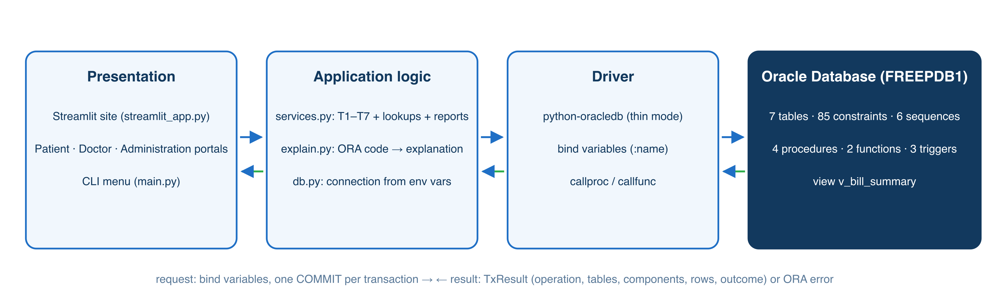
Figure 4: System architecture: front ends, service layer, driver, database
Both front ends call the same functions in services.py, so the database logic exists in one place. Each function returns a TxResult (operation, tables, components, statements, rows_affected, result, error_code), which the CLI prints and the website renders as the “Behind the scenes” strip.

11.2 Technology Stack
Table 24: Technology stack
Layer | Technology
Database | Oracle Database Free 23ai (Docker); SQL, PL/SQL
Driver | python-oracledb 2.x, thin mode
Back end | Python 3.13: db.py, services.py, explain.py, setup_db.py
Front end 1 | Streamlit ≥ 1.35 multi-page site (streamlit_app.py, pages_patient.py, pages_doctor.py, pages_admin.py, ui.py), custom light-blue theme
Front end 2 | Menu-driven CLI (main.py) with tabulate tables
Tools | Docker Desktop, VS Code, SQL*Plus / SQL Developer (optional)

11.3 Database Connectivity
import oracledb
conn = oracledb.connect(user=os.environ["ORACLE_USER"],
password=os.environ["ORACLE_PASSWORD"],
dsn=os.environ["ORACLE_DSN"]) # e.g. localhost:1521/FREEPDB1
cur = conn.cursor()
appt_id = cur.var(int)
cur.callproc("book_appointment", [patient_id, doctor_id, appt_date, slot, reason, appt_id])
due = cur.callfunc("patient_total_due", float, [patient_id])
conn.commit()
Thin mode talks Oracle's network protocol directly, so no Instant Client is needed. Procedures are called with callproc, functions with callfunc, and OUT parameters with cursor.var(). db.run_script() executes the SQL*Plus files (splitting on ; and /, reading DBMS_OUTPUT) for setup_db.py and the Rebuild tab.

11.4 CRUD Operations
Table 25: CRUD operations in the application
Operation | Workflow in the app | SQL / PL-SQL
Create | Patient › New patient; Book a visit; Doctor › Order tests; Lab desk › Enter result; Complete visit | INSERT PATIENT; book_appointment; INSERT SAMPLE; INSERT TEST_RESULT; generate_bill
Read | Dashboards, My visits, Lab reports, Bills, Reports (Q1–Q15), Database explorer | SELECT, v_bill_summary, data dictionary views
Update | Lab desk › sample status; Complete visit; Billing › Record payment; My visits › Cancel | UPDATE SAMPLE / APPOINTMENT; record_payment
Delete | Lab desk › Remove rejected sample | DELETE SAMPLE (cascades to TEST_RESULT)

11.5 Input Validation and Error Handling
Forms restrict input (select boxes for doctors, slots, modes; number inputs with min/max; a date of birth must be in the past because a CHECK constraint cannot use SYSDATE). Every database call is wrapped in try … except oracledb.DatabaseError; the unit is rolled back and db.business_error() extracts the ORA code: for -20001…-20099 the message raised by our PL/SQL; for ORA-00001 / 02290 / 02291 / 02292 the violated constraint's name. explain.py maps each code or constraint to a title, the reason the rule exists, the object that enforced it and what to do next.
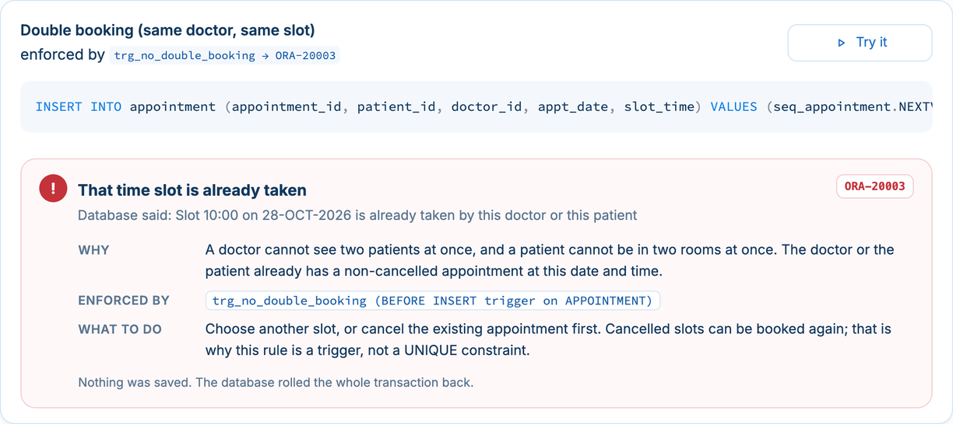
Figure 5: Error panel: a double booking refused by trg_no_double_booking (ORA-20003)

11.6 Application Screenshots
There is no login screen: the patient and doctor portals use a “Signed in as” picker for the demo. Key screens:
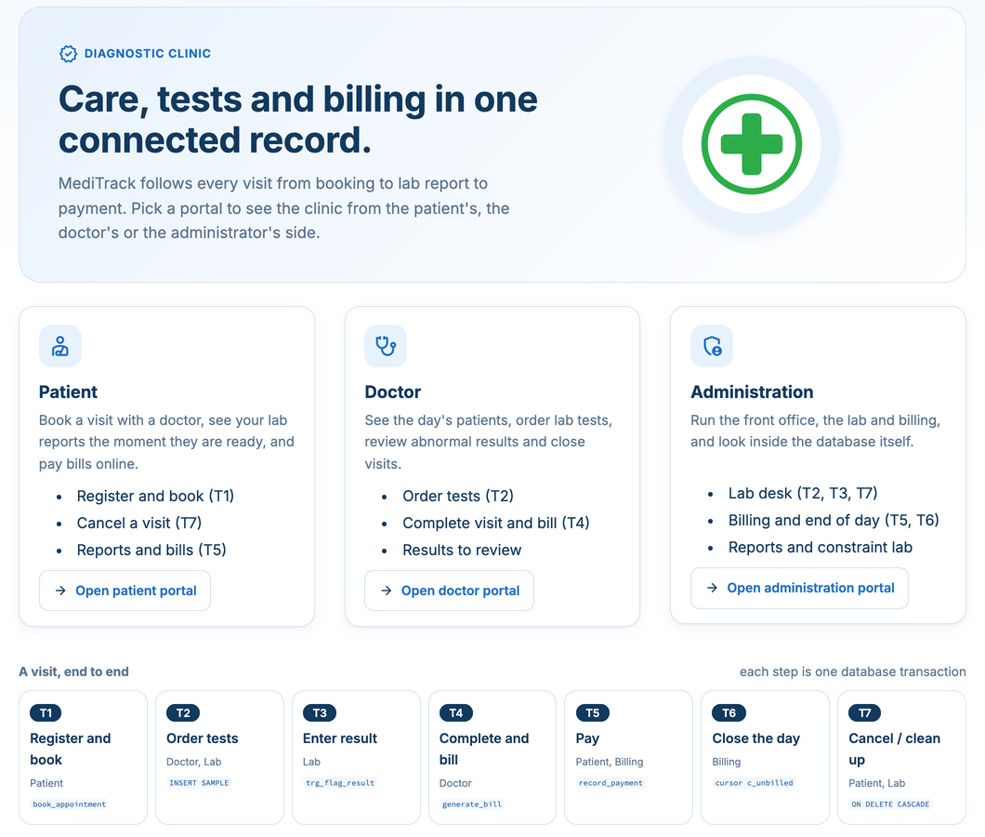
Figure 6: Home page with the three portals and the T1–T7 visit flow
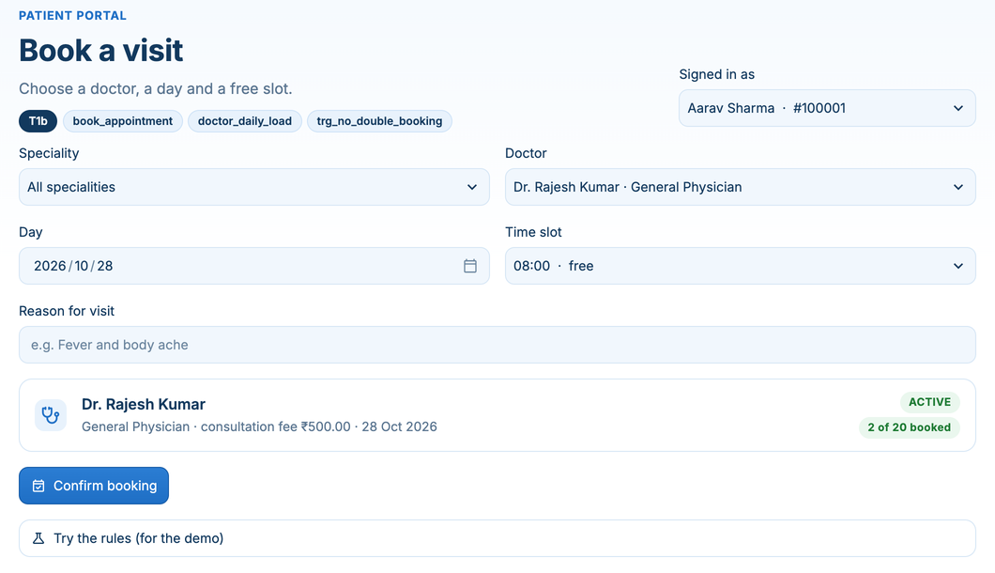
Figure 7: Patient portal: Book a visit (live free/taken slots, doctor's load from doctor_daily_load)
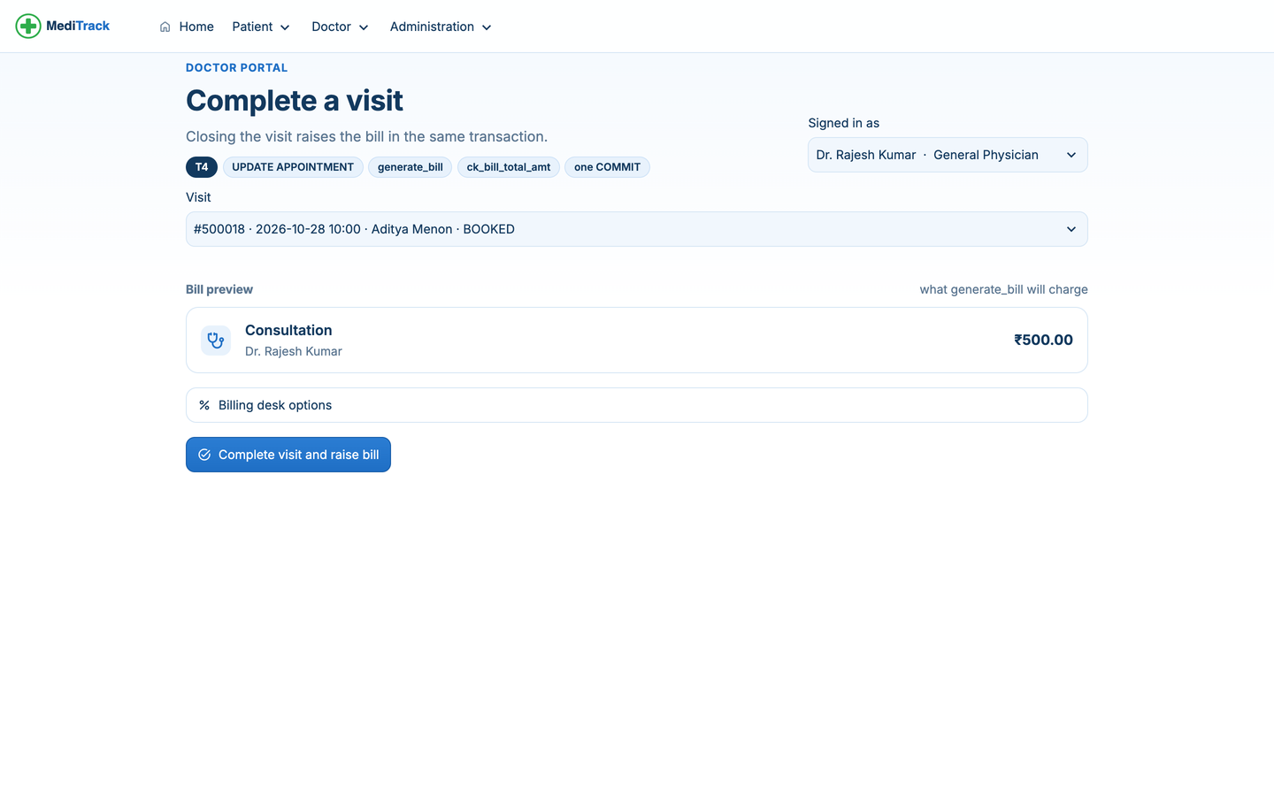
Figure 8: Doctor portal: Complete a visit with the bill preview (T4)
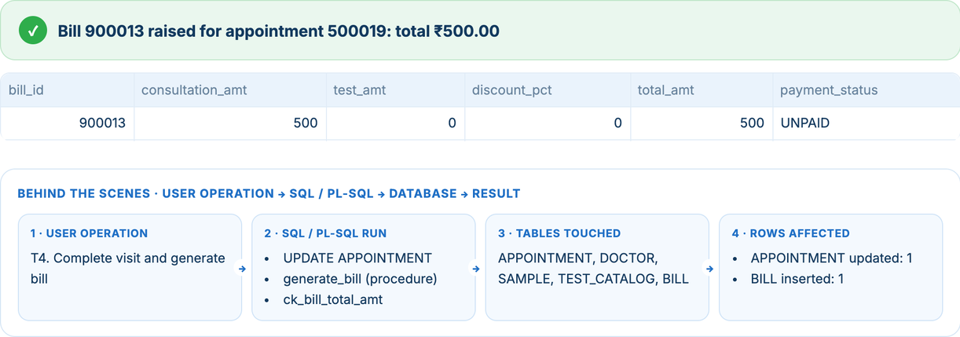
Figure 9: “Behind the scenes” trace after T4: operation → SQL/PL-SQL → tables → rows affected
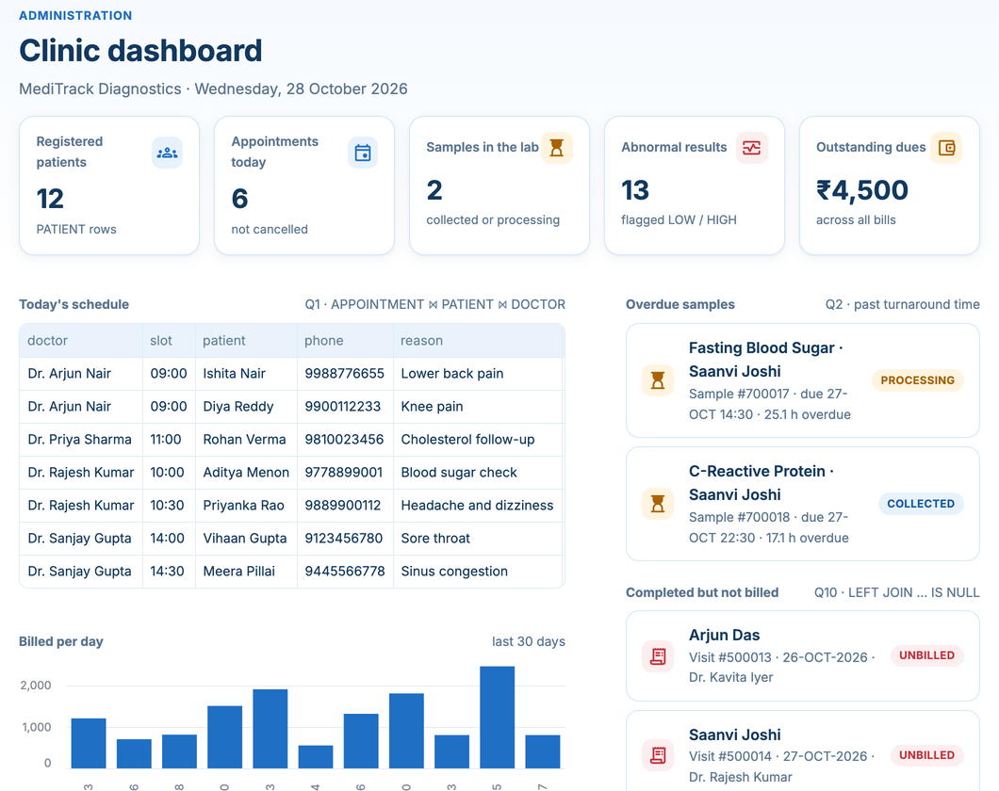
Figure 10: Administration: clinic dashboard built from Q1, Q2 and Q10
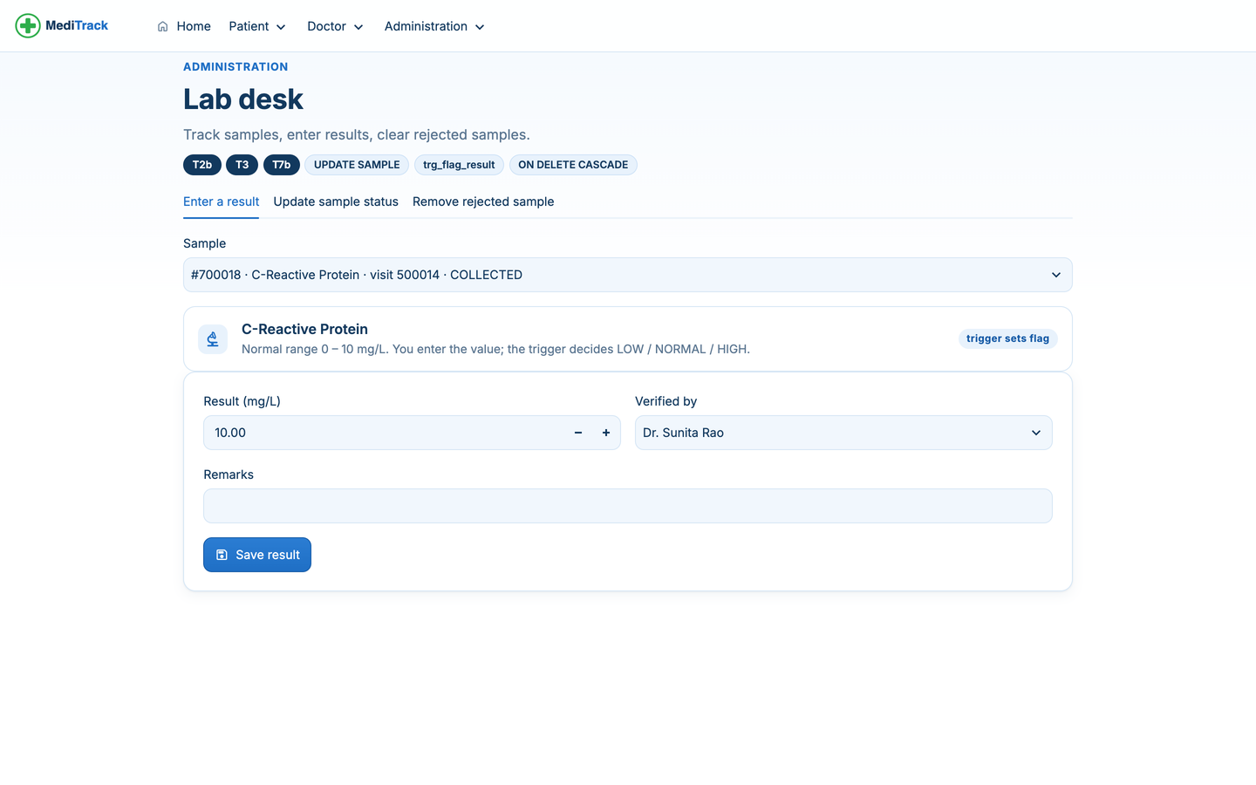
Figure 11: Administration: Lab desk (T2b, T3, T7b)
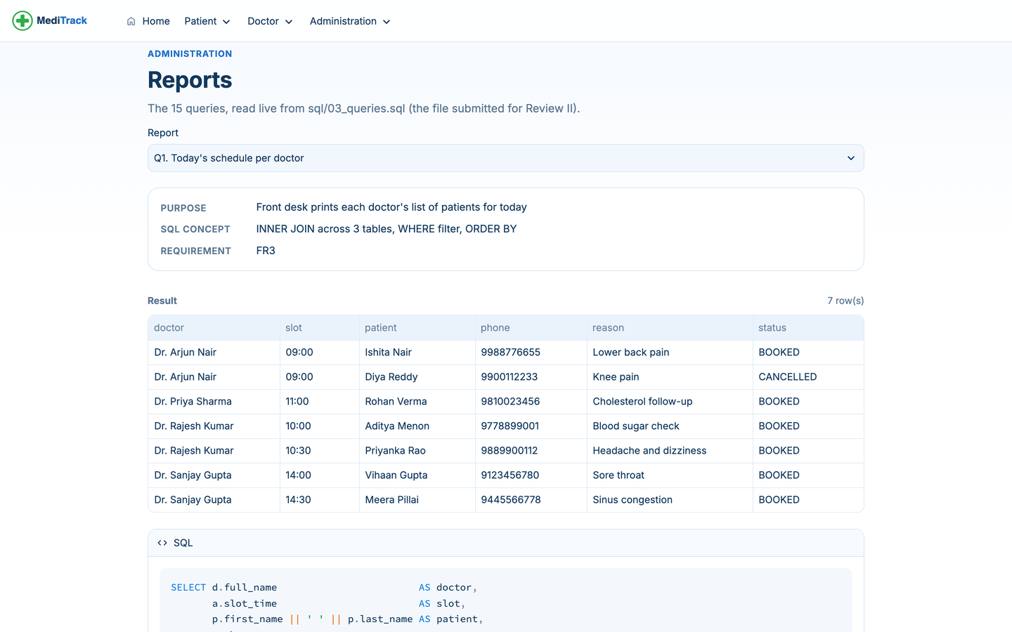
Figure 12: Administration: Reports page running the 15 queries from 03_queries.sql
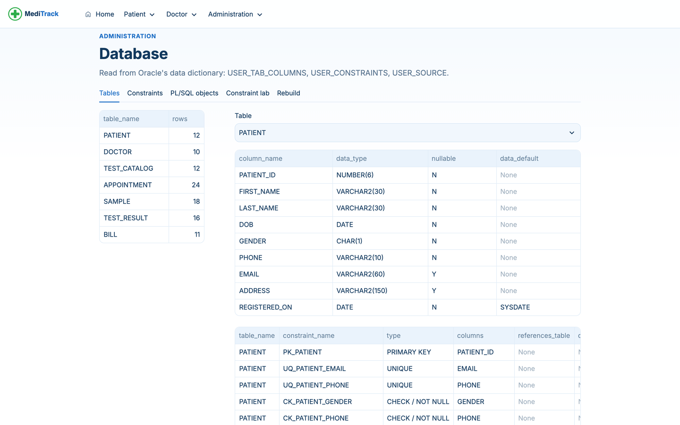
Figure 13: Administration: Database explorer reading Oracle's data dictionary

11.7 Relational/NoSQL Note
MediTrack is purely relational (Oracle); no NoSQL store is used. A document model was considered and rejected: a visit document could embed its samples and bill, but the rules that matter most here span documents (no two visits in one slot, payments never above the bill, prices snapshotted from a shared catalogue), and they are enforced most simply by relational constraints, foreign keys and triggers.

CHAPTER 12: TESTING AND RESULTS

12.1 Testing Strategy
- Unit (database): each procedure, function and trigger exercised by 07_dml_demo.sql, including expected failures run inside BEGIN … EXCEPTION blocks.
- Integration: the service functions T1–T7 run against a freshly built schema through both front ends.
- Validation: the constraint lab (10 deliberate violations) and form-level checks.
- Functional: each functional requirement FR1–FR12 traced to a query or transaction that returns non-empty, correct output on the seed data.
- Build test: python app/setup_db.py on a clean schema must finish without errors with every object VALID.

12.2 Test Cases
Table 26: Test cases and results
Test ID | Test / Input | Expected Result | Actual Result | Status
TC01 | T1: book patient 100013 with Dr 1001 tomorrow 09:00 | Appointment created; load 0 → 1 | Appointment 500025; load 0 → 1 | Pass
TC02 | T1: book patient 100003 with Dr 1001, same date and slot | ORA-20003 | ORA-20003 from trg_no_double_booking | Pass
TC03 | T1: book INACTIVE Dr 1010 | ORA-20001 | ORA-20001 | Pass
TC04 | T1: book Dr 1009 today (limit 2, already 2) | ORA-20002 | ORA-20002 | Pass
TC05 | T1: book a date in the past | ORA-20004 | ORA-20004 | Pass
TC06 | T1: rebook a CANCELLED slot (Dr Nair 09:00) | Allowed | Allowed (trigger ignores CANCELLED) | Pass
TC07 | T2: order FBS twice in visit 500018 | ORA-00001 uq_sample_appt_test | ORA-00001 uq_sample_appt_test | Pass
TC08 | T3: FBS result 165 (range 70–100) | Flag HIGH, sample COMPLETED | HIGH, COMPLETED | Pass
TC09 | T3: HbA1c result 5.4 (range 4–5.7) | Flag NORMAL | NORMAL | Pass
TC10 | T3: result for REJECTED sample 700013 | ORA-20030 | ORA-20030 | Pass
TC11 | T4: complete 500018 with 10 % discount | Bill = (500 + 700) × 0.9 = 1080, UNPAID | Bill 900012, 1080, UNPAID | Pass
TC12 | T4: bill a BOOKED visit (500019) | ORA-20010 | ORA-20010 | Pass
TC13 | T4: bill 500018 again | ORA-20011 | ORA-20011 | Pass
TC14 | T4: discount 60 % (atomicity) | CHECK fails; visit stays BOOKED | ck_bill_discount_pct; 500017 still BOOKED, 0 bills | Pass
TC15 | T5: pay ₹500 UPI on bill 900012 | PARTIAL; dues 1080 → 580 | PARTIAL; 1080 → 580 | Pass
TC16 | T5: pay more than the balance on 900005 | ORA-20020 | ORA-20020 (balance 1900.00) | Pass
TC17 | T6: end-of-day billing for 26 and 27 Oct | Bills for 500013 and 500014 | 900013 (₹950), 900014 (₹1150) | Pass
TC18 | T7: delete REJECTED sample 700013 | Sample deleted; its result cascades | Results for 700013: 1 → 0 | Pass
TC19 | Delete doctor 1001 with appointments | ORA-02292 | ORA-02292 fk_appointment_doctor_id | Pass
TC20 | Invalid gender 'X' / slot '9am' / duplicate phone | CHECK / CHECK / UNIQUE errors | ORA-02290 / 02290 / 00001 | Pass
TC21 | SAVEPOINT then ROLLBACK TO on bill 900005 | Back to 500, PARTIAL | 500, PARTIAL | Pass
TC22 | Two sessions lock the same bill (FOR UPDATE NOWAIT) | Second session refused | ORA-00054 | Pass
TC23 | Least-privilege user reads PATIENT | Denied | ORA-00942 | Pass
TC24 | Clean build with setup_db.py | All objects VALID, 15 queries non-empty | 16/16 VALID, 15/15 non-empty | Pass

12.3 SQL Query Validation
Each query was checked against hand-computed answers on the seed data. Examples: Q7 returns exactly B12, the one test the seed never orders; Q10 returns visits 500013 and 500014, the two COMPLETED visits seeded without bills, and after T6 it returns no rows; Q6's threshold was verified by computing the average due by hand (total dues ÷ patients with bills); Q12's percentages sum to 100 %; Q13 returns Aarav Sharma (HbA1c HIGH, TSH LOW) and Meera Pillai (TSH HIGH, Vitamin D LOW), matching Q3.

12.4 Constraint and Transaction Tests
Invalid data: the 10 constraint-lab cases (Table in 7.10) and TC02–TC05, TC07, TC10, TC16, TC19–TC20. Referential integrity: TC19 (RESTRICT on delete) and TC18 (CASCADE). Rollback: TC14 (atomic T4), TC21 (SAVEPOINT), and end_of_day_billing's all-or-nothing batch. Access control: TC23 and Section 7.11. All passed.

12.5 Results and Discussion
All requirements FR1–FR12 are implemented and demonstrable. The final build contains 7 tables, 85 named constraints, 6 sequences, 4 procedures (one with an explicit cursor), 2 functions, 3 triggers and 1 view, all VALID; 15 queries return meaningful output; and 7 transactions (Review III requires 5) run from both front ends with a full SQL trace. The new Streamlit front end organises the transactions by role (Patient, Doctor, Administration) and makes the database's behaviour visible: the trace strip after each action and the explained error panel when a rule is broken. Performance is interactive on the seed data (Section 9.5).

12.6 Limitations
- No real authentication: the portals use a demo “Signed in as” picker, and the app connects as the schema owner.
- Rescheduling is cancel + rebook, because the double-booking trigger fires on INSERT only (mutating-table restriction).
- Slots are a fixed half-hour grid shared by all doctors; doctor-specific working hours and leave are not modelled.
- One clinic, one currency; no inventory, insurance claims or pharmacy (out of scope).
- Performance was measured on a small dataset only; the composite index in Chapter 9 is recommended but not built.

CHAPTER 13: CONCLUSION AND FUTURE ENHANCEMENTS

13.1 Conclusion
MediTrack meets its objectives. One Oracle schema keeps a consistent record of every visit, and the clinic's rules are enforced by the database itself, so they hold for the CLI, the website and raw SQL alike. The project demonstrates ER modelling, mapping to a BCNF schema with a justified snapshot, the full range of SQL (DDL, DML, joins, subqueries, set operators, window functions, views), PL/SQL procedures, functions, an explicit cursor and triggers, transaction control, and a Python application that exposes all of it through seven traceable transactions.

13.2 Learning Outcomes
- Modelling: resolving an M:N relationship with an associative entity, and choosing 1:0..1 with FK + UNIQUE.
- SQL: writing anti-joins, correlated subqueries, RANK() and set operators, and reading execution plans.
- PL/SQL: where a rule belongs (CHECK vs trigger vs procedure), the mutating-table restriction, and RAISE_APPLICATION_ERROR codes.
- Transactions: keeping COMMIT in the caller so multi-step operations are atomic; row locking against lost updates.
- Security: bind variables against SQL injection; least-privilege roles with GRANT / REVOKE.
- Integration: a single service layer shared by two front ends, and showing users why the database refused something.

13.3 Future Enhancements
- Real sign-in, with one Oracle account and role per portal (front desk, doctor, lab, billing).
- One-step rescheduling via a compound trigger that checks clashes without the mutating-table error.
- Doctor working hours and leave days, with slot generation per doctor.
- Printable PDF bills and lab reports, and an audit table filled by triggers.
- The composite index on APPOINTMENT(doctor_id, appt_date) and partitioning by month once volume grows; cloud deployment of the database.

REFERENCES
1. A. Silberschatz, H. F. Korth and S. Sudarshan, Database System Concepts, 7th ed., McGraw-Hill, 2019.
2. R. Elmasri and S. B. Navathe, Fundamentals of Database Systems, 7th ed., Pearson, 2016.
3. Oracle Corporation, Oracle Database SQL Language Reference, 23ai, docs.oracle.com.
4. Oracle Corporation, Oracle Database PL/SQL Language Reference, 23ai, docs.oracle.com.
5. Oracle Corporation, python-oracledb documentation, python-oracledb.readthedocs.io.
6. Streamlit Inc., Streamlit documentation (multipage apps, st.navigation), docs.streamlit.io.
7. G. Venzl, gvenzl/oracle-free Docker images, hub.docker.com/r/gvenzl/oracle-free.
8. BCSE302L Database Systems course material, VIT, Fall Semester 2026–27.

APPENDIX A: SQL SCRIPTS
The complete, executable scripts in build order: 99_drop_all → 01_ddl → 04_functions → 05_procedures → 06_triggers → 02_seed_data → 03_queries, then 07_dml_demo. Triggers are created before the seed so that seeded flags and statuses are set by the triggers. No passwords appear in the scripts.

A. sql/00_build_all.sql
-- =====================================================================
-- MediTrack : 00_build_all.sql
-- Builds the whole database from scratch in SQL*Plus / SQLcl:
-- cd sql
-- sqlplus meditrack/<password>@localhost/FREEPDB1 @00_build_all.sql
-- (In SQL Developer: open this file and press F5 "Run Script".)
--
-- Order matters: triggers are created BEFORE the seed data so every
-- seed row passes through them (flags and payment statuses are set by
-- the triggers, not typed by hand).
-- =====================================================================
SET SERVEROUTPUT ON
SET DEFINE OFF

PROMPT ==== Dropping old objects ====
@@99_drop_all.sql
PROMPT ==== Creating tables, constraints, sequences ====
@@01_ddl.sql
PROMPT ==== Creating functions ====
@@04_functions.sql
PROMPT ==== Creating procedures ====
@@05_procedures.sql
PROMPT ==== Creating triggers ====
@@06_triggers.sql
PROMPT ==== Loading seed data ====
@@02_seed_data.sql
PROMPT ==== Creating view and running the 15 queries ====
@@03_queries.sql
PROMPT ==== Build complete. Run 07_dml_demo.sql to walk through T1-T7 ====

A. sql/99_drop_all.sql
-- =====================================================================
-- MediTrack : 99_drop_all.sql
-- Drops every MediTrack object in reverse dependency order so the whole
-- build (01 -> 07) can be re-run on a clean schema.
-- Each DROP is wrapped in a block that ignores "does not exist" errors,
-- so this script also works on an empty schema.
-- =====================================================================

-- Views
BEGIN EXECUTE IMMEDIATE 'DROP VIEW v_bill_summary'; EXCEPTION WHEN OTHERS THEN IF SQLCODE != -942 THEN RAISE; END IF; END;
/

-- Procedures and functions (triggers are dropped with their tables)
BEGIN EXECUTE IMMEDIATE 'DROP PROCEDURE end_of_day_billing'; EXCEPTION WHEN OTHERS THEN IF SQLCODE != -4043 THEN RAISE; END IF; END;
/
BEGIN EXECUTE IMMEDIATE 'DROP PROCEDURE record_payment'; EXCEPTION WHEN OTHERS THEN IF SQLCODE != -4043 THEN RAISE; END IF; END;
/
BEGIN EXECUTE IMMEDIATE 'DROP PROCEDURE generate_bill'; EXCEPTION WHEN OTHERS THEN IF SQLCODE != -4043 THEN RAISE; END IF; END;
/
BEGIN EXECUTE IMMEDIATE 'DROP PROCEDURE book_appointment'; EXCEPTION WHEN OTHERS THEN IF SQLCODE != -4043 THEN RAISE; END IF; END;
/
BEGIN EXECUTE IMMEDIATE 'DROP FUNCTION patient_total_due'; EXCEPTION WHEN OTHERS THEN IF SQLCODE != -4043 THEN RAISE; END IF; END;
/
BEGIN EXECUTE IMMEDIATE 'DROP FUNCTION doctor_daily_load'; EXCEPTION WHEN OTHERS THEN IF SQLCODE != -4043 THEN RAISE; END IF; END;
/

-- Tables, children first
BEGIN EXECUTE IMMEDIATE 'DROP TABLE bill CASCADE CONSTRAINTS PURGE'; EXCEPTION WHEN OTHERS THEN IF SQLCODE != -942 THEN RAISE; END IF; END;
/
BEGIN EXECUTE IMMEDIATE 'DROP TABLE test_result CASCADE CONSTRAINTS PURGE'; EXCEPTION WHEN OTHERS THEN IF SQLCODE != -942 THEN RAISE; END IF; END;
/
BEGIN EXECUTE IMMEDIATE 'DROP TABLE sample CASCADE CONSTRAINTS PURGE'; EXCEPTION WHEN OTHERS THEN IF SQLCODE != -942 THEN RAISE; END IF; END;
/
BEGIN EXECUTE IMMEDIATE 'DROP TABLE appointment CASCADE CONSTRAINTS PURGE'; EXCEPTION WHEN OTHERS THEN IF SQLCODE != -942 THEN RAISE; END IF; END;
/
BEGIN EXECUTE IMMEDIATE 'DROP TABLE test_catalog CASCADE CONSTRAINTS PURGE'; EXCEPTION WHEN OTHERS THEN IF SQLCODE != -942 THEN RAISE; END IF; END;
/
BEGIN EXECUTE IMMEDIATE 'DROP TABLE doctor CASCADE CONSTRAINTS PURGE'; EXCEPTION WHEN OTHERS THEN IF SQLCODE != -942 THEN RAISE; END IF; END;
/
BEGIN EXECUTE IMMEDIATE 'DROP TABLE patient CASCADE CONSTRAINTS PURGE'; EXCEPTION WHEN OTHERS THEN IF SQLCODE != -942 THEN RAISE; END IF; END;
/

-- Sequences
BEGIN EXECUTE IMMEDIATE 'DROP SEQUENCE seq_bill'; EXCEPTION WHEN OTHERS THEN IF SQLCODE != -2289 THEN RAISE; END IF; END;
/
BEGIN EXECUTE IMMEDIATE 'DROP SEQUENCE seq_test_result'; EXCEPTION WHEN OTHERS THEN IF SQLCODE != -2289 THEN RAISE; END IF; END;
/
BEGIN EXECUTE IMMEDIATE 'DROP SEQUENCE seq_sample'; EXCEPTION WHEN OTHERS THEN IF SQLCODE != -2289 THEN RAISE; END IF; END;
/
BEGIN EXECUTE IMMEDIATE 'DROP SEQUENCE seq_appointment'; EXCEPTION WHEN OTHERS THEN IF SQLCODE != -2289 THEN RAISE; END IF; END;
/
BEGIN EXECUTE IMMEDIATE 'DROP SEQUENCE seq_doctor'; EXCEPTION WHEN OTHERS THEN IF SQLCODE != -2289 THEN RAISE; END IF; END;
/
BEGIN EXECUTE IMMEDIATE 'DROP SEQUENCE seq_patient'; EXCEPTION WHEN OTHERS THEN IF SQLCODE != -2289 THEN RAISE; END IF; END;
/

A. sql/01_ddl.sql
-- =====================================================================
-- MediTrack : 01_ddl.sql
-- Creates the 7 tables (in dependency order) with every constraint
-- named, plus one sequence per surrogate key.
--
-- Constraint naming: pk_<table> fk_<table>_<col> uq_<table>_<col>
-- ck_<table>_<col>
-- Run 99_drop_all.sql first for a clean re-run.
-- =====================================================================

-- ---------------------------------------------------------------------
-- Sequences (NOCACHE so numbers stay consecutive and readable in a demo)
-- ---------------------------------------------------------------------
CREATE SEQUENCE seq_patient START WITH 100001 INCREMENT BY 1 NOCACHE;
CREATE SEQUENCE seq_doctor START WITH 1001 INCREMENT BY 1 NOCACHE;
CREATE SEQUENCE seq_appointment START WITH 500001 INCREMENT BY 1 NOCACHE;
CREATE SEQUENCE seq_sample START WITH 700001 INCREMENT BY 1 NOCACHE;
CREATE SEQUENCE seq_test_result START WITH 800001 INCREMENT BY 1 NOCACHE;
CREATE SEQUENCE seq_bill START WITH 900001 INCREMENT BY 1 NOCACHE;

-- ---------------------------------------------------------------------
-- 1. PATIENT : one row per registered person
-- ---------------------------------------------------------------------
CREATE TABLE patient (
patient_id NUMBER(6) CONSTRAINT pk_patient PRIMARY KEY,
first_name VARCHAR2(30) CONSTRAINT nn_patient_first_name NOT NULL,
last_name VARCHAR2(30) CONSTRAINT nn_patient_last_name NOT NULL,
dob DATE CONSTRAINT nn_patient_dob NOT NULL,
gender CHAR(1) CONSTRAINT nn_patient_gender NOT NULL,
phone VARCHAR2(10) CONSTRAINT nn_patient_phone NOT NULL,
email VARCHAR2(60),
address VARCHAR2(150),
registered_on DATE DEFAULT SYSDATE
CONSTRAINT nn_patient_registered_on NOT NULL,
CONSTRAINT ck_patient_gender CHECK (gender IN ('M', 'F', 'O')),
CONSTRAINT ck_patient_phone CHECK (REGEXP_LIKE(phone, '^[0-9]{10}$')),
CONSTRAINT uq_patient_phone UNIQUE (phone),
CONSTRAINT uq_patient_email UNIQUE (email)
);

-- ---------------------------------------------------------------------
-- 2. DOCTOR : consultants; deactivated (status = 'INACTIVE'), never deleted
-- ---------------------------------------------------------------------
CREATE TABLE doctor (
doctor_id NUMBER(4) CONSTRAINT pk_doctor PRIMARY KEY,
full_name VARCHAR2(60) CONSTRAINT nn_doctor_full_name NOT NULL,
specialization VARCHAR2(40) CONSTRAINT nn_doctor_specialization NOT NULL,
phone VARCHAR2(10),
consultation_fee NUMBER(8,2) CONSTRAINT nn_doctor_consultation_fee NOT NULL,
max_daily_appts NUMBER(2) DEFAULT 20
CONSTRAINT nn_doctor_max_daily_appts NOT NULL,
status VARCHAR2(8) DEFAULT 'ACTIVE'
CONSTRAINT nn_doctor_status NOT NULL,
CONSTRAINT ck_doctor_consultation_fee CHECK (consultation_fee > 0),
CONSTRAINT ck_doctor_max_daily_appts CHECK (max_daily_appts BETWEEN 1 AND 50),
CONSTRAINT ck_doctor_status CHECK (status IN ('ACTIVE', 'INACTIVE')),
CONSTRAINT ck_doctor_phone CHECK (REGEXP_LIKE(phone, '^[0-9]{10}$')),
CONSTRAINT uq_doctor_phone UNIQUE (phone)
);

-- ---------------------------------------------------------------------
-- 3. TEST_CATALOG : master list of lab tests, price and normal range
-- ---------------------------------------------------------------------
CREATE TABLE test_catalog (
test_code VARCHAR2(10) CONSTRAINT pk_test_catalog PRIMARY KEY,
test_name VARCHAR2(60) CONSTRAINT nn_test_catalog_test_name NOT NULL,
category VARCHAR2(30) CONSTRAINT nn_test_catalog_category NOT NULL,
price NUMBER(8,2) CONSTRAINT nn_test_catalog_price NOT NULL,
unit VARCHAR2(15) CONSTRAINT nn_test_catalog_unit NOT NULL,
normal_min NUMBER(10,2) CONSTRAINT nn_test_catalog_normal_min NOT NULL,
normal_max NUMBER(10,2) CONSTRAINT nn_test_catalog_normal_max NOT NULL,
turnaround_hrs NUMBER(3) DEFAULT 24
CONSTRAINT nn_test_catalog_turnaround NOT NULL,
CONSTRAINT uq_test_catalog_test_name UNIQUE (test_name),
CONSTRAINT ck_test_catalog_price CHECK (price > 0),
CONSTRAINT ck_test_catalog_range CHECK (normal_min <= normal_max),
CONSTRAINT ck_test_catalog_turnaround CHECK (turnaround_hrs > 0)
);

-- ---------------------------------------------------------------------
-- 4. APPOINTMENT : a patient's visit to one doctor in one slot
-- Double booking is blocked by trg_no_double_booking (not a UNIQUE
-- constraint) so that a CANCELLED slot can be booked again.
-- ---------------------------------------------------------------------
CREATE TABLE appointment (
appointment_id NUMBER(8) CONSTRAINT pk_appointment PRIMARY KEY,
patient_id NUMBER(6) CONSTRAINT nn_appointment_patient_id NOT NULL,
doctor_id NUMBER(4) CONSTRAINT nn_appointment_doctor_id NOT NULL,
appt_date DATE CONSTRAINT nn_appointment_appt_date NOT NULL,
slot_time VARCHAR2(5) CONSTRAINT nn_appointment_slot_time NOT NULL,
reason VARCHAR2(200),
status VARCHAR2(10) DEFAULT 'BOOKED'
CONSTRAINT nn_appointment_status NOT NULL,
booked_on DATE DEFAULT SYSDATE
CONSTRAINT nn_appointment_booked_on NOT NULL,
CONSTRAINT fk_appointment_patient_id FOREIGN KEY (patient_id)
REFERENCES patient (patient_id),
CONSTRAINT fk_appointment_doctor_id FOREIGN KEY (doctor_id)
REFERENCES doctor (doctor_id),
-- 'HH:MI' in 24-hour form, e.g. '09:30', '16:00'
CONSTRAINT ck_appointment_slot_time
CHECK (REGEXP_LIKE(slot_time, '^([01][0-9]|2[0-3]):[0-5][0-9]$')),
-- appt_date holds the day only; the time lives in slot_time
CONSTRAINT ck_appointment_appt_date CHECK (appt_date = TRUNC(appt_date)),
CONSTRAINT ck_appointment_status
CHECK (status IN ('BOOKED', 'COMPLETED', 'CANCELLED', 'NO_SHOW'))
);

-- ---------------------------------------------------------------------
-- 5. SAMPLE : resolves the M:N between APPOINTMENT and TEST_CATALOG.
-- One row = one test ordered in one visit + the specimen collected.
-- ---------------------------------------------------------------------
CREATE TABLE sample (
sample_id NUMBER(8) CONSTRAINT pk_sample PRIMARY KEY,
appointment_id NUMBER(8) CONSTRAINT nn_sample_appointment_id NOT NULL,
test_code VARCHAR2(10) CONSTRAINT nn_sample_test_code NOT NULL,
sample_type VARCHAR2(6) CONSTRAINT nn_sample_sample_type NOT NULL,
collected_on DATE DEFAULT SYSDATE
CONSTRAINT nn_sample_collected_on NOT NULL,
collected_by VARCHAR2(40),
status VARCHAR2(10) DEFAULT 'COLLECTED'
CONSTRAINT nn_sample_status NOT NULL,
remarks VARCHAR2(100),
CONSTRAINT fk_sample_appointment_id FOREIGN KEY (appointment_id)
REFERENCES appointment (appointment_id),
CONSTRAINT fk_sample_test_code FOREIGN KEY (test_code)
REFERENCES test_catalog (test_code),
-- the same test cannot be ordered twice in one visit
CONSTRAINT uq_sample_appt_test UNIQUE (appointment_id, test_code),
CONSTRAINT ck_sample_sample_type
CHECK (sample_type IN ('BLOOD', 'URINE', 'SALIVA', 'SWAB', 'OTHER')),
CONSTRAINT ck_sample_status
CHECK (status IN ('COLLECTED', 'PROCESSING', 'COMPLETED', 'REJECTED'))
);

-- ---------------------------------------------------------------------
-- 6. TEST_RESULT : at most one result per sample (UNIQUE sample_id).
-- Deleting a sample deletes its result (ON DELETE CASCADE).
-- Removing a doctor keeps the result but clears verified_by.
-- ---------------------------------------------------------------------
CREATE TABLE test_result (
result_id NUMBER(8) CONSTRAINT pk_test_result PRIMARY KEY,
sample_id NUMBER(8) CONSTRAINT nn_test_result_sample_id NOT NULL,
result_value NUMBER(10,2) CONSTRAINT nn_test_result_result_value NOT NULL,
result_flag VARCHAR2(6) DEFAULT 'NORMAL'
CONSTRAINT nn_test_result_result_flag NOT NULL,
result_date DATE DEFAULT SYSDATE
CONSTRAINT nn_test_result_result_date NOT NULL,
verified_by NUMBER(4),
remarks VARCHAR2(200),
CONSTRAINT fk_test_result_sample_id FOREIGN KEY (sample_id)
REFERENCES sample (sample_id) ON DELETE CASCADE,
CONSTRAINT fk_test_result_verified_by FOREIGN KEY (verified_by)
REFERENCES doctor (doctor_id) ON DELETE SET NULL,
CONSTRAINT uq_test_result_sample_id UNIQUE (sample_id),
CONSTRAINT ck_test_result_result_flag
CHECK (result_flag IN ('LOW', 'NORMAL', 'HIGH'))
);

-- ---------------------------------------------------------------------
-- 7. BILL : one bill per appointment (UNIQUE appointment_id).
-- consultation_amt / test_amt / total_amt are a SNAPSHOT taken when
-- the bill is raised, so later fee or price changes never alter an
-- issued bill.
-- ---------------------------------------------------------------------
CREATE TABLE bill (
bill_id NUMBER(8) CONSTRAINT pk_bill PRIMARY KEY,
appointment_id NUMBER(8) CONSTRAINT nn_bill_appointment_id NOT NULL,
bill_date DATE DEFAULT SYSDATE
CONSTRAINT nn_bill_bill_date NOT NULL,
consultation_amt NUMBER(10,2) CONSTRAINT nn_bill_consultation_amt NOT NULL,
test_amt NUMBER(10,2) DEFAULT 0
CONSTRAINT nn_bill_test_amt NOT NULL,
discount_pct NUMBER(5,2) DEFAULT 0
CONSTRAINT nn_bill_discount_pct NOT NULL,
total_amt NUMBER(10,2) CONSTRAINT nn_bill_total_amt NOT NULL,
amount_paid NUMBER(10,2) DEFAULT 0
CONSTRAINT nn_bill_amount_paid NOT NULL,
payment_status VARCHAR2(7) DEFAULT 'UNPAID'
CONSTRAINT nn_bill_payment_status NOT NULL,
payment_mode VARCHAR2(10),
CONSTRAINT fk_bill_appointment_id FOREIGN KEY (appointment_id)
REFERENCES appointment (appointment_id),
CONSTRAINT uq_bill_appointment_id UNIQUE (appointment_id),
CONSTRAINT ck_bill_consultation_amt CHECK (consultation_amt >= 0),
CONSTRAINT ck_bill_test_amt CHECK (test_amt >= 0),
CONSTRAINT ck_bill_discount_pct CHECK (discount_pct BETWEEN 0 AND 50),
-- the stored total must always equal the bill's own parts
CONSTRAINT ck_bill_total_amt
CHECK (total_amt = ROUND((consultation_amt + test_amt) * (1 - discount_pct / 100), 2)),
CONSTRAINT ck_bill_amount_paid CHECK (amount_paid >= 0),
CONSTRAINT ck_bill_paid_le_total CHECK (amount_paid <= total_amt),
CONSTRAINT ck_bill_payment_status
CHECK (payment_status IN ('UNPAID', 'PARTIAL', 'PAID')),
CONSTRAINT ck_bill_payment_mode
CHECK (payment_mode IN ('CASH', 'CARD', 'UPI', 'INSURANCE'))
);

A. sql/04_functions.sql
-- =====================================================================
-- MediTrack : 04_functions.sql
-- Stored functions. Both are read-only (no DML), so they can also be
-- called from plain SQL, e.g. SELECT patient_total_due(100001) FROM dual;
-- =====================================================================
SET SERVEROUTPUT ON

-- ---------------------------------------------------------------------
-- doctor_daily_load
-- Used by : T1 (book_appointment checks it against max_daily_appts)
-- Returns : number of non-CANCELLED appointments a doctor has on a day
-- ---------------------------------------------------------------------
CREATE OR REPLACE FUNCTION doctor_daily_load (
p_doctor_id IN doctor.doctor_id%TYPE,
p_date IN DATE
) RETURN NUMBER
IS
v_count NUMBER;
BEGIN
SELECT COUNT(*)
INTO v_count
FROM appointment
WHERE doctor_id = p_doctor_id
AND appt_date = TRUNC(p_date)
AND status <> 'CANCELLED';

RETURN v_count;
END doctor_daily_load;
/

-- ---------------------------------------------------------------------
-- patient_total_due
-- Used by : T5 (dues check after a payment), reports
-- Returns : SUM(total_amt - amount_paid) over the patient's bills, 0 if none
-- ---------------------------------------------------------------------
CREATE OR REPLACE FUNCTION patient_total_due (
p_patient_id IN patient.patient_id%TYPE
) RETURN NUMBER
IS
v_due NUMBER;
BEGIN
SELECT NVL(SUM(b.total_amt - b.amount_paid), 0)
INTO v_due
FROM bill b
JOIN appointment a ON a.appointment_id = b.appointment_id
WHERE a.patient_id = p_patient_id;

RETURN v_due;
END patient_total_due;
/

A. sql/05_procedures.sql
-- =====================================================================
-- MediTrack : 05_procedures.sql
-- Stored procedures for the clinic's transactions.
--
-- Business-rule error codes raised here (RAISE_APPLICATION_ERROR):
-- -20001 Doctor is INACTIVE (book_appointment)
-- -20002 Doctor's day is full (max_daily_appts) (book_appointment)
-- -20004 Appointment date is in the past (book_appointment)
-- -20005 Doctor does not exist (book_appointment)
-- -20010 Appointment is not COMPLETED (generate_bill)
-- -20011 Appointment already has a bill (generate_bill)
-- -20012 Appointment does not exist (generate_bill)
-- -20020 Payment amount <= 0 or exceeds the balance (record_payment)
-- -20021 Bill does not exist (record_payment)
-- (-20003 and -20030/-20031 are raised by triggers, see 06_triggers.sql)
--
-- Transaction control: book_appointment, generate_bill and
-- record_payment do NOT commit. The caller (the app, or the batch job
-- end_of_day_billing) decides when the unit of work is complete and
-- commits once, so several steps succeed or fail together.
-- =====================================================================
SET SERVEROUTPUT ON

-- ---------------------------------------------------------------------
-- book_appointment Transaction T1
-- Checks the doctor is ACTIVE and has room on that day (using
-- doctor_daily_load), then inserts the appointment. The INSERT fires
-- trg_no_double_booking, which rejects a clash in the same slot.
-- ---------------------------------------------------------------------
CREATE OR REPLACE PROCEDURE book_appointment (
p_patient_id IN appointment.patient_id%TYPE,
p_doctor_id IN appointment.doctor_id%TYPE,
p_date IN DATE,
p_slot IN appointment.slot_time%TYPE,
p_reason IN appointment.reason%TYPE,
p_appt_id OUT appointment.appointment_id%TYPE
)
IS
v_status doctor.status%TYPE;
v_max doctor.max_daily_appts%TYPE;
BEGIN
IF TRUNC(p_date) < TRUNC(SYSDATE) THEN
RAISE_APPLICATION_ERROR(-20004, 'Cannot book an appointment in the past');
END IF;

BEGIN
SELECT status, max_daily_appts
INTO v_status, v_max
FROM doctor
WHERE doctor_id = p_doctor_id;
EXCEPTION
WHEN NO_DATA_FOUND THEN
RAISE_APPLICATION_ERROR(-20005, 'Doctor ' || p_doctor_id || ' does not exist');
END;

IF v_status = 'INACTIVE' THEN
RAISE_APPLICATION_ERROR(-20001, 'Doctor ' || p_doctor_id || ' is INACTIVE and cannot take bookings');
END IF;

IF doctor_daily_load(p_doctor_id, p_date) >= v_max THEN
RAISE_APPLICATION_ERROR(-20002, 'Doctor ' || p_doctor_id || ' already has '
|| v_max || ' appointments on ' || TO_CHAR(p_date, 'DD-MON-YYYY'));
END IF;

INSERT INTO appointment (appointment_id, patient_id, doctor_id, appt_date, slot_time, reason)
VALUES (seq_appointment.NEXTVAL, p_patient_id, p_doctor_id, TRUNC(p_date), p_slot, p_reason)
RETURNING appointment_id INTO p_appt_id;
END book_appointment;
/

-- ---------------------------------------------------------------------
-- generate_bill Transactions T4, T6
-- Bill = consultation fee (from DOCTOR) + SUM(price) of the visit's
-- non-REJECTED samples, less the discount. The amounts are copied into
-- BILL as a snapshot.
-- ---------------------------------------------------------------------
CREATE OR REPLACE PROCEDURE generate_bill (
p_appointment_id IN bill.appointment_id%TYPE,
p_discount_pct IN bill.discount_pct%TYPE DEFAULT 0
)
IS
v_status appointment.status%TYPE;
v_fee doctor.consultation_fee%TYPE;
v_test_amt bill.test_amt%TYPE;
v_total bill.total_amt%TYPE;
v_bill_count NUMBER;
BEGIN
BEGIN
SELECT a.status, d.consultation_fee
INTO v_status, v_fee
FROM appointment a
JOIN doctor d ON d.doctor_id = a.doctor_id
WHERE a.appointment_id = p_appointment_id;
EXCEPTION
WHEN NO_DATA_FOUND THEN
RAISE_APPLICATION_ERROR(-20012, 'Appointment ' || p_appointment_id || ' does not exist');
END;

IF v_status <> 'COMPLETED' THEN
RAISE_APPLICATION_ERROR(-20010, 'Appointment ' || p_appointment_id
|| ' is ' || v_status || '; only COMPLETED visits can be billed');
END IF;

SELECT COUNT(*)
INTO v_bill_count
FROM bill
WHERE appointment_id = p_appointment_id;

IF v_bill_count > 0 THEN
RAISE_APPLICATION_ERROR(-20011, 'Appointment ' || p_appointment_id || ' already has a bill');
END IF;

SELECT NVL(SUM(tc.price), 0)
INTO v_test_amt
FROM sample s
JOIN test_catalog tc ON tc.test_code = s.test_code
WHERE s.appointment_id = p_appointment_id
AND s.status <> 'REJECTED';

v_total := ROUND((v_fee + v_test_amt) * (1 - p_discount_pct / 100), 2);

INSERT INTO bill (bill_id, appointment_id, consultation_amt, test_amt, discount_pct, total_amt)
VALUES (seq_bill.NEXTVAL, p_appointment_id, v_fee, v_test_amt, p_discount_pct, v_total);
END generate_bill;
/

-- ---------------------------------------------------------------------
-- record_payment Transaction T5
-- Adds a payment to a bill. The UPDATE of amount_paid fires
-- trg_payment_status, which sets UNPAID / PARTIAL / PAID.
-- SELECT ... FOR UPDATE locks the bill row so two counters cannot
-- take money against the same balance at the same time.
-- ---------------------------------------------------------------------
CREATE OR REPLACE PROCEDURE record_payment (
p_bill_id IN bill.bill_id%TYPE,
p_amount IN bill.amount_paid%TYPE,
p_mode IN bill.payment_mode%TYPE
)
IS
v_total bill.total_amt%TYPE;
v_paid bill.amount_paid%TYPE;
BEGIN
IF p_amount IS NULL OR p_amount <= 0 THEN
RAISE_APPLICATION_ERROR(-20020, 'Payment amount must be greater than zero');
END IF;

BEGIN
SELECT total_amt, amount_paid
INTO v_total, v_paid
FROM bill
WHERE bill_id = p_bill_id
FOR UPDATE;
EXCEPTION
WHEN NO_DATA_FOUND THEN
RAISE_APPLICATION_ERROR(-20021, 'Bill ' || p_bill_id || ' does not exist');
END;

IF v_paid + p_amount > v_total THEN
RAISE_APPLICATION_ERROR(-20020, 'Overpayment: balance on bill ' || p_bill_id
|| ' is ' || TO_CHAR(v_total - v_paid, 'FM999999990.00'));
END IF;

UPDATE bill
SET amount_paid = amount_paid + p_amount,
payment_mode = p_mode
WHERE bill_id = p_bill_id;
END record_payment;
/

-- ---------------------------------------------------------------------
-- end_of_day_billing Transaction T6
-- Explicit cursor over the day's COMPLETED appointments that have no
-- bill yet; calls generate_bill for each one. Commits ONCE at the end:
-- either every visit of the day is billed or (on error) none is.
-- ---------------------------------------------------------------------
CREATE OR REPLACE PROCEDURE end_of_day_billing (
p_date IN DATE
)
IS
CURSOR c_unbilled IS
SELECT a.appointment_id
FROM appointment a
WHERE a.appt_date = TRUNC(p_date)
AND a.status = 'COMPLETED'
AND NOT EXISTS (SELECT 1
FROM bill b
WHERE b.appointment_id = a.appointment_id)
ORDER BY a.appointment_id;

v_appt_id appointment.appointment_id%TYPE;
v_count NUMBER := 0;
BEGIN
OPEN c_unbilled;
LOOP
FETCH c_unbilled INTO v_appt_id;
EXIT WHEN c_unbilled%NOTFOUND;

generate_bill(v_appt_id);
v_count := v_count + 1;
DBMS_OUTPUT.PUT_LINE('Billed appointment ' || v_appt_id);
END LOOP;
CLOSE c_unbilled;

COMMIT;
DBMS_OUTPUT.PUT_LINE(v_count || ' bill(s) generated for ' || TO_CHAR(p_date, 'DD-MON-YYYY'));
EXCEPTION
WHEN OTHERS THEN
IF c_unbilled%ISOPEN THEN
CLOSE c_unbilled;
END IF;
ROLLBACK;
RAISE;
END end_of_day_billing;
/

A. sql/06_triggers.sql
-- =====================================================================
-- MediTrack : 06_triggers.sql
-- Row-level triggers that enforce rules no CHECK constraint can express.
--
-- Business-rule error codes raised here (RAISE_APPLICATION_ERROR):
-- -20003 Slot clash: doctor or patient already booked (trg_no_double_booking)
-- -20030 Result entered for a REJECTED sample (trg_flag_result)
-- -20031 Sample does not exist (trg_flag_result)
--
-- Run BEFORE 02_seed_data.sql so the seed rows pass through the triggers
-- (flags and payment statuses in the seed are set by the triggers).
-- =====================================================================
SET SERVEROUTPUT ON

-- ---------------------------------------------------------------------
-- trg_no_double_booking Transaction T1
-- A doctor cannot see two patients, and a patient cannot see two
-- doctors, in the same date + slot. CANCELLED rows are ignored, so a
-- cancelled slot can be booked again (why this is a trigger and not a
-- UNIQUE constraint).
--
-- BEFORE INSERT only: a row trigger may not query its own table during
-- an UPDATE (ORA-04091 mutating table). Rescheduling = cancel + rebook.
-- ---------------------------------------------------------------------
CREATE OR REPLACE TRIGGER trg_no_double_booking
BEFORE INSERT ON appointment
FOR EACH ROW
DECLARE
v_clashes NUMBER;
BEGIN
IF :NEW.status <> 'CANCELLED' THEN
SELECT COUNT(*)
INTO v_clashes
FROM appointment
WHERE appt_date = :NEW.appt_date
AND slot_time = :NEW.slot_time
AND status <> 'CANCELLED'
AND (doctor_id = :NEW.doctor_id OR patient_id = :NEW.patient_id);

IF v_clashes > 0 THEN
RAISE_APPLICATION_ERROR(-20003, 'Slot ' || :NEW.slot_time || ' on '
|| TO_CHAR(:NEW.appt_date, 'DD-MON-YYYY')
|| ' is already taken by this doctor or this patient');
END IF;
END IF;
END;
/

-- ---------------------------------------------------------------------
-- trg_flag_result Transaction T3
-- Looks up the test's normal range through SAMPLE -> TEST_CATALOG and
-- sets result_flag to LOW / NORMAL / HIGH, then marks the SAMPLE as
-- COMPLETED. The technician never types the flag.
-- ---------------------------------------------------------------------
CREATE OR REPLACE TRIGGER trg_flag_result
BEFORE INSERT OR UPDATE OF result_value ON test_result
FOR EACH ROW
DECLARE
v_min test_catalog.normal_min%TYPE;
v_max test_catalog.normal_max%TYPE;
v_sample_status sample.status%TYPE;
BEGIN
BEGIN
SELECT tc.normal_min, tc.normal_max, s.status
INTO v_min, v_max, v_sample_status
FROM sample s
JOIN test_catalog tc ON tc.test_code = s.test_code
WHERE s.sample_id = :NEW.sample_id;
EXCEPTION
WHEN NO_DATA_FOUND THEN
RAISE_APPLICATION_ERROR(-20031, 'Sample ' || :NEW.sample_id || ' does not exist');
END;

IF v_sample_status = 'REJECTED' THEN
RAISE_APPLICATION_ERROR(-20030, 'Sample ' || :NEW.sample_id
|| ' was REJECTED; collect a new sample before entering a result');
END IF;

IF :NEW.result_value < v_min THEN
:NEW.result_flag := 'LOW';
ELSIF :NEW.result_value > v_max THEN
:NEW.result_flag := 'HIGH';
ELSE
:NEW.result_flag := 'NORMAL';
END IF;

UPDATE sample
SET status = 'COMPLETED'
WHERE sample_id = :NEW.sample_id;
END;
/

-- ---------------------------------------------------------------------
-- trg_payment_status Transaction T5
-- Keeps payment_status consistent with amount_paid on every payment.
-- ---------------------------------------------------------------------
CREATE OR REPLACE TRIGGER trg_payment_status
BEFORE UPDATE OF amount_paid ON bill
FOR EACH ROW
BEGIN
IF :NEW.amount_paid = 0 THEN
:NEW.payment_status := 'UNPAID';
ELSIF :NEW.amount_paid >= :NEW.total_amt THEN
:NEW.payment_status := 'PAID';
ELSE
:NEW.payment_status := 'PARTIAL';
END IF;
END;
/

A. sql/02_seed_data.sql
-- =====================================================================
-- MediTrack : 02_seed_data.sql
-- Realistic sample data for every table (>= 10 rows each).
--
-- RUN ORDER: 99_drop_all -> 01_ddl -> 04_functions -> 05_procedures
-- -> 06_triggers -> 02_seed_data
-- The triggers must exist first: result flags, sample COMPLETED status
-- and bill payment statuses below are all set BY the triggers.
--
-- Dates are relative to TRUNC(SYSDATE) (written D below) so that
-- "today's schedule" and "overdue samples" always have data on demo day.
-- IDs come from the sequences; on a clean schema they are deterministic,
-- so the comment next to each row shows the ID it receives.
--
-- Built-in demo cases:
-- * Dr. Ramesh Patel (1010) is INACTIVE -> -20001 demo
-- * Dr. Sanjay Gupta (1009) max 2/day, full today -> -20002 demo
-- * Today 09:00 with Dr. Nair: cancelled, then rebooked -> trigger allows it
-- * Test B12 is never ordered -> NOT EXISTS query
-- * Sample 700013 (PLT) resulted then REJECTED -> T7 cascade delete
-- * Visits 500013 and 500014 are COMPLETED, not billed -> T6 end-of-day
-- * Bills cover UNPAID / PARTIAL / PAID
-- =====================================================================
SET DEFINE OFF

-- ---------------------------------------------------------------------
-- PATIENT (12 rows) IDs 100001-100012
-- ---------------------------------------------------------------------
INSERT INTO patient VALUES (seq_patient.NEXTVAL, 'Aarav', 'Sharma', DATE '1985-03-12', 'M', '9876543210', 'aarav.sharma@gmail.com', '12 Gandhi Road, Vellore', TRUNC(SYSDATE) - 160);
INSERT INTO patient VALUES (seq_patient.NEXTVAL, 'Ananya', 'Iyer', DATE '1990-07-25', 'F', '9845012345', 'ananya.iyer@yahoo.com', '4 Anna Nagar, Chennai', TRUNC(SYSDATE) - 150);
INSERT INTO patient VALUES (seq_patient.NEXTVAL, 'Rohan', 'Verma', DATE '1978-11-02', 'M', '9810023456', 'rohan.verma@outlook.com', '7 Katpadi Main Road, Vellore', TRUNC(SYSDATE) - 130);
INSERT INTO patient VALUES (seq_patient.NEXTVAL, 'Diya', 'Reddy', DATE '1995-01-18', 'F', '9900112233', 'diya.reddy@gmail.com', '22 Sathuvachari, Vellore', TRUNC(SYSDATE) - 115);
INSERT INTO patient VALUES (seq_patient.NEXTVAL, 'Vihaan', 'Gupta', DATE '2001-05-30', 'M', '9123456780', 'vihaan.g@gmail.com', 'VIT Men''s Hostel, Vellore', TRUNC(SYSDATE) - 95);
INSERT INTO patient VALUES (seq_patient.NEXTVAL, 'Ishita', 'Nair', DATE '1988-09-14', 'F', '9988776655', 'ishita.nair@gmail.com', '3 Gandhi Nagar, Vellore', TRUNC(SYSDATE) - 80);
INSERT INTO patient VALUES (seq_patient.NEXTVAL, 'Kabir', 'Singh', DATE '1972-12-05', 'M', '9001122334', 'kabir.singh@rediffmail.com','18 Arcot Road, Ranipet', TRUNC(SYSDATE) - 62);
INSERT INTO patient VALUES (seq_patient.NEXTVAL, 'Meera', 'Pillai', DATE '1983-04-22', 'F', '9445566778', 'meera.pillai@gmail.com', '9 Bagayam, Vellore', TRUNC(SYSDATE) - 50);
INSERT INTO patient VALUES (seq_patient.NEXTVAL, 'Arjun', 'Das', DATE '1999-08-09', 'M', '9556677889', 'arjun.das@gmail.com', '41 Officers Line, Vellore', TRUNC(SYSDATE) - 40);
INSERT INTO patient VALUES (seq_patient.NEXTVAL, 'Saanvi', 'Joshi', DATE '2010-02-17', 'F', '9667788990', NULL, '5 Thottapalayam, Vellore', TRUNC(SYSDATE) - 33);
INSERT INTO patient VALUES (seq_patient.NEXTVAL, 'Aditya', 'Menon', DATE '1965-06-11', 'M', '9778899001', 'aditya.menon@gmail.com', '11 Kosapet, Vellore', TRUNC(SYSDATE) - 30);
INSERT INTO patient VALUES (seq_patient.NEXTVAL, 'Priyanka', 'Rao', DATE '1992-10-03', 'F', '9889900112', 'priyanka.rao@gmail.com', '27 Gudiyatham Road, Katpadi', TRUNC(SYSDATE) - 23);

-- ---------------------------------------------------------------------
-- DOCTOR (10 rows) IDs 1001-1010
-- columns: id, name, specialization, phone, fee, max_daily_appts, status
-- ---------------------------------------------------------------------
INSERT INTO doctor VALUES (seq_doctor.NEXTVAL, 'Dr. Rajesh Kumar', 'General Physician', '9840011001', 500, 20, 'ACTIVE');
INSERT INTO doctor VALUES (seq_doctor.NEXTVAL, 'Dr. Priya Sharma', 'Endocrinologist', '9840011002', 800, 15, 'ACTIVE');
INSERT INTO doctor VALUES (seq_doctor.NEXTVAL, 'Dr. Anil Mehta', 'Cardiologist', '9840011003', 1000, 12, 'ACTIVE');
INSERT INTO doctor VALUES (seq_doctor.NEXTVAL, 'Dr. Sunita Rao', 'Pathologist', '9840011004', 600, 20, 'ACTIVE');
INSERT INTO doctor VALUES (seq_doctor.NEXTVAL, 'Dr. Vikram Singh', 'Nephrologist', '9840011005', 900, 10, 'ACTIVE');
INSERT INTO doctor VALUES (seq_doctor.NEXTVAL, 'Dr. Kavita Iyer', 'Gynaecologist', '9840011006', 700, 15, 'ACTIVE');
INSERT INTO doctor VALUES (seq_doctor.NEXTVAL, 'Dr. Arjun Nair', 'Orthopaedic Surgeon','9840011007', 750, 10, 'ACTIVE');
INSERT INTO doctor VALUES (seq_doctor.NEXTVAL, 'Dr. Meera Joshi', 'Dermatologist', '9840011008', 600, 15, 'ACTIVE');
INSERT INTO doctor VALUES (seq_doctor.NEXTVAL, 'Dr. Sanjay Gupta', 'ENT Specialist', '9840011009', 550, 2, 'ACTIVE');
INSERT INTO doctor VALUES (seq_doctor.NEXTVAL, 'Dr. Ramesh Patel', 'General Physician', '9840011010', 450, 20, 'INACTIVE');

-- ---------------------------------------------------------------------
-- TEST_CATALOG (12 rows)
-- columns: code, name, category, price (INR), unit, normal_min, normal_max, turnaround_hrs
-- ---------------------------------------------------------------------
INSERT INTO test_catalog VALUES ('CBC_HB', 'Haemoglobin', 'Haematology', 250, 'g/dL', 12, 17, 6);
INSERT INTO test_catalog VALUES ('WBC', 'White Blood Cell Count', 'Haematology', 200, '10^3/uL', 4, 11, 6);
INSERT INTO test_catalog VALUES ('PLT', 'Platelet Count', 'Haematology', 200, '10^3/uL', 150, 450, 6);
INSERT INTO test_catalog VALUES ('FBS', 'Fasting Blood Sugar', 'Biochemistry', 150, 'mg/dL', 70, 100, 4);
INSERT INTO test_catalog VALUES ('HBA1C', 'Glycated Haemoglobin HbA1c', 'Biochemistry', 550, '%', 4, 5.7, 24);
INSERT INTO test_catalog VALUES ('LDL', 'LDL Cholesterol', 'Biochemistry', 400, 'mg/dL', 0, 100, 24);
INSERT INTO test_catalog VALUES ('CREAT', 'Serum Creatinine', 'Biochemistry', 300, 'mg/dL', 0.6, 1.2, 12);
INSERT INTO test_catalog VALUES ('TSH', 'Thyroid Stimulating Hormone', 'Endocrinology', 450, 'mIU/L', 0.4, 4.0, 24);
INSERT INTO test_catalog VALUES ('VITD', 'Vitamin D (25-OH)', 'Endocrinology', 1200,'ng/mL', 30, 100, 48);
INSERT INTO test_catalog VALUES ('B12', 'Vitamin B12', 'Endocrinology', 900, 'pg/mL', 200, 900, 48);
INSERT INTO test_catalog VALUES ('UPROT', 'Urine Protein', 'Urinalysis', 180, 'mg/dL', 0, 14, 6);
INSERT INTO test_catalog VALUES ('CRP', 'C-Reactive Protein', 'Immunology', 500, 'mg/L', 0, 10, 12);

-- ---------------------------------------------------------------------
-- APPOINTMENT (24 rows) IDs 500001-500024
-- Inserted one row at a time in date order: every row passes through
-- trg_no_double_booking. booked_on is set to before the visit.
-- columns: id, patient, doctor, appt_date, slot, reason, status, booked_on
-- ---------------------------------------------------------------------
-- Past visits
INSERT INTO appointment VALUES (seq_appointment.NEXTVAL, 100011, 1005, TRUNC(SYSDATE) - 25, '09:00', 'Routine kidney function review', 'COMPLETED', TRUNC(SYSDATE) - 27); -- 500001
INSERT INTO appointment VALUES (seq_appointment.NEXTVAL, 100012, 1006, TRUNC(SYSDATE) - 22, '15:30', 'Antenatal consultation', 'COMPLETED', TRUNC(SYSDATE) - 23); -- 500002
INSERT INTO appointment VALUES (seq_appointment.NEXTVAL, 100001, 1001, TRUNC(SYSDATE) - 20, '10:00', 'Fatigue and frequent thirst', 'COMPLETED', TRUNC(SYSDATE) - 21); -- 500003
INSERT INTO appointment VALUES (seq_appointment.NEXTVAL, 100002, 1002, TRUNC(SYSDATE) - 18, '10:30', 'Diabetes follow-up', 'COMPLETED', TRUNC(SYSDATE) - 20); -- 500004
INSERT INTO appointment VALUES (seq_appointment.NEXTVAL, 100003, 1003, TRUNC(SYSDATE) - 15, '11:00', 'Chest discomfort on exertion', 'COMPLETED', TRUNC(SYSDATE) - 16); -- 500005
INSERT INTO appointment VALUES (seq_appointment.NEXTVAL, 100009, 1009, TRUNC(SYSDATE) - 14, '12:30', 'Recurring ear infection', 'COMPLETED', TRUNC(SYSDATE) - 15); -- 500006
INSERT INTO appointment VALUES (seq_appointment.NEXTVAL, 100004, 1005, TRUNC(SYSDATE) - 12, '09:30', 'Swelling in feet', 'COMPLETED', TRUNC(SYSDATE) - 13); -- 500007
INSERT INTO appointment VALUES (seq_appointment.NEXTVAL, 100005, 1001, TRUNC(SYSDATE) - 10, '10:00', 'Fever', 'CANCELLED', TRUNC(SYSDATE) - 11); -- 500008
INSERT INTO appointment VALUES (seq_appointment.NEXTVAL, 100001, 1002, TRUNC(SYSDATE) - 8, '12:00', 'Thyroid and sugar review', 'COMPLETED', TRUNC(SYSDATE) - 9); -- 500009
INSERT INTO appointment VALUES (seq_appointment.NEXTVAL, 100006, 1008, TRUNC(SYSDATE) - 7, '16:00', 'Skin rash', 'NO_SHOW', TRUNC(SYSDATE) - 8); -- 500010
INSERT INTO appointment VALUES (seq_appointment.NEXTVAL, 100007, 1004, TRUNC(SYSDATE) - 5, '10:00', 'Recurrent infections, low energy', 'COMPLETED', TRUNC(SYSDATE) - 6); -- 500011
INSERT INTO appointment VALUES (seq_appointment.NEXTVAL, 100008, 1002, TRUNC(SYSDATE) - 3, '11:30', 'Weight gain and tiredness', 'COMPLETED', TRUNC(SYSDATE) - 4); -- 500012
INSERT INTO appointment VALUES (seq_appointment.NEXTVAL, 100009, 1006, TRUNC(SYSDATE) - 2, '15:00', 'Anaemia check', 'COMPLETED', TRUNC(SYSDATE) - 3); -- 500013 (not billed)
INSERT INTO appointment VALUES (seq_appointment.NEXTVAL, 100010, 1001, TRUNC(SYSDATE) - 1, '10:00', 'Persistent cough and fever', 'COMPLETED', TRUNC(SYSDATE) - 2); -- 500014 (not billed)
INSERT INTO appointment VALUES (seq_appointment.NEXTVAL, 100002, 1003, TRUNC(SYSDATE) - 1, '12:00', 'Blood pressure review', 'COMPLETED', TRUNC(SYSDATE) - 3); -- 500015
-- Today: the 09:00 slot with Dr. Nair is cancelled, then rebooked by another patient
INSERT INTO appointment VALUES (seq_appointment.NEXTVAL, 100004, 1007, TRUNC(SYSDATE), '09:00', 'Knee pain', 'CANCELLED', TRUNC(SYSDATE) - 4); -- 500016
INSERT INTO appointment VALUES (seq_appointment.NEXTVAL, 100006, 1007, TRUNC(SYSDATE), '09:00', 'Lower back pain', 'BOOKED', TRUNC(SYSDATE) - 1); -- 500017
INSERT INTO appointment VALUES (seq_appointment.NEXTVAL, 100011, 1001, TRUNC(SYSDATE), '10:00', 'Blood sugar check', 'BOOKED', TRUNC(SYSDATE) - 2); -- 500018
INSERT INTO appointment VALUES (seq_appointment.NEXTVAL, 100012, 1001, TRUNC(SYSDATE), '10:30', 'Headache and dizziness', 'BOOKED', TRUNC(SYSDATE) - 1); -- 500019
INSERT INTO appointment VALUES (seq_appointment.NEXTVAL, 100003, 1002, TRUNC(SYSDATE), '11:00', 'Cholesterol follow-up', 'BOOKED', TRUNC(SYSDATE) - 5); -- 500020
INSERT INTO appointment VALUES (seq_appointment.NEXTVAL, 100005, 1009, TRUNC(SYSDATE), '14:00', 'Sore throat', 'BOOKED', TRUNC(SYSDATE) - 1); -- 500021
INSERT INTO appointment VALUES (seq_appointment.NEXTVAL, 100008, 1009, TRUNC(SYSDATE), '14:30', 'Sinus congestion', 'BOOKED', TRUNC(SYSDATE) - 1); -- 500022
-- Upcoming
INSERT INTO appointment VALUES (seq_appointment.NEXTVAL, 100006, 1008, TRUNC(SYSDATE) + 2, '10:00', 'Skin rash (rebooked after no-show)','BOOKED', TRUNC(SYSDATE)); -- 500023
INSERT INTO appointment VALUES (seq_appointment.NEXTVAL, 100007, 1003, TRUNC(SYSDATE) + 3, '11:00', 'ECG review', 'BOOKED', TRUNC(SYSDATE)); -- 500024

-- ---------------------------------------------------------------------
-- SAMPLE (18 rows) IDs 700001-700018
-- All inserted as COLLECTED; trg_flag_result moves them to COMPLETED
-- when their result is entered below.
-- columns: id, appointment, test, sample_type, collected_on, collected_by, status, remarks
-- ---------------------------------------------------------------------
INSERT INTO sample VALUES (seq_sample.NEXTVAL, 500001, 'CREAT', 'BLOOD', TRUNC(SYSDATE) - 25 + 9.5/24, 'Lakshmi (Tech)', 'COLLECTED', NULL); -- 700001
INSERT INTO sample VALUES (seq_sample.NEXTVAL, 500003, 'CBC_HB', 'BLOOD', TRUNC(SYSDATE) - 20 + 10.5/24, 'Lakshmi (Tech)', 'COLLECTED', NULL); -- 700002
INSERT INTO sample VALUES (seq_sample.NEXTVAL, 500003, 'FBS', 'BLOOD', TRUNC(SYSDATE) - 20 + 10.5/24, 'Lakshmi (Tech)', 'COLLECTED', NULL); -- 700003
INSERT INTO sample VALUES (seq_sample.NEXTVAL, 500004, 'FBS', 'BLOOD', TRUNC(SYSDATE) - 18 + 11/24, 'Ravi (Tech)', 'COLLECTED', NULL); -- 700004
INSERT INTO sample VALUES (seq_sample.NEXTVAL, 500004, 'HBA1C', 'BLOOD', TRUNC(SYSDATE) - 18 + 11/24, 'Ravi (Tech)', 'COLLECTED', NULL); -- 700005
INSERT INTO sample VALUES (seq_sample.NEXTVAL, 500005, 'LDL', 'BLOOD', TRUNC(SYSDATE) - 15 + 11.5/24, 'Lakshmi (Tech)', 'COLLECTED', NULL); -- 700006
INSERT INTO sample VALUES (seq_sample.NEXTVAL, 500005, 'CRP', 'BLOOD', TRUNC(SYSDATE) - 15 + 11.5/24, 'Lakshmi (Tech)', 'COLLECTED', NULL); -- 700007
INSERT INTO sample VALUES (seq_sample.NEXTVAL, 500007, 'CREAT', 'BLOOD', TRUNC(SYSDATE) - 12 + 10/24, 'Ravi (Tech)', 'COLLECTED', NULL); -- 700008
INSERT INTO sample VALUES (seq_sample.NEXTVAL, 500007, 'UPROT', 'URINE', TRUNC(SYSDATE) - 12 + 10/24, 'Ravi (Tech)', 'COLLECTED', NULL); -- 700009
INSERT INTO sample VALUES (seq_sample.NEXTVAL, 500009, 'HBA1C', 'BLOOD', TRUNC(SYSDATE) - 8 + 12.5/24, 'Lakshmi (Tech)', 'COLLECTED', NULL); -- 700010
INSERT INTO sample VALUES (seq_sample.NEXTVAL, 500009, 'TSH', 'BLOOD', TRUNC(SYSDATE) - 8 + 12.5/24, 'Lakshmi (Tech)', 'COLLECTED', NULL); -- 700011
INSERT INTO sample VALUES (seq_sample.NEXTVAL, 500011, 'WBC', 'BLOOD', TRUNC(SYSDATE) - 5 + 10.5/24, 'Ravi (Tech)', 'COLLECTED', NULL); -- 700012
INSERT INTO sample VALUES (seq_sample.NEXTVAL, 500011, 'PLT', 'BLOOD', TRUNC(SYSDATE) - 5 + 10.5/24, 'Ravi (Tech)', 'COLLECTED', NULL); -- 700013
INSERT INTO sample VALUES (seq_sample.NEXTVAL, 500012, 'TSH', 'BLOOD', TRUNC(SYSDATE) - 3 + 12/24, 'Lakshmi (Tech)', 'COLLECTED', NULL); -- 700014
INSERT INTO sample VALUES (seq_sample.NEXTVAL, 500012, 'VITD', 'BLOOD', TRUNC(SYSDATE) - 3 + 12/24, 'Lakshmi (Tech)', 'COLLECTED', NULL); -- 700015
INSERT INTO sample VALUES (seq_sample.NEXTVAL, 500013, 'CBC_HB', 'BLOOD', TRUNC(SYSDATE) - 2 + 15.5/24, 'Ravi (Tech)', 'COLLECTED', NULL); -- 700016
INSERT INTO sample VALUES (seq_sample.NEXTVAL, 500014, 'FBS', 'BLOOD', TRUNC(SYSDATE) - 1 + 10.5/24, 'Lakshmi (Tech)', 'COLLECTED', NULL); -- 700017
INSERT INTO sample VALUES (seq_sample.NEXTVAL, 500014, 'CRP', 'BLOOD', TRUNC(SYSDATE) - 1 + 10.5/24, 'Lakshmi (Tech)', 'COLLECTED', NULL); -- 700018

-- Sample 700017 has gone to the analyser but no result yet (overdue: FBS turnaround is 4 h)
UPDATE sample SET status = 'PROCESSING' WHERE sample_id = 700017;

-- ---------------------------------------------------------------------
-- TEST_RESULT (16 rows) IDs 800001-800016
-- result_flag is NOT supplied: trg_flag_result sets it from the
-- test's normal range and marks the sample COMPLETED.
-- ---------------------------------------------------------------------
INSERT INTO test_result (result_id, sample_id, result_value, result_date, verified_by, remarks) VALUES (seq_test_result.NEXTVAL, 700001, 1.0, TRUNC(SYSDATE) - 25 + 20/24, 1004, NULL); -- NORMAL
INSERT INTO test_result (result_id, sample_id, result_value, result_date, verified_by, remarks) VALUES (seq_test_result.NEXTVAL, 700002, 13.5, TRUNC(SYSDATE) - 20 + 16/24, 1004, NULL); -- NORMAL
INSERT INTO test_result (result_id, sample_id, result_value, result_date, verified_by, remarks) VALUES (seq_test_result.NEXTVAL, 700003, 128, TRUNC(SYSDATE) - 20 + 14/24, 1004, 'Suggest HbA1c'); -- HIGH
INSERT INTO test_result (result_id, sample_id, result_value, result_date, verified_by, remarks) VALUES (seq_test_result.NEXTVAL, 700004, 142, TRUNC(SYSDATE) - 18 + 15/24, 1004, NULL); -- HIGH
INSERT INTO test_result (result_id, sample_id, result_value, result_date, verified_by, remarks) VALUES (seq_test_result.NEXTVAL, 700005, 7.2, TRUNC(SYSDATE) - 17 + 10/24, 1002, 'Poor glycaemic control'); -- HIGH
INSERT INTO test_result (result_id, sample_id, result_value, result_date, verified_by, remarks) VALUES (seq_test_result.NEXTVAL, 700006, 165, TRUNC(SYSDATE) - 14 + 10/24, 1004, NULL); -- HIGH
INSERT INTO test_result (result_id, sample_id, result_value, result_date, verified_by, remarks) VALUES (seq_test_result.NEXTVAL, 700007, 4, TRUNC(SYSDATE) - 15 + 22/24, 1004, NULL); -- NORMAL
INSERT INTO test_result (result_id, sample_id, result_value, result_date, verified_by, remarks) VALUES (seq_test_result.NEXTVAL, 700008, 1.9, TRUNC(SYSDATE) - 12 + 20/24, 1004, 'Refer nephrology follow-up'); -- HIGH
INSERT INTO test_result (result_id, sample_id, result_value, result_date, verified_by, remarks) VALUES (seq_test_result.NEXTVAL, 700009, 30, TRUNC(SYSDATE) - 12 + 15/24, 1004, NULL); -- HIGH
INSERT INTO test_result (result_id, sample_id, result_value, result_date, verified_by, remarks) VALUES (seq_test_result.NEXTVAL, 700010, 6.4, TRUNC(SYSDATE) - 7 + 11/24, 1002, NULL); -- HIGH
INSERT INTO test_result (result_id, sample_id, result_value, result_date, verified_by, remarks) VALUES (seq_test_result.NEXTVAL, 700011, 0.2, TRUNC(SYSDATE) - 7 + 11/24, 1002, 'Possible hyperthyroidism'); -- LOW
INSERT INTO test_result (result_id, sample_id, result_value, result_date, verified_by, remarks) VALUES (seq_test_result.NEXTVAL, 700012, 3.1, TRUNC(SYSDATE) - 5 + 15/24, 1004, NULL); -- LOW
INSERT INTO test_result (result_id, sample_id, result_value, result_date, verified_by, remarks) VALUES (seq_test_result.NEXTVAL, 700013, 95, TRUNC(SYSDATE) - 5 + 15/24, 1004, NULL); -- LOW (sample rejected below)
INSERT INTO test_result (result_id, sample_id, result_value, result_date, verified_by, remarks) VALUES (seq_test_result.NEXTVAL, 700014, 6.8, TRUNC(SYSDATE) - 2 + 11/24, 1002, NULL); -- HIGH
INSERT INTO test_result (result_id, sample_id, result_value, result_date, verified_by, remarks) VALUES (seq_test_result.NEXTVAL, 700015, 18, TRUNC(SYSDATE) - 1 + 12/24, 1002, 'Start supplementation'); -- LOW
INSERT INTO test_result (result_id, sample_id, result_value, result_date, verified_by, remarks) VALUES (seq_test_result.NEXTVAL, 700016, 10.2, TRUNC(SYSDATE) - 2 + 21/24, 1004, NULL); -- LOW

-- Pathologist finds platelet clumping on the smear: sample 700013 is rejected,
-- so its result cannot be trusted and it is excluded from billing.
UPDATE sample
SET status = 'REJECTED', remarks = 'Platelet clumping on smear; recollect'
WHERE sample_id = 700013;

-- ---------------------------------------------------------------------
-- BILL (11 rows) IDs 900001-900011
-- Snapshot amounts = doctor fee + SUM(price of non-REJECTED samples),
-- less discount (ck_bill_total_amt verifies the arithmetic).
-- Bills start UNPAID; payments are then applied with UPDATE so that
-- trg_payment_status sets PARTIAL / PAID.
-- columns: id, appointment, bill_date, consult, tests, disc%, total, paid, status, mode
-- ---------------------------------------------------------------------
INSERT INTO bill VALUES (seq_bill.NEXTVAL, 500001, TRUNC(SYSDATE) - 25, 900, 300, 0, 1200.00, 0, 'UNPAID', NULL); -- 900001
INSERT INTO bill VALUES (seq_bill.NEXTVAL, 500002, TRUNC(SYSDATE) - 22, 700, 0, 0, 700.00, 0, 'UNPAID', NULL); -- 900002
INSERT INTO bill VALUES (seq_bill.NEXTVAL, 500003, TRUNC(SYSDATE) - 20, 500, 400, 10, 810.00, 0, 'UNPAID', NULL); -- 900003
INSERT INTO bill VALUES (seq_bill.NEXTVAL, 500004, TRUNC(SYSDATE) - 18, 800, 700, 0, 1500.00, 0, 'UNPAID', NULL); -- 900004
INSERT INTO bill VALUES (seq_bill.NEXTVAL, 500005, TRUNC(SYSDATE) - 15, 1000, 900, 0, 1900.00, 0, 'UNPAID', NULL); -- 900005
INSERT INTO bill VALUES (seq_bill.NEXTVAL, 500006, TRUNC(SYSDATE) - 14, 550, 0, 0, 550.00, 0, 'UNPAID', NULL); -- 900006
INSERT INTO bill VALUES (seq_bill.NEXTVAL, 500007, TRUNC(SYSDATE) - 12, 900, 480, 5, 1311.00, 0, 'UNPAID', NULL); -- 900007
INSERT INTO bill VALUES (seq_bill.NEXTVAL, 500009, TRUNC(SYSDATE) - 8, 800, 1000, 0, 1800.00, 0, 'UNPAID', NULL); -- 900008
INSERT INTO bill VALUES (seq_bill.NEXTVAL, 500011, TRUNC(SYSDATE) - 5, 600, 200, 0, 800.00, 0, 'UNPAID', NULL); -- 900009 (PLT rejected, not charged)
INSERT INTO bill VALUES (seq_bill.NEXTVAL, 500012, TRUNC(SYSDATE) - 3, 800, 1650, 0, 2450.00, 0, 'UNPAID', NULL); -- 900010
INSERT INTO bill VALUES (seq_bill.NEXTVAL, 500015, TRUNC(SYSDATE) - 1, 1000, 0, 20, 800.00, 0, 'UNPAID', NULL); -- 900011

-- Payments (each UPDATE fires trg_payment_status)
UPDATE bill SET amount_paid = 1200, payment_mode = 'CARD' WHERE bill_id = 900001; -- PAID
UPDATE bill SET amount_paid = 700, payment_mode = 'CASH' WHERE bill_id = 900002; -- PAID
UPDATE bill SET amount_paid = 810, payment_mode = 'UPI' WHERE bill_id = 900003; -- PAID
UPDATE bill SET amount_paid = 1000, payment_mode = 'CASH' WHERE bill_id = 900004; -- PARTIAL
UPDATE bill SET amount_paid = 550, payment_mode = 'INSURANCE' WHERE bill_id = 900006; -- PAID
UPDATE bill SET amount_paid = 1311, payment_mode = 'CARD' WHERE bill_id = 900007; -- PAID
UPDATE bill SET amount_paid = 500, payment_mode = 'UPI' WHERE bill_id = 900008; -- PARTIAL
UPDATE bill SET amount_paid = 2450, payment_mode = 'UPI' WHERE bill_id = 900010; -- PAID
UPDATE bill SET amount_paid = 800, payment_mode = 'CARD' WHERE bill_id = 900011; -- PAID
-- 900005 and 900009 stay UNPAID

COMMIT;

A. sql/03_queries.sql
-- =====================================================================
-- MediTrack : 03_queries.sql
-- 15 queries, each tied to a functional requirement (FR1-FR12, see
-- README "Functional requirements") and to a SQL concept.
--
-- Header format (the Python app reads these headers to build its
-- Reports menu, so keep the "-- Qn." line and the field names):
-- -- Qn. <title>
-- -- Purpose : what the clinic uses it for
-- -- FR : requirement served
-- -- Concept : SQL feature demonstrated
-- -- Output : columns returned
-- =====================================================================
SET DEFINE OFF

-- ---------------------------------------------------------------------
-- Q1. Today's schedule per doctor
-- Purpose : Front desk prints each doctor's list of patients for today
-- FR : FR3
-- Concept : INNER JOIN across 3 tables, WHERE filter, ORDER BY
-- Output : doctor | slot | patient | phone | reason | status
-- ---------------------------------------------------------------------
SELECT d.full_name AS doctor,
a.slot_time AS slot,
p.first_name || ' ' || p.last_name AS patient,
p.phone,
a.reason,
a.status
FROM appointment a
JOIN patient p ON p.patient_id = a.patient_id
JOIN doctor d ON d.doctor_id = a.doctor_id
WHERE a.appt_date = TRUNC(SYSDATE)
ORDER BY d.full_name, a.slot_time;

-- ---------------------------------------------------------------------
-- Q2. Pending samples older than their test's turnaround time
-- Purpose : Lab supervisor chases samples that are overdue
-- FR : FR8
-- Concept : JOIN, date arithmetic (hours -> days), multi-condition WHERE
-- Output : sample | test | patient | collected_on | due_by | hours_overdue | status
-- ---------------------------------------------------------------------
SELECT s.sample_id,
tc.test_name,
p.first_name || ' ' || p.last_name AS patient,
TO_CHAR(s.collected_on, 'DD-MON HH24:MI') AS collected_on,
TO_CHAR(s.collected_on + tc.turnaround_hrs / 24, 'DD-MON HH24:MI') AS due_by,
ROUND((SYSDATE - (s.collected_on + tc.turnaround_hrs / 24)) * 24, 1) AS hours_overdue,
s.status
FROM sample s
JOIN test_catalog tc ON tc.test_code = s.test_code
JOIN appointment a ON a.appointment_id = s.appointment_id
JOIN patient p ON p.patient_id = a.patient_id
WHERE s.status IN ('COLLECTED', 'PROCESSING')
AND s.collected_on + tc.turnaround_hrs / 24 < SYSDATE
ORDER BY hours_overdue DESC;

-- ---------------------------------------------------------------------
-- Q3. All abnormal (LOW / HIGH) results with patient and test names
-- Purpose : Doctors review results that need attention
-- FR : FR7
-- Concept : 5-table INNER JOIN, IN list filter
-- Output : patient | test | value | unit | normal range | flag | verified_by
-- ---------------------------------------------------------------------
SELECT p.first_name || ' ' || p.last_name AS patient,
tc.test_name,
r.result_value,
tc.unit,
RTRIM(TO_CHAR(tc.normal_min, 'FM99990.99'), '.') || ' - ' ||
RTRIM(TO_CHAR(tc.normal_max, 'FM99990.99'), '.') AS normal_range,
r.result_flag,
d.full_name AS verified_by
FROM test_result r
JOIN sample s ON s.sample_id = r.sample_id
JOIN test_catalog tc ON tc.test_code = s.test_code
JOIN appointment a ON a.appointment_id = s.appointment_id
JOIN patient p ON p.patient_id = a.patient_id
LEFT JOIN doctor d ON d.doctor_id = r.verified_by
WHERE r.result_flag IN ('LOW', 'HIGH')
AND s.status <> 'REJECTED'
ORDER BY p.last_name, tc.test_name;

-- ---------------------------------------------------------------------
-- Q4. Revenue collected by day and by payment mode
-- Purpose : Accounts reconciles the cash drawer, card machine and UPI
-- FR : FR12
-- Concept : GROUP BY on two columns, SUM / COUNT aggregates
-- Output : bill_date | payment_mode | bills | billed | collected
-- ---------------------------------------------------------------------
SELECT TO_CHAR(b.bill_date, 'YYYY-MM-DD') AS bill_date,
NVL(b.payment_mode, 'NOT PAID') AS payment_mode,
COUNT(*) AS bills,
SUM(b.total_amt) AS billed,
SUM(b.amount_paid) AS collected
FROM bill b
GROUP BY TO_CHAR(b.bill_date, 'YYYY-MM-DD'), NVL(b.payment_mode, 'NOT PAID')
ORDER BY bill_date, payment_mode;

-- ---------------------------------------------------------------------
-- Q5. Doctors with more than 2 appointments in the last 30 days
-- Purpose : Management sees which doctors carry the most load
-- FR : FR12
-- Concept : GROUP BY + HAVING
-- Output : doctor | specialization | appointments
-- ---------------------------------------------------------------------
SELECT d.full_name AS doctor,
d.specialization,
COUNT(*) AS appointments
FROM appointment a
JOIN doctor d ON d.doctor_id = a.doctor_id
WHERE a.appt_date >= TRUNC(SYSDATE) - 30
AND a.status <> 'CANCELLED'
GROUP BY d.full_name, d.specialization
HAVING COUNT(*) > 2
ORDER BY appointments DESC;

-- ---------------------------------------------------------------------
-- Q6. Patients whose outstanding dues are above the average due
-- Purpose : Billing follows up the largest unpaid balances first
-- FR : FR10
-- Concept : Non-correlated subquery in HAVING (average of per-patient dues)
-- Output : patient_id | patient | phone | total_due
-- ---------------------------------------------------------------------
SELECT p.patient_id,
p.first_name || ' ' || p.last_name AS patient,
p.phone,
SUM(b.total_amt - b.amount_paid) AS total_due
FROM patient p
JOIN appointment a ON a.patient_id = p.patient_id
JOIN bill b ON b.appointment_id = a.appointment_id
GROUP BY p.patient_id, p.first_name, p.last_name, p.phone
HAVING SUM(b.total_amt - b.amount_paid) >
(SELECT AVG(patient_due)
FROM (SELECT SUM(b2.total_amt - b2.amount_paid) AS patient_due
FROM bill b2
JOIN appointment a2 ON a2.appointment_id = b2.appointment_id
GROUP BY a2.patient_id))
ORDER BY total_due DESC;

-- ---------------------------------------------------------------------
-- Q7. Tests in the catalogue that have never been ordered
-- Purpose : Lab manager reviews unused tests (reagents, pricing)
-- FR : FR5
-- Concept : NOT EXISTS with a correlated subquery
-- Output : test_code | test_name | category | price
-- ---------------------------------------------------------------------
SELECT tc.test_code, tc.test_name, tc.category, tc.price
FROM test_catalog tc
WHERE NOT EXISTS (SELECT 1
FROM sample s
WHERE s.test_code = tc.test_code);

-- ---------------------------------------------------------------------
-- Q8. Most-ordered test in each category
-- Purpose : Lab plans stock and staffing around its busiest tests
-- FR : FR12
-- Concept : Window function RANK() OVER (PARTITION BY ... ORDER BY ...)
-- Output : category | test_name | times_ordered | rank_in_category
-- ---------------------------------------------------------------------
SELECT category, test_name, times_ordered, rank_in_category
FROM (SELECT tc.category,
tc.test_name,
COUNT(s.sample_id) AS times_ordered,
RANK() OVER (PARTITION BY tc.category
ORDER BY COUNT(s.sample_id) DESC) AS rank_in_category
FROM test_catalog tc
LEFT JOIN sample s ON s.test_code = tc.test_code
GROUP BY tc.category, tc.test_name)
WHERE rank_in_category = 1
ORDER BY times_ordered DESC, category;

-- ---------------------------------------------------------------------
-- Q9. Patients who have consulted more than one doctor (completed visits)
-- Purpose : Doctors see patients under multiple specialists
-- FR : FR3
-- Concept : COUNT(DISTINCT ...) with HAVING, LISTAGG
-- Output : patient | doctors_seen | doctor_names
-- ---------------------------------------------------------------------
SELECT p.first_name || ' ' || p.last_name AS patient,
COUNT(DISTINCT a.doctor_id) AS doctors_seen,
LISTAGG(DISTINCT d.full_name, ', ')
WITHIN GROUP (ORDER BY d.full_name) AS doctor_names
FROM patient p
JOIN appointment a ON a.patient_id = p.patient_id
JOIN doctor d ON d.doctor_id = a.doctor_id
WHERE a.status = 'COMPLETED'
GROUP BY p.patient_id, p.first_name, p.last_name
HAVING COUNT(DISTINCT a.doctor_id) > 1
ORDER BY doctors_seen DESC, patient;

-- ---------------------------------------------------------------------
-- Q10. Completed appointments that have not been billed
-- Purpose : Billing finds visits that would otherwise be missed
-- (this is exactly the set end_of_day_billing will pick up)
-- FR : FR9, FR11
-- Concept : LEFT OUTER JOIN ... WHERE right side IS NULL (anti-join)
-- Output : appointment_id | appt_date | patient | doctor
-- ---------------------------------------------------------------------
SELECT a.appointment_id,
TO_CHAR(a.appt_date, 'DD-MON-YYYY') AS appt_date,
p.first_name || ' ' || p.last_name AS patient,
d.full_name AS doctor
FROM appointment a
JOIN patient p ON p.patient_id = a.patient_id
JOIN doctor d ON d.doctor_id = a.doctor_id
LEFT JOIN bill b ON b.appointment_id = a.appointment_id
WHERE a.status = 'COMPLETED'
AND b.bill_id IS NULL
ORDER BY a.appt_date;

-- ---------------------------------------------------------------------
-- Q11. Average result value per test compared with its normal range
-- Purpose : Pathologist spots tests where the population runs high/low
-- FR : FR7
-- Concept : AVG / MIN / MAX aggregates, CASE expression
-- Output : test_name | results | avg_value | normal_min | normal_max | avg_position
-- ---------------------------------------------------------------------
SELECT tc.test_name,
COUNT(*) AS results,
ROUND(AVG(r.result_value), 2) AS avg_value,
MIN(r.result_value) AS min_value,
MAX(r.result_value) AS max_value,
tc.normal_min,
tc.normal_max,
CASE
WHEN AVG(r.result_value) < tc.normal_min THEN 'BELOW RANGE'
WHEN AVG(r.result_value) > tc.normal_max THEN 'ABOVE RANGE'
ELSE 'WITHIN RANGE'
END AS avg_position
FROM test_result r
JOIN sample s ON s.sample_id = r.sample_id
JOIN test_catalog tc ON tc.test_code = s.test_code
WHERE s.status <> 'REJECTED'
GROUP BY tc.test_name, tc.normal_min, tc.normal_max
ORDER BY tc.test_name;

-- ---------------------------------------------------------------------
-- Q12. Each doctor's share of total billed revenue
-- Purpose : Management compares revenue contribution per doctor
-- FR : FR12
-- Concept : Scalar subquery in SELECT for the grand total, percentage
-- Output : doctor | bills | revenue | pct_of_total
-- ---------------------------------------------------------------------
SELECT d.full_name AS doctor,
COUNT(b.bill_id) AS bills,
SUM(b.total_amt) AS revenue,
ROUND(100 * SUM(b.total_amt) / (SELECT SUM(total_amt) FROM bill), 1) AS pct_of_total
FROM bill b
JOIN appointment a ON a.appointment_id = b.appointment_id
JOIN doctor d ON d.doctor_id = a.doctor_id
GROUP BY d.full_name
ORDER BY revenue DESC;

-- ---------------------------------------------------------------------
-- Q13. Patients with both a HIGH and a LOW result
-- Purpose : Flags patients with mixed abnormalities for a full review
-- FR : FR7
-- Concept : Set operator INTERSECT
-- Output : patient_id | patient
-- ---------------------------------------------------------------------
SELECT p.patient_id, p.first_name || ' ' || p.last_name AS patient
FROM patient p
JOIN appointment a ON a.patient_id = p.patient_id
JOIN sample s ON s.appointment_id = a.appointment_id
JOIN test_result r ON r.sample_id = s.sample_id
WHERE r.result_flag = 'HIGH'
INTERSECT
SELECT p.patient_id, p.first_name || ' ' || p.last_name AS patient
FROM patient p
JOIN appointment a ON a.patient_id = p.patient_id
JOIN sample s ON s.appointment_id = a.appointment_id
JOIN test_result r ON r.sample_id = s.sample_id
WHERE r.result_flag = 'LOW'
ORDER BY 1;

-- ---------------------------------------------------------------------
-- Q14. New patient registrations per month
-- Purpose : Management tracks growth of the clinic's patient base
-- FR : FR1, FR12
-- Concept : GROUP BY on a derived value (TO_CHAR month), COUNT
-- Output : month | new_patients
-- ---------------------------------------------------------------------
SELECT TO_CHAR(registered_on, 'YYYY-MM') AS month,
COUNT(*) AS new_patients
FROM patient
GROUP BY TO_CHAR(registered_on, 'YYYY-MM')
ORDER BY month;

-- ---------------------------------------------------------------------
-- Q15. View v_bill_summary : one readable line per bill
-- Purpose : Billing desk and reports read bills without writing joins
-- FR : FR9, FR10
-- Concept : CREATE VIEW over a 4-table join; querying the view
-- Output : bill_id | bill_date | patient | doctor | total | paid | balance | status | mode
-- ---------------------------------------------------------------------
CREATE OR REPLACE VIEW v_bill_summary AS
SELECT b.bill_id,
b.bill_date,
a.appointment_id,
p.patient_id,
p.first_name || ' ' || p.last_name AS patient,
d.full_name AS doctor,
b.consultation_amt,
b.test_amt,
b.discount_pct,
b.total_amt,
b.amount_paid,
b.total_amt - b.amount_paid AS balance,
b.payment_status,
b.payment_mode
FROM bill b
JOIN appointment a ON a.appointment_id = b.appointment_id
JOIN patient p ON p.patient_id = a.patient_id
JOIN doctor d ON d.doctor_id = a.doctor_id;

SELECT bill_id,
TO_CHAR(bill_date, 'DD-MON-YYYY') AS bill_date,
patient,
doctor,
total_amt,
amount_paid,
balance,
payment_status,
payment_mode
FROM v_bill_summary
ORDER BY bill_id;

A. sql/07_dml_demo.sql
-- =====================================================================
-- MediTrack : 07_dml_demo.sql
-- INSERT / UPDATE / DELETE demonstrations, walked through as the
-- clinic's transactions T1-T7. Each step prints what it did.
-- Run on freshly seeded data (99 -> 01 -> 04 -> 05 -> 06 -> 02 -> 07).
-- Failure cases are run inside BEGIN ... EXCEPTION blocks so the
-- business-rule error is printed and the script carries on.
-- =====================================================================
SET SERVEROUTPUT ON
SET DEFINE OFF

-- =====================================================================
-- T1. Register a patient and book an appointment
-- INSERT PATIENT, book_appointment, doctor_daily_load,
-- trg_no_double_booking
-- =====================================================================
INSERT INTO patient (patient_id, first_name, last_name, dob, gender, phone, email, address)
VALUES (seq_patient.NEXTVAL, 'Neha', 'Kapoor', DATE '1997-06-21', 'F', '9345678901',
'neha.kapoor@gmail.com', '15 Sainathapuram, Vellore');

DECLARE
v_patient_id patient.patient_id%TYPE;
v_appt_id appointment.appointment_id%TYPE;
BEGIN
SELECT patient_id INTO v_patient_id FROM patient WHERE phone = '9345678901';

DBMS_OUTPUT.PUT_LINE('T1: Dr 1001 load tomorrow before booking = '
|| doctor_daily_load(1001, TRUNC(SYSDATE) + 1));

book_appointment(v_patient_id, 1001, TRUNC(SYSDATE) + 1, '09:00', 'Annual health check', v_appt_id);

DBMS_OUTPUT.PUT_LINE('T1: booked appointment ' || v_appt_id || ' for patient ' || v_patient_id);
DBMS_OUTPUT.PUT_LINE('T1: Dr 1001 load tomorrow after booking = '
|| doctor_daily_load(1001, TRUNC(SYSDATE) + 1));
END;
/

-- T1 failure: same doctor, same slot, different patient -> -20003 (trigger)
DECLARE
v_appt_id appointment.appointment_id%TYPE;
BEGIN
book_appointment(100003, 1001, TRUNC(SYSDATE) + 1, '09:00', 'Follow-up', v_appt_id);
EXCEPTION
WHEN OTHERS THEN DBMS_OUTPUT.PUT_LINE('T1 rejected as expected: ' || SQLERRM);
END;
/

-- T1 failure: INACTIVE doctor -> -20001
DECLARE
v_appt_id appointment.appointment_id%TYPE;
BEGIN
book_appointment(100003, 1010, TRUNC(SYSDATE) + 1, '11:00', 'General check', v_appt_id);
EXCEPTION
WHEN OTHERS THEN DBMS_OUTPUT.PUT_LINE('T1 rejected as expected: ' || SQLERRM);
END;
/

-- T1 failure: Dr 1009 allows 2 per day and already has 2 today -> -20002
DECLARE
v_appt_id appointment.appointment_id%TYPE;
BEGIN
book_appointment(100010, 1009, TRUNC(SYSDATE), '16:00', 'Ear ache', v_appt_id);
EXCEPTION
WHEN OTHERS THEN DBMS_OUTPUT.PUT_LINE('T1 rejected as expected: ' || SQLERRM);
END;
/

-- =====================================================================
-- T2. Order tests and collect samples for today's visit 500018
-- (Aditya Menon with Dr. Rajesh Kumar)
-- INSERT SAMPLE, UPDATE SAMPLE status
-- =====================================================================
INSERT INTO sample (sample_id, appointment_id, test_code, sample_type, collected_by)
VALUES (seq_sample.NEXTVAL, 500018, 'FBS', 'BLOOD', 'Lakshmi (Tech)');

INSERT INTO sample (sample_id, appointment_id, test_code, sample_type, collected_by)
VALUES (seq_sample.NEXTVAL, 500018, 'HBA1C', 'BLOOD', 'Lakshmi (Tech)');

-- the FBS tube goes onto the analyser
UPDATE sample
SET status = 'PROCESSING'
WHERE appointment_id = 500018
AND test_code = 'FBS';

-- T2 failure: ordering the same test twice in one visit -> uq_sample_appt_test
BEGIN
INSERT INTO sample (sample_id, appointment_id, test_code, sample_type)
VALUES (seq_sample.NEXTVAL, 500018, 'FBS', 'BLOOD');
EXCEPTION
WHEN DUP_VAL_ON_INDEX THEN DBMS_OUTPUT.PUT_LINE('T2 rejected as expected: ' || SQLERRM);
END;
/

SELECT sample_id, appointment_id, test_code, sample_type, status
FROM sample
WHERE appointment_id = 500018;

-- =====================================================================
-- T3. Enter test results (flag is set by trg_flag_result)
-- INSERT TEST_RESULT, trg_flag_result
-- =====================================================================
INSERT INTO test_result (result_id, sample_id, result_value, verified_by)
SELECT seq_test_result.NEXTVAL, sample_id, 165, 1004
FROM sample
WHERE appointment_id = 500018 AND test_code = 'FBS';

INSERT INTO test_result (result_id, sample_id, result_value, verified_by)
SELECT seq_test_result.NEXTVAL, sample_id, 5.4, 1004
FROM sample
WHERE appointment_id = 500018 AND test_code = 'HBA1C';

-- both samples are now COMPLETED and each result carries its flag
SELECT s.sample_id, s.test_code, s.status AS sample_status, r.result_value, r.result_flag
FROM sample s
JOIN test_result r ON r.sample_id = s.sample_id
WHERE s.appointment_id = 500018;

-- T3 failure: a result for the REJECTED sample 700013 -> -20030
BEGIN
UPDATE test_result SET result_value = 160 WHERE sample_id = 700013;
EXCEPTION
WHEN OTHERS THEN DBMS_OUTPUT.PUT_LINE('T3 rejected as expected: ' || SQLERRM);
END;
/

-- =====================================================================
-- T4. Complete the visit and raise the bill (one unit of work)
-- UPDATE APPOINTMENT, generate_bill
-- =====================================================================
UPDATE appointment
SET status = 'COMPLETED'
WHERE appointment_id = 500018;

BEGIN
generate_bill(500018, 10); -- 10% senior-citizen discount
DBMS_OUTPUT.PUT_LINE('T4: bill raised for appointment 500018');
END;
/

-- T4 failures: billing a BOOKED visit (-20010) and billing twice (-20011)
BEGIN
generate_bill(500019);
EXCEPTION
WHEN OTHERS THEN DBMS_OUTPUT.PUT_LINE('T4 rejected as expected: ' || SQLERRM);
END;
/
BEGIN
generate_bill(500018);
EXCEPTION
WHEN OTHERS THEN DBMS_OUTPUT.PUT_LINE('T4 rejected as expected: ' || SQLERRM);
END;
/

SELECT bill_id, appointment_id, consultation_amt, test_amt, discount_pct, total_amt, payment_status
FROM bill
WHERE appointment_id = 500018;

COMMIT;

-- =====================================================================
-- T5. Take a payment and check the patient's dues
-- record_payment, trg_payment_status, patient_total_due
-- =====================================================================
DECLARE
v_bill_id bill.bill_id%TYPE;
BEGIN
SELECT bill_id INTO v_bill_id FROM bill WHERE appointment_id = 500018;

DBMS_OUTPUT.PUT_LINE('T5: patient 100011 due before payment = ' || patient_total_due(100011));
record_payment(v_bill_id, 500, 'UPI');
DBMS_OUTPUT.PUT_LINE('T5: paid 500 by UPI on bill ' || v_bill_id);
DBMS_OUTPUT.PUT_LINE('T5: patient 100011 due after payment = ' || patient_total_due(100011));
END;
/

-- T5 failure: paying more than the balance -> -20020
BEGIN
record_payment(900005, 5000, 'CASH');
EXCEPTION
WHEN OTHERS THEN DBMS_OUTPUT.PUT_LINE('T5 rejected as expected: ' || SQLERRM);
END;
/

SELECT bill_id, total_amt, amount_paid, payment_status, payment_mode
FROM bill
WHERE appointment_id = 500018;

COMMIT;

-- =====================================================================
-- T6. End-of-day billing for the last two days (explicit cursor)
-- end_of_day_billing -> generate_bill for each unbilled visit
-- =====================================================================
BEGIN
end_of_day_billing(TRUNC(SYSDATE) - 2);
end_of_day_billing(TRUNC(SYSDATE) - 1);
END;
/

SELECT bill_id, appointment_id, total_amt, payment_status
FROM bill
WHERE appointment_id IN (500013, 500014);

-- =====================================================================
-- T7. Cancel a visit and delete a rejected sample
-- UPDATE APPOINTMENT, DELETE SAMPLE (cascades to TEST_RESULT)
-- =====================================================================
UPDATE appointment
SET status = 'CANCELLED'
WHERE appointment_id = 500019
AND status = 'BOOKED';

-- the freed 10:30 slot can now be booked by someone else
DECLARE
v_appt_id appointment.appointment_id%TYPE;
BEGIN
book_appointment(100005, 1001, TRUNC(SYSDATE), '10:30', 'Fever follow-up', v_appt_id);
DBMS_OUTPUT.PUT_LINE('T7: cancelled slot rebooked as appointment ' || v_appt_id);
END;
/

SELECT COUNT(*) AS results_for_700013_before FROM test_result WHERE sample_id = 700013;

DELETE FROM sample
WHERE sample_id = 700013
AND status = 'REJECTED';

-- ON DELETE CASCADE removed the result as well
SELECT COUNT(*) AS results_for_700013_after FROM test_result WHERE sample_id = 700013;

COMMIT;

APPENDIX B: SAMPLE DATA AND SCREENSHOTS
Representative seed records (all names, phones and addresses are fictitious).
Table 27: DOCTOR rows
doctor_id | full_name | specialization | consultation_fee | max_daily_appts | status
1001 | Dr. Rajesh Kumar | General Physician | 500 | 20 | ACTIVE
1002 | Dr. Priya Sharma | Endocrinologist | 800 | 15 | ACTIVE
1003 | Dr. Anil Mehta | Cardiologist | 1000 | 12 | ACTIVE
1004 | Dr. Sunita Rao | Pathologist | 600 | 20 | ACTIVE
1005 | Dr. Vikram Singh | Nephrologist | 900 | 10 | ACTIVE
1006 | Dr. Kavita Iyer | Gynaecologist | 700 | 15 | ACTIVE
1007 | Dr. Arjun Nair | Orthopaedic Surgeon | 750 | 10 | ACTIVE
1008 | Dr. Meera Joshi | Dermatologist | 600 | 15 | ACTIVE
1009 | Dr. Sanjay Gupta | ENT Specialist | 550 | 2 | ACTIVE
1010 | Dr. Ramesh Patel | General Physician | 450 | 20 | INACTIVE

Table 28: TEST_CATALOG rows
test_code | test_name | category | price | unit | normal_min | normal_max | turnaround_hrs
CREAT | Serum Creatinine | Biochemistry | 300 | mg/dL | 0.6 | 1.2 | 12
FBS | Fasting Blood Sugar | Biochemistry | 150 | mg/dL | 70 | 100 | 4
HBA1C | Glycated Haemoglobin HbA1c | Biochemistry | 550 | % | 4 | 5.7 | 24
LDL | LDL Cholesterol | Biochemistry | 400 | mg/dL | 0 | 100 | 24
B12 | Vitamin B12 | Endocrinology | 900 | pg/mL | 200 | 900 | 48
TSH | Thyroid Stimulating Hormone | Endocrinology | 450 | mIU/L | 0.4 | 4 | 24
VITD | Vitamin D (25-OH) | Endocrinology | 1200 | ng/mL | 30 | 100 | 48
CBC_HB | Haemoglobin | Haematology | 250 | g/dL | 12 | 17 | 6
PLT | Platelet Count | Haematology | 200 | 10^3/uL | 150 | 450 | 6
WBC | White Blood Cell Count | Haematology | 200 | 10^3/uL | 4 | 11 | 6
CRP | C-Reactive Protein | Immunology | 500 | mg/L | 0 | 10 | 12
UPROT | Urine Protein | Urinalysis | 180 | mg/dL | 0 | 14 | 6

Table 29: PATIENT rows (first 8)
patient_id | name | gender | phone | registered
100001 | Aarav Sharma | M | 9876543210 | 2026-05-21
100002 | Ananya Iyer | F | 9845012345 | 2026-05-31
100003 | Rohan Verma | M | 9810023456 | 2026-06-20
100004 | Diya Reddy | F | 9900112233 | 2026-07-05
100005 | Vihaan Gupta | M | 9123456780 | 2026-07-25
100006 | Ishita Nair | F | 9988776655 | 2026-08-09
100007 | Kabir Singh | M | 9001122334 | 2026-08-27
100008 | Meera Pillai | F | 9445566778 | 2026-09-08

(12 rows in total; first 8 shown.)
Further screenshots of the application:
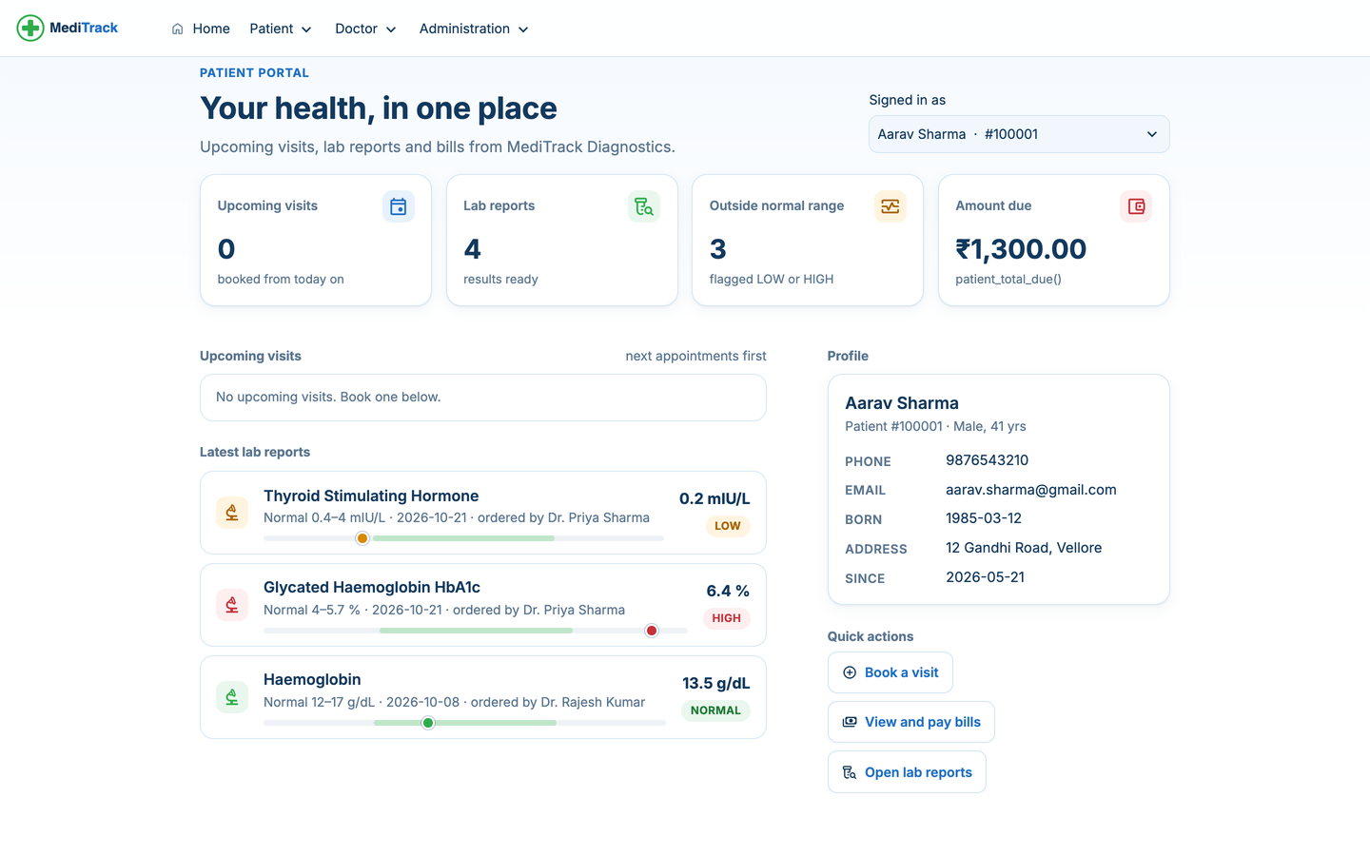
Figure 14: Patient portal: My health
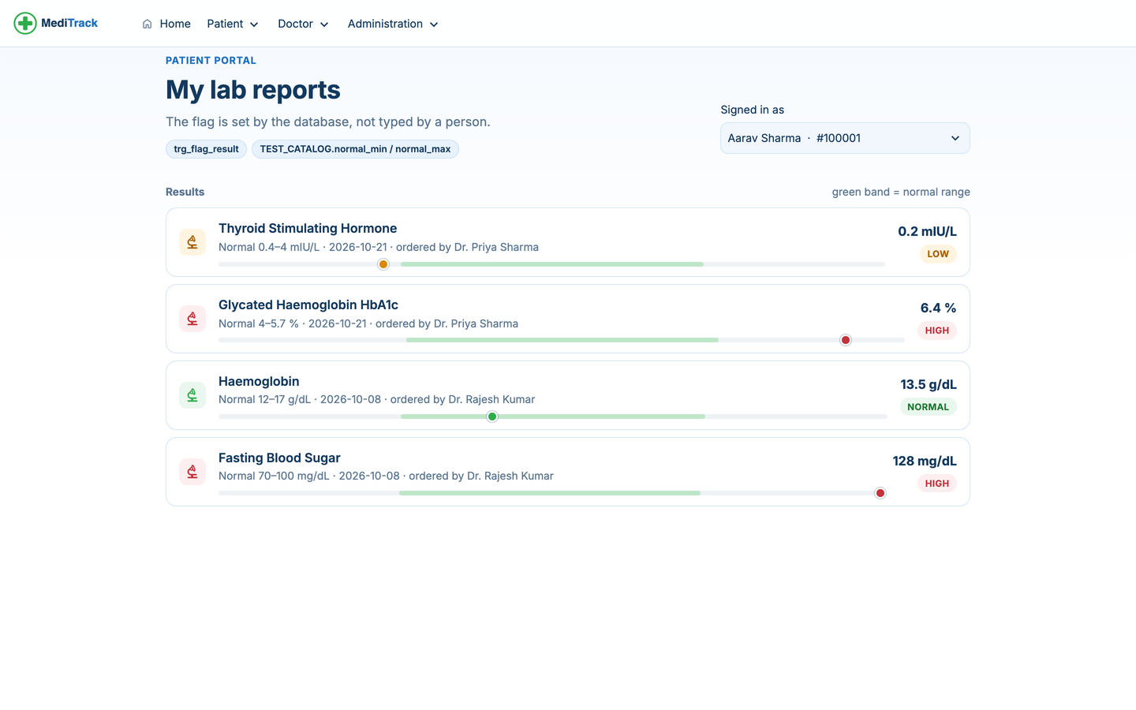
Figure 15: Patient portal: Lab reports with trigger-set flags
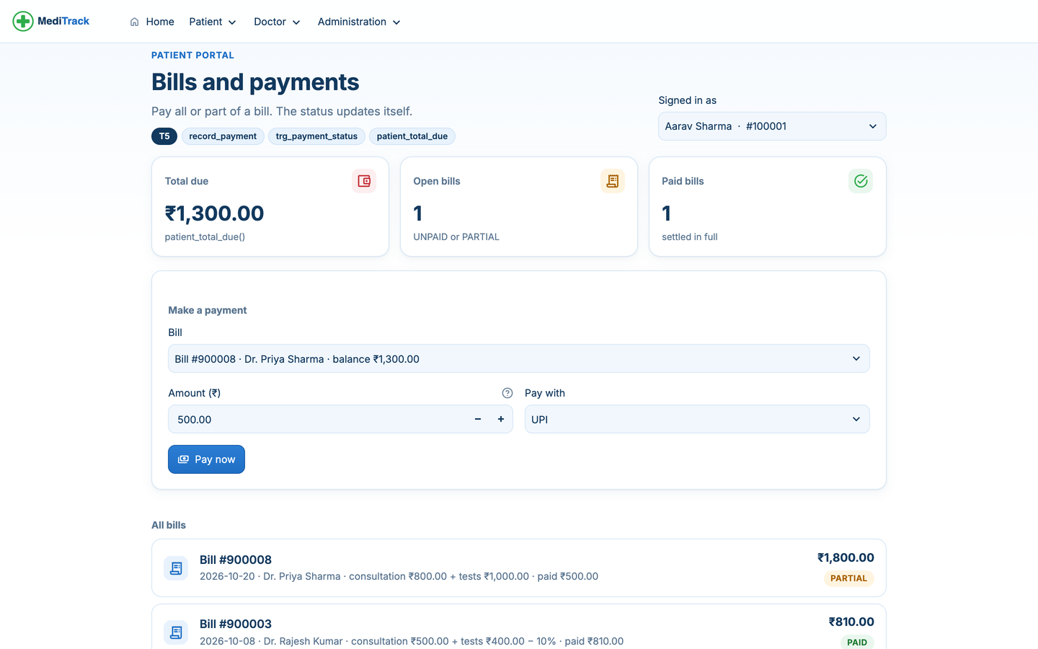
Figure 16: Patient portal: Bills and payments (T5)
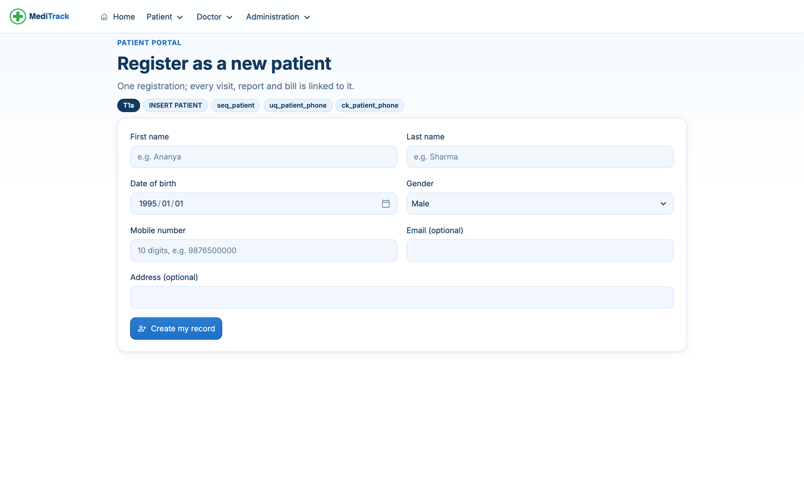
Figure 17: Patient portal: New patient registration (T1a)
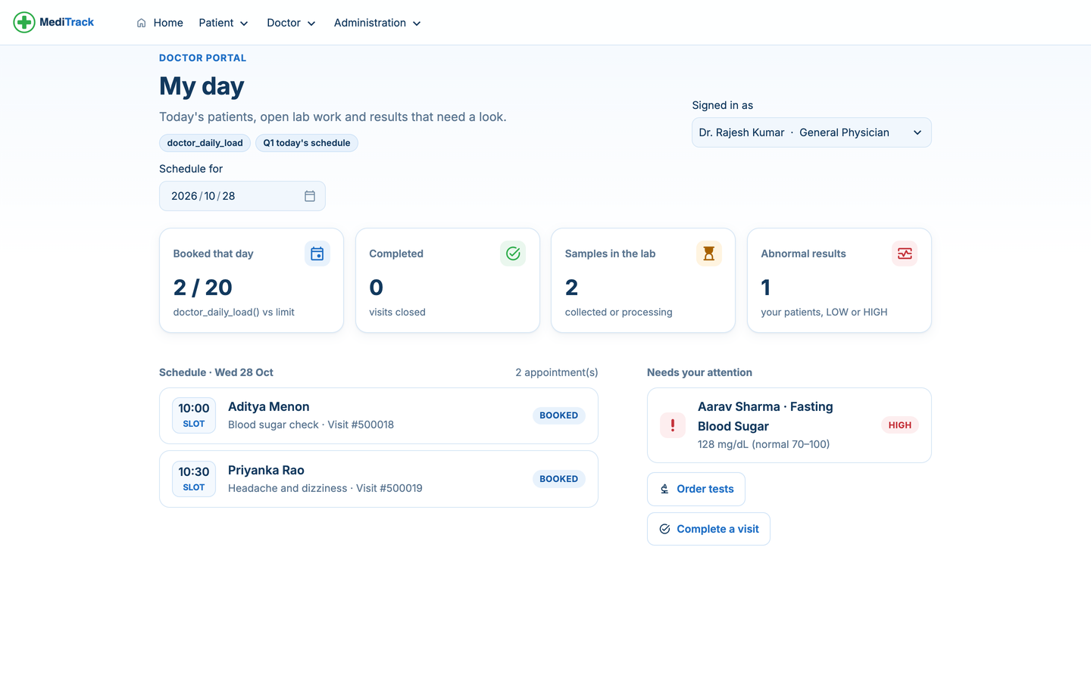
Figure 18: Doctor portal: My day
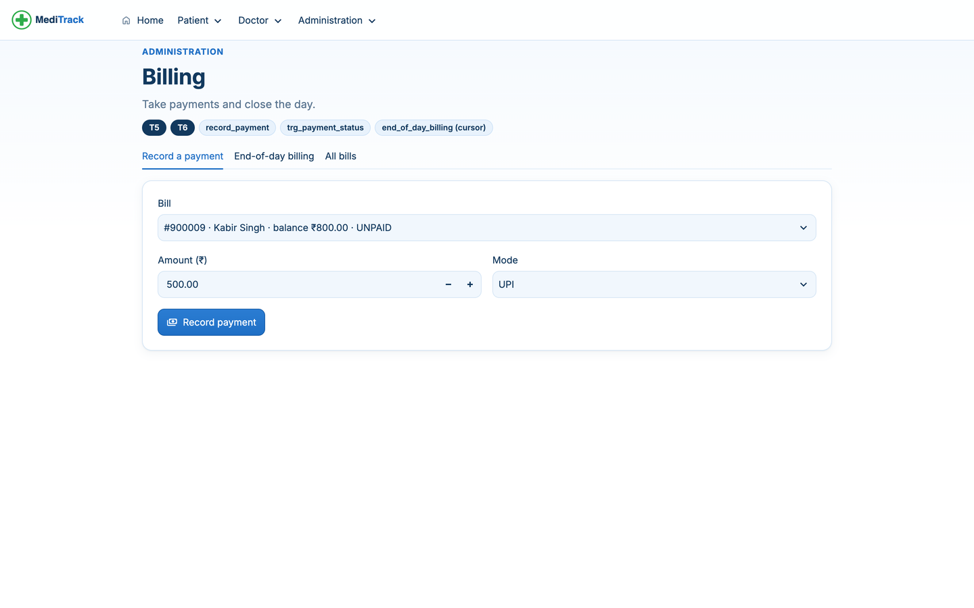
Figure 19: Administration: Billing (T5, T6)

APPENDIX C: SAMPLE TEST CASE TABLE
Summary of the test cases in Table form as required by the template (full list in Section 12.2).
Table 30: Sample test cases
Test ID | Test / Input | Expected Result | Actual Result | Status
TC01 | T1: book patient 100013 with Dr 1001 tomorrow 09:00 | Appointment created; load 0 → 1 | Appointment 500025; load 0 → 1 | Pass
TC02 | T1: book patient 100003 with Dr 1001, same date and slot | ORA-20003 | ORA-20003 from trg_no_double_booking | Pass
TC08 | T3: FBS result 165 (range 70–100) | Flag HIGH, sample COMPLETED | HIGH, COMPLETED | Pass
TC11 | T4: complete 500018 with 10 % discount | Bill = (500 + 700) × 0.9 = 1080, UNPAID | Bill 900012, 1080, UNPAID | Pass
TC15 | T5: pay ₹500 UPI on bill 900012 | PARTIAL; dues 1080 → 580 | PARTIAL; 1080 → 580 | Pass
TC17 | T6: end-of-day billing for 26 and 27 Oct | Bills for 500013 and 500014 | 900013 (₹950), 900014 (₹1150) | Pass
TC18 | T7: delete REJECTED sample 700013 | Sample deleted; its result cascades | Results for 700013: 1 → 0 | Pass
TC19 | Delete doctor 1001 with appointments | ORA-02292 | ORA-02292 fk_appointment_doctor_id | Pass

