Dota 2: Explortory Data Anlaysis and Prediction

Dejian Wang
Department of Statistics, Columbia University
dw2726@columbia.edu
Jihan Wei
Department of Statistics, Columbia University
jw3447@columbia.edu
Ynxiang Wu
Department of Statistics, Columbia University
yw2920@columbia.edu

Abstract—Dota 2 is a hot Multiplayer Online Battle Arena (MOBA) which has a huge number of followers around the world. As big funs of this game, our team applied various exploratory data analysis, classification and graph analysis methods to historical Dota 2 matches data to gain valuable insights for player evaluation, hero recommendation, team training and match prediction. To make our project well-organized and attractive, an interactive APP has been built to display the results.

Keywords: Dota2; Explortory Data Anlaysis; Recommendation; Logistic regression; Graph Analysis; Shiny App

Introduction
Dota 2 is one of the most popular Multiplayer Online Battle Arena (MOBA) games in the world. There were over a million of concurrent players at the peak. Due to popularity of this game, there is an annual professional competition, The International, held in Seattle, starting from 2011, with the prize pool exceeding $18.4 million last year, even higher than Super Bowl, Masters Tournament, and Tour de France [2]. Therefore, it is worthwhile to conduct research through massive amount of data produced by this game to reveal hidden values.

Dota 2 is played between two teams of five players competing to collectively destroy a large structure defended by the opposing team known as the "Ancient", whilst defending their own[1]. Two teams can be called “radiant” and “dire” respectively. Ten players each control one of the game's 113 playable characters, known as "heroes", with each having their own design, benefits, and weaknesses [1]. Before a match begins, two teams take turns to select heroes and a hero cannot be chosen twice. Therefore, a massive hero pool actually makes this game more playable, more competitive and unpredictable.

For the purpose of teammate selection, hero recommendation, team training and match prediction. We mainly focused on solving the following four questions.

- Player’s Performance Analysis
Evaluation the performance of a specific player is necessary for teammate selection. Thus, we intend to identify indicators of the player’s performance.

- Hero Recommendation
Hero selection has a non-negligible effect on the outcome of one match. At the beginning of each match, both teams take turns to select heroes. For a higher chance to win, we want to recommend a new hero which will give the highest wining probability based on the information of all the selected heroes at each stage.

- Relationship between Heroes: Synergy and Suppression
Since different heroes have different skills, benefits and weaknesses, we are interested in potential relationships between them. More specifically, we are interested in whether two specific heroes chosen in a team can significantly increase the team’s winning rate. This is a kind of synergy effect. From another perspective, whether a specific hero can be chosen to suppress the hero chosen in the opposing team is also of our interest. This is suppression effect.

- Match Outcome Prediction
As mentioned before, Dota 2 has its worldwide tournament every year and thus game gambling is not rare (2016). Since the prediction model of our interest can predict match outcome once a match begins, it has potential business value. In addition, the model can be also used for team training. Professional teams can simulate match outcomes based on the model in training process so as to better make targeted or adjust their strategies in real games.

Finally, to put our results into practice, we integrate three parts of applications into a Shiny APP based R studio so that it can be easy for people without programming or statistical knowledge to use.

Related Works
There has been so many projects related to Dota 2. For example, player skill rating is computed by Devin using the python trueskill library with implements the TrueSkill rating system [3]. TrueSkill rating system is a python-based library first developed by Microsoft. There are also some works about investigating correlation between winning rate and true skill of a player, correlation between winning rate and match duration and effects of communication on winning rate.

For the indicators of player’s performance, several websites have given reasonable indicators of player’s performance such as KAD (Kills Assists and Deaths Ratio), Experience Gaining Ability, Gold Gaining Ability and so on. (KawaiiSocks, 2016). We will use them as reference for our project. But these works commonly lack visualizations and are very difficult to communicate with people without statistical knowledge, which is one of reasons why we want to using Shiny to present our results.

Similar to the prediction part of this project, there are already some efforts to build prediction models [4]. However, some of them are predictions based on information that can be only collected after a match finishes. Although some models give very high correct prediction rate on testing data, they do not have practical value, since prediction is only sensible before beginning of a match. Some models, though practical, do not provide satisfactory prediction results, due in great part to the lack of suitable predictors. Thus, we hope to figure out a better collection of predictors and improve correct prediction rate. As for the graph analysis part, we rarely find previous works about research on relationships between heroes. Hence, we hope our project could serve as a pioneering work in this area.

System Overview
The EDA, hero recommendation and match outcome prediction are mainly done using R, along with TrueSkill rating system in trueskill python library. All these results are integrated into R Shiny APP. The graph analysis mainly used IBM system G visualizer.
Shiny is an open source R package that provides an elegant and powerful web framework for building web applications using R. Shiny can help turn analyses into interactive web applications without requiring HTML, CSS, or JavaScript knowledge.
IBM System G is the first complete software stack for all aspects of Graph Computing. Graph database is a tool for efficiently managing large-scale graph data, especially important for contextual and relationship analysis [5]. The essential input for using System G visualizer is node and edge files. In the graph analysis part, heroes are treated as nodes and synergy or suppression relationships are treated as edges.

The dataset used is downloaded from the Kaggle posted in November 2016. It contains more than 50000 ranked matches with 18 csv files including exhaustive information about players, heroes, match records and so on. The total size of the dataset is around 2GB. We endeavored to utilize as much information as possible to gain more trustworthy results. Some files were used as the testing data for model evaluation.

Algorithm
For the evaluation of player performance, basic statistical methods are used for the player’s performance analysis. We selected the KDA (a measure of number of kills, deaths and assists), average Last Hit (only the hero that lands the killing blow on a creep obtains gold from it, an act called "last hitting"), experience gained per minute, gold gained per minute, hero damage score, and tower damage score (Tower is a kind of defense building. The higher tower damage score, the better awareness of attack a player would have.) as six indicators of a player’s ability. The historical winning rate was also calculated to show the players’ performance. And radar chart and donut charts were used for performance indicator display.

Hero recommendation part is essentially an iterative querying process. Since two teams take turns to select heroes, recommendation is based on existed hero combination of each team and outcomes of historical matches in which the same hero combinations occurred in two teams. For example, suppose there are two teams called A and B. We want to use our recommendation algorithm for team B. If team A selects a hero, “a1”, first, matches involving “a1” in historical records are selected and output five heroes that have the highest winning rate against “a1”. If team B selects heroes first, the algorithm will recommend five heroes with highest winning rate without any other constrains. Suppose in team B’s round, hero “b1” is chosen and in the next round team A selects hero “a2”. Then the existed hero combination for team A is “a1” and “a2” and for team B is “b1”. For the next turn of team B, a new query is conducted to search for matches involving “a1”, “a2” in a team and “b1” in the opposing team and outputs five heroes with the highest winning rate against “a1”, “a2”. This process is iterated until team B finishes selection.

For Graph analysis part, files, nodes.csv and edges.csv are created for IBM System G Visualizer to construct the graph database. Each hero is treated as a vertex and the synergy and suppression effects among pairwise heroes are used separately in two graphs as the edges to reflect the interaction and relationships among heroes. Nodes.csv file is simple to create, containing the information of hero id, hero name, hero average winning rate and hero average last hits calculated from the match data as node variables. In edges.csv files, each edge contains two heroes as its vertices and total number of games as well as the winning percentage of these games of these two heroes as edge variables. For two graphs representing synergy and suppression effects, these two heroes in the vertices appear in the same team or different teams, respectively. We use matrixes to store the counting of winning games and total games for pairwise heroes. To build these matrixes up, the match information is traversed, and we update the matrixes for every pair of heroes appear in the same team or different teams in every match. It only takes one pass of traversal to build up all matrixes containing the necessary information. Lastly, we extract the information from the matrix and created two edges.csv files with correct formats for IBM System G Visualizer. Note that the synergy graph is undirected and the suppression graph is directed, which are determined by the meaning of two graphs.

For the match outcome prediction, the Logistic regressions are adopted. Training (80%) and testing (20%) datasets are used for examining performance of the model. Four types of predictors are chosen, namely average player rating, average hero winning rate, average hero “last hits” and pairwise synergy and suppression score among all heroes selected. Average player rating is a predictor measuring historical average player performance, which is calculated by TrueSkill library in Python. For each player, output includes average performance, μ, and variation of performance, σ. Average hero “last hits” is hopefully a measure how well a team is expected to utilize resources in a match. Since usually in a match, resources per minute is limited, if five heroes in a team all have very high historical “last hits”, this combination of heroes would probably have problems distributing resources. Finally, pairwise synergy and suppression score among all heroes is actually a by-product of graph analysis, which intuitively could also affect a match’s outcome.

Based on these predictors, the logistic regression is outlined as below.

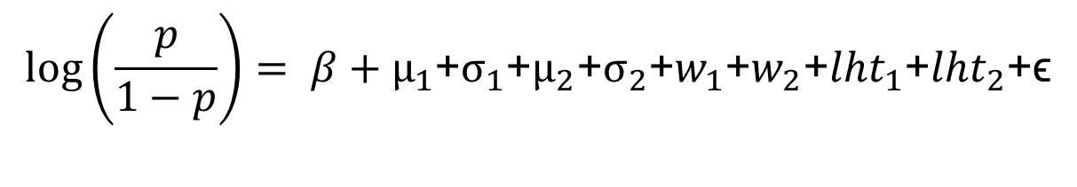
where p is probability of “radiant” team winning the match, β is an intercept term, μ1, σ1, w1 and lht1 are average player ratings, standard deviation of player ratings, averge winning rate of hero combinations, average last hits for “radiant” team respectively. μ2, σ2, w2 and lht2 are corresponding predictors for “dire” team. ϵ is error term. The model predicts “radiant” team to win if estimated p is greater than 0.5.

Software Package Description
There are four submitted files, and the “Player Performance APP”, “Hero Recommendation APP” and “Prediction APP” contain code for Creating APP. Each of them aims to show one part of the results. Figure 1 is a screen shot of one of the Shiny APPs. To run the APP:
Step 1: Gather all the needed data files and record their path, change the path in the “read.csv” line.
Step 2: Open the file in R studio and click the “Run App” bottom at the top right corner.
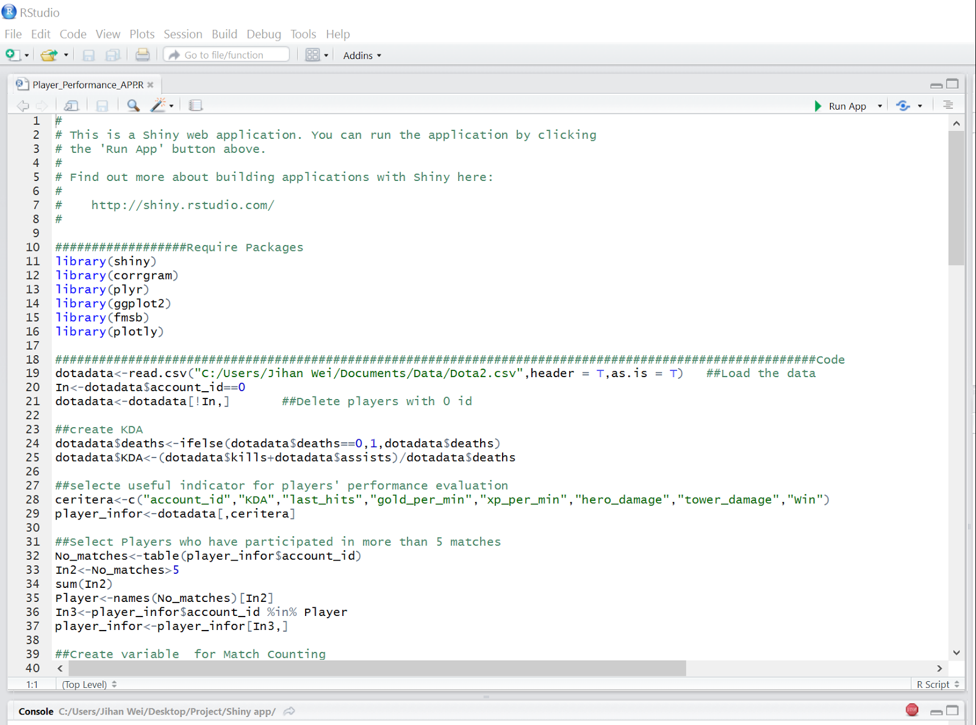
Fig. 1 screen shot of Shiny APP codes

Step 3: App will appear automatically and you can play with it. Note that if an error occurs, please change the file’s name to “Player_Performance_APP”, “Hero_Recommendation_APP” and “Prediction_APP”.

Experiment Results
- Player’s Performance Analysis
In the “Player Performance APP”, once a player is selected, a radar chart with six different indicators will be shown. Also, we provided the historical wining rate for the chosen player.

Taking player 508 as an example (Figure 3), the radar chart indicates that the 508 doesn’t have an outstanding ability among all the players. And among all the six indicators, the “Experience Gaining” ability is relative higher for him. Also, his wining rate is only 50%, which is not desirable. Thus, we can conclude that player 508’s performance is not excellent and he maybe not a good candidate for teammate. This app enables people to obtain the information easily and quickly.

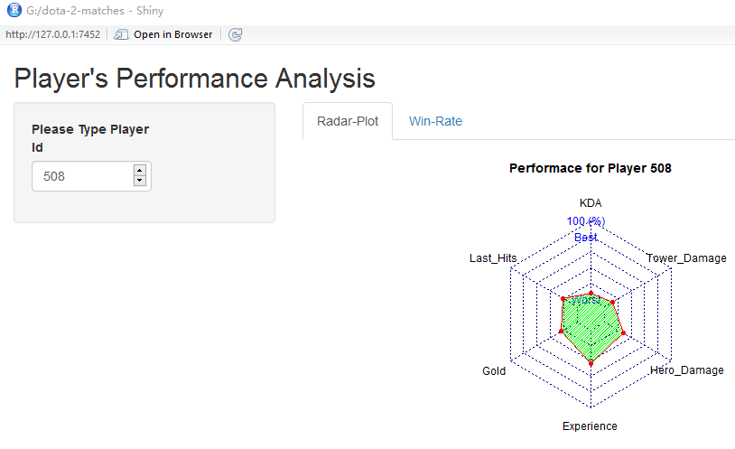
Fig. 2 Player Performance APP

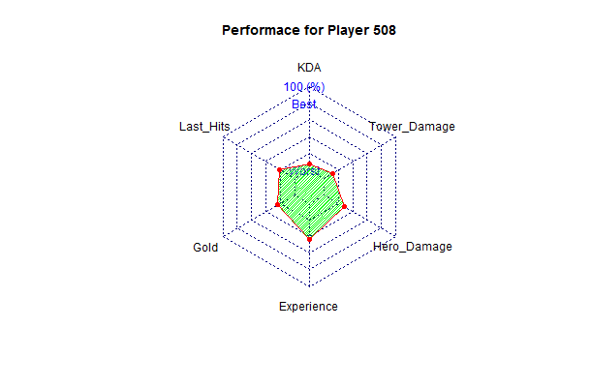
Fig.3 performance of player 508

- Hero Recommendation
In the “Recommendation APP”, people could type in all selected hero IDs. At each step, the app will give 5 recommended heroes which will gives the highest wining probability. At the very beginning, the App will recommend 5 heroes which have the highest historical wining rate. The 5 heroes are "Huskar", "Doom", "Phantom Assassin", "Disruptor" and "Legion Commander". As the process goes on, the recommended heroes will change based on different selections. For instance, if Team A already selected two heroes named “Omniknight” and “Axe” and Team B has selected one hero named “Shadow Fiend”. Our APP will recommend heroes “Earthshaker”, “Tidehunter”,” Juggernaut”, “Skywrath Mage” and “Clockwerk” for team B to choose as next hero. Thanks to the APP, teams could adaptively choose the best heroes to increase their winning provability.

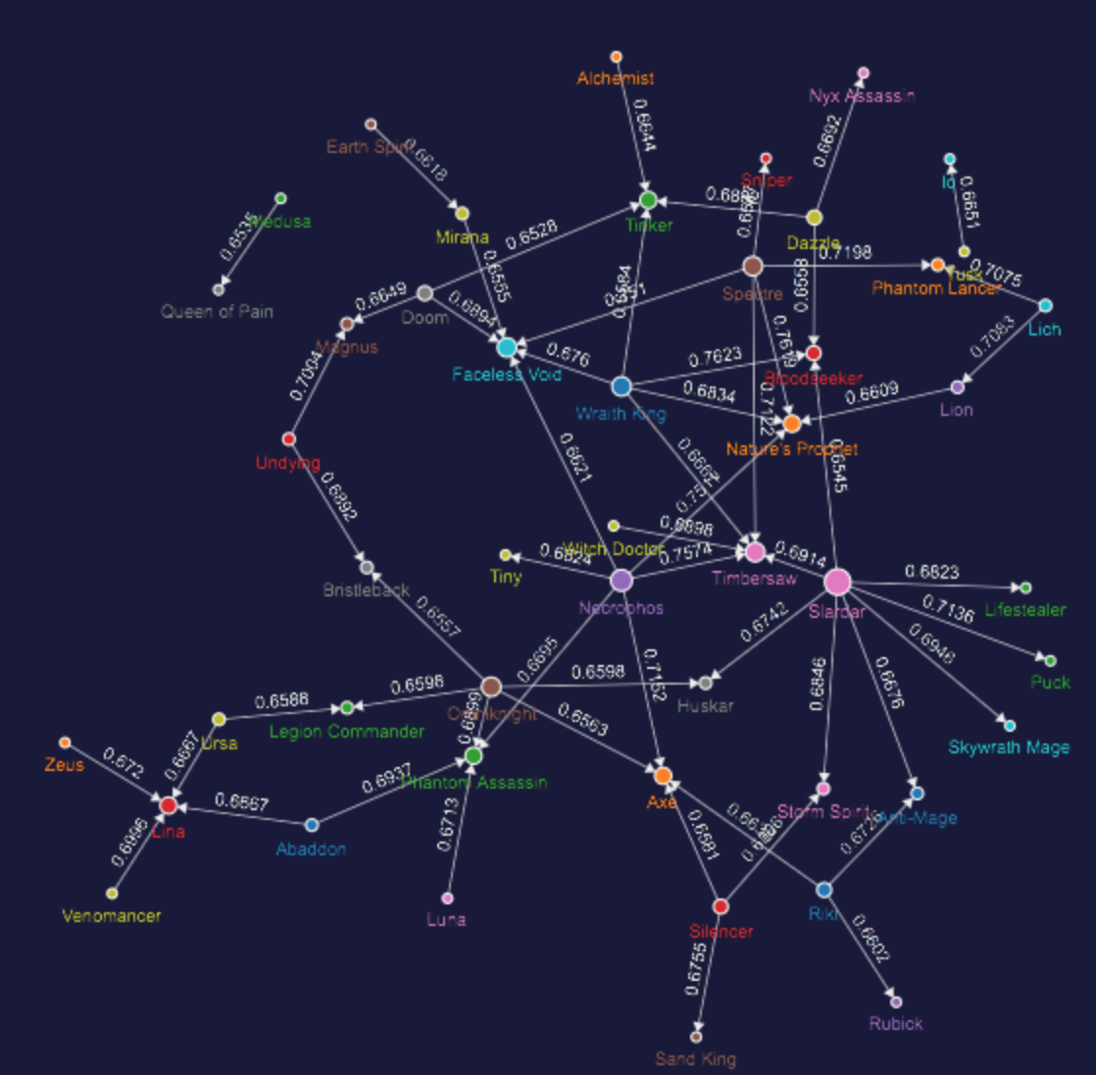
Fig.4 suppression-effect graph among heroes

- Graph Analysis
Connect the IBM System G Visualizer and upload the node files and two edge files separately to create two graphs. When the graph construction finished, we can do queries to study on the inter-relationships among heroes. An example would be the query with the suppression-effect graph with edge values winning rate over 0.65 and the total number of games over 200 as the filtering condition (Figure 4). A high wining rate will screen out the strong and distinct relationship and a large games counts shows that the relationship is not accidental. From the query result in the example, the filtered strong suppression effect between heroes is displayed clearly with hero names as the node label and the winning rate as the edge variable displayed of one hero against another. The size of the node represents the degree of the node, which also indicates the significance of the heroes. Also note the arrow of the edge indicating the "superior-inferior" relationship between heroes. The information this graph conveys is in accordance with our knowledge about the game. We can apply different threshold values for queries and detect hidden relationship among heroes with the resulting sub-graph in a vivid, clear and subtle way, which help us gain deeper insight of the game.

- Match Outcome Prediction
In the “Prediction APP”, when all the information about the 5 players and their selected heroes for both teams are provided, our APP will give the predicted wining ability for Team A. For instance, if Team A consists of players 1 to 5, with heroes IDs 86,51,83,11,67, and team B consists of players 10000 to 10005, with heroes IDs 106,102,46,7,73, the predicted wining probability will be 54.68%. With this APP, people can predict the wining probability for Team A at the beginning of the match. The higher the wining probability, the more we are confident that Team A will be the winner.

To evaluate the effectiveness of the prediction model, we use a test set, compare the prediction outcomes of all test matches with their labels and compute the accuracy rate. The accuracy rate of our model is 0.60077, which is acceptable and hopefully still can be improved in the future work.

Conclusion and discussion
This project mainly addressed four practical issues related to Dota 2 games. Firstly, quantitative evaluation of players’ performance is proposed. It takes into account player’s KDA, average “last hits”, experience gained per minute, gold gained per minute, hero damage score and tower damage score. Secondly, we come up with a simple but useful hero recommendation algorithm based on an iterative querying process. Thirdly, synergy and suppression metrics were established to form the node and edge files and hence build synergy and suppression graph among heroes respectively. Finally, a logistic regression was used with several synthetic predictors to predict match outcome and provides reasonable results based on testing data. To make analysis results and prediction model more interactive and easy to use in practice, we integrated them into a Shiny APP.

Future improvements may be conducted in two directions. First, more data will be collected. Although 50000 matches seem to be a large number, a much larger dataset is actually needed especially for the hero recommendation and prediction part. Since there are more than a hundred heroes, the number of different combinations of ten heroes will be very large. Based on our algorithm, ideally, the dataset should have repeated records of most of these combinations. But in our dataset, it can be found that there is only one or no record for some specific hero combination. If this is the case in the real hero selection process, the hero recommendation process will recommend nothing, which is not desirable. The prediction model also suffers the lack of data. Since the model takes average player’s rating as a predictor, bad prediction should be expected if there is no historical records for some players in a team in the dataset. Second, it is possible to further improve the prediction model if more information is available. Since a small number of predictors, compared with the number of observations, is used, high-bias problem probably exists, especially due to the lack of repeated records for most of players. In addition, there are other potential but unavailable predictors, such as continuous win or lose matches for a player, number of MVP (most valuable player) in previous ten matches for a player and so on, that can contribute to predicted outcome.

References

- McDonald, Tim. "A Beginner's Guide to Dota 2: Part One – The Basics". PC Invasion. Retrieved 1 August 2016.
- Newhouse, Alex (June 27, 2014). "$10 Million Dota 2 International Exceeds Super Bowl, Masters, and Tour de France Prizes". GameSpot. Retrieved October 12, 2015.I. S. Jacobs and C. P. Bean, “Fine particles, thin films and exchange anisotropy,” in Magnetism, vol. III, G. T. Rado and H. Suhl, Eds. New York: Academic, 1963, pp. 271–350.
- Minka, Tom. “TrueSkill Rating System”. Nov, 2005.
- Devin, “setting up a prediction problem for Dota 2”, from https://www.kaggle.com/devinanzelmo/d/devinanzelmo/dota-2-matches/setting-up-a-prediction-problem-dota-2, Nov, 2016
- Description of system G. Retrived December 21, 2016, from
http://systemg.research.ibm.com/doc/gshell.html, 2013.

