**Comparison of Trading Strategy in U.S. and Chinese Market**

Anlu Chen, Mao Guan, Zijun Nie

Columbia University

e-mail: {ac4218, mg3844, zn2146}@columbia.edu

*Abstract*

**Trading Strategy can have a huge impact on stock market. An appropriate trading strategy may help people make profit from volatile stock market. In this paper, we compare different algorithms to predict price or price movement in U.S and Chinese market. And based on the results, we generate trading strategies accordingly, which are whether to buy, sell or hold stock given the prediction. Using the final output of trading strategies, we measure the similarities and differences for U.S and Chinese market in terms of the performance of the algorithms. Finally, we conclude which algorithms are more suitable in specific market and what will they perform in that market.**

Keywords: Trading Strategy; U.S. and Chinese Market; OLMAR; PAMR; Causality Analysis; ADF Test; Reinforcement Learning; LSTM Algorithm

# Introduction

Trading strategy in stock market can be affected by various factors. Stock market in different countries may also have impact to each other. In this paper, we explore different methods to find optimal trading strategy in U.S. and Chinese market. In addition, we compare the performance of the algorithms in these two markets and try to find some pattern based on the results. For example, we want to explore whether one algorithm tend to outperform another in a specific countries’ stock market or whether one algorithm will generate better result in one country but not the other in general.

The structure of this paper organizes as follows:

1. We will introduce two traditional trading strategy algorithms (OLMAR and PAMR) as benchmark of our method;

2. We will implement Causality Analysis as our first approach for main stock indices in U.S. and Chines market and explore the logic behind the causality results;

3. We will use Long Short-Term Memory (LSTM) algorithm to predict close price for the stock indices;

4. We will implement two reinforcement learning algorithms (DQN and Actor-Critic). For DQN, we will focus on individual stock index in both markets. For Actor-Critic, we will combine stock indices in the two countries as a portfolio and see if we can make profit by pair trading;

5. Finally, in the last part, we will present the results for each of the above section and compare their performance.

# Related Works

In this section, we review some popular trading strategy approaches and trading philosophies that inspire our proposed approach.

Since one of our methods is to use reinforcement learning approach to do pair trading, we need to first explore some prior work about portfolio selection. Portfolio selection, which has been explored in both finance and quantitative fields, aims to obtain certain targets in the long run by sequentially allocating the wealth among a set of assets. Traditionally in finance, portfolios are often selected according to mean-variance theory. Rather than trading with a single stock using computational intelligence techniques, learning to select portfolio approach focuses on a portfolio, which consists of multiple stocks. In our case, we trade indices in pairs.

On-line portfolio selection has attracted increasing interests in machine learning and AI communities recently. A new on-line portfolio selection strategy named “On-Line Moving Average Reversion” (OLMAR), which exploits Moving Average Reversion (MAR) by applying powerful online learning techniques, has been popular in recent days. The approach can solve the problems of the state of the art caused by the single-period mean reversion and achieve satisfying results in real markets. It also runs extremely fast and is suitable for large-scale real applications.

Another traditional trading strategy is Passive Aggressive mean reversion strategy for portfolio selection (PAMR). This approach relies upon the mean reversion relation of financial markets. Using online passive aggressive learning technique from machine learning, this portfolio selection strategy can effectively exploit the mean reversion property of markets. The underlying assumption of this approach is that better-performing stocks would perform worse than others in the next trading day. However, if the market drops too much, we would stop actively rebalancing the portfolio to avoid certain “mine” stocks and their associated risk. Thus, the basic idea of PA for classification is that it passively keeps previous solution if loss is zero, while it aggressively updates the solution whenever the suffering loss is nonzero.

In our project, we implement both OLMAR and PAMR as benchmark for our LSTM and DQN algorithms.

# System Overview

In this section, we describe datasets we used in our design and then give explanation of the architecture of our design.

**3.1 Datasets**

For Causality Analysis: main stock indices in U.S. and Chinese market;

For OLMAR, PAMR, LSTM and DQN algorithms: S&P 500 index in U.S. market and HS300 index in Chinese market;

For Actor-Critic Pair Trading algorithm: S&P 500 index in U.S. market and Fund index in Chinese market.

**3.2 Architecture of the system**

There are basically four parts of our work. The first part is trading strategy based on the causal relationship. The second part is to apply LSTM for close price prediction. The third part is to use the DNQ method to generate action signals. The fourth part to build Actor-Critic network to use pair trading method to generate action signals. In the meantime, we also implement OLMAR and PAMR as benchmark and use it to compare with other algorithms in terms of performance.



Fig1. Work Flow for Causality Analysis

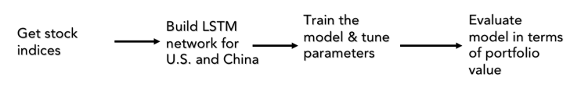

Fig2. Work Flow for LSTM



Fig3. Work Flow for DQN

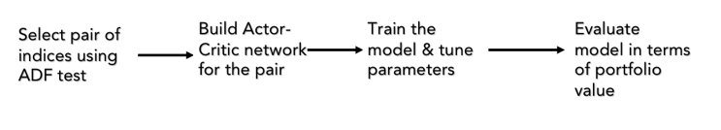

Fig4. Work Flow for Pair Trading

# Strategies

In this section, we will introduce our trading strategies in details.

**4.1 Causality Analysis**

**4.1.1 Approach**

**4.1.2 Trading Strategy & Evaluation**

**4.2 LSTM Method**

In this part, we focus on predicting close price of two selected individual stock indices, one from U.S. market and the other from Chinese market. The two indices we pick here are S&P 500 index and HS300 index.

**4.2.1 Approach**

Long Short-term memory (LSTM) units are a building unit for layers of a Recurrent Neural Network (RNN). It is composed of a cell, an input gate, an output gate and a forget gate. The reason why we use it here is because that it can “remember” short term memory for a long period of time. Therefore, it is well suited for predicting time series given specific time lags.

**4.2.2** **Parameter Setting**

For U.S. market (S&P 500):

For Chinese market (HS300):

**4.2.3** **Trading Strategy & Evaluation**

**4.3 DQN Method**

In this part, we build Deep-Q-Learning network for stock indices. Also, as LSTM method above, we pick S&P 500 index for U.S. market and HS300 index for Chinese market. And the output of our system is “buy”, “sell” or “hold” signals for our portfolio (indices).

**4.3.1 Approach**

**4.3.2** **Parameter Setting**

For U.S. market (S&P 500):

For Chinese market (HS300):

**4.3.3** **Trading Strategy & Evaluation**

**4.4 Actor-Critic Method for Pair Trading**

In this part, we use Reinforcement Learning (RL) to do pair trading, which is a market-neutral strategy involving the trading of a pair highly positive correlated stocks in unison.

To satisfy the requirement of pair trading, we must ensure that stocks in selected pair have cointegration relationship. Since we want to do pair trading by holding one of main indices in U.S. and one of those in China, we must test cointegration relationships across these two countries. Thus, we implement Augmented Dickey-Fuller (ADF) Test (which is a test for existence of cointegration relationship) for stock indices from these two countries. Since the indices are from different markets from different countries, few of them satisfied the required condition. However, we do find out a pair from the index pool, which are S&P index from U.S and Fund index from China, that pass the test. Therefore, these two indices are picked as our dataset for this section.

**4.4.1 Actor-Critic Approach**

In this part, we use Actor-Critic RL architecture as our approach. We develop a trading agent to maximize long-term profit for pairs of our selected stock indices with cointegration relationship. Actor-Critic method has two components interacting with each other. A policy network (Actor) that outputs a policy based on the current state; a value network (Critic) that evaluate the current policy.

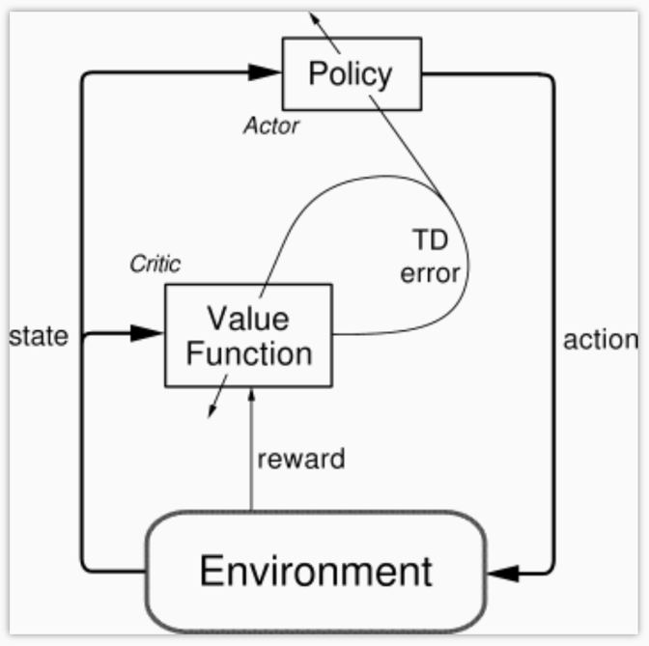

More specifically, when the actor agent is doing gradient ascent, we use the state and action to generate the direction of gradient ascent. And the critic agent would tell the actor whether the direction of gradient ascent is correct and how much ascent should take. And in the critic part, we use TD error to evaluate the state and action and feed back to the action network.

**4.4.2 Parameter Setting**

We use two Recurrent Neural Network (RNN) to approximate the policy function (actor) and the value function (critic). Each state as the input to RNN is a series of historical OHLC features. The output of policy function is a probability of actions.

The RNN model we implement is LSTM model. The length of look-back period is 50, which means every decision made by the agent is based on the market status of the past 50 trading days. The number of hidden layer units is 20.

**4.4.3 Trading Strategy & Evaluation**

Possible actions in a stock market are buy (e.g. buy 100 A stock and sell 100 B stock), sell (e.g. sell 100 A stock and buy 100 B stock) and hold (maintain portfolio structure). The reward is daily return. The ultimate goal is to maximize long-term accumulated returns. We evaluate the model using annual return. We start at 100,000 RMB cash as the net value of the portfolio and evaluate the model using annual return. In-sample training data is from 2014/10/9 to 2017/10/30. Out-sample test data is from 2017/10/30 to 2018/4/10.

# Experiment Results

In this section, we will display the results for each of the above sections.

**5.1 Causal relationship Results**

For the causality test, we use the python package “causality”.

<https://pypi.python.org/pypi/causality/0.0.3>

**5.2 LSTM Method Results**

Based on our results, we can see that our LSTM model performs pretty well. Both S&P500 and HS300 are able to outperform benchmark index return, OLMAR and PAMR algorithms. So, given our prediction for close price, trading strategy seems profitable.

**5.2.1 U.S. Market (S&P500)**

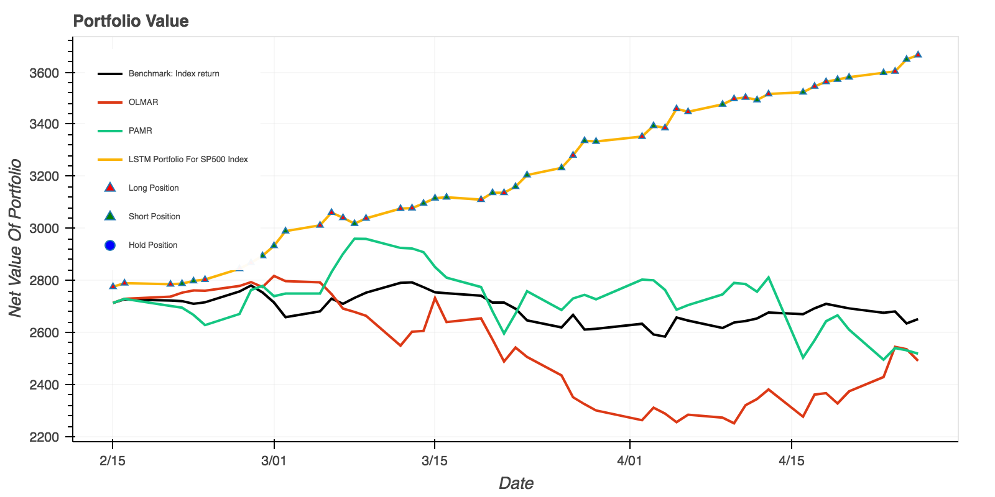

**5.2.2 Chinese Market (HS300)**

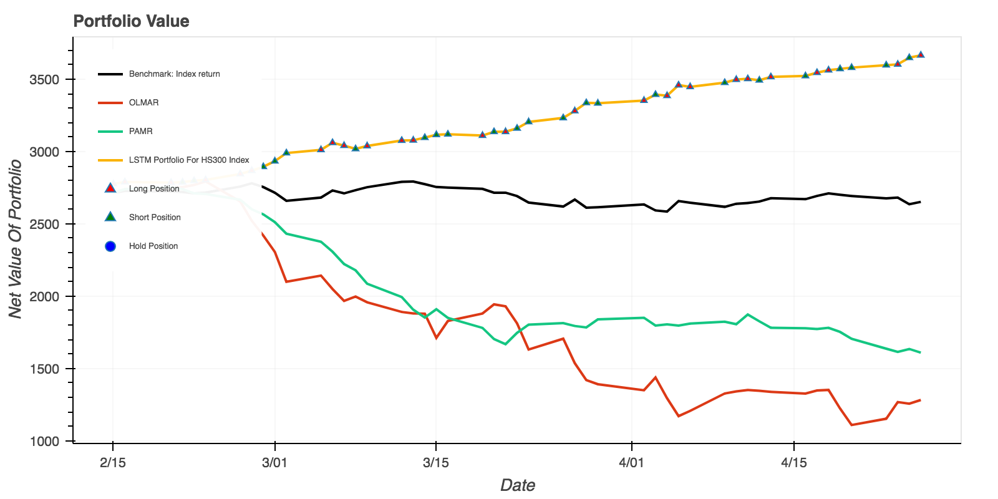

**5.3 DQN Method Results**

Based on our results, we can see that trading strategy based on our DQN model, does not seem to distinguish from benchmark index return for S&P500. For HS300, the net value of portfolio for DQN results also seems to be in the same level as that for benchmark index return, although it seems to outperform OLMAR and PAMR algorithms. It may be hard to be profitable using this method to generate trading strategy.

**5.3.1 U.S. Market (S&P500)**

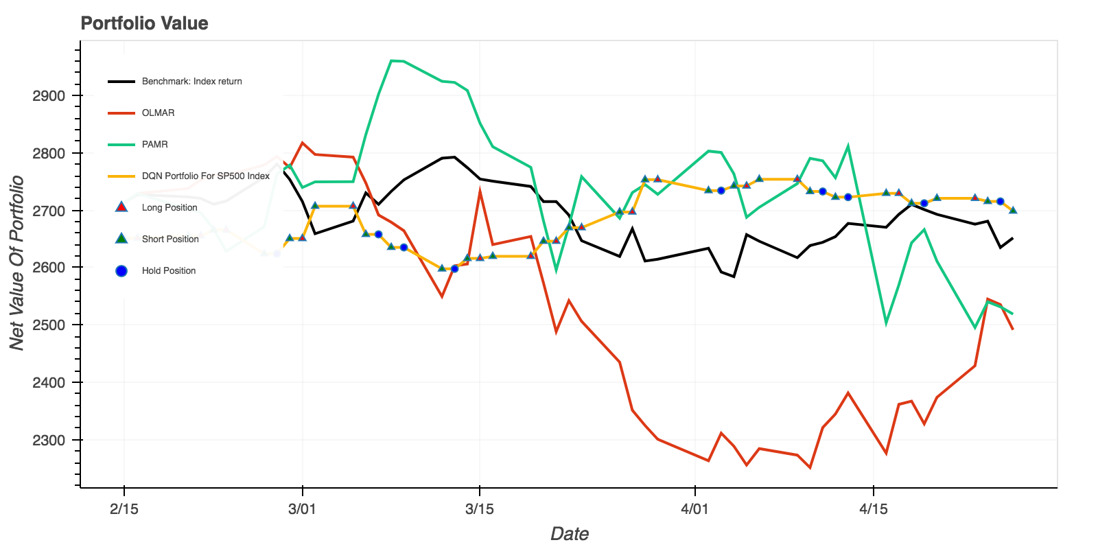

**5.3.2 Chinese Market (HS300)**

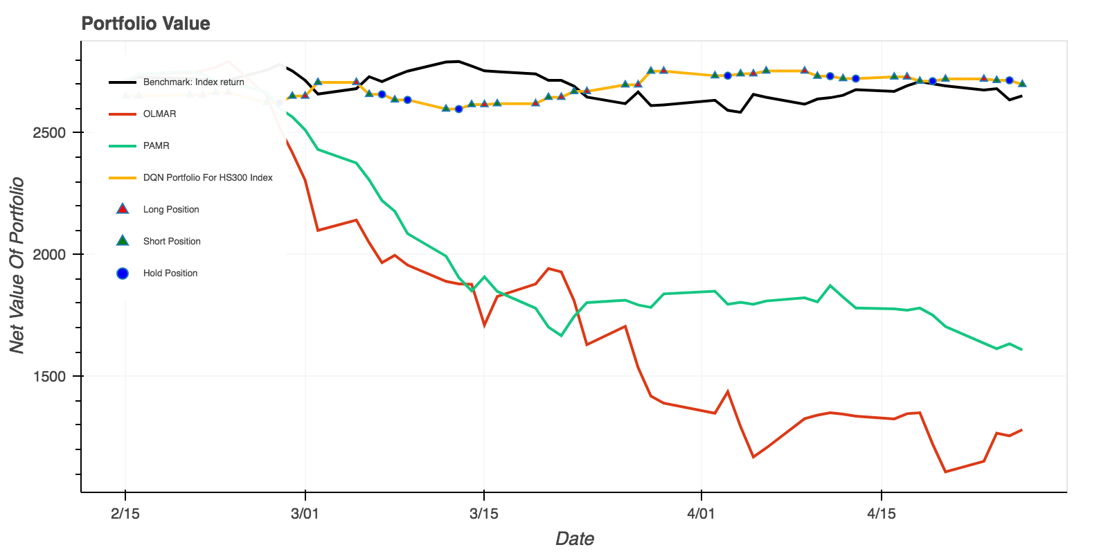

**5.3 Comparison for LSTM and DQN Methods**

To compare LSTM and DQN methods, we explore their performance within the same market. We can see that within U.S. market (S&P500), LSTM performs better than DQN; within Chinese market (HS300), LSTM also performs better than DQN. So, in our case, if we have to select a method to generate trading strategy within a specific market, we would recommend picking LSTM method over DQN.

**5.3.1 U.S. Market**

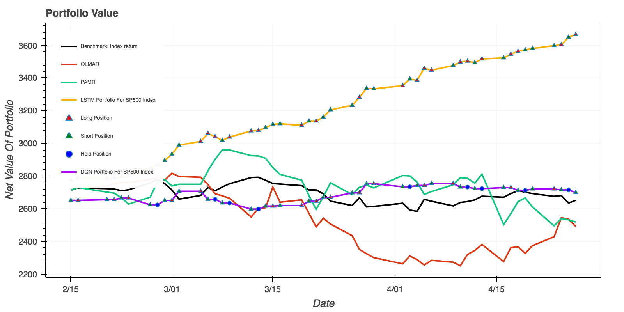

**5.3.2 Chinese Market**

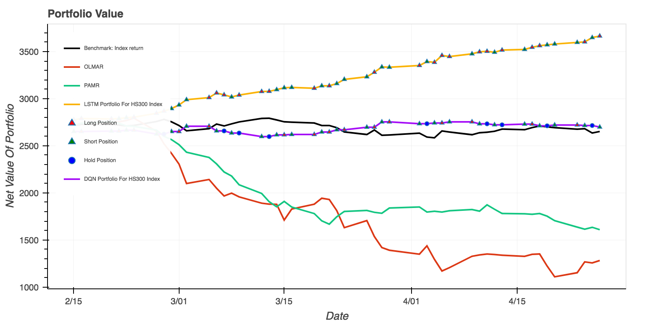

**5.4 Actor-Critic Evaluation Results**

# Conclusion

This paper discusses and compares different approaches for trading strategies in U.S. and Chinese stock market.

##### Appendix

**Github Repo:**

##### References

1. Saahil Madge, “Predicting Stock Price Deirection using Suppot Vector MachineDeep” , 2015.
2. Bellalah M, Levyne O. “Does co-integreation and causal relationship exist between the non-stationary variables for Chinese bank’s profitability? Empirical evidence[J]”, Thema Working Papers, 2013.
3. Herwany A, Febrian E. Co-integration and Causality Analysis on Developed Asian Markets For Risk Management & Portfolio Selection[J]. Mpra Paper, 2008.
4. Bin Li, Steven C.H.Hoi, On-Line Portfolio Selection with Moving Average Reversion.
5. Bin Li, Peilin Zhao, Steven C.H.Hoi, Vivekanand Gopalkrishnan, PAMR: Passive aggressive mean reversion strategy for portfolio selection.
6. Wenwei Hu, Jianqiang Hu, Shen Li, Jianfeng Zhou, “Self-adaptive Pari Trading Model Based on Reinforcement Learning”, Jan 2017.
7. Markowitz, H. (1952). Portfolio Selection. The Journal of Fianance, 7(1), 77-91.