Boom or Bust:
The Fantasy Football Gold Rush

Craig Darmetko
Department of Computer Science
Columbia University
cd2698@columbia.edu

Abstract—This project examines Boom or Bust fantasy football players; players who usually either score a large amount of points per week, or barely any. A classifier was created to identify these players based on their scoring output. Overall trends related to scoring variance were examined and based on insights from this a recommender was created to help fantasy football players pick players to improve their team based on the current and target variance of the players on the team. (Abstract)
Keywords-component; formatting; style; styling; insert (key words)

Introduction
Show motivation of your final project and a summarization
of the problem you would like to solve.
- Description from web site
- Draft Kings and Fan Duel
- Revenue and moneys
It’s estimated that approximately 75 million people will play fantasy football sometime this year and the fantasy football industry will likely bring in approximately XXX billion dollars on top of the billions coming in to the actual NFL through viewership, merchandising and marketing. Fantasy Football has also been trending in most media outlets due to the saturation of Daily Fantasy Sports marketing and legality investigations. Two of the largest, Draft Kings and Fan Duel, have bombarded almost every form of media with frequent advertisements and funded with hundreds of millions in venture capital and are expected to bring in close to a billion dollars this year in entry fees alone [http://www.forbes.com/sites/darrenheitner/2015/09/16/the-hyper-growth-of-daily-fantasy-sports-is-going-to-change-our-culture-and-our-laws].
These organizations hold contests where players create their own football ‘team’ picked from the ranks of currnet NFL players and their fantasy ‘team’ is graded each week based on each player’s performance on in their real football game that week. Different actions reward or penalize points, such as making a catch, scoring a touchdown or fumbling the ball. After each player’s game is completed, the player’s total points are added together to get a final team score. From here, there are many different rules and styles, but at it’s heart, most fantasy football is based off this.
Year long fantasy football leagues usually have a team playing another one in a ‘head-to-head’ style game where which ever team scores the most gets a ‘win’. Daily Fantasy Sports don’t have specific opponents, but rather you try to outscore all the others in the competition for that week. There are even more subtle choices, but at it’s heart is picking a team of players that has the highest likelihood of scoring more than the competition.
One of the biggest debates is of the distinction between fantasy sports, especially the ‘Daily’ branch, and sports betting, a highly regulated and monitored industry. Proponents of fantasy sports argue that it is a skill based game, which makes it separate from gambling. Opponents argue that the outcomes are largely based on chance, a hallmark of gambling. Some studies have shown ???. Regardless, both seem to be a factor, but only one side is controllable, so most successful players focus large amounts of effort on statistical analysis to give them the competitive advantage over the competition.

Skill based vs legalized gambling: there are arguments to both, and there is certainly an aspect of luck to the game (just like the stock market), but certain strategies significantly decrease the likelihood of catastrophic failure and the severity. <Talk about how the top 1% or whatever win most of the money repetitively>
<talk about interview with guy who wins a lot and employs some intense analytics to do so, remember to cite!\
Statistical data analysis can give players a huge edge over the competition and many players scour over a ritual of sites every week to help keep their team ahead. For example, of the approximately 1.5% of players that win decent money on Daily Fantasy Sports, most are repeat players using sophisticated, customized algorithms based on their data gathering and analysis[CITE].
In most situations, star NFL players are also recognized in the fantasy realm with similar regard. A player that consistently makes plays on the field will also usually score higher than other players in their position in Fantasy, leading to a higher desirability for fantasy teams.

Many football players can be categorized into one of two fantasy subtypes:

- Boom or Bust: they either score a ton of points or practically none each week.
- Consistent: they consistently score at least a certain amount of points, but rarely exceed it

A player’s scoring range is usually described by their ‘floor’ and ‘ceiling’, the floor being their average poor game score and ceiling being their average monster game score. Players may have the same scoring mean, but one player may have a higher ceiling, which leads to better games than the other occasionally. Statistically, this idea of a ‘floor’ and ‘ceiling’ is similar to higher and lower statistical quartiles [CITE?].
The common recommendation is to have at least as much consistent as boom or bust players on your team, but is that the optimal distribution? Does a team with more consistent players do better over the course of a season than a team of mostly boom or bust players? We will analyze this relationship and create a classification algorithm to classify each current NFL player based on their performance history and an algorithm to determine the optimal distribution of boom and bust players to maximize the chance of winning a fantasy league or matchup. [https://www.fanduel.com/insider/2015/08/13/fantasy-football-2015-ceiling-floor-consistency-and-the-big-difference/]

Related Works
Boris Chen has a great web site where he ranks and clusters fantasy players based on aggregated rankings from ‘experts’[http://www.borischen.co/]. This site is updated weekly and has sections for each fantasy position and includes a variance ranking when expert opinions differ widely. This is similar to our goal, except Boris is examining the relationships between players, rather than absolute points and their range for each player.
Many web sites claim to compile information on player’s ceilings and floors [https://rotogrinders.com/lessons/ceiling-consistency-and-floor-stats-174300, http://www.4for4.com/fantasy-football/2015/w1/floor-ceiling-projections-fanduel05-ppr] but most information is hidden behind paywalls and algorithms are only described in an extremely vague sense and details classified as proprietary. Most talk in general terms about being aware of variance and picking players with high floors, but none were backed up with more than a small (and statistically insignificant) group of examples.

System Overview
The analysis is built upon the powerful nfldb python package [CITE] that provides an open source API to manipulate NFL statistics as well as a database of statistics compiled from 2009 to present. The database is automatically installed with the package and is simple to update as new games are played and the data comes straight from the NFL’s official web page and has granularity down to individual player actions on each play during a game. This level of detail is powerful, but also requires some work to aggregate information to the game and season level, which is required for our analysis.
Our analysis also uses the scikit-learn python package[CITE] for machine learning algorithms, such as KMeans clustering, and numpy for various statistical computations and graphical analysis[CITE], such as quartile calculations and scatter plots.
The system currently does not cache any information except for what is already stored with nfldb, but this could easily be added to speed up runtime for any analysis.
Because of the extreme variance introduced between years due to teams gaining and losing personnel and players role’s changing, each year was considered separately for each player. These ‘player years’, or the statistics of a player over a single year, are the items we will be analyzing.
The player year information was first derived and used as a base for subsequent analyses. To do this the system first determines which players to analyze. Most NFL players are not very relevant to fantasy football because even in large leagues there is usually not more than 14 teams. Since each team only has a maximum of three slots for players of the same position, any player below the top 50 players for that position is usually irrelevant. This can further be optimized based on position; for example, the quarterback usually only has one representative per team, so analyzing only the top 20 quarterbacks is usually sufficient. For this analysis, the system selected for each year the top 20 quarterbacks, top 40 running backs, top 60 wide receivers and top 20 tight ends, as most leagues have a spot for one quarterback and tight end, two running backs and three wide receivers. The best were chosen from their position based on their total passing yards for the season for quarterbacks, rushing yards for running backs and receiving yards for wide receivers and tight ends. Players that played less than ten games in the given year were then filtered out to reduce anomalies. This resulted in approximately 980 player years to analyze.
Next, for each player year the fantasy score was calculated for each game the player participated in that year. The scoring system used for determining points was ‘Standard Scoring’[http://www.fantasypros.com/scoring-settings/], the most common setup for fantasy football scoring, although this was designed to be easily adjustable to other scoring methodologies for future analysis.
After the fantasy point score was determined for each game for the player in the given year we calculated various statistics on the list of scores. Some of the statistics calculated by the system include the Standard Deviation, Variance, high and low Quartiles and the Mean score. We can use these values as features to be fed into our algorithms for higher level analysis across all of the players. This is the base for the other steps

Algorithm
Show algorithm and tools you have used to solve your
problem.
The first tool was built to determine Boom or Bust players and classify new ones. Since Boom or Bust players typically score either a lot of points or barely any, they usually have a high Variance and Standard Deviation and often a low Floor. To classify players and determine the proper values for each, the system takes the feature vectors for each player year from the previous step and uses only the variance, standard deviation and lowest quartile (Floor) as input into an unsupervised clustering algorithm. The system used KMeans clustering[CITE] with a k = 2 to classify each player into either the boom or bust cluster or the consistent one. The boom or bust cluster is the cluster with higher variance, as one cluster usually had a distinct higher average variance for elements in it. The model can then be used to classify individual players as Boom or Bust or consistent, including new players not in the training set.
To understand the best allocation of Boom or Bust and consistent players, the system first needed a method of creating similar teams for comparison. This was accomplished using a modified version of the well known Knapsack Algorithm where items from a set list were picked to create a set that closely matches the size of the desired ‘knapsack’ capacity. We want to compare similar teams, so we used a ‘Knapsack’ target that was a mean weekly points average for the whole team equivalent to a team composed of an average player in every position. Since we can only have a certain number of players in each position, the Knapsack approach was altered to support a limit of how many players for each position could be selected to guarantee a full team. A threshold for mean team score was also implemented to allow for some flexibility in player selection.
To compare the teams, each team ‘competed’ in a simulated season against every other team in the league for every week in a single season. Since player years with less than ten weeks were filtered out, this because a simple comparison of team scores for each of the first ten weeks for each pair of teams. Each time a team scores more than an other team in the same week they get a win and scoring less gives them a loss. This resulted in many data points, approximately O(n^2) with n is the number of teams. From here, the total wins and losses for each team was compared, as well as the team composition.
For recommending players to improve a team during initial drafting, the system uses a similar method to compare and suggest potential players. After the user supplies their current team, the system identifies potential players to fit the vacant positions. From here it compares each potential team against each other in a similar head-to-head ‘season’ style used in the previous step where each team compares their total score each week against every other team every week an accumulates a win/loss record. The added players from the potential teams with the best records are suggested to the user as best choices to improve the team. The overall records of all the teams are also plotted and a line of best fit is determined. From the slope of this line the user can understand whether picking players to increase or decrease the variance of their team would be most beneficial.

Software Package Description
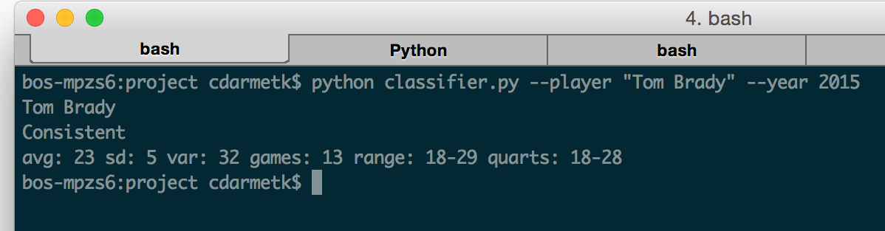
The classifier running on New England Patriots’ Quarterback Tom Brady’s performance from the current season.

The package contains two tools for users, the classifier and the recommender. The classifier accepts a player as input and classifies the player as a Boom or Bust or consistent player based on their performance. It also outputs various intermediary statistics calculated for further analysis, such as the mean score, Standard Deviation, scoring ranges and more.

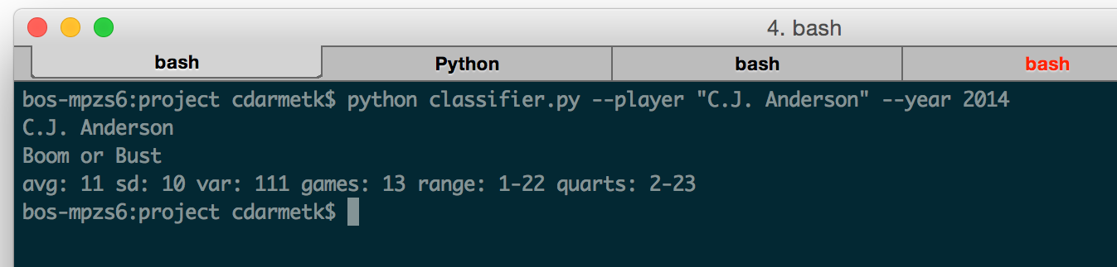
The classifier running on Denver Bronco’s Running Back C.J. Anderson’s performance from last year’s season.

The recommender takes as input the currently drafted team and the desired position to fill. After computing on the data it returns the top ten suggested players and the overall variance of the team and the win/loss record of that potential ‘team’ against all other player choices with the currently drafted team. The data for all player choices is also graphed and a line of best fit is calculated which can be used for determining generally if the team would benefit from more or less variance. A positive slope for the best fit line indicates a need for increased variance and more Boom or Bust players and a negative slope indicates a need for more consistent players.
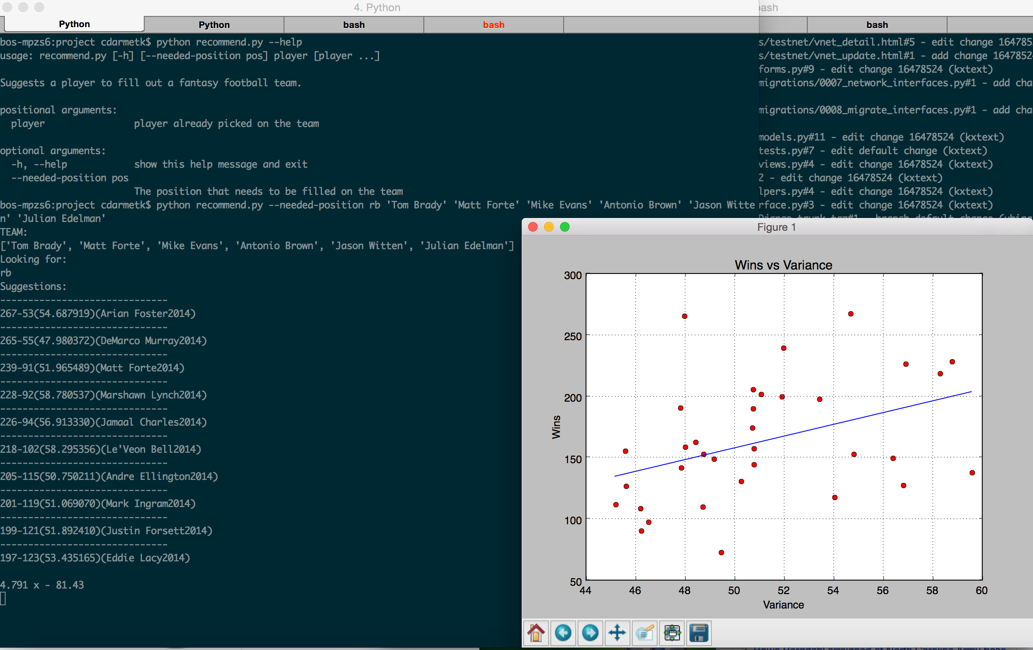
The output of asking or a Running Back suggestion for a drafted team. Arian Foster seems to be the best choice for this query.

The output of asking or a Quarterback suggestion for a drafted team. Overall, the system is suggesting an increase in variance, as shown by the positive slope in the graph.

Experiment Results
To understand the overall effect of variance, the variance trends were analyzed.

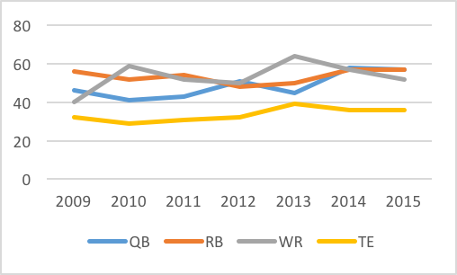
Average Variance for each Position over Time

Overall the Wide Reciever position had the most variance, although the trend was strongly downward in recent years. Running Backs were generally trending downward in variance over time and Quarterbacks and Tight Ends upward.

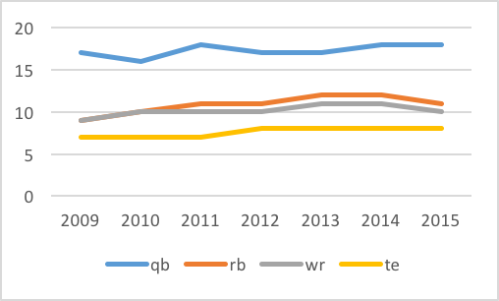
Mean Fantasy Points Score per Week by Position over Time

As for mean weekly score, Quarterbacks had much higher scores than the rest of the positions, and this is usually balanced by having more than one player per position for the other positions in most leagues. Tight Ends were the lowest scorerers, although the trend seems to be upward, and the gap between them and Running Backs and Wide Receivers looks to be shrinking significantly.
Both the classifier and recommender performed well when analyzed. The classifier was able to recognize all of the boom or bust players from a few hand curated pages online[http://www.rantsports.com/fantasy/2014/06/24/fantasy-football-the-15-biggest-boom-or-bust-players-for-2014/][http://nflmocks.com/2015/08/12/the-top-2015-nfl-fantasy-football-boom-or-busts/] as well as a hand curated list of well known consistent players.
Precision, recall?
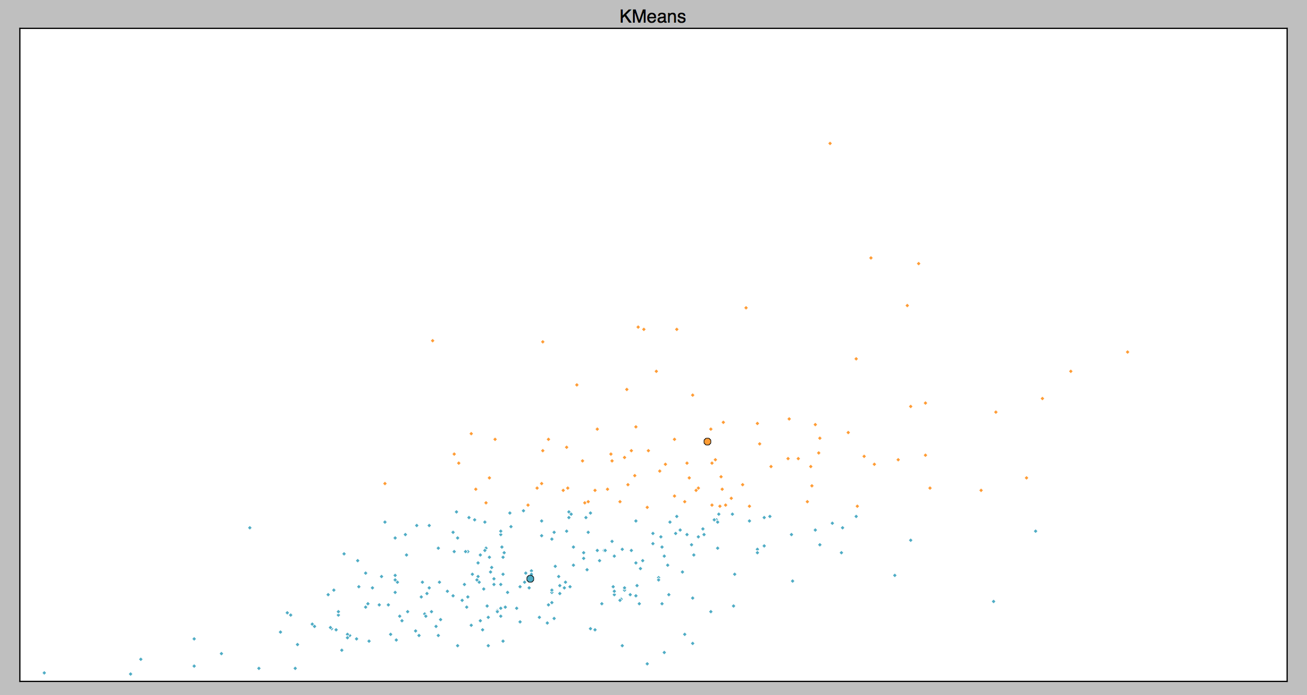
KMeans clustering top fantasy player years since 2009. Blue is low variance and orange is high variance.

The visualization of the clustering of player years based on variance and mean show that generally an increase in variance is related to an increase in mean score. The cluster centers for the Boom or Bust cluster were around 13 for mean points per week and 85 for variance, while the consistent cluster center was around 9 points per week and a value of 34 for variance.
The overall runtime is approximately 2 minutes, which is on the slower end of acceptable for manual analysis. Since most of the computation happens in the initial analysis of the whole dataset and clustering, this could easily be precomputed and the model could be saved out for repeated queries. Expected runtime would likely be on the order of seconds with this change after the model is trained.

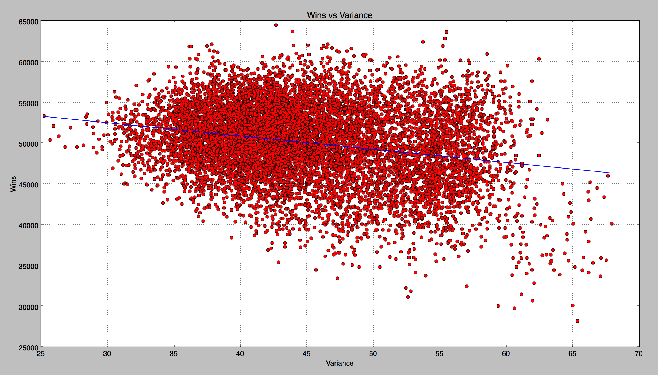
Wins vs Variance for 10,000 teams

In the graph above we graph each average scoring fantasy team based on their record against every other team ever week and their variance. As you can see from the line of best fit, although for players higher variance correlated with a higher weekly mean, for teams it looks like generally a lower variance leads to more wins. There is some variation here, as the most successful teams had either a moderate or slightly below moderate level of variance. This suggests that a certain amount of variance is needed for the best teams, but consistency should be more of a priority. Another interesting observation is that most poor teams had very high levels of variance, but other teams with similar levels of variance had some of the best records. This seems similar to the player Boom or Bust analogy; likely enough Boom or Bust players seem to have created Boom or Bust teams.

Conclusion
Overall, the project and system found some interesting insights and created helpful and novel tools for analyzing player tendencies and recommending players for fantasy football teams. Most fantasy sports analysis is protected by trade secrets and proprietary and subscription paywalls. The hope of this work is to influence more open and rigorous research and information sharing on the topic as the field is pretty new and naive at this point.
The classifier performed well in determining Boom or Bust or consistent players. It successfully identified players from Boom or Bust and consistent player lists manually curated by experts. The recommender also performed well as an initial approach for determining and improving weaknesses on a fantasy team, but there is plenty room for expansion to other player tendencies and supporting other less influential fantasy positions, such as Kicker and Defense. Future work on precomputing most of the base analysis would also significantly speed up runtime of both the classifier and recommender.

Acknowledgment

The authors would like to thank the people at NFLDB for making an amazing package that is the base for most of this analysis, John Madden for his video game affinity and love of consuming animal hybrids, Tom Brady for being the greatest GOAT any fan could ask for and my wife for reading everything over.

Appendix

References

- G. Eason, B. Noble, and I. N. Sneddon, “On certain integrals of Lipschitz-Hankel type involving products of Bessel functions,” Phil. Trans. Roy. Soc. London, vol. A247, pp. 529–551, April 1955. (references)
- J. Clerk Maxwell, A Treatise on Electricity and Magnetism, 3rd ed., vol. 2. Oxford: Clarendon, 1892, pp.68–73.
- I. S. Jacobs and C. P. Bean, “Fine particles, thin films and exchange anisotropy,” in Magnetism, vol. III, G. T. Rado and H. Suhl, Eds. New York: Academic, 1963, pp. 271–350.
- K. Elissa, “Title of paper if known,” unpublished.
- R. Nicole, “Title of paper with only first word capitalized,” J. Name Stand. Abbrev., in press.
- Y. Yorozu, M. Hirano, K. Oka, and Y. Tagawa, “Electron spectroscopy studies on magneto-optical media and plastic substrate interface,” IEEE Transl. J. Magn. Japan, vol. 2, pp. 740–741, August 1987 [Digests 9th Annual Conf. Magnetics Japan, p. 301, 1982].
- M. Young, The Technical Writer’s Handbook. Mill Valley, CA: University Science, 1989.
- Electronic Publication: Digital Object Identifiers (DOIs):
Article in a journal:
- D. Kornack and P. Rakic, “Cell Proliferation without Neurogenesis in Adult Primate Neocortex,” Science, vol. 294, Dec. 2001, pp. 2127-2130, doi:10.1126/science.1065467.
Article in a conference proceedings:
- H. Goto, Y. Hasegawa, and M. Tanaka, “Efficient Scheduling Focusing on the Duality of MPL Representatives,” Proc. IEEE Symp. Computational Intelligence in Scheduling (SCIS 07), IEEE Press, Dec. 2007, pp. 57-64, doi:10.1109/SCIS.2007.357670.

