**Wiring up Redux**

Iteration 1: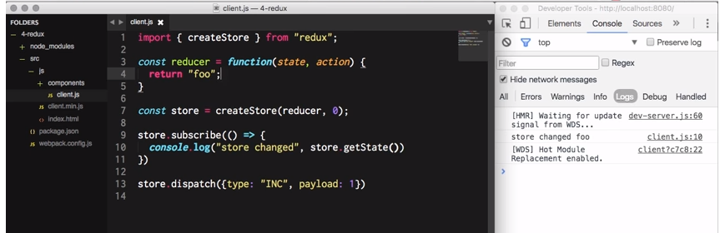

Iteration 2: 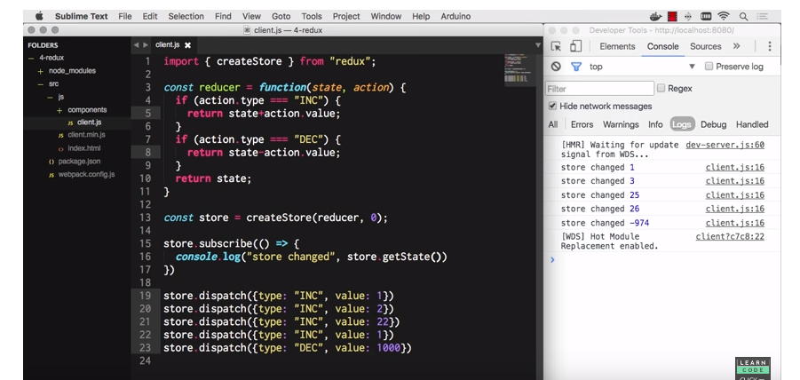

Can be named

Can be named arbitrarily

Must be named ‘type’

**Cons**

**Props in JSX:**