**J - Component**

**Group Members:**

Saptajit Banerjee 20BCE1513

**Title of project:** Authentication System on AWS using React.js and Serverless API

**Abstract:**

In this project, an authentication system will be built on AWS from scratch. This project will use cloud computing concepts. The back-end is a node that uses node.js serverless API with DynamoDB for information storage. The serverless API will use the serverless computing concept which will make the system faster and more secure. It uses bcrypt to encrypt passwords and uses jwt to generate tokens. The front-end will be built using React.js and will be hosted on the AWS S3 bucket.

The system will authorize and register users so that only the registered users can access the premium content which is secured by the system. The non-registered users cannot view the premium content but they can make an account in the system to access it.

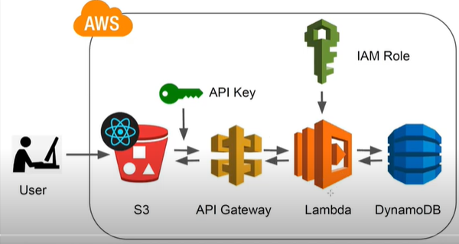

**Software Used:**

1. React.js
2. AWS (Amazon Web Services)

**References:**

1. <https://www.smashingmagazine.com/2017/08/user-authentication-web-ios-apps-aws-cognito-part-1/>
2. <https://www.raywenderlich.com/12931711-using-aws-as-a-back-end-authentication-api>