**To what extent, can Fourier Analysis be used to solve Ordinary Differential Equations and Partial Differential Equations?**

June 2023

Subject: Mathematics Word Count: xxxx

**Contents**

1. Introduction 2
2. Background 2
   1. Differential Equations 2
      1. Why are Differential Equations important? 2
      2. Properties of Differential Equations 3
      3. Solution to Differential Equations 3
      4. ODE vs PDE 4
   2. Fourier Analysis 4
      1. What is Fourier Analysis? 4
      2. Fourier and Inverse Fourier Transforms 5
      3. Fourier Series 5
      4. Properties of the Fourier Transform 6
3. ODE Simplification 8
   1. Bessel’s Equation 8
      1. Brief Derivation 8
      2. Application of the Fourier Transform 9
      3. Boundary Conditions 9
      4. Numerical Solution to Bessel’s Equation 9
4. PDE to ODE Reduction 9
   1. The Heat Equation 9
      1. Brief Derivation 9
      2. Application of the Fourier Transform 9
      3. Boundary Conditions 10
      4. Numerical Solution to Heat Equation 10
   2. The Wave Equation 11
      1. Brief Derivation 11
      2. Application of the Fourier Transform 11
      3. Boundary Conditions 11
      4. Numerical Solution to Wave Equation 11

# Introduction

This year I utilized differential equations to come up with the following ac- curate and applicable epidemic model for policymakers that accounts for disease incubation, quarantine, immunity wear-off, and mortality rates.

*dS βSI*

= −

*dt N*

+ *µR* (1)

*dE βSI*

=

*dt N*

*dI*

− *ϕE* (2)

where:

= *ϕE* − *ζI* − *γI* − *αI* (3)

*dt*

*dQ*

= *ζI* − *κQ* − *ϵQ* (4)

*dt*

*dR*

= *γI* + *κQ* − *µR* (5)

*dt*

*dD*

= *αI* + *ϵQ* (6)

*dt*

* *N* is the total population.
* *β* is the contact rate (1/days).
* *ϕ* is the incubation rate (1/days).
* *ζ* is the quarantine rate (1/days).
* *γ* is the recovery rate (non-quarantine) (1/days).
* *κ* is the recovery rate (quarantine) (1/days).
* *µ* is the immunity wearoff rate (1/days).
* *α* is the case fatality rate (non-quarantine) (1/days).
* *ϵ* is the case fatality rate (quarantine) (1/days).

# Background

## Differential Equations

### Why are Differential Equations important?

Differential Equations are extremely powerful in their ability to model var- ious systems in applied mathematics, physics, and engineering. Calculus is the mathematics of change. Hence, differential equations, which relate the deriva- tives or integrals of a function to the function itself, can very elegantly summa- rize the behavior of otherwise complex, dynamic systems.

For example, the Lotka-Volterra equations describe the dynamics of popu- lations of predators and prey. These equations are described below.

where:

*dx*

= *αx* − *βxy* (7)

*dt*

*dy*

= *δxy* − *γy* (8)

*dt*

* *x* is the population density of the prey.
* *y* is the population density of the predator.
* *α* is the exponential growth rate of the prey.
* *γ* is the exponential decay rate of the predators.
* *β* is the effect of the predators on the prey growth rate.
* *δ* is the effect of the presence of prey on the predator growth rate.

Equations 7 and 8 are a set of first-order, nonlinear ODEs. This is further explained in Section 2.1.2 Properties of Differential Equations.

### Properties of Differential Equations

**Definition 2.1.** The order of a system of differential equations is defined as the highest-order derivative the system contains. Since the highest order derivative

*dt*2

in the Lotka-Volterra Equations 7 and 8 is *d*

*dt*

(no *d*2 ), the equations are first-

order.

**Definition 2.2.** A system of differential equations is said to be linear if and only if the equations follow the form:

*a*0*y* + *a*1*y′* + *a*2*y′′* · · · + *any*(*n*) = *b*(*x*)

where *a*0*, a*1*, a*2*, ..., an* are any differentiable functions (do not need to be linear).

### Solution to Differential Equations

Note that the solution to a differential equation is not one function, but rather a set of functions that all satisfy the differential equation. Some initial conditions must be given to reduce the solution to a single function. For exam- ple, for the Lotka-Volterra equations, the phase space shown in Figure 1 plots the various function solutions given various different initial conditions. The solution for a specific initial condition over time is plotted in Figure 2.

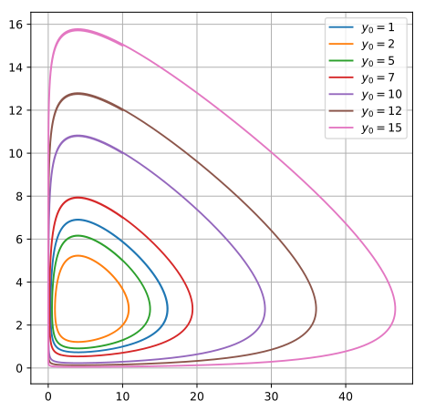

Figure 1: Solution to the Lotka-Volterra Equations given different predator

initial conditions. The predator solution is shifted *π*

2

radians right of the prey

solution.

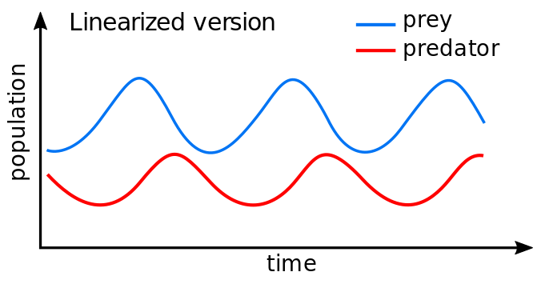

Figure 2: Solution to the Lotka-Volterra Equations given some initial conditions. The predator solution is shifted *π* radians right of the prey solution.

2

### ODE vs PDE

## Fourier Analysis

### What is Fourier Analysis?

Fourier Analysis is a field of mathematics that studies how complex function waveforms can be decomposed into a series of sinusoidal functions, whose fre- quencies form a harmonic series. In other words, the Fourier Transform (FT),

the cornerstone of Fourier Analysis, turns a signal in time space into a signal in frequency space and a signal in real space into a signal in Fourier space.

### Fourier and Inverse Fourier Transforms

**Definition 2.3.** For a continuous function *f* (*x*), the continuous Fourier Trans- form F{*f* (*x*)} (CFT) is defined as below. The transform returns the frequency space function *F* (*ω*).

*F* (*ω*) = F{*f* (*x*)} =

*∞*

*f* (*x*) *e−iωx dx* (9)

❒

*−∞*

**Definition 2.4.** In order to reverse the Fourier Transform, the Inverse Fourier Transform F*−*1{*F* (*ω*)} (IFFT) can be applied as defined below.

1  *∞*

*f* (*x*) = F*−*1{*F* (*ω*)} =

2*π*

*F* (*ω*) *eiωx dω* (10)

*−∞*

### Fourier Series

Let *f* (*x*) be defined as the following periodic, yet discontinuous square wave- form signal (Heaviside Step Function):

1 if *nT < x < T* (2*n*+1) *, n* ∈ Z

2

*f* (*x*) =

2

0 if *x* = *nT , n* ∈ Z

−1 if *T* (2*n*+1) *< x < T* (*n* + 1)*, n* ∈ Z

2

(11)

In order to obtain the Fourier Series for *f* (*x*), the Fourier Transform of *f* (*x*) must be taken.

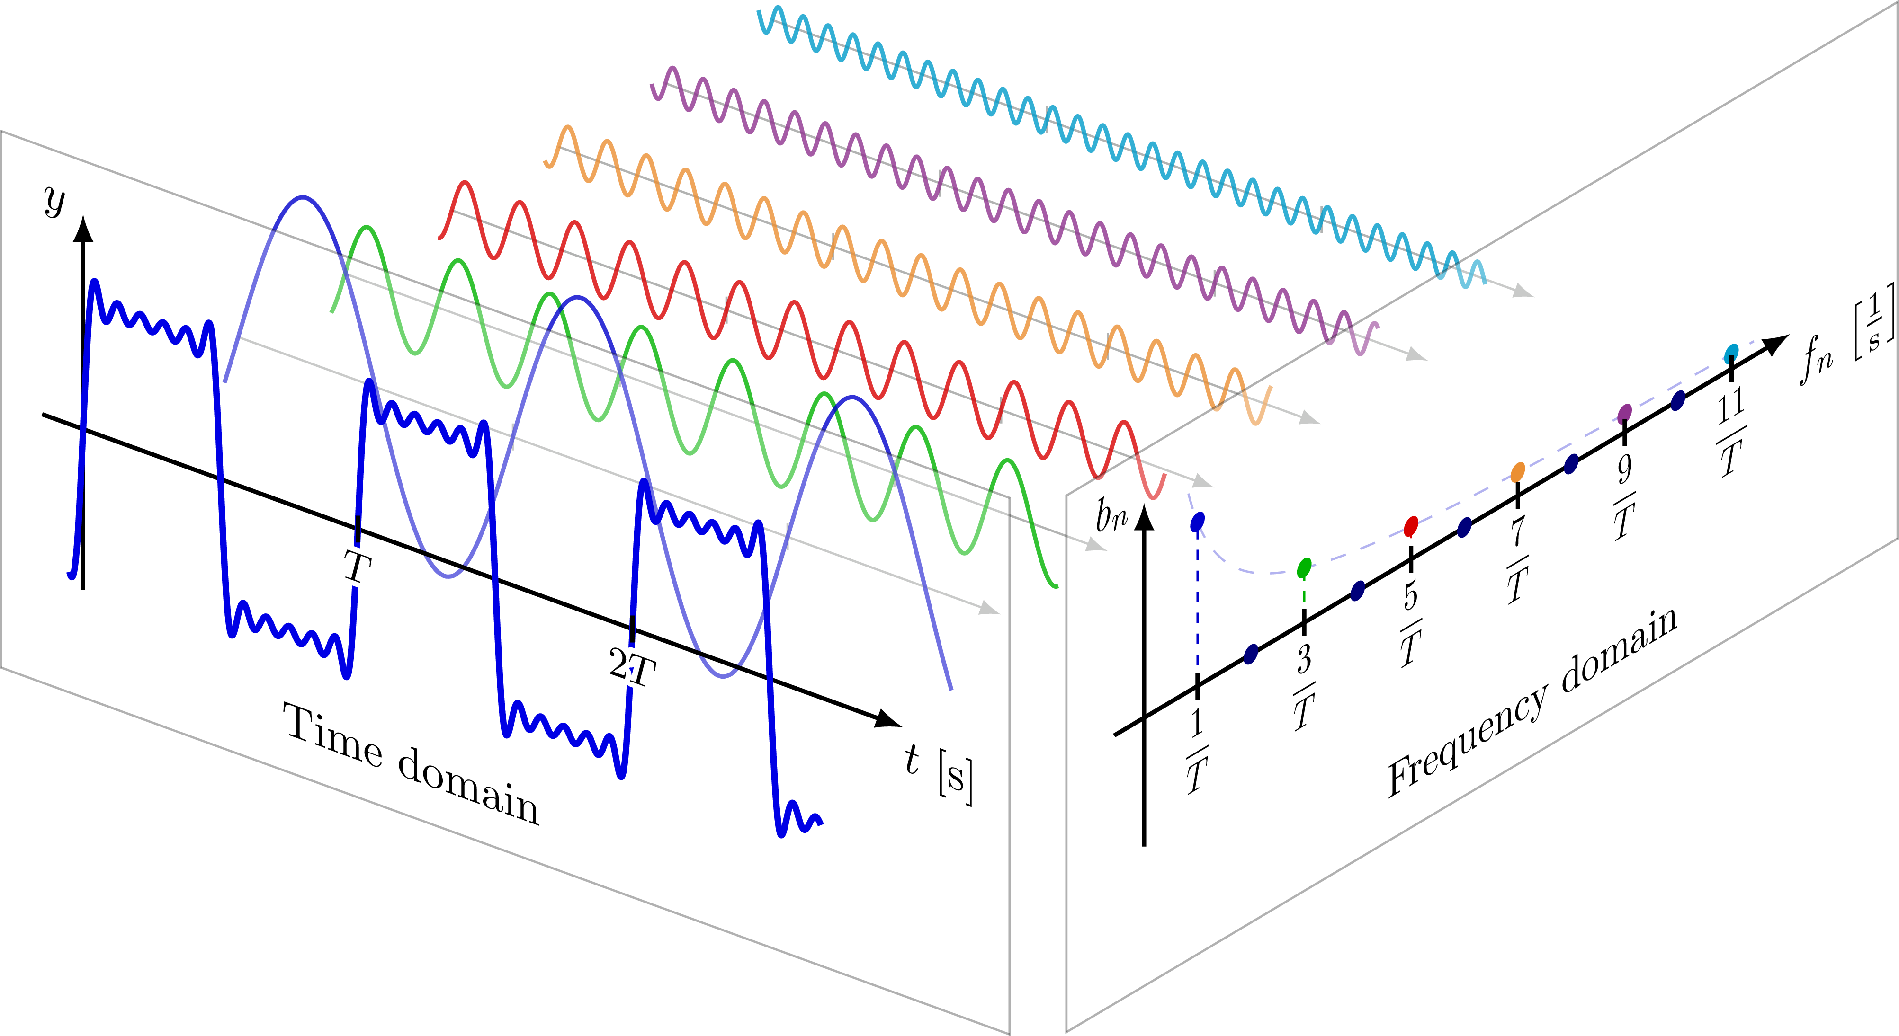

Figure 3: On the axis to the right, the Fourier Transform of *f* (*x*) can be seen. If an infinite summation of all the frequencies with their corresponding ampli- tudes was performed as defined by the Fourier Transform, the solution would be exactly equal to *f* (*x*).

Therefore, f(x) (Equation 10) can be defined by the infinite summation of sine functions through its Fourier Series as follows:

*f* (*x*) =

4 1

*π n*

*∞*

 

*n*=1*,*3*,*5*,...*

sin

2*πnx* 

*T*

### Properties of the Fourier Transform

The Fourier Transform, which is a coordinate transform, is important and useful because many mathematical operations in Fourier space are simplified compared to the original space. Below are some of the important properties of the Fourier Transform that will be useful in solving differential equations using Fourier Analysis.

**Lemma 2.1.** If a function *f* (*x*) is scaled by a constant *a*, the Fourier Transform will also be scaled by *a*.

F{*af* (*x*)} = *a*F{*f* (*x*)} (12)

*Proof.*

F{*af* (*x*)} =

❒ *∞*

*∞*

*af* (*x*) *e−iωx dx*

❒

*−∞*

= *a f* (*x*) *e−iωx dx* = *a*F{*f* (*x*)}

*−∞*

**Theorem 2.1.** The Fourier Transform is a linear transformation. This means that the transform of a linear combination of functions is equal to the linear combination of the transforms of the individual functions.

F{*af* (*x*) + *bg*(*x*)} = *a*F{*f* (*x*)} + *b*F{*g*(*x*)} (13)

*Proof.*

F{*af* (*x*) + *bg*(*x*)} =

❒ *∞*

*∞*

(*af* (*x*) + *bg*(*x*)) *e−iωx dx*

❒

*−∞*

❒ *∞*

=

Using Lemma 2.1,

*af* (*x*) *e−iωx dx* +

*−∞*

*bg*(*x*) *e−iωx dx*

*−∞*

*∞*

❒

= *a f* (*x*) *e−iωx dx* + *b*

*−∞*

*∞*

*g*(*x*) *e−iωx dx*

❒

*−∞*

= *a*F{*f* (*x*)} + *b*F{*g*(*x*)}

**Theorem 2.2.** The Fourier Transform can be shifted easily along the axis of the transform. When a function *f* (*x*) along the x-axis by *x*0 units, the transform of the shifted function is equal to the transform of the original function multiplied by *e−iωx*0 .

*Proof.*

F{*f* (*x* − *x*0)} = *e−iωx*0 *F* (*ω*) (14)

❒ *∞*

F{*f* (*x* − *x*0)} = *f* (*x* − *x*0) *e−iωx dx*

*−∞*

Let *u* = *x* − *x*0. Thus, *x* = *u* + *x*0 and *dx* = *du*.

= *f* (*u*) *e−iω*(*u*+*x*0 ) *dx*

❒ *∞*

*−∞*

❒ *∞*

= *e−iωx*0

*f* (*u*) *e−iωu du*

*−∞*

= *e−iωx*0 *F* (*ω*)

**Theorem 2.3.** The Fourier Transform of a function’s derivative is equal to the transform of the original function multiplied by *iω*.

*Proof.*

*df* (*x*)

F{

*dx*

} = *iω*F{*f* (*x*)} (15)

*df* (*x*)

F{ } =

*dx*

*∞ df* (*x*)

*−∞ dx*

❒

*e−iωx dx*

Using integration by parts, let *u* = *f* (*x*) and *dv* = *e−iωxdx*.

 

= *f* (*x*)*e−iωx*

*∞*

*−∞* −

 

*∞*

*f* (*x*)

❒

*−∞*

*d e−iωx dx dx*

Since *f* (*x*) must be continuous and integrable to be differentiable and take the Fourier Transform on R, lim*x→−∞* = lim*x→∞* = 0 must be true. Thus, the first term is equal to zero.

*∞*

❒

= − *f* (*x*)

*−∞*

−*iωe−iωx dx*

= *iω*

*∞*

*f* (*x*)*e−iωx dx*

❒

*−∞*

= *iω*F{*f* (*x*)}

# ODE Simplification

## Bessel’s Equation

### Brief Derivation

2 *d*2*y dy* 2 2

*x dx*2 + *xdx* + (*x* − *α* )*y* = 0 (16)

To simplify Bessel’s equation using the Fourier-Bessel transform, we can introduce a new variable, *ρ*, defined as:

*x* = *αρ*

where *α* is a constant.

Now, let’s take the Fourier-Bessel transform of Bessel’s equation. The Fourier- Bessel transform of a function *f* (*x*) is defined as:

❒ *∞*

*Fα*(*ρ*) = *f* (*x*)*Jn*(*αρ*)*xdx*

0

where *Jn*(*αρ*) is the Bessel function of the first kind of order n. Applying the Fourier-Bessel transform to Bessel’s equation, we get:

*α*2*ρ*2*d*2*Fα*(*ρ*)

*αρdFα*(*ρ*)

2 2 2

*dρ*2 +

+ (*α ρ*

*dρ*

− *n* )*Fα*(*ρ*) = 0

This transformed equation simplifies to:

*ρ*2*d*2*Fα*(*rho*)

*dρ*2 +

*ρdFα*(*ρ*) + (

*dρ*

*ρ*2 − *n*2

*α*2 )*Fα*(*ρ*) = 0

Notice that this transformed equation no longer contains the derivative with respect to x.

The solution to this transformed equation is given by the Bessel differential equation:

*ρ*2*d*2*Fα*(*ρ*)

*dρ*2 +

*ρdFα*(*ρ*) + (

*dρ*

*ρ*2 − *n*2

*α*2 )*Fα*(*ρ*) = 0

The general solution to the Bessel differential equation is expressed in terms of Bessel functions:

*Fα*(*ρ*) = *c*1*Jn*(*αρ*) + *c*2*Yn*(*αρ*)

where *Jn*(*αρ*) is the Bessel function of the first kind and *Yn*(*αρ*) is the Bessel function of the second kind. c1 and c2 are constants determined by the boundary conditions of the problem.

By taking the inverse Fourier-Bessel transform of *Fα*(*ρ*), we can obtain the solution *y*(*x*) to Bessel’s equation in terms of Bessel functions.

### Application of the Fourier Transform

### Boundary Conditions

### Numerical Solution to Bessel’s Equation

# PDE to ODE Reduction

## The Heat Equation

Fourier Analysis was first discovered when Joseph Fourier first developed the Heat Equation. The Heat Equation models the flow of heat along a certain heat profile over time. In this example, a 1D solution will be derived and solved.

### Brief Derivation

Let us define a rod with the following assumptions:

* + - * The rod is of length *L* and is composed of an homogenous material with a heat diffusion coefficient *α*2.
      * The rod is perfectly insulated along the Y and Z axes. Thus, heat can only flow along the X axis of the rod.
      * The rod is thin enough such that the temperature of the rod at any cross- section is uniform.
      * The rod is initially at a uniform temperature *u*(*x,* 0) = *f* (*x*). Thus, the rod temperature at position *x* at time *t* is *u*(*x, t*).

Thus, the heat equation in one dimension is defined as follows:

*∂u* 2 2

2 *∂*2*u*

Or in subscript notation,

= *α* ∇ *u* = *α*

*∂t*

*∂x*2 (17)

*ut* = *α*2*uxx* (18)

### Application of the Fourier Transform

Since *u*(*x, t*) is defined as the temperature of the rod at position *x* and time *t*, we can apply the Fourier Transform to *u*(*x, t*) with respect to position *x* to reduce the Equation 18 PDE into an ODE. Thus, let *U* (*κ, t*) be the Fourier Transform of *u*(*x, t*) with respect to *x*.

Taking the Fourier Transform of Equation 18 with respect to *x*,

F {*ut*} = F  *α*2*uxx* (19)

Using Lemma 2.1,

F {*ut*} = *α*2F {*uxx*} (20)

Using Theorem 2.3,

*∂*2*u*(*x, t*)

F{ *∂x*2 } = *iκ*F{

*du*(*x, t*)

} (21)

*dx*

= −*κ*2F{*u*(*x, t*)} (22)

= −*κ*2*U* (23)

Therefore,

F {*ut*} = −*α*2*κ*2*U* (24)

*dU* = −*α*2*κ*2*U* (25)

*dt*

### Boundary Conditions

### Numerical Solution to Heat Equation

Equation 34 is a decoupled ODE that can be easily numerically integrated. A numerical solution to Equation 34 using a fifth-order Runge-Kutta approxi- mation in Python is presented below:

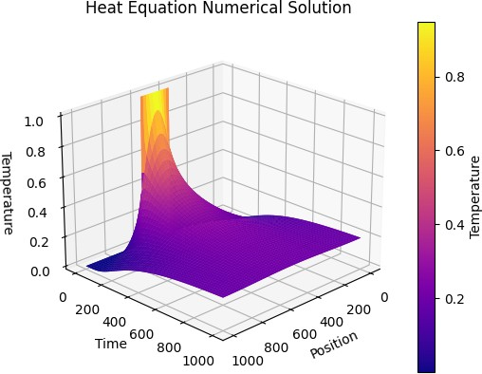

Figure 4: Using a simple square waveform as the initial temperature function of the rod, this plot shows the temperature change along *x* and *t* by performing a numerical integration of Equation 34.

## The Wave Equation

### Brief Derivation

Or in subscript notation,

*∂*2*u*

*∂t*2 = *c*

2 *∂*2*u*

*∂x*2 (26)

*utt* = *c*2*uxx* (27)

### Application of the Fourier Transform

Since *u*(*x, t*) is defined as the displacement of the wave at position *x* and time *t*, we can apply the Fourier Transform to *u*(*x, t*) with respect to position *x* to reduce the Equation 27 PDE into an ODE. Thus, let *U* (*κ, t*) be the Fourier Transform of *u*(*x, t*) with respect to *x*.

Taking the Fourier Transform of Equation 27 with respect to *x*,

F {*utt*} = F  *α*2*uxx* (28)

Using Lemma 2.1,

Using Theorem 2.3,

F {*utt*} = *α*2F {*uxx*} (29)

*∂*2*u*(*x, t*)

F{ *∂x*2 } = *iκ*F{

*du*(*x, t*)

} (30)

*dx*

= −*κ*2F{*u*(*x, t*)} (31)

= −*κ*2*U* (32)

Therefore,

F {*utt*} = −*α*2*κ*2*U* (33)

*d*2*U* 2 2

*dt*2 = −*c κ U* (34)

### Boundary Conditions

### Numerical Solution to Wave Equation