ML Lab 8

Name: Saptanshu Wanjari

Class: A-A2

Roll No: 18
Lab No.: 8
Lab Aim and Objective: Implement Support Vector Machine (SVM) classification on the AI4I 2020 Predictive Maintenance Dataset, compare the linear and RBF kernels, and tune the model using GridSearchCV.
Dataset or Resources Used: AI4I 2020 Predictive Maintenance Dataset (UCI Machine Learning Repository), 10,000 rows and 14 columns. Target is Machine failure (9661 no failure, 339 failure). Input features used: Air temperature, Process temperature, Rotational speed, Torque, Tool wear and Product Type.
Date of Performance: 24 October 2026

1. Theory

1.1 Support Vector Machine
Support Vector Machine is a supervised classification algorithm that tries to draw the best boundary between two classes. It looks for the boundary with the largest margin, which is the biggest possible gap between the boundary and the closest points of both classes. Those closest points are called support vectors and they decide where the boundary sits. When the data cannot be separated by a straight line, SVM uses a kernel to work in a higher dimension where a plane can separate the classes. The linear kernel gives a straight boundary and the RBF kernel can give a curved one. The C parameter controls how much the model punishes mistakes, and gamma controls how far the effect of one training point reaches in the RBF kernel.

1.2 Techniques Applied
• ColumnTransformer with StandardScaler: scales the five numeric features so rpm, torque and temperature come to a similar range.
• OneHotEncoder for Type: converts the L, M and H product types into separate 0/1 columns.
• Pipeline: keeps scaling and encoding inside the model, so they are fit only on the training data and there is no data leakage.
• Stratified train_test_split (80/20, random_state 42): keeps the same small share of failures in both train and test sets.
• Linear and RBF SVM: compared a straight boundary with a curved one on the same preprocessed data.
• GridSearchCV (5-fold, scoring f1): tried kernel, C and gamma combinations and picked the best one by cross-validation.
• Accuracy, precision, recall, F1 and confusion matrix: because the failure class is only 3.39% of the data, recall and F1 matter more than accuracy.

2. Code with GitHub URL
The complete code for this lab is written in a Jupyter Notebook and uploaded to GitHub:
https://github.com/SaptanshuWanjari/3rd-Year-/blob/main/ML/lab/lab8/Lab_8_A_18_Saptanshu_Wanjari.ipynb
https://github.com/SaptanshuWanjari/3rd-Year-/blob/main/ML/lab/lab8/Lab_8_A_18_Saptanshu_Wanjari.py
The complete written code is given below:
#!/usr/bin/env python
# coding: utf-8
# ## Machine Learning Lab - 8
#
# ### Name : Saptanshu Wanjari
#
# ### Class : A-A2
#
# ### Roll no : 18
# In[1]:
import pandas as pd
import numpy as np
import matplotlib.pyplot as plt
import seaborn as sns
from sklearn.model_selection import train_test_split, GridSearchCV
from sklearn.preprocessing import StandardScaler, OneHotEncoder
from sklearn.compose import ColumnTransformer
from sklearn.pipeline import Pipeline
from sklearn.svm import SVC
from sklearn.metrics import (
accuracy_score,
precision_score,
recall_score,
f1_score,
classification_report,
confusion_matrix,
ConfusionMatrixDisplay
)
import warnings
warnings.filterwarnings('ignore')
# In[2]:
df=pd.read_csv("ai4i2020.csv")
# In[3]:
df.head()
# In[4]:
df.tail()
# In[5]:
df.shape
# In[6]:
df.columns
# In[7]:
df.dtypes
# In[8]:
df.info()
# In[9]:
df.describe()
# In[10]:
df.isnull().sum()
# In[11]:
df.duplicated().sum()
# In[12]:
df["Type"].unique()
# In[13]:
df["Machine failure"].value_counts()
# In[14]:
numerical_features = [
"Air temperature [K]",
"Process temperature [K]",
"Rotational speed [rpm]",
"Torque [Nm]",
"Tool wear [min]"
]
df[numerical_features].hist(figsize=(15, 10), bins=30)
plt.show()
# In[15]:
plt.figure(figsize=(6,4))
sns.countplot(x="Machine failure", data=df)
plt.title("Distribution of Machine Failure")
plt.xlabel("Machine Failure")
plt.ylabel("Number of Machines")
plt.show()
# In[18]:
plt.figure(figsize=(12,8))
for i, column in enumerate(numerical_features,1):
plt.subplot(2,3,i)
sns.boxplot(y=df[column])
plt.title(column)
plt.tight_layout()
plt.show()
# In[19]:
plt.figure(figsize=(12,7))
correlation = df[numerical_features + ["Machine failure"]].corr()
sns.heatmap(correlation, annot=True, cmap="coolwarm", fmt=".2f")
plt.title("Correlation Heatmap")
plt.show()
# In[20]:
for column in numerical_features:
plt.figure(figsize=(7,4))
sns.boxplot(x="Machine failure", y=column, data=df)
plt.title(f"{column} Vs Machine failure")
plt.show()
# In[21]:
plt.figure(figsize=(7,5))
sns.countplot(x="Type",hue="Machine failure",data=df)
plt.title("Machine failure by product Type")
plt.xlabel("Product type")
plt.ylabel("Count")
plt.show()
# In[22]:
X= df[
[
"Air temperature [K]",
"Process temperature [K]",
"Rotational speed [rpm]",
"Torque [Nm]",
"Tool wear [min]",
"Type"
]
]
# In[23]:
y=df["Machine failure"]
# In[24]:
print("Input shape",X.shape)
print("Output shape",y.shape)
# In[25]:
categorical_features =["Type"]
numerical_features =[
"Air temperature [K]",
"Process temperature [K]",
"Rotational speed [rpm]",
"Torque [Nm]",
"Tool wear [min]"
]
# In[26]:
X_train, X_test, y_train, y_test = train_test_split(X, y, test_size=0.2, random_state=42, stratify=y)
print("Training samples:", X_train.shape[0])
print("Testing samples:", X_test.shape[0])
# In[27]:
processor = ColumnTransformer(
transformers=[
("num",StandardScaler(),numerical_features),
("cat",OneHotEncoder(handle_unknown='ignore'),categorical_features)
]
)
# In[28]:
linear_svm = Pipeline(
steps=[("preprocessor", processor), ("classifier", SVC(kernel="linear"))]
)
linear_svm.fit(X_train, y_train)
# In[29]:
y_pred_linear = linear_svm.predict(X_test)
# In[30]:
accuracy_linear = accuracy_score(y_test, y_pred_linear)
precision_linear = precision_score(y_test, y_pred_linear)
recall_linear = recall_score(y_test, y_pred_linear)
f1_linear = f1_score(y_test, y_pred_linear)
print("Accuracy:", accuracy_linear)
print("Precision:", precision_linear)
print("Recall:", recall_linear)
print("F1 Score:", f1_linear)
# In[31]:
print(
classification_report(
y_test,
y_pred_linear,
target_names=["No Failure", "Failure"],
zero_division=0
)
)
# In[32]:
cm_linear = confusion_matrix(y_test, y_pred_linear)
plt.figure(figsize=(6, 4))
sns.heatmap(cm_linear, annot=True, fmt="d", cmap="Set2",
xticklabels=["No Failure","Failure"],
yticklabels=["No Failure","Failure"]
)
plt.xlabel("Predicted")
plt.ylabel("Actual")
plt.title("Confusion Matrix - Linear SVM")
plt.show()
# In[33]:
rbf_svm = Pipeline(
steps=[("preprocessor", processor), ("classifier", SVC(kernel="rbf"))]
)
rbf_svm.fit(X_train, y_train)
# In[34]:
y_pred_rbf = rbf_svm.predict(X_test)
# In[35]:
accuracy_rbf = accuracy_score(y_test, y_pred_rbf)
precision_rbf = precision_score(y_test, y_pred_rbf)
recall_rbf = recall_score(y_test, y_pred_rbf)
f1_rbf = f1_score(y_test, y_pred_rbf)
print("RBF SVM Results")
print("Accuracy:", accuracy_rbf)
print("Precision:", precision_rbf)
print("Recall:", recall_rbf)
print("F1 Score:", f1_rbf)
# In[36]:
print(classification_report(y_test,y_pred_rbf,target_names= ["No Failure","Failure"],zero_division=0))
# In[37]:
cm_rbf = confusion_matrix(y_test, y_pred_rbf)
plt.figure(figsize=(6, 4))
sns.heatmap(cm_rbf, annot=True, fmt="d", cmap="Set2",
xticklabels=["No Failure","Failure"],
yticklabels=["No Failure","Failure"]
)
plt.xlabel("Predicted")
plt.ylabel("Actual")
plt.title("Confusion Matrix - RBF SVM")
plt.show()
# In[38]:
comparison =pd.DataFrame({
"Model": ["Linear SVM", "RBF SVM"],
"Accuracy": [accuracy_linear, accuracy_rbf],
"Precision": [precision_linear, precision_rbf],
"Recall": [recall_linear, recall_rbf],
"F1 Score": [f1_linear, f1_rbf]
})
comparison
# In[39]:
comparison_plot = comparison.set_index("Model")
comparison_plot.plot(
kind="bar",
figsize=(10,6)
)
plt.title("Comparison of SVM Kernels")
plt.xlabel("SVM Kernel")
plt.ylabel("Score")
plt.ylim(0,1)
plt.xticks(rotation=0)
plt.legend(bbox_to_anchor=(1.05, 1), loc="upper left")
plt.tight_layout()
plt.show()
# In[41]:
param_grid = [
{"classifier__kernel": ["linear"], "classifier__C": [0.1, 1, 10]},
{"classifier__kernel": ["rbf"], "classifier__C": [1, 10, 50], "classifier__gamma": ["scale", 0.05, 0.1]}
]
# In[42]:
grid_search = GridSearchCV(
estimator=pipeline,
param_grid=param_grid,
scoring="f1",
cv=5,
n_jobs=1,
verbose=1
)
# In[43]:
grid_search.fit(X_train, y_train)
print("GridSearchCV completed successfully.")
# In[44]:
print("Best Parameters:")
print(grid_search.best_params_)
# In[45]:
print("Best Cross-Validation F1 Score:",grid_search.best_score_)
# In[46]:
best_model = grid_search.best_estimator_
y_pred_tuned = best_model.predict(X_test)
# In[47]:
accuracy_tuned = accuracy_score(y_test, y_pred_tuned)
precision_tuned = precision_score(y_test, y_pred_tuned, zero_division=0)
recall_tuned = recall_score(y_test, y_pred_tuned, zero_division=0)
f1_tuned = f1_score(y_test, y_pred_tuned, zero_division=0)
print("Tuned Model Results")
print("Accuracy:", accuracy_tuned)
print("Precision:", precision_tuned)
print("Recall:", recall_tuned)
print("F1 Score:", f1_tuned)
# In[48]:
final_comparison = pd.DataFrame({
"Model": ["Linear SVM", "RBF SVM", "Tuned SVM"],
"Accuracy": [accuracy_linear, accuracy_rbf, accuracy_tuned],
"Precision": [precision_linear, precision_rbf, precision_tuned],
"Recall": [recall_linear, recall_rbf, recall_tuned],
"F1 Score": [f1_linear, f1_rbf, f1_tuned]
})
final_comparison
# In[49]:
final_comparison.set_index("Model").plot(kind="bar", figsize=(11, 6))
plt.title("Performance Comparison of Original and Tuned Models")
plt.xlabel("Model")
plt.ylabel("Score")
plt.ylim(0, 1.1)
plt.xticks(rotation=0)
plt.legend(bbox_to_anchor=(1.05, 1), loc="upper left")
plt.tight_layout()
plt.show()

3. Procedures and Materials Used

3.1 Materials Used
• Hardware: my laptop with a normal CPU (SVM and GridSearchCV ran on CPU, it just took a little time).
• Software: Python 3 with pandas, numpy, matplotlib, seaborn and scikit-learn, run inside Jupyter Notebook.

3.2 Procedure
1. Imported pandas, numpy, matplotlib, seaborn and the required scikit-learn modules.
2. Loaded ai4i2020.csv into a DataFrame with read_csv.
3. Checked the first and last rows, shape, column names, data types and summary with head, tail, shape, columns, dtypes, info and describe.
4. Checked missing values with isnull().sum() and duplicates with duplicated().sum().
5. Checked the unique product types and the count of Machine failure.
6. Plotted histograms and a count plot for the failure classes.
7. Plotted box plots and a correlation heatmap for the numeric features.
8. Plotted box plots of each feature against Machine failure and a Type vs failure count plot.
9. Selected the six input features and set Machine failure as the target.
10. Split the data into 80% training and 20% testing with stratify=y.
11. Built a ColumnTransformer with StandardScaler for numeric columns and OneHotEncoder for Type.
12. Trained a linear SVM pipeline and predicted the test set.
13. Calculated accuracy, precision, recall and F1 for the linear SVM.
14. Printed the classification report and drew the linear SVM confusion matrix.
15. Trained an RBF SVM pipeline and repeated the same evaluation.
16. Compared the linear and RBF results in a table and a bar chart.
17. Ran GridSearchCV over linear and RBF kernels with different C and gamma values.
18. Printed the best parameters and the best cross-validation F1 score.
19. Evaluated the tuned model on the test set.
20. Made the final comparison table and bar chart for all three models.

4. Output Screenshots with Descriptions

Output 1 – First Five Rows
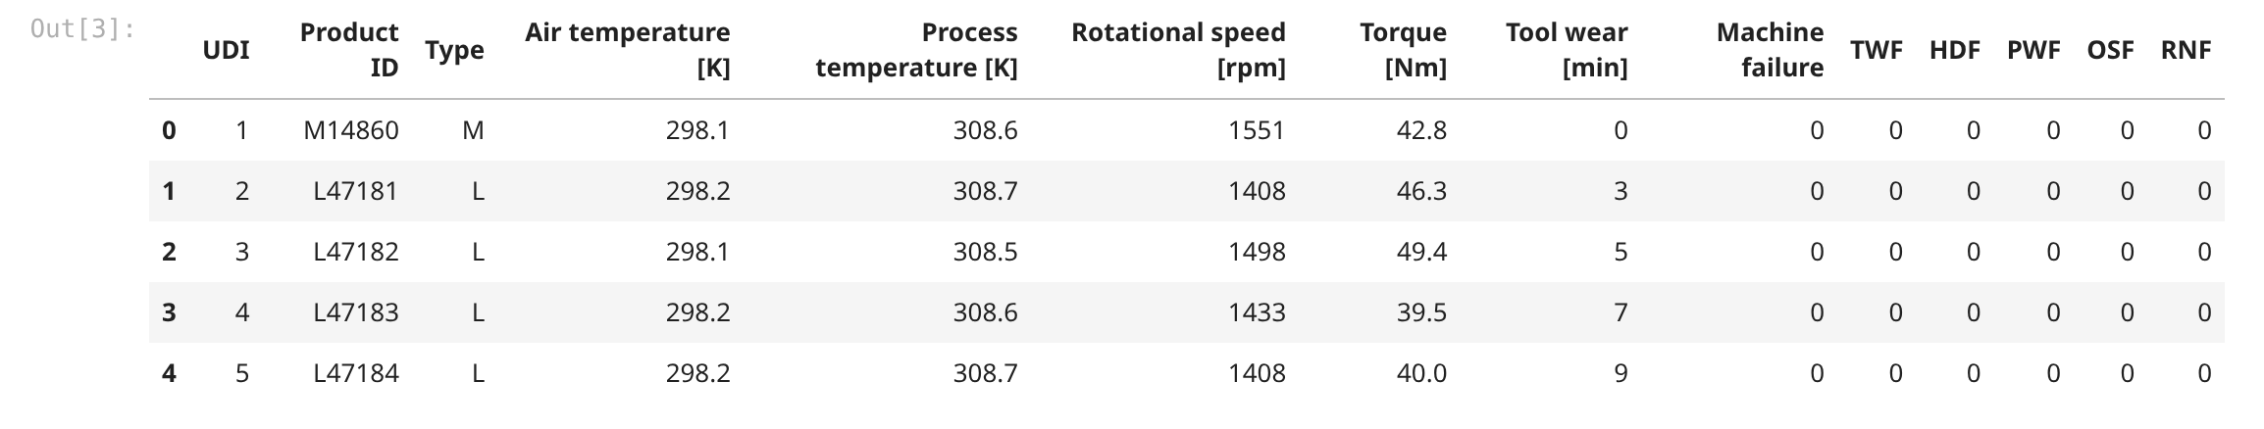
First five rows of ai4i2020.csv. There are 14 columns including UDI, Product ID and Type. The last five columns TWF, HDF, PWF, OSF and RNF are separate failure flags, so I did not use them as input.

Output 2 – Dataset Info
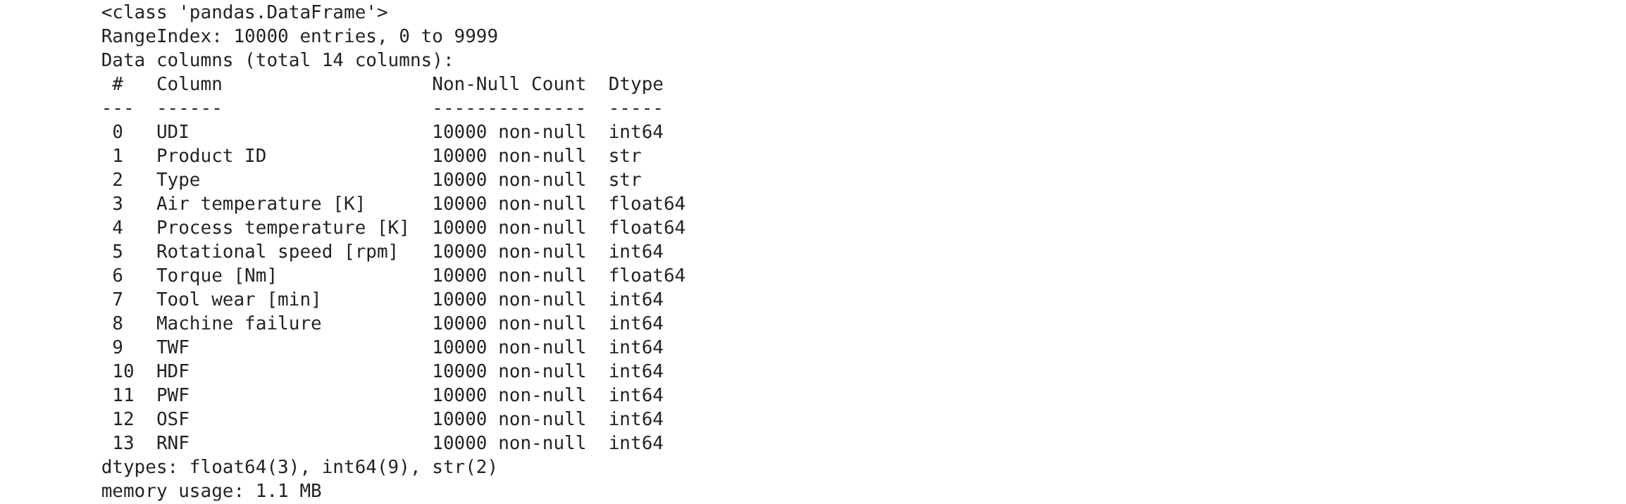
df.info() output. The dataset has 10,000 rows and 14 columns, and none of them have null values. Type and Product ID are strings and the rest are numbers.

Output 3 – Missing Values
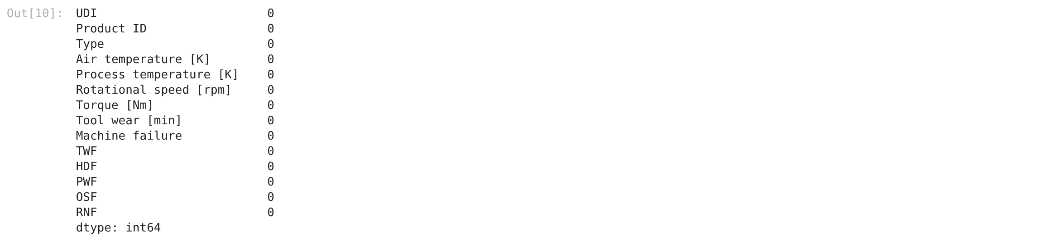
Missing value count for every column. All of them are 0, so the data was already clean. The duplicate check also gave 0.

Output 4 – Failure Counts
value_counts of the Machine failure column. 9661 rows are normal and only 339 are failures, so the classes are very imbalanced. This is why accuracy alone can be misleading here.

Output 5 – Histograms
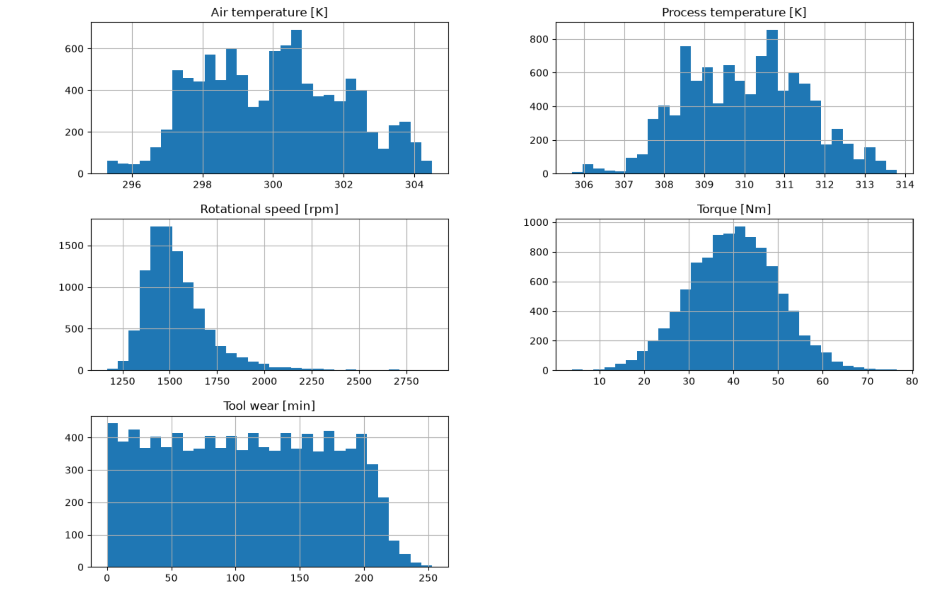
Histograms of the five numeric features with 30 bins. Air and process temperature look almost normal, tool wear is spread from 0 to 253, and rotational speed has a long right tail.

Output 6 – Correlation Heatmap
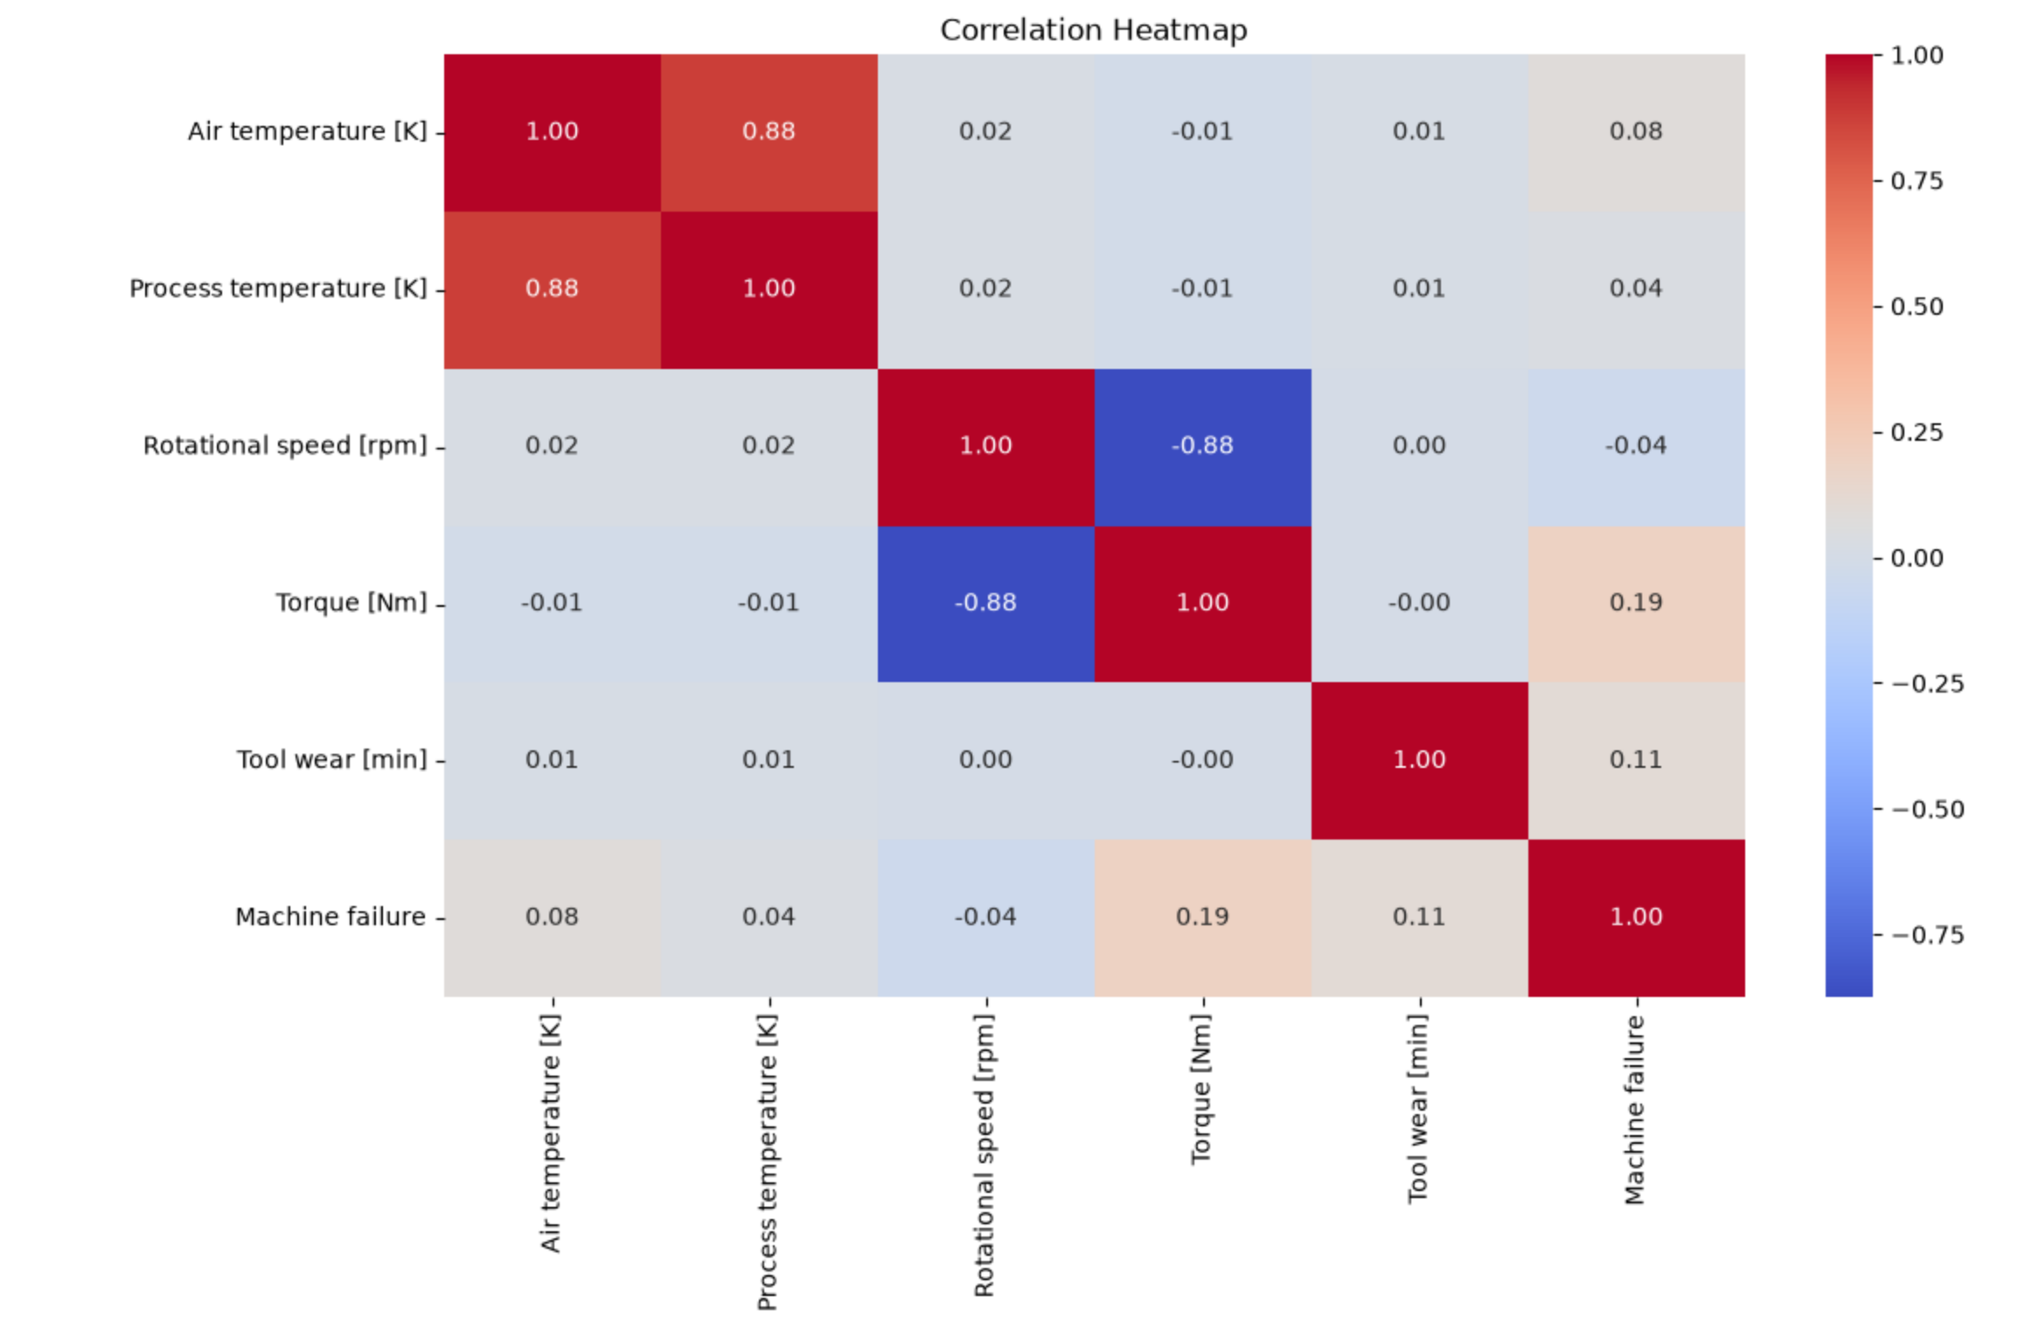
Correlation heatmap of the numeric features and the target. Air temperature and process temperature are strongly positively correlated, and torque and rotational speed are negatively correlated. None of the features has a high correlation with Machine failure.

Output 7 – Train/Test Split
Train/test split output. The input has 10,000 rows and 6 columns, and the split gave 8000 training rows and 2000 testing rows. I used stratify=y so the small failure class is shared between both sets.

Output 8 – Linear SVM Scores
Linear SVM scores. Accuracy is 96.6% but precision, recall and F1 are all 0. The model predicted every test row as no failure, so it did not find a single failure.

Output 9 – RBF SVM Scores
RBF SVM scores. Accuracy is 97.2%, precision 0.875 and recall only 0.2058. So when it says failure it is usually right, but it catches only about 21% of the actual failures.

Output 10 – Best Parameters
Best parameters from GridSearchCV. The best model is RBF with C=50 and gamma='scale'. GridSearch tried 12 combinations with 5 folds, so 60 fits in total.

Output 11 – Tuned Model Results
Tuned SVM results on the test set. Accuracy went up to 98%, recall improved to 0.60 and F1 to 0.67. The tuned model finds many more failures than the plain RBF model.

Output 12 – Final Comparison
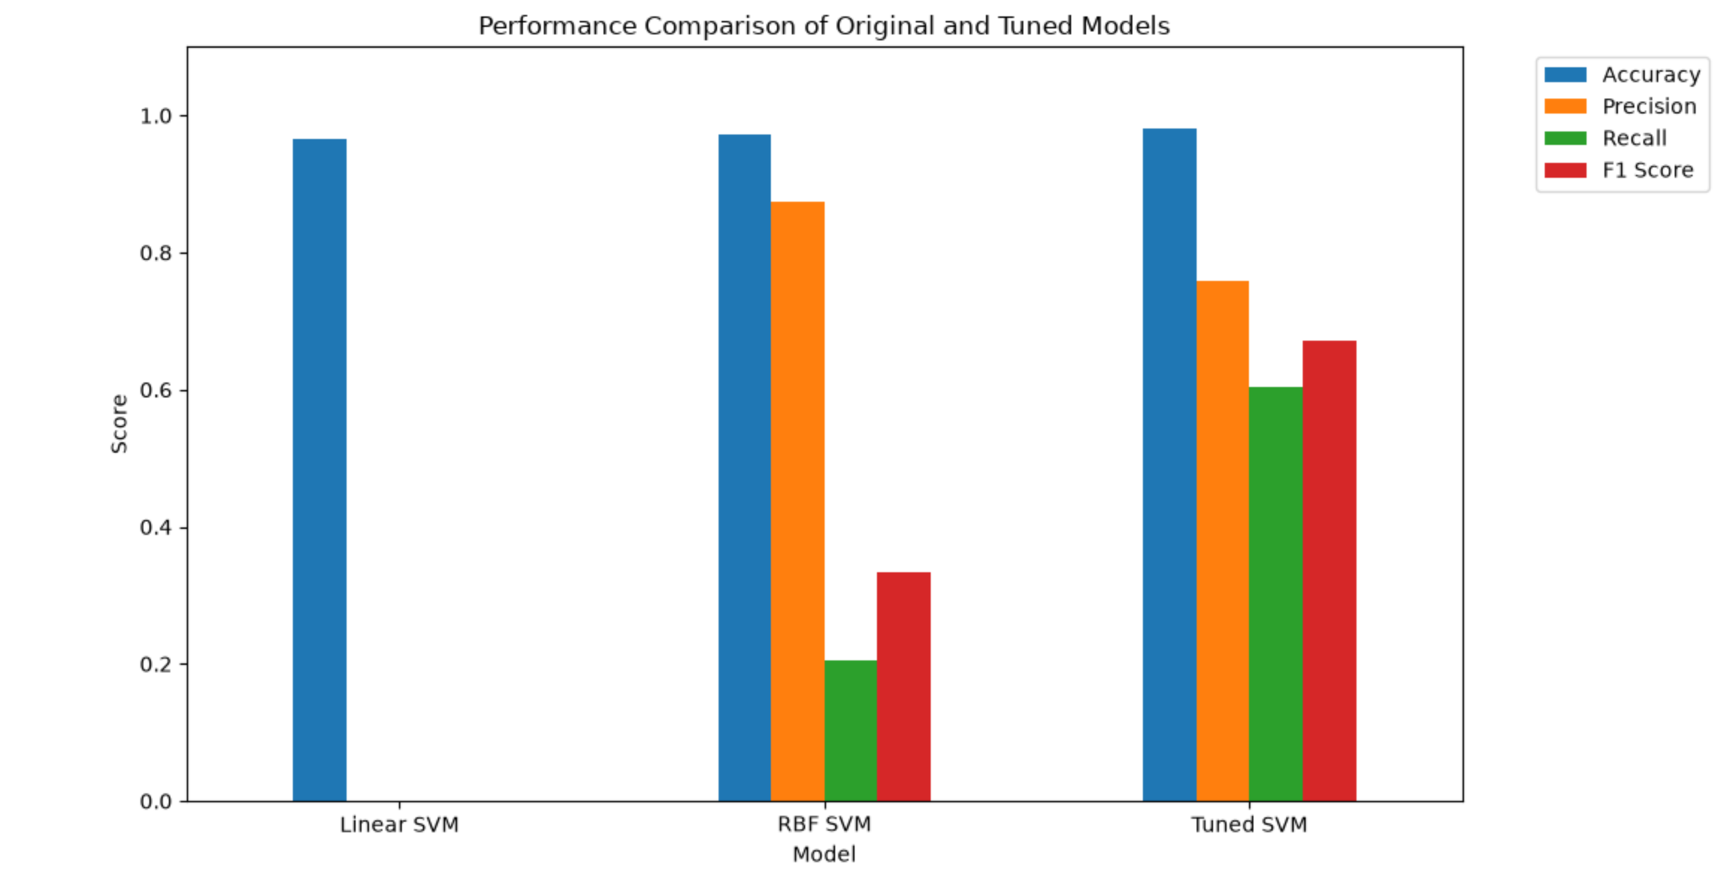
Bar chart comparing all three models on the four metrics. Linear SVM has good accuracy but zero on the failure class, and the tuned SVM has the best F1. The accuracy of all three is close because most rows are normal.

5. Viva Questions and Solutions
Q1. What is a Support Vector Machine?
Solution: It is a classification algorithm that finds the boundary with the largest margin between the classes. The closest points to the boundary are called support vectors and they decide where the boundary goes. A new point is classified by which side of the boundary it falls on.
Q2. What is a kernel, and what is the difference between linear and RBF?
Solution: A kernel lets SVM separate data that is not linearly separable by working in a higher dimension without actually calculating the coordinates. The linear kernel draws a straight boundary, and the RBF kernel can draw a curved boundary. RBF worked better here because the failure data is not linearly separable.
Q3. What do the C and gamma parameters do?
Solution: C controls the penalty for misclassification. A large C tries hard to classify every training point correctly, which can overfit. Gamma controls how far the influence of a single point reaches in the RBF kernel; a small gamma means far and a large gamma means close. GridSearch picked C=50 and gamma = scale.
Q4. Why did we scale the features and use a Pipeline?
Solution: The features have very different ranges, like rpm in thousands and torque around 40, so StandardScaler brings them to a similar scale. The pipeline makes sure scaling and one-hot encoding are fit only on the training data and then applied to the test data, so there is no data leakage.
Q5. Why is accuracy not a good metric here?
Solution: Only 339 out of 10,000 rows are failures. A model that always predicts no failure still gets 96.6% accuracy but catches zero failures, which is exactly what the linear SVM did. So recall and F1 for the failure class matter much more than plain accuracy.

