ML Lab 7

Name: Saptanshu Wanjari

Class: A-A2

Roll No: 18
Lab No.: 7
Lab Aim and Objective: Implement Gaussian Naive Bayes classification on the Raisin Dataset and evaluate the model with accuracy, precision, recall, F1 score and a confusion matrix.
Dataset or Resources Used: Raisin Dataset (UCI Machine Learning Repository), 900 samples, 7 numeric features (Area, MajorAxisLength, MinorAxisLength, Eccentricity, ConvexArea, Extent, Perimeter) and 2 classes (Kecimen 450, Besni 450).
Date of Performance: 24 October 2026

1. Theory

1.1 Naive Bayes Classification
Naive Bayes is a classification algorithm based on Bayes' theorem. For a new sample it calculates the probability of each class given the feature values and picks the class with the highest probability. It is called naive because it assumes that all the features are independent of each other given the class. That is not really true for raisin measurements, because Area, ConvexArea and Perimeter are strongly related, but the model still works well and is very fast. Gaussian Naive Bayes is the version used when the features are continuous numbers. For every feature and every class it learns a mean and a standard deviation from the training data, and then uses the normal distribution to get the likelihood of a value.

1.2 Techniques Applied
• LabelEncoder: turned the Class column (Kecimen, Besni) into 1 and 0 because scikit-learn models need numeric labels.
• train_test_split (80/20, random_state 42): gave 720 rows for training and 180 rows for testing, and keeps the same split every time.
• GaussianNB with default var_smoothing 1e-9: the model learns a mean and variance for each feature in each class.
• Accuracy, weighted precision, weighted recall and weighted F1: accuracy alone can hide which class is doing badly, so I printed all four.
• Confusion matrix heatmap: shows the exact number of correct and wrong predictions for both classes.
• var_smoothing loop from 1e-12 to 1e-2: checks whether changing the smoothing value changes the accuracy.

2. Code with GitHub URL
The complete code for this lab is written in a Jupyter Notebook and uploaded to GitHub:
https://github.com/SaptanshuWanjari/3rd-Year-/blob/main/ML/lab/lab7/Lab_7_A_18_Saptanshu_Wanjari.ipynb
https://github.com/SaptanshuWanjari/3rd-Year-/blob/main/ML/lab/lab7/Lab_7_A_18_Saptanshu_Wanjari.py
The complete written code is given below:
#!/usr/bin/env python
# coding: utf-8
# ## Machine Learning Lab - 7
#
# ### Name : Saptanshu Wanjari
#
# ### Class : A-A2
#
# ### Roll no : 18
# In[1]:
import pandas as pd
import numpy as np
import matplotlib.pyplot as plt
import seaborn as sns
from sklearn.model_selection import train_test_split
from sklearn.preprocessing import LabelEncoder
from sklearn.naive_bayes import GaussianNB
from sklearn.metrics import accuracy_score, confusion_matrix, classification_report,ConfusionMatrixDisplay,precision_score,recall_score,f1_score
# In[2]:
pd.set_option('display.max_columns',None)
# In[3]:
df=pd.read_excel('Raisin_Dataset.xlsx')
# In[4]:
df.head()
# In[5]:
df.tail()
# In[6]:
df.info()
# In[7]:
df.describe()
# In[8]:
df.isnull().sum()
# In[9]:
df.dtypes
# In[10]:
df.duplicated().sum()
# In[11]:
df['Class'].unique()
# In[12]:
df['Class'].value_counts()
# **BAR PLOT**
# In[13]:
plt.figure(figsize=(10,5))
sns.countplot(x="Class",data=df)
plt.title("Distribution of Raisin Classes")
plt.xlabel("Raisin Class")
plt.ylabel("Number of Samples")
plt.show()
# **PIE-CHART**
# In[14]:
class_counts = df['Class'].value_counts()
plt.figure(figsize=(8, 8))
plt.pie(class_counts, labels=class_counts.index, autopct='%1.1f%%', startangle=90)
plt.title('Distribution of Raisin Classes')
plt.show()
# In[15]:
numerical_features=df.select_dtypes(include=np.number).columns
print(numerical_features.tolist())
# **HISTOGRAM**
# In[16]:
df[numerical_features].hist(figsize=(15,10))
plt.suptitle("Distribution of Numerical Features",y=1.02,fontsize=16)
plt.tight_layout()
plt.show()
# **BOX PLOT**
# In[17]:
plt.figure(figsize=(15,10))
for i,column in enumerate(numerical_features):
plt.subplot(3,3,i+1)
sns.boxplot(y=df[column],color='skyblue')
plt.tight_layout()
plt.title(column)
plt.tight_layout()
plt.show()
# **HISTOGRAM WITH KDE FUNCTION**
# In[18]:
for column in numerical_features:
plt.figure(figsize=(8,6))
sns.histplot(data=df,x=column,hue="Class",kde=True,bins=25)
plt.title(f"{column} Distribution by Class")
plt.xlabel(column)
plt.ylabel("Frequency")
plt.show()
# **CORRELATION MATRIX**
# In[19]:
correlation_matrix=df[numerical_features].corr()
plt.figure(figsize=(10,8))
sns.heatmap(correlation_matrix,annot=True,cmap='coolwarm',fmt=".2f")
plt.title("Correlation Matrix")
plt.show()
# In[20]:
plt.figure(figsize=(10,6))
sns.scatterplot(data=df,x='Area',y='Perimeter',palette={'Kecimen':'Green','Besni':'blue'},hue='Class')
plt.title("Area vs Perimeter")
plt.xlabel("Area")
plt.ylabel("Perimeter")
plt.show()
# In[21]:
plt.figure(figsize=(10,6))
sns.scatterplot(data=df,x='MajorAxisLength',y='MinorAxisLength',s=70,hue='Class')
plt.title("MajorAxisLength vs MinorAxislength")
plt.show()
# **DATA PREPROCESSING**
# In[22]:
label_encoder=LabelEncoder()
df['Class_encoded']=label_encoder.fit_transform(df['Class'])
print(df[['Class','Class_encoded']].head(10))
# In[23]:
print("Class Mapping:")
for index,class_name in enumerate(label_encoder.classes_):
print(f"{index} : {class_name}")
# In[24]:
X=df[numerical_features]
y=df["Class_encoded"]
print("X shape",X.shape)
print("Y shape",y.shape)
# In[25]:
X_train,X_test,y_train,y_test=train_test_split(X,y,test_size=0.2,random_state=42)
print("Training Samples:",X_train.shape[0])
print("Testing Samples:",X_test.shape[0])
# In[26]:
GaussianNB()
# In[27]:
gnb=GaussianNB()
gnb.fit(X_train,y_train)
# In[28]:
y_pred=gnb.predict(X_test)
print(y_pred)
# In[29]:
comparison=pd.DataFrame({'Actual':y_test,'Predicted':y_pred})
print(comparison.head(10))
# In[30]:
comparison["Actual Class"]=label_encoder.inverse_transform(comparison["Actual"])
comparison["Predicted Class"]=label_encoder.inverse_transform(comparison["Predicted"])
print(comparison.head(10))
# In[31]:
accuracy=accuracy_score(y_test,y_pred)
print("Accuracy:",accuracy)
print("Accuracy Percentage:",accuracy*100,"%")
# In[32]:
precision=precision_score(y_test,y_pred,average='weighted')
print("Precision:",precision)
print("Precision Percentage:",precision*100,"%")
# In[33]:
recall=recall_score(y_test,y_pred,average='weighted')
print("Recall:",recall)
print("Recall Percentage:",recall*100,"%")
# In[34]:
f1=f1_score(y_test,y_pred,average='weighted')
print("F1 Score:",f1)
print("F1 Score Percentage:",f1*100,"%")
# In[35]:
print("=========MODEL PERFORMANCE=========")
print("Accuracy:",accuracy*100,"%")
print("Precision:",precision*100,"%")
print("Recall:",recall*100,"%")
print("F1 Score:",f1*100,"%")
# In[36]:
print("Classification Report:")
print(classification_report(y_test,y_pred,target_names=label_encoder.classes_))
# In[37]:
cm=confusion_matrix(y_test,y_pred)
print("Confusion Matrix:")
print(cm)
# In[38]:
plt.figure(figsize=(8,6))
sns.heatmap(cm,annot=True,fmt="d",cmap="Blues",xticklabels=label_encoder.classes_,yticklabels=label_encoder.classes_)
plt.xlabel("Predicted Class")
plt.ylabel("Actual Class")
plt.title("Confusion Matrix - Gaussian Naive bayes")
plt.show()
# In[39]:
from sklearn.metrics import accuracy_score
y_train_pred=gnb.predict(X_train)
y_test_pred=gnb.predict(X_test)
test_accuracy=accuracy_score(y_test,y_test_pred)
print("Testing Accuracy:",test_accuracy)
print("Testing Accuracy Percentage:",test_accuracy*100,"%")
train_accuracy=accuracy_score(y_train,y_train_pred)
print("Training Accuracy:",train_accuracy)
print("Training Accuracy Percentage:",train_accuracy*100,"%")
#
# In[40]:
GaussianNB(priors=None)
# **MAIN_HYPERPARAMETERS**
# In[41]:
GaussianNB(var_smoothing=1e-9)
# In[42]:
print(gnb.get_params())
# In[43]:
smoothing_values=[1e-12,1e-10,1e-9,1e-8,1e-7,1e-6,1e-5,1e-4,1e-3,1e-2]
result=[]
for var in smoothing_values:
model=GaussianNB(var_smoothing=var)
model.fit(X_train,y_train)
prediction=model.predict(X_test)
acc=accuracy_score(y_test,prediction)
prec=precision_score(y_test,prediction)
rec=recall_score(y_test,prediction)
f1=f1_score(y_test,prediction)
result.append([var,acc,prec,rec,f1])
# In[44]:
results_df=pd.DataFrame(result,columns=["var_smoothing","accuracy","precision","recall","f1"])
print(results_df)

3. Procedures and Materials Used

3.1 Materials Used
• Hardware: my laptop with a normal CPU (the dataset is small, so no GPU was needed).
• Software: Python 3 with pandas, numpy, matplotlib, seaborn and scikit-learn, run inside Jupyter Notebook.

3.2 Procedure
1. Imported pandas, numpy, matplotlib, seaborn and the required scikit-learn modules.
2. Loaded Raisin_Dataset.xlsx into a DataFrame with read_excel.
3. Checked the first and last rows, data types and summary using head, tail, info and describe.
4. Checked missing values with isnull().sum() and duplicate rows with duplicated().sum().
5. Checked the unique class values and their counts.
6. Plotted a bar chart and a pie chart for the class distribution.
7. Plotted histograms, box plots and KDE plots for all the numeric features.
8. Made a correlation heatmap and scatter plots to see how the features relate to each other.
9. Encoded the Class column into numbers using LabelEncoder.
10. Split the data into 80% training and 20% testing with random_state 42.
11. Trained the GaussianNB model on the training data and predicted the test data.
12. Compared the actual and predicted classes side by side.
13. Calculated accuracy, precision, recall and F1 score.
14. Printed the classification report and drew the confusion matrix as a heatmap.
15. Tried different var_smoothing values and compared the resulting scores.

4. Output Screenshots with Descriptions

Output 1 – First Five Rows
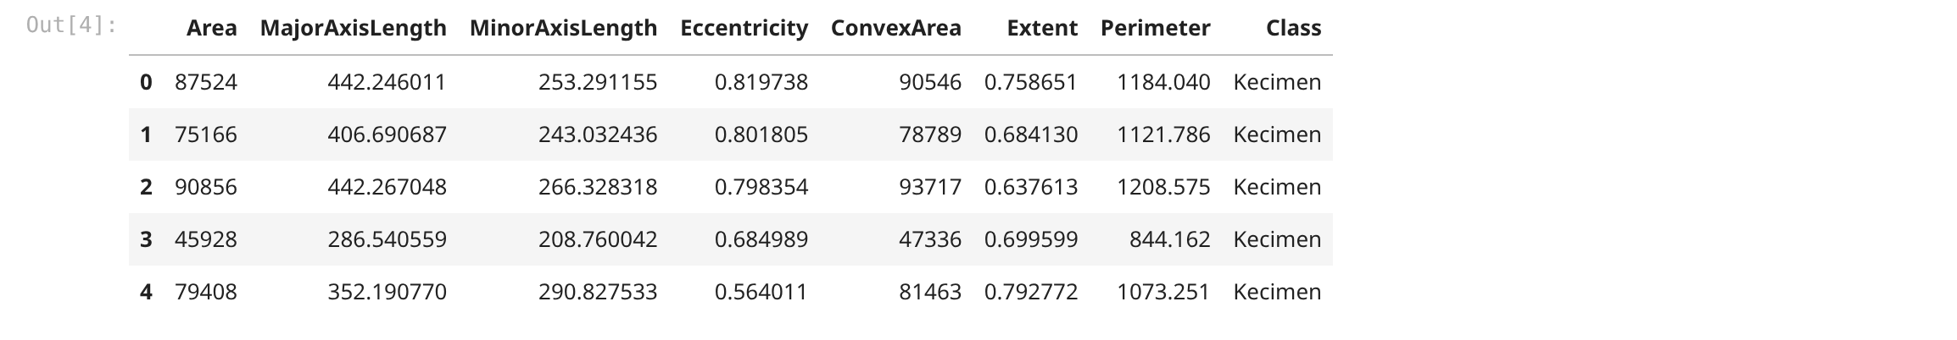
First five rows of the dataset. You can see 7 number columns and the Class column at the end. Area and Perimeter have big values while Extent is between 0 and 1, so the columns are on very different scales.

Output 2 – Dataset Info
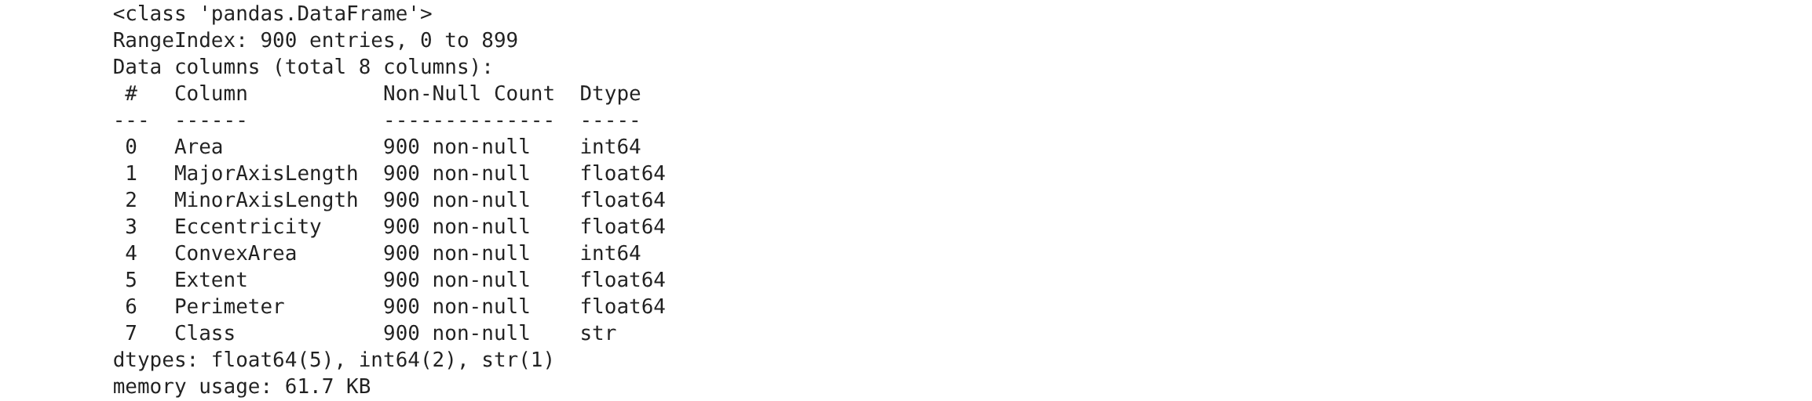
df.info() output. There are 900 rows and 8 columns, and every column has 900 non-null values. Area and ConvexArea are int64, the other measurements are float64, and Class is a string.

Output 3 – Missing Values
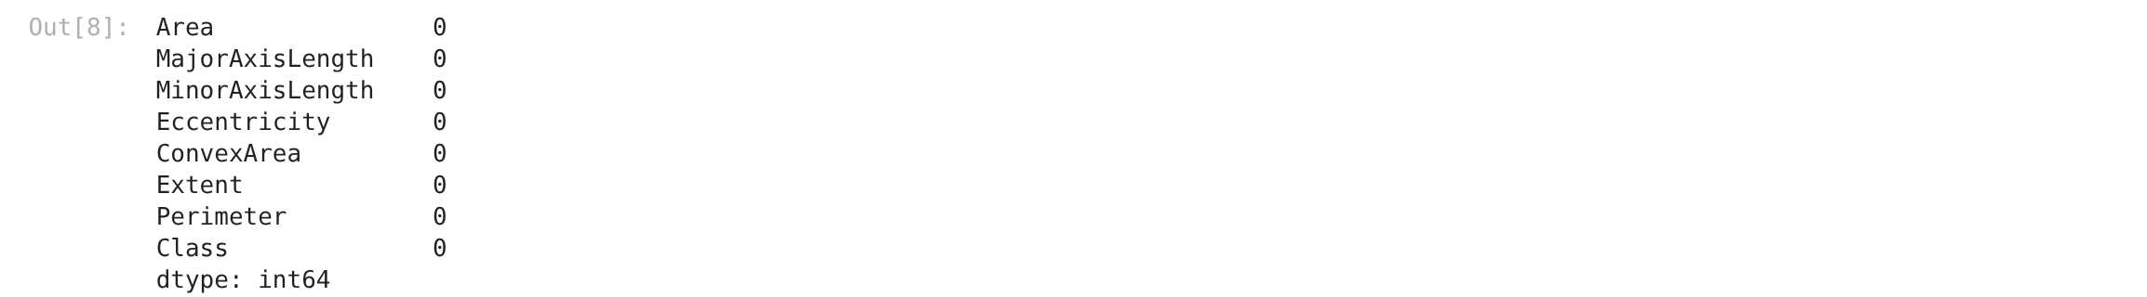
Missing value count for each column. All of them show 0, so the data was already clean and we did not have to fill anything. The duplicate check also gave 0.

Output 4 – Class Distribution
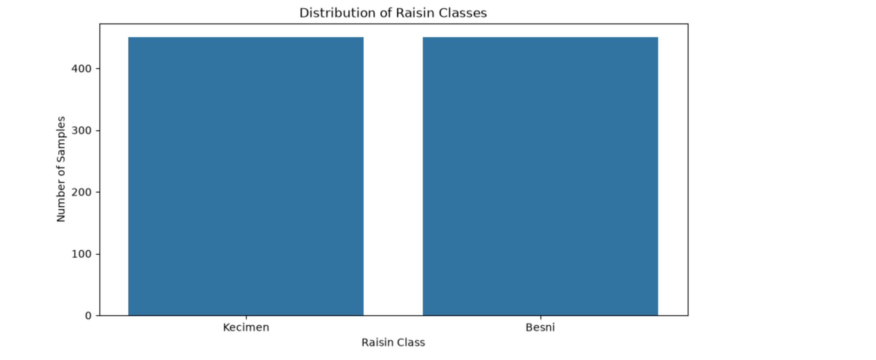
Bar chart of the two raisin classes. Kecimen and Besni both have 450 samples, so the dataset is balanced. Because of this, one class will not dominate the training.

Output 5 – Histograms
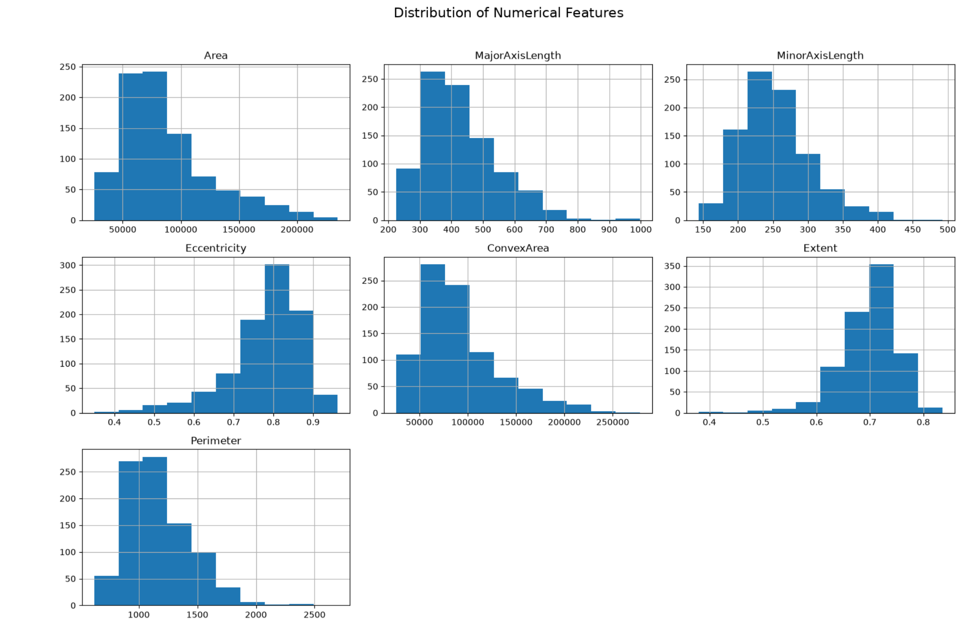
Histograms of all 7 numeric features. Area, ConvexArea and Perimeter are right skewed, while Extent and Eccentricity are packed in a small range. The plots have different scales, so separate subplots were used.

Output 6 – Box Plots
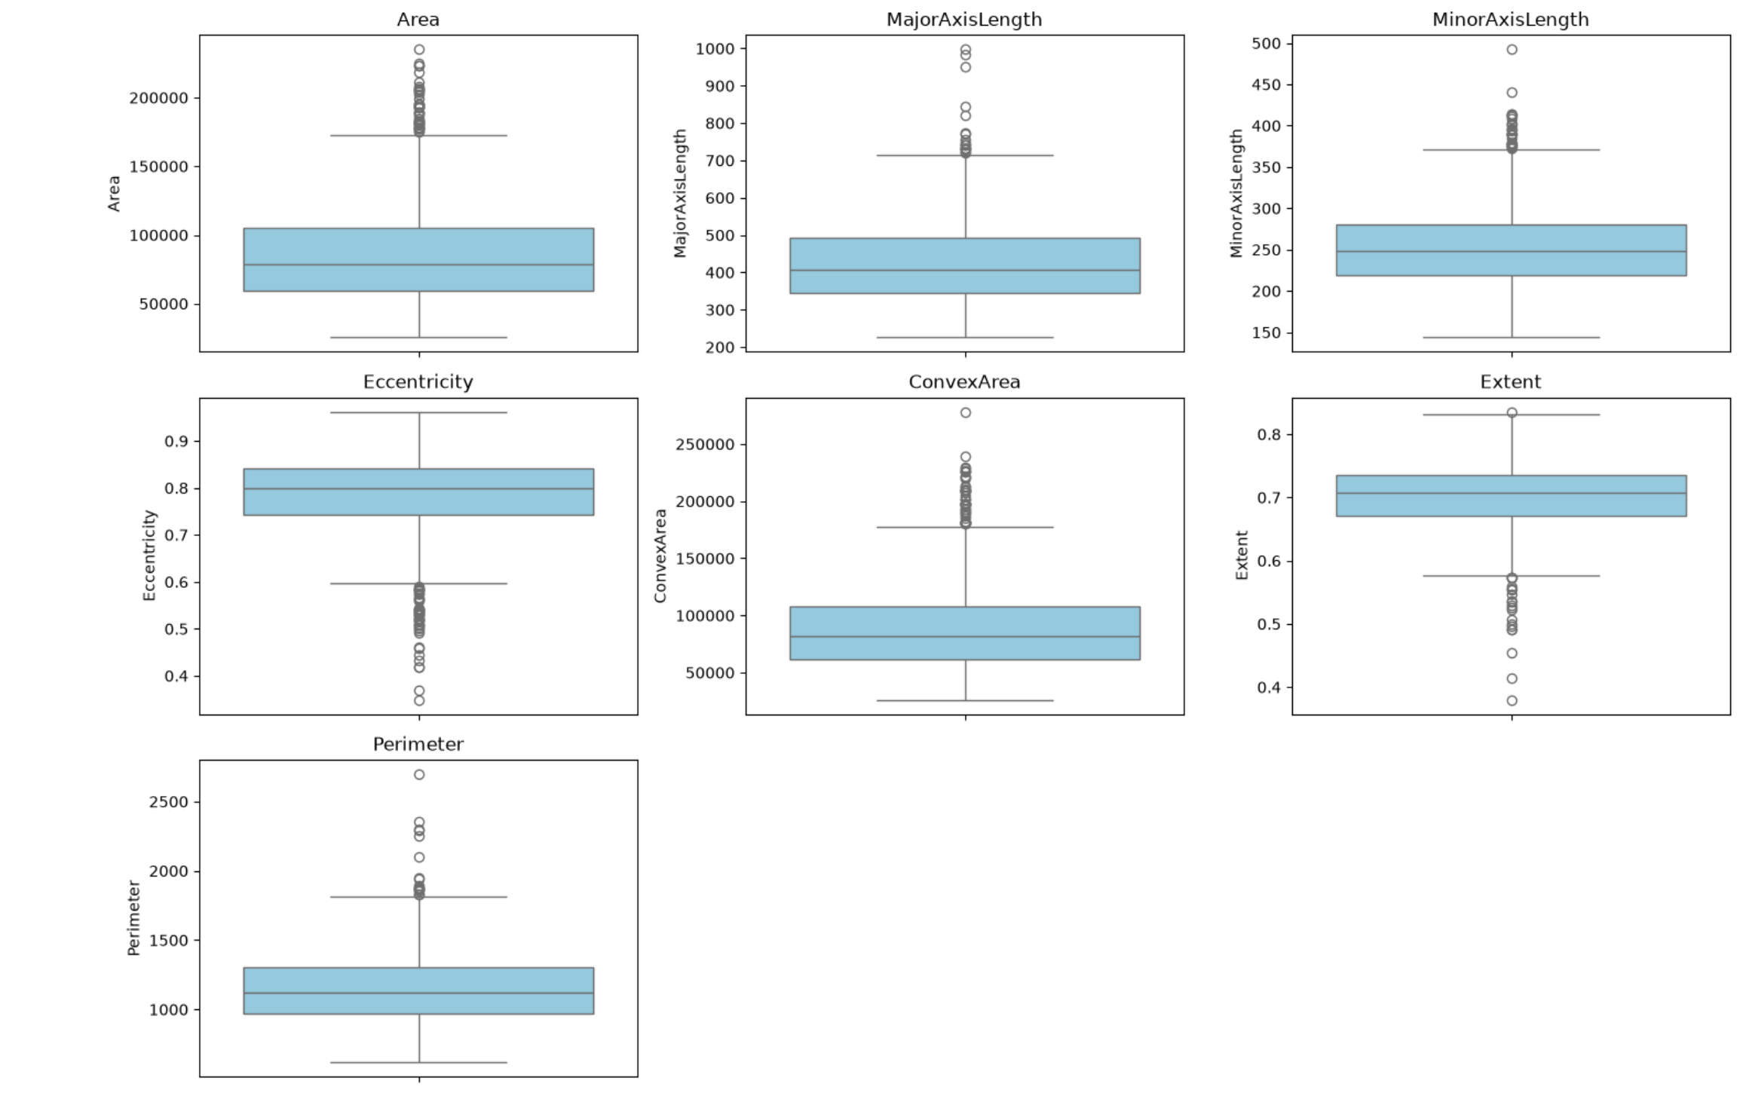
Box plots for the numeric columns. Most features have a few dots above the whiskers, so there are some large values. Area and Perimeter have the most outliers, but I kept them because they look like real big raisins and not typing mistakes.

Output 7 – Correlation Heatmap
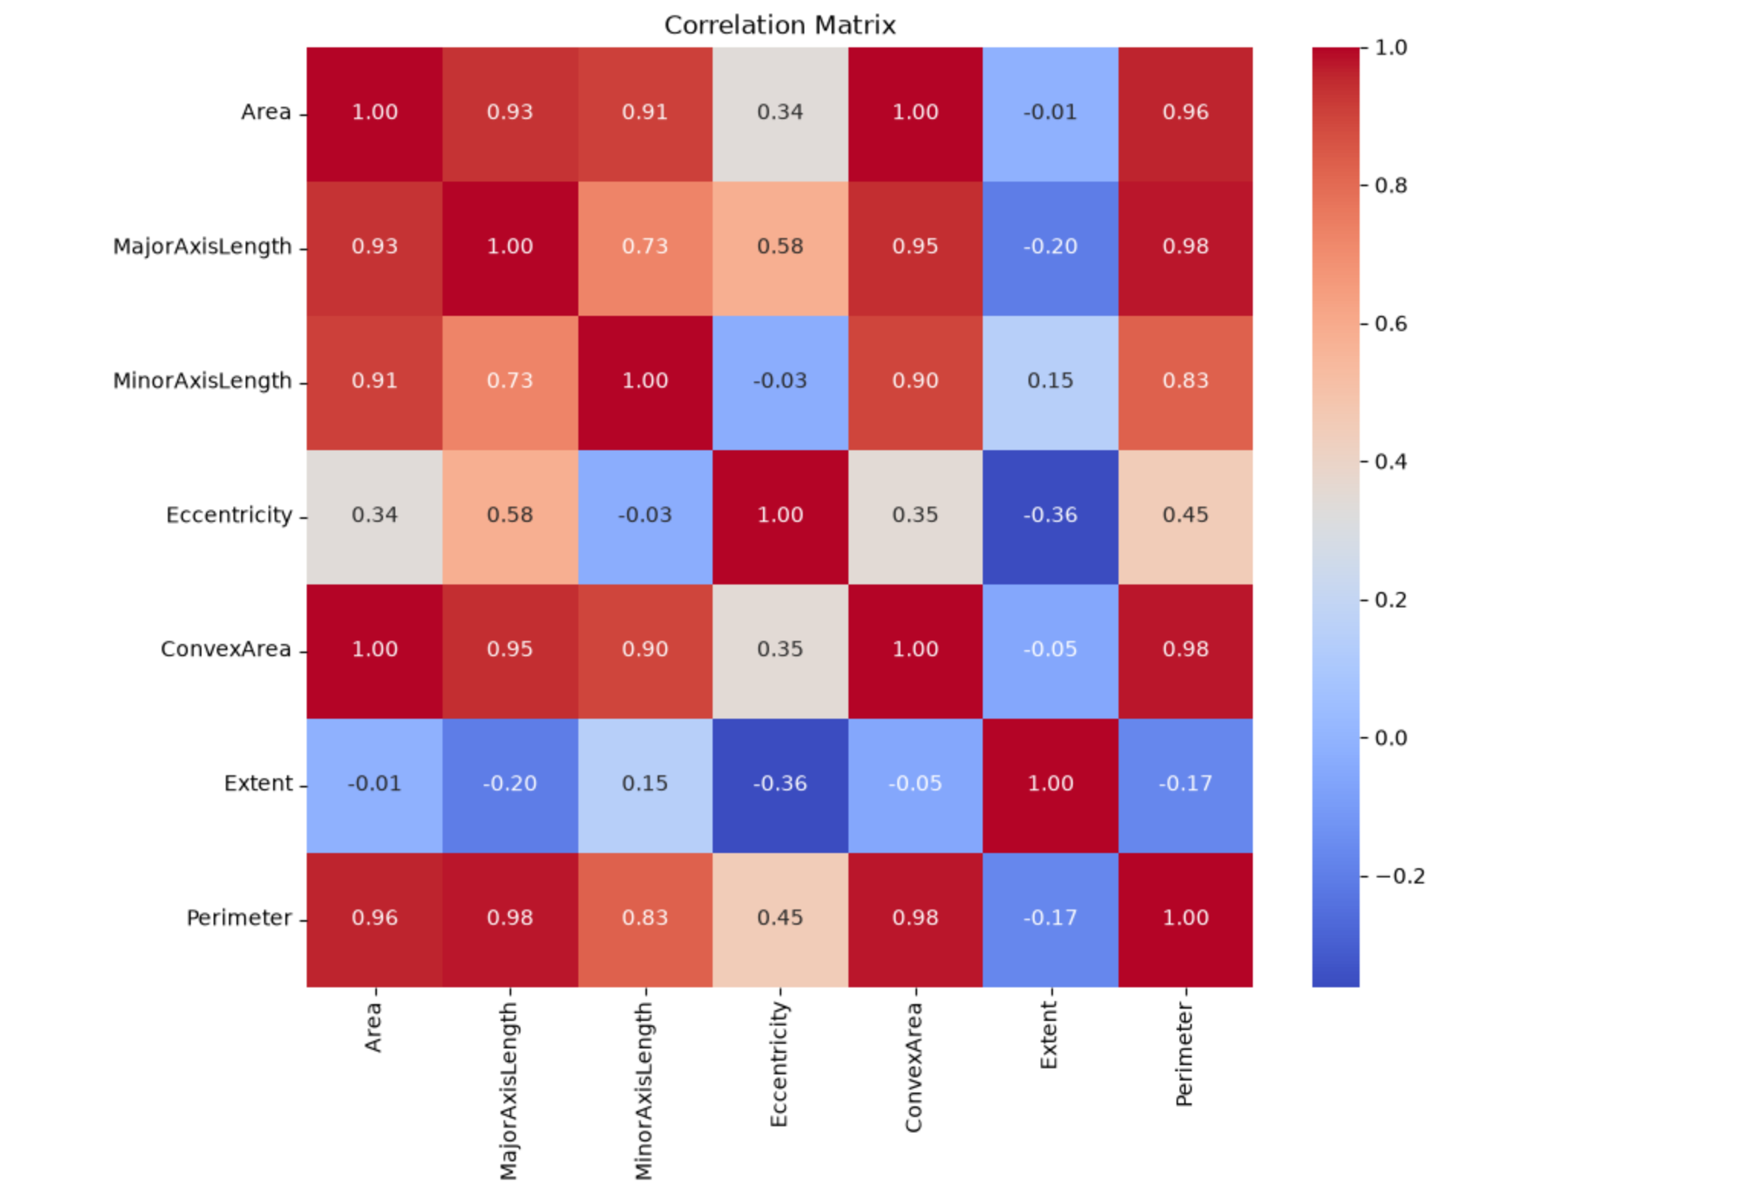
Correlation matrix of the features. Area, ConvexArea and Perimeter are very highly correlated with each other, which makes sense because all three measure size. Eccentricity and Extent have low correlation with the rest.

Output 8 – Label Encoding
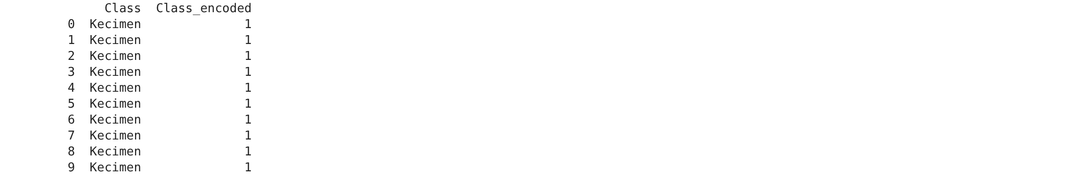
Class column after label encoding. Kecimen became 1 and Besni became 0, and the mapping printed in the next cell confirms it. The model needs numbers, so this step was necessary.

Output 9 – Train/Test Split
Shapes after train_test_split. X has 900 rows and 7 columns, and the split gave 720 rows for training and 180 for testing. I used test_size 0.2 and random_state 42 so the result is repeatable.

Output 10 – Model Performance
Accuracy, precision, recall and F1 of the Gaussian Naive Bayes model. Accuracy is about 82.78% and the weighted F1 is about 82.59%. The scores are close to each other, so the model is not badly biased to one class.

Output 11 – Classification Report
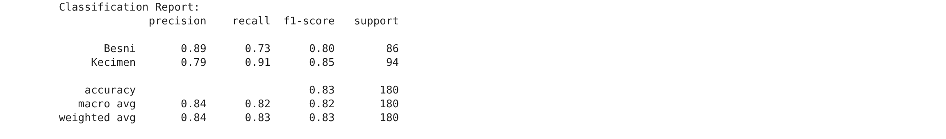
Classification report for both classes. Besni has precision 0.89 but recall 0.73, while Kecimen has recall 0.91. So the model misses more Besni raisins than Kecimen ones.

Output 12 – Confusion Matrix
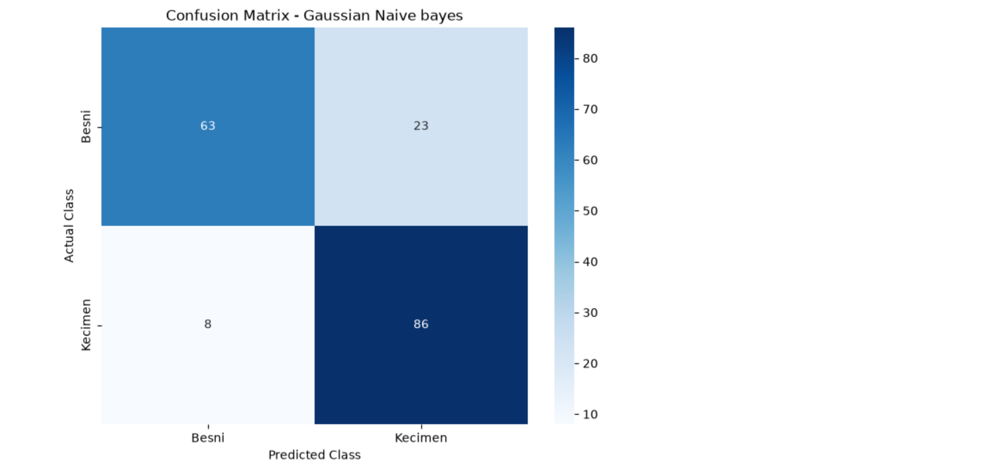
Confusion matrix heatmap. Out of 180 test rows, 63 Besni and 86 Kecimen were correct. 23 Besni were predicted as Kecimen and 8 Kecimen were predicted as Besni, which matches the report above.

5. Viva Questions and Solutions
Q1. Why is the algorithm called naive?
Solution: It assumes that every feature is independent of the others given the class. In real data the features are usually correlated, like Area and Perimeter here, so the assumption is not fully true. That is why it is called naive, but it still gives decent results and is very fast.
Q2. What is Gaussian Naive Bayes?
Solution: It is the Naive Bayes version for continuous features. For each feature and each class it calculates the mean and standard deviation from the training data, then uses the Gaussian formula to get the probability. The class with the higher final probability is predicted.
Q3. What does var_smoothing do?
Solution: It adds a small value to the variance so the probability does not become zero when a feature has very low variance. The default is 1e-9. I tried values from 1e-12 to 1e-2 and the accuracy stayed around 82 to 83%.
Q4. Why did we use LabelEncoder here?
Solution: The Class column had text values Kecimen and Besni, and scikit-learn models need numbers. LabelEncoder turned them into 0 and 1. Since there are only two classes, this does not create any order problem.
Q5. Why not use only accuracy?
Solution: Accuracy can look good even if the model ignores a class. Precision, recall and F1 tell us how the model does on each class separately, and the confusion matrix shows the exact mistakes. Here accuracy is 82.78% but the per-class recall is different, so the extra metrics are useful.

