# **Tasks**

**Learners have to develop a dashboard to support the answers to the following questions and suggestions for places for newer restaurants.**

**Objective Questions**:

1. What is the total no. of tables present in the data?

= 2

1. What is the total no. of attributes present in the data?

= 21

1. How many categorical columns are there in the data? [Search about categorical and continuous data, and try to answer this question]

= 14

1. The data consists of some inconsistent and missing values so ensure that the data used for further analysis is cleaned.

= 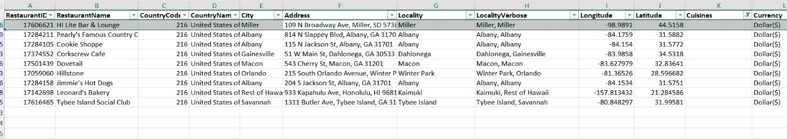

I have deleted the rows containing the missing data.

1. Using the LookUp functions, fill up the countries in the original data using the country code.

= 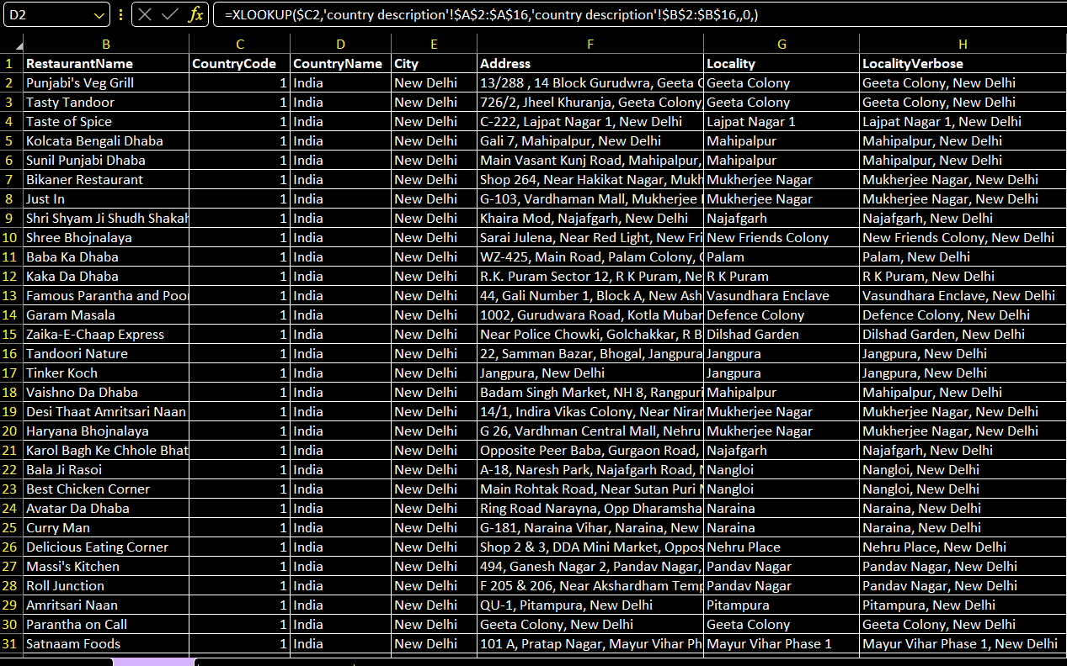

1. Create a table to represent the number of restaurants opened in each country.

= 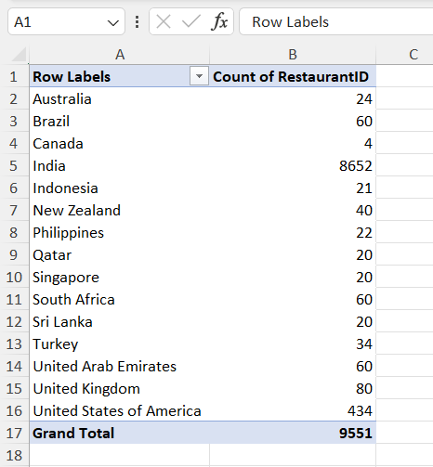

1. Also, the management wants to look at the number of restaurants opened each year, so provide them with something here.

= 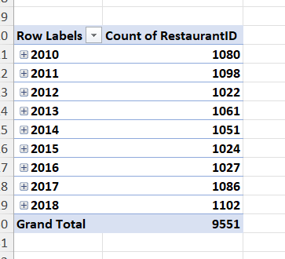

1. What is the total number of restaurants in India in the price range of 4?

= 388 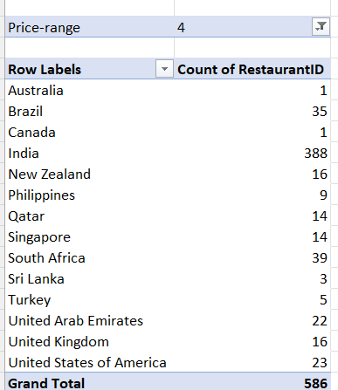

1. What is the average number of voters for the restaurants in each country according to the data?

= 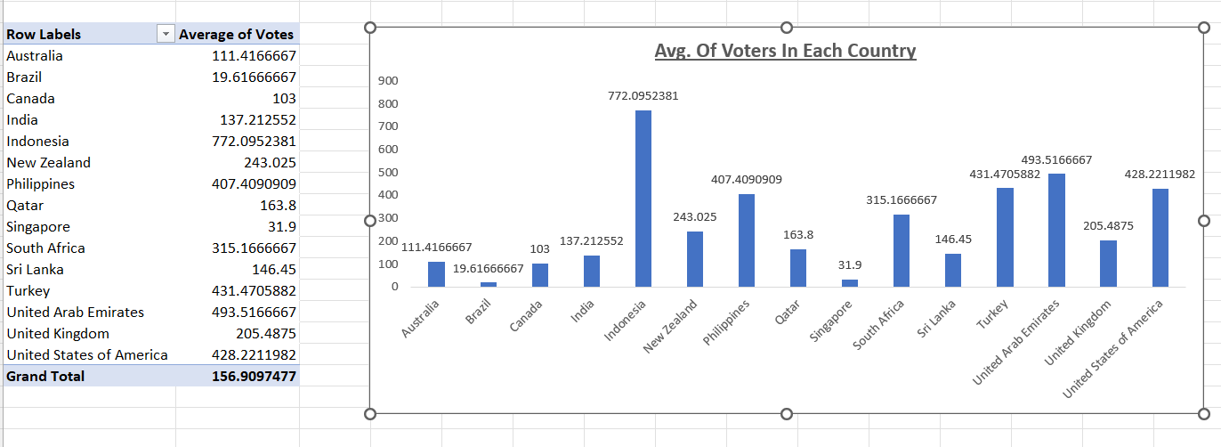

1. Calculate the average rating for all the restaurants that have price range < 4 and provide online delivery. Use only the “IF” function, Logical Operators, and Aggregation functions to solve this problem. **[Note: Don’t use Conditional aggregation in this question.]**

**= =AVERAGE(FILTER(U2:U9552, N2:N9552="Yes",Q2:Q9552<4))** 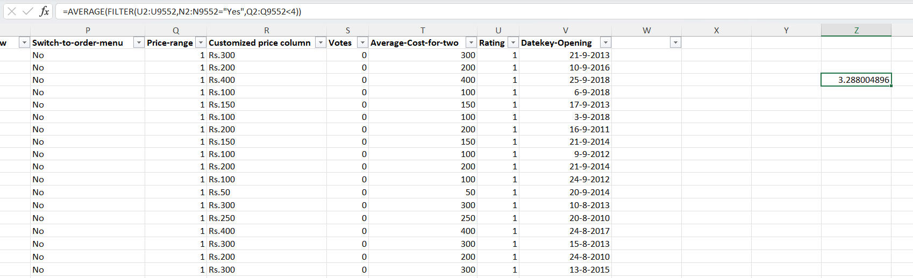

1. Using Conditional formatting highlight the rows of restaurants that are located in the countries or cities that you’ve suggested to the management for opening new restaurants.

= I used the formula { =OR($C:$C = 14,$C:$C = 37,$C:$C = 148,$C:$C = 166,$C:$C = 184,$C:$C = 208,$C:$C = 214,$C:$C = 215) } in the new rule and highlighted them with yellow colour.

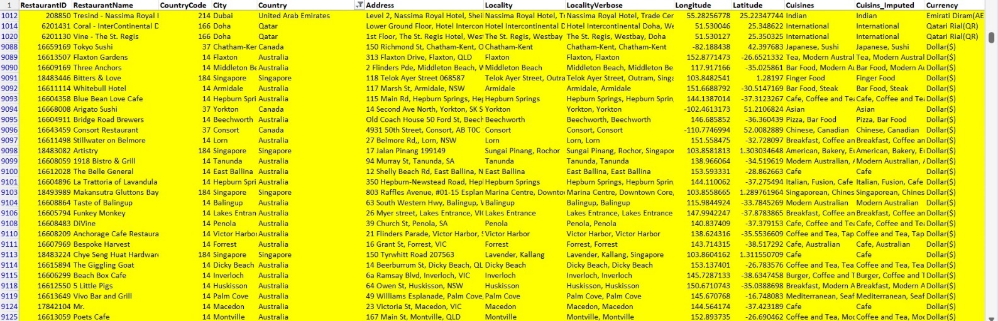

1. Create a new customized price column that consists of the abbreviation/symbol of the currency along with the Average_cost_for_two value. [Use string operations to do this task]

= 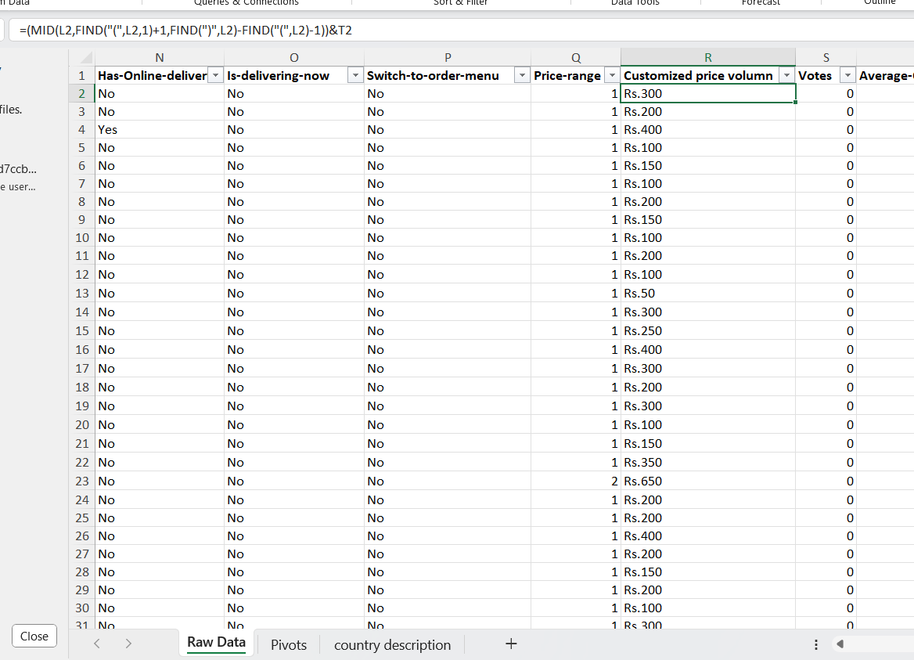

1. How can you create an array formula in Excel or Google Sheets to count the number of restaurants listed that do not offer online delivery, are in the lowest price range, and have an average cost for two people less than or equal to 250 Indian Rupees?

= {=ARRAYFORMULA(COUNTIFS($M$2:$M$9552,"No",$R$2:$R$9552, "<=250",$P$2:$P$9552, "<3"))}

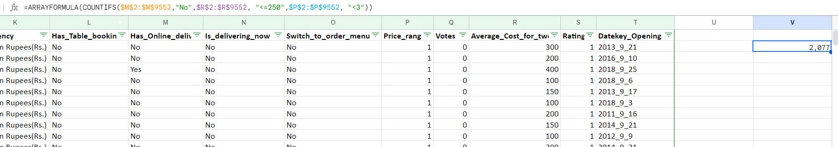

**Subjective Question:**

1. Suggest a few countries where the team can open newer restaurants with lesser competition. Which visualization/technique will you use here to justify the suggestions?

=

|  |
| --- |
| Australia |
| Canada |
| New Zealand |
| Qatar |
| Singapore |
| Turkey |
| United Arab Emirates |
| United Kingdom |

These are based on sum of average cost for two “<=5000” with their average rating >=3.5 and count of restaurant in between 20 to 80.

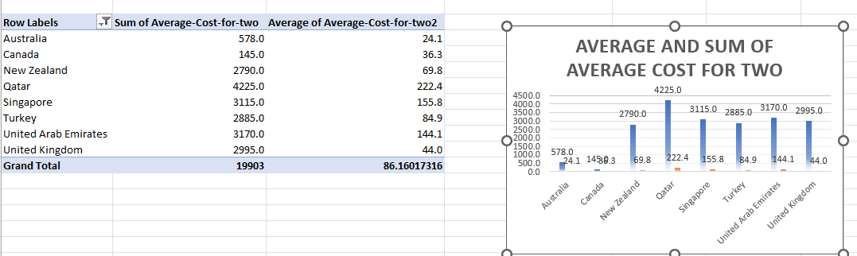

1. Come up with the names of States and cities in the suggested countries suitable for opening restaurants.

=

**Name of the State or City** :-

Abu Dhabi

Ankara

Armidale

Auckland

Balingup

Beechworth

Birmingham

Chatham-Kent

Consort

Dicky Beach

Doha

Dubai

East Ballina

Edinburgh

Flaxton

Forrest

Hepburn Springs

Huskisson

Inverloch

Lakes Entrance

London

Lorn

Macedon

Manchester

Mayfield

Middleton Beach

Montville

Palm Cove

Paynesville

Penola

Phillip Island

Sharjah

Singapore

Tanunda

Trentham East

ÛÁstanbul

Victor Harbor

Vineland Station

Wellington City

Yorkton

These are the states and cities name in the suggested countries who have rating “>=3.5” with price range of 1-3.

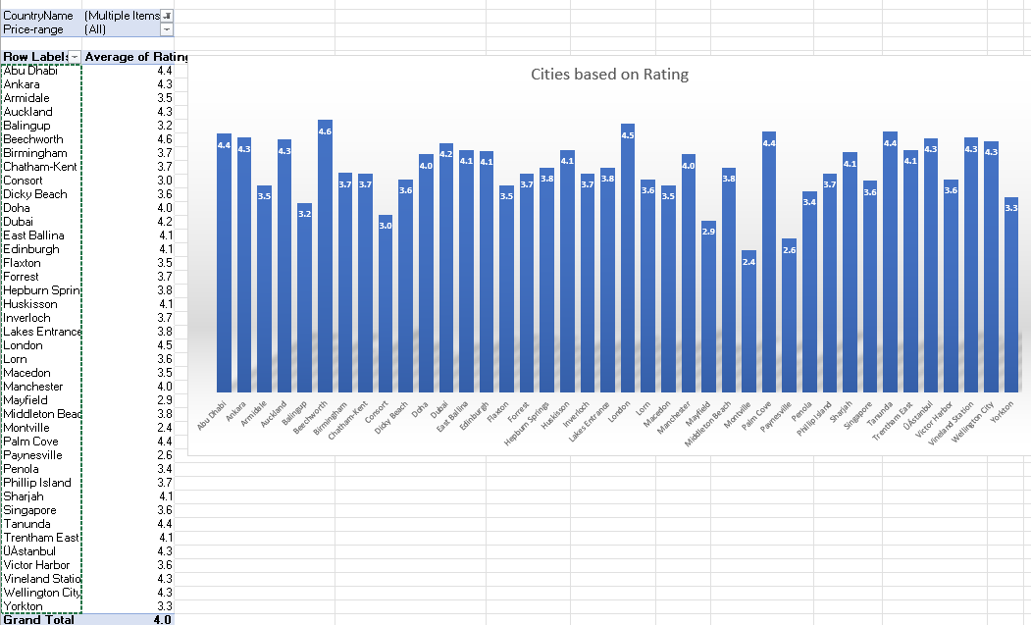

1. According to the countries you suggested, what is the current quality regarding ratings for restaurants that are open there?

= The current quality of rating is “>=3.5”.

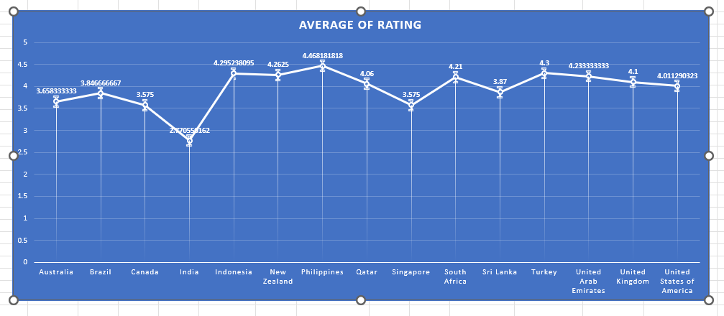

1. Also, what is the current expenditure on food in the suggested countries, so we can keep our financial expenditure in control?

= The average of average cost for two is less than or equal to 300 and the sum of average cost for two is less the 5000. 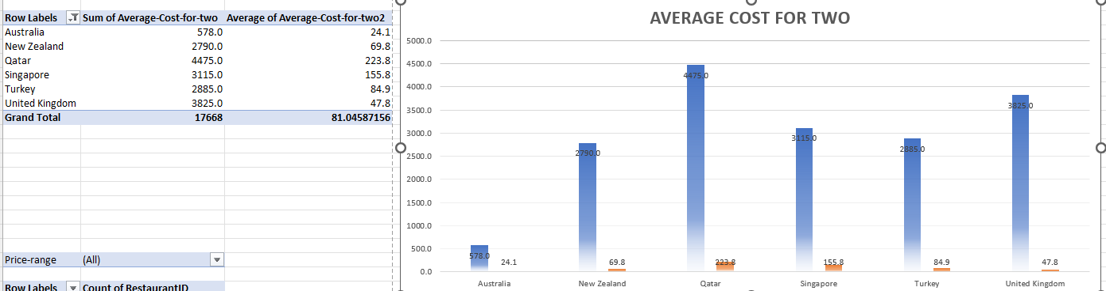

1. Come up with the names of restaurants from the recommended states that are our biggest competitors and also those that are rated in the lower brackets, i.e. 1-2 or 2-3.

= Our biggest competitors into the recommended states which meet’s the condition of rating “>=3.5” & Average cost for two “>=550” --

**Name of the restaurant**:-

|  |
| --- |
| 10 To 10 In Delhi |
| 1918 Bistro & Grill |
| 5 Little Pigs |
| Aôôk Kahve |
| Aalishan |
| Akbars |
| Al Mukhtar Bakery |
| Al'frank Cookies |
| Almost Famous Burgers |
| Anchorage Cafe Restaurant Wine Bar |
| Applebee's |
| Aroos Damascus |
| Artistry |
| Baduzzi |
| Baltazar |
| Bao |
| Bar Estilo |
| Beach Box Cafe |
| Bentoya |
| Bespoke Harvest |
| Big Fish Eatery |
| Bitters & Love |
| Blue Bean Love Cafe |
| Bocca Di Lupo |
| Bodega |
| Bone Daddies |
| Bridge Road Brewers |
| Burger Liquor |
| Cafemiz |
| Caffe L'affare |
| Ceviz AÛôacÛ± |
| Charley Noble Eatery & Bar |
| Chennai Dosa |
| Chinoiserie |
| Chye Seng Huat Hardware |
| Civerinos |
| Colony |
| Coral - InterContinental Doha |
| Crafted Blends |
| Cut By Wolfgang Puck |
| Dem Karakí-y |
| Denny's |
| Depot Eatery and Oyster Bar |
| Derby |
| Din Tai Fung |
| Dishoom |
| Dí-veroÛôlu |
| Draft Gastro Pub |
| Dragonfly |
| Duck & Waffle |
| Eatopia |
| Eden Noodles Cafe Î--Î‡-†ƒ-†ƒ-¢ |
| Eight - The Langham Hotel |
| Ekim Burgers |
| El Cartel |
| Emirgan Sí-tiô |
| Enigma Cafe |
| Federal Delicatessen |
| Fidel's |
| Fiesta del Asado |
| Fisherman's Plate |
| Five Boroughs |
| Five Guys |
| Flat Iron |
| Flaxton Gardens |
| Floriditas |
| Frasers |
| Fratini La Trattoria |
| Funkey Monkey |
| Gaga Manjero |
| Gaucho |
| Genghis Grill |
| Giapo |
| Gokul Gujarati Restaurant |
| Handmade Burger Co. |
| Hard Rock Cafe |
| Hattena Hatay SofrasÛ± |
| Hippopotamus - Museum Hotel |
| Home Sweet Home |
| Huqqa |
| íˆukuraÛôa SofrasÛ± |
| Istanbul Restaurant |
| Jaan |
| J'adore Chocolatier |
| Jamie's Italian |
| Ju Ju's Cafe |
| Karakí-y Gí-llí-oÛôlu |
| Katis Restaurant |
| Kebap 49 |
| Kiss Kiss |
| La Favorita |
| La Trattoria of Lavandula |
| Lahore |
| Lake House Restaurant |
| Lasan Restaurant |
| Leman Kí-ltí-r |
| Little Penang |
| Little Sister Cafe |
| Loretta |
| Loudons Cafe & Bakery |
| Love Crumbs |
| Mad Cowes Cafe |
| Mainland China Restaurant |
| Manchester House |
| Maranui Cafe |
| MasabaôÛ± |
| MasabaôÛ± Kebapí-Û±sÛ± |
| Meôhur í-zí-elik Aspava |
| Meôhur TavacÛ± Recep Usta |
| Miann |
| Midnight Espresso |
| Milse |
| Mimi's Bakehouse |
| Mother India's Cafe |
| Mr. |
| MRA Bakery Sweets & Restaurant |
| Mughal E Azam |
| Mughli |
| NamlÛ± Gurme |
| Nawaab |
| Nusr-Et |
| Olive |
| Olive Garden |
| Ombra |
| Orleans |
| P.F. Chang's |
| Paper Fig |
| Paper Moon |
| PappaRich |
| Parker's |
| Pig and Whistle |
| Pizza ÛÁl Forno |
| Ponderosa |
| Punjab Restaurant |
| Purnell's |
| Rajasthan Al Malaki |
| Restaurant Andre |
| Restaurant Gordon Ramsay |
| Rhubarb Le Restaurant |
| Roka |
| Roseleaf Bar Cafe |
| Roti & Boti |
| Sabai Thai - The Westin Doha Hotel & Spa |
| Salt |
| San Carlo |
| Shake Shack |
| Sis Burger |
| sketch Gallery |
| Sofra Istanbul |
| Solita |
| Starbucks |
| Steak |
| Stillwater on Belmore |
| Summer Pavilion |
| Teacup |
| Texas Roadhouse |
| The Belle General |
| The Bigos |
| The Boozy Cow |
| The Breakfast Club |
| The Cheesecake Factory |
| The Crab Shack |
| The Elephant House |
| The French by Simon Rogan - The Midland |
| The Garden Shed |
| The Giggling Goat |
| The Grill On The Alley |
| The Hangar |
| The Hanging Bat |
| The Kimchi Project |
| The Kitchin |
| The Manhattan FISH MARKET |
| The Plough |
| The Warehouse Cafe |
| Three Anchors |
| Timboo Cafe |
| Ting Thai Caravan |
| Tipu Sultan |
| Tokyo Sushi |
| Tucks and Bao |
| Tuk Tuk Indian Street Food |
| Turta Home Cafe |
| Valonia |
| Vine - The St. Regis |
| Vivo Bar and Grill |
| wagamama |
| Walter's Coffee Roastery |
| Whitebull Hotel |
| Winona Forever |
| YÛ±ldÛ±z Aspava |
| Zaffran Dining Experience |
| Zaoq |
| Zigana Pide |
| Zouk Tea Bar & Grill |

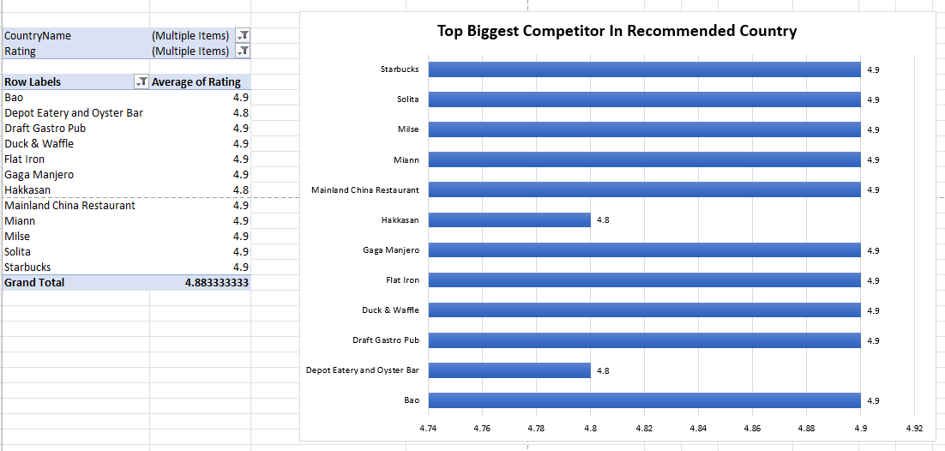

The restaurants that are in the lowest rating bracket –

|  |
| --- |
| Consort Restaurant |
| Damascena Coffee House |
| De Fontein Belgian Beer Cafe |
| Makansutra Gluttons Bay |
| Pepe's Piri Piri |
| Pier 70 |
| Pizza Hut |
| Poets Cafe |
| Star Buffet |

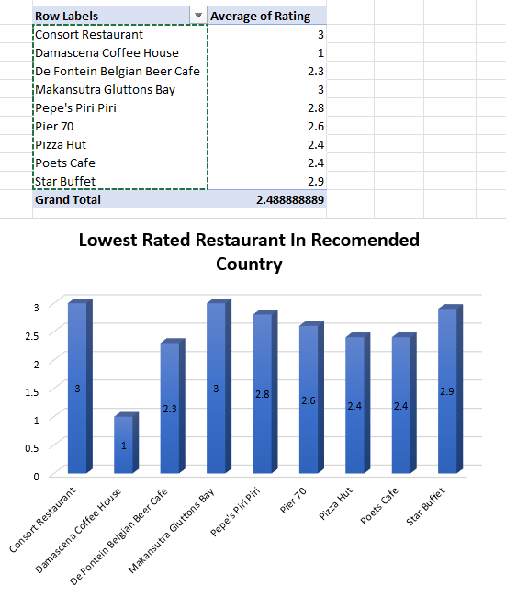

1. Which cuisines should we focus on in the newer restaurants to get better feedback? Does the choice of cuisines affect the restaurant ratings?

= **Cuisines to focus on –**

American, Asian, Burger

American, BBQ, Sandwich

American, Desserts

American, Desserts, Steak

American, Sandwich, Salad

American, Sandwich, Tea

American, Seafood, Sushi

American, Southern, Southwestern

BBQ, Burger, Desserts

BBQ, Caribbean, Seafood

Brazilian, Steak

Breakfast, Mexican

British, Bar Food, Sandwich

Burger, Bar Food, Steak

Burger, Sandwich, Seafood

Cajun

Cuban, Spanish

Desserts, Bar Food

Desserts, Bí-rek

Hawaiian

Hawaiian, Seafood

Hawaiian, Seafood, Steak

Indian, Continental

Indian, Rajasthani

International, Italian, Southern

Italian, Deli

Latin American, Mexican, Southwestern

Mexican, Vegetarian

New American, Tapas

Pub Food

World Cuisine, Patisserie, Cafe

As per the screenshot we can see that the highest rated restaurant also have highest rated cuisines. So we can draw the conclusion here that the choice of cuisine does affect the restaurant rating.

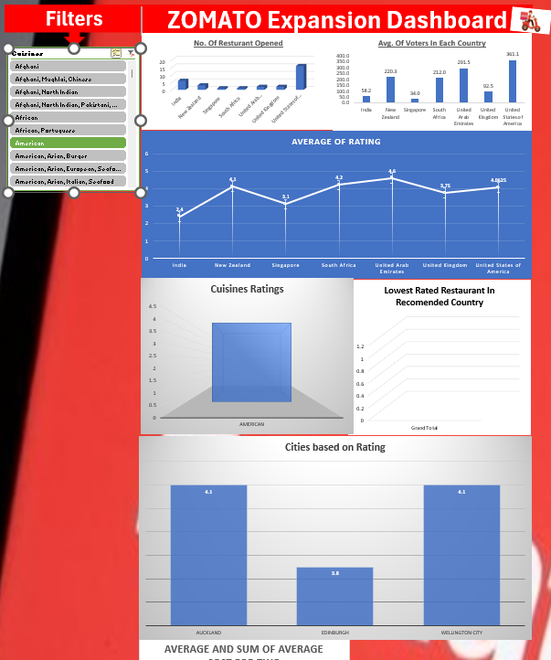

1. According to our current data, should we go for online delivery and table booking? Does that affect the customer’s ratings?

= As per our current data, the recommended states have no online delivery system. 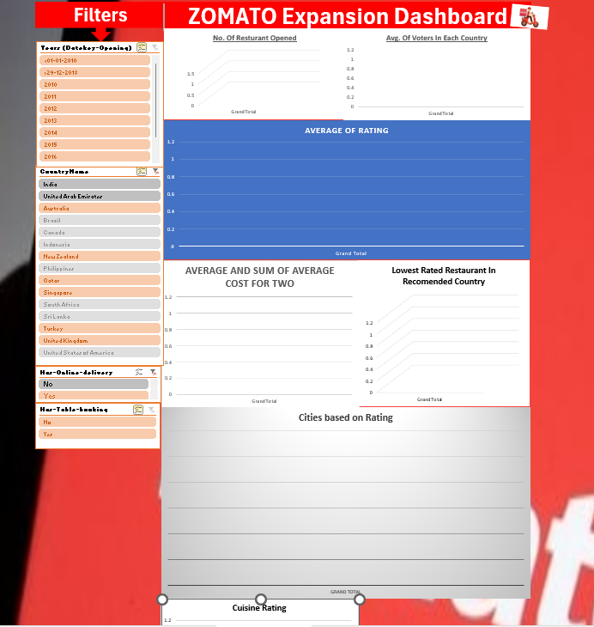

As per our data, we can see that there are only two countries where table booking are present. 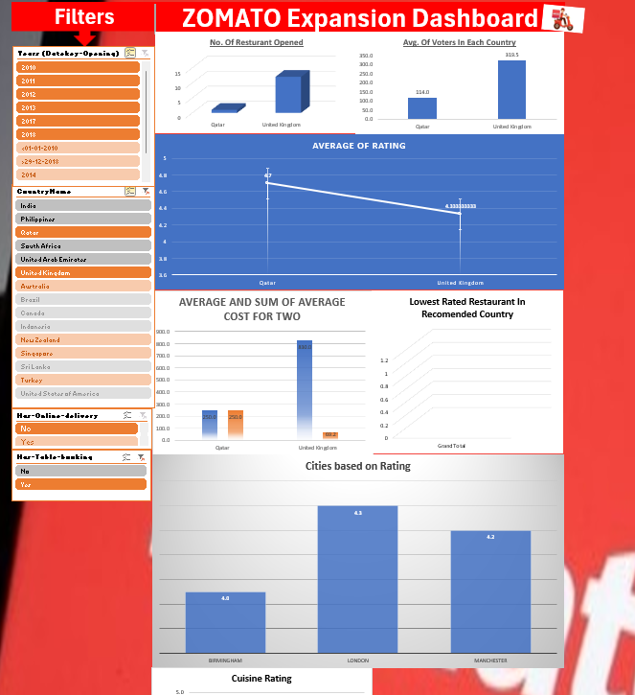

As per my observation, we can conclude that we can go for table booking in the countries where it’s already present i.e. Quatar & United Kingdom. And for the other countries we could go for online delivery as there is none and will be a good scope to capture the market. Online delivery is the primary buissness for ZOMATO.

1. Should the team keep the rate of cuisines higher? Will that affect the feedback? According to our data are the rates of cuisines and ratings, correlated?

= As per our current data the average rating on price range of 3 - 4 is higher compare to Price range of 1 – 2. But the ideal will be keeping the price range in between 2 - 3. We can see that the overall average rating for individual price range of 1 & 4 is unsatisfactory but the overall rating of price range 2-3 is satisfactory. So, the team should keep the price range in between 2 – 3.

**Price Range Of 2-3.**

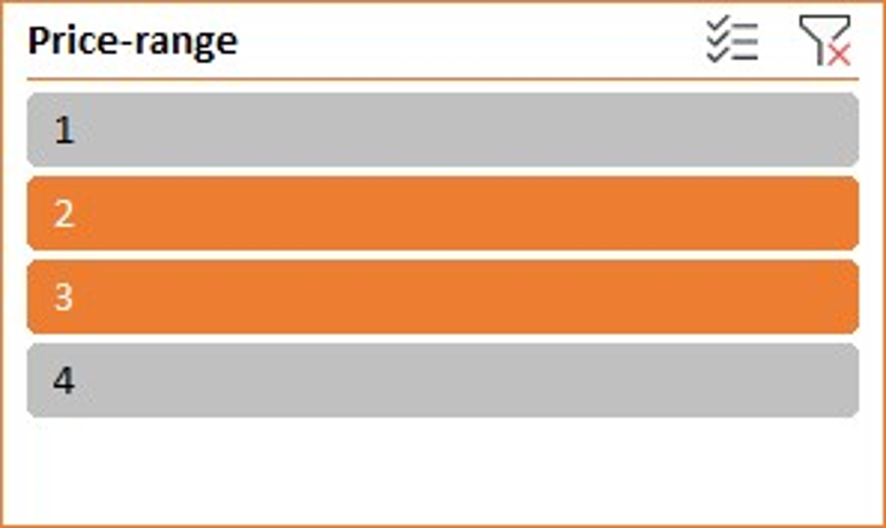

**Price Range Of 3-4.**

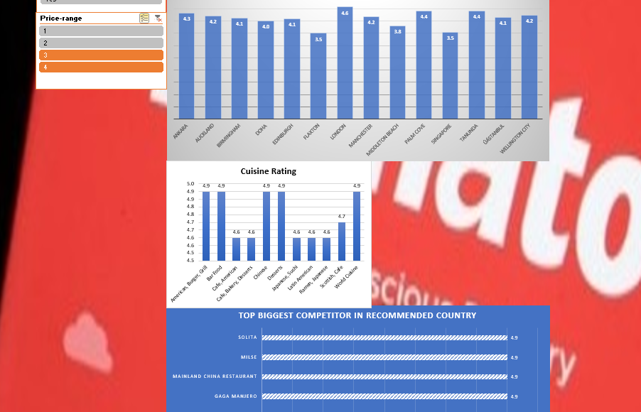

**Price Range Of 1-2.**

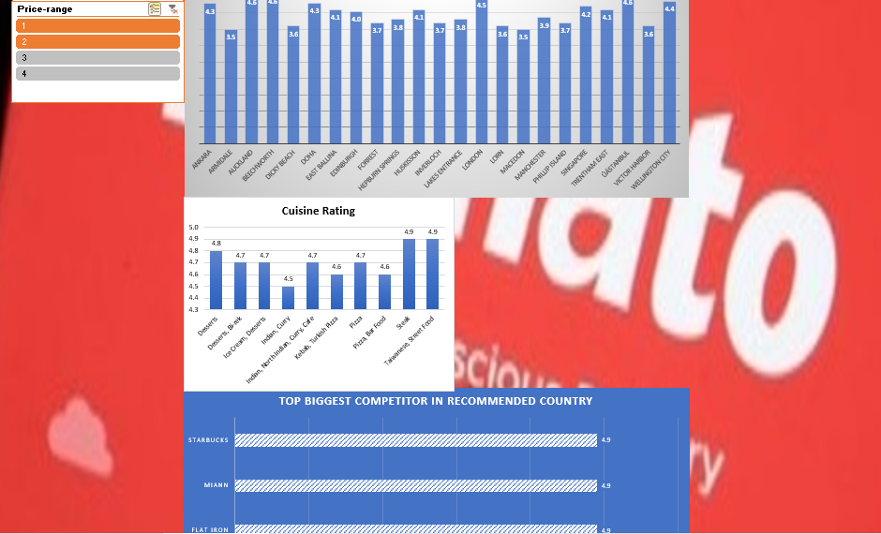

1. What is the distribution of the number of restaurants of different price ranges in all the countries?

=

**Price Range Of 1.**

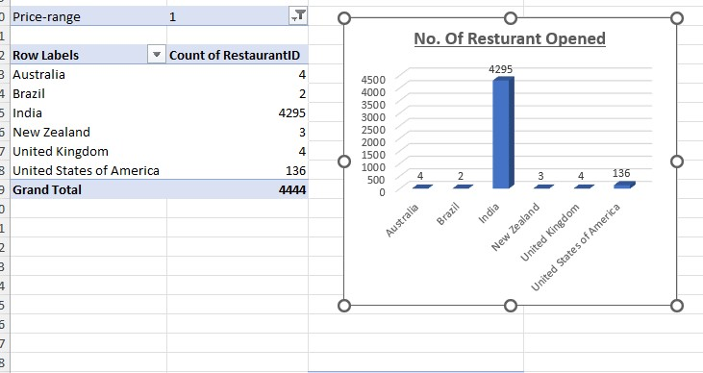

**Price Range Of 2.**

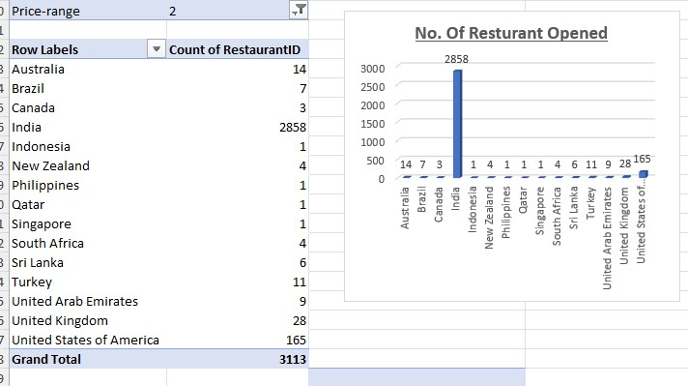

**Price Range Of 3.**

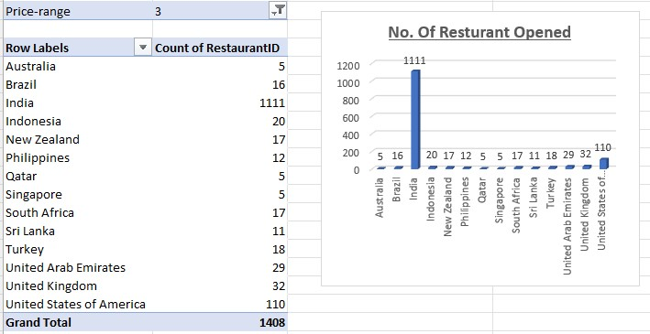

**Price Range Of 4.**

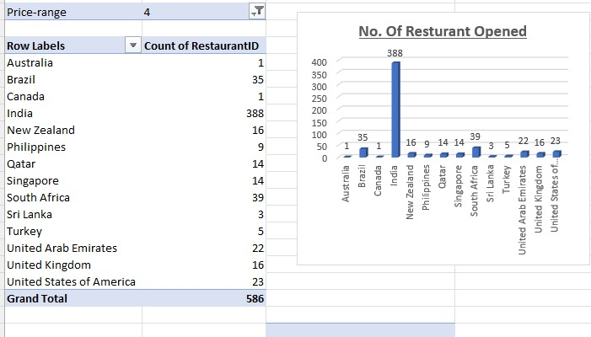

1. Explain your approach in brief for suggesting countries/cities in order to open new restaurants, if the objective and subjective questions would have not been given to assist you. **[you have to give bullet pointers in order to answer this question]**

**=**

1. First, I would have considered cleaning the data.
2. Worked with missing value.
3. Then remove duplicates and tried using functions to bring relevant data.
4. After all this, I would have created tables for understanding and reading data such as country wise count of restaurant or year wise trend and also average rating year wise as well as country wise.
5. Then would have created data visualisation for presenting the data in simpler way.
6. Looked into the data to found corelation condition as well as proportional and inversely proportional data.
7. Would try to create a different interactive slicer to make it compact and also for understanding and comparing different data through this slicer.
8. And a brief description of what every chart and slicer represent.

**The dashboard must consist of Year-wise and country slicers.**