Employee Attrition Analysis
Insight Memo & Retention Recommendations
Prepared by: Saptarshi Mandal June 2026

Executive Summary
Of 1,470 employees analyzed, 237 (16.1%) left the company. Attrition is not random — it is concentrated among a clearly identifiable group: employees working overtime, in Sales and Laboratory Technician roles, who travel frequently, are single, sit in the lowest income quartile, and have gone the longest without a promotion. A logistic regression model trained on this pattern correctly flags 64% of actual leavers (vs. a 16% baseline), giving HR a usable early-warning tool rather than just a retrospective report.

Key Findings
Driver | Finding | Risk Multiple
Overtime | 30.5% attrition with overtime vs. 10.4% without | ~3.0x
Job Role | Sales Representatives: 39.8% attrition — the single highest-risk role | ~8.1x vs. Research Director
Marital Status | Single employees: 25.5% vs. 12.5% for married employees | ~2.0x
Income | Lowest income quartile: 29.3% vs. 10.3% in the top quartile | ~2.8x
Business Travel | Frequent travelers: 24.9% vs. 8.0% for non-travelers | ~3.1x
Tenure | Leavers average 5.1 years at the company vs. 7.4 years for stayers — exits cluster relatively early in tenure | —

Visual Highlights
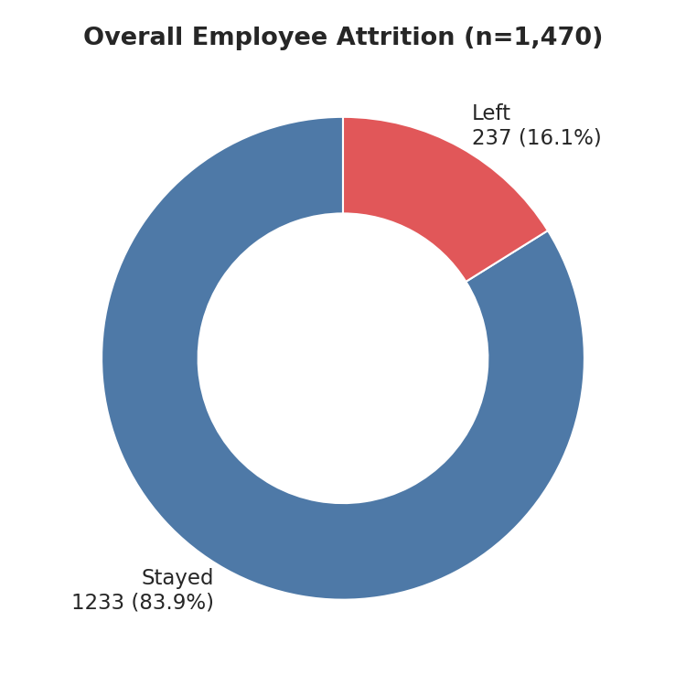 | 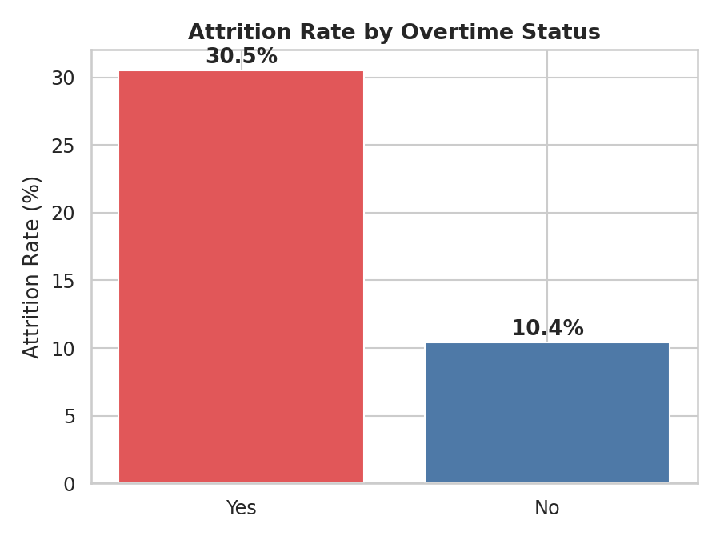

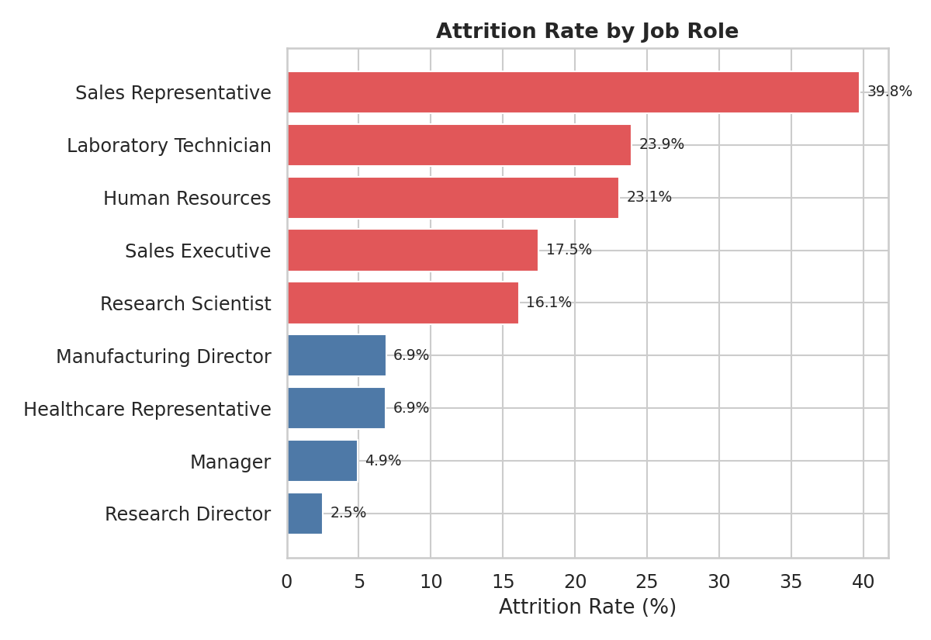

Predictive Model Summary
A logistic regression model was trained on 44 encoded features (75/25 train-test split, stratified for class imbalance). On held-out test data, the model achieved 77.7% accuracy and a ROC-AUC of 0.81, correctly identifying 64% of employees who actually left. The chart below ranks the strongest statistical drivers of attrition risk, controlling for all other factors simultaneously.
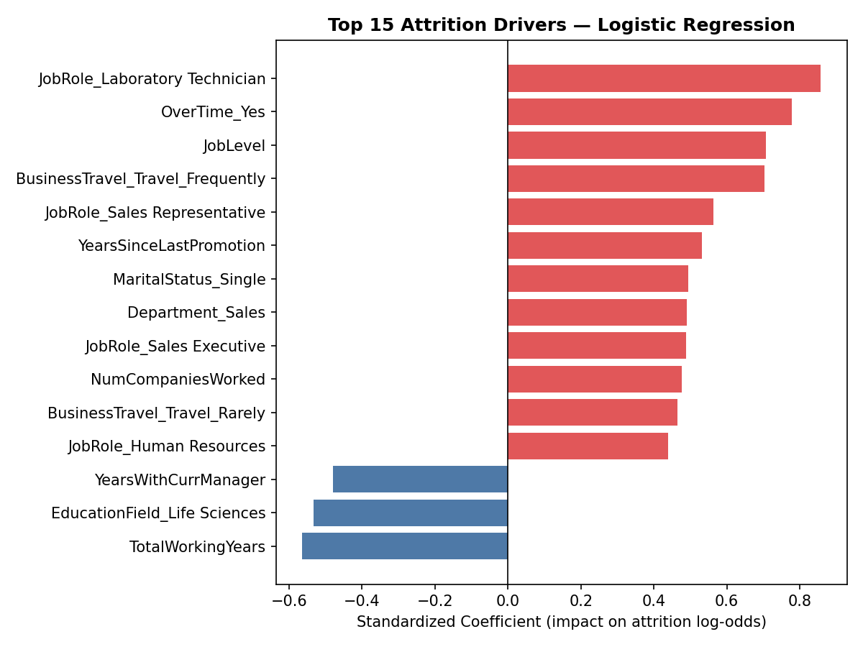

Recommendations
- Cap or compensate overtime in Sales and Lab Technician roles: these two groups carry the highest combined overtime + role risk; consider overtime caps, shift redistribution, or an overtime premium tied to retention bonuses.
- Review promotion velocity: "Years Since Last Promotion" is a top-15 statistical driver. Introduce structured 18–24 month promotion/career-conversation checkpoints, especially for tenure-track employees in years 3–6 (the window where most exits cluster).
- Target retention budget using the risk score, not tenure alone: use the model's risk-scored employee list (471 employees flagged "High Risk") to prioritize stay interviews and retention offers rather than spreading HR effort evenly across the workforce.
- Re-examine frequent-travel role design: frequent travelers churn at ~3x the rate of non-travelers; consider rotating travel-heavy assignments or adding travel-frequency caps for at-risk segments (single, early-tenure, lower-income).

Methodology & Data
- Dataset: IBM HR Analytics Employee Attrition dataset, 1,470 employees, 35 original features, no missing values.
- Tools: Python (pandas, scikit-learn, matplotlib/seaborn) for EDA and modeling; Power BI for the interactive dashboard.
- Model: Logistic regression with standardized features and class-balanced weighting to correct for the 16% positive-class imbalance.
- Validation: Stratified 75/25 train-test split; metrics reported on the held-out test set only (not training data).

