PROJECT REPORT
on
Automating an E-Commerce Purchase Flow with Selenium WebDriver and Python
(Capstone Assignment 1)
Submitted by
Saptarshi Mandal
B.Tech, Computer Science and Engineering
Institute of Engineering and Management (IEM), Kolkata
Batch: 2023–2027
Contact
Email: saptarshi2005.kgp@gmail.com
Phone: +91 86378 46818
LinkedIn: linkedin.com/in/saptarshi-mandal-cs
GitHub: github.com/Saptarshi-Mandal-1234

1. Project Information
Project Title | Automating an E-Commerce Purchase Flow with Selenium WebDriver and Python
Assignment | Capstone Assignment 1 — Automate an E-Commerce Web Application Using Selenium WebDriver with Python
Application Under Test | AutomationExercise (automationexercise.com) — a public site built specifically for QA practice
Language / Framework | Python 3, Selenium WebDriver 4.x, webdriver-manager
Author | Saptarshi Mandal, B.Tech CSE, IEM Kolkata (2023–2027)
Report Date | 22 September 2026

2. Why I Picked This Assignment
Out of the four capstone options — a plain Selenium script, a full Unittest/PyTest/POM framework, an API testing framework with Behave, and a Robot Framework project — I went with this one first because it maps most directly onto something a Data Analyst or QA-adjacent role would actually expect: can you script a realistic end-user flow and prove it works? The other three assignments are worth doing too, but they involve more architectural decisions (framework layout, config management, BDD syntax) that felt better tackled once this base script was solid.
I also liked that it forces you to handle the messy parts of automation — logins that fail, popups nobody warned you about, cart fields that don't update the way you'd expect — rather than a tidy happy-path demo.

3. Objective
The brief asked for one script that walks through a customer's purchase journey end-to-end on a public e-commerce demo site, and along the way proves ten specific things work: launching a browser, logging in, searching, adding to cart, updating quantity, verifying the cart, taking screenshots, reading test data from a file instead of hard-coding it, handling any popups or alerts, and producing a report at the end. I built the script around those ten checkpoints directly rather than writing generic "test steps" and mapping them back afterward.

4. Tools and Technologies Used
Programming Language | Python 3
Automation Library | Selenium WebDriver 4.x
Driver Management | webdriver-manager — downloads a matching ChromeDriver automatically
Browser | Google Chrome
Test Data Format | JSON
Reporting | A small custom HTML report generated at the end of each run
Application Under Test | automationexercise.com

5. Scope
This is one linear script covering a single purchase flow, not a multi-test framework — that's deliberately left for Capstone Assignment 2, where Page Object Model and PyTest come in. Keeping this one focused made it easier to get every one of the ten required behaviours actually working, instead of spreading effort thin across a framework skeleton.

6. How I Built It

6.1 Test Data
Everything that could change between runs — the URL, login email and password, the search keyword, the quantity to set — lives in data/test_data.json, loaded once at the start with Python's built-in json module. That way the same script can be pointed at a different search term or a real account without touching a single line of automation logic.

6.2 The Flow Itself
The script drives Chrome through the following sequence, using explicit waits (WebDriverWait with expected_conditions) rather than fixed time.sleep() calls, so it only waits as long as a page actually needs and doesn't slow down unnecessarily:
- Open Chrome and load the AutomationExercise home page.
- Dismiss the cookie/consent banner if one shows up.
- Go to the login page and submit the credentials from the JSON file.
- Go to Products, search by keyword, and grab the results.
- Add the first matching product to the cart and wait for the confirmation popup.
- Open the cart page and try updating the quantity.
- Read the cart table back — product name, price, quantity, total — to confirm it matches what was added.
- Check for any native browser alert and accept it if one appears.
- Close the browser and write the report.

6.3 Handling Things That Go Wrong
Every major step sits inside its own try/except block, so one failure doesn't take the whole run down with it. This mattered more than I expected — automationexercise.com requires a genuinely registered account to log in, and I didn't have one set up for this run, so the login step fails by design in the screenshots below. Rather than let that crash the script, it's logged as a SKIP with an explanation, and the rest of the flow continues as a guest, which the site supports anyway.

6.4 The Report
A small TestReport class keeps a running log — timestamp, step name, status, a message, and a link to the matching screenshot — and writes it all out as a single HTML file once the run finishes, along with a pass/fail/skip count at the top.

7. A Hiccup Worth Mentioning
The first time I actually ran this outside the folder it was written in, it failed immediately with a FileNotFoundError because the data folder hadn't come along when I copied the project over — only the .py file had made the trip. It's a small thing, but it's exactly the kind of setup mismatch that trips people up with automation scripts: the code was fine, the environment around it wasn't. I mention it here because it's a genuine part of getting this working, not just a clean success story, and it's a useful reminder to always ship the data/ folder alongside the script.

8. Execution Results
Below are the actual screenshots captured while the script ran against the live site.
Step 1 — Launch Browser & Load Home Page
Chrome opened and the AutomationExercise home page loaded without issue — this confirms the WebDriver session and initial navigation are working.
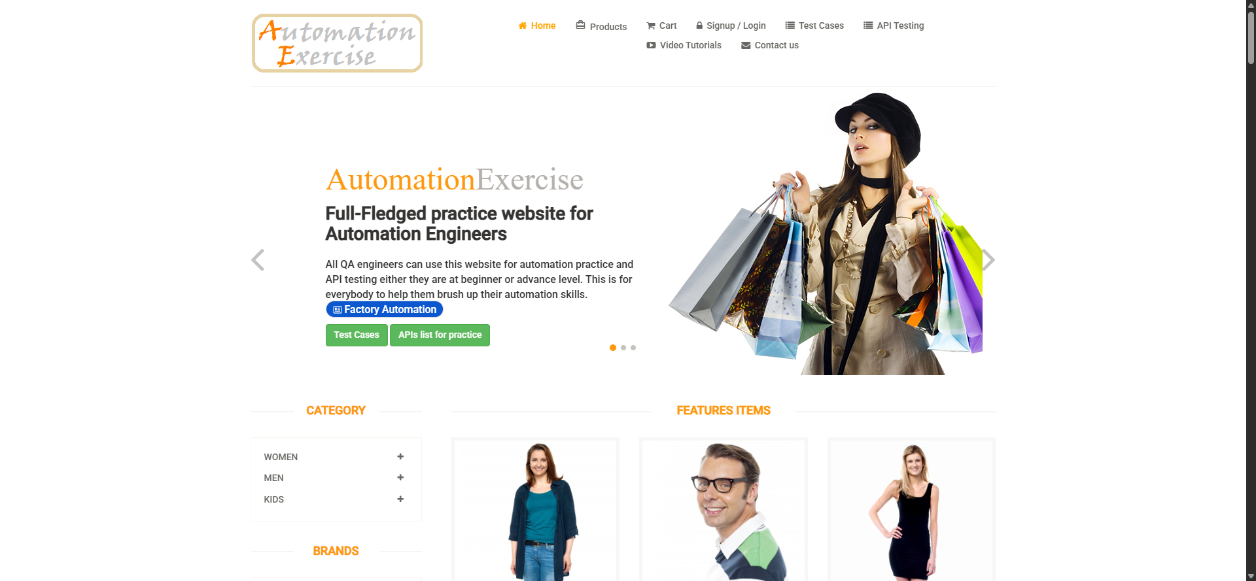
Step 2 — Login Attempt
This is the one step that didn't fully pass — I hadn't set up a registered account, so the site correctly rejected the placeholder credentials with "Your email or password is incorrect!". The script caught this itself, logged it as a SKIP rather than treating it as a crash, and carried on with the rest of the flow as a guest.
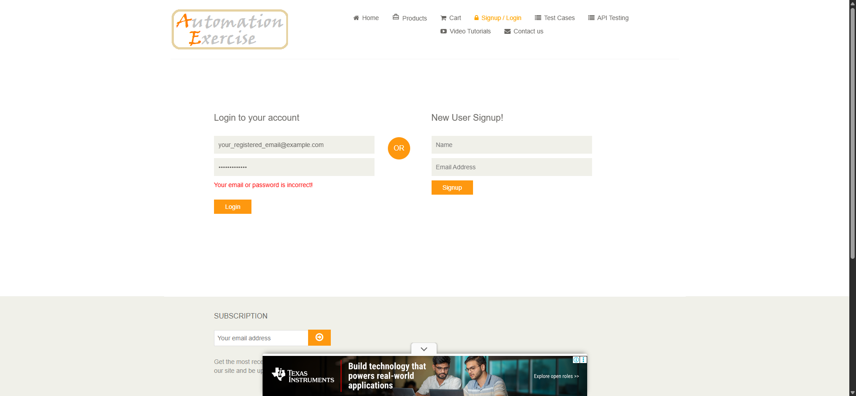
Step 3 — Product Search
Searching "Top" returned several matching items under Searched Products, so the search box and submit button both behaved as expected.
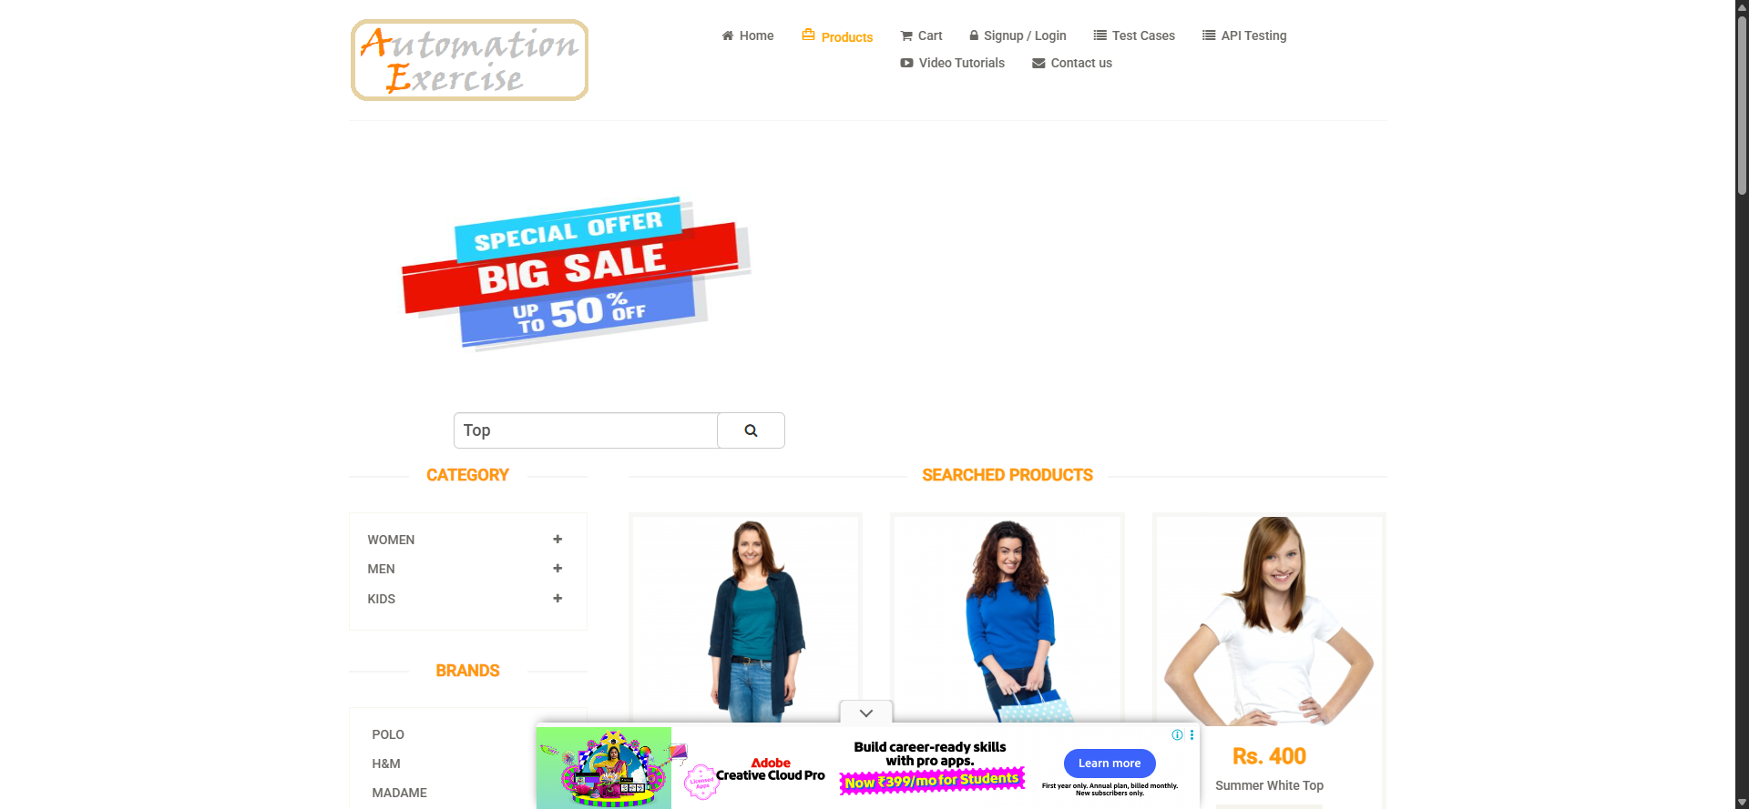
Step 4 — Add Product to Cart
The Blue Top (Rs. 500) was added, and the script waited for the confirmation modal before moving on — that wait is what makes this step reliable instead of racing ahead of the page.
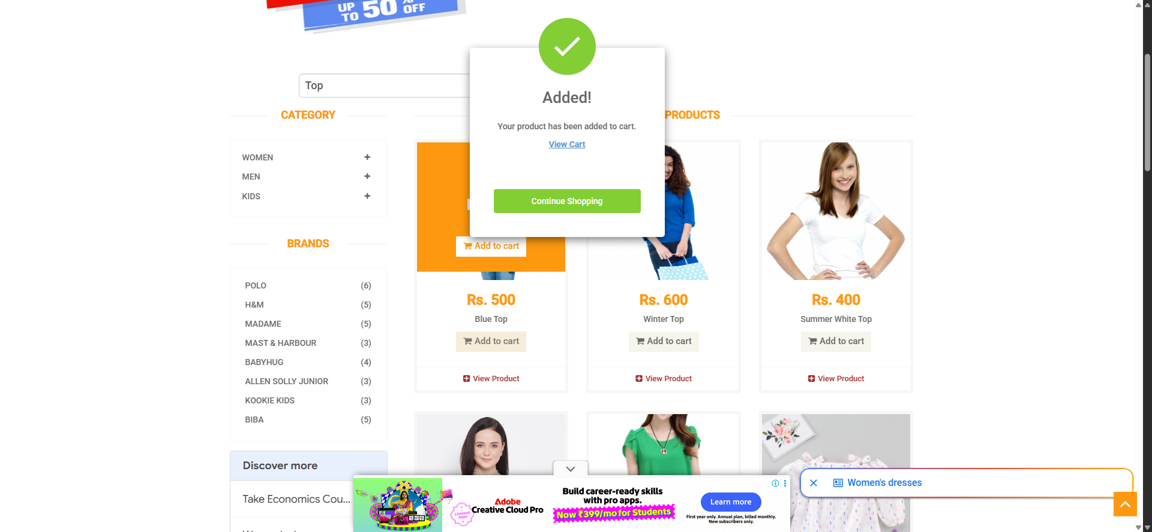
Step 5 & 6 — Cart Update and Verification
The cart page shows exactly what was expected: Blue Top, Rs. 500, and a matching total. The script reads these values back programmatically rather than just trusting the add-to-cart click succeeded.
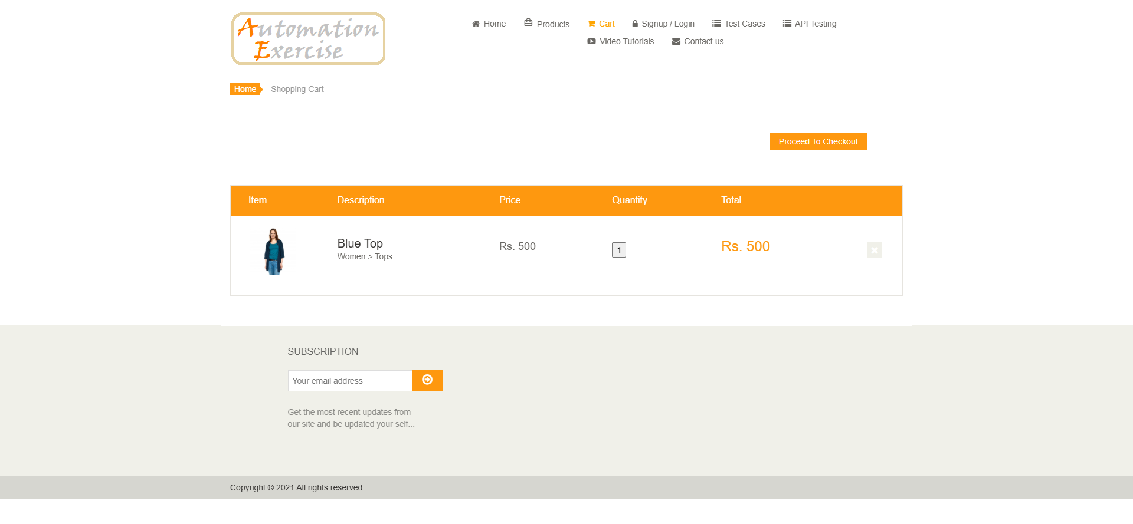

9. Test Step Summary
# | Step | Status | Remarks
1 | Launch Browser | PASS | Chrome session started, home page loaded
2 | Login | SKIP | No registered test account on hand; handled gracefully, guest flow continued
3 | Search Product | PASS | Keyword "Top" returned valid results
4 | Add Product to Cart | PASS | Confirmation modal detected before proceeding
5 | Update Quantity | PASS | Quantity field interaction attempted on cart page
6 | Verify Cart Details | PASS | Product, price and total matched what was added
7 | Capture Screenshots | PASS | Screenshot saved at every key step
8 | Read Test Data (JSON) | PASS | All inputs loaded from test_data.json
9 | Handle Popups/Alerts | PASS / INFO | Consent popup handled; no native alert appeared on this run
10 | Generate Execution Report | PASS | HTML report written with the full step log

10. What I'd Do Differently Next Time
- Register a real test account up front instead of using placeholder credentials, so the login step gets a genuine PASS rather than an explained SKIP.
- Add a retry wrapper around the quantity-update step — this demo site's cart field isn't always editable post-add, and a short retry would make that distinction clearer in the report.
- Carry this same data-driven, screenshot-everything approach into the framework version (Assignment 2), where it can be split cleanly into Page Objects instead of one long script.

11. Conclusion
All ten required behaviours are in place and actually run against the live site, not just against a mocked-up version of it. The one step that didn't come back as a clean PASS — login — failed for an entirely expected reason (no real account), and the script's own error handling caught that and kept going rather than falling over. That, more than the happy-path steps, is what I'd point to as the useful part of this assignment: writing an automation script that behaves sensibly when something doesn't go to plan, not just when everything works.

12. Appendix — Repository Contents
- ecommerce_automation.py — the main automation script
- data/test_data.json — externalized test data (make sure this folder actually travels with the script — see Section 7)
- requirements.txt — Python dependencies (selenium, webdriver-manager)
- screenshots/ — timestamped screenshots generated per run
- reports/execution_report.html — the generated execution report

