**React**

**1. ReactJS-HOL**

App.js:

import React from 'react';

function App() {

  return (

    <div>

      <h1>Welcome to the first session of React</h1>

    </div>

  );

}

export default App;

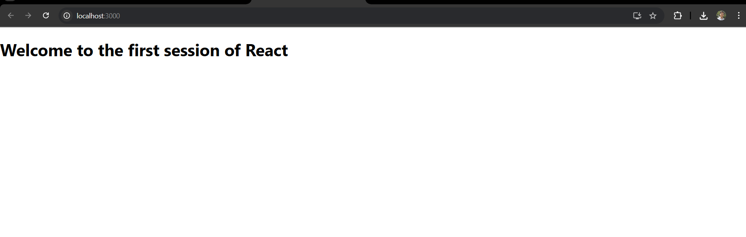

**2. ReactJS-HOL**

Home.js:

import React, { Component } from 'react';

class Home extends Component {

  render() {

    return (

      <div>

        <h2>Welcome to the Home page of Student Management Portal</h2>

      </div>

    );

  }

}

export default Home;

About.js:

import React, { Component } from 'react';

class About extends Component {

  render() {

    return (

      <div>

        <h2>Welcome to the About page of the Student Management Portal</h2>

      </div>

    );

  }

}

export default About;

Contact.js:

import React, { Component } from 'react';

class Contact extends Component {

  render() {

    return (

      <div>

        <h2>Welcome to the Contact page of the Student Management Portal</h2>

      </div>

    );

  }

}

export default Contact;

App.js:

import React from 'react';

import Home from './Components/Home';

import About from './Components/About';

import Contact from './Components/Contact';

function App() {

  return (

    <div>

      <Home />

      <About />

      <Contact />

    </div>

  );

}

export default App;

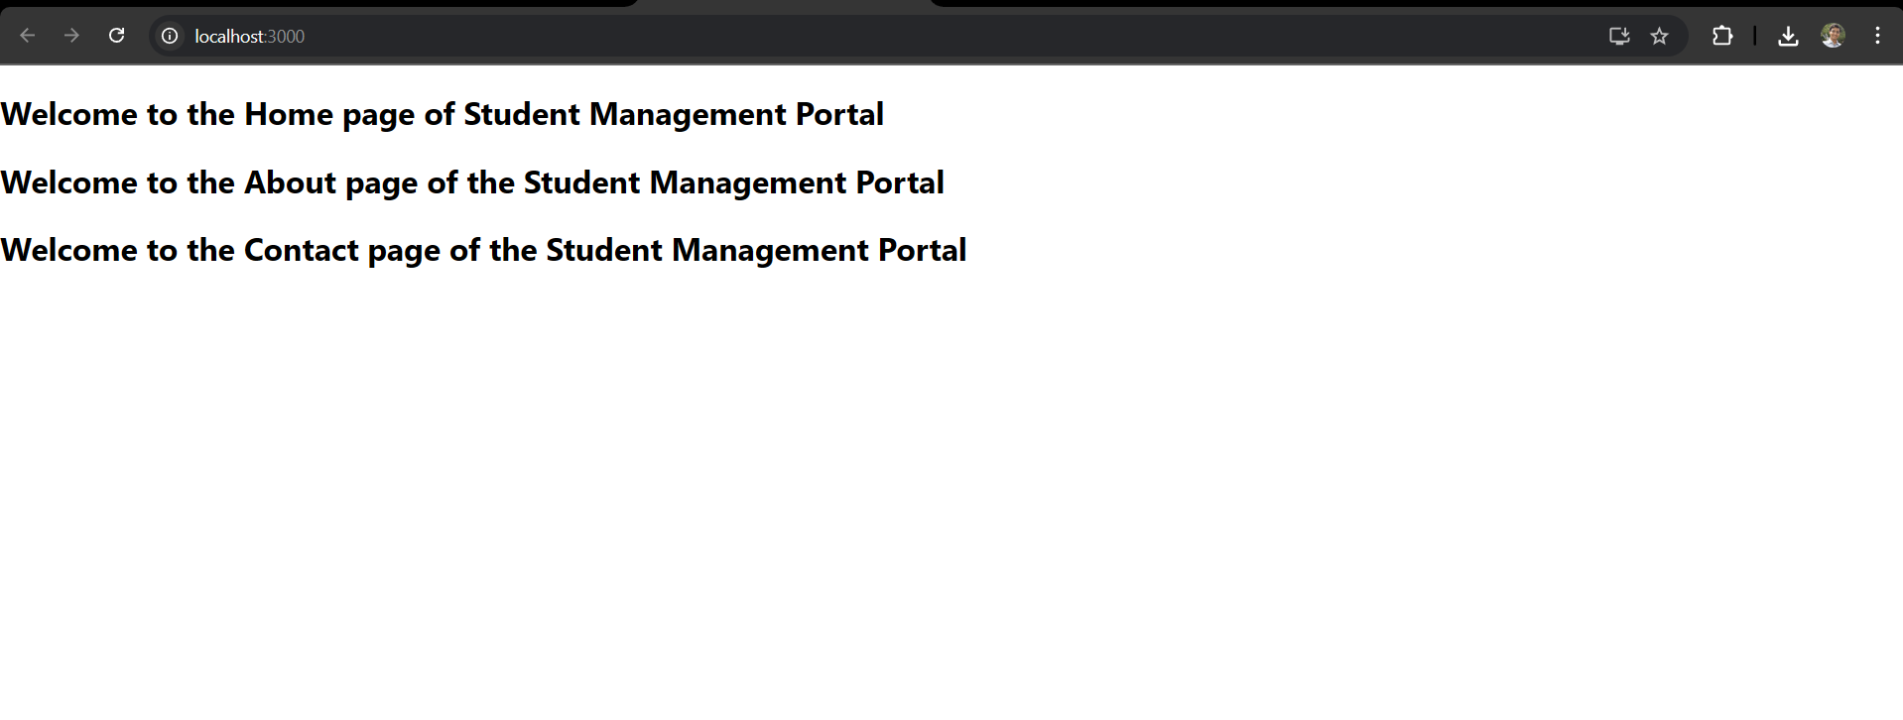

**3. ReactJS-HOL**

App.js:

import { CalculateScore } from '../src/CalculateScore';

function App() {

  return (

    <div>

      <CalculateScore

        Name={"Steeve"}

        School={"DNV Public School"}

        total={284}

        goal={3}

      />

    </div>

  );

}

export default App;

CalculateScore.js:

import '../src/Stylesheets/mystyle.css'

const percentToDecimal = (decimal) => {

  return (decimal.toFixed(2) + '%')

}

const calcScore = (total, goal) => {

  return percentToDecimal(total / goal)

}

export const CalculateScore = ({Name, School, total, goal}) => (

  <div className="formatstyle">

    <h1><font color="Brown">Student Details:</font></h1>

    <div className="Name">

      <b> <span> Name: </span></b>

      <span>{Name}</span>

    </div>

    <div className="School">

      <b> <span> School: </span> </b>

      <span>{School}</span>

    </div>

    <div className="Total">

      <b><span>Total:</span></b>

      <span>{total}</span>

      <span>Marks</span>

    </div>

    <div className="Score">

      <b>Score:</b>

      <span>

        {calcScore( total, goal )}

      </span>

    </div>

  </div>

);

mystyle.css:

.Name {

  font-weight: 300;

  color:blue;

}

.School {

  color: crimson;

}

.Total {

  color: darkmagenta;

}

.formatstyle {

  text-align: center;

  font-size: large;

  margin-top: 50px;

}

.Score {

  color: forestgreen;

}

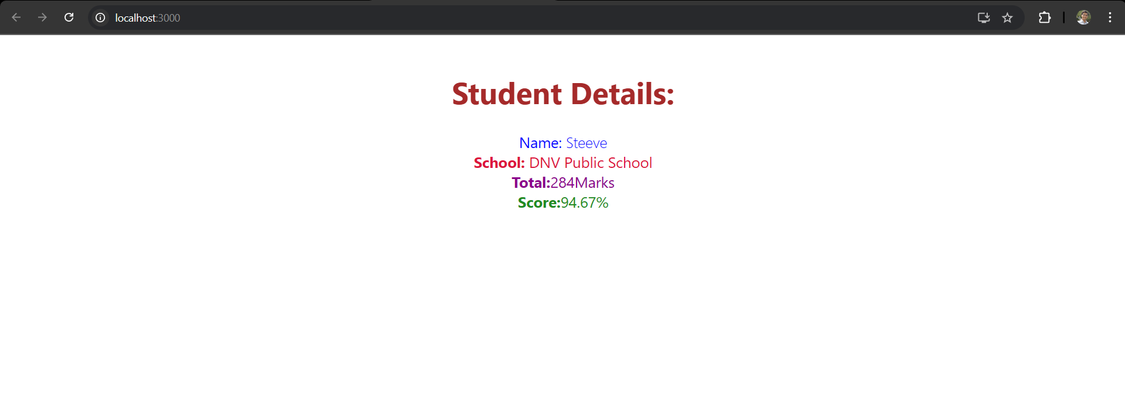

**4. ReactJS-HOL**

App.js:

import React from 'react';

import Posts from './Posts';

function App() {

  return (

    <div>

      <Posts />

    </div>

  );

}

export default App;

Post.js:

import React from 'react';

function Post({ title, body }) {

  return (

    <div style={{ border: '1px solid gray', padding: '10px', marginBottom: '10px' }}>

      <h3>{title}</h3>

      <p>{body}</p>

    </div>

  );

}

export default Post;

Posts.js:

import React, { Component } from 'react';

import Post from './Post';

class Posts extends Component {

  constructor(props) {

    super(props);

    this.state = {

      posts: [],

      hasError: false

    };

  }

  // Lifecycle method to load posts after component mounts

  componentDidMount() {

    this.loadPosts();

  }

  // Fetch posts from API and update state

  loadPosts = () => {

    fetch('https://jsonplaceholder.typicode.com/posts')

      .then((response) => response.json())

      .then((data) => this.setState({ posts: data }))

      .catch((error) => {

        console.error('Error loading posts:', error);

        this.setState({ hasError: true });

      });

  };

  // Lifecycle method for catching errors

  componentDidCatch(error, info) {

    console.error('Error caught in component:', error, info);

    alert('An error occurred while loading the component.');

    this.setState({ hasError: true });

  }

  render() {

    const { posts, hasError } = this.state;

    if (hasError) {

      return <h2>Something went wrong.</h2>;

    }

    return (

      <div style={{ padding: '20px' }}>

        <h1>Blog Posts</h1>

        {posts.map((post) => (

          <Post key={post.id} title={post.title} body={post.body} />

        ))}

      </div>

    );

  }

}

export default Posts;

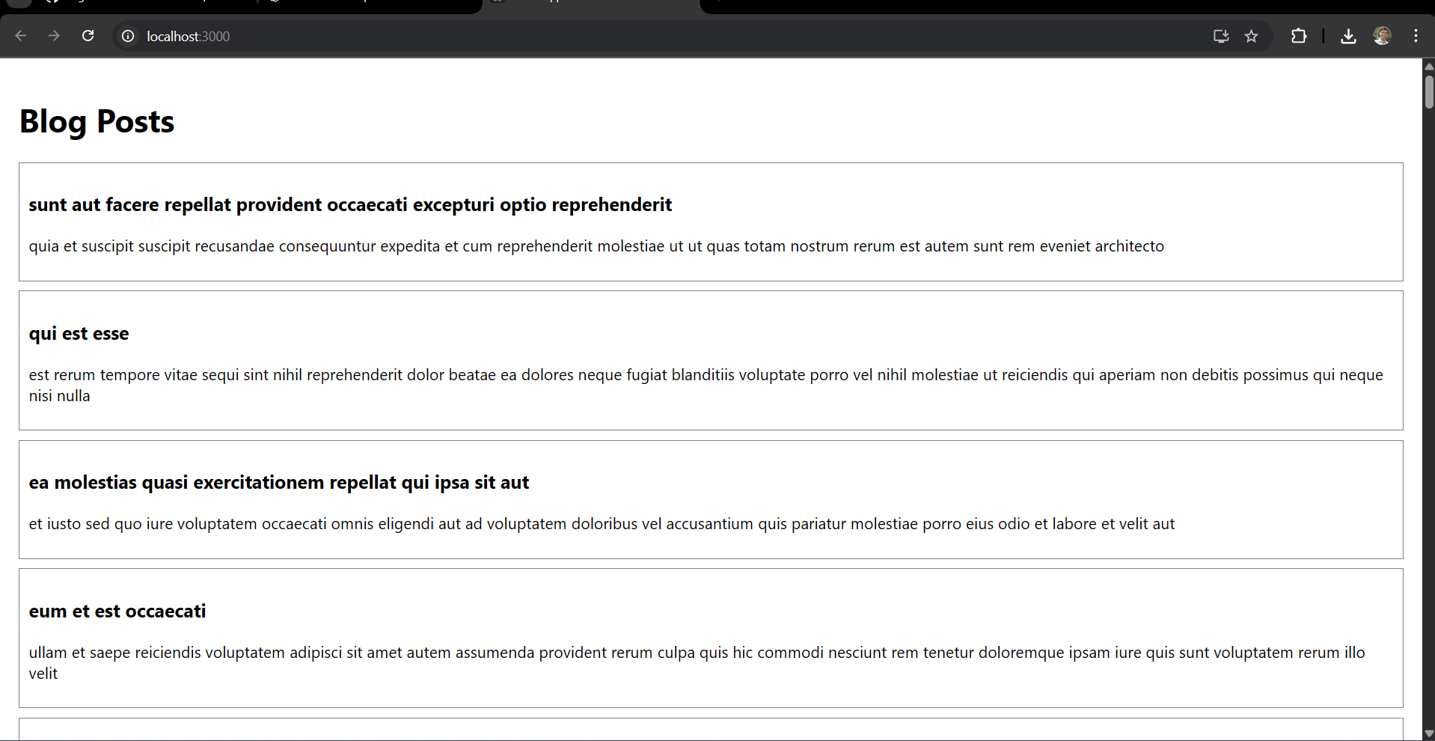

**5. ReactJS-HOL**

CohortDetails.js:

import React from 'react';

import styles from './CohortDetails.module.css';

function CohortDetails(props) {

  const { cohort } = props;

  return (

    <div className={styles.box}>

      <h3 style={{ color: cohort.currentStatus === 'Ongoing' ? 'green' : 'blue' }}>

        {cohort.cohortCode} - <span>{cohort.technology}</span>

      </h3>

      <dl>

        <dt>Started On</dt>

        <dd>{cohort.startDate}</dd>

        <dt>Current Status</dt>

        <dd>{cohort.currentStatus}</dd>

        <dt>Coach</dt>

        <dd>{cohort.coachName}</dd>

        <dt>Trainer</dt>

        <dd>{cohort.trainerName}</dd>

      </dl>

    </div>

  );

}

export default CohortDetails;

CohortDetails.module.css:

.box {

  width: 300px;

  display: inline-block;

  margin: 10px;

  padding: 10px 20px;

  border: 1px solid black;

  border-radius: 10px;

}

dt {

  font-weight: 500;

}

App.js:

import React from 'react';

import CohortDetails from './CohortDetails';

import { CohortsData } from './Cohort';

function App() {

  return (

    <div style={{ padding: '20px' }}>

      <h1>Academy Cohort Dashboard</h1>

      {CohortsData.map((cohort, index) => (

        <CohortDetails key={index} cohort={cohort} />

      ))}

    </div>

  );

}

export default App;

