In this project I have created a quiz software , it is mainly for the school student , when you open the software it will forward it to a login ,

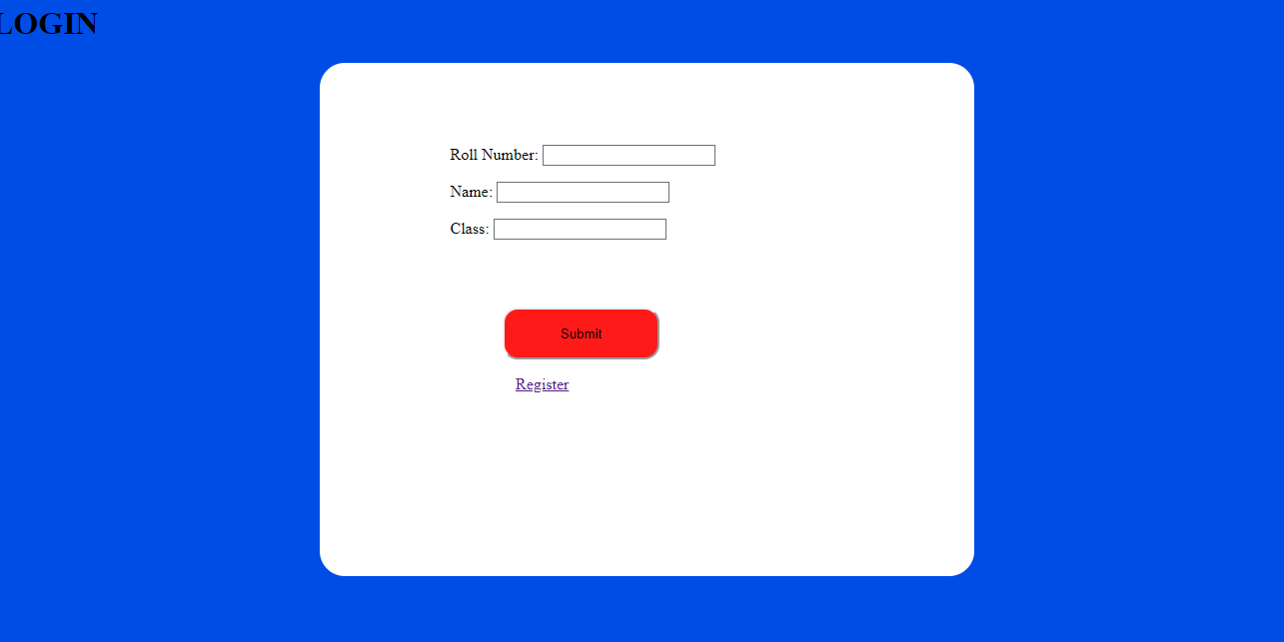

If you have already registered then provide the credential , or click on the Register link ,it will forward you to the registration page

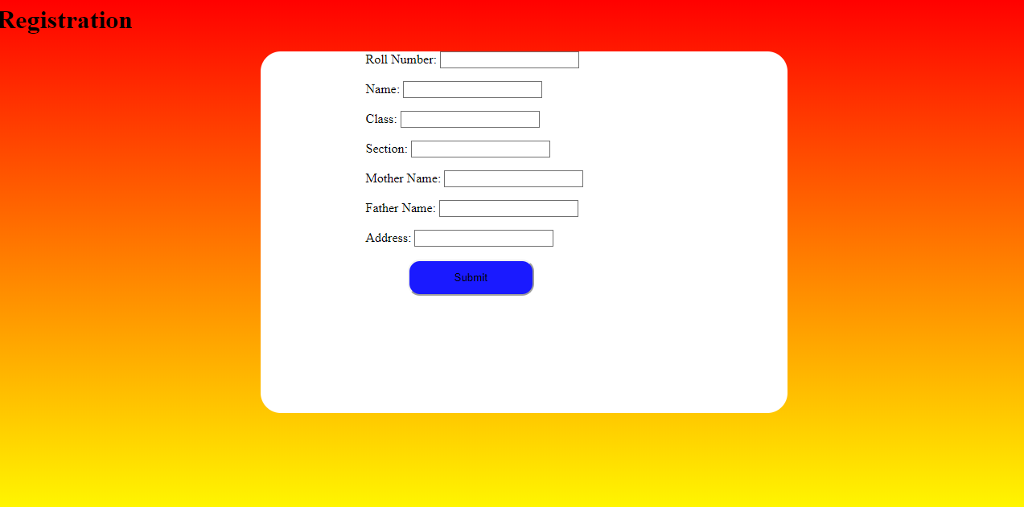

This is the registration page , on clicking the submit it will forward you to the login page

On clicking the button we will get the question

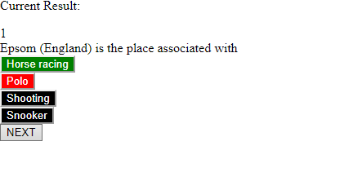

In this way it will show you the current result and on clicking each button if the answer is right it will show you green , if it is wrong it will be red and the result will be shown

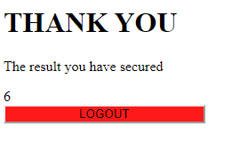

When the 10 question is completed you will click on logout , you will again in the login page

**Things can be improved in this project:-**

I thought I will improve in this project that a particular person is entered by his/her roll number next time he will be unable to give this quiz with his roll-number , this facility to ensure a particular person can give exam only once , not more than once .

**Database Part:-**

In this project I have used SQLite database and the information of requirement you can get from the requirements.txt file