**R. C. Patel Educational Trust’s**

Institute of Management Research and Development

“Quality Education for Nourishing Tomorrow’s IT & Management” Professionals”

A Project Report on:

## Online Library Management System

Submitted to:

## Institute of Management Research and Development, Shirpur, Dhule, Maharashtra, India

Affiliated to:

## Kavayitri Bahinabai Chaudhari North Maharashtra University, Jalgaon, Maharashtra, India

**BACHELOR OF COMPUTER APPLICATION**

Submitted by :

## Mr. Saptesh Anil Dhakare

(TYBCA SEMESTER-VIth)

PRN No: **2021015400009387**

[dhakaresaptsh@gmail.com](mailto:dhakaresaptsh@gmail.com)

Guided by :

## Ms. Priyanka S. Saindane

### Academic Year 2023-2024

**CERTIFICATE OF PROJECT REPORT**

This is to certify that **Mr. Saptesh Anil Dhakare** has completed her project entitled “Online Library Management System” for partial fulfilment of Bachelor of Computer Application (BCA) for North Maharashtra University, Jalgaon under for Guidance During the academic year 2023 - 2024.

This performance and the system are up to mark and I am satisfied with the same.

Date : / / 2024

|  |  |  |
| --- | --- | --- |
| (Ms. Priyanka S. Saindane) | (Dr. Tushar R. Patel) | (Dr. Vaishali B. Patil) |
| Guide | HOD of UG Department | Director of IMRD |

Internal Examiner :

External Examiner :

**CERTIFICATE**

This is certifying that **Mr. Saptesh Anil Dhakare** student of Institute of Management Research and Development, Shirpur has completed her project and report **"Online Library Management System"** as a part of **BCA Sem-VI** in our organization. His project work is satisfied and meets all requirements for computerization of our system. We wish them for their bright future.

Name of Organization:

Name of Owner:

**DECLARATION**

I, Saptesh Anil Dhakare the student of the Bachelor of Computer Application (BCA) course in the Institute of Management Research & Development , Shirpur under

K.B.C North Maharashtra University , Jalgaon.

I declared that the present report title ***“Online Library Management System”*** is based on my project and it is genuine work.

Thanking You.

Date: Place:

**ACKNOWLEDGEMENT**

It is with great pleasure that I take this I have opportunity to head in respect and gratitude for those who helped me in making this project a get success.

I am thankful to our respected Director Prof. Dr. Vaishali B. Patil Mam for supporting us in completion of project by granting many useful things.

I have developed this project with the help of faculty members of our Institute and I am extremely grateful to all of them.

I am also taking this opportunity to thank the Head of the UG Department Dr. Tushar Patel Sir for his timely suggestion, help, guidance and encouragement during the project.

I have immense pleasure in expressing my sincerest and deepest sense of gratitude toward our guide Ms. Priyanka S. Saindane for the assistance, valuable guidance and co- operation in carrying out this project successfully.

I also thank to all who indirectly help me in completion of my report and obligate and great hands in behind my achieving goals.

Name : ***Dhakare Saptesh Anil***

**INDEX**

|  |  |
| --- | --- |
| **1.Introduction** | **8** |
| 1.1 Introduction to project | 8 |
| 1.2 About organization | 8 |
| **2.Need of system** | **9** |
| **3.System study analysis** | **10** |
| 3.1 Objective of proposed system | 10 |
| 3.2 Scope of proposed system | 10 |
| 3.3 Existing system Overview | 10 |
| 3.4 Drawback and limitation of system | 11 |
| **4.Feasibility study** | **12** |
| 4.1 Information gathering | 12 |
| 4.2 Economic feasibility study | 13 |
| 4.3 Technical feasibility study | 13 |
| 4.4 Operational study | 14 |
| **5.System development** | **15** |
| 5.1 Operating environment | 15 |
| 5.2 Introduction of technology | 16 |
| 5.3 Introduction of database | 16 |
| **6.Detail design of proposed system** | **17** |
| 6.1 Data Flow Diagram | 17 |
| 6.2 Entity Relationship Diagram | 20 |

|  |  |
| --- | --- |
| **7.Screenshots** | 21 |
| **8.Coding system** | 27 |
| **9.Testing and implementation** | 28 |
| 9.1 Testing | 28 |
| 9.2 Types of testing | 28 |
| **10.Conclusion and remark** | 30 |
| **11.Bibliography** | 31 |

# CHAPTER 1: INTRODUCTION OF PROJECT

## INTRODUCTION:

In an age dominated by digital innovation and information exchange, libraries stand as timeless pillars of knowledge dissemination and academic growth. However, the traditional notion of libraries has evolved with the advent of technology, leading to the emergence of online library management systems. Our project, the Online Library Management System, aims to seamlessly blend the rich legacy of libraries with the efficiency and convenience afforded by modern digital tools.

The Online Library Management System is a comprehensive web-based platform designed to facilitate the management of library resources, streamline administrative tasks, and enhance user experience. Developed using ASP.NET, Bootstrap, jQuery, and MySQL, our system offers a robust framework for librarians and users alike to interact with library resources in a cohesive and intuitive manner.

## ABOUT ORGANIZATION:

The Online Library Management System is a sophisticated web-based platform developed using ASP.NET, Bootstrap, jQuery, and MySQL, aimed at revolutionizing library operations by seamlessly integrating digital tools with traditional library functionalities. With user authentication ensuring secure access, librarians can efficiently manage book cataloging, user registrations, and borrowing processes, while users benefit from intuitive search and reservation features. The system's responsive design ensures accessibility across devices, while comprehensive reporting tools provide valuable insights for administrative decision-making. By leveraging cutting-edge technologies, the project seeks to enhance the user experience, streamline administrative tasks, and foster a dynamic and enriching library environment.

# CHAPTER 2: NEED OF SYSTEM

## NEED OF STUDY:

The main need for studying your Online Library Management System project lies in its potential to revolutionize traditional library operations by integrating modern technology. Here are the key reasons why studying this project is essential:

* **Efficiency Enhancement:** Understanding how digital tools can streamline tasks such as book management, user authentication, and reporting can significantly improve the efficiency of library operations.
* **User Experience Improvement:** By studying the project, you can learn how to create a user-centric library experience, making it easier for patrons to access resources and services seamlessly.
* **Technological Proficiency:** Learning about the software development methodologies, frameworks, and technologies used in the project enhances your technological proficiency, a valuable skill in today's digital age.
* **Cost Reduction:** Implementing digital library management systems can lead to cost savings by reducing manual labor, paper-based processes, and the need for physical storage space.
* **Accessibility Enhancement:** Digital library systems can improve accessibility for users with disabilities by offering features such as screen readers and customizable interfaces, fostering inclusivity within the library community.
* **Academic Advancement:** Studying the project contributes to academic research and innovation in library science and information technology, driving continuous improvement in library management practices.

# CHAPTER 3: SYSTEM STUDY ANALYSIS

## OBJECTIVES OF PROPOSED SYSTEM:

The objective of the Online Library Management System project is to develop a comprehensive web-based platform that modernizes traditional library operations by seamlessly integrating digital tools and technologies. This system aims to streamline book management processes, enhance user experience through intuitive search and reservation functionalities, ensure robust data security and privacy compliance, facilitate seamless borrowing and returning of resources, provide comprehensive reporting and analytics for informed decision-making, improve accessibility for users with disabilities, optimize resource allocation and strategic planning, foster academic research and innovation, adapt to digital trends and technological advancements, and promote inclusivity and diversity within the library community, ultimately revolutionizing library services and promoting lifelong learning.

The main objectives of this website development can be defined as follows:

1. **Efficiency**: Streamline library operations for efficient resource management.
2. **User Experience**: Enhance accessibility and usability for patrons.
3. **Data Security**: Ensure the protection of sensitive user information.
4. **Functionality**: Enable seamless borrowing and returning processes.
5. **Insight**: Provide actionable insights through comprehensive reporting.
6. **Inclusivity**: Cater to diverse user needs and preferences.
7. **Sustainability**: Optimize resource allocation for long-term viability.
8. **Innovation**: Foster technological advancement and academic research.
9. **Adaptability**: Stay abreast of digital trends and technological evolution.
10. **Community Engagement**: Promote a culture of learning and knowledge sharing.

## SCOPE OF PROPOSED SYSTEM:

1. **Member Signup**
   * + - New users can sign up via this module
2. **Member Login**
   * + - Signed up users will login in
3. **View Books**
   * + - Anyone can view the books available
4. **Admin Login**
   * + - Admin will login via this module
5. **Book Author Management**
   * + - Add/Update/Delete Author details
6. **Publisher Management**
   * + - Add/Update/Delete Publisher details
7. **Book Inventory**
   * + - Add/Update/Delete Book details
8. **Book Issuing Process**
   * + - Issue/Return Books

## LIMITATION OF SYSTEM:

## 

1. **Dependency on Technology:**

* Reliance on technology may lead to disruptions in case of technical failures or system downtimes.

1. **Initial Implementation Costs:**

* The upfront costs of implementing the system may pose a financial burden for smaller societies.

1. **Learning Curve:**

* Residents and staff may need time to adapt to the new system, causing a temporary decrease in efficiency during the transition period.

1. **Data Security Concerns:**

* Potential security risks may arise, requiring robust measures to protect sensitive resident information.

1. **Limited Accessibility:**

* Residents without internet access or familiarity with technology may face challenges in using the system.

1. **Customization Constraints:**

* The system might have limitations in accommodating unique needs and specific requirements of diverse societies.

1. **Integration Issues:**

* Challenges may arise when integrating the system with existing infrastructure or other third-party tools.

1. **Maintenance Challenges:**

* Regular maintenance is essential, and delays or negligence in upkeep could impact system performance.

# CHAPTER 4: FEASIBILITY STUDY

## INFORMATION GATHERING:

The main aim of fact-finding techniques is to determine the information requirements of an organization used by analysts to prepare a precise SRS understood by user.

Ideal SRS Document should –

* + - Be complete, Unambiguous, and Jargon-free.
    - Specify operational, tactical, and strategic information requirements.
    - Solve possible disputes between users and analyst.
    - Use graphical aids which simplify understanding and design. There are various information gathering techniques −

### Interviewing -

Systems analyst collects information from individuals or groups by interviewing. The analyst can be formal, legalistic, play politics, or be informal; as the success of an interview depends on the skill of analyst as interviewer.

### Questionnaires -

This method is used by analyst to gather information about various issues of system from large number of persons.

### Review of Records, Procedures, and Forms -

Review of existing records, procedures, and forms helps to seek insight into a system which describes the current system capabilities, its operations, or activities.

### Observation -

This is a method of gathering information by noticing and observing the people, events, and objects. The analyst visits the organization to observe the working of current system and understands the requirements of the system.

## ECONOMIC FEASIBILITY STUDY:

Economic analysis is most frequently used for evaluation of the effectiveness of the system. More commonly known as cost/benefit analysis the procedure is to determine the benefit and saving that are expected from a system and compare them with costs, decisions is made to design and implement the system.

This part of feasibility study gives the top management the economic justification for the new system. This is an important input to the management the management, because very often the top management does not like to get confounded by the various technicalities that bound to be associated with a project of this kind. A simple economic analysis that gives the actual comparison of costs and benefits is much more meaningful in such cases.

## TECHNICAL FEASIBILITY STUDY:

Technical feasibility assesses the current resources (such as hardware and software) and technology, which are required to accomplish user requirements in the software within the allocated time and budget. For this, the software development team ascertains whether the current resources and technology can be upgraded or added in the software to accomplish specified user requirements. Technical feasibility also performs the following tasks:

* + - Analyses the technical skills and capabilities of the software development team members.
    - Determines whether the relevant technology is stable and established.

Ascertains that the technology chosen for software development has a large number of users so that they can be consulted when problems arise or improvements are required.

## OPERATIONAL FEASIBILITY STUDY:

Operational feasibility assesses the extent to which the required software performs a series of steps to solve business problems and user requirements. This feasibility is dependent on human resources (software development team) and involves visualizing whether the software will operate after it is developed and be operative once it is installed. Operational feasibility also performs the following tasks.

It is Operational feasible, since the system is providing an attractive user interface to the operator/end user, so he feels very easy to work onto it. Response to operator/end user is very fast and very good. Since, as we mentioned above that it requires much less amount of cost, it uses computer work so it is very fast to operate and it is very easy for user to work on it.

# CHAPTER 5: SYSTEM DEVELOPMENT

## OPERATING ENVIRONMENT:

A major element in building system is selection of compatible hardware & software. Hardware selection they begin with requirements analysis following by a request for proposal, evaluation & validation, post installation review.

While selecting the software various criteria is considered such as reliability (gives consistent results), functionality (function to standards), capacity (satisfies volume requirements), flexibility (adapts to changing needs), usability (user friendly), security (to prevent unauthorized access), performance (capacity to deliver as expected), serviceability (good documentation), minimal cost (affordable for intended application).

**Software Requirement:**

* + 1. Operating System-Windows 11.
    2. Google Chrome or any other browser.

**Hardware Requirement:**

1. Intel Core i7.
2. Minimum 4GB RAM.
3. Input Devices: Keyboard, Mouse.

## INTRODUCTION TO TECHNOLOGY:

### Asp .Net

* Leverage ASP.NET's robust framework for scalable and secure web application development.
* Implement asynchronous programming with async/await for improved responsiveness and scalability.
* Apply LINQ (Language Integrated Query) for efficient querying and manipulation of data.
* Utilize ASP.NET MVC (Model-View-Controller) architecture for clean separation of concerns and maintainable code.
* Harness ASP.NET's built-in authentication and authorization features for secure user management and access control. Asp .Net supports many databases (MYSQL, Informix, Oracle, Sybase, Solid, Generic ODBC, etc).
* Asp .Net is an open source software.
* Asp .Net is free to download and use.

### CSS

* Cascading Style Sheets (CSS).
* Simple mechanism.
* Easy for adding style (e.g., fonts, colors, spacing) to Web documents.

### Bootstrap

### Employ Bootstrap's responsive grid system for seamless adaptation across various screen sizes.

### Utilize Bootstrap's extensive library of pre-styled components for rapid UI development.

### Implement Bootstrap's utility classes for quick and flexible styling adjustments.

### Leverage Bootstrap's JavaScript plugins for interactive and dynamic user experiences.

### Customize Bootstrap themes and styles using Sass variables for consistent branding.

### Utilize Bootstrap's documentation and community support for efficient development and troubleshooting.

## INTRODUCTION TO DATABASE:

### MS SQL

* Microsoft SQL is a database server.
* Microsoft SQL is ideal for both small and large applications.
* Microsoft SQL supports standard SQL.
* Microsoft SQL compiles on a number of platforms.
* Microsoft SQL is free to download and use.
* Utilize Microsoft SQL Server's relational database management system for efficient storage and retrieval of structured data.

# CHAPTER 6: CHAPTER DESIGN

## DATA FLOW DIAGRAM:

* + - Data flow diagram is graphical tool which is used to describe and analyse the movement of data through a system. They focus on the data flowing into the system, between processes and in & out of data stores.
    - DFD is a graphical technique that detects information flow and transformation that are applied as data move from input and output.
    - DFD is a central tool and the basis from which other components are developed.
    - DFD provides mechanism for a final modelling as well as information flow modelling.
    - DFD has very simple notation which are easily understood by the users & those who involved in the system.

Symbol used for DFD

**Symbol Meaning**

External Entity as source Destination.

Process or Function.

Indicates the direction of Data flow.

File Storage i.e., data is Stored for use by one or more.

0-LEVEL DFD OF APPLICATION:

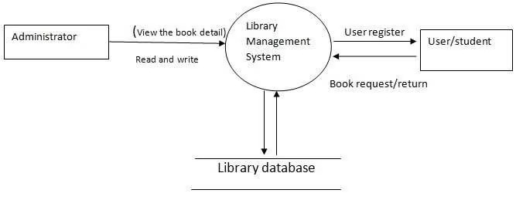

Data Flow Diagram of Society Management System Portal for the User:

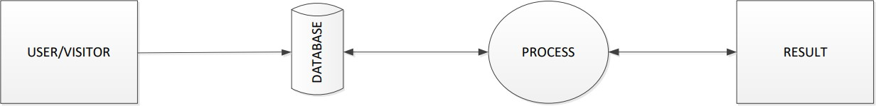

Data Flow Diagram of Society Management System Portal for the Admin:

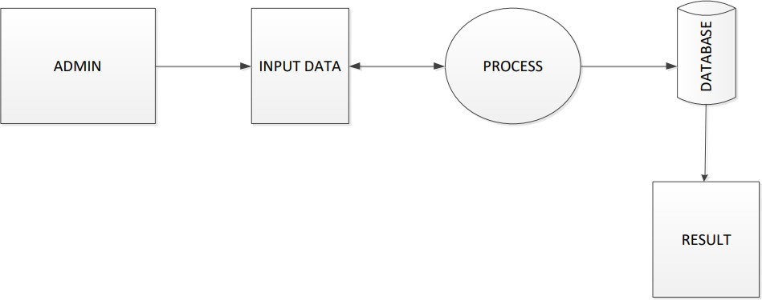

PANEL FLOW CHART

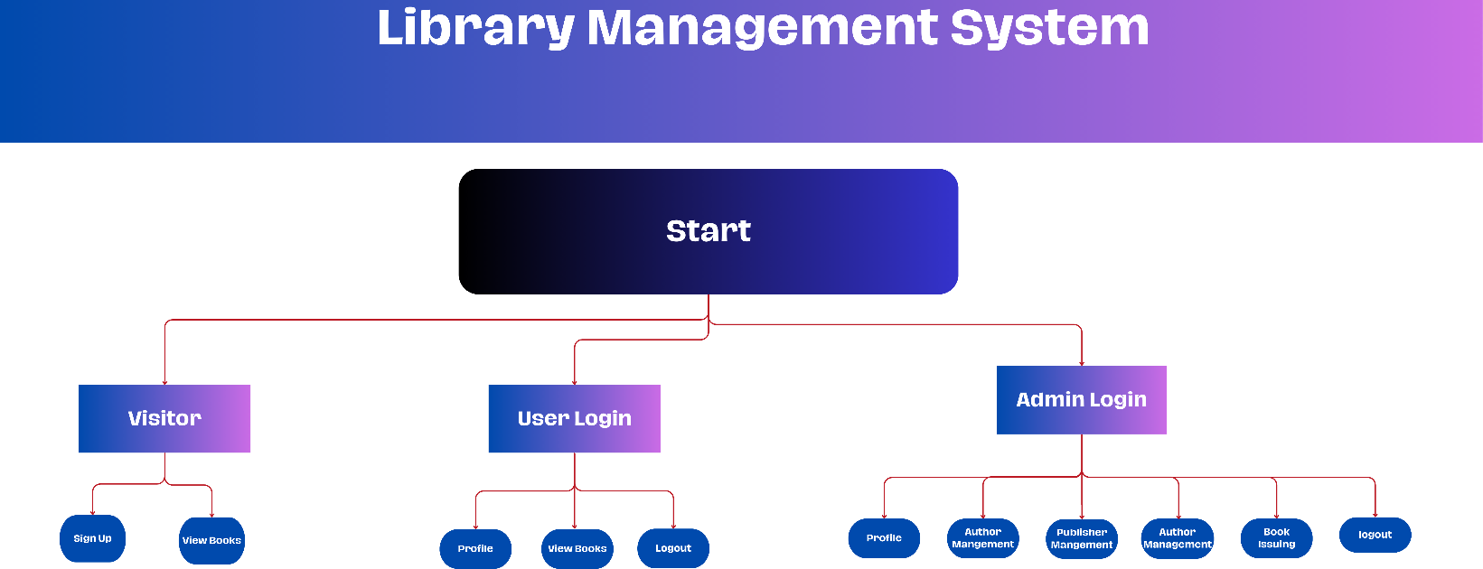

USE CASE DIAGRAM

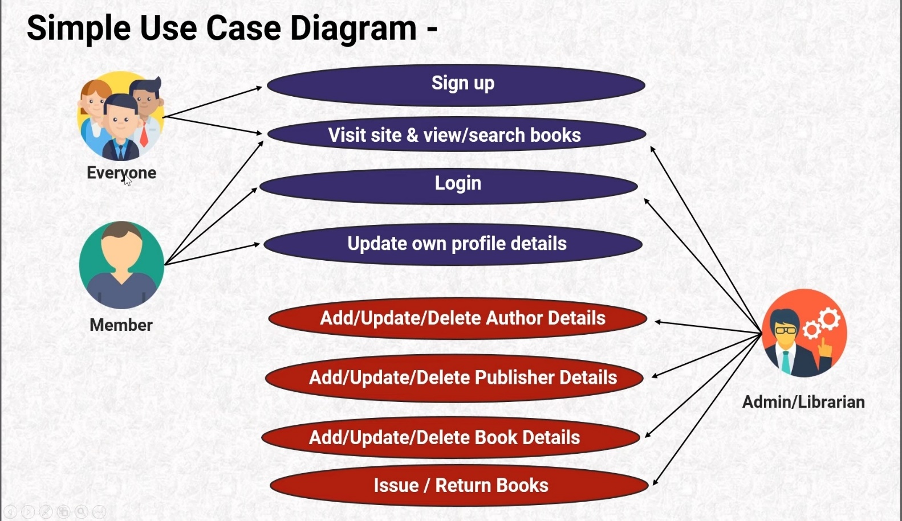

ENTITY RELATIONSHIP DIAGRAM

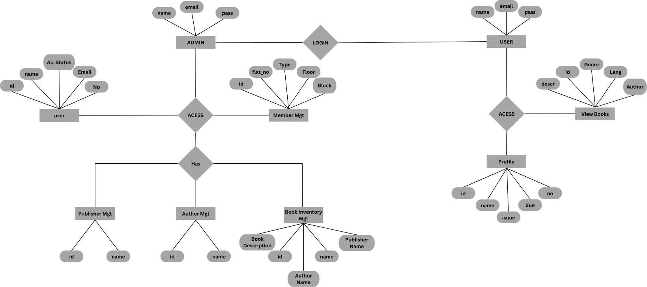

# CHAPTER 7: SCREENSHOTS

HOMEPAGE:

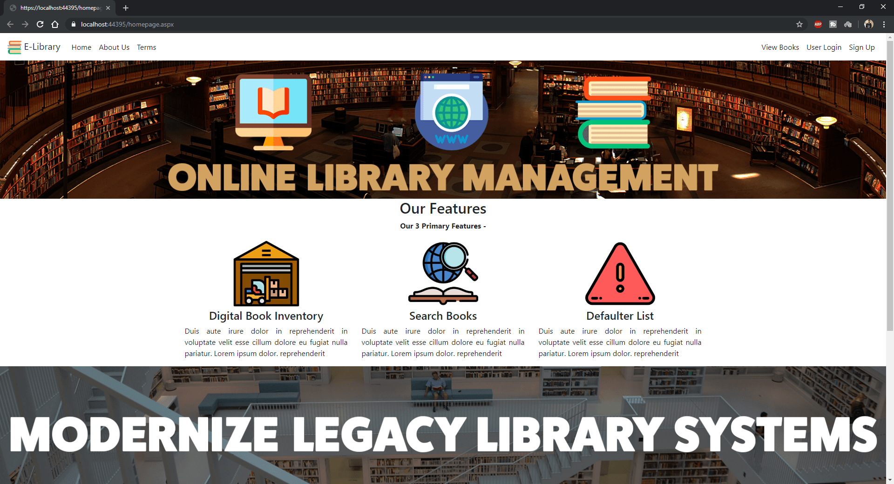

USER SIGNUP:

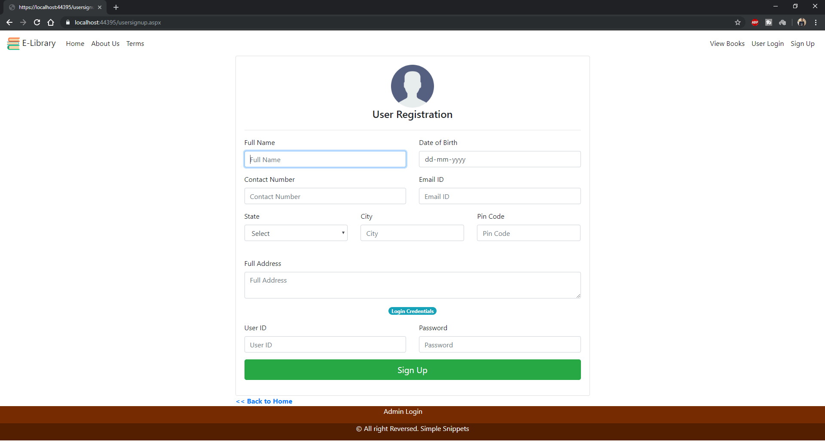

USER LOGIN:

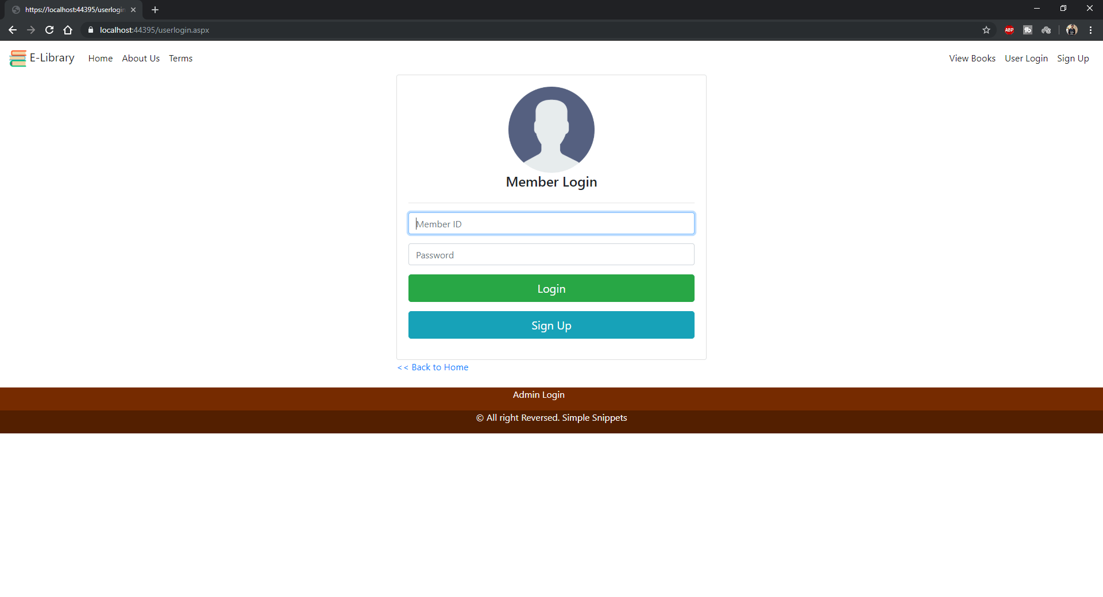

ADMIN LOGIN:

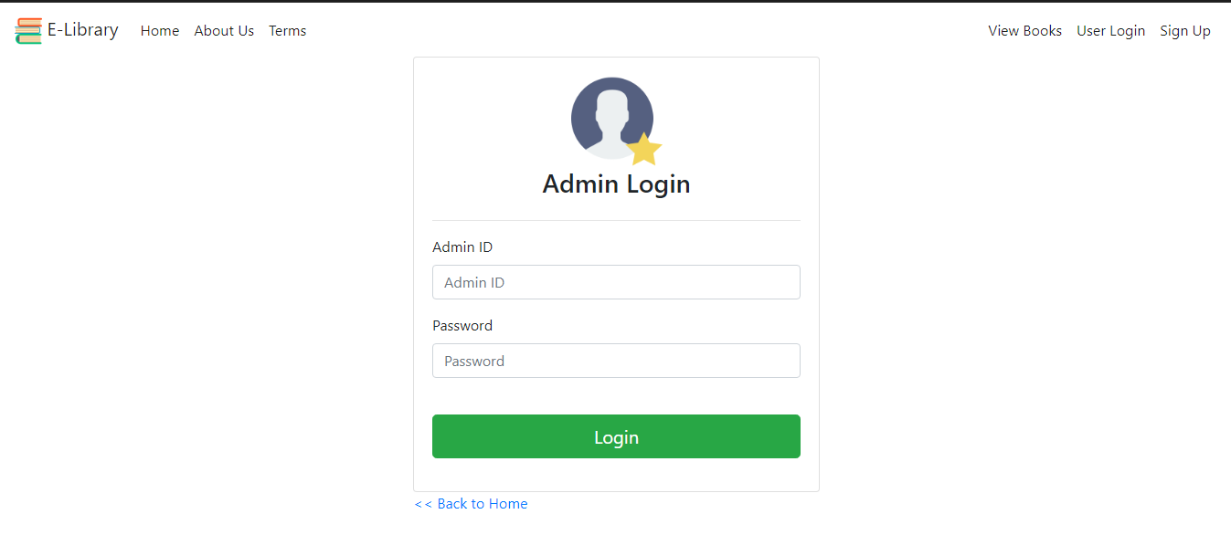

BOOK INVENTORY:

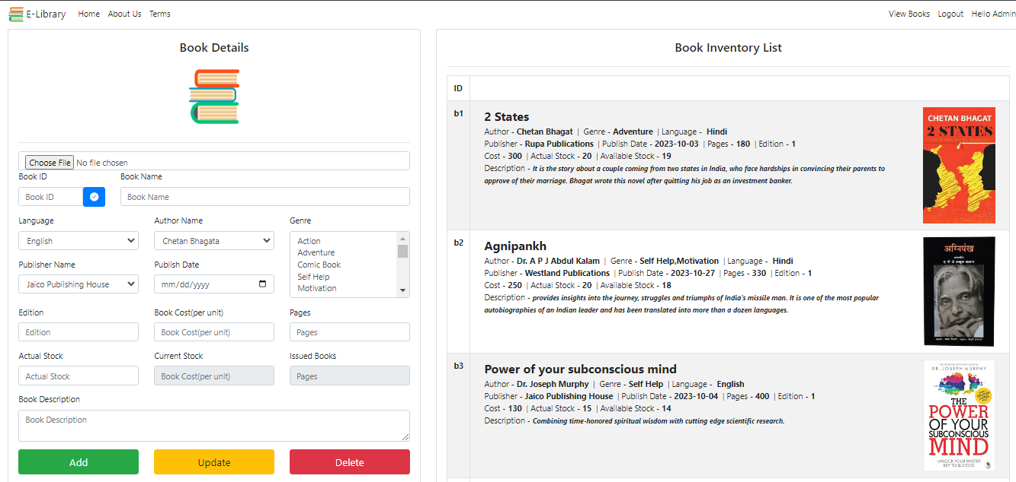

PROFILE:

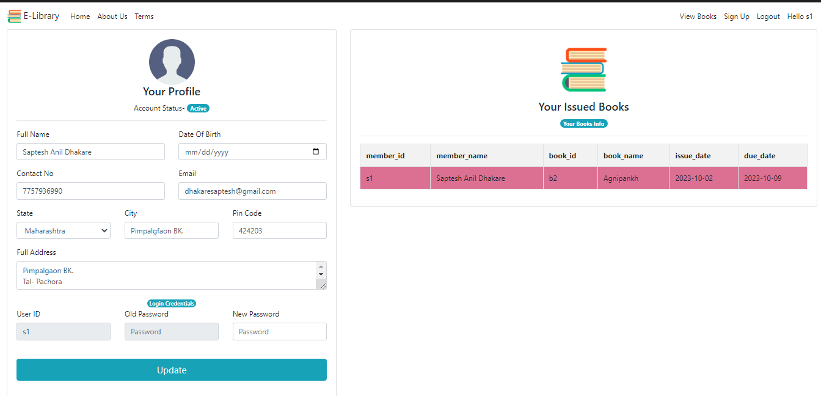

AUTHOR MANAGEMENT:

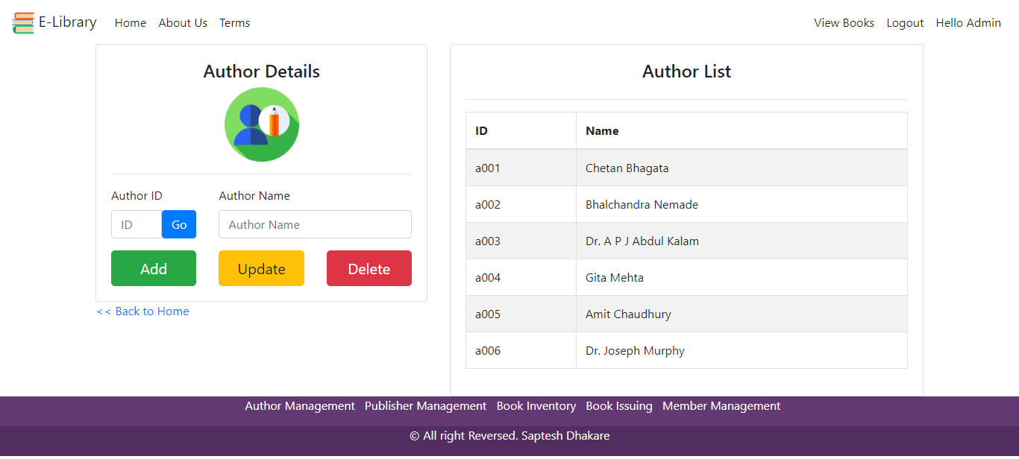

PUBLISHER MANAGEMENT:

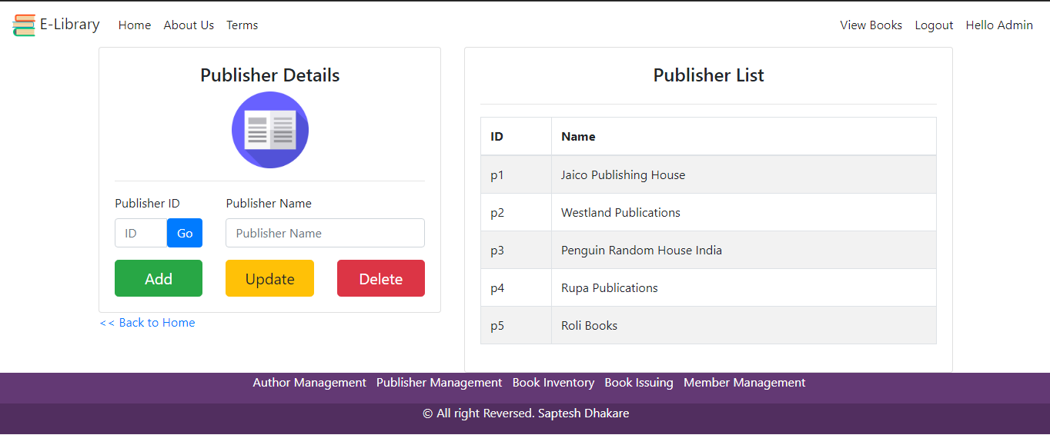

MEMBER MANAGEMENT:

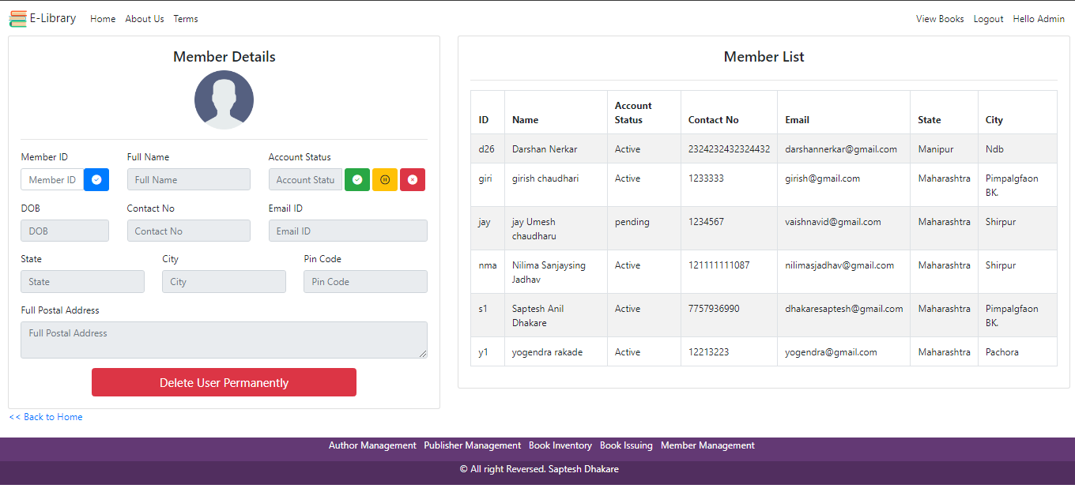

BOOK ISSUING:

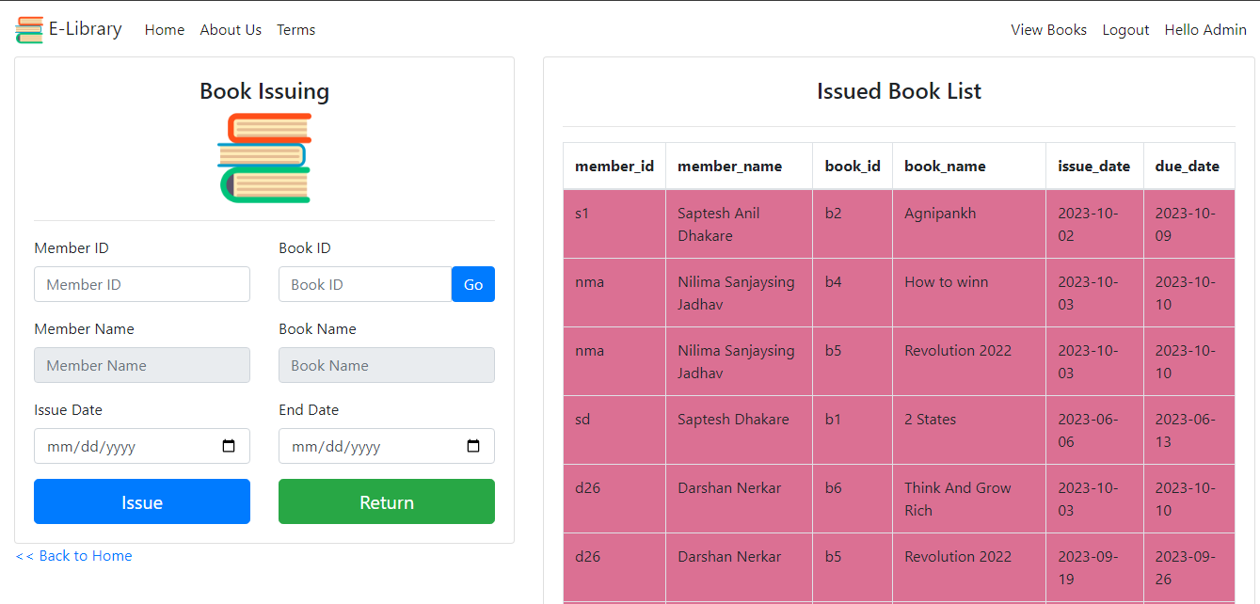

Admin_login_tbl (Database):

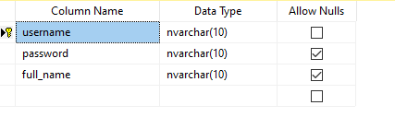

User_signup (Database):

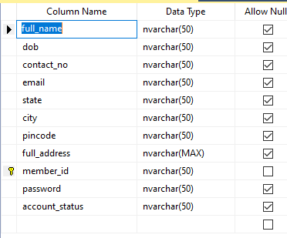

Publisher_mgt (Database):

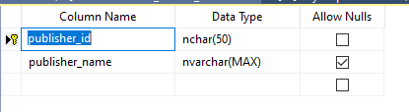

Author_mgt (Database):

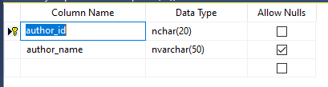

Book_inventory (Database):

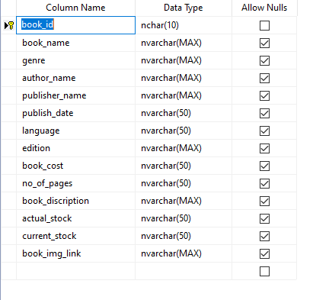

# CHAPTER 8: CODING

## Coding

A code is an ordered collection symbols to provide unique identification of data. Codes can be used by people who do not with data processing; the following are characters of a good code generation.

Characteristics of good coding are:

* Uniqueness
* Meaningfulness
* Stability
* Uniform Size and Format
* Simplicity
* Conciseness
* Versatility

The goal of the coding or programming phase is to translate the design of the system produced during the design phase into code in a given programming language, which can be executed by a computer and that performs the computation specified by the design. The coding phase affects both testing and maintenance profoundly. As we saw earlier, the time spent in coding is a small percentage of the total software cost, while testing and maintenance consume the major percentage. Thus, it should be clear the goal during coding should not be to reduce the implementation cost, but the goal should be to reduce the cost of later phases, even if it means that the cost of this phase has to increase. In other words, the goal during this phase is not to simplify the job of the programmer. Rather the goal should be to simplify the job of the tester and the maintainer.

# CHAPTER 9: TESTING & IMPLEMENTATION

## Testing

Testing of website perform coding like validation and verification testing. Different testing tools are used for testing like white box testing and black box testing.

Basic tools used to test this project are:

* + 1. Black Box Testing.
    2. White Box Testing.
    3. GUI Testing.

## Type of Testing

### Black Box Testing:

It is a method of software testing that tests the functionality of an application as opposed to its internal structures or workings. Specific knowledge of the application’s code/internal structure and programming language in general is not required. The tester is only aware of what the software is supposed to do, but not how i.e., when he enters a certain input, he gets certain output; without being aware of how the output was produced. Tests cases are built around specifications and requirements, i.e., what the application is supposed to do. It uses external descriptions of the software, including specifications, requirements and designs to derive test cases. These test designers select valid and invalid inputs and determine the correct output. There is knowledge of the test object’s internal structure.

This method of test can be applied to all levels of software testing: Unit, Integration, System and Acceptance. It typically comprises most if not all testing at higher levels, but can also dominate unit testing as well.

### The advantages of this type of testing include:

* The test is unbiased because the designer and the tester are independent of each other.
* The tester does not need knowledge of any specific programming languages.
* The test is done from the point of view of the user, not designer.

### The disadvantages of this type of testing include:

* The case can be redundant if the software designer has already run a test case.
* The test cases are difficult to design.

### White Box Testing:

White box testing is a method of testing software that tests internal structures or workings of an application, as opposed to its functionality. In white-box testing an internal perspective of the system, as well as programming skills, are required and used to design the test cases. The tester chooses input to exercise paths through the code and determine the appropriate outputs. While white-box testing can be applied at the unit, integration and system levels of the software testing process, it is usually done at unit level. It can test paths within a unit, paths between units during integration, and between subsystems during a system level test. Though this method of test design can uncover many errors or problems, it might not detect unimplemented parts of the specification or missing requirements.

### White-Box test design techniques include:

* + Control flow Testing
  + Data flow Testing
  + Branch Testing
  + Path Testing

### Graphical User Interface Testing:

It is the process of testing a product’s graphical user interface to ensure it meets its written specifications. This is normally done through the use of a variety of test cases. It checks only the user friendliness. The creation of the user interface is less time consuming for the user but more complex for the programmer. It must be tested for its sole purpose.

### This test must be carried out to ensure:

* + Windows open properly.
  + All data contents are properly addressable.
  + All the graphical elements are available and displayed.
  + Multiple or incorrect mouse click do not produce side effects.

# CHATER 10: CONCLUSION AND REMARK

## Conclusion:

* + In my project work, an attempt has been made to develop a Online Library Management web site.
  + I developed this project to help the students and librarians to reduce paper work and available all features at online.
  + To establish this website we use various methodologies, this project we have faced many problems but we hardly tried to develop this project. Our supervisor helps us by giving his valuable opinion, decision and time.

### I hereby conclude by stating some salient features:

1. The whole project is menu driven, which enables the user to handle the system without any difficulty.
2. The input screen designed in a simple manner and associated with proper messaged and prompt so that the user can easily enter the data.
3. All forms have proper validations.
4. Computerization speeds up the processing, user-friendly interface.
5. Reports are available by just selecting the option in a main menu.

# CHAPTER 11: BIBLIOGRAPHY

**References:** [www.google.com](http://www.google.com/) [www.wikipedia.com](http://www.wikipedia.com/)