Experiment 1
Library Management System
My Details
Name | Narjala Saptha Nageswar
Register Number | 192372001
Department | Artificial Intelligence and Data Science, SIMATS Engineering
Course Code | CSA4304
Course Name | Internet Programming
Aim
To design and develop an online Library Management System using HTML5, CSS and JavaScript, in which the librarian manages books, issues and returns books, calculates fines and updates study materials, and students search books, view their borrowing history and download study materials.
Algorithm
- Start and open the Library Management System page; the login page is displayed.
- A new student registers by giving name, username, password and department, and the details are stored.
- The user selects the role (Student or Librarian Admin), enters the username and password and clicks Login; the credentials are verified.
- If the credentials are valid, the dashboard of the selected role is displayed, otherwise an error message is shown.
- The librarian adds, updates and deletes books, issues a book to a student with a 14 day due date and updates study materials by year and semester.
- On return, the fine is calculated at Rs 5 per day after the due date; the student searches books, views the borrow history and fine, and downloads study material.
- The user clicks Logout to end the session and the program stops.
Output
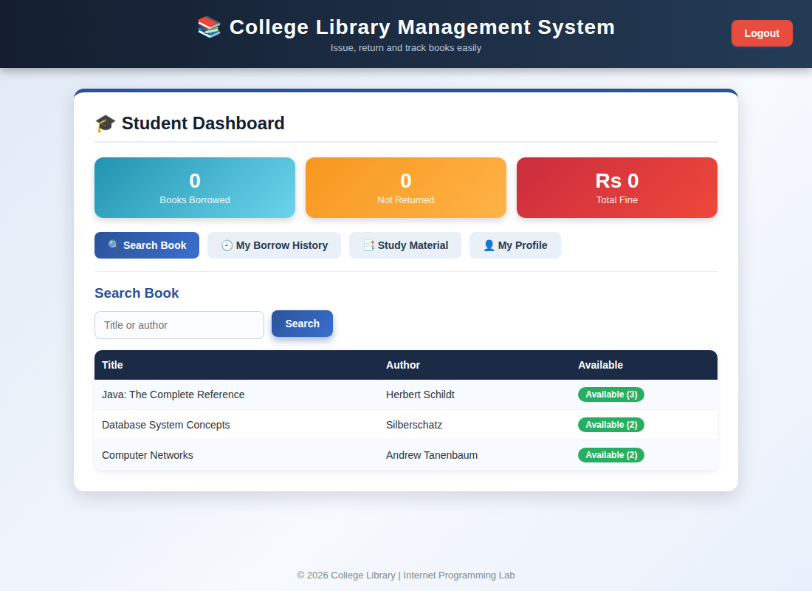
Student dashboard displayed after login
Result
Thus the Library Management System was designed and developed successfully using HTML5, CSS and JavaScript, and the output of the dashboard was verified.

